VConnect App Design Document

Index | Update | Name | Date
1 | Initial document | Ashwini | 16/9/2015
2 | Added details of create and manage request. Added data design. Overall document updated for sections. | Ashwini | 21/9/2015
3 | Updated the rest of the screens. Modifies sing up screen,login screen, entry screen. | Ashwini | 23/9/2015
4 | Updated screen1 2, 3 and 11 as per inputs from y'day's antardrishti doc | Ashwini | 25/9/2015
5 | Updated screen 1 and 2 | Gayathri | 30/09/2015
6 | Updated DB design info | Ashwini | 13/10/2015

This design document is divided in below sections.

- software stack:
- Screens:
- data design:
- backend services:

Software stack:

Lakshmi, can you please update this part.

Screens :

Below is the list of probable screens in our App.

- Login – Only Facebook Login
- Login screen providing option for sign up
- Sign up
- Create Request
- Manage Request
- Entry screen
- Match Selection
- view screen
- Settings. - Where user can update his profile
- Sysadmin view
- Forgot Password

Let us go through each screen in detail. Please follow the below color coding while going thru the doc.
Icon : for user inputs
Icon : Action required by app.
Icon : To indicate the Screen.
Icon: view only
If we decide to provide only Facebook login, we will need only screen 1. But if we plan to provide local authentication also, we need screen 2 and screen 3. So screen1 is alternative to screen 2 & 3.

- Login Screen

This is the first screen which will appear when a person clicks on our app. The screen will have some caption suggesting the cause of the App. And only one icon “login with Facebook” and email id, pwd for sysadmin to login.

Actions:

login with Facebook”: When the “login with Facebook” icon is clicked/touched the plugin for Facebook login should get called. Facebook plugin can return us user details like name , email id , contact no. Front end should call appropriate back end service to store these user detail in user table.After successful facebook login , create request screen should pop up.
EmailId::default sysadmin username.
pwd:default sysadmin pwd.
sign in: Go to sysadmin screen.

Old screen1 New screen1
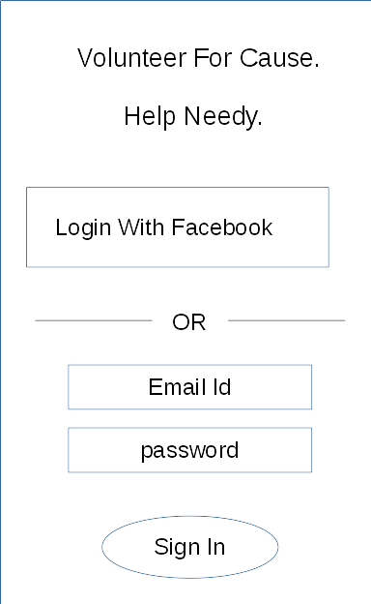
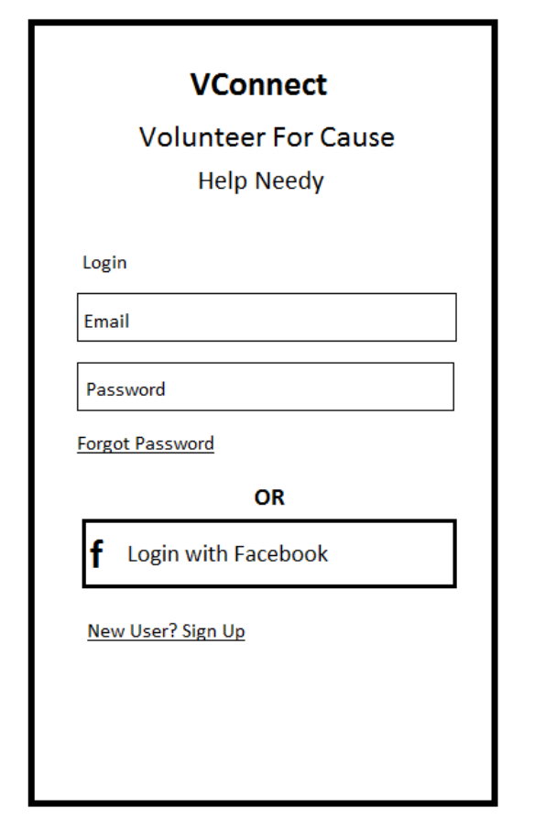
*** Change : @Ashwini, we think both sign-in and sign-up should be in same page. No need of two different login screen for each case.***

- Login screen providing option for sign up

This screen will provide two options facebook login and local authentication also.
For Facebook login we will provide one icon “Login with Facebook”.
For local authentication user needs to key inEmail iD, pwd .And then he has to “Sign In”
We also need to provide a facility if user has forgotten the password “Forgot password”.
If the user does have login credentials, the “sign up/Join Now” should be provided.
Actions:
“Login with Facebook” - Facebook login plugin should get called. The facebook login plugin returns user details like name , email id , contact. The frontend should call corresponding backend service to store these user details in user table.
Email Id: Store the user entered email Id. Validate the email id for spaces , @ char and other.
Pwd :store the pwd as is.( ? How to store )
Sign In:With click of this icon , frontend will call backend authenticate service with parameters - email id and password. Backend service with verify this email id and password from its user table and respond back to frontend. If the response is valid , we should jump to “Create Request” screen.
“Forgot Password”: When clicked on this “Forgot Password” screen should pop up.
“Join Now”: If user clicks this icon, “Join Now/Sign UP” screen should pop up.

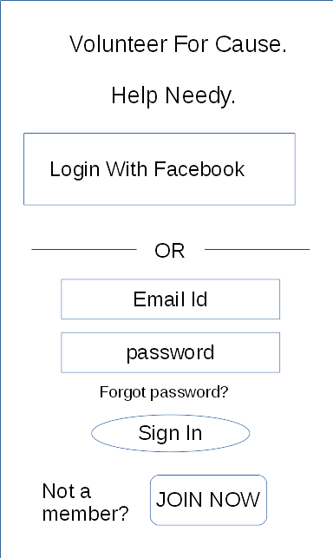

- Sign Up/ Join Now Screen

This screen will let user enter his details – name ,surname , email id , contact number , location ,birth date , gender,short description about self With this filled in user will be able to sign up with app.
Actions:
Name:validate name(?)
Surname:validate surname(?)
Email id:validate the email id
Mobile Number: Validation for valid mobile number.
Location: we will provide one tick box for location detection. If user clicks that location
detection logic should get called and location should be updated in the box. If not possible a warning should pop up “ saying can not detect location” and user should enter location details.
BirthDate: date of birth should be validated.
Gender: Two option icon will be provided. Male , Female. User should click on an one.
Short Description:text. Here seeker/volunteer can enter short info about self.
Security question: 3 most commonly asked quns (can hard code in frontend)
answer: user to input
“Join Now”: When clicked on this icon, frontend should call backend authentication service to add a user in user table. When the backend responds ok , the create request screen should pop up.
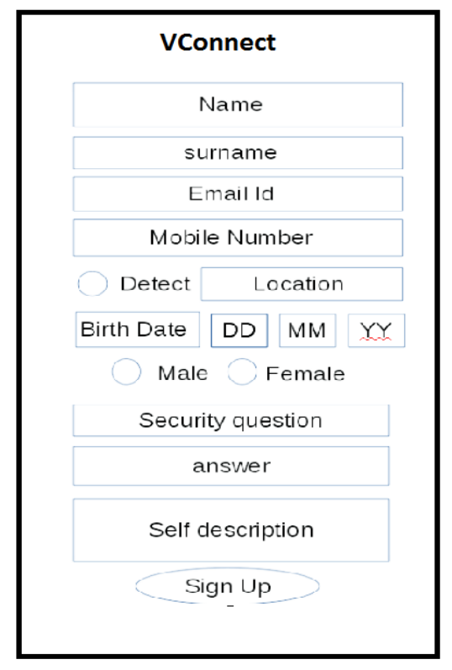
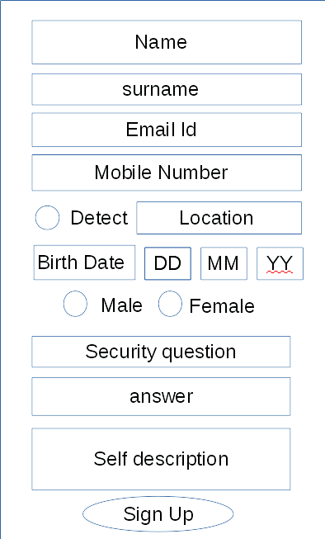
Old screen3 New screen2

- Create Request

In this screen user can create request for seeking some aid or he can volunteer for a need.
The screen will display the categories available for seeker or activities available for volunteer to
work depending upon what user chooses. Seeker or volunteer can chose only one activity at a time. User can upload his photo. Seeker can provide the date , when the help is needed. Volunteer can provide from which date he is available for that activity and till when.
The screen will have three icons – create , Manage , connect
Actions:
email Id:Update from user table if already available or allow the user to enter and provide validation.
Contact number: Update from user table if already available or allow the user to enter and provide validation.
Photo:User can upload his photo.
Seeking Aid / Volunteer : options..to choose only one.
Catagories : list of activities to populate from activity table depending upon which option is select.
Availability Date, Time : User to input when the help is required or from where he is available for the volunteered work.Date,time validation.
Till Date,Time: for the user seeking aid this will get automatically popluated with one day added in availability date. For volunteer he needs to enter this.Date,time validation.

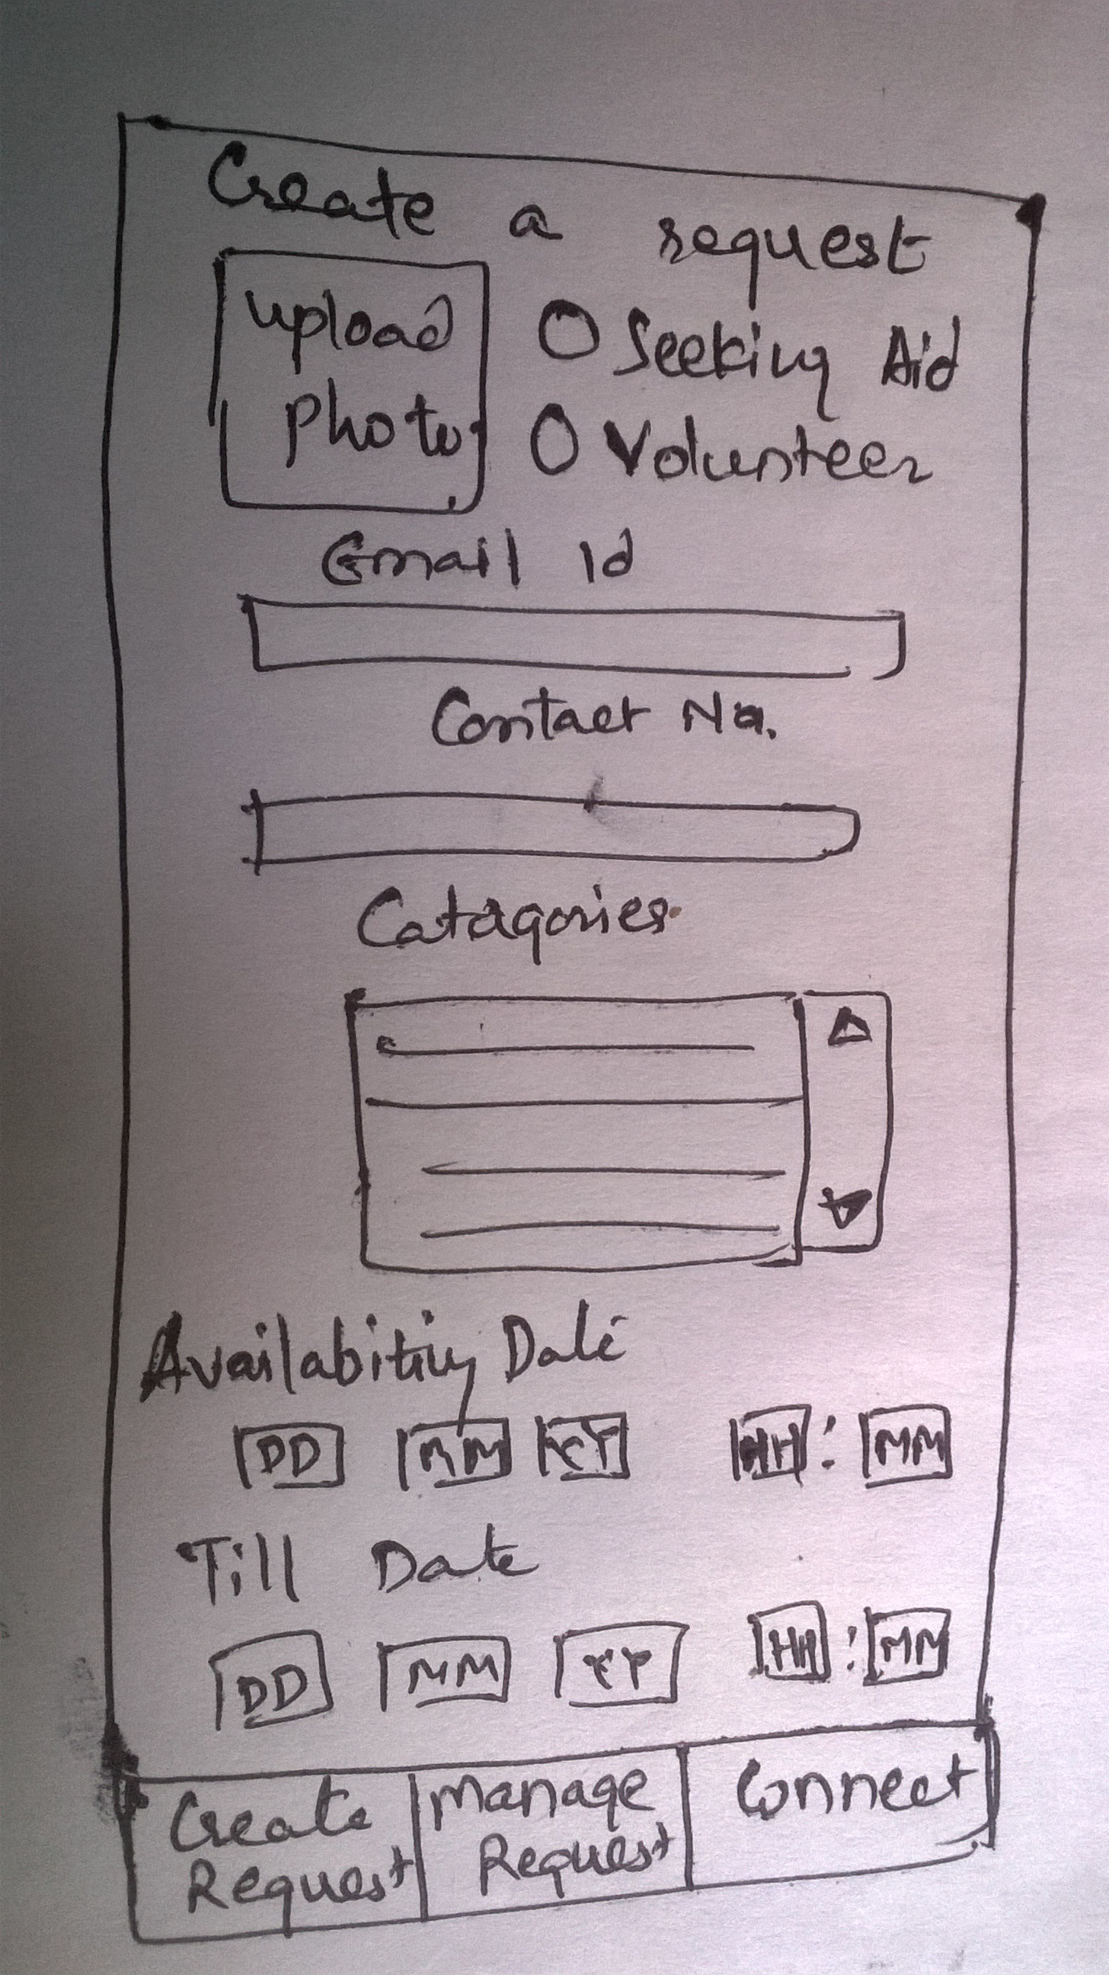

Create: when user presses this icon, the above entered data should be passed to backend to create one request in request table or volunteer table depending upon the type or request.
If the entry is added successfully, The backend service to find match for this entry to be called.
Depending upon the number of matches, the count should be updated on connect ion . If no match mesg should be displayed saying on match found currently.And an email will be sent when the match is found. (mesg should be altered properly depending upon to whom it is addressed seeker/volunteer).
Manage:When this icon is pressed, manage request screen pops up.
Connect:When this icon is pressed, if any match/matches already found,Match selection screen pops up.If not the backend service for match is called, where current user's outstanding requests are searched against volunteer table to find possible matches.If found any, Match selection screen pops up.

- Manage Request

On this screen, list of entries created by logged in user will be displayed,if any. If there are no entries msg should come saying “no entries”. When user clicks on any one,the entry gets selected. User can delete or update an entry.
Actions:
View:IF user clicks view, after selecting an entry Entry screen pops up.
delete:after selecting an entry user can click this icon, to delete selected entry.

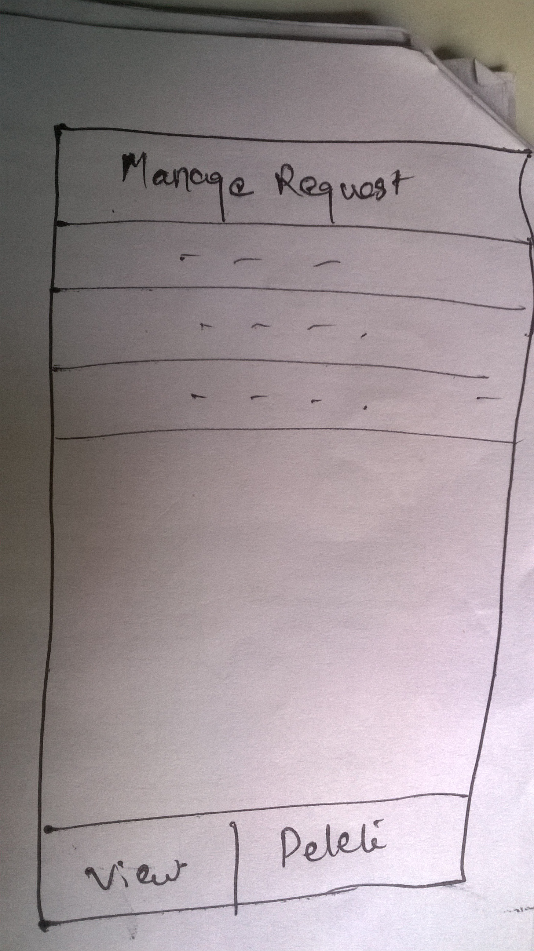

- Entry Screen:

This screen shows the details of the entry selected by user. The control comes to this screen from Manage screen. Seeker/volunteer both will use this screen. This screen can be called to serve four different purposes.
1) user can just view his entry when status is 2,3,4 and his status is 1 and volunteer's status is 0.
(refer to confirm action in match selection)
User can edit the entry for which match is not found.status – 0.
2) User wants to update the entry which is awaiting his confirmation.
3) User wants to mark the entry as resolved
4) user wants to reject the entry which awaits confirmation as he no longer needs the help/can not volunteer.

This screen is the main screen which handles the different combinations of states of both entries. NEED TO PUT THE LAYOUT OF THE SCREEN.

Actions:
email Id:User can update this if he wants. Validate if user updates.
Contact number: User can update this if he wants. Validate if user updates..
Photo:User can upload his photo.
Activity : This is non editable.
Availability Date, Time : user can update this. Date,time validation.
Till Date,Time: user can update this. Date,time validation.
Volunteered by/ Helping To : Name of the volunteer or seeker if status is 1,2, 4.
If user clicks on this, the view screen should come to show details of the person and the matching entry.
Status: This displays the current status of the entry
. 0 – Free / No Match found
1 – awaiting confirmation from other person.(peer status 0)
1 – awaiting confirmation(peer status 1)
2 – confirmed
3 – rejected
5 – rejected by peer
4 – resolved
a drop down box next to status for user to select the next action.
In case of status 1 – drop down should show options 2,3.
In case of status 2 – drop down should show options 3,4
In case of status 1(peer status 0) – only show option 3
In case of status 5 – show option 0
.
Ok : For readonly view no action.The control goes back to Manage requests screen.
When this icon is clicked , the user table is updated with the updates of this entry, if any.
The control goes back to Manage requests screen.
If the user has selected option 2 – confirmed , while status was 1 – awaiting confirmation, the status is updated to 2 for entries in both the tables and notification(email/?) goes to the other person.
If the user has selected option 3 – rejected , while status was 1 – awaiting confirmation, the status is updated to 3 for user''s own entry and 5 for peer's entry and notification(email/?) goes to the peer person.
If the user has selected option 3 – rejected , while status was 2 – confirmation , notification goes to the other person and the status is marked as 3.
If the user has selected option 4 – resolved , status for that entry should get marked as 4 – resolved.
If the user has selected option 3 – rejected , while status 1(peer status 0), notification goes to the peer and the status is marked as 3.The peer's status is set to 5.
In the case user selects 0 – while status is 5 ( This is the case where seeker / volunteer has go peer but they do not want to continue..) mark the entry free.

- Match Selection:

This screen shows the matching volunteer entries for the logged in seeker. Seeker can select an entry . He can view the selected entry for more details or confirm.

NEED TO PUT THE SCREEN LAYOUT.

Actions:

view: When seeker clicks on view, the view screen pops up.
Confirm: When seeker clicks on confirm a notification(email / ?) goes to the volunteer. Seeker's entry id is updated in the volunteer's entry and vice versa. And status is set to 1 – awaiting confirmation, in request_table . No change in volunteer_table for the entry.
Manage Requests : This will take the user back to Manage requests screen.

- View Screen

This will be ready only view. All the details of the seeker/volunteer entry will be showed.

NEED TO PUT THE SCREEN LAYOUT.

Name:
Surname:
email Id:
Contact number:
Location:
Photo:
Catagory :
Availability Date, Time :
Till Date,Time:
Age:
gender:

OK : clicking this button will take the control back to previous screen.

- Settings. - Where user can update his profile
Where this icon should go for settings screen to appear? Once user logs in ..in upper right hand corner of app along with sign out?
Actions:
Name:validate name(?)
Surname:validate surname(?)
Email id:validate the email id
Mobile Number: Validation for valid mobile number.
Location:
Age: Age should be validated for proper age limit.
Gender:
Security question:
Answer:
OK:user entry will be updated with the details.

NEED TO PUT THE IMAGE FOR THIS.

- Sysadmin view

Update categories
reset password
NEED TO PUT THE IMAGE FOR THIS.

- Forgot Password
security qn
answer
new password
retype password
confirm
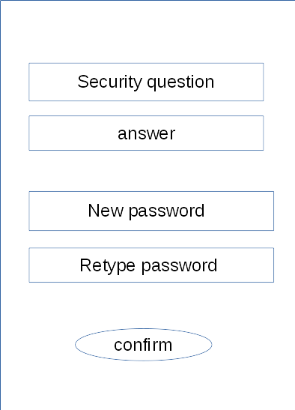

Data Design :

Please refer to vconnect-DB-Design.pdf for latest DB design.

