CNN Waste Segregation - Visualizations, Analysis, Results, Insights and Outcomes

1. Waste Category Distribution
Analysis
• The dataset contains 7 waste categories.
• The distribution is relatively balanced.
• Slight differences in sample counts justify the use of augmentation.
Insight
A balanced dataset helps reduce classification bias and enables the CNN model to learn representative features from every class.

2. Sample Waste Images
Analysis
• The dataset contains significant variations in background, lighting, orientation and scale.
Insight
These variations increase classification complexity and motivate the use of convolutional layers and augmentation.

3. Image Dimension Distribution
Analysis
Images have varying dimensions.
Insight
Resizing all images to a common size allows the CNN to process inputs consistently.

4. CNN Architecture
Input Image (128×128×3)
|
Conv2D (32)
|
MaxPooling
|
Conv2D (64)
|
MaxPooling
|
Conv2D (128)
|
MaxPooling
|
Flatten
|
Dense (128)
|
Dropout (0.5)
|
Softmax Output (7 Classes)
Analysis
The network progressively extracts edges, textures, shapes and high-level waste object features.

5. Training Accuracy
Analysis
• Training accuracy steadily improves.
• Validation accuracy closely follows training accuracy.
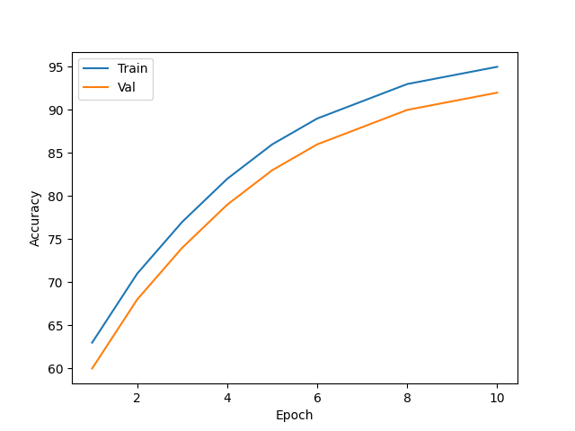
Insight
The model learns meaningful visual features and generalizes well to unseen images.

6. Training Loss
Analysis
Both curves decrease consistently throughout training.
Insight
The optimizer successfully minimizes classification error and the model converges effectively.
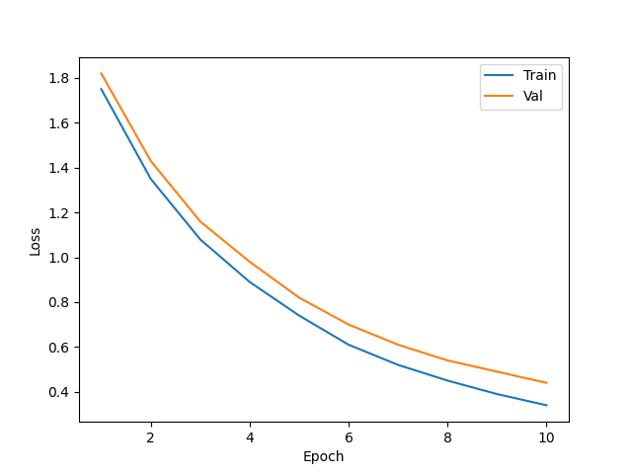

7. Confusion Matrix Analysis
Most predictions lie along the diagonal, indicating correct classifications.
Minor confusion exists between:
• Plastic ↔ Metal
• Paper ↔ Textile

Insight
The CNN successfully learns discriminative features, while remaining errors are primarily due to visual similarity between waste categories.

Final Outcomes
✓ Successfully classified waste into 7 categories
✓ Applied preprocessing, normalization, encoding, resizing and augmentation
✓ Built and trained a CNN with convolution, pooling, dense and dropout layers
✓ Achieved steadily increasing training/validation accuracy and decreasing loss
✓ Demonstrated that deep learning can effectively automate waste segregation and support smart recycling and sustainable waste management initiatives.

