2/3/2025

Ashwini Bagde

ashwinibagde43@gmail.com

**Petrol Pump Development**

Business Analysis Report

**Introduction**

The Petrol Pump Development project aims to develop a state-of-the-art petrol pump with modern technology and efficient infrastructure. The project encompasses several critical stages, including site preparation, construction of fuel dispensers and storage tanks, installation of advanced payment systems, and implementation of safety and compliance measures. The project will follow a structured approach using agile methodology to complete construction tasks within a planned timeline. The ultimate goal is to provide a superior customer experience with seamless fuel management, secure payment processing, and a safe environment for all users.

**Project Goals and Objectives**

* **Efficient Fuel Inventory Management**: Install and configure state-of-the-art fuel dispensers, underground storage tanks, and automated gauging systems to track fuel levels and manage inventory efficiently.
* **Seamless Payment Processing**: Set up advanced POS systems and payment terminals that support multiple payment methods, ensuring quick and secure transactions for customers.
* **Safety and Compliance**: Implement fire suppression systems, spill containment systems, and surveillance systems to meet safety regulations and ensure a secure environment for customers and staff.
* **Aesthetic and Functional Design**: Construct a modern and aesthetically pleasing forecourt, canopy, office building, and driveways to provide a comfortable and convenient experience for customers.

**Project Need**

The need for this project arises from the increasing demand for efficient and reliable fuel services. Manual processes at petrol pumps can lead to errors, inefficiencies, and customer dissatisfaction. By adopting modern technology and infrastructure, this project aims to address these challenges and provide a superior customer experience. The integration of advanced systems will streamline operations, reduce downtime, and enhance overall efficiency. Additionally, compliance with regulatory standards is essential to operate legally and safely.

**SDLC Cycle**

**1. Planning**

**Objective:** Define the project's scope and objectives.

**Tasks:**

* Identify project goals and objectives.
* Conduct feasibility study to evaluate the project's viability.
* Estimate costs, resources, and timelines.
* Develop a project plan and schedule with key milestones.

**Deliverables:**

* Project Plan
* Feasibility Study
* Cost and Resource Estimates
* Project Schedule

**2. Requirements Analysis**

**Objective:** Gather detailed requirements from stakeholders.

**Tasks:**

* Conduct meetings and interviews with stakeholders (e.g., project owners, Fuel Suppliers, regulatory authorities, local community).
* Document functional and non-functional requirements.
* Create a detailed Requirements Specification document.
* Prioritize requirements based on business value and feasibility.

**Deliverables:**

* Requirements Specification (RS)
* Requirements Prioritization

**3. Design**

**Objective:** Create a detailed blueprint for the construction project.

**Tasks:**

* Develop the architectural design and layout of the petrol pump.
* Create detailed engineering designs and specifications.
* Design the infrastructure for fuel storage and distribution.
* Design safety and environmental protection measures.
* Review and finalize designs with stakeholders.

**Deliverables:**

* Architectural Design
* Engineering Design Specifications
* Safety and Environmental Design
* Design Review Notes

**4. Implementation (Construction)**

**Objective:** Construct the petrol pump based on the design.

**Tasks:**

* Procure materials and equipment needed for construction.
* Hire contractors and construction teams.
* Execute the construction of the petrol pump infrastructure.
* Perform regular inspections to ensure compliance with design and safety standards.
* Conduct quality assurance and quality control (QA/QC) processes.

**Deliverables:**

* Constructed Petrol Pump Infrastructure
* QA/QC Reports
* Inspection Reports

**5. Testing and Commissioning**

**Objective:** Ensure the petrol pump is ready for operation.

**Tasks:**

* Conduct functional testing of all systems (e.g., fuel dispensing, storage tanks, safety systems).
* Perform integration testing to ensure all components work together seamlessly.
* Conduct environmental and safety testing to comply with regulations.
* Commission the petrol pump and obtain necessary certifications.

**Deliverables:**

* Functional Test Reports
* Integration Test Reports
* Safety and Environmental Test Reports
* Commissioning Certificates

**6. Deployment (Opening)**

**Objective:** Open the petrol pump for business.

**Tasks:**

* Prepare the petrol pump for opening (e.g., stocking fuel, setting up point-of-sale systems).
* Train staff on operational procedures and safety protocols.
* Conduct a soft launch to test operations and gather feedback.
* Officially open the petrol pump to the public.

**Deliverables:**

* Operational Petrol Pump
* Staff Training Materials
* Soft Launch Feedback
* Grand Opening Plan

**7. Maintenance and Support**

**Objective:** Provide ongoing support and maintenance.

**Tasks:**

* Monitor the petrol pump operations and address any issues.
* Perform regular maintenance and inspections.
* Implement improvements based on customer feedback and operational data.
* Ensure compliance with safety and environmental regulations.

**Deliverables:**

* Maintenance Logs
* Inspection Reports
* Improvement Plans
* Compliance Certificates

**Data Flow Diagram:**

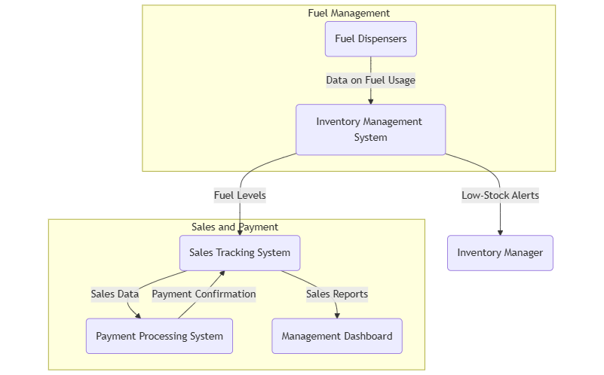

**Sprint Planning Overview**

**Sprint 1: Initiation and Site Preparation**

* **Conduct Site Survey:** Complete a comprehensive survey of the site to understand the terrain and layout.
* **Obtain Necessary Permits and Approvals:** Acquire all necessary legal permissions and regulatory approvals for construction.
* **Clear and Prepare Site:** Clear the site of any debris and prepare it for the construction process.
* **Install Underground Storage Tanks (USTs):** Set up the underground storage tanks for fuel storage.

**Sprint 2: Foundation and Infrastructure Setup**

* **Construct Fuel Dispensers:** Build and install fuel dispensers for efficient fuel distribution.
* **Lay Fuel Pipes and Connections:** Install and connect fuel pipes from storage tanks to dispensers.
* **Construct Office Building:** Build the main office structure to manage operations.
* **Install POS Systems and Payment Terminals:** Set up the Point of Sale (POS) systems and payment terminals to handle transactions.

**Sprint 3: Canopy, Forecourt, and Safety Systems**

* **Construct Canopy and Forecourt:** Build the canopy and forecourt area where vehicles will be serviced.
* **Install CCTV and Surveillance Systems:** Set up surveillance cameras for security monitoring.
* **Implement Fire Suppression Systems:** Install fire suppression systems to ensure safety compliance.

**Sprint 4: Backup Systems and Containment**

* **Set Up Backup Power Systems (UPS):** Ensure uninterrupted power supply by installing backup power systems.
* **Install Spill Containment Systems:** Implement systems to contain any fuel spills and prevent environmental damage.
* **Construct Driveways and Parking Areas:** Build driveways and parking spaces for vehicle access and customer convenience.

**Sprint 5: Digital Signage and Aesthetic Improvements**

* **Install Digital Signage:** Set up electronic displays for fuel prices and promotional content.
* **Landscaping and Aesthetic Improvements:** Enhance the visual appeal of the petrol pump with landscaping and aesthetic improvements.

**Sprint 6: Quality Inspection and Testing**

* **Conduct Quality Inspection and Testing:** Perform thorough inspections to ensure all installations meet quality standards.
* **Finalize and Clean Up Site:** Finalize all construction activities and clean up the site for operational readiness.

**Sprint 7: Integration and Training**

* **Conduct Training for Staff on New Facilities:** Provide comprehensive training to staff on how to use the new facilities and systems.
* **Integrate Fuel Management System with Infrastructure:** Ensure the fuel management system is fully integrated with the physical infrastructure for seamless operations.

**Sprint 8: Final Approvals and Launch**

* **Obtain Final Regulatory Approval:** Secure final regulatory approvals for operational commencement.
* **Conduct Soft Launch and Initial Operations:** Begin initial operations with a soft launch to test all systems and processes.

**Cost Estimation for Petrol Pump Development**

**1. Land Acquisition**

* **Description**: Purchase of suitable land for petrol station.
* **Estimated Cost**: ₹40,00,000 - ₹60,00,000

**2. Construction Costs**

* **Building Structure**: Construction of the main station building, including restroom facilities and a convenience store.
  + **Estimated Cost**: ₹20,00,000 - ₹30,00,000
* **Fuel Tanks Installation**: Costs for above-ground or underground fuel tanks.
  + **Estimated Cost**: ₹15,00,000 - ₹25,00,000
* **Canopy and Pump Installation**: Structure over the fuel pumps.
  + **Estimated Cost**: ₹10,00,000 - ₹15,00,000
* **Pavement and Driveway**: Construction of access roads, parking areas, and pavement.
  + **Estimated Cost**: ₹5,00,000 - ₹10,00,000

**3. Equipment Costs**

* **Fuel Dispensers**: Purchase and installation of fuel dispensers.
  + **Estimated Cost**: ₹20,00,000 - ₹25,00,000
* **Point of Sale Systems**: Cash registers, card terminals, and other sales equipment.
  + **Estimated Cost**: ₹5,00,000 - ₹7,00,000

**4. Regulatory and Permitting Costs**

* **Environmental Assessments**: Necessary studies and compliance assessments.
  + **Estimated Cost**: ₹5,00,000 - ₹10,00,000
* **Permits and License Fees**: Costs for acquiring necessary operating licenses and permits.
  + **Estimated Cost**: ₹3,00,000 - ₹5,00,000

**5. Operational Costs**

* **Initial Inventory**: Purchase of initial fuel stock, convenience store inventory, etc.
  + **Estimated Cost**: ₹10,00,000 - ₹15,00,000

**6. Marketing and Branding**

* **Description**: Initial marketing, brand signage, and promotional costs.
* **Estimated Cost**: ₹2,00,000 - ₹5,00,000

**7. Contingency Fund**

* **Description**: A buffer for unexpected costs, typically 10-15% of total project costs.
* **Estimated Cost**: ₹14,00,000 - ₹22,00,000

**Total Estimated Cost**

| **Cost Category** | **Estimated Low (INR)** | **Estimated High (INR)** |
| --- | --- | --- |
| Land Acquisition | ₹40,00,000 | ₹60,00,000 |
| Construction Costs | ₹50,00,000 | ₹90,00,000 |
| Equipment Costs | ₹25,00,000 | ₹32,00,000 |
| Regulatory and Permitting Costs | ₹8,00,000 | ₹15,00,000 |
| Operational Costs | ₹10,00,000 | ₹15,00,000 |
| Marketing and Branding | ₹2,00,000 | ₹5,00,000 |
| Contingency Fund | ₹14,00,000 | ₹22,00,000 |
| **Total Estimated Cost** | **₹1,49,00,000** | **₹2,39,00,000** |

**Conclusion:**

The Development of the Petrol Pump is a comprehensive project that involves meticulous planning, modern technology integration, and adherence to safety standards. By following a structured sprint plan and leveraging agile methodology, the project aims to complete construction tasks efficiently within the planned timeline. The end result will be a state-of-the-art petrol pump that offers efficient fuel management, seamless payment processing, enhanced safety, and a superior customer experience. This project will set a new standard in petrol pump operations and serve as a model for future developments in the industry.