BIODATA

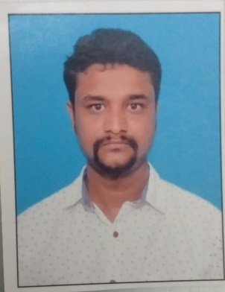

**Name :** Sushil Hagargi

**Address :** H no:2-907/76/98 Pragati colony,

near Subhash Guttedar House.

**Date of Birth :** 21/09/1991

**Mobile No :** 6361715304

**Email-Id :**

**Marital Status :** Unmarried

**Religion :** Hindu

**Nationality :** Indian

**Name of Father :** Laxmikant Hagargi

**Name of Mother :** Kamala

**Languages Known :** Kannada ,English ,Hindi

**Educational Details :** PUC

**Experience :** 1 year of experience in Call Centre in Cogent e-Service Pvt Ltd Bangalore.

**­_____________________________**

**Applicant Signature**