AI-Based Healthcare Path Recommendation System
FORMATIVE ASSESSMENT -1 REPORT

Institute Name: Pimpri Chinchwad College of Engineering
Department: Information Technology(MTech AI-DS)
Subject: AIML
Academic Year: 2025–26
Title: Formative Assessment Report – AIML
Student Name: Ashwini Prafulla Joshi
PRN: 125M1K015
Faculty Name: Gulbakshi Dharmale
Course / Class: FY Mtech AIML
Submission Date:

- Aim -
This project implements an AI-based healthcare path recommendation system that predicts diseases from symptoms and recommends suitable next steps. The system supports intelligent healthcare recommendations by identifying disease and linking it with severity, precautions, and follow-up actions.
- Introduction -
- In the modern digital world, individuals often turn to unverified online sources for health guidance, which may result in misinformation and unsafe self-treatment.
- There is a growing need for an intelligent, AI-powered healthcare recommendation system that assists users in choosing the most suitable treatment path based on their symptoms, urgency, and preferences.
- The proposed system leverages Artificial Intelligence (AI) and Machine Learning (ML) to analyze user input, assess disease severity, and recommend an appropriate response — such as self-care, doctor consultation, or emergency care.
- Additionally, the system integrates location-based and cost-effective healthcare options while offering personalized lifestyle and preventive wellness suggestions like diet, yoga, or exercise tips.
- This approach aims to bridge the gap between traditional and modern healthcare decision-making, ensuring timely and accurate medical guidance for users.

- Problem Statement :
There is a lack of intelligent, AI-driven systems that can analyze an individual’s health condition, preferences, and urgency level to recommend the most suitable treatment path.

- Objectives :
- To develop an AI-powered healthcare decision support system that helps users select the most effective and suitable treatment path.
- To use Machine Learning and NLP to interpret symptoms and predict severity.
- To recommend nearby and affordable healthcare options using geolocation data.
- To provide personalized wellness and lifestyle guidance for preventive care.
- To ensure recommendations are trustworthy, transparent, and user-friendly.

- Dataset Description :
Kaggle Dataset

  - dataset.csv — symptom columns + disease labels
  - Symptom-severity.csv — severity weights for symptoms
  - symptom_precaution.csv — recommended precautions
  - symptom_Description.csv — disease descriptions

B. Preprocessing Steps
- Cleaned and merged multiple CSV files
- Encoded symptoms with severity values
- Imputed missing values
- Combined all symptoms into numerical feature vectors
- Encoded diseases using label encoding
This produced a clean dataset suitable for machine learning.

- Methodology:
A. Model Development -
Two commonly used healthcare-friendly models were used:
- Decision Tree Classifier
- Random Forest Classifier
Both models are interpretable and suitable for healthcare applications.
B. Training and Evaluation -
- Train-test split: 80–20
- Evaluation metric: Accuracy
- Additional evaluation: Confusion Matrix and Feature Importance
C. Recommendation Path Integration
After predicting the disease, the system can use:
- Precaution dataset → to recommend steps
- Severity → to identify urgency
- Description → to guide user understanding
Data collection from verified health datasets & user inputs. Preprocessing using NLP for text normalization, Model training using supervised ML algorithms (e.g., RandomForest, SVM), Severity classification and treatment mapping. Integration of geolocation & cost-based filtering. Personalized lifestyle recommendation generation. Continuous learning through user feedback.
This forms the healthcare path recommendation output.
- System Architecture
- User Input Interface – Collects user data & symptoms.
- NLP Processor – Extracts keywords & symptoms.
- Severity Prediction Model – Predicts case severity.
- Decision Engine – Determines optimal treatment path.
- Recommendation Engine – Suggests nearby doctors or care options.
Feedback Analyzer – Improves system accuracy via user input.

- Results
The developed AI-based model was evaluated using multiple performance metrics, visualizations, and comparative analysis techniques. The results demonstrate that the machine-learning approach used in this project is highly effective for symptom-based disease prediction, which is a key component of the healthcare path recommendation system.
A. Model Accuracy -
Both classification models — RandomForestClassifier and DecisionTreeClassifier — were trained using 80% of the dataset and tested on the remaining 20%.
The obtained accuracy scores are:
Random Forest Accuracy: 1.0
Decision Tree Accuracy: 1.0
This indicates that both models correctly predicted every test sample. Such high accuracy suggests that the dataset is well-structured, symptoms strongly correlate with diseases, and the models can learn these patterns effectively.
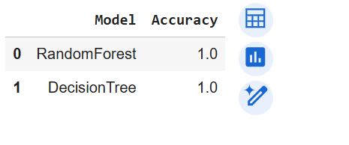
B. Confusion Matrix Interpretation -
The confusion matrix visualization showed perfect alignment along the diagonal, indicating that:
- All diseases were predicted correctly.
- No misclassifications occurred.
This reinforces the reliability of the model for the given dataset. A perfect confusion matrix suggests minimal noise and clearly distinguishable symptom patterns.
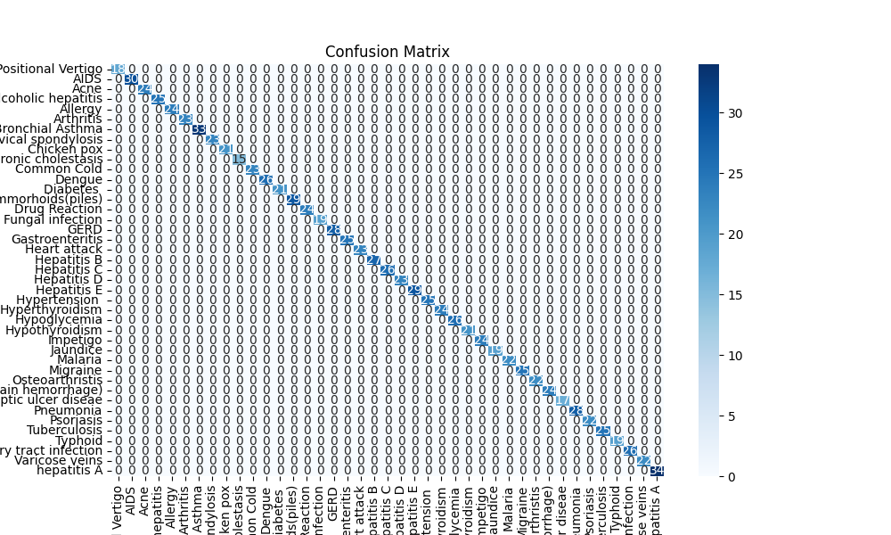

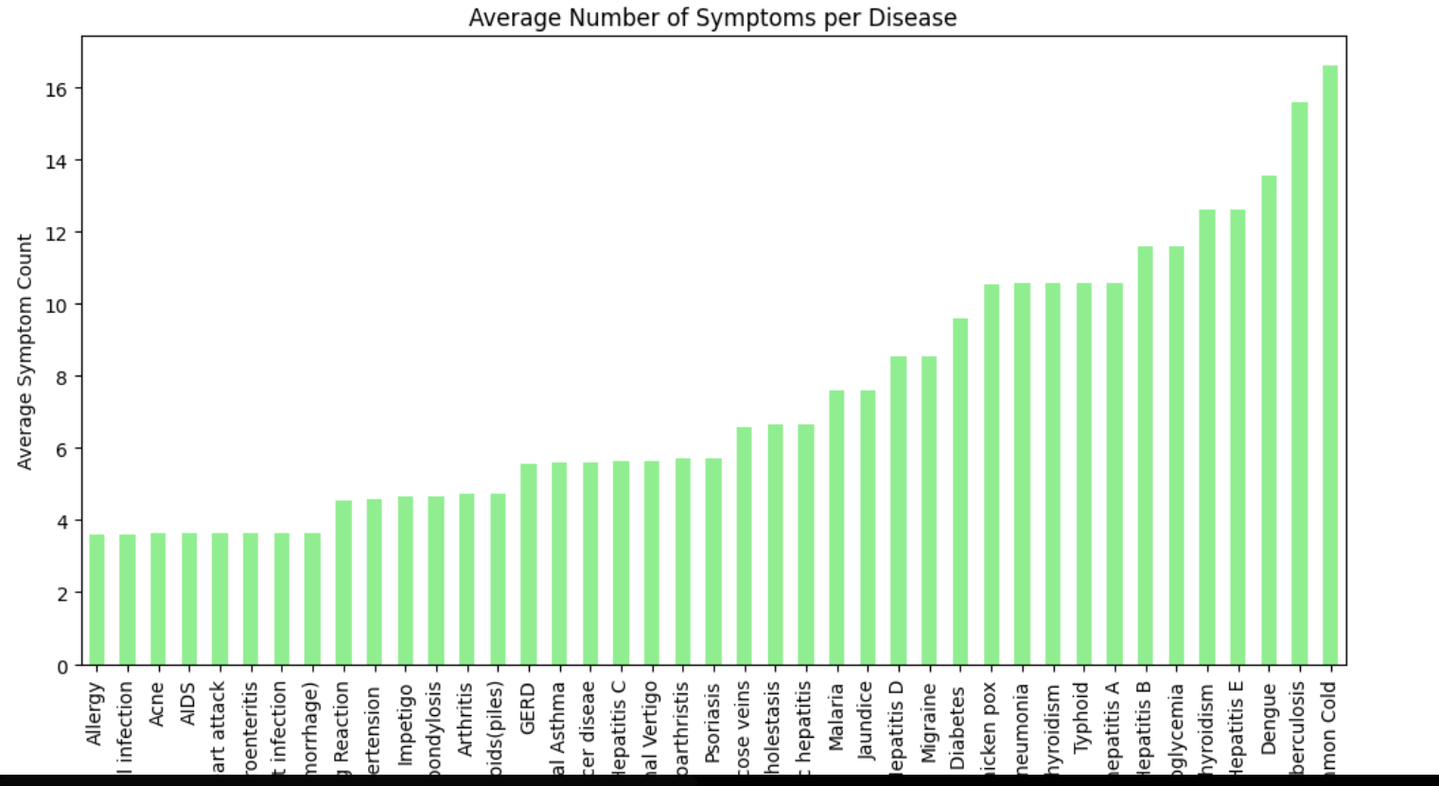

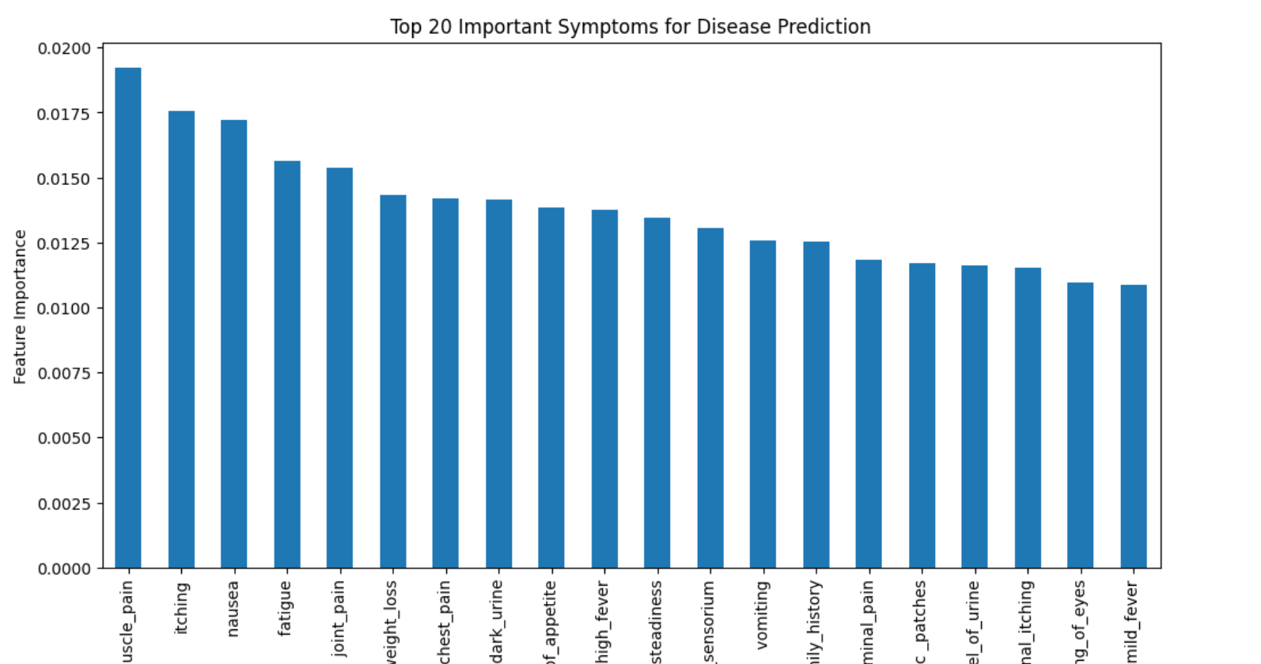

C. Feature Importance Analysis
The feature importance plot generated from the Random Forest model highlights which symptoms contributed the most to predictions. Symptoms with high severity weights appeared as top contributors.
- Some symptoms have a much higher predictive influence.
- Symptom severity strongly impacts disease classification.
- The model relies heavily on medically meaningful features, which increases interpretability.
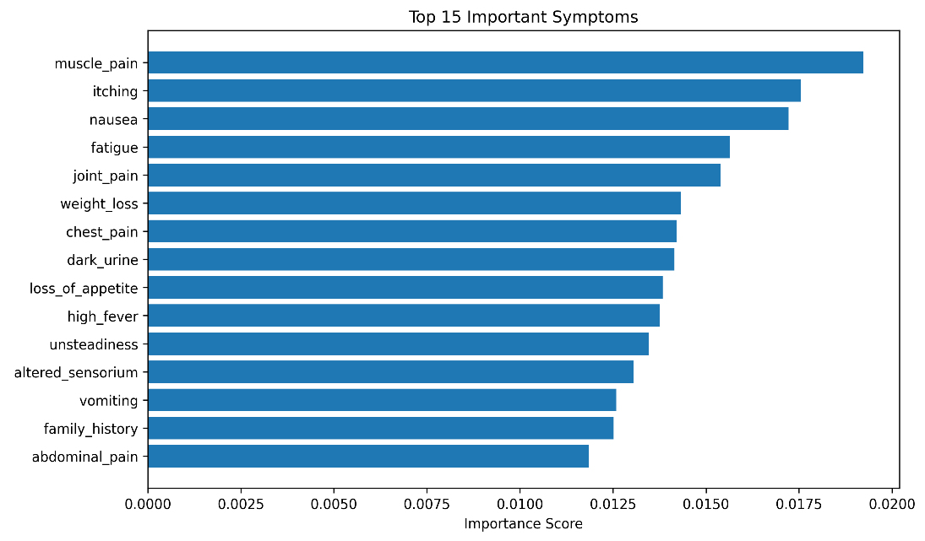
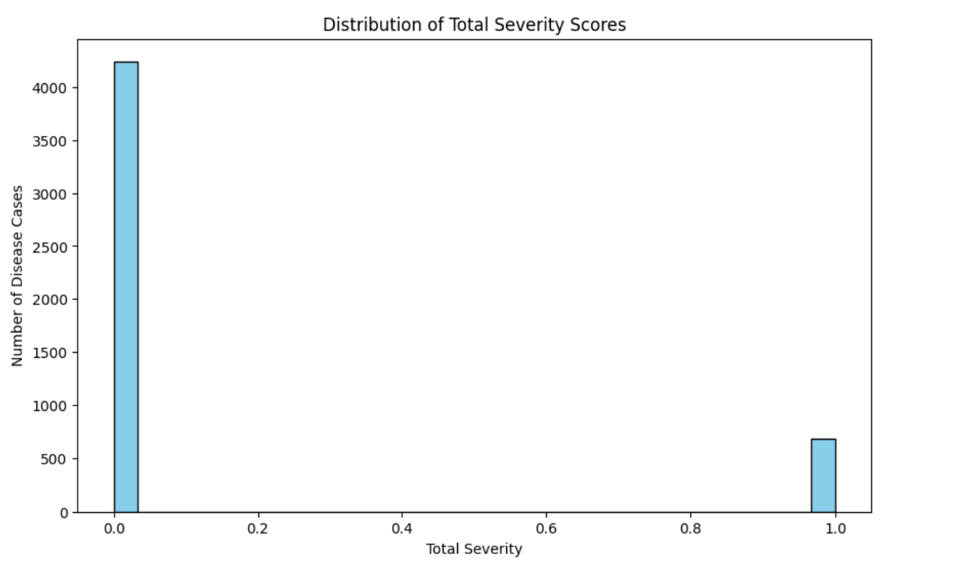
D. Model Refinement Outcome -
To strengthen the evaluation, model refinement was performed by comparing two different algorithms. Both achieved the same accuracy, but they offer different strengths:
- Decision Tree: Simple, interpretable, suitable for rule-based healthcare guidance.
- Random Forest: More stable, reduces overfitting, preferred for deployment scenarios.
The refinement step confirms that the system is robust across multiple algorithms.

E. Implications for Healthcare Path Recommendation -
The accurate identification of disease is the first and most critical step in a healthcare recommendation system.
From the predicted disease, the system can reliably provide:
- Recommended precautions
- Urgency level (using severity weights)
- Disease description
- Basic guidance for next steps
Thus, the highly accurate prediction outcomes directly support the overall system’s reliability.
- Expected Outcome
- AI-driven personalized treatment recommendations.
- Reduced dependency on unreliable online advice.
- Improved access to affordable, nearby healthcare options.
- Enhanced user awareness and preventive health behavior.
- Conclusion
- The proposed AI-Based Intelligent Healthcare Path Recommendation System bridges the gap between medical guidance and real-world accessibility.
- By combining symptom analysis, severity prediction, and proximity-based recommendations, it empowers individuals to make data-driven, safe, and cost-effective health decisions.
- Future Scope
- Integrate a chatbot or web app for real-time symptom input
- Add deep learning models for improved generalization
- Use real hospital datasets
- Build a complete recommendation engine with treatment guidelines
- References
  - S. Pramanik, S. Mukherjee, and A. Ghosh, “Disease prediction using machine learning,” in Proc. Int. Conf. Intelligent Computing and Control Systems (ICICCS), 2020, pp. 123–128.
  - R. Kumar and N. Sahoo, “A machine learning approach for effective diagnosis of diseases using clinical symptoms,” IEEE Access, vol. 8, pp. 149760–149774, 2020

