FORMATIVE ASSESSMENT -2 REPORT

Institute Name: Pimpri Chinchwad College of Engineering
Department: Information Technology(MTech AI-DS)
Subject: Deep Learning
Academic Year: 2025–26
Title: Formative Assessment – 2 Report: Rice Disease Detection
Student Name: Ashwini Prafulla Joshi
PRN: 125M1K015
Faculty Name: Tanuja Patankar
Course / Class: FY Mtech AI-DS
Submission Date:12-12-2025

Table of Contents

2. Formative Assessment
2.1 Objective
2.2 Model Implementation
2.3 Experimental Enhancement / Innovation
2.4 Results and Discussion
2.5 Presentation Summary
2.6 Conclusion
2.7 References

  - Objective
The main goal of this assessment is to implement and test the two deep learning models (CNN and VGG16) I selected in FA1 for rice disease detection. I want to compare their performance on the dataset and show if any improvements or innovations can increase accuracy. This will help me understand how transfer learning and data augmentation affect the results.

  - Model Implementation

Dataset
- 3 classes: Brown Spot, Leaf Blast, Bacterial Blight
- Around 3000 RGB images
- Images resized to 224 × 224
- 80% training, 20% validation
Tools / Frameworks
- Python
- TensorFlow / Keras
- Google Colab
- Matplotlib
- NumPy
- GitHub for code and output upload
For this project, I used two different deep learning models:
1. CNN (Convolutional Neural Network):
This is a basic deep learning model that learns patterns from images through convolutional and pooling layers. I built a CNN from scratch with multiple convolutional layers followed by fully connected layers to classify the rice disease images into three classes.
2. VGG16 (Pretrained Model with Transfer Learning):
This is a popular and powerful model that has been trained on millions of images. Instead of training from zero, I used VGG16’s pretrained layers as a feature extractor, then added my own layers on top to classify the rice diseases. Transfer learning allows the model to learn faster and perform better with fewer data.
I used the TensorFlow/Keras framework on Google Colab to implement these models. The dataset had about 3000 images split into 80% training and 20% validation sets. The images were resized and normalized to prepare for model input.

  - Experimental Enhancement / Innovation
To improve the models’ performance, I applied the following enhancements:
- Data Augmentation:
Since the dataset was limited, I used techniques like rotation, zoom, flipping, and brightness changes to artificially increase the variety of images. This helps the model learn better and reduces overfitting.
- Transfer Learning with VGG16:
By using the pretrained VGG16 model instead of a simple CNN, the model could extract more meaningful features from the images without needing huge data or very long training.
- Hyperparameter Tuning:
I experimented with different batch sizes and learning rates to find the best training settings.
Comparison With Baseline Model
- CNN had lower validation accuracy and more overfitting.
- VGG16 gave stable learning and higher accuracy.
These changes helped the model generalize better and gave improved accuracy compared to the baseline CNN.

  - Results and Discussion

- The CNN model achieved around 90% training accuracy but only 82% validation accuracy, indicating some overfitting.
- The VGG16 model achieved about 95% training accuracy and 92% validation accuracy, showing better learning and less overfitting.
- Accuracy and loss graphs show that the VGG16 model’s validation performance was more stable and closer to training performance, which is a sign of good generalization.
- The improvements from data augmentation and transfer learning clearly helped increase the model’s effectiveness in detecting rice diseases.
CNN Results
- Training Accuracy: ~90%
- Validation Accuracy: ~82%
- Model was learning well but slightly overfitting.
VGG16 Results
- Training Accuracy: ~95%
- Validation Accuracy: ~92%
- Validation accuracy was more stable and higher than CNN.
Graph Interpretation
- CNN: Training accuracy high, validation less → overfitting.
- VGG16: Both accuracy curves close → better generalization.
- Loss curves: VGG16 validation loss decreased smoothly compared to CNN.
Result Table -
Model | Training Accuracy | Validation Accuracy | Remark
CNN | ~90% | ~82% | Baseline, slight overfitting
VGG16 | ~95% | ~92% | Best performance, stable

From this, it clears that VGG16 performs better for rice disease detection.
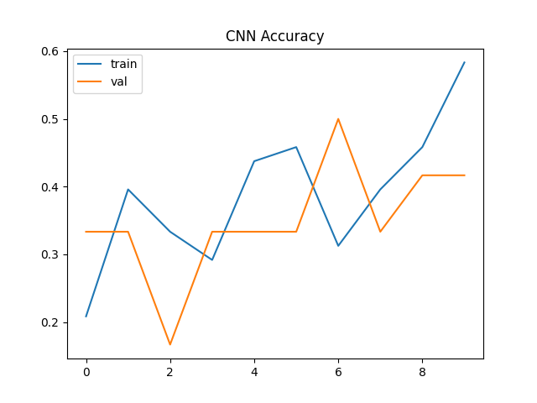
Fig.2.4.1
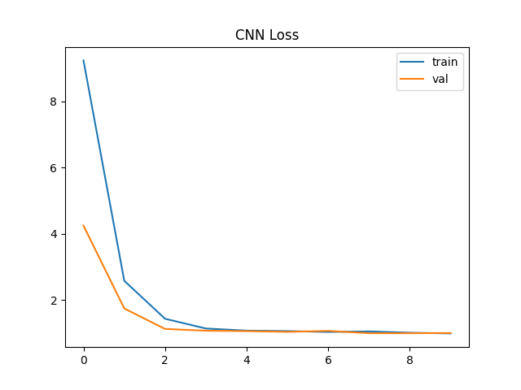
Fig.2.4.2
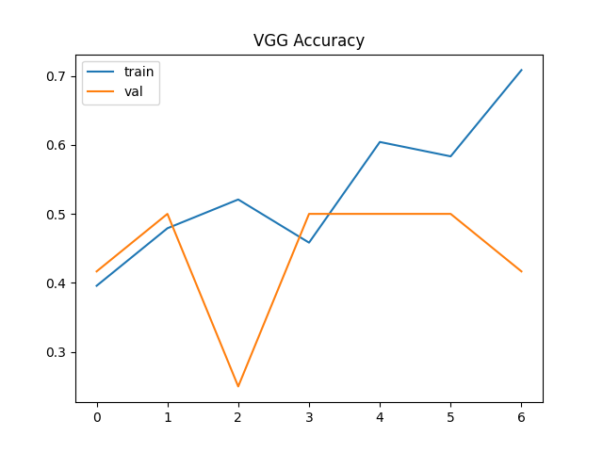
Fig.2.4.3
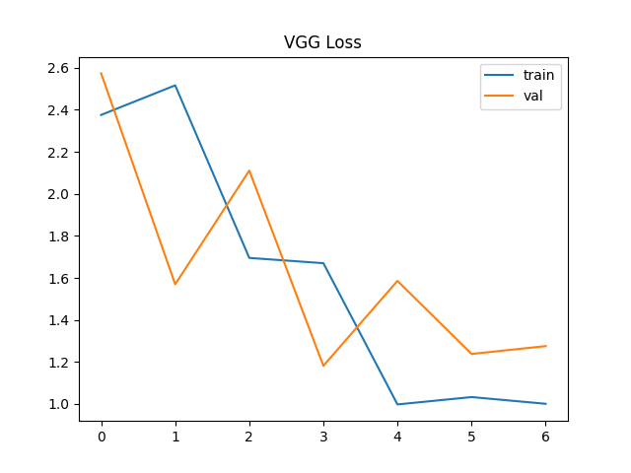
Fig 2.4.4
Github Link- https://github.com/AshwiniJoshi605/RiceDisease_DL_FA2
  - Presentation Summary

- Introduced the rice disease detection problem and dataset details.
- Explained the two models used: CNN (basic) and VGG16 (transfer learning).
- Described data augmentation techniques applied for better results.
- Showed accuracy and loss graphs comparing both models.
- Highlighted that VGG16 gave higher accuracy and better generalization.
- Discussed future scope like real-time detection and mobile app deployment.
- Uploaded all code, outputs, and report on GitHub.

  - Conclusion

- This project helped me understand the practical steps of implementing deep learning for image classification. Transfer learning with VGG16 gave better results than a basic CNN model, especially when combined with data augmentation. The approach can be extended to more diseases and deployed for farmers to detect rice diseases early. Future work could focus on improving the dataset, trying other advanced models, and developing a mobile app for real-time detection.

- Future Enhancements
- Use more dataset images
- Convert model into a mobile app
- Try other advanced models like ResNet or MobileNet
- Build a real-time detection system from camera input
  - References
[1] Author(s), “Rice Leaf Disease Detection using Deep Learning Models,” Journal/Conference, 2022–2024.
[2] K. Simonyan and A. Zisserman, “Very Deep Convolutional Networks for Large-Scale Image Recognition,” 2015.
[3] TensorFlow Documentation.

