**Ashwini Rathod**

**MIp DA 03**

**

**Understanding SQL Joins: Inner, Outer, Left, and Right.**

**Understanding SQL Joins: Inner, Outer, Left, and Right.**

**Abstract: -**

**The topic of the paper is “Understanding SQL Joins: Inner, Outer, Left, and Right” The reason for selecting this topic is** **SQL joins are a powerful feature used in database management systems to combine data from multiple tables. By linking related information, joins enable efficient data retrieval and analysis. Types of Joins are Inner join, Left join, right join, full join, Cartesian join, and Self-join.**

**Keywords: - SQL Joins, database, tables, data, inner join, self-join, left join, right full joins, join, Outer join, links**

**Introduction**

SQL stands for Structured Query Language. It is used to Create a Database which will be there in the foams of rows & and columns.

**SQL joins: -** These statements Allow us to Access information from or more tables at once. They also keep our database normalized.

* A join Clause is used to combine rows from two or more tables, based on a common field between them.
* The join clause allows us to retrieve data from two or more related tables into a meaningful result set.
* We can join the table using a select statement and a join condition.

**Types of SQL Joins:**

**Outer join**

**Left Join**

**Inner join**

**Right Join**

**Consider the two Tables Below: -**

**Student table: -**

|  |  |  |  |
| --- | --- | --- | --- |
| Std_id | Std_Name | Contact | Address |
| 101 | Ashwini | 7181288847 | Nagpur |
| 102 | Payal | 1254897151 | Pune |
| 103 | Sneha | 2546789245 | Amravati |
| 104 | Sneha | 8319756489 | Mumbai |
| 105 | Priya | 1254897151 | Nashik |
| 106 | Anvay | 5798459456 | Yavatmal |

**Course table: -**

|  |  |
| --- | --- |
| Course_id | Student_id |
| 1 | 101 |
| 2 | 102 |
| 4 | 104 |
| 4 | 105 |
| 5 | 109 |
| 6 | 108 |
| 3 | 107 |
|  |  |

**Inner join**

* The inner join is used to select all matching rows or columns in both rows or as long as the defined condition is valid in SQL.
* The inner join keyword selects all rows from the tables as long as the condition is satisfied.

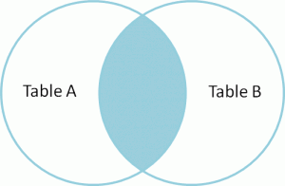**Syntax:**

Select Column_name (s)

From Table1

Inner join table 2

On table 1 column_name = table 2 column_name;

* Table 1: first table
* Table 2: Second table
* Matching Column: Column common to both the tables.

Example:

|  |
| --- |
| Input |
| Select student. std_id, student.std_name, course. Course_id from student inner join course on Student std_id = course. Student_id |

**Result:**

Number of records: 4

|  |  |  |
| --- | --- | --- |
| Std_id | Course_id | Std_name |
| 101 | 1 | Ashwini |
| 102 | 2 | Payal |
| 104 | 4 | Sneha |
| 105 | 4 | Priya |

**Left join**

* The left join is used to retrieve all records from the left table (table 1) and the matched rows or columns from the right table (Table2)
* If both tables do not contain any matched rows or columns, it returns the Null
* Left joins are also known As Left outer Join.

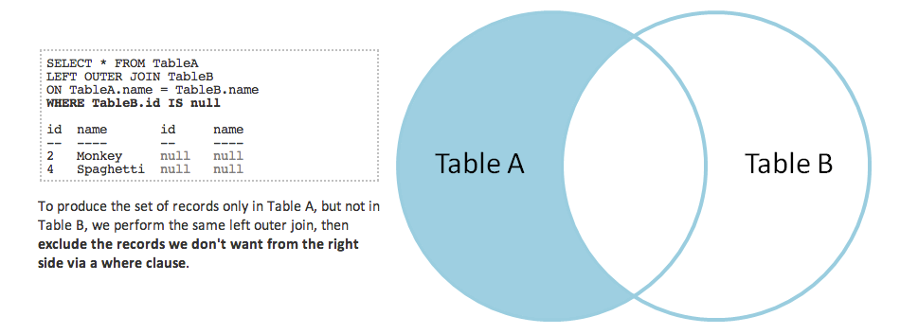

**Syntax**

Select table 1. column, Table 1. column2, table2.column1.

From table 1

Left join table 2

On table 1. matching column = table 2. matching column;

Example:

Input

|  |
| --- |
| Select std_name, course.course_id  From student  Left join course  On course. Student_id = student. Std_id; |

Result:

Number of records 6;

|  |  |
| --- | --- |
| Std_name | Course_id |
| Ashwini | 1 |
| Payal | 2 |
| Sneha | Null |
| Sneha | 4 |
| Priya | 4 |
| Anvay | Null |

**Right Join**

* The SQL right returns All the values from the rows of the tables.
* It also includes the matched values from left tables but if there is no matching in both tables, it returns NULL.
* Right join is also known as right Outer join.

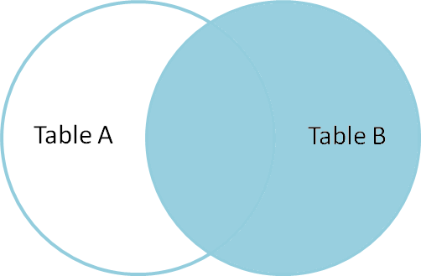

**Syntax:**

Select std_name, Course.Course_id

From Student Right Join Course

ON Student .std_id = Course.Student_id;

**Result:**

Number of Records: 7

|  |  |
| --- | --- |
| Std_name | Course_id |
| Ashwini | 1 |
| Payal | 2 |
| Sneha | 4 |
| Priya | 4 |
| Null | 5 |
| Null | 6 |
| Null | 3 |

**Outer Join**

* Outer join creates the result set by combining both the Left and Right join results.
* The joined tables return all records from both the tables and if no matches are found in the table, it places Null.
* It is also called a full Outer Join.

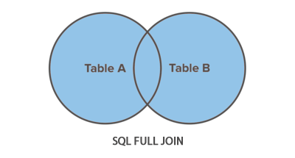

**Syntax:**

Select table.column1, table2.Column2..

From table1

Full Join table2

ON table1.column_field = table2.column_field;

Example: SQL statement:

Select Std_name, course. Course_id

From Course Full Join Student

ON student. std_id = Course. Student_id;

Number of Records = 8

|  |  |
| --- | --- |
| Std_name | Course_id |
| Ashwini | 1 |
| Payal | 2 |
| Sneha | Null |
| Sneha | 4 |
| Anvay | Null |
| Null | 5 |
| Null | 6 |
| Null | 3 |

**Conclusion:**

SQL Join Is a Vital tool for merging data from multiple tables based on Related Columns. They Enable efficient data Analysis and Retrieval. By using various join types like inner join left join, right join, and Outer join you can manipulate and analyze data effectively.

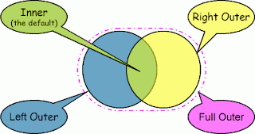

***You got it! Keep on rockin’ on SQL Skills by diving into different join types. the more you practice and explore.***