Part A

What will the following commands do?

1.echo "Hello, World!"

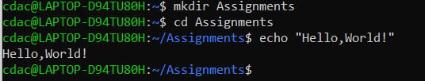

2 name="Productive"



3. touch file.txt

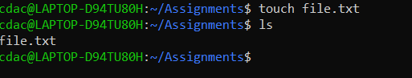

4. ls -a



5. rm file.txt



6. cp file1.txt file2.txt

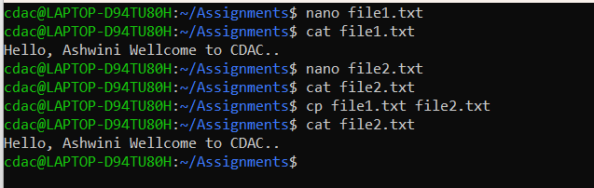

7. mv file.txt /path/to/directory/



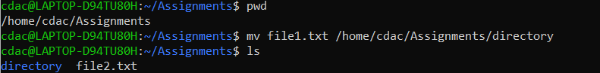

8. chmod 755 script.sh

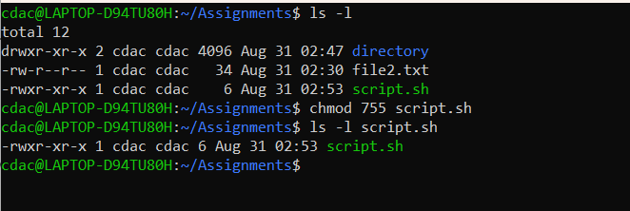

9. grep "pattern" file.txt

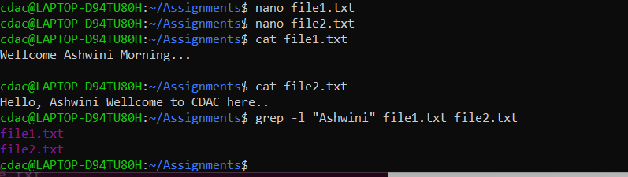

10. kill PID

PID = The `kill` command requires the process ID (PID) of the process we want to terminate.

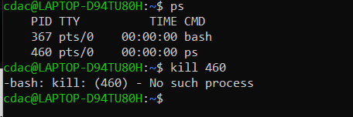

11. mkdir mydir && cd mydir && touch file.txt && echo "Hello, World!" > file.txt && cat file.txt

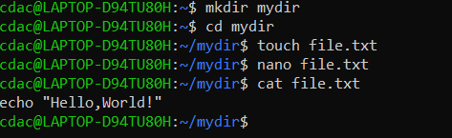

12.ls -l | grep ".txt" 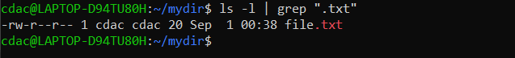

13.cat file1.txt file2.txt | sort | uniq

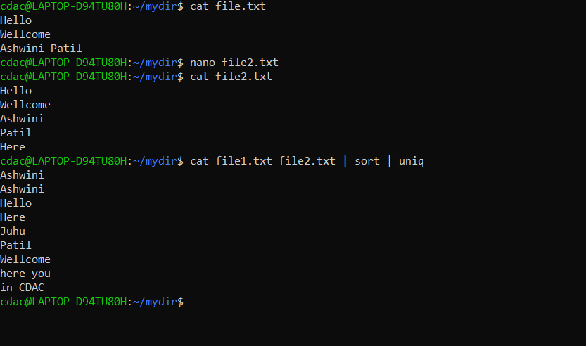

14. ls -l | grep "^d"

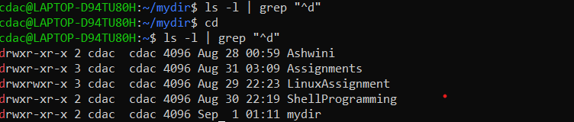

15. grep -r "pattern" /path/to/directory/

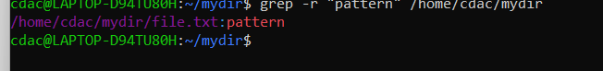

16.cat file1.txt file2.txt | sort | uniq –d

-> The cat command concatenates the contents of file1.txt and file2.txt.

It displays the combined content to the standard output (usually your terminal).

**sort:**

The sort command sorts the lines of text alphabetically.

It takes the combined content from the previous step and arranges it in ascending order.

**uniq**

The uniq command filters out adjacent duplicate lines from sorted input.

It ensures that only unique lines are displayed.

By default, it keeps only the first occurrence of each unique line.

17.chmod 644 file.txt

The numeric value 644 represents the permissions you’re setting for the file

18.cp -r source directory destination directory

cp Command:

The cp command stands for “copy.”

It allows you to copy files and directories.

-r Option (Recursive):

The -r (or -R) option tells cp to copy files and directories recursively.

When you use -r, it copies not only the specified source file or directory but also all its subdirectories and their contents.

19.find /path/to/search -name "*.txt"

Used to find all the file gor given path with “.txt ” extention.

20.chmod u+x file.txt

u+x will assign execute permissions for the user (owner) of the file.

21.echo $PATH

