**Assignment no. 1**

# 1. Reading Assignment: A Short History of Java

* **Task**: Read about the history and development of Java.
* **Link**: <http://sunsite.uakom.sk/sunworldonline/swol-07-1995/swol-07-java.html>
* **Notes**:
  1. Java was created by sun microsystem green team under the project known as green project the mission was to create a distributed systems and they were struggling because of using c/c ++ so there team lead James gosling in mid of 1991 started to develop java but it was called Oak. It didn’t pass the trademark test to named as java.
  2. After that they tried to market java but did not work “*7”.
  3. After that in mid 1994 gosling the though a web browser would be a good idea, so created a browser “Web Runner” also known as “hotjava” and to read java in browser creates “Applet”
  4. After that java became famous.
  5. Now owned by Oracle since 2010. As it was acquired by oracle.

# 2. Reading Assignment: Java Language Features

* **Task**: Learn about the main features of Java.
* **Link**: <https://javaalmanac.io/features/>•
* **Notes:**
  1. java version has been releasing as of jdk 9 with every six months(march and september).With every release new functionality is added for developers to use java for their application.
  2. java first version: Jdk 1
  3. most stable version: Jdk1.8
  4. Jdk with LTS: jdk8,jdk11,jdk17,jdk21

**3. Reading Assignment: Which Version of JDK Should I Use?**

* **Task**: Find out which JDK version is right for you. • **Link**: <https://whichjdk.com/>

**Notes:**

1. Java jdk are offered by many companies other than oracle such as

* + Azul
  + Microsoft
  + Red Hat
  + Temurin

# 4. Reading Assignment: JDK Installation Directory Structure

* **Task**: Understand the folder structure and files in the JDK installation.
* **Link**: <https://docs.oracle.com/javase/8/docs/technotes/tools/windows/jdkfiles.html> **Notes**:
  1. Jdk has many files that are essential for java. Bin folder in java has a rt.jar and jre file which essential for java to run.
  2. rt.jar contains the support files of java so very essential. It contains java support files.
  3. rt.jar & Jvm -----inside-----→Jre(java runtime environment) hence clients only needs jre to run java applications on there system while developer need whole jdk for development.

# 5. Reading Assignment: About Java Technology

* **Task**: Read about the basics of Java technology and its components.
* **Link**: <https://docs.oracle.com/javase/tutorial/getStarted/intro/definition.html>• **Notes**:
  1. Java is a language, a technology as well as a platform.
  2. It is a object oriented as well as procedural and functional programming paradigm.
  3. It is case sensitive, strongly statically type language.
  4. Many editions
     + Java Standard Edition(Java SE)→for standalone programs
     + Java Enterprise Edition(Java EE)→for client and server based applications.
     + Java Micro Edition(Java ME)→for embedded system and old phones.
     + Java FX→For rich GUI
     + Java card→for smart cards and secure IOT devices.
  5. Java flow:

Source file(java)→---compiler---→java.class→---jvm---→ execution.

# 6. Coding Assignments

1. **Hello World Program**: Write a Java program that prints "Hello World!!" to the console. **Program**:

class Program1{

public static void main(String[] args){

System.*out*.println("Hello World!");

}

}

output: Hello World!

1. **Compile with Verbose Option**: Compile your Java file using the -verbose option with javac. Check the output.

-verbose is used to see all the details regarding loading the drivers, softwares necessary for the making a class file.

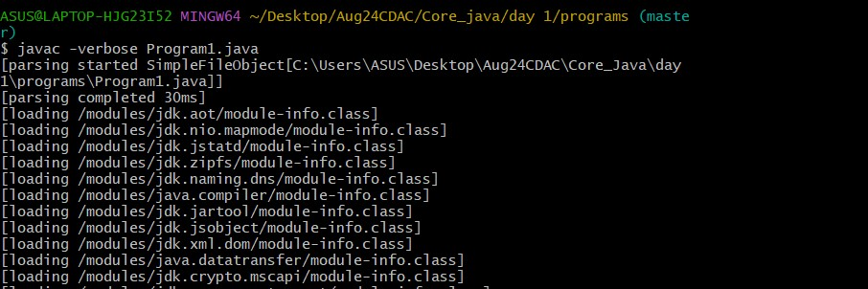

1. **Inspect Bytecode**: Use the javap tool to examine the bytecode of the compiled .class file. Observe the output.

Javap is used to disassemble the class file.

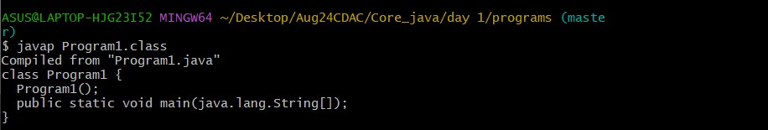

# 7. Reading Assignment: The JVM Architecture Explained

* **Task**: Learn about how the Java Virtual Machine (JVM) works.
* **Link**: <https://dzone.com/articles/jvm-architecture-explained>• **Notes**:
  1. JVM stands for java virtual machine
  2. The tag line “WORA” represents that it works on a virtual machine.

Source file(java)→--compiler--→java.class→--jvm--→loads & execution.

* 1. JVM divided into 3 parts:
* ClassLoader Subsystem: loads, links and initializes class file at runtime
* Runtime Data Area:
  + 1. Method Area
    2. Heap area
    3. Stack area
    4. Pc registers
    5. Native Method Stacks
* Execution engine
  + 1. Interpreter
    2. Jit compiler
    3. Garbage collector

# 8. Reading Assignment: The Java Language Environment: Contents

* **Task**: Explore the content and features of the Java language environment.
* **Link**: <https://www.oracle.com/java/technologies/language-environment.html>
* **Notes**:
  1. Primitive Datatypes
  2. Arithmetic and relational operations
  3. Memory Management and garbage collection
  4. Features removed from c and c++.