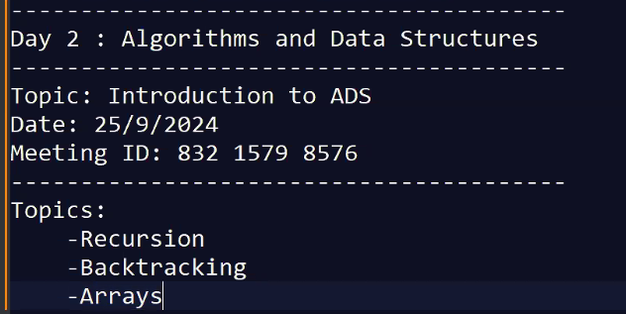

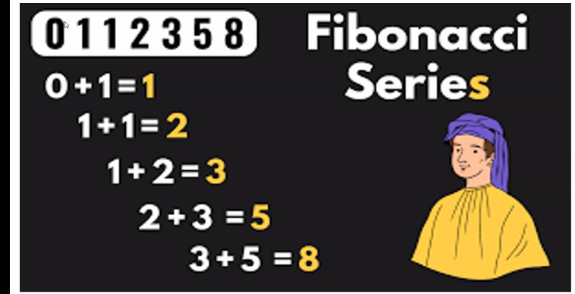

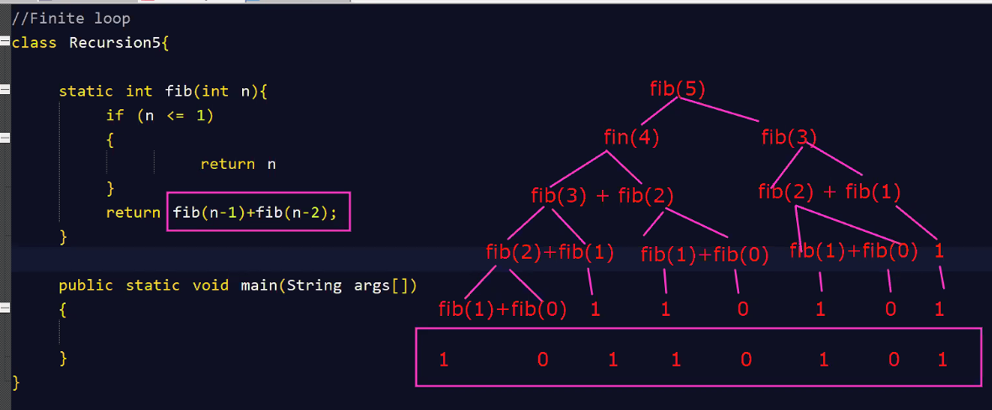

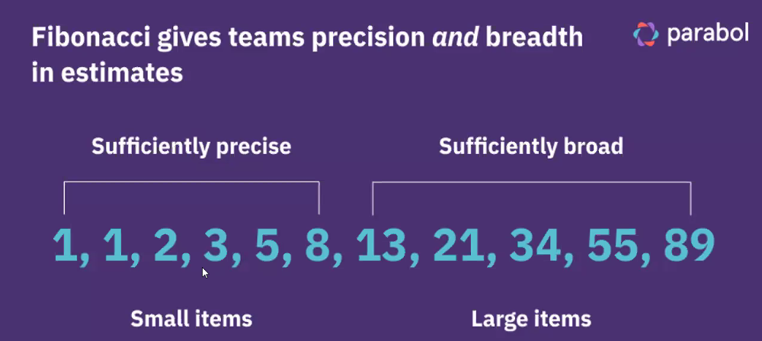

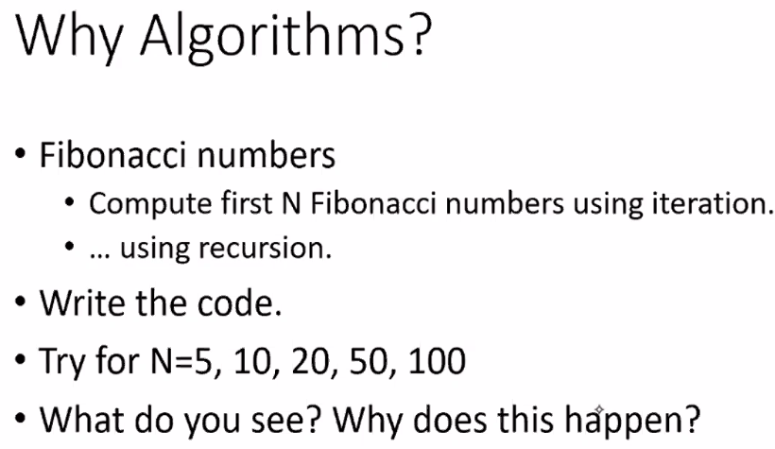

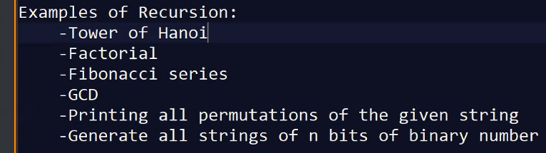

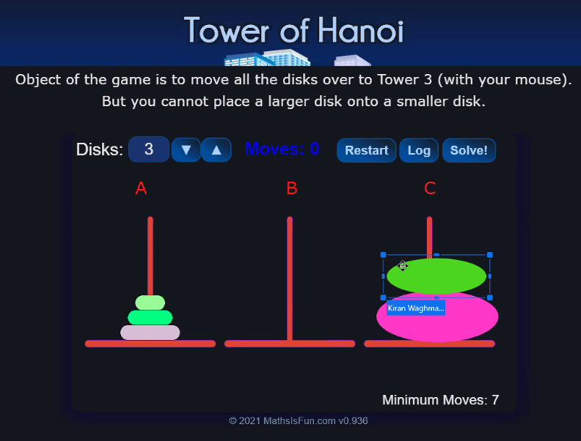

[**https://www.mathsisfun.com/games/towerofhanoi.html**](https://www.mathsisfun.com/games/towerofhanoi.html)

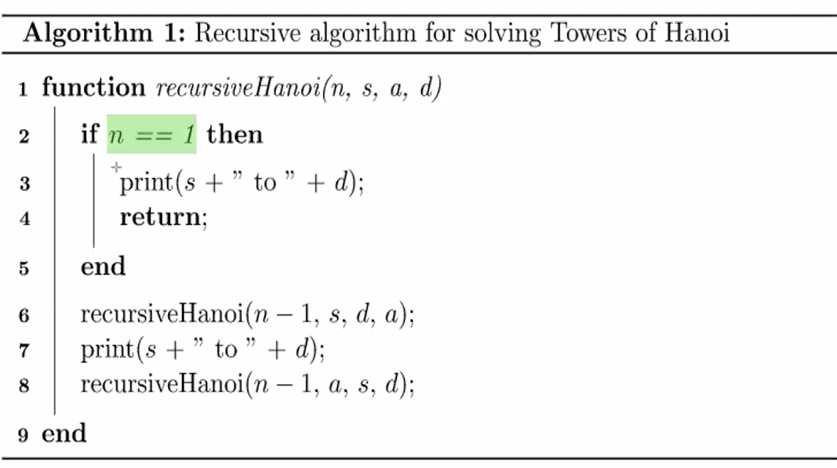

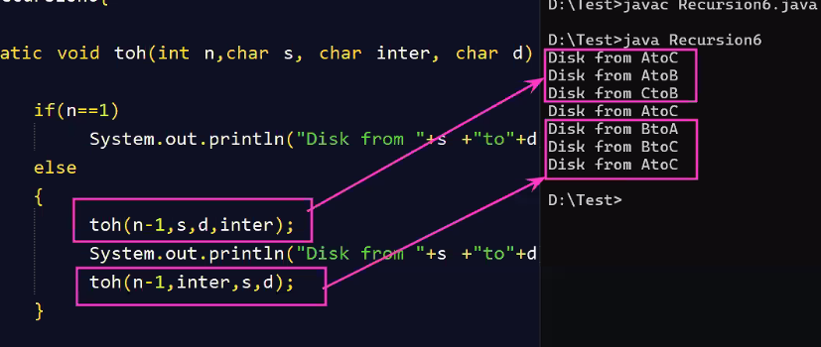

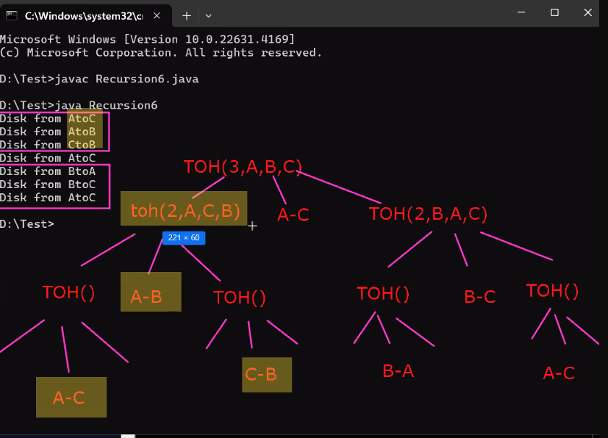

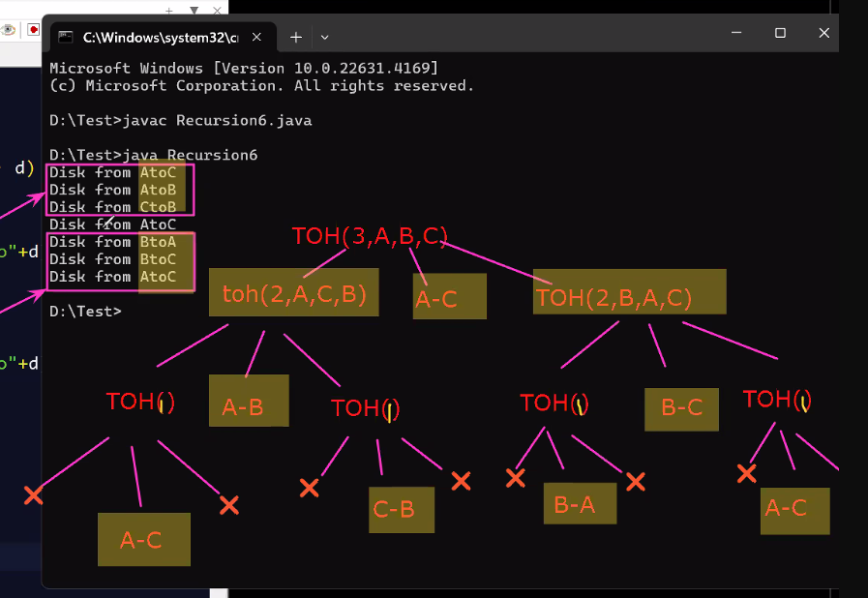

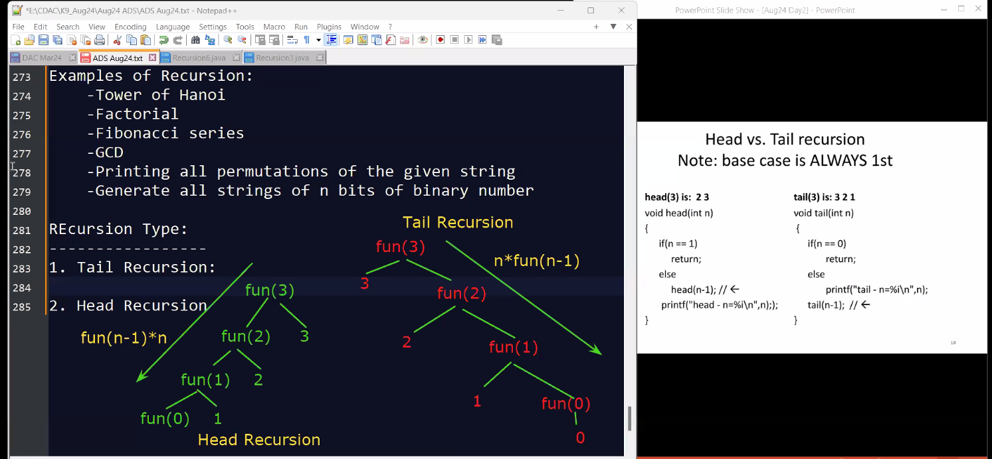

**operation first = tail;   
operation last = head.**

**Type:**

**There are 2 types of recusive call in the function.**

1. **Tail Recursion:**
2. **Head Recursion.**

**When you give recursive call within the function and how the function progresses to the base case is defined in head and tail recursion.**

**Head Recursion:**

* **It is the recursive call made before any other operations or calculations in the function. The Function performs after the recursive call.**

**Tail Recursion:**

* **It is the recursive call made after all the processing in the function. The function performs its operations first, and the recursive call is the last operation performed before returning.**

