Right click in the program -> Run As -> Run configuration

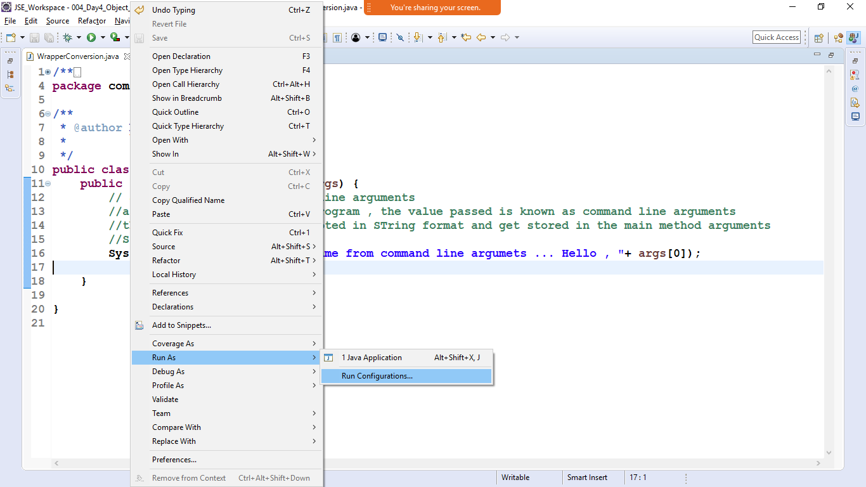

Click on Argument tab

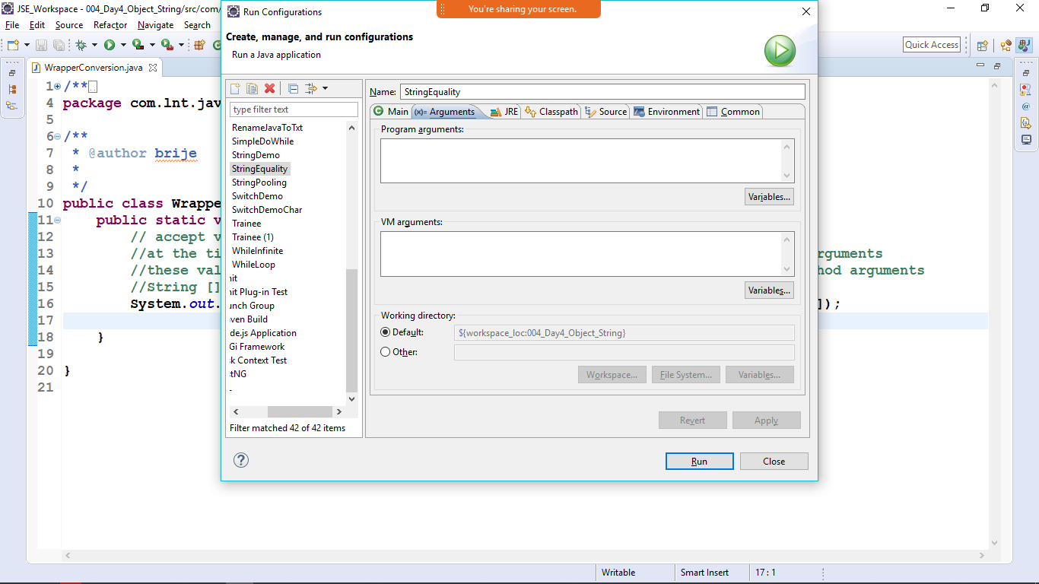

Enter the name in the program Arguments text Area

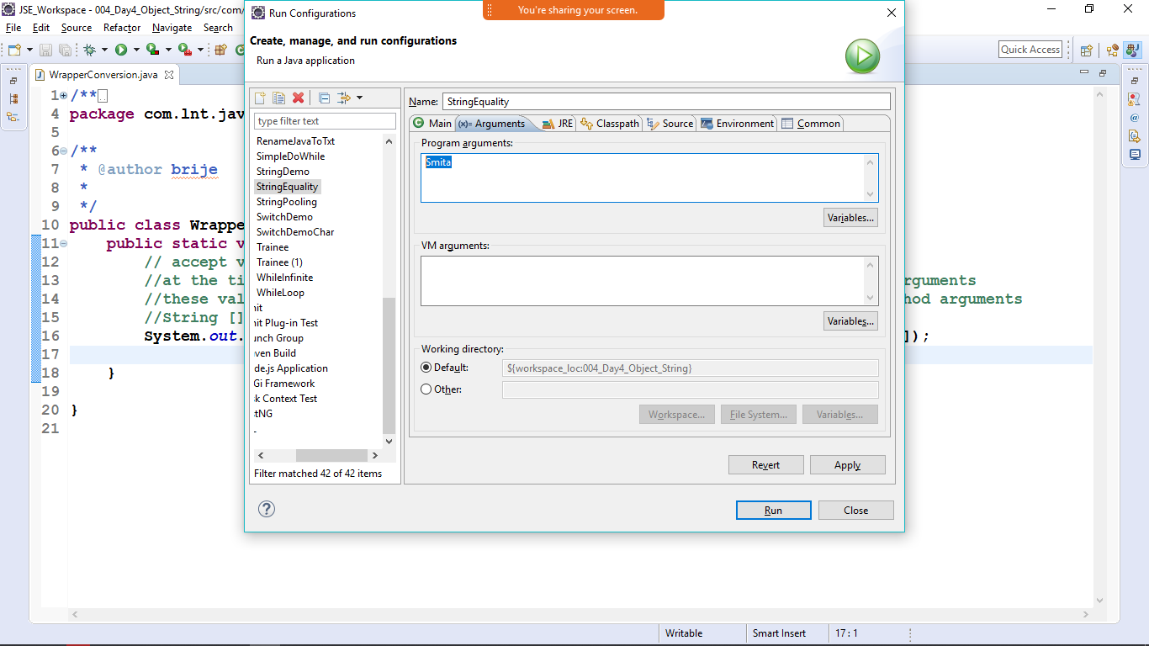hit on run

If you will not pass the command line arguments the it will show you

Exception in thread "main" java.lang.ArrayIndexOutOfBoundsException: 0

Inorder to pass two cmd line args

Separate it with spaces

