Right click in the body of the class -> source -> generate toString() method

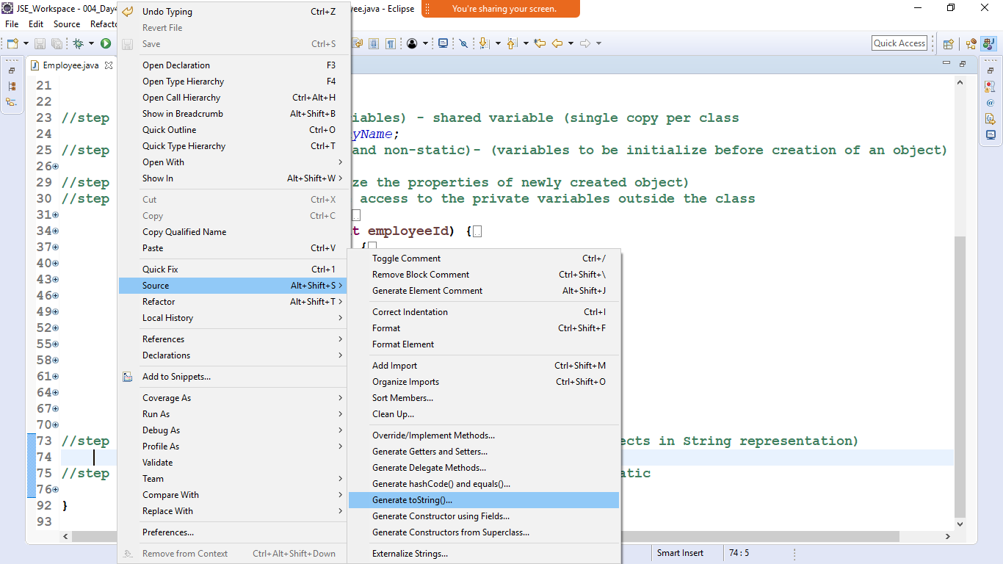

Select all the properties of an object to be returned by toString()

