**What is Maven?**

Maven is an automation and management tool developed by Apache Software Foundation. It was initially released on 13 July 2004. In Yiddish language the meaning of Maven is "accumulator of knowledge".

It is written in Java Language and used to build and manage projects written in C#, Ruby, Scala, and other languages. It allows the developer to create projects using Project Object Model and plugins.

It helps to build projects, dependency, and documentation. Its development process is very similar to ANT. However, it is much advanced than ANT.

Maven is also able to build any number of projects into desired output such as jar, war, metadata.

## How can Maven benefit my development process?

Maven helps the developer to create a java-based project more easily. Accessibility of new feature created or added in Maven can be easily added to a project in Maven configuration. It increases the performance of project and building process.

The main feature of Maven is that it can download the project dependency libraries automatically.

Below are the examples of some popular IDEs supporting development with Maven:

* Eclipse
* IntelliJ IDEA
* JBuilder
* NetBeans
* MyEclipse

## Processes which can manage using maven:

* Builds
* Documentation
* Reporting
* Dependencies
* SCMs
* Releases
* Distribution
* mailing list

## Maven Architecture

Maven Architecture includes plugin jar, code file etc.

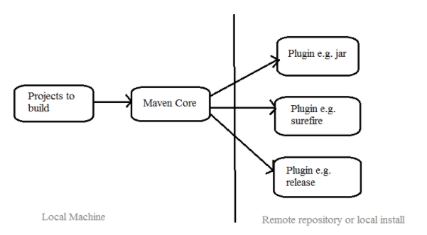

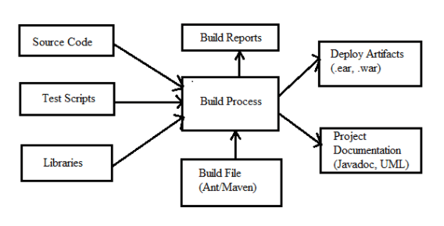

## How to use Maven

* To configure the Maven, you need to use Project Object Model, which is stored in a pom.xml-file.
* POM includes all the configuration setting related to Maven. Plugins can be configured and edit in the <plugins> tag of a pom.xml file. And developer can use any plugin without much detail of each plugin.
* When user start working on Maven, it provides default setting of configuration, so the user does not need to add every configuration in pom.xml

## Steps/process involved in building the project:

* Add / Write the code for application creation and process that into source code repository
* Edit configuration / pom.XML / plugin details
* Build the application
* Save the build process output as WAR or EAR file to a local location or server
* Get the file from local location or server and deploy the file to the production site or
* client site Updated the application document with date and updated version number of the application
* create and generate a report as per the application or requirement.

## Summary:

* Maven is an automation and management tool.
* It is written in Java Language and used to build and manage projects written in C#, Ruby, Scala, and other languages.
* Maven helps the developer to create a java-based project more easily.
* To configure the Maven, you need to use Project Object Model, which is stored in a pom.xml-file.

## What is a Build Tool?

A build tool is a tool that automates everything related to building the software project. Building a software project typically includes one or more of these activities:

* Generating source code (if auto-generated code is used in the project).
* Generating documentation from the source code.
* Compiling source code.
* Packaging compiled code into JAR files or ZIP files.
* Installing the packaged code on a server, in a repository or somewhere else.

Any given software project may have more activities than these needed to build the finished software. Such activities can normally be plugged into a build tool, so these activities can be automated too.

The advantage of automating the build process is that you minimize the risk of humans making errors while building the software manually. Additionally, an automated build tool is typically faster than a human performing the same steps manually.

## Installing Maven

To install Maven on your own system (computer), go to the [**Maven download page**](http://maven.apache.org/download.cgi) and follow the instructions there. In summary, what you need to do is:

1. Set the JAVA_HOME environment variable to point to a valid Java SDK (e.g. Java 8).
2. Download and unzip Maven.
3. Set the M2_HOME environment variable to point to the directory you unzipped Maven to.
4. Set the M2 environment variable to point to M2_HOME/bin (%M2_HOME%\bin on Windows, $M2_HOME/bin on unix).
5. Add M2 to the PATH environment variable (%M2% on Windows, $M2 on unix).
6. Open a command prompt and type 'mvn -version' (without quotes) and press enter.

After typing in the mvn -version command you should be able to see Maven execute, and the version number of Maven written out to the command prompt.

Note: Maven uses Java when executing, so you need Java installed too (and the JAVA_HOME environment variable set as explained above). Maven 3.0.5 needs a Java version 1.5 or later. I use Maven 3.3.3 with Java 8 (u45).

I have a tutorial about [**installing the Java SDK**](http://tutorials.jenkov.com/java/installing-java-sdk.html) in case you are not familiar with that. Remember, it has to be an SDK (Software Developer Kit), not just a JRE (Java Runtime Environment). The JRE does not contain a Java compiler. Only the SDK does.

## Maven Overview - Core Concepts

Maven is centered around the concept of POM files (Project Object Model). A POM file is an XML representation of project resources like source code, test code, dependencies (external JARs used) etc. The POM contains references to all of these resources. The POM file should be located in the root directory of the project it belongs to.

Here is a diagram illustrating how Maven uses the POM file, and what the POM file primarily contains:

|  |
| --- |
| Overview of Maven core concepts. |
| **Overview of Maven core concepts.** |

These concepts are explained briefly below to give you an overview, and then in more detail in their own sections later in this tutorial.

**POM Files**  
When you execute a Maven command you give Maven a POM file to execute the commands on. Maven will then execute the command on the resources described in the POM.

**Build Life Cycles, Phases and Goals**  
The build process in Maven is split up into build life cycles, phases and goals. A build life cycle consists of a sequence of build phases, and each build phase consists of a sequence of goals. When you run Maven you pass a command to Maven. This command is the name of a build life cycle, phase or goal. If a life cycle is requested executed, all build phases in that life cycle are executed. If a build phase is requested executed, all build phases before it in the pre-defined sequence of build phases are executed too.

**Dependencies and Repositories**  
One of the first goals Maven executes is to check the dependencies needed by your project. Dependencies are external JAR files (Java libraries) that your project uses. If the dependencies are not found in the local Maven repository, Maven downloads them from a central Maven repository and puts them in your local repository. The local repository is just a directory on your computer's hard disk. You can specify where the local repository should be located if you want to (I do). You can also specify which remote repository to use for downloading dependencies. All this will be explained in more detail later in this tutorial.

**Build Plugins**  
Build plugins are used to insert extra goals into a build phase. If you need to perform a set of actions for your project which are not covered by the standard Maven build phases and goals, you can add a plugin to the POM file. Maven has some standard plugins you can use, and you can also implement your own in Java if you need to.

**Build Profiles**  
Build profiles are used if you need to build your project in different ways. For instance, you may need to build your project for your local computer, for development and test. And you may need to build it for deployment on your production environment. These two builds may be different. To enable different builds you can add different build profiles to your POM files. When executing Maven you can tell which build profile to use.

## Maven vs. Ant

Ant is another popular build tool by Apache. If you are used to Ant and you are trying to learn Maven, you will notice a difference in the approach of the two projects.

Ant uses an imperative approach, meaning you specify in the Ant build file what actions Ant should take. You can specify low level actions like copying files, compiling code etc. You specify the actions, and you also specify the sequence in which they are carried out. Ant has no default directory layout.

Maven uses a more declarative approach, meaning that you specify in the Maven POM file *what* to build, but not *how* to build it. The POM file describes your project resources - not how to build it. Contrarily, an Ant file describes how to build your project. In Maven, how to build your project is predefined in the [**Maven Build Life Cycles, Phases and Goals**](http://tutorials.jenkov.com/maven/maven-tutorial.html#maven-build-life-cycles-phases-and-goals).

## Maven POM Files

A Maven POM file (Project Object Model) is an XML file that describe the resources of the project. This includes the directories where the source code, test source etc. is located in, what external dependencies (JAR files) your projects has etc.

The POM file describes *what* to build, but most often not *how* to build it. How to build it is up to the Maven build phases and goals. You can insert custom actions (goals) into the Maven build phase if you need to, though.

Each project has a POM file. The POM file is named pom.xml and should be located in the root directory of your project. A project divided into subprojects will typically have one POM file for the parent project, and one POM file for each subproject. This structure allows both the total project to be built in one step, or any of the subprojects to be built separately.

Throughout the rest of this section I will describe the most important parts of the POM file. For a full reference of the POM file, see the [**Maven POM Reference**](http://maven.apache.org/pom.html).

Here is a minimal POM file:

<project xmlns="http://maven.apache.org/POM/4.0.0"

xmlns:xsi="http://www.w3.org/2001/XMLSchema-instance"

xsi:schemaLocation="http://maven.apache.org/POM/4.0.0

http://maven.apache.org/xsd/maven-4.0.0.xsd">

<modelVersion>4.0.0</modelVersion>

<groupId>com.lnt</groupId>

<artifactId>023_Maven_Project</artifactId>

<version>1.0.0</version>

</project>

The modelVersion element sets what version of the POM model you are using. Use the one matching the Maven version you are using. Version 4.0.0 matches Maven version 2 and 3.

The groupId element is a unique ID for an organization, or a project (an open source project, for instance). Most often you will use a group ID which is similar to the root Java package name of the project. For instance, for my Java Web Crawler project I may choose the group ID com.lnt. If the project was an open source project with many independent contributors, perhaps it would make more sense to use a group ID related to the project than an a group ID related to my company. Thus, com.javawebcrawler could be used.

The group ID does not have to be a Java package name, and does not need to use the . notation (dot notation) for separating words in the ID. But, if you do, the project will be located in the Maven repository under a directory structure matching the group ID. Each . is replaced with a directory separator, and each word thus represents a directory. The group ID com.lnt would then be located in a directory called MAVEN_REPO/com/lnt. The MAVEN_REPO part of the directory name will be replaced with the directory path of the Maven repository.

The artifactId element contains the name of the project you are building. In the case of my Java Web Crawler project, the artifact ID would be 023_Maven_Proeject. The artifact ID is used as name for a subdirectory under the group ID directory in the Maven repository. The artifact ID is also used as part of the name of the JAR file produced when building the project. The output of the build process, the build result that is, is called an artifact in Maven. Most often it is a JAR, WAR or EAR file, but it could also be something else.

The versionId element contains the version number of the project. If your project has been released in different versions, for instance an open source API, then it is useful to version the builds. That way users of your project can refer to a specific version of your project. The version number is used as a name for a subdirectory under the artifact ID directory. The version number is also used as part of the name of the artifact built.

The above groupId, artifactId and version elements would result in a JAR file being built and put into the local Maven repository at the following path (directory and file name):

MAVEN_REPO/com/lnt/023_Maven_Proeject/1.0.0/023_Maven_Proeject-1.0.0.jar

If your project uses the [**Maven directory structure**](http://tutorials.jenkov.com/maven/maven-tutorial.html#maven-directory-structure), and your project has no external dependencies, then the above minimal POM file is all you need to build your project.

If your project does not follow the standard directory structure, has external dependencies, or need special actions during building, you will need to add more elements to the POM file. These elements are listed in the Maven POM reference (see link above).

In general you can specify a lot of things in the POM which gives Maven more details about how to build your projects. See the Maven POM reference for more information about what can be specified.

### Super POM

All Maven POM files inherit from a super POM. If no super POM is specified, the POM file inherits from the base POM. Here is a diagram illustrating that:

|  |
| --- |
| Super POM and POM inheritance. |
| **Super POM and POM inheritance.** |

You can make a POM file explicitly inherit from another POM file. That way you can change the settings across all inheriting POM's via their common super POM. You specify the super POM at the top of a POM file like this:

<project xmlns="http://maven.apache.org/POM/4.0.0"

xmlns:xsi="http://www.w3.org/2001/XMLSchema-instance"

xsi:schemaLocation="http://maven.apache.org/POM/4.0.0

http://maven.apache.org/xsd/maven-4.0.0.xsd">

<modelVersion>4.0.0</modelVersion>

**<parent>**

**<groupId>org.codehaus.mojo</groupId>**

**<artifactId>my-parent</artifactId>**

**<version>2.0</version>**

**<relativePath>../my-parent</relativePath>**

**</parent>**

<artifactId>my-project</artifactId>

...

</project>

An inheriting POM file may override settings from a super POM. Just specify new settings in the inheriting POM file.

POM inheritance is also covered in more detail in the Maven POM reference.

### Effective POM

With all this POM inheritance it may be hard to know what the total POM file looks like when Maven executes. The total POM file (result of all inheritance) is called the *effective POM*. You can get Maven to show you the effective POM using this command:

mvn help:effective-pom

This command will make Maven write out the effective POM to the command line prompt.

## Maven Settings File

Maven has two settings files. In the settings files you can configure settings for Maven across all Maven POM files. For instance, you can configure:

* Location of local repository
* Active build profile
* Etc.

The settings files are called settings.xml. The two settings files are located at:

* The Maven installation directory: $M2_HOME/conf/settings.xml
* The user's home directory: ${user.home}/.m2/settings.xml

Both files are optional. If both files are present, the values in the user home settings file overrides the values in the Maven installation settings file.

You can read more about the Maven settings files in the [**Maven Settings Reference**](http://maven.apache.org/settings.html).

## Running Maven

When you have [**installed Maven**](http://tutorials.jenkov.com/maven/maven-tutorial.html#installing-maven) and have created a [**POM file**](http://tutorials.jenkov.com/maven/maven-tutorial.html#maven-pom-files) and put the POM file in the root directory of your project, you can run Maven on your project.

Running Maven is done by executing the mvn command from a command prompt. When executing the mvn command you pass the name of a **build life cycle, phase or goal** to it, which Maven then executes. Here is an example:

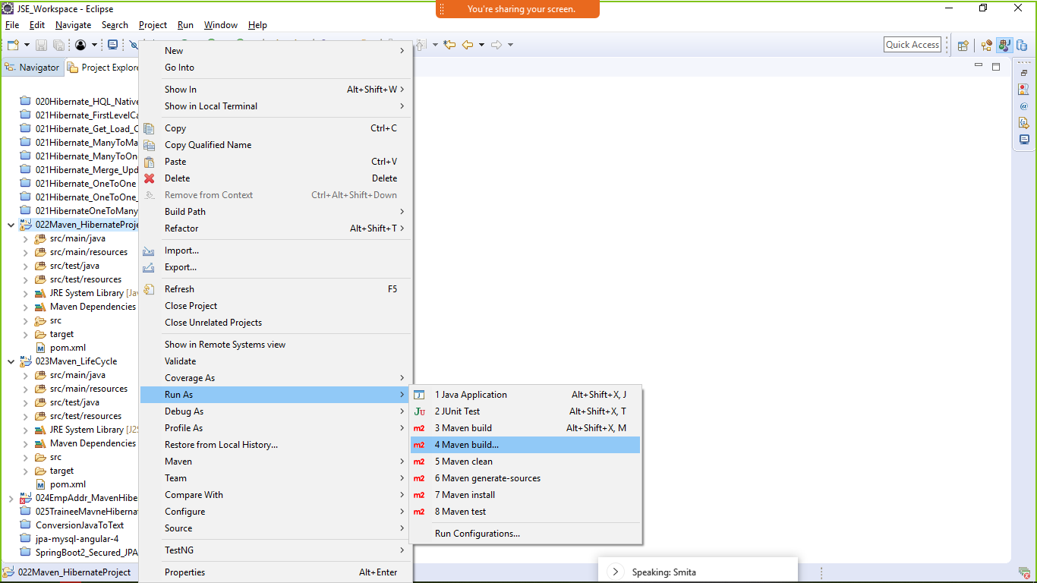

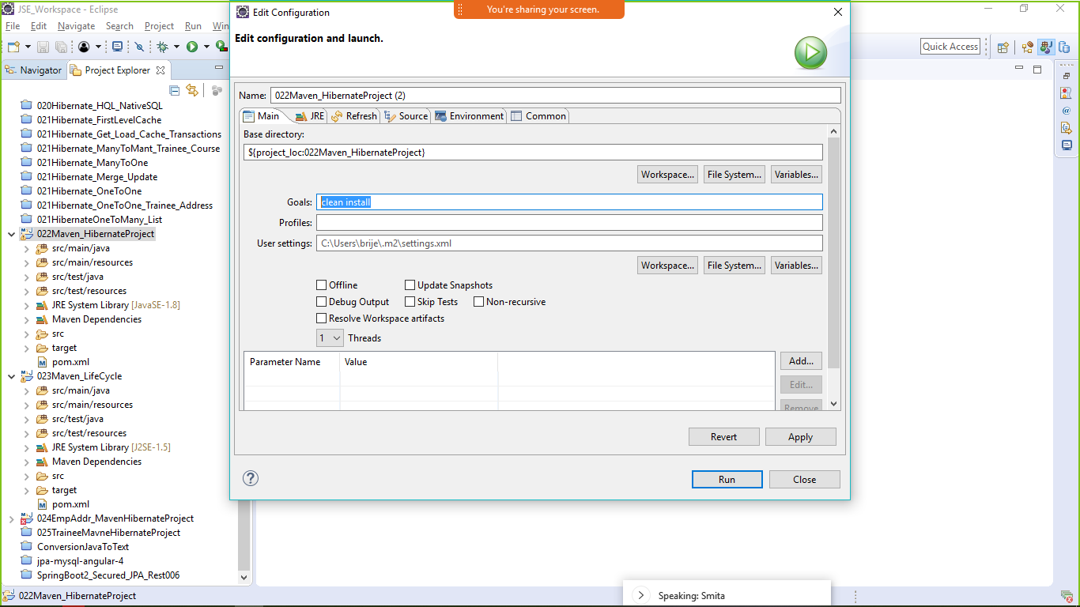

mvn install

This command executes the build phase called install (part of the default build life cycle), which builds the project and copies the packaged JAR file into the local Maven repository. Actually, this command executes all build phases before install in the build phase sequence, before executing the install build phase.

You can execute multiple build life cycles or phases by passing more than one argument to the mvn command. Here is an example:

mvn clean install

This command first executes the clean build life cycle, which removes compiled classes from the Maven output directory, and then it executes the install build phase.

You can also execute a Maven goal (a subpart of a build phase) by passing the build phase and goal name concatenated with a : in between, as parameter to the Maven command. Here is an example:

mvn dependency:copy-dependencies

This command executes the copy-dependencies goal of the dependency build phase.

## Maven Directory Structure

Maven has a standard directory structure. If you follow that directory structure for your project, you do not need to specify the directories of your source code, test code etc. in your POM file.

You can see the full directory layout in the **Introduction to the Maven Standard Directory Layout**.

Here are the most important directories:

- src

- main

- java

- resources

- webapp

- test

- java

- resources

- target

The src directory is the root directory of your source code and test code. The main directory is the root directory for source code related to the application itself (not test code). The test directory contains the test source code. The java directories under main and test contains the Java code for the application itself (under main) and the Java code for the tests (under test).

The resources directory contains other resources needed by your project. This could be property files used for internationalization of an application, or something else.

The webapp directory contains your Java web application, if your project is a web application. The webappdirectory will then be the root directory of the web application. Thus the webapp directory contains the WEB-INF directory etc.

The target directory is created by Maven. It contains all the compiled classes, JAR files etc. produced by Maven. When executing the clean build phase, it is the target directory which is cleaned.

## Project Dependencies

Unless your project is small, your project may need external Java APIs or frameworks which are packaged in their own JAR files. These JAR files are needed on the classpath when you compile your project code.

Keeping your project up-to-date with the correct versions of these external JAR files can be a comprehensive task. Each external JAR may again also need other external JAR files etc. Downloading all these external dependencies (JAR files) recursively and making sure that the right versions are downloaded is cumbersome. Especially when your project grows big, and you get more and more external dependencies.

Luckily, Maven has built-in dependency management. You specify in the POM file what external libraries your project depends on, and which version, and then Maven downloads them for you and puts them in your local Maven repository. If any of these external libraries need other libraries, then these other libraries are also downloaded into your local Maven repository.

You specify your project dependencies inside the dependencies element in the POM file. Here is an example:

<project xmlns="http://maven.apache.org/POM/4.0.0"

xmlns:xsi="http://www.w3.org/2001/XMLSchema-instance"

xsi:schemaLocation="http://maven.apache.org/POM/4.0.0

http://maven.apache.org/xsd/maven-4.0.0.xsd">

<modelVersion>4.0.0</modelVersion>

<groupId>com.lnt.crawler</groupId>

<artifactId>023_Maven_Proeject</artifactId>

<version>1.0.0</version>

**<dependencies>**

**<dependency>**

**<groupId>org.jsoup</groupId>**

**<artifactId>jsoup</artifactId>**

**<version>1.7.1</version>**

**</dependency>**

**<dependency>**

**<groupId>junit</groupId>**

**<artifactId>junit</artifactId>**

**<version>4.8.1</version>**

**<scope>test</scope>**

**</dependency>**

**</dependencies>**

<build>

</build>

</project>

Notice the dependencies element in bold. Inside it are two dependency elements. Each dependencyelement describes an external dependency.

Each dependency is described by its groupId, artifactId and version. You may remember that this is also how you identified your own project in the beginning of the POM file. The example above needs the org.jsoup group's jsoup artifact in version 1.7.1, and the junit group's junit artifact in version 4.8.1.

When this POM file is executed by Maven, the two dependencies will be downloaded from a central Maven repository and put into your local Maven repository. If the dependencies are already found in your local repository, Maven will not download them. Only if the dependencies are missing will they be downloaded into your local repository.

Sometimes a given dependency is not available in the central Maven repository. You can then download the dependency yourself and put it into your local Maven repository. Remember to put it into a subdirectory structure matching the groupId, artifactId and version. Replace all dots (.) with / and separate the groupId, artifactId and version with / too. Then you have your subdirectory structure.

The two dependencies downloaded by the example above will be put into the following subdirectories:

MAVEN_REPOSITORY_ROOT/junit/junit/4.8.1

MAVEN_REPOSITORY_ROOT/org/jsoup/jsoup/1.7.1

### External Dependencies

An external dependency in Maven is a dependency (JAR file) which is not located in a Maven repository (neiterh local, central or remote repository). It may be located somewhere on your local hard disk, for instance in the lib directory of a webapp, or somewhere else. The word "external" thus means external to the Maven repository system - not just external to the project. Most dependencies are external to the project, but few are external to the repository system (not located in a repository).

You configure an external dependency like this:

<dependency>

<groupId>mydependency</groupId>

<artifactId>mydependency</artifactId>

<scope>system</scope>

<version>1.0</version>

<systemPath>${basedir}\war\WEB-INF\lib\mydependency.jar</systemPath>

</dependency>

The groupId and artifactId are both set to the name of the dependency. The name of the API used, that is. The scope element value is set to system. The systemPath element is set to point to the location of the JAR file containing the dependency. The ${basedir} points to the directory where the POM is located. The rest of the path is relative from that directory.

### Snapshot Dependencies

Snapshot dependencies are dependencies (JAR files) which are under development. Instead of constantly updating the version numbers to get the latest version, you can depend on a snapshot version of the project. Snapshot versions are always downloaded into your local repository for every build, even if a matching snapshot version is already located in your local repository. Always downloading the snapshot dependencies assures that you always have the latest version in your local repository, for every build.

You can tell Maven that your project is a snapshot version simply by appending -SNAPSHOT to the version number in the beginning of the POM (where you also set the groupId and artifactId). Here is a version element example:

<version>1.0-SNAPSHOT</version>

Notice the -SNAPSHOT appended to the version number.

Depending on a snapshot version is also done by appending the -SNAPSHOT after the version number when configuring dependencies. Here is an example:

<dependency>

<groupId>com.lnt</groupId>

<artifactId>023_Maven_Proeject</artifactId>

**<version>1.0-SNAPSHOT</version>**

</dependency>

The -SNAPSHOT appended to the version number tells Maven that this is a snapshot version.

## Maven Repositories

Maven repositories are directories of packaged JAR files with extra meta data. The meta data are POM files describing the projects each packaged JAR file belongs to, including what external dependencies each packaged JAR has. It is this meta data that enables Maven to download dependencies of your dependencies recursively, until the whole tree of dependencies is download and put into your local repository.

Maven has three types of repository:

* Local repository
* Central repository
* Remote repository

Maven searches these repositories for dependencies in the above sequence. First in the local repository, then in the central repository, and third in remote repositories if specified in the POM.

Here is a diagram illustrating the three repository types and their location:

|  |
| --- |
| Maven Repository Types and Location. |
| **Maven Repository Types and Location.** |

**Local Repository**  
A local repository is a directory on the developer's computer. This repository will contain all the dependencies Maven downloads. The same Maven repository is typically used for several different projects. Thus Maven only needs to download the dependencies once, even if multiple projects depends on them (e.g. Junit).

Your own projects can also be built and installed in your local repository, using the mvn installcommand. That way your other projects can use the packaged JAR files of your own projects as external dependencies by specifying them as external dependencies inside their Maven POM files.

By default Maven puts your local repository inside your user home directory on your local computer. However, you can change the location of the local repository by setting the directory inside your Maven settings file. Your Maven settings file is also located in your user-home/.m2 directory and is called settings.xml. Here is how you specify another location for your local repository:

<settings>

<localRepository>

d:\data\java\products\maven\repository

</localRepository>

</settings>

**Central Repository**

The central Maven repository is a repository provided by the Maven community. By default Maven looks in this central repository for any dependencies needed but not found in your local repository. Maven then downloads these dependencies into your local repository. You need no special configuration to access the central repository.

**Remote Repository**  
A remote repository is a repository on a web server from which Maven can download dependencies, just like the central repository. A remote repository can be located anywhere on the internet, or inside a local network.

A remote repository is often used for hosting projects internal to your organization, which are shared by multiple projects. For instance, a common security project might be used across multiple internal projects. This security project should not be accessible to the outside world, and should thus not be hosted in the public, central Maven repository. Instead it can be hosted in an internal remote repository.

Dependencies found in a remote repository are also downloaded and put into your local repository by Maven.

You can configure a remote repository in the POM file. Put the following XML elements right after the <dependencies> element:

<repositories>

<repository>

<id>lnt.code</id>

<url>http://maven.lnt.com/maven2/lib</url>

</repository>

</repositories>

## Maven Build Life Cycles, Phases and Goals

When Maven builds a software project it follows a build life cycle. The build life cycle is divided into build phases, and the build phases are divided into build goals. Maven build life cycles, build phases and goals are described in more detail in the **Maven Introduction to Build Phases**, but here I will give you a quick overview.

**Build Life Cycles**  
Maven has 3 built-in build life cycles. These are:

1. default
2. clean
3. site

Each of these build life cycles takes care of a different aspect of building a software project. Thus, each of these build life cycles are executed independently of each other. You can get Maven to execute more than one build life cycle, but they will be executed in sequence, separately from each other, as if you had executed two separate Maven commands.

The default life cycle handles everything related to compiling and packaging your project. The clean life cycle handles everything related to removing temporary files from the output directory, including generated source files, compiled classes, previous JAR files etc. The site life cycle handles everything related to generating documentation for your project. In fact, site can generate a complete website with documentation for your project.

**Build Phases**  
Each build life cycle is divided into a sequence of build phases, and the build phases are again subdivided into goals. Thus, the total build process is a sequence of build life cycle(s), build phases and goals.

You can execute either a whole build life cycle like clean or site, a build phase like install which is part of the default build life cycle, or a build goal like dependency:copy-dependencies. Note: You cannot execute the default life cycle directly. You have to specify a build phase or goal inside the default life cycle.

When you execute a build phase, all build phases before that build phase in this standard phase sequence are executed. Thus, executing the install build phase really means executing all build phases before the install phase, and then execute the install phase after that.

The default life cycle is of most interest since that is what builds the code. Since you cannot execute the default life cycle directly, you need to execute a build phase or goal from the default life cycle. The default life cycle has an extensive sequence of build phases and goals, ,so I will not describe them all here. The most commonly used build phases are:

|  |  |
| --- | --- |
| Build Phase | Description |
| validate | Validates that the project is correct and all necessary information is available. This also makes sure the dependencies are downloaded. |
| compile | Compiles the source code of the project. |
| test | Runs the tests against the compiled source code using a suitable unit testing framework. These tests should not require the code be packaged or deployed. |
| package | Packs the compiled code in its distributable format, such as a JAR. |
| install | Install the package into the local repository, for use as a dependency in other projects locally. |
| deploy | Copies the final package to the remote repository for sharing with other developers and projects. |

You execute one of these build phases by passing its name to the mvn command. Here is an example:

mvn package

This example executes the package build phase, and thus also all build phases before it in Maven's predefined build phase sequence.

If the standard Maven build phases and goals are not enough to build your project, you can create [**Maven plugins**](http://tutorials.jenkov.com/maven/maven-tutorial.html#maven-plugins) to add the extra build functionality you need.

**Build Goals**  
Build goals are the finest steps in the Maven build process. A goal can be bound to one or more build phases, or to none at all. If a goal is not bound to any build phase, you can only execute it by passing the goals name to the mvn command. If a goal is bound to multiple build phases, that goal will get executed during each of the build phases it is bound to.

## Maven Build Profiles

Maven build profiles enable you to build your project using different configurations. Instead of creating two separate POM files, you can just specify a profile with the different build configuration, and build your project with this build profile when needed.

You can read the full story about build profiles in the Maven POM reference under **Profiles**. Here I will give you a quick overview though.

Maven build profiles are specified inside the POM file, inside the profiles element. Each build profile is nested inside a profile element. Here is an example:

<project xmlns="http://maven.apache.org/POM/4.0.0"

xmlns:xsi="http://www.w3.org/2001/XMLSchema-instance"

xsi:schemaLocation="http://maven.apache.org/POM/4.0.0

http://maven.apache.org/xsd/maven-4.0.0.xsd">

<modelVersion>4.0.0</modelVersion>

<groupId>com.lnt.crawler</groupId>

<artifactId>023_Maven_Proeject</artifactId>

<version>1.0.0</version>

<profiles>

<profile>

<id>test</id>

<activation>...</activation>

<build>...</build>

<modules>...</modules>

<repositories>...</repositories>

<pluginRepositories>...</pluginRepositories>

<dependencies>...</dependencies>

<reporting>...</reporting>

<dependencyManagement>...</dependencyManagement>

<distributionManagement>...</distributionManagement>

</profile>

</profiles>

</project>

A build profile describes what changes should be made to the POM file when executing under that build profile. This could be changing the applications configuration file to use etc. The elements inside the profile element will override the values of the elements with the same name further up in the POM.

Inside the profile element you can see a activation element. This element describes the condition that triggers this build profile to be used. One way to choose what profile is being executed is in the settings.xml file. There you can set the active profile. Another way is to add -P profile-name to the Maven command line. See the profile documentation for more information.

## Maven Plugins

Maven plugins enable you to add your own actions to the build process. You do so by creating a simple Java class that extends a special Maven class, and then create a POM for the project. The plugin should be located in its own project.

To keep this tutorial short, I will refer to the **Maven Plugin Developers Centre** for more information about developing plugins.

## Maven Command Structure

A Maven command consists of two elements:

* mvn
* One or more build life cycles, build phases or build goals

Here is a Maven command example:

mvn clean

This command consists of the mvn command which executes Maven, and the build life cycle namedclean.

Here is another Maven command example:

mvn clean install

This maven command executes the clean build life cycle and the install build phase in the defaultbuild life cycle.

You might wonder how you see the difference between a build life cycle, build phase and build goal. I will get back to that later.

## Build Life Cycles, Phases and Goals

As mentioned in the introduction in the section about **Build life cycles, build phases and build goals**, Maven contains three major build life cycles:

* clean
* default
* site

Inside each build life cycle there are build phases, and inside each build phase there are build goals.

You can execute either a build life cycle, build phase or build goal. When executing a build life cycle you execute all build phases (and thus build goals) inside that build life cycle.

When executing a build phase you execute all build goals within that build phase. Maven also executes all build phases earlier in the build life cycle of the desired build phase.

Buid goals are assigned to one or more buid phases. When the build phases are executed, so are all the goals in that build phase. You can also execute a build goal directly.

## Executing Build Life Cycles, Phases and Goals

When you run the mvn command you pass one or more arguments to it. These arguments specify either a build life cycle, build phase or build goal. For instance to execute the clean build life cycle you execute this command:

mvn clean

To execute the site build life cycle you execute this command:

mvn site

### Executing the Default Life Cycle

The default life cycle is the build life cycle which generates, compiles, packages etc. your source code.

You cannot execute the default build life cycle directly, as is possible with the clean and site. Instead you have to execute a specific build phase within the default build life cycle.

The most commonly used build phases in the default build life cycle are:

|  |  |
| --- | --- |
| Build Phase | Description |
| validate | Validates that the project is correct and all necessary information is available. This also makes sure the dependencies are downloaded. |
| compile | Compiles the source code of the project. |
| test | Runs the tests against the compiled source code using a suitable unit testing framework. These tests should not require the code be packaged or deployed. |
| package | Packs the compiled code in its distributable format, such as a JAR. |
| install | Install the package into the local repository, for use as a dependency in other projects locally. |
| deploy | Copies the final package to the remote repository for sharing with other developers and projects. |

Executing one of these build phases is done by simply adding the build phase after the mvn command, like this:

mvn compile

This example Maven command executes the compile build phase of the default build life cycle. This Maven command also executes all earlier build phases in the default build life cycle, meaning the validate build phase.

### Executing Build Phases

You can execute a build phase located inside a build life cycle by passing the name of the build phase to the Maven command. Here are a few build phase command examples:

mvn pre-clean

mvn compile

mvn package

Maven will find out what build life cycle the specified build phase belongs to, so you don't need to explicitly specify which build life cyle the build phase belongs to.

The default Java compiler version used by Maven is Java 1.5 . Why that is still the default Java compiler version is a good question, since Java 5 was released in 2004. To make Maven compile your Java code with a newer version of the Java compiler, you need to specify the Java compiler explicitly in your project's POM file (pom.xml).

There are two ways to set the Java compiler version in a Maven POM file:

1. Via the Maven Java compiler properties.
2. Via the Maven Java compiler plugin.

Both of these methods to set the Java compiler version in Maven will be explained in the following sections.

**Maven Java Compiler Properties**

The first, newest and easiest way to set the Java compiler version in your Maven POM file, is via the Maven Java compiler properties. Here is how the Maven Java compiler properties look:

<properties>

<maven.compiler.target>1.8</maven.compiler.target>

<maven.compiler.source>1.8</maven.compiler.source>

</properties>

These properties have to be included in the properties element of your POM file. I usually have the properties element as the last element in my POM files.

**Maven Java Compiler Plugin**

The second, oldest, and more verbose to set the Java compiler version in your Maven POM files, is via the Maven Java compiler plugin. Here is how the configuration of the Maven Java compiler plugin looks:

<build>

<plugins>

<plugin>

<groupId>org.apache.maven.plugins</groupId>

<artifactId>maven-compiler-plugin</artifactId>

<version>3.6.1</version>

<configuration>

<source>1.8</source>

<target>1.8</target>

</configuration>

</plugin>

</plugins>

</build>

**Full Maven POM File With Java Compiler Version Set**

For your convenience, here is a full Maven POM file with the Java compiler version set using both of the above mechanisms. Please note, that only one of the mechanisms should be used in your POM file. The example only shows both examples so you can see where in the POM file they are to be placed.

<project xmlns="http://maven.apache.org/POM/4.0.0"

xmlns:xsi="http://www.w3.org/2001/XMLSchema-instance"

xsi:schemaLocation="http://maven.apache.org/POM/4.0.0

http://maven.apache.org/xsd/maven-4.0.0.xsd">

<modelVersion>4.0.0</modelVersion>

<groupId>com.nanosai</groupId>

<artifactId>grid-ops</artifactId>

<version>0.8.0</version>

<packaging>jar</packaging>

<dependencies>

<dependency>

<groupId>junit</groupId>

<artifactId>junit</artifactId>

<version>4.12</version>

<scope>test</scope>

</dependency>

</dependencies>

<build>

<plugins>

<plugin>

<groupId>org.apache.maven.plugins</groupId>

<artifactId>maven-compiler-plugin</artifactId>

<version>3.6.1</version>

<configuration>

<source>1.8</source>

<target>1.8</target>

</configuration>

</plugin>

</plugins>

</build>

<properties>

<project.build.sourceEncoding>UTF-8</project.build.sourceEncoding>

<maven.compiler.target>1.8</maven.compiler.target>

<maven.compiler.source>1.8</maven.compiler.source>

</properties>

</project>

*Maven archetypes* are project templates which can be generated for your by Maven. In other words, when you are starting a new project you can generate a template for that project with Maven. In Maven a template is called an *archetype*. Each Maven archetype thus corresponds to a project template that Maven can generate.

## Available Maven Archetypes

Maven contains a lot of archetypes, so this Maven archetype tutorial will just show you some of the most commonly used archetypes. To see a full list of Maven archetypes, simply run this command:

mvn archetype:generate

This command actually intends to generate a Maven archetype for you, but since you have not specified in the command which archetype to build, Maven will output all its available archetypes to the command prompt. At the end Maven will ask you which Maven archetype to generate. If you know the number of the archetype to generate, you can type in the number in the command prompt and press enter.

The list contains more than 1.300 Maven archetypes, so it is not really that easy to find the archetype you need. Too look at the list of available Maven archetypes, you can pipe the output into a file, and open that file in e.g. Notepad++ or so. You pipe the available Maven archetypes into a file using this Maven command:

mvn archetype:generate > archetypes.txt

You may have to cancel the command at the point where it asks you to enter the archetype number. You can do so on Windows with CTRL-C. The archetypes will still be written into the file.

## Named Archetypes

Maven contains a set of named archetypes which you can create. I will list a few of these archetypes in the following sections.

### Eclipse

There is a Maven archetype which can generate a new Java project including files for the Eclipse IDE. You can generate that archetype using this Maven command:

mvn eclipse:eclipse

Before you can generate this Maven archetype though, you need to have a POM file in the project root directory into which you want to generate the archetype.

### IDEA Archetype

Similar to the Eclipse archetype, Maven contains an IntelliJ IDEA archetype. You can generate the IDEA archetype using this Maven command:

mvn idea:idea

Maven can generate unit test reports in HTML. Maven does so by running the unit tests and recording the results of the unit tests. Maven then generates an HTML report from the unit test results.

Using Maven to generate unit test reports can be useful to see what unit tests fails during the build. Especially if the build is big and takes a long time, because then you might not run all the unit tests from inside your IDE during development. You might only run the unit tests relevant to the changes you make. Then, to check that everything in the project still works, you can tell Maven to run the unit tests and generate a unit test report. You can then read the report to see if any of the unit test have failed during the build.

The Maven unit test report is an HTML file. That means that it can be copied to a server if you need to share it with other developers.

## The Maven Surefire Plugin

The Maven unit test reports are generated by the Maven Surefire plugin. Therefore a unit test report is also some times referred to as *surefire report*.

## Generating a Unit Test Report

You generate a Maven unit test report (Surefire unit test report) using the following Maven command:

mvn surefire-report:report

The generated unit test report can be found in the target/site directory. The unit test report is named surefire-report.html. The path to the unit test report is thus:

your-project/target/site/surefire-report.html

## Skipping the Tests

Sometimes you might want Maven to generate a unit test report without running all the unit tests again. You might just want to use the results from the last run. You can get Maven to just generate the unit test report without rerunning the unit tests using this command:

mvn surefire-report:report-only

This command will only generate the unit test report.

## Installing Maven

To use Maven your must first make sure that you have installed Maven on your computer. The first page in this Maven tutorial covers how to [**install Maven**](http://tutorials.jenkov.com/maven/maven-tutorial.html#installing-maven).

## Creating the Project Directory

Once you have assured that Maven is installed, create a new directory somewhere on your hard disk. This directory will be the root directory for your first Maven project.

## Creating the POM File

Once you have created the project root directory, create a file called pom.xml inside the directory.

Inside the pom.xml file you put the following XML:

<project xmlns="http://maven.apache.org/POM/4.0.0"

xmlns:xsi="http://www.w3.org/2001/XMLSchema-instance"

xsi:schemaLocation="http://maven.apache.org/POM/4.0.0

http://maven.apache.org/xsd/maven-4.0.0.xsd">

<modelVersion>4.0.0</modelVersion>

<groupId>com.lnt</groupId>

<artifactId>hello-world</artifactId>

<version>1.0.0</version>

</project>

This is a minimal pom.xml file.

The groupId identifies your organization.

The artifactId identifies the project. More specifically, it identifies the artifact built from the project, like for instance a JAR file.

The version identifies the version of the artifact which the POM file builds. When you evolve the project and you are ready to release, remember to update the version number.

Other projects that need to use your artifact will refer to it using the groupId, artifactId and version, so make sure to set these to some sensible values.

### Testing the POM File

When you have created the pom.xml file inside the project root directory it is a good idea to just test that Maven works, and that Maven understands the pom.xml file.

To test the pom.xml file, open a command prompt and change directory (cd) into the project root directory. Then execute this command:

mvn clean

The mvn clean command will clean the project directory for any previous temporary build files. Since the project is all new, there will be no previous build files to delete. The command will thus succeed.

You will see that Maven writes what project it has found. It will output that to the command prompt. This is a sign that Maven understands your POM. Here is an example of what Maven could output:

D:\data\projects\my-first-maven-project>mvn clean

[INFO] Scanning for projects...

[INFO]

[INFO] ------------------------------------------------------------------------

[INFO] Building hello-world 1.0.0

[INFO] ------------------------------------------------------------------------

[INFO]

[INFO] --- maven-clean-plugin:2.5:clean (default-clean) @ hello-world ---

[INFO] ------------------------------------------------------------------------

[INFO] BUILD SUCCESS

[INFO] ------------------------------------------------------------------------

[INFO] Total time: 0.873 s

[INFO] Finished at: 2015-07-05T14:57:00+02:00

[INFO] Final Memory: 4M/15M

[INFO] ------------------------------------------------------------------------

## Creating a Java Source Directory

Once you have tested the POM file works, create a Java source directory. The Java source directory should be located inside the [**standard directory layout**](http://tutorials.jenkov.com/maven/maven-tutorial.html#maven-directory-structure). Basically, that means that should should create the following directory structure:

src

main

java

That means, a src directory inside the project root directory. Inside the src directory you create a maindirectory. Inside the main directory you create a java directory. The java directory is the root directory for your Java source code.

## Creating a Java Source File

Inside the Java root source directory (src/main/java) create a new directory (java package) calledhelloworld.

Inside the helloworld directory (java package) insert a file named HelloWorld.java. Inside the HelloWorld.java file you put the following Java code:

package helloworld;

public class HelloWorld {

public static void main(String args[]){

System.out.println("Hello World, Maven");

}

}

Save the file.

## Building the Project

When you have created the Java source file, open a command prompt and change directory into the project root directory. Then execute this command:

mvn package

The mvn package command instructs Maven to run the package build phase which is part of the defaultbuild life cycle

.

Maven should now run. Maven will compile the Java source file and create a JAR file containing the compiled Java class.

Maven creates a target subdirectory inside the project root directory. Inside the target directory you will find the finished JAR file, as well as lots of temporary files (e.g. a classes directory containing all the compiled classes).

The finished JAR file will be named after this pattern:

artifactId-version

So, based on the POM shown earlier in this tutorial, the JAR file will be named:

hello-world-1.0.0.jar

You have now built your first Maven project! Congratulations!