**CSE 473/573 Summer 2017 Programming Assignment #1**

**Problem (1) (1D and 2D Convolution on Images):**

1. **2D Convolution**
2. Gx –

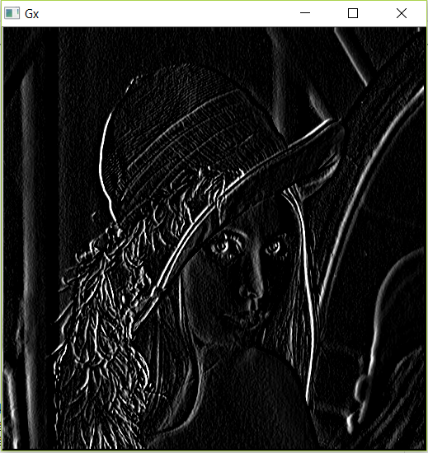

1. Gy –

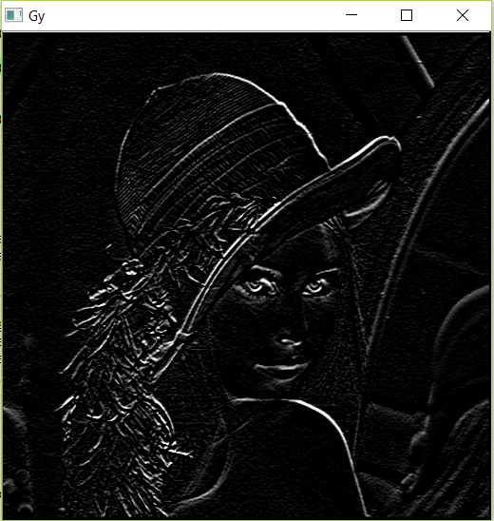

1. G

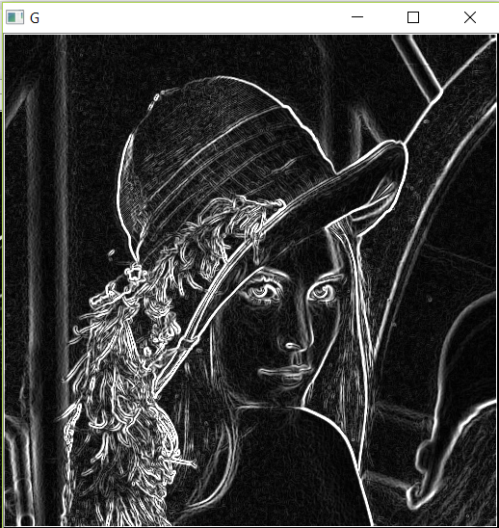

**1D Convolution:**

1. Gx1-

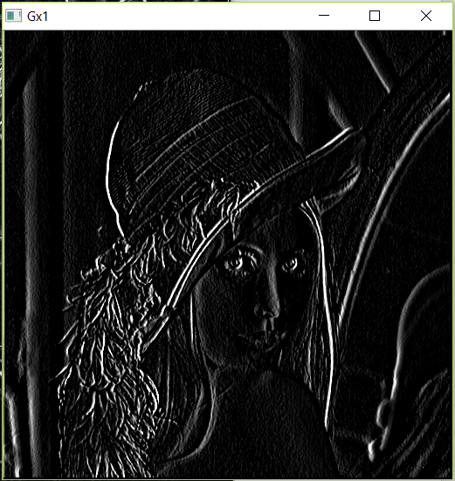

1. Gy1-

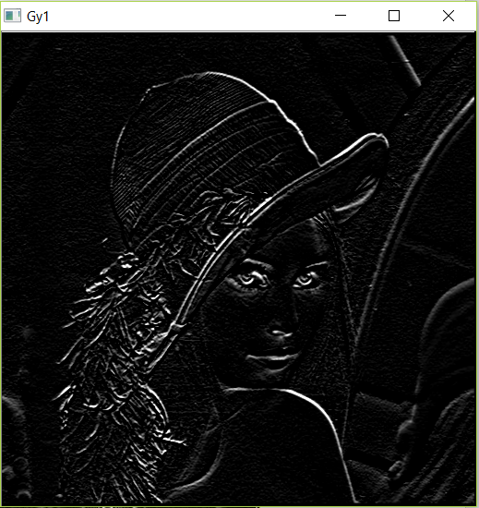

1. G1-

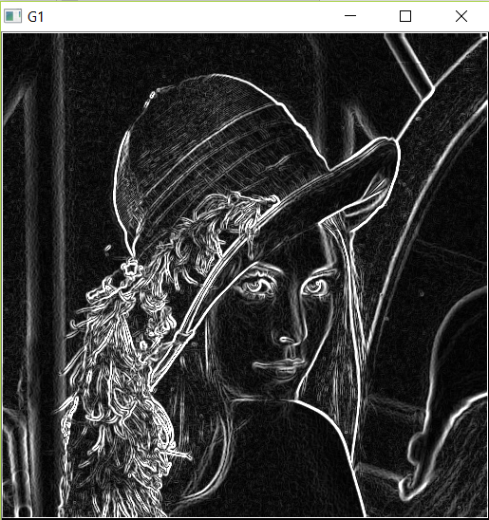

Final result Comparison of 2D and 1D convolution:

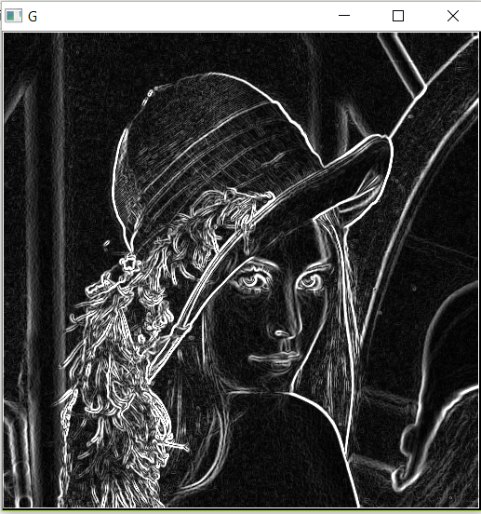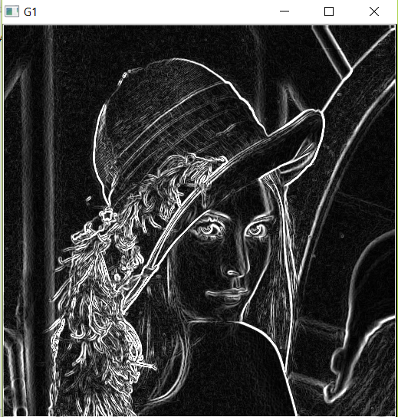

**Given an MxN Image and a PxQ filter, compute and report the computational complexity of performing 2D convolution vs using separable filters with 1D convolution.**

It is clearly understood from the program that, for 2D convolution, we have sobel filter of 3 X 3 matrix, hence each pixel will be requiring 9 multiplications. While for 1D convolution, the same sobel matrix filter is represented as multiplication of 3 X 1 and 1 X 3 matrices. When we use these matrices in our computation, for every pixel we require 6 multiplications.

This reduces the computational complexity, and hence given P X Q filter, we can break it down to (PX1) and (1XQ) 1D filters and perform the computation on image. The complexity for 2D convolution will be O(MNPQ) as PXQ will be entirely multiplied within the loops while for 1D convolution it will be O(MN(P+Q)) as first P will be multiplied and then Q will be multipled in separate loops.

**Problem (2) (Histogram Equalization):**

Histogram 1: - Image Histogram

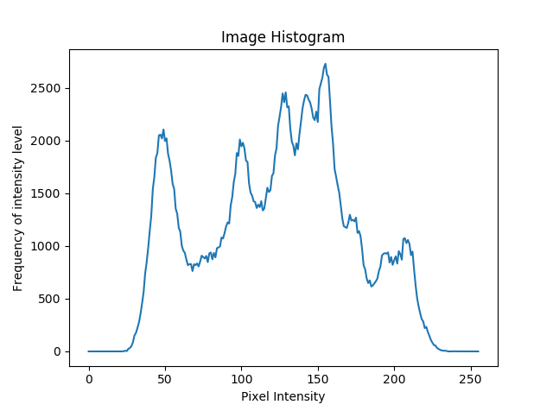

Histogram 2: - Cumulative Histogram

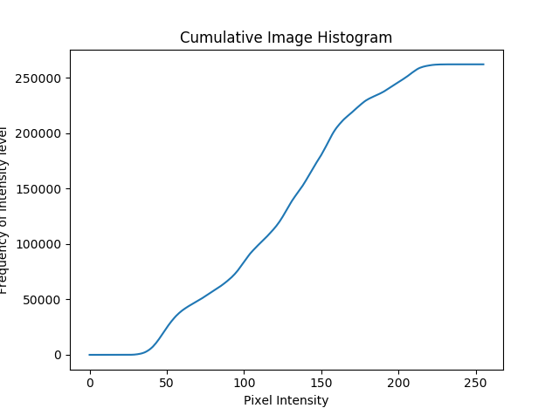

Histogram 3: - Transformed Image Histogram (Cumulative multiplied by factor)

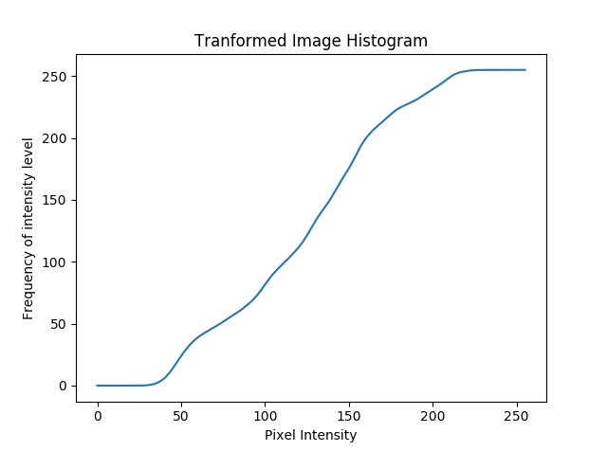

Histogram 4: - Final Result Image Histogram

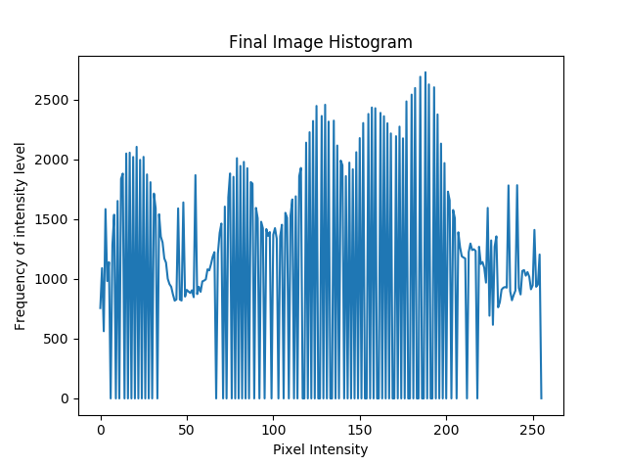

Original Image and Enhanced Image:

