**CSE 473/573 Summer 2017 - Programming Assignment 2**

1. **Stereo Vision**

**1.1 Disparity estimation using block matching**

1. **For 3X3 window**

Following is the (left) disparity image of the view1 image -

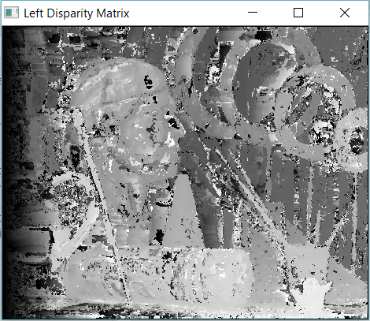

Following is the (right) disparity image of the view5 image -

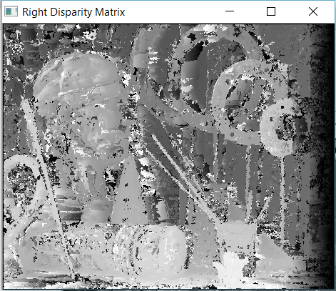

**For 9X9 window**

Following is the (left) disparity image of the view1 image -

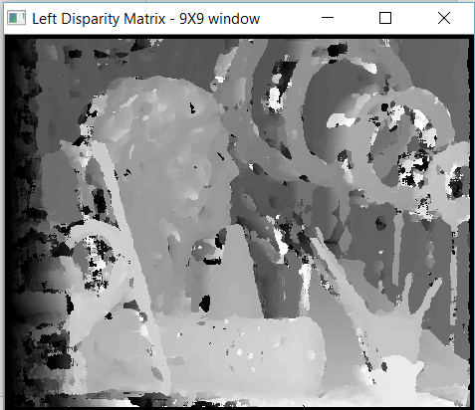

Following is the (right) disparity image of the view5 image -

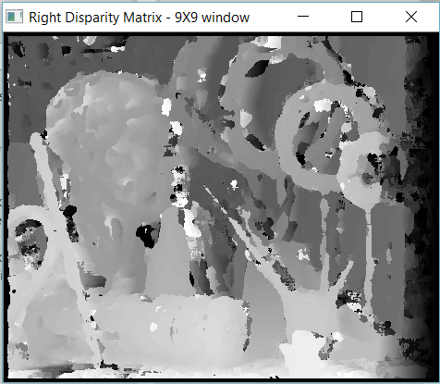

* 1. **Consistency check**

1. **For 3X3 window**

Left Back Projection Image

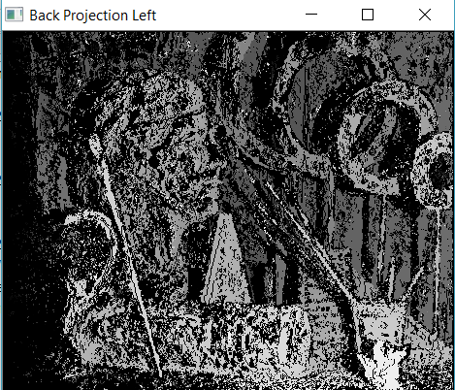

Right Back Projection Image

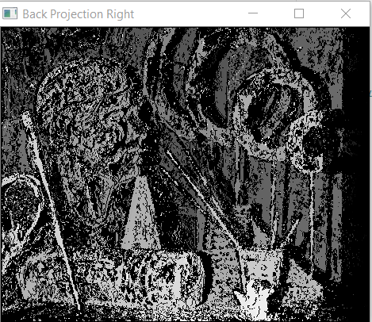

1. **For 9X9 window**

Left Back Projection Image

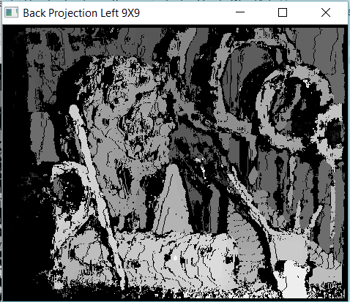

Right Back Projection Image

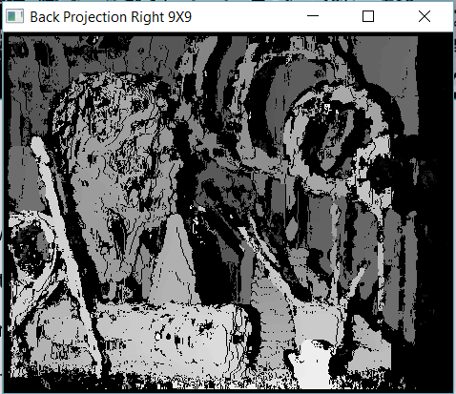

**Mean Square Error of Above (Disparity and Back Projection) Images:**

3X3 Window

Left Disparity Map - 395.435520402

Right Disparity Map - 272.509158835

Back Projection Left – 47.7056914366

Back Projection Right – 45.2385383223

9X9 Window

Left Disparity Map - 312.57593252

Right Disparity Map - 188.57380188

Back Projection Left – 20.7479248147

Back Projection Right – 21.2137586831

* 1. **Dynamic Programming**

Left Disparity -

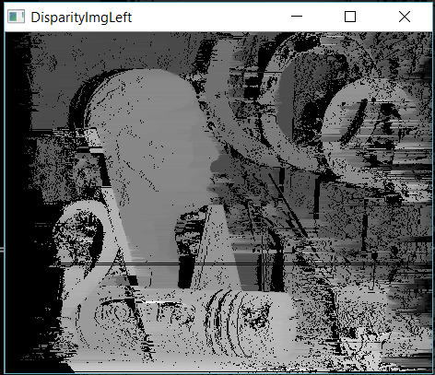

Right Disparity -

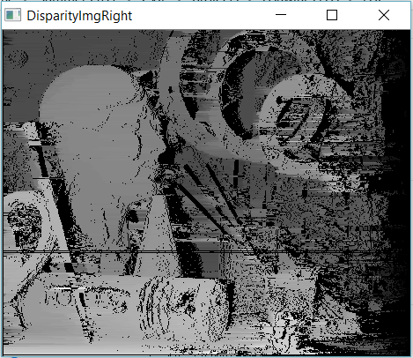

* 1. **View Synthesis**

Following is the (left) view synthesis of view 1 image:

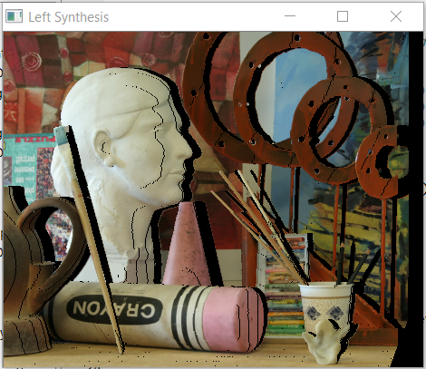

Following is the (right) view synthesis of view5 image:

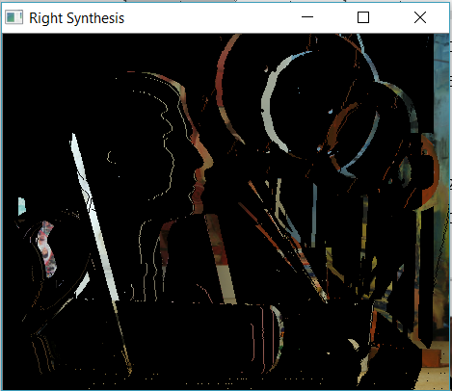

From the above two images we get the following image -

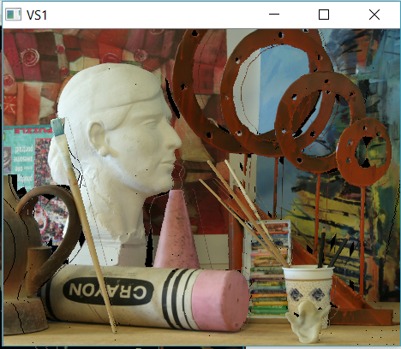

1. **Mean Shift Segmentation –**

h = 180

iter1 = 40

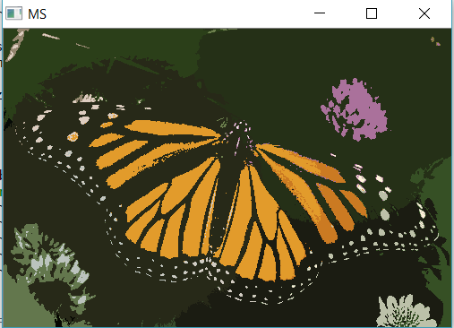

h = 160

Iter1 = 40

