Software Requirements Specification

For

Indian Culture System

Prepared by

|  |  |  |
| --- | --- | --- |
| Ajitkumar Shinde | Roll No: 04 | ajitkumarshinde41@gmail.com |
| Ramesh Shirsath | Roll No: 40 | ramesh.shirsath1991@gmail.com |
|  |  |  |
|  |  |  |
|  |  |  |

|  |  |
| --- | --- |
| Instructor: | *Prof.Rupali Chavan Mam* |
| Course: | M.C.A |
| Lab Section: | *A* |
| Teaching Assistant: | Prof.Snehal Paymal Mam |
| Date: | <place the date of submission here> |

Contents

1 Introduction 1

1.1 Document Purpose 1

1.2 Product Scope 1

1.3 Intended Audience and Document Overview 1

1.4 Definitions, Acronyms and Abbreviations 1

1.5 References and Acknowledgments 2

2 Overall Description 3

2.1 Product Perspective 3

2.2 Product Functionality 3

2.3 Users and Characteristics 3

2.4 Operating Environment 3

2.5 Design and Implementation Constraints 4

2.6 Assumptions and Dependencies 4

3 Specific Requirements 5

3.1 External Interface Requirements 5

3.2 Functional Requirements 6

3.3 Behaviour Requirements 6

4 Other Non-functional Requirements 7

4.1 Performance Requirements 7

4.2 Safety and Security Requirements 7

# 

# 1 Introduction

## Indian Culture System

**Indian culture system is a web based application that helps to get cultural information like Indian currency,weather,states,leader,reformers, clothing, food,Languages, cultural images and get a clear idea about the Indian culture. Also system manages clothes & jewellery Order**.

## Document Purpose

## The purpose of this document is to present a detail description of Indian culture system. It will explain the purpose and features of the system, the interfaces of the system, what the system will do, the constraints under which it must operate. This document is intended for all the stakeholders of the system and will be proposed for its approval.

## Product Scope

**The objective of “Indian culture system” is to help the user to get cultural information from a Single computerized system. It will save the time to collect information from different-different site. From here user can view the information like Indian currency, weather,**

**states,leader,reformers,clothing,food,language,festival,rangoli,architecture,Dances of india,crafts,forts,religions,monuments,jewellery,symbols,music,tour packages and wedding and cultural images and get a clear idea about the Indian culture.Also User can give clothes & jewellery Order.**

## Intended Audience and Document Overview

This document is intended for developers and users of the system. The rest of SRS contains Definition, acronyms, abbreviations, conventions used, references and acknowledgement, operating environment etc.

## Definitions, Acronyms and Abbreviations

|  |  |
| --- | --- |
| SRS | Software Requirement Specification |
| ICS | Indian Culture System |
| OS | Operating System |
| PC | Personal computer (Windows based) |
| MAC | Macintosh computer (Apple based) |
| GUI | Graphical user interface |
| IEEE | Institute of electrical and electronics engineers |
| IC | Indian Culture |

## References and Acknowledgments

**Web Sites**

* [www.w3schools.com](http://www.w3schools.com)

# Overall Description

## Product Perspective

This is self contained software. The basic of this software product is described in the diagram below:

Registered user

Indian Culture system (ICS)

User (General)

User can views all the types of details such as jewellery, cloths, Indian currency,

Weather, states, leader reformers, Clothing,

Food, language, festival,

Rangoli, crafts, forts, religions,

Monuments, jewellery, symbols, music, tour packages and wedding

Can view

Can give

*User can view all the types of details & can give Order for jewellery and clothes.*

## Product Functionality

1. New user registration.
2. User can view the IC information details(E.g.currency, states, leader,

Reformers, clothing, food, Languages, etc.)

1. Maintaining cloths & jewellery order.
2. Maintaining user’s feedback.
3. Send alerts through email and SMS.

## Users and Characteristics

**1. Site administrator:** Site administrator will the person or group of persons who is assigned to manage the whole functionality and working of the web site, they will periodically backup the database and verify the code from time to time, they are responsible for updating of code and adding or removing some features.

**2. User (Registered):** The person who has registered himself / herself on site and they can views all services and give jewellery and clothes order.

**3.User (General):** General users are the person who has not yet registered but just visit the site for the views cultural information.

## Operating Environment

As this software is a web based application it requires an active internet connection and standard-complaint browser. It is advisable to use the latest browser. This application can be accessed either through Windows OS, MAC OS etc.. The minimum hardware requirement is a CPU of 200 MHz for good performance and a RAM of more than120 MB is recommended.

## Design and Implementation Constraints

1. This software requires an active internet connection
2. This software has components made in CSS hence requires a browser that is capable of rendering CSS.
3. This web application may not be compatible with all mobile browsers.
4. This application uses JavaScript for client side events hence it is mandatory that JavaScript is enabled on the user’s browser.
5. This application uses cookies to store some information so that ICS can give better service to the user, hence it is advisable to accept the cookies and browsers should be able to handle cookies.

## Assumptions and Dependencies

1. It is assumed that the user should know the basic functionalities of computer operation and must know how to operate a web browser.

# Specific Requirements

## External Interface Requirements

### User Interfaces

Some basic User interface will be:-

**1. Home page:** From here any user can either Log into his/her account or can Sign up.

.

**2. Services:** From here user can view the services such as Indian currency,weather,

states,leader,reformers,clothing,food,language,festival,rangoli,architecture,Dances of india,

crafts,forts,religions, monuments, jewellery,symbols,music,tour packages and wedding and cultural images and get a clear idea about the Indian culture.

**3. Registration:** From here user can do registration on site.

**4. Clothes**: From here user can view the jewellery details & only Registered user can give order.

5. **Jewellery:** From here user can view the jewellery details & only Registered user can give order.

6. **Feedback:** From here user can give opinion about Indian culture services.

### Software Interfaces

This application is made in HTML Version 4.0 and it also uses the JavaScript Library for enhancing the interaction between the user and system. The server side scripting language used is ASP (Active Server Page) by Microsoft. The database used is Microsoft Access Database.

### Communications Interfaces

As this is a webpage the connection protocol used to transmit is HTTP. Other communication protocol used will be FTP to upload the images and videos. For sending e-mail to the user it uses SMTP protocol.

## Functional Requirements

The inputs are taken from the different controls like textboxes, combo boxes; text area etc. The input is processed at the client end and validated against some conditions. If the condition is passed the data is transmitted to the server for further processing. If the validation is not succeeded an error pop-up window showing the error is displayed. In case the user name and password combination is incorrect an error page showing invalid credentials is displayed and re-prompts for user name and password.

# Other Non-functional Requirements

## Performance Requirements

1. Any transaction will not take more than 15seconds.
2. No web page request will take more than 25seconds.
3. The use of AJAX (Asynchronous JavaScript and XML) will help dynamically update a page and decrease the traffic overhead caused by full page refresh.

## Safety and Security Requirements

* The data transferred will be encrypted either with MD5 or SHA1 and will also have “Salts” for password and other sensitive data.
* The files at the server end are scanned regularly for tracing any virus or malware that can affect the security.

**ER-Diagram for Indian Culture**

Do

Subscription

Shop

Select

Services

Have

Views

Order

Gives

User

For

Product

Jewellery

Gives

Clothes

Feedback

**DF-Diagram for Indian Culture**

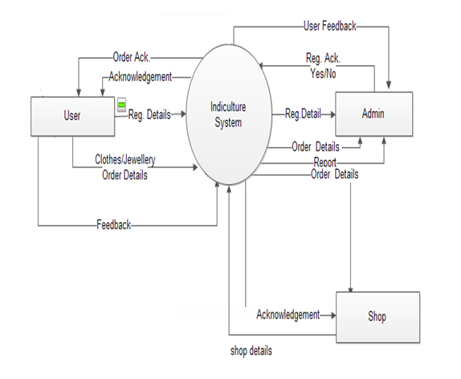

Reg.details

User

Reg.details user

a

Acknowledgment

User

Order details Order details

Order

Acknowledgment Order details

Shop

Order details

Feedback details Feedback

Feedback details

Admin

Feedback details

Sub.det Subscription

Shop

Shop details

Subscr.details

Shop.det

Shopdet

Subscr.Acknow.

Admin

Requested reports

order details

Order Reports details

order details

Feedback details Regis. details

Feedback

Feedback details

Registration

Registration details