WEEK 4: COMPREHENSIVE DATA ANALYSIS REPORT
Stroke Risk Analysis Using R

Internship Project: Data Analysis and Predictive Modeling
Dataset: Stroke Prediction Dataset
Analysis Environment: R / RStudio
Project Duration: Weeks 1–4

Final integrated report combining data cleaning, exploratory analysis, visualization, statistical testing, predictive modeling, model evaluation, diagnostics, and recommendations.

Executive Summary
This final report integrates the four-week analysis workflow performed on the Stroke Prediction dataset. The project began with data preparation and preliminary exploration, progressed to visualization and insight communication, and then advanced to statistical hypothesis testing and predictive modeling using logistic regression. The final week consolidates these activities into a single analytical narrative.
The dataset contained 5,110 patient records and 12 variables in the cleaned analytical file. No missing values were present in the cleaned dataset. Stroke was the target outcome, with 249 stroke cases (4.87%) and 4,861 non-stroke cases (95.13%). This substantial class imbalance became an important consideration during model evaluation.
Descriptive and statistical analyses showed strong evidence of differences in age, average glucose level, and BMI between stroke and non-stroke groups. Wilcoxon tests returned p-values below 0.001 for all three variables. Chi-square tests also identified statistically significant associations between stroke and hypertension and between stroke and heart disease, with p-values below 2.2 × 10⁻¹⁶.
A multivariable logistic regression model was developed after an 80:20 train-test split. Age and average glucose level were statistically significant predictors in the fitted model. The model's ROC-AUC was 0.8668 with a 95% confidence interval of 0.8270–0.9067, indicating good discrimination. However, the default 0.50 threshold classified every test observation as No Stroke, producing 95.20% accuracy but 0% sensitivity. Threshold analysis demonstrated the trade-off between sensitivity, specificity, precision, and accuracy and showed why accuracy alone is inadequate for this imbalanced medical classification problem.
Overall, the project demonstrates an end-to-end R-based analytics workflow and highlights the importance of combining statistical significance, visualization, predictive discrimination, threshold selection, and model diagnostics rather than relying on a single performance metric.

1. Introduction
Stroke is a clinically important outcome for which early identification of higher-risk individuals can support preventive decision-making and further clinical assessment. From a data analytics perspective, stroke prediction is also a useful example of a binary classification problem involving demographic, clinical, and lifestyle variables.
This project was designed as a progressive four-week internship exercise. Week 1 focused on data cleaning and preliminary analysis; Week 2 focused on visualization and communicating patterns; Week 3 introduced statistical testing and predictive modeling; and Week 4 integrates the preceding work into a comprehensive final report.
The analysis is intended as an educational data analytics project. The statistical relationships and model outputs should not be interpreted as clinical diagnosis or as a replacement for professional medical assessment.

1.1 Project Objectives
- Prepare and validate a structured healthcare dataset for analysis using R.
- Perform descriptive and exploratory analysis to understand stroke outcomes and patient characteristics.
- Create visualizations that communicate important distributions, group differences, and risk-related patterns.
- Use statistical hypothesis tests to evaluate relationships between selected variables and stroke outcome.
- Develop a logistic regression model for stroke classification.
- Evaluate discrimination, classification performance, threshold behavior, and model diagnostics.
- Integrate the findings into clear conclusions, limitations, recommendations, and future analytical directions.

2. Dataset Overview
The project used a publicly available Stroke Prediction dataset. The cleaned dataset contained 5,110 observations and 12 variables. The target variable was stroke, coded as 0 for no stroke and 1 for stroke during the data-preparation stage.
Variable | Type / Role | Description
id | Integer / Identifier | Patient record identifier; removed before modeling.
gender | Categorical | Patient gender category.
age | Numeric | Patient age.
hypertension | Binary | Indicator of hypertension.
heart_disease | Binary | Indicator of heart disease.
ever_married | Categorical | Marital status indicator.
work_type | Categorical | Employment/work category.
Residence_type | Categorical | Urban or rural residence.
avg_glucose_level | Numeric | Average glucose level.
bmi | Numeric | Body mass index.
smoking_status | Categorical | Smoking-status category.
stroke | Binary target | Stroke outcome.
The structure check reported 5,110 observations and 12 variables. The cleaned file contained zero missing values across all variables.

3. Week 1 – Data Cleaning and Preliminary Analysis

3.1 Data Quality Assessment
The cleaned dataset was inspected using str(), dim(), colSums(is.na()), and summary(). The structure confirmed 5,110 observations and 12 variables. The missing-value check returned zero missing values for every variable. This provided a complete analytical dataset for the subsequent visualization and statistical stages.
Metric | Result
Observations | 5,110
Variables | 12
Missing values | 0 across all variables
Stroke cases | 249
Non-stroke cases | 4,861
Stroke prevalence | 4.872798%
Non-stroke prevalence | 95.127202%

3.2 Preliminary Descriptive Findings
The overall mean age was 43.23 years, mean average glucose level was 106.15, and mean BMI was 28.86. The mean hypertension indicator was 0.09746 and the mean heart disease indicator was 0.05401, corresponding to approximately 9.75% and 5.40% respectively.
The preliminary analysis already suggested that the stroke outcome was highly imbalanced. Only 249 of 5,110 observations were stroke cases. This imbalance was carried through to the modeling stage and became central to interpreting classification metrics.

4. Week 2 – Data Visualization and Insight Communication
Week 2 extended the preliminary analysis into a structured visualization workflow. Nine plots were created to examine outcome distribution, age, glucose, BMI, hypertension, heart disease, smoking, age-group stroke rates, and correlations.

4.1 Stroke Outcome Distribution
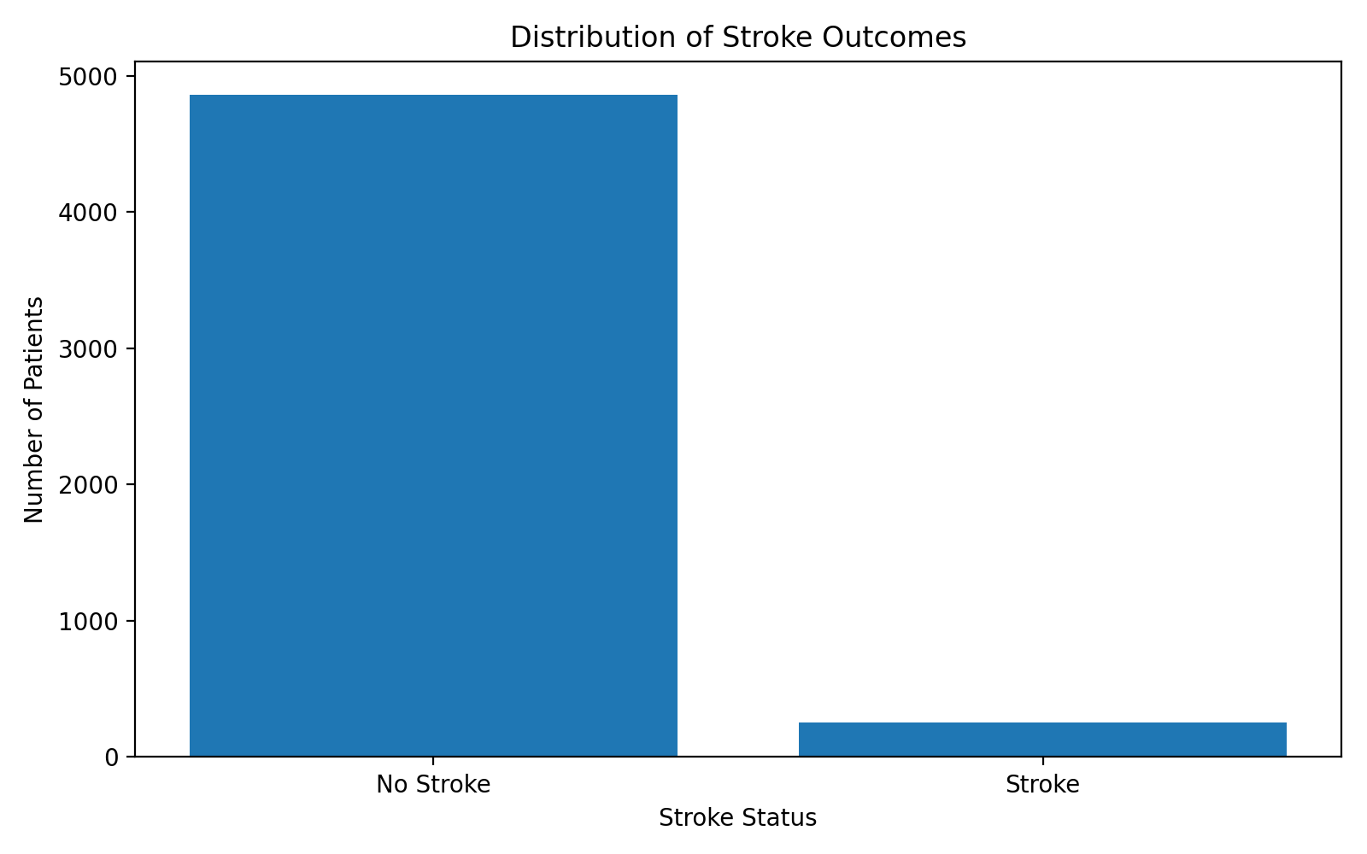
Figure 1. Distribution of stroke outcomes.
The outcome distribution is strongly imbalanced: 4,861 records were classified as No Stroke and 249 as Stroke. Stroke therefore represented only 4.87% of the dataset. This visualization is important because it explains why a model can obtain high overall accuracy while still failing to identify positive stroke cases.

4.2 Age, Glucose and BMI
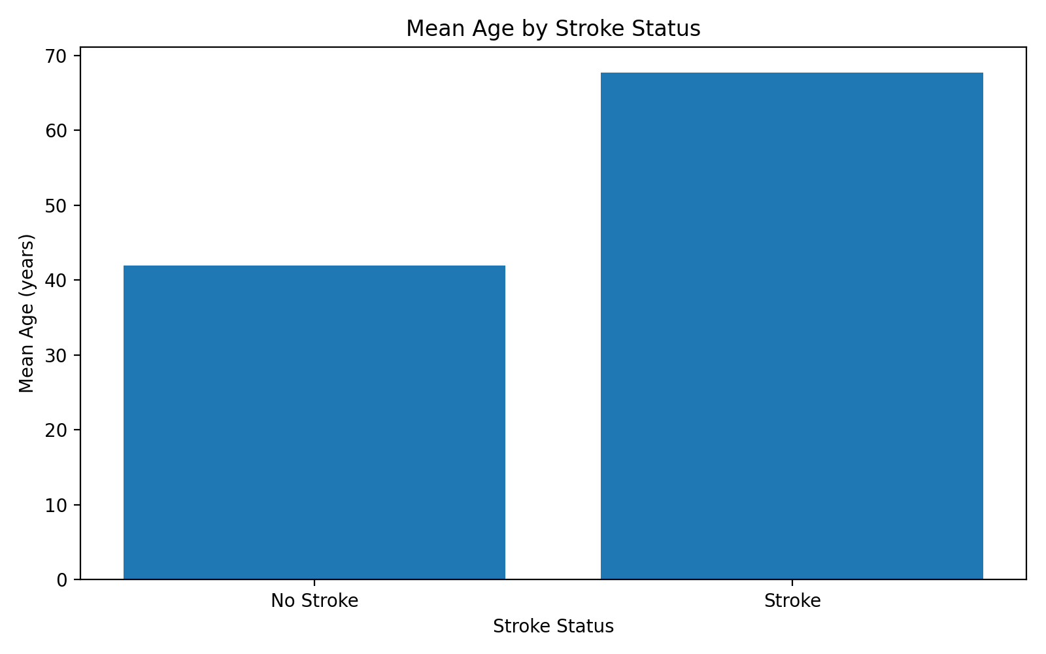
Figure 2. Mean age by stroke status.
The mean age was 41.97 years among non-stroke observations and 67.73 years among stroke observations. The median ages were 43 and 71 respectively. The large difference suggests a strong relationship between age and stroke outcome, which was subsequently confirmed by statistical testing and logistic regression.
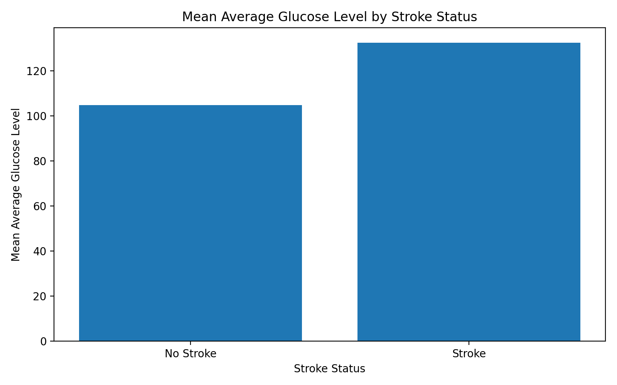
Figure 3. Mean average glucose level by stroke status.
Mean average glucose level was 104.80 among non-stroke observations and 132.54 among stroke observations. The corresponding medians were 91.47 and 105.22. The difference was statistically significant in the Week 3 Wilcoxon test.
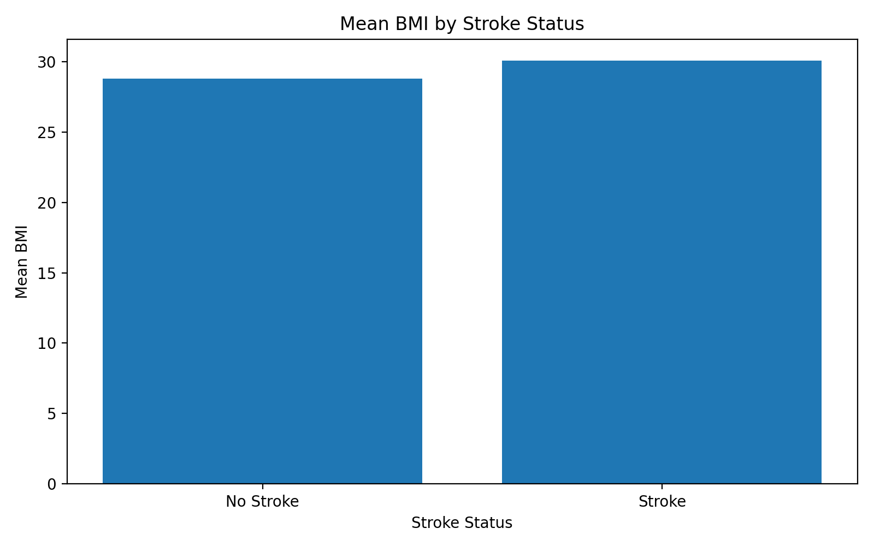
Figure 4. Mean BMI by stroke status.
Mean BMI was 28.80 for non-stroke observations and 30.09 for stroke observations. The median BMI was 28.1 in both groups, indicating that the mean difference was relatively modest and that the distributions should be considered alongside the statistical test rather than interpreted from the mean alone.

4.3 Hypertension and Heart Disease
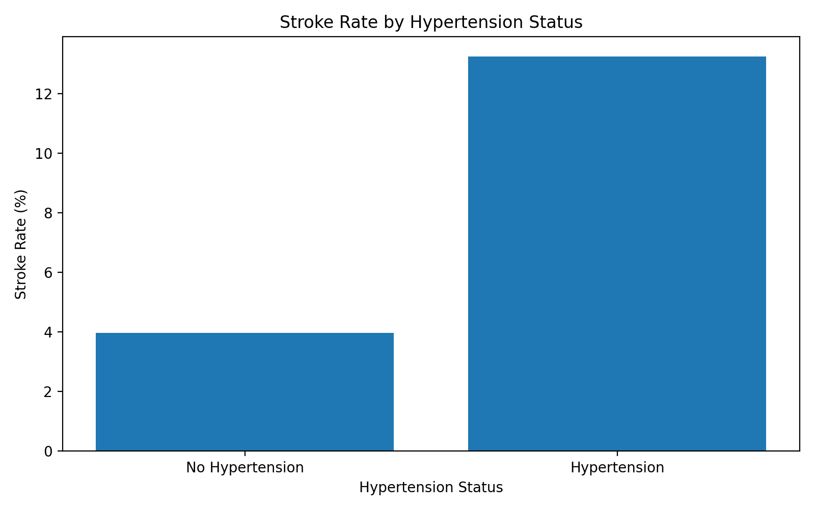
Figure 5. Stroke rate by hypertension status.
Using the supplied contingency table, the stroke rate was approximately 3.97% among patients without hypertension and 13.25% among patients with hypertension. The Week 3 chi-square test showed a highly statistically significant association (p < 2.2 × 10⁻¹⁶).
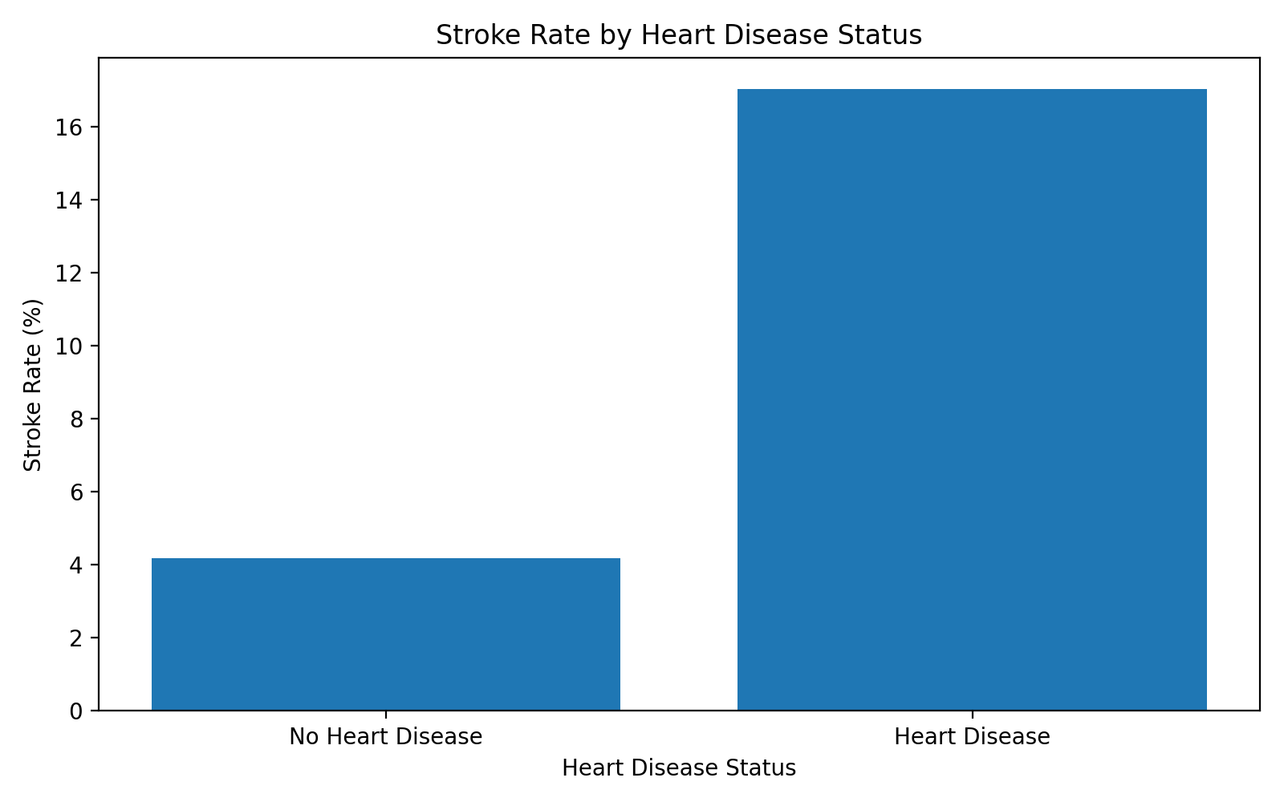
Figure 6. Stroke rate by heart disease status.
The supplied contingency table corresponds to a stroke rate of approximately 4.18% among patients without heart disease and 17.03% among patients with heart disease. The chi-square test was highly statistically significant (p < 2.2 × 10⁻¹⁶).

4.4 Smoking, Age Groups and Correlation Heatmap
Week 2 also included plots for smoking status, stroke rate across age groups, and a correlation heatmap. These visualizations were used to examine lifestyle patterns, age-related changes, and relationships among numeric/indicator variables. The exact smoking-category rates and age-group rate table were not included in the supplied Week 3 outputs, so this final report does not invent numerical values for those plots.
The correlation heatmap provided an overview of pairwise linear associations among age, hypertension, heart disease, average glucose level, BMI, and stroke. Correlation should be interpreted as association rather than causation and does not replace multivariable modeling.

5. Week 3 – Statistical Analysis

5.1 Descriptive Statistics by Stroke Status
Variable | No Stroke – Mean | Stroke – Mean | No Stroke – Median | Stroke – Median
Age | 41.97154 | 67.72819 | 43 | 71
Average glucose | 104.7955 | 132.5447 | 91.47 | 105.22
BMI | 28.79912 | 30.09036 | 28.1 | 28.1

5.2 Hypothesis Testing
Because the distributions were assessed using histograms and Q-Q plots, non-parametric Wilcoxon rank-sum tests were used for continuous variables. Chi-square tests were used for the categorical indicators hypertension and heart disease.
Test | Statistic | p-value | Interpretation
Age: Wilcoxon rank-sum | W = 200,264 | < 2.2 × 10⁻¹⁶ | Strong evidence of a difference in age distributions.
Glucose: Wilcoxon rank-sum | W = 471,239 | 3.64 × 10⁻⁹ | Strong evidence of a difference in glucose distributions.
BMI: Wilcoxon rank-sum | W = 522,643 | 0.0002769 | Statistically significant difference in BMI distributions.
Hypertension: Chi-square | X² = 81.605, df = 1 | < 2.2 × 10⁻¹⁶ | Statistically significant association with stroke.
Heart disease: Chi-square | X² = 90.26, df = 1 | < 2.2 × 10⁻¹⁶ | Statistically significant association with stroke.
These tests provide evidence of statistical association in the observed dataset. They do not by themselves establish causation, and they do not account for all variables simultaneously.

6. Predictive Modeling

6.1 Model Preparation
For modeling, categorical variables were converted to factors and the stroke outcome was converted to a factor with levels No_Stroke and Stroke. The ID field was removed because it is an identifier rather than a meaningful clinical predictor. The resulting modeling dataset contained 11 variables.
Modeling step | Implementation
Outcome | stroke: No_Stroke / Stroke
ID | Removed
Categorical variables | Converted to factors
Train-test split | 80% training / 20% testing
Random seed | 123
Model | Binary logistic regression
The outcome distribution remained approximately 95.13% No Stroke and 4.87% Stroke. This preserved class balance in proportions but not in absolute class size, leaving relatively few positive cases for model evaluation.

6.2 Logistic Regression
A multivariable logistic regression model was fitted using gender, age, hypertension, heart disease, ever-married status, work type, residence type, average glucose level, BMI, and smoking status as predictors.
The fitted model reported a null deviance of 1597.1 on 4,088 degrees of freedom, residual deviance of 1281.0 on 4,072 degrees of freedom, AIC of 1315, and 14 Fisher Scoring iterations.

6.3 Significant Predictors
Predictor | Coefficient | p-value | Odds Ratio | Interpretation
Age | 0.074370394 | 1.758380 × 10⁻³⁰ | 1.0772 | Each additional year was associated with higher modeled odds of stroke.
Average glucose level | 0.004199302 | 0.001609685 | 1.0042 | Higher glucose was associated with higher modeled odds of stroke.
Age had an odds ratio of approximately 1.077 per year, with a 95% confidence interval of 1.063917–1.091329. Average glucose level had an odds ratio of approximately 1.0042 per unit, with a 95% confidence interval of 1.001569–1.006815. These estimates are model-adjusted associations within the fitted logistic regression.
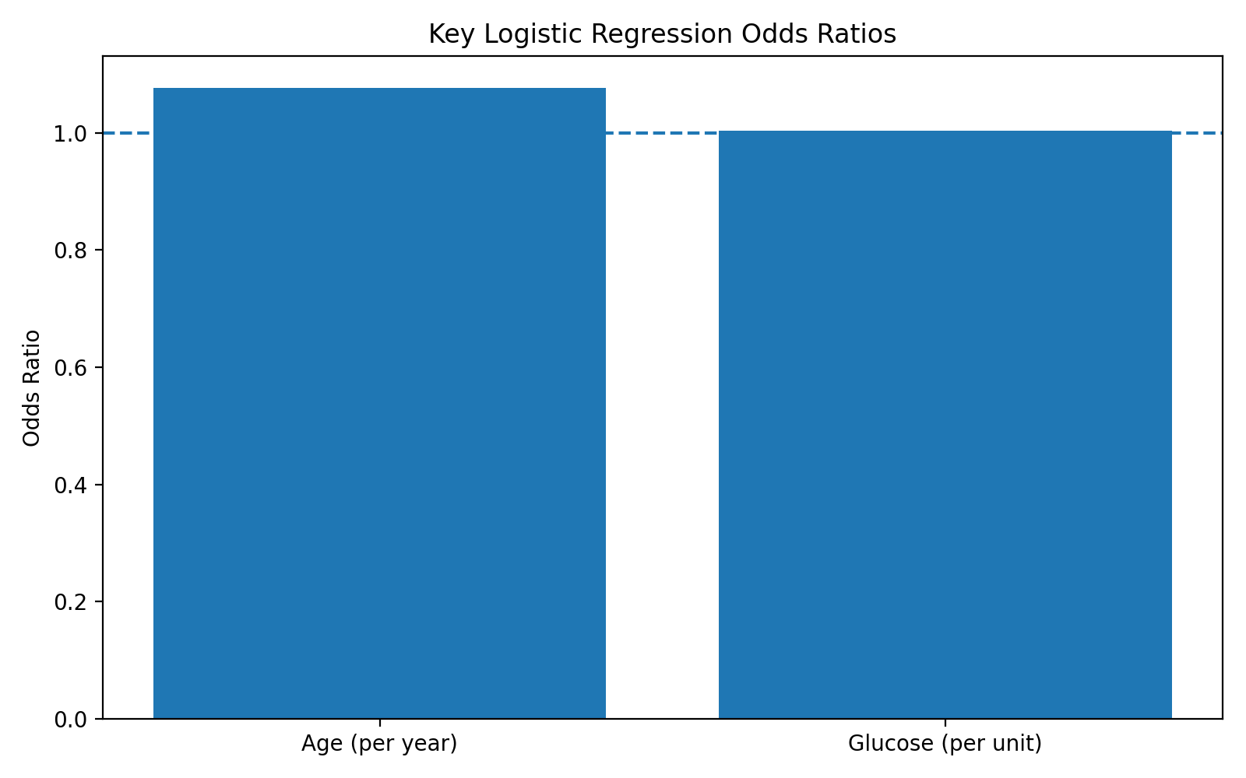
Figure 7. Key odds ratios from the logistic regression model. The plot displays odds ratios for age and average glucose level using the supplied coefficients.

7. Model Evaluation

7.1 Predicted Probabilities
The test-set predicted probabilities ranged from approximately 1.4 × 10⁻⁷ to 0.4408. The median predicted probability was 0.01641 and the mean was 0.04767. Importantly, the maximum predicted probability was below the default 0.50 classification threshold.

7.2 Default 0.50 Threshold
Metric | Result
Accuracy | 0.9520078 (95.20%)
Sensitivity | 0
Specificity | 1
Precision | NaN / undefined because no positive predictions were made
True negatives | 972
False positives | 0
False negatives | 49
True positives | 0
At a 0.50 threshold, all 1,021 test observations were classified as No Stroke. This produced high accuracy because the majority class dominated the test set, but sensitivity was 0% because no stroke case was detected. Therefore, 95.20% accuracy should not be interpreted as evidence that the model is clinically effective for detecting stroke cases.

7.3 Threshold Analysis
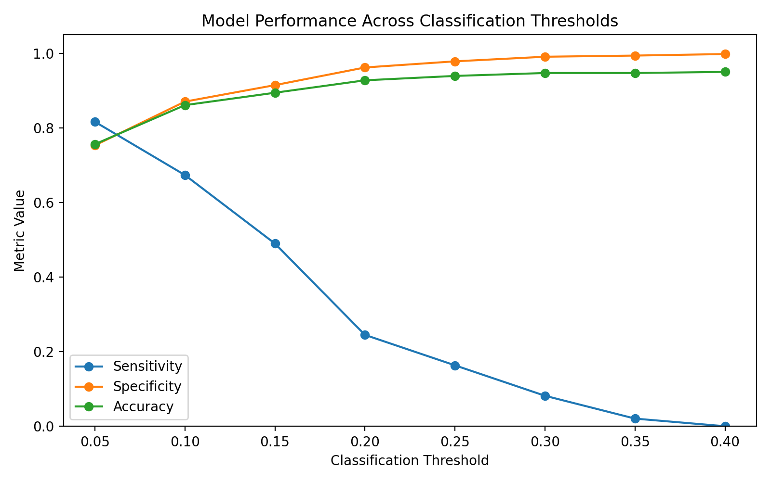
Figure 8. Model performance across classification thresholds.
Threshold | Accuracy | Sensitivity | Specificity | Precision
0.05 | 75.61% | 81.63% | 75.31% | 14.29%
0.10 | 86.09% | 67.35% | 87.04% | 20.75%
0.15 | 89.42% | 48.98% | 91.46% | 22.43%
0.20 | 92.75% | 24.49% | 96.19% | 24.49%
0.25 | 93.93% | 16.33% | 97.84% | 27.59%
0.30 | 94.71% | 8.16% | 99.07% | 30.77%
0.35 | 94.71% | 2.04% | 99.38% | 14.29%
0.40 | 95.00% | 0.00% | 99.79% | 0.00%
The threshold analysis clearly demonstrates the trade-off between sensitivity and specificity. At 0.05, sensitivity was 81.63%, but precision was only 14.29%. As the threshold increased, sensitivity declined while specificity and overall accuracy generally increased. For a screening-oriented application, a lower threshold may be preferable because missing positive cases can be more consequential than generating additional false positives; however, threshold selection should ultimately depend on the intended use and validation setting.

7.4 ROC-AUC
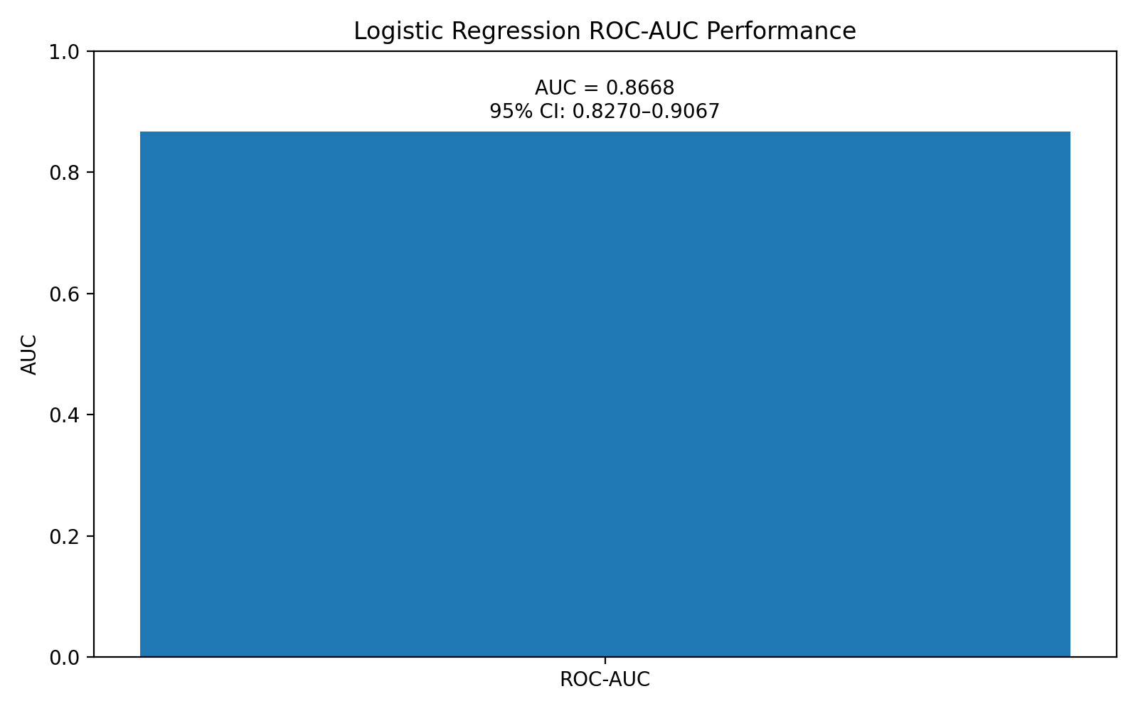
Figure 9. Reported ROC-AUC performance.
The model achieved an ROC-AUC of 0.8668. The 95% DeLong confidence interval was 0.8270–0.9067. This indicates good discrimination: the model has useful ability to rank stroke cases above non-stroke cases even though the default classification threshold performed poorly for sensitivity.
The Youden-optimal threshold reported by pROC was 0.03642306, with sensitivity of 0.9183673 and specificity of 0.691358. This result reinforces that the model's useful discrimination occurs at probabilities far below 0.50 in this imbalanced dataset.

8. Model Diagnostics

8.1 Multicollinearity
Variable | Adjusted GVIF measure
gender | 1.011465
age | 1.229893
hypertension | 1.036441
heart_disease | 1.039513
ever_married | 1.066628
work_type | 1.052167
Residence_type | 1.004145
avg_glucose_level | 1.049261
bmi | 1.055846
smoking_status | 1.019753
The adjusted GVIF values were all close to 1, with the largest value being 1.229893 for age. This provides no indication of problematic multicollinearity among the included predictors.

8.2 Cook's Distance
Cook's distance had a minimum of 0, median of approximately 1.637 × 10⁻⁶, mean of approximately 2.146 × 10⁻⁴, and maximum of approximately 0.03168. Using the supplied screening rule of 4/n for the training dataset, 203 observations were flagged as potentially influential. This is a screening criterion rather than proof that those observations are erroneous or should be removed.

8.3 Deviance Residuals and Predicted Probabilities
Deviance residuals were examined against fitted values as part of model diagnostics. The predicted-probability distribution showed that most observations had low estimated probabilities, consistent with the low prevalence of stroke in the dataset. The maximum test-set probability was only 0.4408, explaining why the 0.50 threshold generated no positive classifications.

9. Integrated Findings
Stage | Major Finding | Contribution to Next Stage
Week 1: Cleaning | 5,110 records; no missing values; 4.87% stroke prevalence. | Established data quality and highlighted class imbalance.
Week 2: Visualization | Age, glucose, BMI and clinical indicators showed visible differences by outcome. | Identified patterns requiring statistical testing.
Week 3: Statistics | Age, glucose, BMI, hypertension and heart disease showed statistically significant associations. | Supported selection and interpretation of predictive variables.
Week 3: Modeling | Logistic regression achieved AUC 0.8668. | Provided a quantitative predictive framework.
Evaluation | 0.50 threshold had 0% sensitivity; lower thresholds recovered stroke cases. | Demonstrated why threshold selection is critical.
Diagnostics | Low VIF values; 203 observations flagged by Cook's criterion. | Supported model review and identified areas for further investigation.

10. Potential Healthcare and Business Impact
From an analytics perspective, the project demonstrates how routinely collected demographic and clinical variables can be transformed into structured insights. A model with good ranking performance could potentially support risk stratification or prioritization workflows if it were further validated, calibrated, externally tested, and evaluated for clinical utility.
- Risk stratification: predicted probabilities could be used to rank observations by estimated risk rather than relying on a single binary threshold.
- Screening support: threshold analysis can help stakeholders choose operating points based on the relative costs of false negatives and false positives.
- Data-driven decision support: visualizations and statistical summaries make complex patterns easier for non-technical stakeholders to interpret.
- Quality improvement: diagnostic checks identify influential observations and model limitations that should be investigated before deployment.
These are potential analytical applications only. The current project is an internship exercise and is not a clinically validated decision-support system.

11. Challenges and Limitations
- The stroke outcome is highly imbalanced, with only 4.87% positive cases.
- The default 0.50 threshold is inappropriate for this dataset because all predicted probabilities were below 0.50.
- High accuracy is therefore misleading and must be interpreted together with sensitivity, specificity, precision, and ROC-AUC.
- The logistic regression model is based on a single train-test split rather than repeated cross-validation or external validation.
- Some categories have very small representation, which can lead to unstable coefficient estimates, as illustrated by the very large uncertainty associated with the 'Other' gender coefficient and 'Never worked' work-type coefficient.
- Cook's distance flagged 203 observations using the supplied screening rule; these observations require investigation rather than automatic deletion.
- Statistical significance does not establish causation.
- Additional calibration, precision-recall analysis, resampling strategies, and external validation would be needed for a stronger predictive study.

12. Recommendations
- Use stratified cross-validation or repeated resampling to obtain more stable estimates of model performance.
- Evaluate class-imbalance strategies such as class weighting or carefully controlled resampling, while preserving a representative validation set.
- Report sensitivity, specificity, precision, F1-score, ROC-AUC and preferably precision-recall metrics rather than accuracy alone.
- Evaluate calibration so that predicted probabilities can be interpreted more reliably.
- Investigate the influential observations identified by Cook's distance and assess whether they reflect valid but unusual patients or data-quality issues.
- Compare logistic regression with alternative models such as decision trees, random forests, gradient boosting, or other suitable classifiers.
- Perform external validation on an independent dataset before considering any real-world application.
- Document the intended operating point and decision threshold according to the practical cost of false negatives and false positives.

13. Future Scope
Future work can extend the project from a single logistic regression model into a more rigorous predictive analytics pipeline. Candidate extensions include repeated stratified cross-validation, imbalance-aware modeling, feature selection, non-linear effects, interaction terms, calibration curves, precision-recall curves, and comparison of multiple machine-learning algorithms.
A further extension would be to develop a reproducible reporting workflow in R using R Markdown or Quarto, allowing the analysis, tables, plots, and narrative to be regenerated automatically when the dataset changes. The project could also be packaged into a dashboard using Shiny or another visualization platform for demonstration purposes.

14. Conclusion
This four-week project demonstrates a complete data analytics workflow using R on a stroke prediction dataset. The work progressed logically from data preparation to exploratory analysis, visualization, statistical testing, predictive modeling, evaluation, and diagnostics.
The cleaned dataset contained 5,110 observations with no missing values. Stroke prevalence was 4.87%, making class imbalance a major analytical consideration. Descriptive analysis showed substantial differences in age and average glucose level between stroke and non-stroke observations, while BMI showed a smaller difference. Wilcoxon and chi-square tests provided strong statistical evidence for the relationships examined.
The multivariable logistic regression model demonstrated good discrimination with an AUC of 0.8668 and a 95% confidence interval of 0.8270–0.9067. Age and average glucose level were statistically significant predictors in the fitted model. At the default 0.50 threshold, however, the model detected none of the stroke cases, producing 95.20% accuracy but 0% sensitivity. Threshold analysis showed that lower thresholds substantially improved sensitivity, demonstrating the importance of evaluating classification performance in the context of the outcome distribution.
The project therefore reinforces a central principle of healthcare analytics: a predictive model should not be judged by accuracy alone. Meaningful evaluation requires statistical reasoning, appropriate visualization, discrimination metrics, threshold analysis, diagnostics, and careful consideration of the intended use. The final workflow provides a strong foundation for further predictive modeling and portfolio development while clearly identifying the additional validation required before any clinical application.

Appendix A – Key R Code Used
# Load cleaned dataset
stroke_clean <- read.csv("Data/stroke_cleaned.csv")

# Data checks
str(stroke_clean)
dim(stroke_clean)
colSums(is.na(stroke_clean))
summary(stroke_clean)

# Outcome distribution
table(stroke_clean$stroke)
prop.table(table(stroke_clean$stroke)) * 100

# Wilcoxon tests
wilcox.test(age ~ stroke, data = stroke_clean)
wilcox.test(avg_glucose_level ~ stroke, data = stroke_clean)
wilcox.test(bmi ~ stroke, data = stroke_clean)

# Chi-square tests
chisq.test(table(stroke_clean$hypertension, stroke_clean$stroke))
chisq.test(table(stroke_clean$heart_disease, stroke_clean$stroke))

# Prepare modeling data
stroke_model <- stroke_clean
stroke_model$gender <- as.factor(stroke_model$gender)
stroke_model$hypertension <- as.factor(stroke_model$hypertension)
stroke_model$heart_disease <- as.factor(stroke_model$heart_disease)
stroke_model$ever_married <- as.factor(stroke_model$ever_married)
stroke_model$work_type <- as.factor(stroke_model$work_type)
stroke_model$Residence_type <- as.factor(stroke_model$Residence_type)
stroke_model$smoking_status <- as.factor(stroke_model$smoking_status)

stroke_model$stroke <- factor(
stroke_model$stroke,
levels = c(0, 1),
labels = c("No_Stroke", "Stroke")
)

stroke_model$id <- NULL

# 80:20 split
library(caret)
set.seed(123)
train_index <- createDataPartition(
stroke_model$stroke,
p = 0.80,
list = FALSE
)

stroke_train <- stroke_model[train_index, ]
stroke_test <- stroke_model[-train_index, ]

# Logistic regression
logistic_model <- glm(
stroke ~ gender + age + hypertension + heart_disease +
ever_married + work_type + Residence_type +
avg_glucose_level + bmi + smoking_status,
data = stroke_train,
family = binomial
)

summary(logistic_model)

# Odds ratios
exp(coef(logistic_model))
exp(confint(logistic_model))

# Predictions
stroke_test$predicted_probability <- predict(
logistic_model,
newdata = stroke_test,
type = "response"
)

# Threshold classification
stroke_test$predicted_class <- ifelse(
stroke_test$predicted_probability >= 0.5,
"Stroke",
"No_Stroke"
)

# ROC-AUC
library(pROC)
roc_curve <- roc(
response = stroke_test$stroke,
predictor = stroke_test$predicted_probability,
levels = c("No_Stroke", "Stroke"),
direction = "<"
)

auc(roc_curve)
ci.auc(roc_curve)

# Multicollinearity
library(car)
vif(logistic_model)

# Cook's distance
cooks_distance <- cooks.distance(logistic_model)
influential_points <- which(
cooks_distance > 4 / nrow(stroke_train)
)

Appendix B – Key Results Summary
Result | Value
Dataset size | 5,110 × 12
Missing values | 0
Stroke prevalence | 4.872798%
Mean age: No Stroke | 41.97154
Mean age: Stroke | 67.72819
Mean glucose: No Stroke | 104.7955
Mean glucose: Stroke | 132.5447
Mean BMI: No Stroke | 28.79912
Mean BMI: Stroke | 30.09036
Age Wilcoxon p-value | < 2.2 × 10⁻¹⁶
Glucose Wilcoxon p-value | 3.64 × 10⁻⁹
BMI Wilcoxon p-value | 0.0002769
Hypertension chi-square p-value | < 2.2 × 10⁻¹⁶
Heart disease chi-square p-value | < 2.2 × 10⁻¹⁶
Logistic regression AIC | 1315
ROC-AUC | 0.8668
ROC-AUC 95% CI | 0.8270–0.9067
Youden threshold | 0.03642306
Youden sensitivity | 0.9183673
Youden specificity | 0.691358
Default threshold accuracy | 95.20%
Default threshold sensitivity | 0%
Potentially influential observations | 203

Appendix C – Figures Included in the Final Report
- Figure 1: Distribution of stroke outcomes
- Figure 2: Mean age by stroke status
- Figure 3: Mean average glucose level by stroke status
- Figure 4: Mean BMI by stroke status
- Figure 5: Stroke rate by hypertension status
- Figure 6: Stroke rate by heart disease status
- Figure 7: Key logistic regression odds ratios
- Figure 8: Model performance across classification thresholds
- Figure 9: Reported ROC-AUC performance

Appendix D – Internship Submission Description (200+ Words)
This final Week 4 report presents a comprehensive end-to-end analysis of the Stroke Prediction dataset using R, integrating the work completed during Weeks 1, 2, and 3 of the internship. The project began with data cleaning, structural assessment, missing-value checks, descriptive statistics, and preliminary exploratory analysis. The cleaned dataset contained 5,110 observations and 12 variables with no missing values, while the stroke outcome showed substantial class imbalance, with 4.87% stroke cases.
The second stage focused on visualization and insight communication. Multiple charts were developed to examine stroke distribution, age, glucose level, BMI, hypertension, heart disease, smoking status, age groups, and correlations. These visualizations were used to identify patterns and communicate findings in an accessible manner.
The third stage applied statistical hypothesis testing and predictive modeling. Wilcoxon rank-sum tests were performed for age, average glucose level, and BMI, while chi-square tests assessed hypertension and heart disease. A multivariable logistic regression model was then developed using an 80:20 train-test split. Model coefficients, odds ratios, confidence intervals, predicted probabilities, classification metrics, threshold performance, ROC-AUC, multicollinearity, and influence diagnostics were evaluated.
The final analysis achieved an ROC-AUC of 0.8668 with a 95% confidence interval of 0.8270–0.9067, demonstrating good discrimination. However, the default 0.50 threshold produced 95.20% accuracy but 0% sensitivity, highlighting the importance of threshold selection in an imbalanced classification problem. The report concludes with integrated findings, limitations, recommendations, and future scope. Overall, the project demonstrates practical skills in R programming, statistical analysis, data visualization, predictive modeling, model evaluation, and professional analytical reporting.

