WEEK 1 INTERNSHIP REPORT
Data Cleaning and Preliminary Analysis with R
Stroke Prediction Dataset
Medical Data Analysis | R Programming

Report Detail | Information
Internship Task | Week 1 – Data Cleaning and Preliminary Analysis with R
Dataset | Stroke Prediction Dataset
Records | 5,110 patient observations
Original Variables | 12
Analysis Software | R 4.6.1 / RStudio
Primary Output | Cleaned dataset, preprocessing workflow, descriptive analysis and preliminary insights

Prepared as part of the internship submission

1. Task Objective
The objective of this Week 1 task was to perform data cleaning, preprocessing and preliminary exploratory analysis using R. A publicly available healthcare dataset was selected to provide practical exposure to real-world data issues such as missing values, mixed data types, categorical variables, potential outliers and an imbalanced clinical outcome. The analysis was designed to create a reliable working dataset for subsequent statistical analysis and machine-learning work.

2. Dataset Overview
The Stroke Prediction Dataset contains 5,110 patient records and 12 variables. The outcome variable is stroke, coded as 0 for no stroke and 1 for stroke. The dataset includes demographic, clinical, lifestyle and socioeconomic variables. Numerical variables include age, average glucose level and BMI, while hypertension, heart disease and stroke are binary indicators. Gender, marital status, work type, residence type and smoking status are categorical variables.
Variable | Type | Description
id | Integer | Patient identifier
gender | Categorical | Gender category
age | Numeric | Age in years
hypertension | Binary | History of hypertension
heart_disease | Binary | History of heart disease
ever_married | Categorical | Marital status
work_type | Categorical | Type of employment
Residence_type | Categorical | Urban or rural residence
avg_glucose_level | Numeric | Average blood glucose level
bmi | Initially character | Body mass index; contained 'N/A' values
smoking_status | Categorical | Smoking category
stroke | Binary | Stroke outcome

3. Data Import and Initial Inspection
The CSV file was imported into R using read.csv(). The initial inspection used head(), dim(), str() and summary() to understand the dimensions, data types, distributions and possible data-quality issues.
stroke_data <- read.csv(
"data/healthcare-dataset-stroke-data.csv",
stringsAsFactors = FALSE
)
head(stroke_data)
dim(stroke_data)
str(stroke_data)
summary(stroke_data)
The imported dataset contained 5,110 observations and 12 variables. During structural inspection, BMI was stored as a character variable because some observations were recorded as the text "N/A". This required explicit cleaning before numerical analysis.
Initial Check | Result
Number of observations | 5,110
Number of variables | 12
Duplicate complete rows | 0
Duplicate patient IDs | 0
BMI values represented as N/A | 201 (3.93%)

4. Missing-Value Assessment and Cleaning
Missing values were first checked using is.na() and colSums(). No standard R NA values were present in the imported columns because the missing BMI observations were represented as the text "N/A". The BMI column was therefore converted by first replacing "N/A" with NA and then converting the column from character to numeric.
missing_na <- colSums(is.na(stroke_data))
stroke_clean <- stroke_data
stroke_clean$bmi[stroke_clean$bmi == "N/A"] <- NA
stroke_clean$bmi <- as.numeric(stroke_clean$bmi)
sum(is.na(stroke_clean$bmi))
# 201
There were 201 missing BMI observations, representing 3.93% of the 5,110 records. The median BMI among observed values was 28.1. Because BMI is a continuous numerical variable and the proportion of missing observations was relatively small, median imputation was used. The median is less sensitive to extreme values than the mean and therefore provides a robust central-value replacement.
median_bmi <- median(
stroke_clean$bmi,
na.rm = TRUE
)
# Result: 28.1
stroke_clean$bmi[is.na(stroke_clean$bmi)] <- median_bmi
sum(is.na(stroke_clean$bmi))
# 0

5. Duplicate and Category Checks
Complete duplicate records and duplicated patient identifiers were checked. Both checks returned zero, indicating that no duplicate records needed to be removed. Category frequencies were also reviewed for gender and smoking status.
sum(duplicated(stroke_data))
# 0
sum(duplicated(stroke_data$id))
# 0
table(stroke_data$gender)
# Female 2994, Male 2115, Other 1
table(stroke_data$smoking_status)
# formerly smoked 885
# never smoked 1892
# smokes 789
# Unknown 1544

6. Outlier Detection
Potential numerical outliers were assessed using the interquartile range (IQR) method. For each continuous variable, the lower threshold was calculated as Q1 − 1.5×IQR and the upper threshold as Q3 + 1.5×IQR. Values outside these limits were flagged for review.
bmi_Q1 <- quantile(stroke_clean$bmi, 0.25)
bmi_Q3 <- quantile(stroke_clean$bmi, 0.75)
bmi_IQR <- IQR(stroke_clean$bmi)
bmi_lower <- bmi_Q1 - 1.5 * bmi_IQR
bmi_upper <- bmi_Q3 + 1.5 * bmi_IQR
sum(
stroke_clean$bmi < bmi_lower |
stroke_clean$bmi > bmi_upper
)
# 126
Variable | Lower IQR Threshold | Upper IQR Threshold | Flagged Values / Result
BMI | 10.3 | 46.3 | 126 potential outliers
Age | -29 | 115 | 0 potential outliers
Average glucose level | 22 | 169 | 627 potential outliers

The flagged observations were retained rather than automatically deleted. In a healthcare dataset, extreme values may represent genuine clinical measurements, and removing them without domain-specific confirmation can introduce bias. Therefore, the analysis documented the potential outliers for later review while preserving the observations in the cleaned dataset.

7. Data Transformation and Normalization
Min-max normalization was applied to age, average glucose level and BMI to transform the variables to a common 0–1 scale. This is useful when variables have different units or ranges and may be used as inputs to machine-learning algorithms.
stroke_clean$age_normalized <-
(stroke_clean$age - min(stroke_clean$age)) /
(max(stroke_clean$age) - min(stroke_clean$age))
stroke_clean$glucose_normalized <-
(stroke_clean$avg_glucose_level -
min(stroke_clean$avg_glucose_level)) /
(max(stroke_clean$avg_glucose_level) -
min(stroke_clean$avg_glucose_level))
stroke_clean$bmi_normalized <-
(stroke_clean$bmi - min(stroke_clean$bmi)) /
(max(stroke_clean$bmi) - min(stroke_clean$bmi))
range(stroke_clean$age_normalized)
# 0 1
range(stroke_clean$glucose_normalized)
# 0 1
range(stroke_clean$bmi_normalized)
# 0 1
Normalized Variable | Minimum | Maximum
Age normalized | 0 | 1
Glucose normalized | 0 | 1
BMI normalized | 0 | 1

8. Categorical Variable Encoding
Categorical predictors were converted into binary indicator variables using model.matrix(). The encoding covered gender, marital status, work type, residence type and smoking status. The resulting categorical_data object contained 5,110 observations and 12 encoded variables.
categorical_data <- model.matrix(
~ gender +
ever_married +
work_type +
Residence_type +
smoking_status - 1,
data = stroke_clean
)
categorical_data <- as.data.frame(categorical_data)
dim(categorical_data)
# 5110 12
names(categorical_data)
The encoded variables included genderFemale, genderMale, genderOther, ever_marriedYes, work-type indicators, Residence_typeUrban, and smoking-status indicators. The encoded variables were then combined with the selected numerical and clinical variables to create the analysis-ready dataset.

9. Final Cleaned Dataset
The cleaned dataset preserved all 5,110 patient observations while converting BMI to numeric form, imputing the 201 missing BMI values with the median, adding normalized numerical features, and creating encoded categorical predictors. A final missing-value check returned zero missing values across the cleaned dataset.
colSums(is.na(stroke_clean))
# All variables returned 0
str(stroke_clean)
# 5110 observations
# 15 variables after adding normalized features
write.csv(
stroke_clean,
"Data/stroke_cleaned.csv",
row.names = FALSE
)

10. Descriptive Statistics
Descriptive statistics were generated using summary() and group-wise aggregation. The dataset showed clear differences between patients with and without stroke, particularly for age and average glucose level.
Measure | No Stroke | Stroke
Mean age | 41.97 years | 67.73 years
Median age | 43 years | 71 years
Mean average glucose | 104.80 | 132.54
Median average glucose | 91.47 | 105.22
Mean BMI | 28.80 | 30.09
Median BMI | 28.1 | 28.1

Stroke patients were considerably older on average and had higher mean average glucose levels. BMI showed a smaller difference in mean values, while the median BMI was identical in both groups.

11. Correlation Analysis
Pearson correlation was examined among the main numerical and binary clinical variables. Age showed the strongest positive correlation with stroke in this preliminary analysis (r = 0.245), followed by heart disease (r = 0.135), average glucose level (r = 0.132) and hypertension (r = 0.128). BMI had a very weak correlation with stroke (r = 0.036). These correlations describe associations and should not be interpreted as proof of causation.
Variable | Correlation with Stroke
Age | 0.2453
Hypertension | 0.1279
Heart disease | 0.1349
Average glucose level | 0.1319
BMI | 0.0361

12. Stroke Outcome Distribution
The stroke outcome was strongly imbalanced. Out of 5,110 patients, 4,861 (95.13%) were classified as having no stroke and 249 (4.87%) were classified as having stroke.
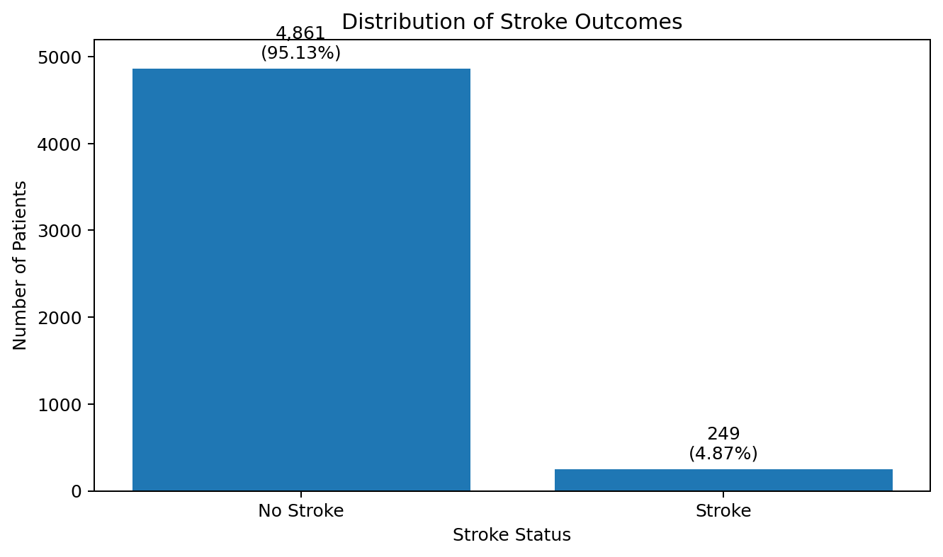
Figure 1. Distribution of stroke outcomes.
This class imbalance is an important consideration for later predictive modelling. Accuracy alone would not provide a complete picture of model performance because a model could achieve high accuracy by predominantly predicting the majority class. Sensitivity/recall, specificity, precision, F1-score and ROC-AUC should therefore be considered in future modelling work.

13. Preliminary Clinical and Demographic Findings

13.1 Hypertension and Stroke
Among patients without hypertension, 3.97% experienced stroke. Among patients with hypertension, 13.25% experienced stroke. This represents a noticeably higher observed stroke prevalence in the hypertension group.
Hypertension | No Stroke | Stroke | Stroke %
No | 4,429 | 183 | 3.97%
Yes | 432 | 66 | 13.25%

13.2 Heart Disease and Stroke
Stroke prevalence was 4.18% among patients without heart disease and 17.03% among patients with heart disease. This was one of the largest differences observed among the binary clinical factors examined.
Heart Disease | No Stroke | Stroke | Stroke %
No | 4,632 | 202 | 4.18%
Yes | 229 | 47 | 17.03%

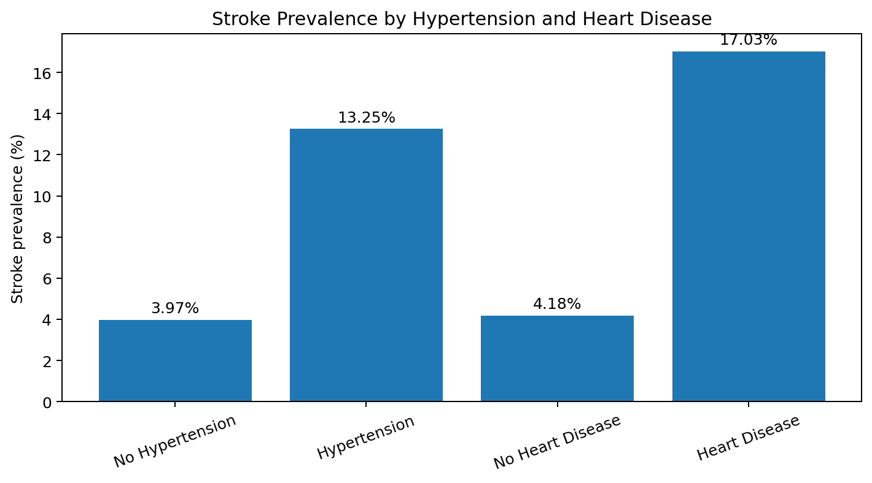
Figure 2. Observed stroke prevalence by hypertension and heart disease status.

13.3 Gender and Stroke
The observed stroke prevalence was 4.71% among females and 5.11% among males. The dataset contained one observation categorized as Other, and that observation did not have a stroke outcome. The difference between female and male stroke prevalence was relatively small compared with the differences observed for age, hypertension and heart disease.

13.4 Smoking Status and Stroke
Smoking Status | Stroke %
Formerly smoked | 7.91%
Never smoked | 4.76%
Smokes | 5.32%
Unknown | 3.04%

The formerly smoked group had the highest observed stroke prevalence at 7.91%. The smoking-status results should be interpreted cautiously because the Unknown category represents a substantial portion of the dataset.

13.5 Work Type and Stroke
Work Type | Stroke %
Children | 0.29%
Government job | 5.02%
Never worked | 0.00%
Private | 5.09%
Self-employed | 7.94%

The self-employed group showed the highest observed stroke prevalence among the listed work categories (7.94%), followed by private employment (5.09%). The very small Never_worked and children groups should not be over-interpreted because their age and sample characteristics differ substantially.

13.6 Residence and Marital Status
Factor | Group | Stroke %
Residence | Rural | 4.53%
Residence | Urban | 5.20%
Marital status | No | 1.65%
Marital status | Yes | 6.56%

Urban patients had an observed stroke prevalence of 5.20% compared with 4.53% in rural patients. Married patients had an observed prevalence of 6.56% compared with 1.65% among unmarried patients. These differences may reflect age and other confounding factors and therefore should not be interpreted as independent causal effects.

14. Comparative Visualization
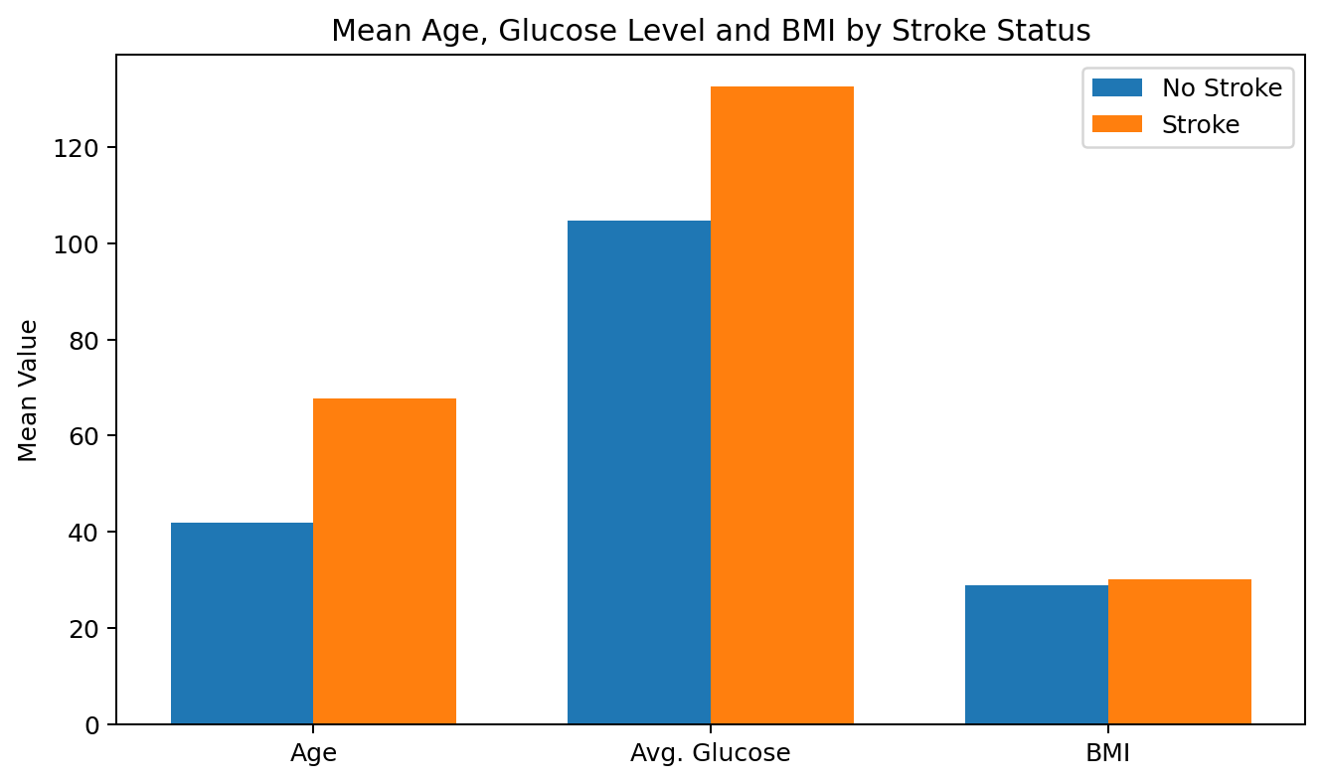
Figure 3. Comparison of mean age, average glucose level and BMI by stroke status.
The visualization reinforces the numerical findings: the stroke group had a substantially higher mean age and mean average glucose level. The mean BMI difference was comparatively small.

15. Key Findings
- The final working dataset contains 5,110 patient records with no duplicate rows or duplicate patient IDs.
- BMI contained 201 text-based missing values (3.93%), which were converted to NA and imputed using the median BMI of 28.1.
- Potential outliers were identified using the IQR method; 126 BMI values and 627 glucose values were flagged for review, while age had no flagged observations.
- Age, average glucose level and BMI were normalized to a 0–1 range using min-max normalization.
- Categorical variables were transformed into binary indicator variables using model.matrix().
- Only 4.87% of patients experienced stroke, demonstrating substantial class imbalance.
- Stroke patients were older on average (67.73 vs 41.97 years) and had higher mean glucose levels (132.54 vs 104.80).
- Observed stroke prevalence was higher among patients with hypertension (13.25%) and heart disease (17.03%).
- Age had the strongest preliminary correlation with stroke among the numerical variables examined (r = 0.245).

16. Limitations and Considerations
- The analysis is observational and identifies associations rather than causal relationships.
- Median imputation is practical for this task, but more advanced missing-data methods could be considered in future work.
- Potential outliers were flagged but not removed because extreme clinical values may be genuine and require domain validation.
- The stroke outcome is highly imbalanced, so future predictive models should use appropriate evaluation metrics and, if necessary, imbalance-handling techniques.
- Categorical variables such as smoking status contain an Unknown category that may represent missing or unreported information.
- The preliminary correlation analysis does not account for confounding or nonlinear relationships.

17. Conclusion
This Week 1 analysis established a clean and analysis-ready version of the Stroke Prediction Dataset using R. The workflow included data inspection, missing-value handling, duplicate checks, category validation, outlier detection, median imputation, numerical normalization and categorical encoding. Preliminary exploratory analysis identified meaningful differences between stroke and non-stroke patients, particularly in age, average glucose level, hypertension and heart disease. The analysis also identified substantial class imbalance in the stroke outcome. These findings provide a strong foundation for subsequent statistical testing, visualization and predictive modelling. The cleaned dataset and documented R workflow can be reused for the next stages of the internship.

Appendix A – Core R Code Used
# Import
stroke_data <- read.csv(
"data/healthcare-dataset-stroke-data.csv",
stringsAsFactors = FALSE
)
# Inspection
head(stroke_data)
dim(stroke_data)
str(stroke_data)
summary(stroke_data)
# Missing values
missing_na <- colSums(is.na(stroke_data))
# Working copy
stroke_clean <- stroke_data
# BMI cleaning
stroke_clean$bmi[stroke_clean$bmi == "N/A"] <- NA
stroke_clean$bmi <- as.numeric(stroke_clean$bmi)
# Median imputation
median_bmi <- median(stroke_clean$bmi, na.rm = TRUE)
stroke_clean$bmi[is.na(stroke_clean$bmi)] <- median_bmi
# Duplicate checks
sum(duplicated(stroke_clean))
sum(duplicated(stroke_clean$id))
# Normalization
stroke_clean$age_normalized <-
(stroke_clean$age - min(stroke_clean$age)) /
(max(stroke_clean$age) - min(stroke_clean$age))
stroke_clean$glucose_normalized <-
(stroke_clean$avg_glucose_level -
min(stroke_clean$avg_glucose_level)) /
(max(stroke_clean$avg_glucose_level) -
min(stroke_clean$avg_glucose_level))
stroke_clean$bmi_normalized <-
(stroke_clean$bmi - min(stroke_clean$bmi)) /
(max(stroke_clean$bmi) - min(stroke_clean$bmi))
# Categorical encoding
categorical_data <- model.matrix(
~ gender + ever_married + work_type +
Residence_type + smoking_status - 1,
data = stroke_clean
)
categorical_data <- as.data.frame(categorical_data)
# Outcome distribution
table(stroke_clean$stroke)
prop.table(table(stroke_clean$stroke)) * 100
# Correlation
correlation_matrix <- cor(
stroke_clean[, c(
"age", "hypertension", "heart_disease",
"avg_glucose_level", "bmi", "stroke"
)]
)
# Save cleaned dataset
write.csv(
stroke_clean,
"Data/stroke_cleaned.csv",
row.names = FALSE
)

Appendix B – Output Summary
Check | Output
Dataset dimensions | 5,110 × 12 initially
Missing BMI before imputation | 201
Missing BMI percentage | 3.93%
Median BMI used for imputation | 28.1
Missing values after cleaning | 0
Duplicate complete rows | 0
Duplicate patient IDs | 0
Normalized feature ranges | 0 to 1
Encoded categorical variables | 12
Final cleaned dataset shown in analysis | 5,110 observations
Stroke cases | 249 (4.87%)
No-stroke cases | 4,861 (95.13%)

