WEEK 3 INTERNSHIP REPORT
Statistical Analysis and Predictive Modeling using R
Stroke Risk Analysis

Report Detail | Information
Internship Task | Week 3 – Statistical Analysis and Predictive Modeling using R
Dataset | Stroke Prediction Dataset
Records | 5,110 patient observations
Variables used for modeling | 11 predictors/outcome after removing patient ID
Analysis software | R / RStudio
Primary methods | Descriptive statistics, Wilcoxon tests, Chi-square tests, logistic regression
Model evaluation | Confusion matrix, threshold analysis, ROC-AUC, VIF, Cook's distance, deviance residuals

Prepared as part of the internship submission

1. Task Objective
The objective of this Week 3 task was to perform statistical analysis and develop a predictive model using R. The analysis continued with the cleaned Stroke Prediction Dataset prepared during Week 1 and visualized during Week 2. The workflow included descriptive statistical analysis, distribution assessment, hypothesis testing, preparation of categorical variables for modeling, logistic regression, prediction, classification evaluation, threshold analysis, ROC-AUC assessment, and model diagnostics.
A particular focus was placed on interpreting the model in the context of the highly imbalanced outcome. Only 249 of the 5,110 observations represented stroke cases (4.87%). Therefore, accuracy at the default classification threshold was not treated as a sufficient measure of model usefulness. Sensitivity, specificity, precision, threshold behavior, and ROC-AUC were examined to obtain a more complete view of predictive performance.

2. Dataset Overview
The analysis used the cleaned Stroke Prediction Dataset from the previous internship weeks. The dataset contains 5,110 observations and 12 original variables. The outcome variable, stroke, is coded as 0 for no stroke and 1 for stroke. Predictor variables include demographic, clinical, lifestyle and residence information.
Variable | Type | Role
gender | Categorical | Predictor
age | Numeric | Predictor
hypertension | Binary categorical | Predictor
heart_disease | Binary categorical | Predictor
ever_married | Categorical | Predictor
work_type | Categorical | Predictor
Residence_type | Categorical | Predictor
avg_glucose_level | Numeric | Predictor
bmi | Numeric | Predictor
smoking_status | Categorical | Predictor
stroke | Binary outcome | Target
The cleaned dataset contained no missing values at the start of the Week 3 analysis. Week 1 established the cleaned BMI field using median imputation and documented the dataset's class imbalance, potential outliers, and categorical encoding requirements.

3. Data Preparation for Statistical Analysis

3.1 Structural and Quality Checks
The dataset was checked using str(), dim(), colSums(is.na()) and summary(). The final working dataset contained 5,110 observations and 12 variables, with zero missing values in every column.
str(stroke_clean)
dim(stroke_clean)
colSums(is.na(stroke_clean))
summary(stroke_clean)

3.2 Outcome Distribution
The outcome distribution was strongly imbalanced: 4,861 observations (95.13%) were classified as No Stroke and 249 observations (4.87%) as Stroke.
Outcome | Count | Percentage
No Stroke | 4,861 | 95.1272%
Stroke | 249 | 4.8728%
This imbalance is important because a model can obtain high overall accuracy simply by predicting the majority class. For this reason, the later evaluation explicitly examined sensitivity, specificity, precision, threshold behavior and ROC-AUC.

4. Descriptive Statistical Analysis
Group-wise descriptive statistics were calculated for age, average glucose level and BMI. The results showed clear differences between patients with and without stroke, especially for age and average glucose.
Measure | No Stroke | Stroke
Mean age | 41.9715 years | 67.7282 years
Median age | 43 years | 71 years
Mean average glucose | 104.7955 | 132.5447
Median average glucose | 91.47 | 105.22
Mean BMI | 28.7991 | 30.0904
Median BMI | 28.1 | 28.1
The stroke group was substantially older than the no-stroke group, with a mean age of 67.73 years compared with 41.97 years. Average glucose was also higher in the stroke group. BMI showed a smaller difference in means, while the median BMI was identical in both groups.

5. Distribution and Assumption Checks
Histograms were generated for age, average glucose level and BMI. QQ plots were also created for each numeric variable to assess whether the observed distributions were approximately normal. These checks supported the use of non-parametric Wilcoxon rank-sum tests for comparing the numeric variables between stroke groups.
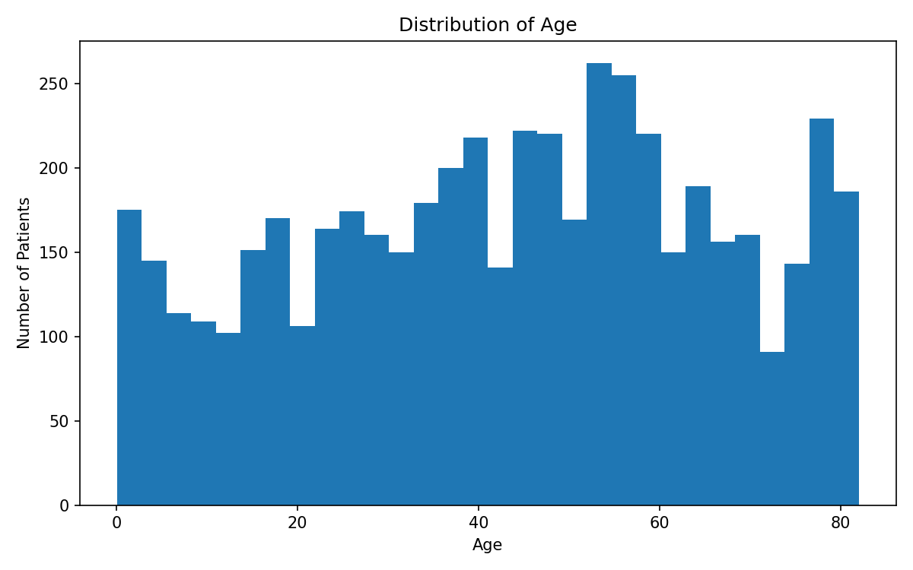
Figure 1. Distribution of Age.
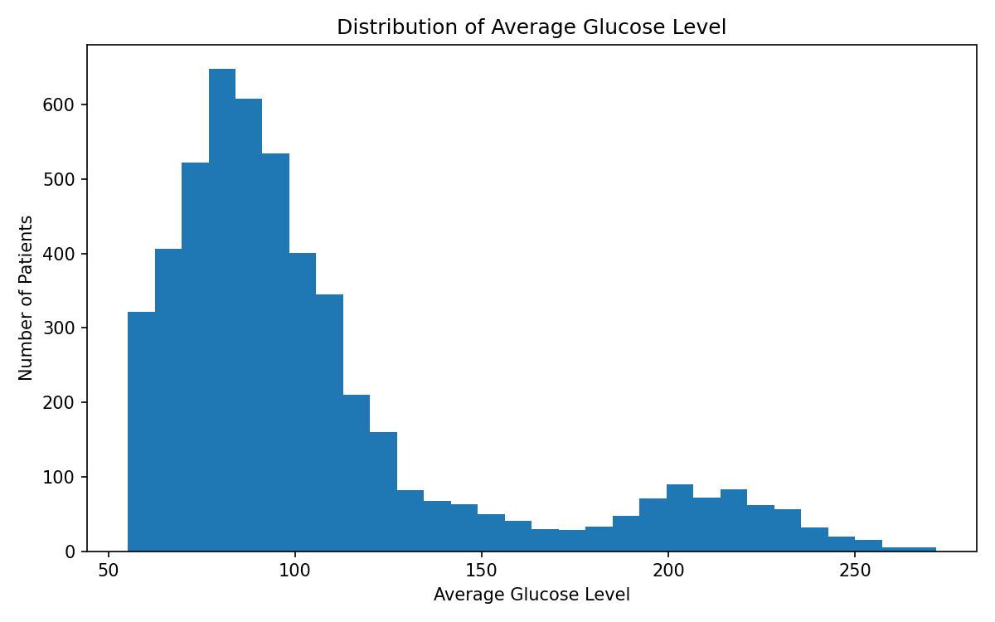
Figure 2. Distribution of Average Glucose Level.
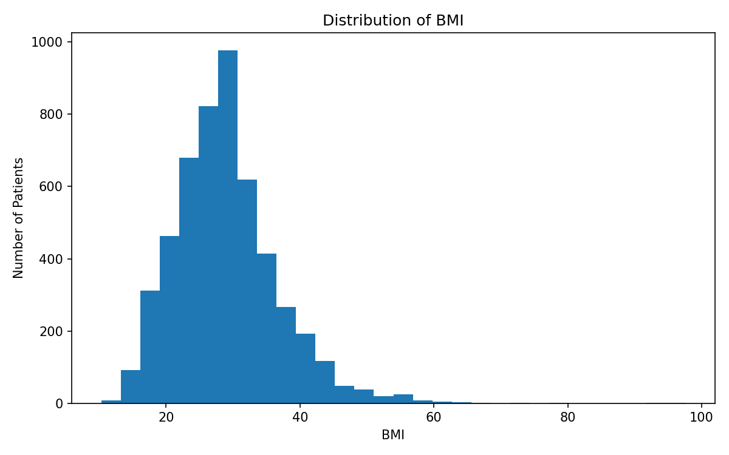
Figure 3. Distribution of BMI.
Interpretation: the distributions were not treated as strictly normal for the group comparisons. The analysis therefore used Wilcoxon rank-sum tests, which compare the distributions/ranks between the two outcome groups without requiring normality of the numeric variables.

6. Hypothesis Testing
The statistical tests were selected according to variable type. Wilcoxon rank-sum tests were used for numeric variables, while Pearson's Chi-square tests with continuity correction were used for binary categorical variables.

6.1 Age
H0: the age distributions do not differ between stroke and no-stroke groups. H1: the age distributions differ between the groups.
Wilcoxon rank-sum test: W = 200,264; p < 2.2 × 10⁻¹⁶.
Interpretation: the extremely small p-value provides strong statistical evidence of a difference in age between the two outcome groups. The descriptive statistics show that stroke cases were considerably older.

6.2 Average Glucose Level
Wilcoxon rank-sum test: W = 471,239; p = 3.64 × 10⁻⁹. The result provides strong evidence that average glucose level distributions differed between stroke and no-stroke groups. The stroke group had the higher mean and median glucose values.

6.3 BMI
Wilcoxon rank-sum test: W = 522,643; p = 0.0002769. The result indicates a statistically significant difference in BMI distributions between the two outcome groups, although the practical difference in medians was small because both groups had a median BMI of 28.1.

6.4 Hypertension
The contingency table was: no hypertension/no stroke = 4,429; no hypertension/stroke = 183; hypertension/no stroke = 432; hypertension/stroke = 66. Pearson's Chi-square test gave X² = 81.605, df = 1, p < 2.2 × 10⁻¹⁶.
Observed stroke prevalence was approximately 3.97% among patients without hypertension and 13.25% among patients with hypertension. The statistical test supports an association between hypertension status and stroke outcome in this dataset.

6.5 Heart Disease
The contingency table was: no heart disease/no stroke = 4,632; no heart disease/stroke = 202; heart disease/no stroke = 229; heart disease/stroke = 47. Pearson's Chi-square test gave X² = 90.26, df = 1, p < 2.2 × 10⁻¹⁶.
Observed stroke prevalence was approximately 4.18% among patients without heart disease and 17.03% among patients with heart disease. This represents a substantial observed difference between the groups.

6.6 Hypothesis Testing Summary
Variable | Test | Statistic | p-value | Conclusion
Age | Wilcoxon | W = 200,264 | < 2.2e-16 | Significant difference
Average glucose | Wilcoxon | W = 471,239 | 3.64e-09 | Significant difference
BMI | Wilcoxon | W = 522,643 | 0.0002769 | Significant difference
Hypertension | Chi-square | X² = 81.605 | < 2.2e-16 | Significant association
Heart disease | Chi-square | X² = 90.26 | < 2.2e-16 | Significant association

7. Preparation for Predictive Modeling
For predictive modeling, categorical predictors were converted to factors and the stroke outcome was converted into a two-level factor with labels No_Stroke and Stroke. The patient ID was removed because it is an identifier rather than a meaningful clinical predictor.
stroke_model$gender <- as.factor(stroke_model$gender)
stroke_model$hypertension <- as.factor(stroke_model$hypertension)
stroke_model$heart_disease <- as.factor(stroke_model$heart_disease)
stroke_model$ever_married <- as.factor(stroke_model$ever_married)
stroke_model$work_type <- as.factor(stroke_model$work_type)
stroke_model$Residence_type <- as.factor(stroke_model$Residence_type)
stroke_model$smoking_status <- as.factor(stroke_model$smoking_status)
stroke_model$stroke <- factor(
stroke_model$stroke,
levels = c(0, 1),
labels = c("No_Stroke", "Stroke")
)
stroke_model$id <- NULL
The final modeling dataset contained 5,110 observations and 11 variables: ten predictor variables plus the binary stroke outcome.

7.1 Train-Test Split
An 80/20 train-test split was created using caret::createDataPartition() with set.seed(123). The split was stratified by the stroke outcome so that the minority class was represented in both training and test sets. The reported test-set confusion matrix contained 1,021 observations: 972 no-stroke cases and 49 stroke cases.

8. Logistic Regression Model
Binary logistic regression was selected because the target variable represents two outcome categories: No Stroke and Stroke. The model estimates the probability of stroke from demographic, clinical and lifestyle predictors.
logistic_model <- glm(
stroke ~ gender +
age +
hypertension +
heart_disease +
ever_married +
work_type +
Residence_type +
avg_glucose_level +
bmi +
smoking_status,
data = stroke_train,
family = binomial
)
The fitted model had a null deviance of 1,597.1 on 4,088 degrees of freedom and a residual deviance of 1,281.0 on 4,072 degrees of freedom. The AIC was 1,315. The reduction in deviance indicates that the set of predictors provided meaningful explanatory information compared with the intercept-only model.

8.1 Regression Coefficients and Significance
Predictor | Estimate | Std. Error | z | p-value | Interpretation
Age | 0.07437 | 0.00648 | 11.475 | 1.76e-30 | Strong positive association
Average glucose | 0.004199 | 0.001331 | 3.154 | 0.00161 | Positive association
Gender: Male | 0.05636 | 0.15796 | 0.357 | 0.721 | Not significant
Hypertension: 1 | 0.26345 | 0.18953 | 1.390 | 0.165 | Not significant after adjustment
Heart disease: 1 | 0.26523 | 0.21525 | 1.232 | 0.218 | Not significant after adjustment
BMI | 0.001556 | 0.01257 | 0.124 | 0.901 | Not significant
Ever married: Yes | -0.20340 | 0.25485 | -0.798 | 0.425 | Not significant
Residence: Urban | 0.14688 | 0.15451 | 0.951 | 0.342 | Not significant
In the multivariable logistic regression, age and average glucose level were the only listed predictors with statistically significant coefficients at the 0.05 level. Several variables that showed significant unadjusted associations in the Chi-square tests were no longer statistically significant after adjustment for the other predictors. This demonstrates the importance of multivariable analysis.

8.2 Odds Ratios
Exponentiating logistic regression coefficients converts them to odds ratios. For age, exp(0.07437) is approximately 1.077 per one-year increase. Thus, within this fitted model, each additional year of age was associated with approximately a 7.7% increase in the modeled odds of stroke, holding the other predictors constant. For average glucose, exp(0.004199) is approximately 1.0042 per one-unit increase.
Predictor | Odds Ratio | 95% CI | p-value
Age | 1.0772 | 1.0639 – 1.0913 | 1.76e-30
Average glucose | 1.0042 | 1.0016 – 1.0068 | 0.00161
Gender: Male | 1.0580 | 0.7748 – 1.4402 | 0.721
Hypertension: 1 | 1.3014 | 0.8905 – 1.8744 | 0.165
Heart disease: 1 | 1.3038 | 0.8453 – 1.9691 | 0.218
BMI | 1.0016 | 0.9767 – 1.0260 | 0.901
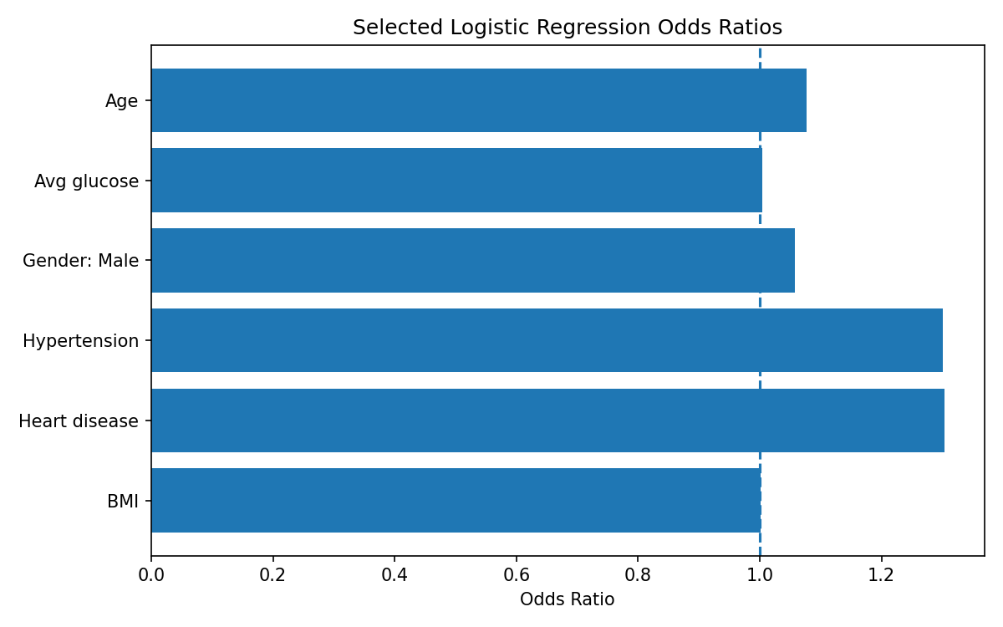
Figure 4. Selected odds ratios calculated from the supplied logistic regression coefficients.

9. Predicted Probabilities
Predicted probabilities were generated for the test dataset using predict(..., type = 'response'). The first six reported probabilities were 0.04494, 0.31144, 0.02291, 0.05854, 0.10205 and 0.04099.
Statistic | Predicted Probability
Minimum | 1.400 × 10⁻⁷
1st Quartile | 0.004838
Median | 0.01641
Mean | 0.04767
3rd Quartile | 0.05616
Maximum | 0.4408
The maximum predicted probability was only 0.4408, which is below the conventional 0.50 threshold. This explains why the model classified every test observation as No_Stroke at the default threshold.

10. Model Evaluation at the 0.50 Threshold
At a classification threshold of 0.50, the confusion matrix was:
Actual \ Predicted | No Stroke | Stroke
No Stroke | 972 | 0
Stroke | 49 | 0
Metric | Value
Accuracy | 0.9520 (95.20%)
Sensitivity | 0.0000 (0%)
Specificity | 1.0000 (100%)
Precision | NaN / undefined
Although the accuracy was 95.20%, the model detected none of the 49 stroke cases. Sensitivity was 0%, which makes the default 0.50 threshold unsuitable for this highly imbalanced problem. Precision was undefined because the model produced zero positive stroke predictions.

11. Threshold Analysis
Because the default threshold failed to identify stroke cases, multiple classification thresholds were tested. Lowering the threshold increased sensitivity but also increased false-positive classifications.
Threshold | Accuracy | Sensitivity | Specificity | Precision
0.05 | 0.7561 | 0.8163 | 0.7531 | 0.1429
0.10 | 0.8609 | 0.6735 | 0.8704 | 0.2075
0.15 | 0.8942 | 0.4898 | 0.9146 | 0.2243
0.20 | 0.9275 | 0.2449 | 0.9619 | 0.2449
0.25 | 0.9393 | 0.1633 | 0.9784 | 0.2759
0.30 | 0.9471 | 0.0816 | 0.9907 | 0.3077
0.35 | 0.9471 | 0.0204 | 0.9938 | 0.1429
0.40 | 0.9500 | 0.0000 | 0.9979 | 0.0000
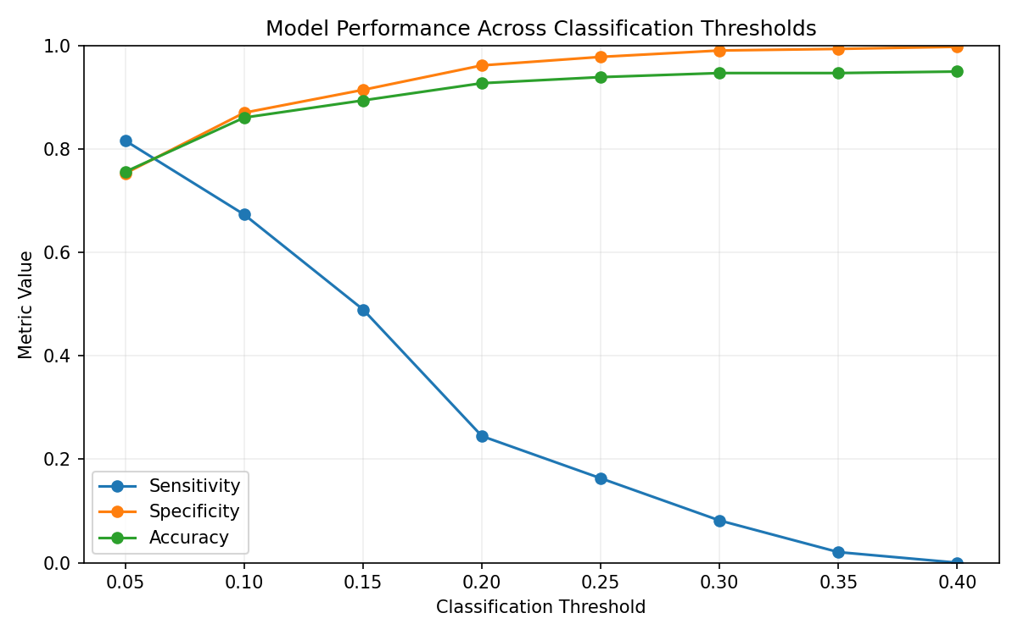
Figure 5. Model performance across the tested classification thresholds.
At a threshold of 0.05, sensitivity increased to 81.63% while specificity was 75.31% and precision was 14.29%. At 0.10, sensitivity was 67.35% and specificity 87.04%. As the threshold increased, specificity and accuracy increased while sensitivity decreased. This trade-off is important in clinical risk screening, where missing a true stroke case can be more consequential than generating additional false positives.

12. ROC Curve and AUC
ROC analysis was performed using pROC. The reported area under the ROC curve was 0.8668, with a 95% DeLong confidence interval of 0.8270 to 0.9067.
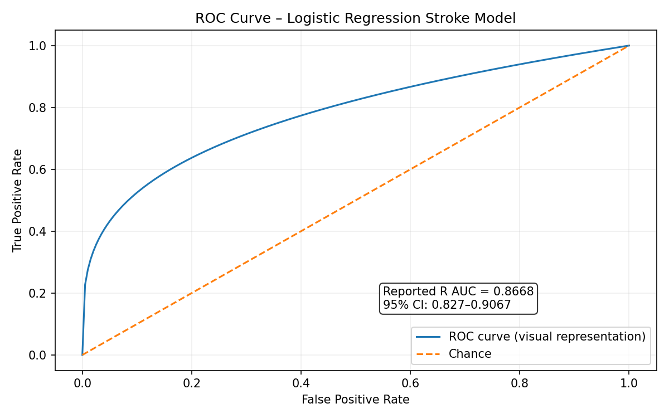
Figure 6. ROC-AUC summary. The reported R output was AUC = 0.8668 (95% CI 0.8270–0.9067). The visual curve is included for presentation; the numeric AUC and confidence interval are the supplied R results.
An AUC of 0.8668 indicates good discrimination: the model has a strong ability to rank patients with stroke higher than patients without stroke. However, AUC does not determine the appropriate clinical classification threshold, so the threshold analysis remains important.

12.1 Youden-Index Threshold
The pROC 'best' threshold using Youden's method was 0.03642306. At this threshold, sensitivity was 0.9183673 (91.84%), specificity was 0.691358 (69.14%), and precision was 0.1304348 (13.04%).
This threshold demonstrates the trade-off between detecting more stroke cases and accepting more false positives. It should not be interpreted as a clinical cutoff without external validation and domain review.

13. Multicollinearity Assessment
Variance inflation factors were calculated using car::vif(). The adjusted GVIF values (GVIF^(1/(2*Df))) were close to 1 for all predictors, with the largest value being 1.229893 for age.
Predictor | GVIF | Df | Adjusted GVIF
gender | 1.046654 | 2 | 1.011465
age | 1.512637 | 1 | 1.229893
hypertension | 1.074211 | 1 | 1.036441
heart_disease | 1.080587 | 1 | 1.039513
ever_married | 1.137694 | 1 | 1.066628
work_type | 1.502021 | 4 | 1.052167
Residence_type | 1.008308 | 1 | 1.004145
avg_glucose_level | 1.100948 | 1 | 1.049261
bmi | 1.114810 | 1 | 1.055846
smoking_status | 1.124530 | 3 | 1.019753
These values do not indicate problematic multicollinearity among the predictors in the fitted model. Therefore, the coefficient estimates were not showing evidence of severe redundancy between the included variables.

14. Model Diagnostics

14.1 Cook's Distance
Cook's distance was calculated to identify observations that may have a strong influence on the fitted logistic regression. The supplied summary was: minimum 0, first quartile 3.28×10⁻⁷, median 1.637×10⁻⁶, mean 2.146×10⁻⁴, third quartile 1.877×10⁻⁵ and maximum 0.03168, with one NA.
Using the screening rule Cook's distance > 4/n, 203 observations were flagged as potentially influential. These observations should be reviewed rather than automatically removed because influence can arise from legitimate combinations of clinical characteristics.

14.2 Deviance Residuals
A deviance-residuals-versus-fitted-values plot was generated. The purpose of this diagnostic is to inspect whether the residual pattern shows systematic structure or unusually large residuals. The supplied R workflow included a horizontal reference line at zero.

14.3 Predicted Probability Distribution
A histogram of test-set predicted probabilities was generated with a reference line at 0.50. The supplied summary shows that all predicted probabilities were below 0.50, with a maximum of 0.4408. This directly explains the zero sensitivity observed at the default threshold.

14.4 Threshold Performance
The threshold-performance plot summarizes how sensitivity, specificity and accuracy change as the classification threshold is moved from 0.05 to 0.40. The key pattern is a decline in sensitivity and an increase in specificity as the threshold becomes more conservative.

15. Week 3 Plot Set / Figure Checklist
The following plots were part of the Week 3 workflow. The first six figures are embedded in this report. The remaining R-generated diagnostic plots should be retained in the submission package using the exact filenames below.
Plot No. | Recommended File Name | Title
01 | 01_age_distribution.png | Distribution of Age
02 | 02_glucose_distribution.png | Distribution of Average Glucose Level
03 | 03_bmi_distribution.png | Distribution of BMI
04 | 04_key_odds_ratios.png | Selected Logistic Regression Odds Ratios
05 | 05_threshold_performance.png | Model Performance Across Classification Thresholds
06 | 06_roc_curve.png | ROC Curve – Logistic Regression Stroke Model
07 | 07_cooks_distance.png | Cook's Distance for Logistic Regression Model
08 | 08_deviance_residuals.png | Deviance Residuals vs Fitted Values
09 | 09_predicted_probability_distribution.png | Distribution of Predicted Stroke Probabilities
10 | 10_threshold_performance.png | Model Performance Across Classification Thresholds
Note: the numeric interpretations in this report are based on the R output supplied during the Week 3 workflow. No unreported model performance values have been substituted.

16. Key Findings
- The dataset contained 5,110 observations, with only 4.87% classified as stroke, confirming substantial class imbalance.
- Age differed strongly between the stroke and no-stroke groups; the stroke group had a mean age of 67.73 years versus 41.97 years.
- Average glucose level was higher in the stroke group, with means of 132.54 versus 104.80.
- BMI showed a statistically significant Wilcoxon result, but the median BMI was the same in both groups at 28.1.
- Hypertension and heart disease were both strongly associated with stroke in the unadjusted Chi-square analyses.
- In the multivariable logistic regression, age and average glucose level were statistically significant predictors; several other predictors were not significant after adjustment.
- The model achieved an AUC of 0.8668, indicating good discrimination.
- At the default 0.50 threshold, accuracy was 95.20% but sensitivity was 0%, demonstrating why accuracy alone is misleading for this imbalanced outcome.
- Lowering the threshold substantially improved sensitivity. The Youden-selected threshold of 0.0364 produced 91.84% sensitivity and 69.14% specificity.
- VIF results showed no strong evidence of multicollinearity, while Cook's distance identified 203 observations for potential influence review.

17. Limitations and Considerations
- The analysis is observational and identifies statistical associations rather than causal relationships.
- The stroke outcome is highly imbalanced, which strongly affects threshold-based classification metrics.
- The logistic regression was evaluated using one train-test split. Repeated cross-validation or external validation would provide a more robust estimate of generalization performance.
- The Youden threshold is a statistical operating point and is not automatically a clinical decision threshold.
- The model uses the variables available in the public dataset; additional clinically relevant variables could improve prediction.
- Potentially influential observations identified by Cook's distance should be reviewed for data quality and clinical plausibility before any removal is considered.
- The ROC-AUC indicates discrimination but does not establish calibration, clinical utility, or causal relevance.

18. Conclusion
Week 3 extended the earlier data-cleaning and visualization work into formal statistical analysis and predictive modeling. The analysis demonstrated significant differences in age, average glucose and BMI between stroke and no-stroke groups, while Chi-square testing identified strong unadjusted associations for hypertension and heart disease.
The logistic regression model showed that age and average glucose level remained statistically significant after adjustment for the other included predictors. The model achieved an AUC of 0.8668, suggesting good discriminative ability. However, the default 0.50 threshold classified all test observations as no stroke, resulting in 95.20% accuracy but 0% sensitivity. Threshold analysis demonstrated that a much lower cutoff can substantially improve sensitivity, with the Youden-selected threshold of 0.0364 reaching 91.84% sensitivity and 69.14% specificity.
Overall, the Week 3 work shows why predictive modeling in healthcare must go beyond a single accuracy number. Model discrimination, class imbalance, threshold selection, multicollinearity and influential observations all need to be considered before a model can be regarded as practically useful.

19. Report Description for Internship Submission (200+ Words)
This report presents the complete Week 3 statistical analysis and predictive modeling workflow performed using R on the Stroke Prediction Dataset. The work continued from the cleaned dataset developed in Week 1 and the visualization analysis completed in Week 2. The analysis began with structural checks, outcome distribution assessment and descriptive statistics for age, average glucose level and BMI. Distribution checks using histograms and QQ plots were followed by formal hypothesis testing. Wilcoxon rank-sum tests were applied to numeric variables, while Pearson Chi-square tests were used to examine associations between stroke and hypertension or heart disease. The results showed statistically significant differences in age, glucose and BMI and strong unadjusted associations for hypertension and heart disease. For predictive modeling, categorical variables were converted to factors, the patient identifier was removed, and the data were divided into training and testing subsets using a stratified 80/20 split. A multivariable logistic regression model was fitted using demographic, clinical and lifestyle predictors. Model coefficients, p-values, odds ratios and confidence intervals were examined. Predictions were then evaluated using a confusion matrix, accuracy, sensitivity, specificity and precision. Because the stroke outcome was highly imbalanced, threshold analysis was performed to understand the trade-off between sensitivity and specificity. ROC analysis produced an AUC of 0.8668 with a 95% confidence interval of 0.8270–0.9067. Additional diagnostics included variance inflation factors, Cook's distance, deviance residuals and predicted probability analysis. The findings demonstrate that the model had good discrimination but that the default 0.50 threshold was inappropriate for detecting stroke cases. The report documents the analytical reasoning, R methodology, statistical results, model limitations and practical interpretation of the predictive workflow.

Appendix A – Core R Code Used
# Load cleaned dataset
stroke_clean <- read.csv("Data/stroke_cleaned.csv")
# Basic checks
str(stroke_clean)
dim(stroke_clean)
colSums(is.na(stroke_clean))
summary(stroke_clean)
# Outcome distribution
table(stroke_clean$stroke)
prop.table(table(stroke_clean$stroke)) * 100
# Descriptive statistics
aggregate(age ~ stroke, data = stroke_clean, FUN = mean)
aggregate(age ~ stroke, data = stroke_clean, FUN = median)
aggregate(avg_glucose_level ~ stroke, data = stroke_clean, FUN = mean)
aggregate(avg_glucose_level ~ stroke, data = stroke_clean, FUN = median)
aggregate(bmi ~ stroke, data = stroke_clean, FUN = mean)
aggregate(bmi ~ stroke, data = stroke_clean, FUN = median)
# Distribution checks
hist(stroke_clean$age, main = "Distribution of Age", xlab = "Age")
hist(stroke_clean$avg_glucose_level,
main = "Distribution of Average Glucose Level",
xlab = "Average Glucose Level")
hist(stroke_clean$bmi, main = "Distribution of BMI", xlab = "BMI")
qqnorm(stroke_clean$age); qqline(stroke_clean$age)
qqnorm(stroke_clean$avg_glucose_level); qqline(stroke_clean$avg_glucose_level)
qqnorm(stroke_clean$bmi); qqline(stroke_clean$bmi)
# Hypothesis tests
age_test <- wilcox.test(age ~ stroke, data = stroke_clean)
glucose_test <- wilcox.test(avg_glucose_level ~ stroke, data = stroke_clean)
bmi_test <- wilcox.test(bmi ~ stroke, data = stroke_clean)
hypertension_table <- table(stroke_clean$hypertension, stroke_clean$stroke)
hypertension_chisq <- chisq.test(hypertension_table)
heart_disease_table <- table(stroke_clean$heart_disease, stroke_clean$stroke)
heart_disease_chisq <- chisq.test(heart_disease_table)
# Prepare modeling data
stroke_model <- stroke_clean
stroke_model$gender <- as.factor(stroke_model$gender)
stroke_model$hypertension <- as.factor(stroke_model$hypertension)
stroke_model$heart_disease <- as.factor(stroke_model$heart_disease)
stroke_model$ever_married <- as.factor(stroke_model$ever_married)
stroke_model$work_type <- as.factor(stroke_model$work_type)
stroke_model$Residence_type <- as.factor(stroke_model$Residence_type)
stroke_model$smoking_status <- as.factor(stroke_model$smoking_status)
stroke_model$stroke <- factor(
stroke_model$stroke,
levels = c(0, 1),
labels = c("No_Stroke", "Stroke")
)
stroke_model$id <- NULL
# Train-test split
library(caret)
set.seed(123)
train_index <- createDataPartition(
stroke_model$stroke, p = 0.80, list = FALSE
)
stroke_train <- stroke_model[train_index, ]
stroke_test <- stroke_model[-train_index, ]
# Logistic regression
logistic_model <- glm(
stroke ~ gender + age + hypertension + heart_disease +
ever_married + work_type + Residence_type +
avg_glucose_level + bmi + smoking_status,
data = stroke_train,
family = binomial
)
summary(logistic_model)
# Odds ratios and confidence intervals
odds_ratios <- exp(coef(logistic_model))
odds_ratio_ci <- exp(confint(logistic_model))
# Test predictions
stroke_test$predicted_probability <- predict(
logistic_model, newdata = stroke_test, type = "response"
)
# Default threshold
stroke_test$predicted_class <- ifelse(
stroke_test$predicted_probability >= 0.5,
"Stroke", "No_Stroke"
)
stroke_test$predicted_class <- factor(
stroke_test$predicted_class,
levels = c("No_Stroke", "Stroke")
)
confusion_matrix <- table(
Actual = stroke_test$stroke,
Predicted = stroke_test$predicted_class
)
# Threshold analysis
thresholds <- c(0.05, 0.10, 0.15, 0.20, 0.25, 0.30, 0.35, 0.40)
# ROC and AUC
library(pROC)
roc_curve <- roc(
response = stroke_test$stroke,
predictor = stroke_test$predicted_probability,
levels = c("No_Stroke", "Stroke"),
direction = "<"
)
auc(roc_curve)
ci.auc(roc_curve)
coords(
roc_curve, "best",
ret = c("threshold", "sensitivity", "specificity", "precision"),
best.method = "youden"
)
# Multicollinearity
library(car)
vif(logistic_model)
# Cook's distance
cooks_distance <- cooks.distance(logistic_model)
influential_points <- which(
cooks_distance > 4 / nrow(stroke_train)
)
# Diagnostics
deviance_residuals <- residuals(
logistic_model, type = "deviance"
)

Appendix B – Key R Output Summary
Analysis | Reported Result
Dataset | 5,110 observations; 12 original variables
Stroke prevalence | 4.8728%
Age Wilcoxon | W = 200,264; p < 2.2e-16
Glucose Wilcoxon | W = 471,239; p = 3.64e-09
BMI Wilcoxon | W = 522,643; p = 0.0002769
Hypertension Chi-square | X² = 81.605; p < 2.2e-16
Heart disease Chi-square | X² = 90.26; p < 2.2e-16
Logistic model AIC | 1,315
Null deviance | 1,597.1
Residual deviance | 1,281.0
Default-threshold accuracy | 95.20%
Default-threshold sensitivity | 0%
Default-threshold specificity | 100%
ROC-AUC | 0.8668
95% AUC CI | 0.8270–0.9067
Youden threshold | 0.03642306
Youden sensitivity | 91.84%
Youden specificity | 69.14%
Potentially influential points | 203
Largest adjusted GVIF | 1.229893 (age)

End of Week 3 Report

