WEEK 2
DATA VISUALIZATION AND INSIGHT COMMUNICATION USING R
Stroke Risk Analysis – Healthcare Dataset
Portfolio Analysis Project
Tools: R, ggplot2, corrplot
Dataset: 5,110 patient records
Visualization outputs: 9

1. Introduction
The objective of Week 2 was to transform the cleaned stroke-risk dataset from Week 1 into clear, informative visualizations and communicate the major patterns in a way that can be understood by both technical and non-technical audiences. The analysis continued with the same publicly available healthcare dataset containing demographic, lifestyle, and clinical variables associated with stroke outcomes.
The visualization stage focused on answering practical analytical questions: How balanced is the stroke outcome? Does age differ between patients with and without stroke? How do age and glucose level interact? Are BMI distributions different? How do hypertension, heart disease, smoking status, and age groups relate to observed stroke rates? Finally, what relationships are visible among the key numerical variables?

2. Dataset Overview
The cleaned dataset contains 5,110 patient records and 12 variables. All missing values were resolved during the Week 1 cleaning process, so the Week 2 visualization dataset contained no missing observations in the variables used for analysis.
Variable | Type | Role
age | Numeric | Patient age
hypertension | Binary | Hypertension indicator
heart_disease | Binary | Heart disease indicator
avg_glucose_level | Numeric | Average glucose level
bmi | Numeric | Body mass index
smoking_status | Categorical | Smoking history/status
work_type | Categorical | Employment category
Residence_type | Categorical | Urban/Rural residence
ever_married | Categorical | Marital status
stroke | Binary | Target outcome
The outcome distribution was highly imbalanced: 4,861 records (95.13%) were classified as no stroke and 249 records (4.87%) as stroke. This imbalance is important because percentages and group-specific rates are more informative than comparing raw counts alone when evaluating risk patterns.

3. Visualization Methodology
- Used ggplot2 for the primary visualizations and corrplot for the correlation heatmap.
- Used counts for overall outcome distribution and stroke rates (percentages) for risk-factor comparisons.
- Used histograms to examine distributions, a scatter plot to examine a numeric relationship, a boxplot to compare BMI distributions, and a correlation heatmap to summarize linear associations.
- Created an age-group variable using the ranges ≤30, 31–40, 41–50, 51–60, 61–70, 71–80, and 80+.
- Saved visualization outputs as high-resolution PNG files at 300 DPI for documentation and portfolio use.

4. Stroke Outcome Distribution

Purpose and visualization choice
This bar chart was selected to establish the overall composition of the target variable before interpreting any risk-factor comparison. The dataset contains 4,861 patients without a recorded stroke and 249 patients with a recorded stroke. Therefore, only 4.87% of observations belong to the stroke group. The visualization makes the class imbalance immediately visible.

R code
stroke_counts <- as.data.frame(table(stroke_clean$stroke))
names(stroke_counts) <- c("Stroke", "Count")
stroke_counts$Stroke <- factor(
stroke_counts$Stroke,
levels = c(0, 1),
labels = c("No Stroke", "Stroke")
)
ggplot(stroke_counts, aes(x = Stroke, y = Count)) +
geom_col() +
labs(
title = "Distribution of Stroke Outcomes",
x = "Stroke Status",
y = "Number of Patients"
) +
theme_minimal()

Visualization
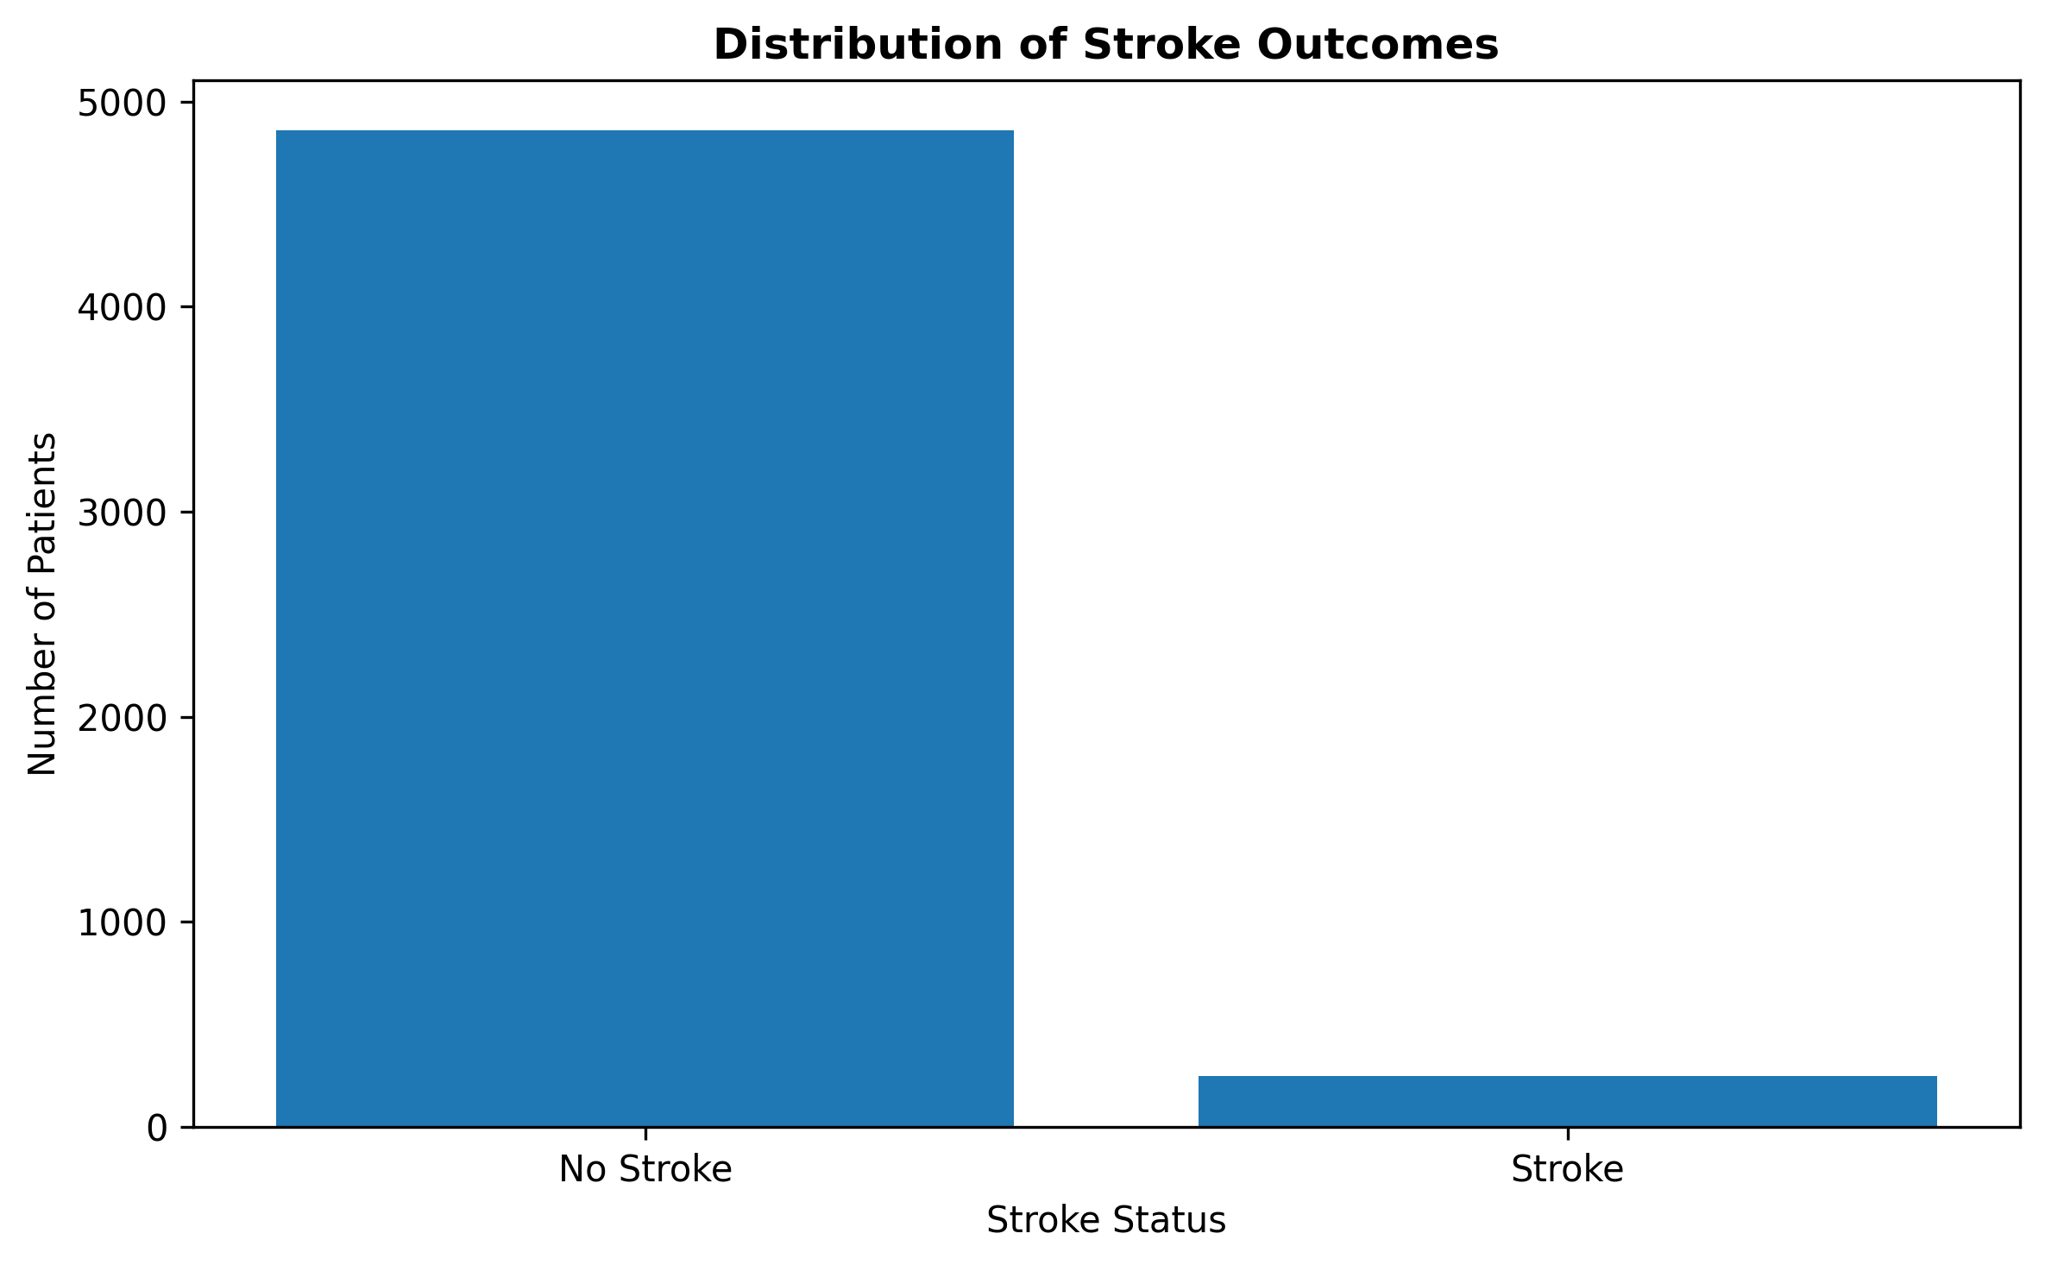
Figure 1. Distribution of stroke outcomes.

Interpretation and key insight
The main insight is that stroke cases represent a relatively small proportion of the dataset. This means that raw counts alone can be misleading when comparing groups. For example, a risk factor may have many more non-stroke observations simply because non-stroke observations are much more common overall. For this reason, the later visualizations use within-group stroke rates wherever appropriate. The imbalance is also an important consideration for any future predictive modelling because accuracy alone could give an overly optimistic impression of model performance.

5. Age Distribution by Stroke Status

Purpose and visualization choice
A histogram was selected because age is a continuous numerical variable and a histogram allows the distribution of values to be compared across the two outcome groups. The visualization shows that the stroke group is concentrated at older ages, while the non-stroke group contains a much broader distribution of younger and middle-aged patients.

R code
stroke_clean$stroke_label <- factor(
stroke_clean$stroke,
levels = c(0, 1),
labels = c("No Stroke", "Stroke")
)
ggplot(stroke_clean, aes(x = age, fill = stroke_label)) +
geom_histogram(
bins = 30,
alpha = 0.6,
position = "identity"
) +
labs(
title = "Age Distribution by Stroke Status",
x = "Age",
y = "Number of Patients",
fill = "Stroke Status"
) +
theme_minimal()

Visualization
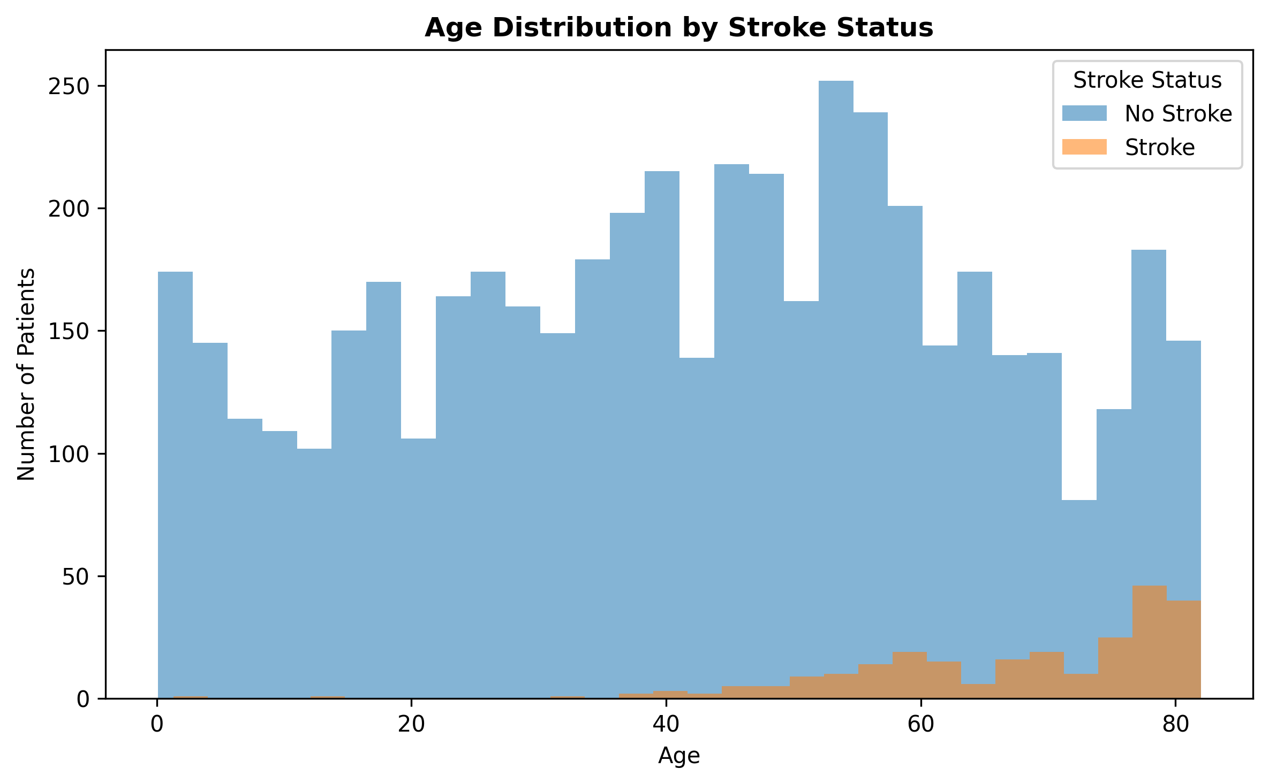
Figure 2. Age distribution by stroke status.

Interpretation and key insight
The numerical summaries support the visual pattern. The mean age was 41.97 years for patients without stroke and 67.73 years for patients with stroke. The median ages were 43 and 71 years, respectively. The difference between the groups is substantial and indicates that age is one of the strongest variables associated with the observed stroke outcome in this dataset. This finding is consistent with the later age-group analysis, where stroke rates increase progressively across older age categories.

6. Age vs Average Glucose Level

Purpose and visualization choice
A scatter plot was selected to examine the relationship between two continuous variables: age and average glucose level. Stroke status was used as the grouping variable so that the distribution of observations could be compared visually.

R code
ggplot(
stroke_clean,
aes(
x = age,
y = avg_glucose_level,
color = stroke_label
)
) +
geom_point(alpha = 0.5) +
labs(
title = "Age vs Average Glucose Level by Stroke Status",
x = "Age",
y = "Average Glucose Level",
color = "Stroke Status"
) +
theme_minimal()

Visualization
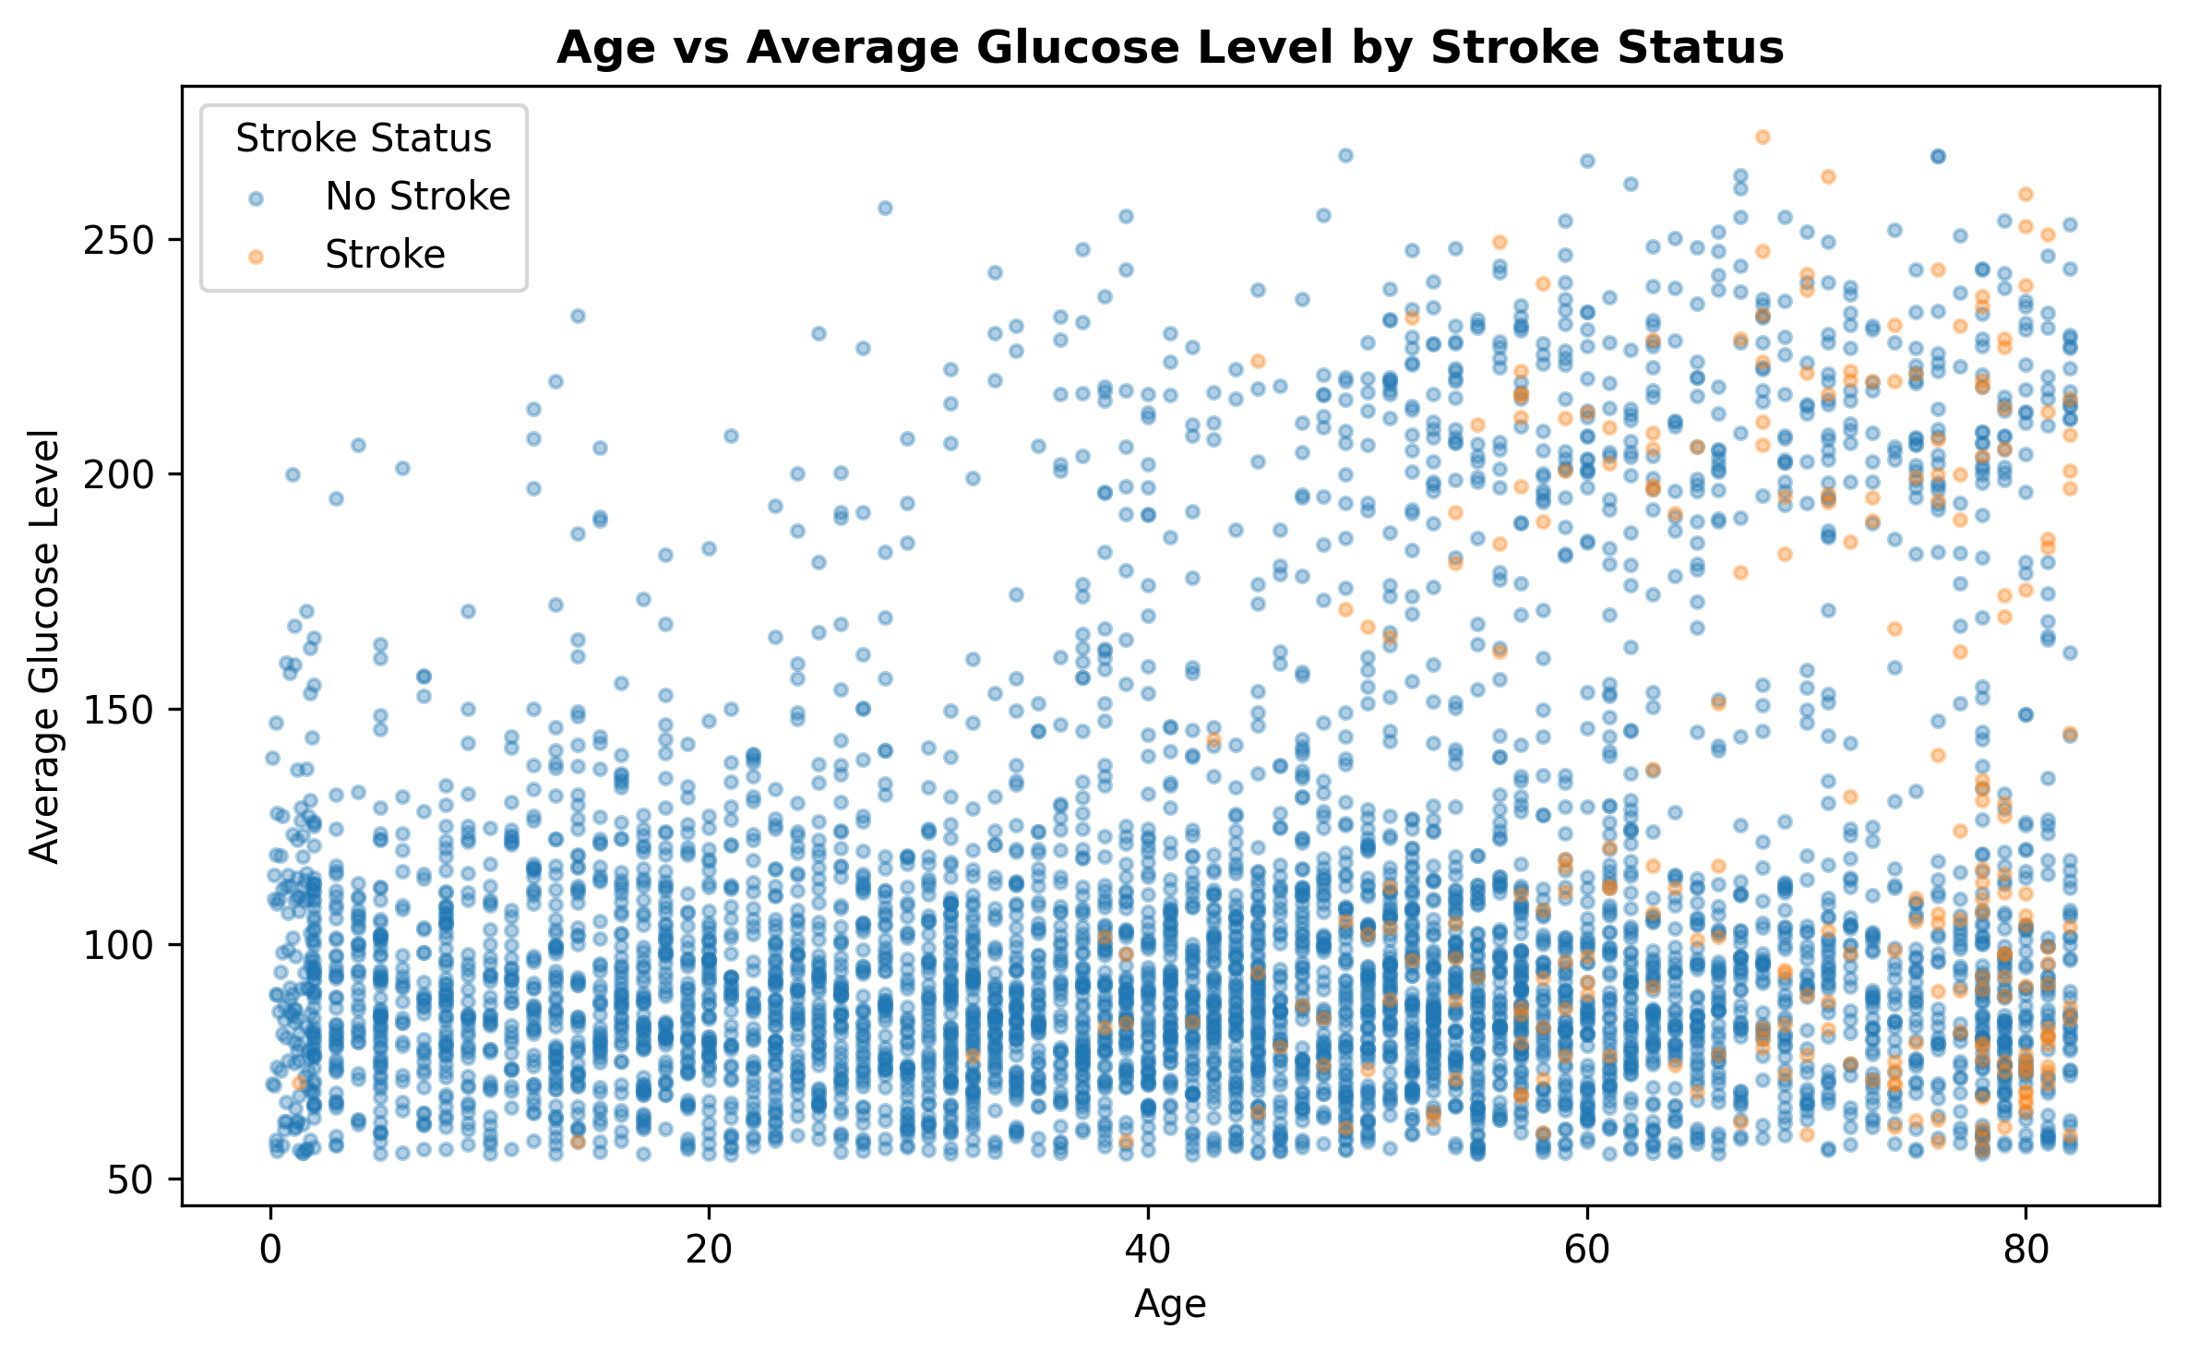
Figure 3. Relationship between age and average glucose level.

Interpretation and key insight
The plot shows that patients with stroke are more visibly concentrated toward older ages and, in many cases, higher glucose levels. The Week 1 numerical analysis also showed a positive correlation between age and stroke (r = 0.245), average glucose level and stroke (r = 0.132), and a positive correlation between age and glucose (r = 0.238). These relationships are moderate rather than deterministic, meaning that age or glucose level alone does not explain every stroke outcome. The scatter plot is therefore useful for identifying patterns while avoiding the interpretation that correlation proves causation.

7. BMI Distribution by Stroke Status

Purpose and visualization choice
A boxplot was selected because BMI is continuous and the analysis needed to compare the center, spread, and potential outliers between the two stroke groups. Boxplots are particularly useful for identifying differences in medians and the presence of extreme observations.

R code
ggplot(
stroke_clean,
aes(
x = stroke_label,
y = bmi
)
) +
geom_boxplot() +
labs(
title = "BMI Distribution by Stroke Status",
x = "Stroke Status",
y = "BMI"
) +
theme_minimal()

Visualization
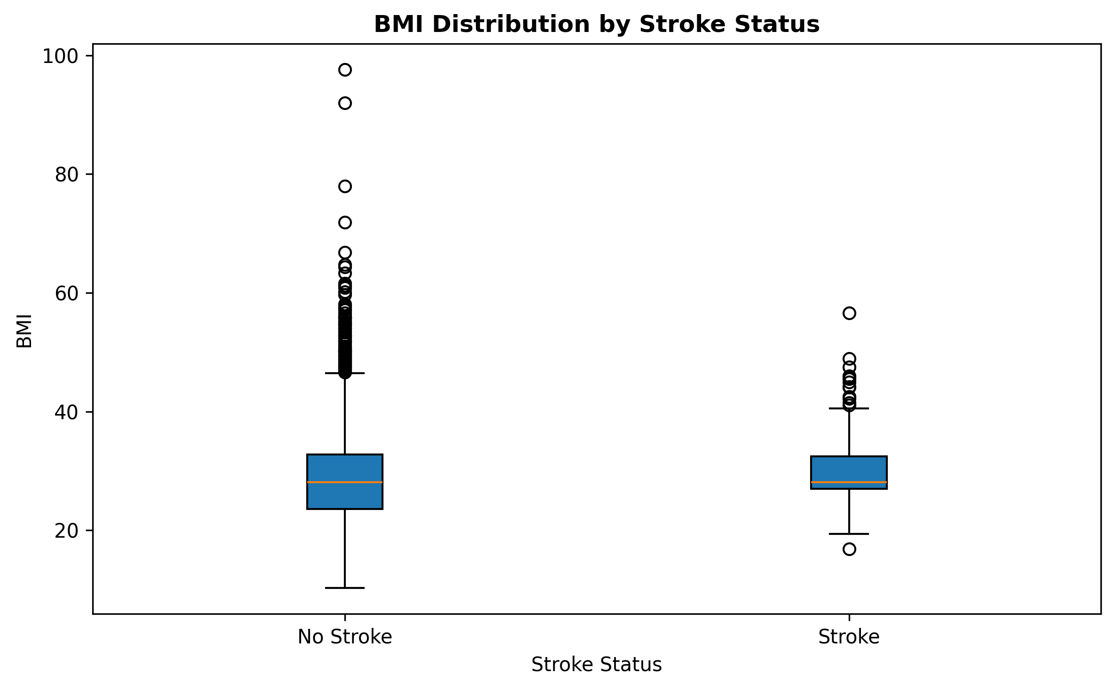
Figure 4. BMI distribution by stroke status.

Interpretation and key insight
The mean BMI was 28.80 for the no-stroke group and 30.09 for the stroke group, suggesting a modest difference in average BMI. However, the median BMI was 28.1 in both groups. This is an important analytical observation: the mean difference is not accompanied by a difference in the median. The boxplot also shows numerous higher BMI values and some low-end observations, demonstrating why distributional analysis is more informative than relying on a single summary statistic.

8. Stroke Rate by Hypertension Status

Purpose and visualization choice
A rate-based bar chart was used instead of a raw-count chart because the two hypertension groups have different sample sizes. Calculating the mean of the binary stroke variable and multiplying by 100 gives the percentage of patients with stroke within each hypertension group.

R code
hypertension_rate <- aggregate(
stroke ~ hypertension,
data = stroke_clean,
FUN = mean
)
hypertension_rate$stroke_percentage <-
hypertension_rate$stroke * 100
hypertension_rate$hypertension <- factor(
hypertension_rate$hypertension,
levels = c(0, 1),
labels = c("No Hypertension", "Hypertension")
)
ggplot(
hypertension_rate,
aes(
x = hypertension,
y = stroke_percentage
)
) +
geom_col() +
labs(
title = "Stroke Rate by Hypertension Status",
x = "Hypertension Status",
y = "Stroke Rate (%)"
) +
theme_minimal()

Visualization
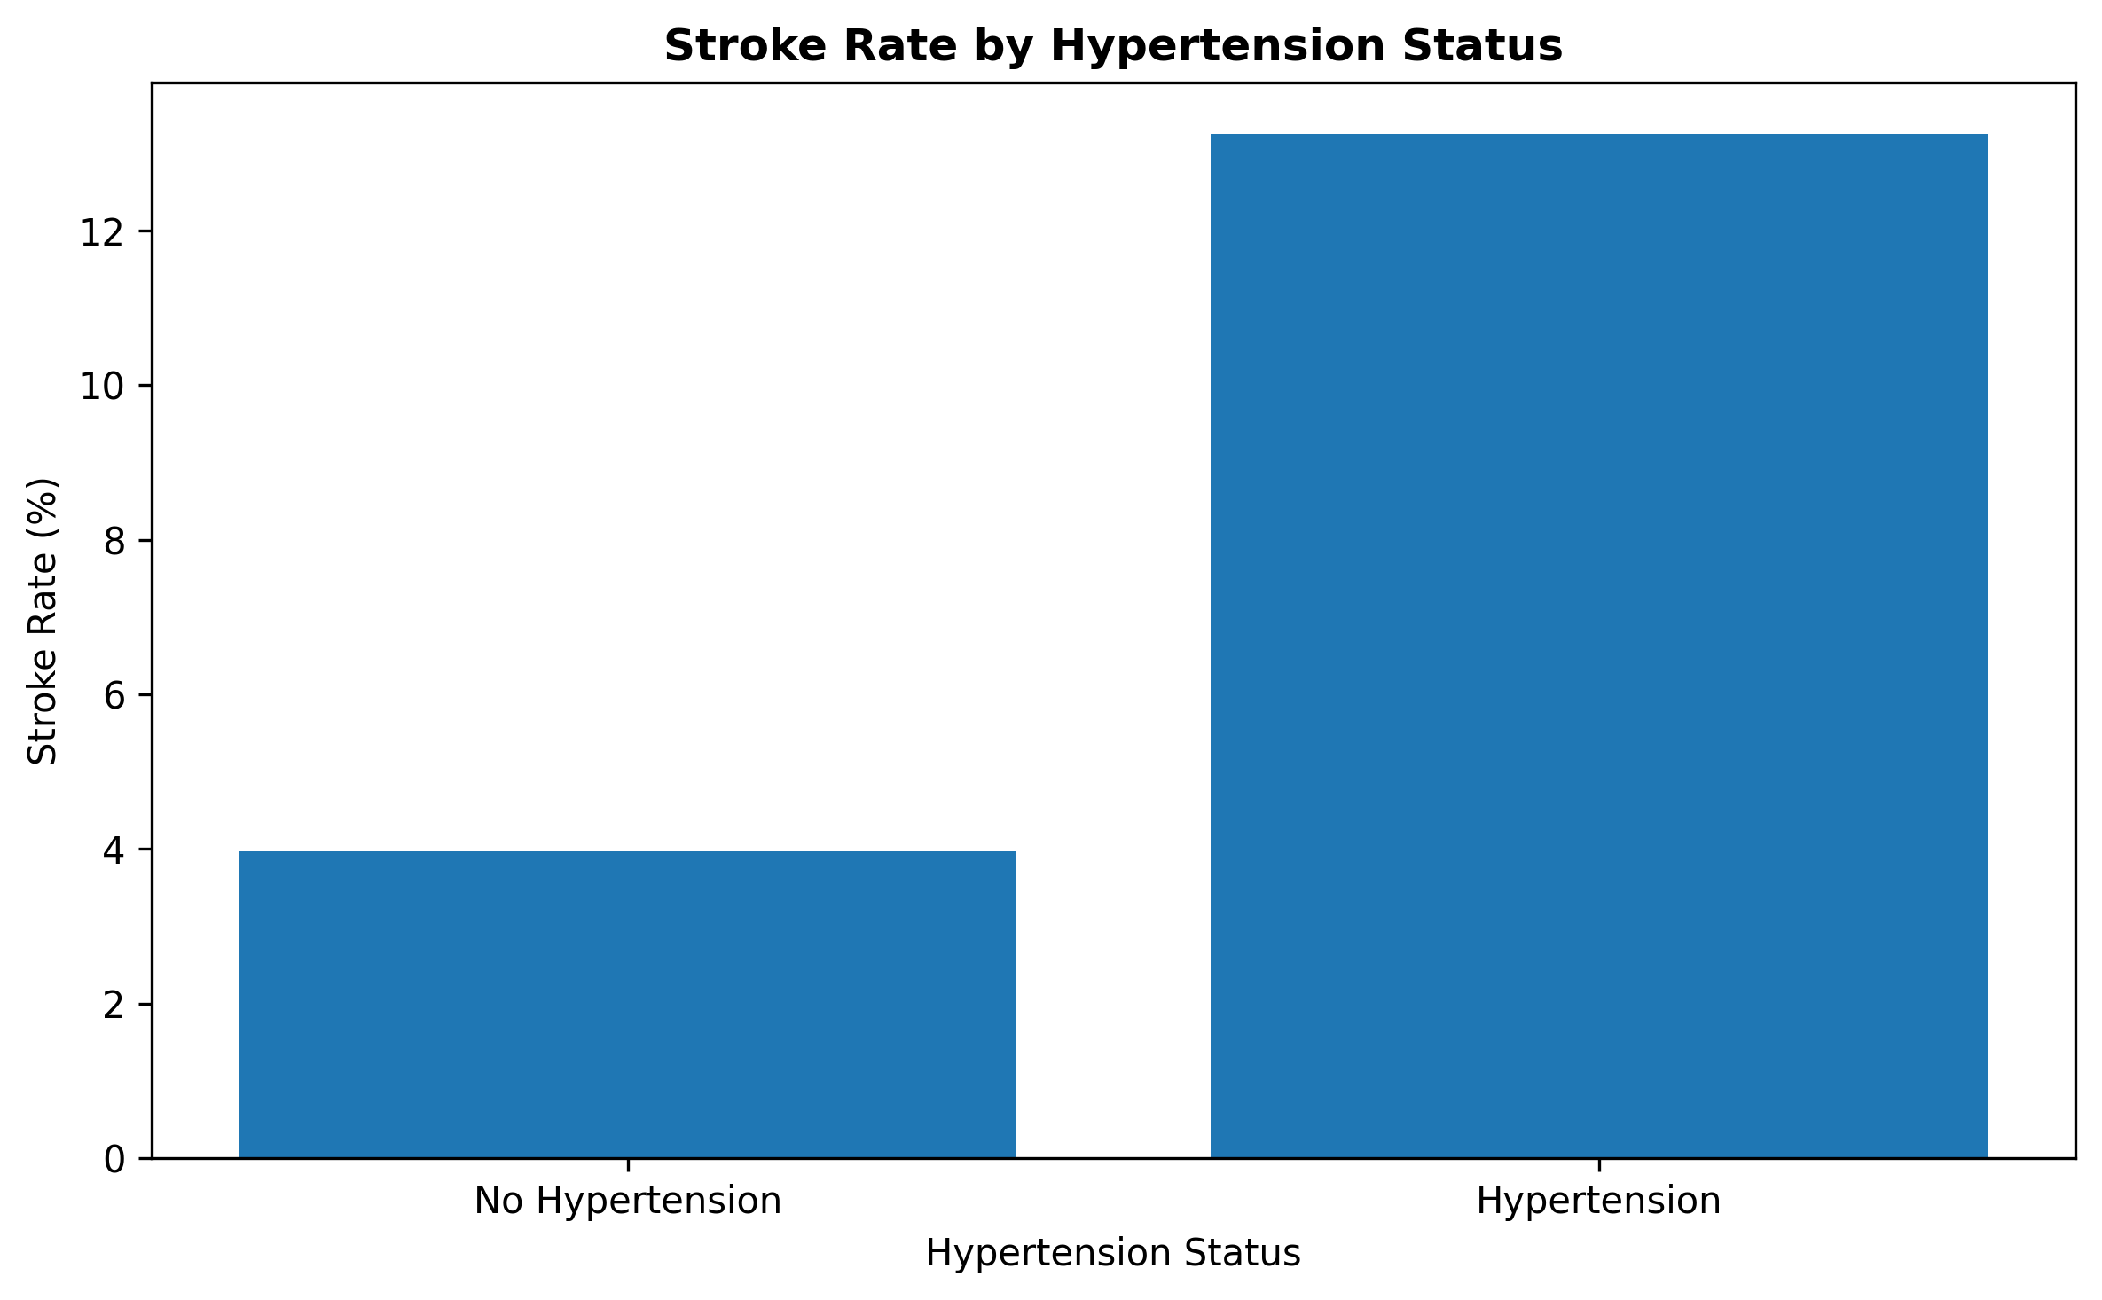
Figure 5. Stroke rate by hypertension status.

Interpretation and key insight
The observed stroke rate was 3.97% among patients without hypertension and 13.25% among patients with hypertension. This represents a substantial difference in the observed rate. The Week 1 correlation between hypertension and stroke was also positive (r = 0.128). The visualization therefore suggests that hypertension is an important risk-related variable in this dataset. However, this is an observational analysis and should not be interpreted as proof that hypertension directly causes stroke.

9. Stroke Rate by Heart Disease Status

Purpose and visualization choice
This visualization compares the percentage of patients with stroke within the heart-disease and no-heart-disease groups. A rate-based comparison is appropriate because the number of patients in the two groups is unequal.

R code
heart_disease_rate <- aggregate(
stroke ~ heart_disease,
data = stroke_clean,
FUN = mean
)
heart_disease_rate$stroke_percentage <-
heart_disease_rate$stroke * 100
heart_disease_rate$heart_disease <- factor(
heart_disease_rate$heart_disease,
levels = c(0, 1),
labels = c("No Heart Disease", "Heart Disease")
)
ggplot(
heart_disease_rate,
aes(
x = heart_disease,
y = stroke_percentage
)
) +
geom_col() +
labs(
title = "Stroke Rate by Heart Disease Status",
x = "Heart Disease Status",
y = "Stroke Rate (%)"
) +
theme_minimal()

Visualization
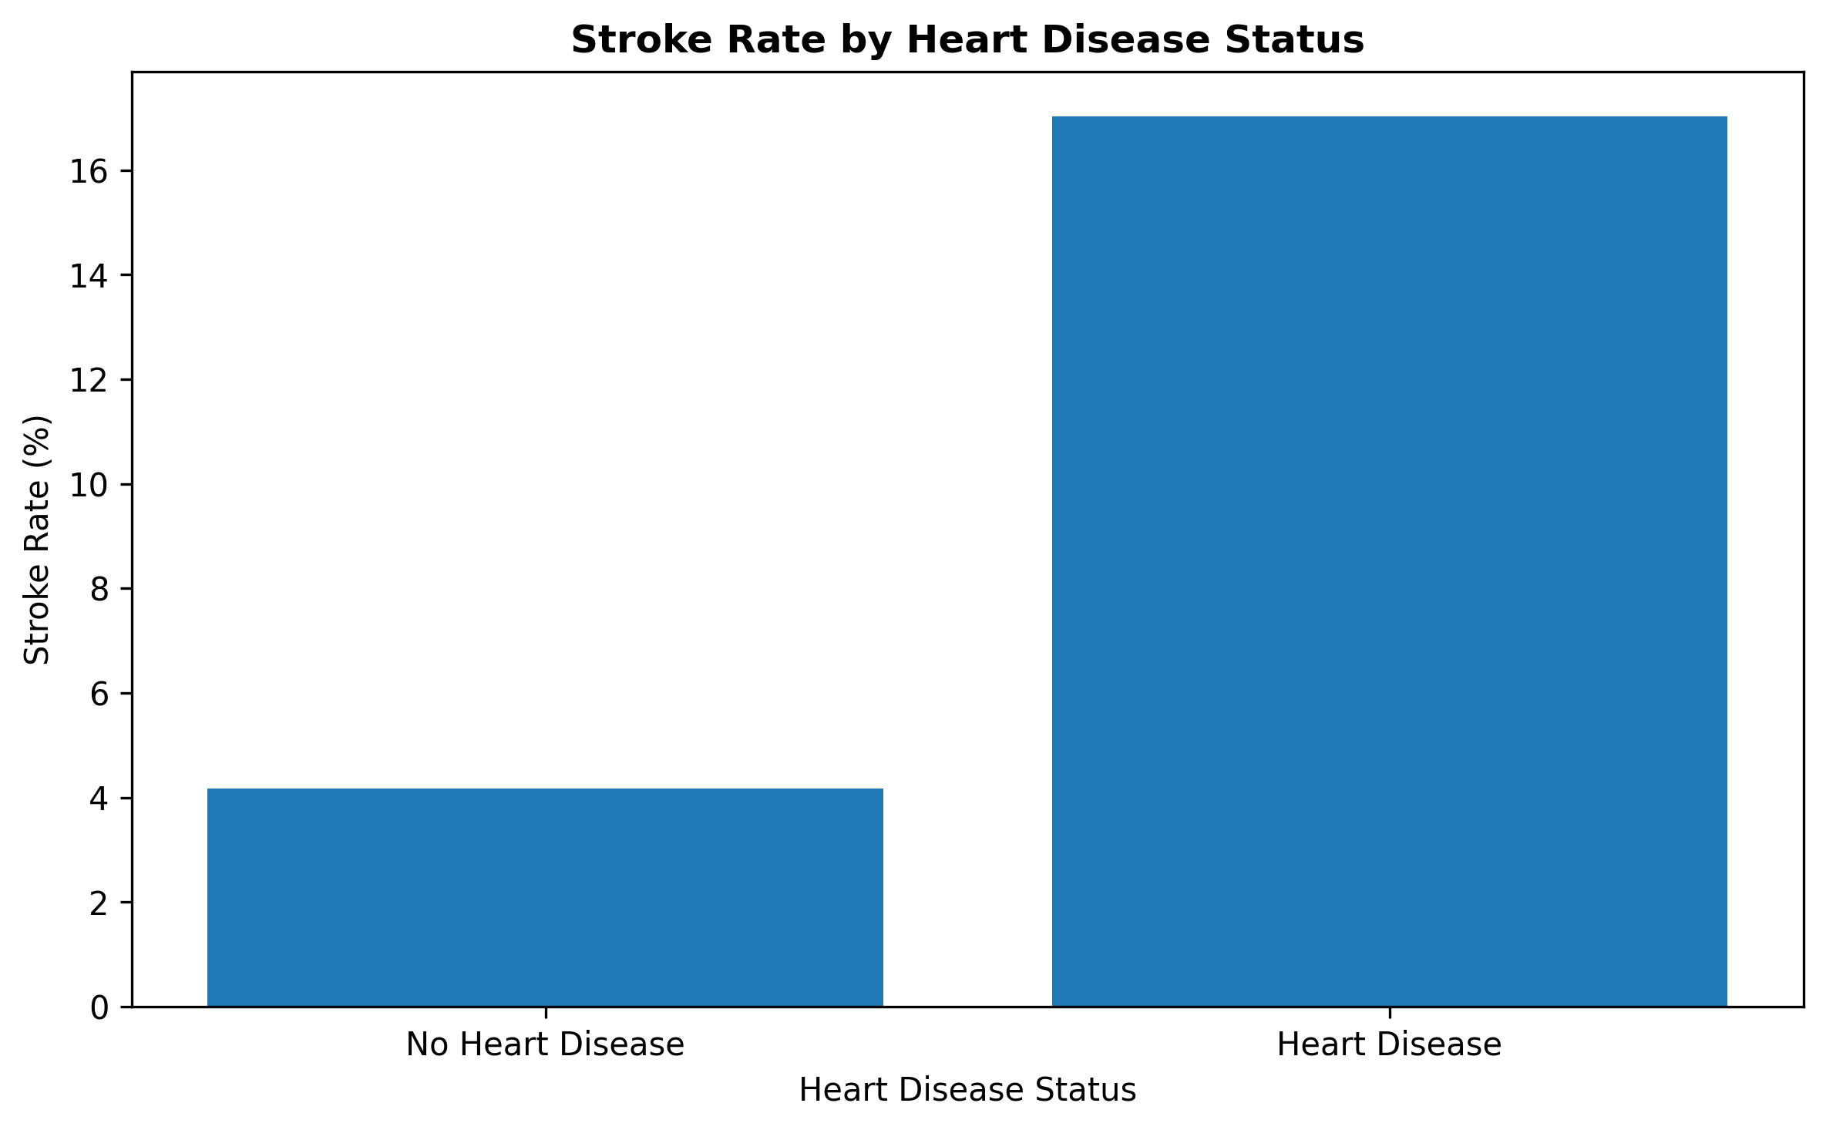
Figure 6. Stroke rate by heart disease status.

Interpretation and key insight
The observed stroke rate was 4.18% among patients without heart disease and 17.03% among patients with heart disease. The difference is substantial. The Week 1 correlation between heart disease and stroke was 0.135, which is positive but still moderate in magnitude. Together, the rate comparison and correlation suggest that heart disease is an important variable for further investigation. As with all observational relationships in this analysis, the result indicates association rather than causation.

10. Stroke Rate by Smoking Status

Purpose and visualization choice
Smoking status was analyzed using within-category stroke rates. This approach provides a fairer comparison than simply plotting the number of stroke cases because the smoking categories contain different numbers of observations.

R code
smoking_rate <- aggregate(
stroke ~ smoking_status,
data = stroke_clean,
FUN = mean
)
smoking_rate$stroke_percentage <-
smoking_rate$stroke * 100
ggplot(
smoking_rate,
aes(
x = smoking_status,
y = stroke_percentage
)
) +
geom_col() +
labs(
title = "Stroke Rate by Smoking Status",
x = "Smoking Status",
y = "Stroke Rate (%)"
) +
theme_minimal() +
theme(
axis.text.x = element_text(angle = 30, hjust = 1)
)

Visualization
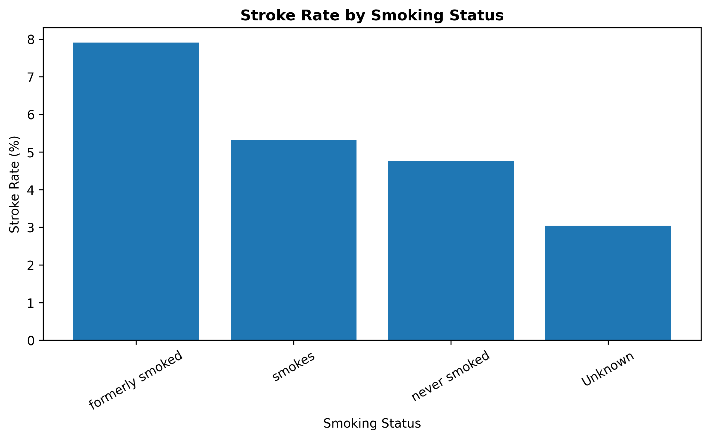
Figure 7. Stroke rate by smoking status.

Interpretation and key insight
The highest observed stroke rate was among participants who formerly smoked (7.91%), followed by those who currently smoke (5.32%). The never-smoked group had a stroke rate of 4.76%, while the Unknown category had the lowest observed rate at 3.04%. The relatively high rate in the formerly-smoked group should not be interpreted as evidence that former smoking itself causes stroke. Former smoking may reflect older age or other health characteristics, and the dataset does not control for confounding factors in this descriptive analysis.

11. Stroke Rate by Age Group

Purpose and visualization choice
Age was grouped into seven clinically intuitive bands to make the relationship between age and stroke rate easier to communicate to a non-technical audience. A grouped rate chart was selected because the objective was to compare the percentage of stroke outcomes within each age category.

R code
stroke_clean$age_group <- cut(
stroke_clean$age,
breaks = c(0, 30, 40, 50, 60, 70, 80, Inf),
labels = c(
"≤30", "31–40", "41–50", "51–60",
"61–70", "71–80", "80+"
),
include.lowest = TRUE
)
age_group_rate <- aggregate(
stroke ~ age_group,
data = stroke_clean,
FUN = mean
)
age_group_rate$stroke_percentage <-
age_group_rate$stroke * 100
ggplot(
age_group_rate,
aes(
x = age_group,
y = stroke_percentage
)
) +
geom_col() +
labs(
title = "Stroke Rate by Age Group",
x = "Age Group",
y = "Stroke Rate (%)"
) +
theme_minimal()

Visualization
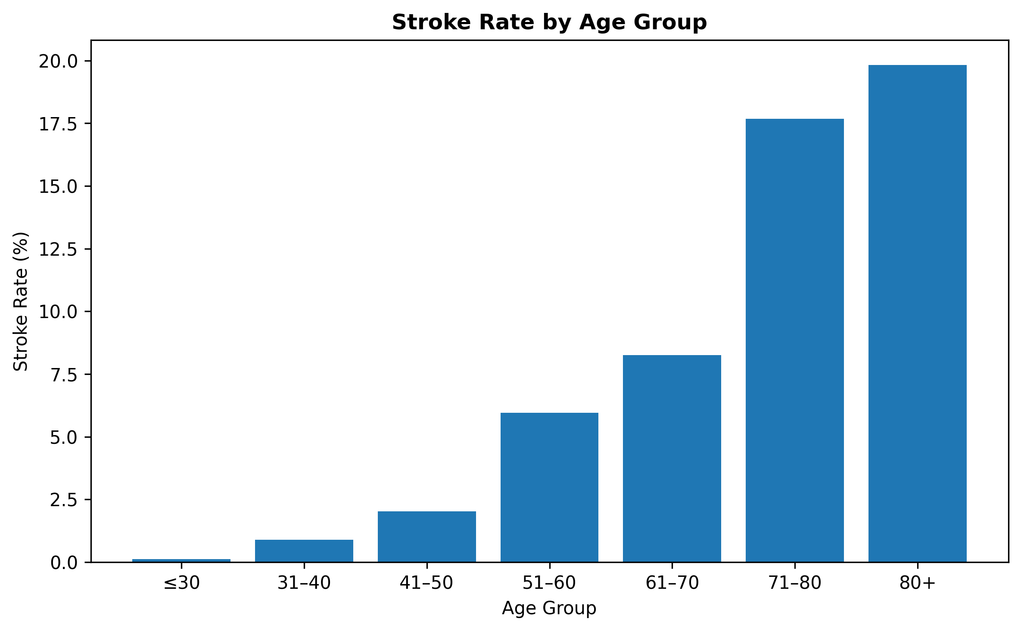
Figure 8. Stroke rate across age groups.

Interpretation and key insight
The age-group results show a clear increasing pattern: the stroke rate was 0.13% for patients aged ≤30, 0.89% for ages 31–40, 2.03% for 41–50, 5.95% for 51–60, 8.25% for 61–70, 17.68% for 71–80, and 19.83% for 80+. The increase becomes particularly pronounced after age 60. This visualization provides one of the clearest portfolio-level insights from the analysis: older age groups have substantially higher observed stroke rates in this dataset.

12. Correlation Heatmap

Purpose and visualization choice
A correlation heatmap was used to summarize the pairwise linear relationships among the main numerical and binary analysis variables. The heatmap provides a compact overview of which variables move together and how strongly they are associated with the stroke outcome.

R code
library(corrplot)
correlation_matrix <- cor(
stroke_clean[
c(
"age",
"hypertension",
"heart_disease",
"avg_glucose_level",
"bmi",
"stroke"
)
]
)
corrplot(
correlation_matrix,
method = "color",
type = "upper",
addCoef.col = "black",
tl.col = "black",
number.cex = 0.7
)

Visualization
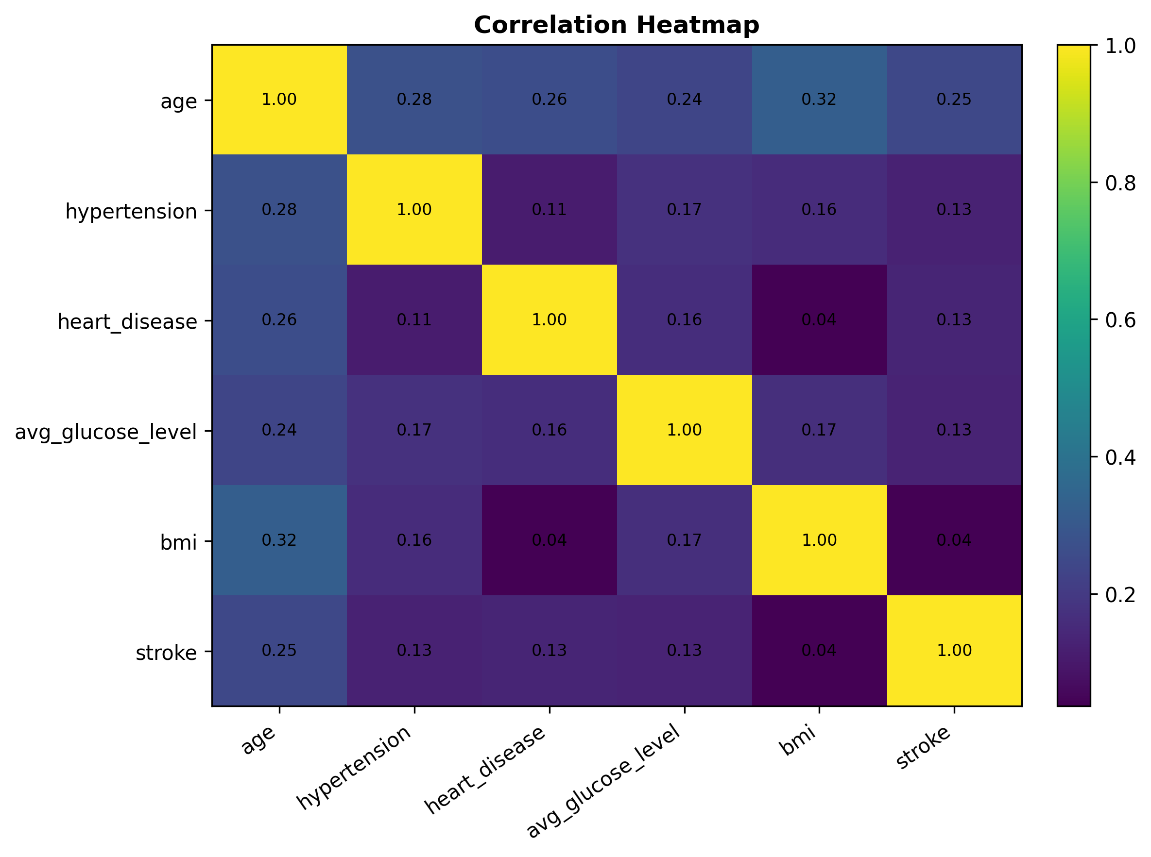
Figure 9. Correlation heatmap of key analysis variables.

Interpretation and key insight
The strongest correlation with stroke was observed for age (r = 0.245), followed by heart disease (r = 0.135), average glucose level (r = 0.132), and hypertension (r = 0.128). BMI had a very weak correlation with stroke (r = 0.036). The heatmap also shows that age has a moderate positive correlation with BMI (r = 0.324) and weaker positive relationships with hypertension (r = 0.276), heart disease (r = 0.264), and glucose (r = 0.238). These values indicate association, not causation, and do not account for interactions or confounding variables.

13. Consolidated Key Insights
The visualizations provide a consistent picture of the main patterns in the dataset. The most important findings are summarized below.
- Stroke outcomes were highly imbalanced: 249 of 5,110 patients (4.87%) had a recorded stroke.
- Age showed the strongest correlation with stroke among the variables examined (r = 0.245). The mean age was 67.73 years in the stroke group compared with 41.97 years in the no-stroke group.
- Stroke rate increased strongly across age groups, from 0.13% among patients aged ≤30 to 19.83% among patients aged 80+.
- Patients with hypertension had an observed stroke rate of 13.25%, compared with 3.97% among patients without hypertension.
- Patients with heart disease had an observed stroke rate of 17.03%, compared with 4.18% among patients without heart disease.
- Average glucose level was higher in the stroke group: mean 132.54 compared with 104.80 in the no-stroke group.
- BMI showed only a small difference in means (30.09 vs 28.80), while the median was 28.1 in both groups.
- Former smokers had the highest observed stroke rate among smoking categories (7.91%), followed by current smokers (5.32%).
- The results are descriptive and identify associations and patterns; they do not establish causal relationships.

14. Insight Communication for a Non-Technical Audience
A key objective of this week's work was to communicate analytical findings without relying only on technical statistics. The visualizations were therefore designed to answer simple questions visually: how common is stroke, which age groups show higher rates, and how do important health factors compare? Bar charts make group differences easy to compare, histograms show distributions, the scatter plot shows how two continuous variables vary together, the boxplot highlights distributional differences and outliers, and the heatmap provides a compact summary of correlations.
For a healthcare or business stakeholder, the most actionable descriptive message is that stroke outcomes are concentrated more strongly among older patients and are more frequent within groups with hypertension or heart disease. The analysis also demonstrates why rates and percentages are preferable to raw counts when group sizes differ. This approach helps turn raw patient records into a concise analytical story.

15. Limitations
- This is a descriptive analysis of an observational dataset; associations should not be interpreted as causal effects.
- The stroke outcome is highly imbalanced, with only 4.87% of observations classified as stroke.
- The analysis uses pairwise correlations and simple group comparisons and does not control for confounding or interaction effects.
- The Unknown smoking-status category limits interpretation of smoking-related patterns.
- The visualizations identify patterns for further analysis but do not constitute clinical recommendations or diagnostic conclusions.

16. Conclusion
Week 2 successfully transformed the cleaned stroke-risk dataset into a set of nine analytical visualizations designed for pattern discovery and insight communication. The analysis showed that age was the most prominent variable associated with stroke among the variables examined, with stroke rates increasing substantially across older age groups. Hypertension and heart disease were also associated with noticeably higher observed stroke rates. Average glucose level was higher among stroke cases, while BMI showed only a modest difference in mean values and identical medians across the two outcome groups.
From a Data Analyst perspective, the project demonstrates the complete visualization workflow: loading a cleaned dataset, selecting appropriate chart types, calculating meaningful group-level metrics, generating high-resolution graphics, interpreting patterns, and communicating findings to a non-technical audience. The resulting analysis can be extended in future work through statistical testing, feature engineering, and predictive modelling.

17. Tools and Technologies
- R
- RStudio
- ggplot2
- corrplot
- Base R functions for aggregation and descriptive analysis
- CSV data handling
- PNG visualization export at 300 DPI

Appendix A – Visualization Output Files
- 01_stroke_distribution.png
- 02_age_distribution.png
- 03_age_glucose_scatter.png
- 04_bmi_stroke_boxplot.png
- 05_hypertension_stroke.png
- 06_heart_disease_stroke.png
- 07_smoking_stroke.png
- 08_age_group_stroke_rate.png
- 09_correlation_heatmap.png
Note: Figure 6 was regenerated from the same cleaned dataset and analytical definition used for the Week 2 heart-disease rate analysis, so the numerical interpretation matches the completed analysis.

