**AWS Traffic Distribution using Application Load Balancers**

**Objective**

The goal of this implementation is to demonstrate how **AWS Application Load Balancers (ALBs)** distribute incoming traffic evenly across multiple EC2 instances to ensure high availability and scalability of a web application.

**Key Concepts**

**1. Amazon EC2 (Elastic Compute Cloud)**

EC2 instances are virtual servers in AWS used to run applications on the cloud. In this project, two EC2 instances are launched, each hosting a simple web page with unique responses.

**2. User Data Script**

A user data script is a set of commands that runs automatically at the instance launch to set up the environment. It installs Apache and deploys the web content to make the web server live.

**3. Application Load Balancer (ALB)**

The ALB is used to automatically distribute incoming application traffic across multiple targets, such as EC2 instances, in multiple availability zones. It operates at the application layer (HTTP/HTTPS).

**4. Target Group**

A target group routes requests to registered targets (EC2 instances). The health of targets is continuously checked, and only healthy instances receive traffic.

**Implementation** (used 2 instances for demonstration) **:**

**1. Website Response after Load Balancing**

When the ALB URL is accessed multiple times, it returns alternating responses from two EC2 instances, showing successful traffic distribution.

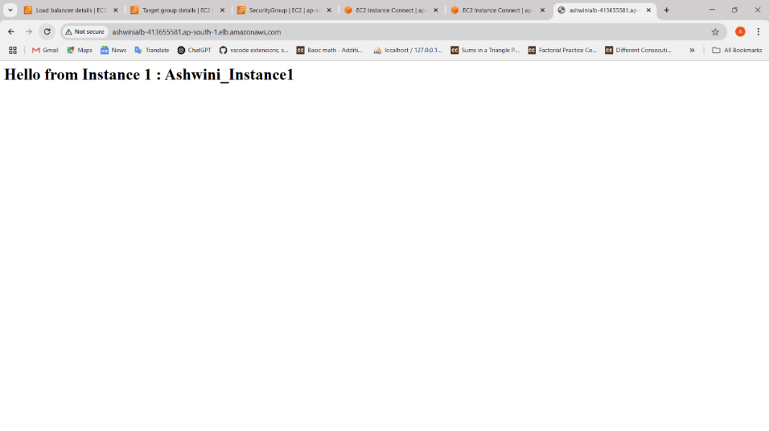

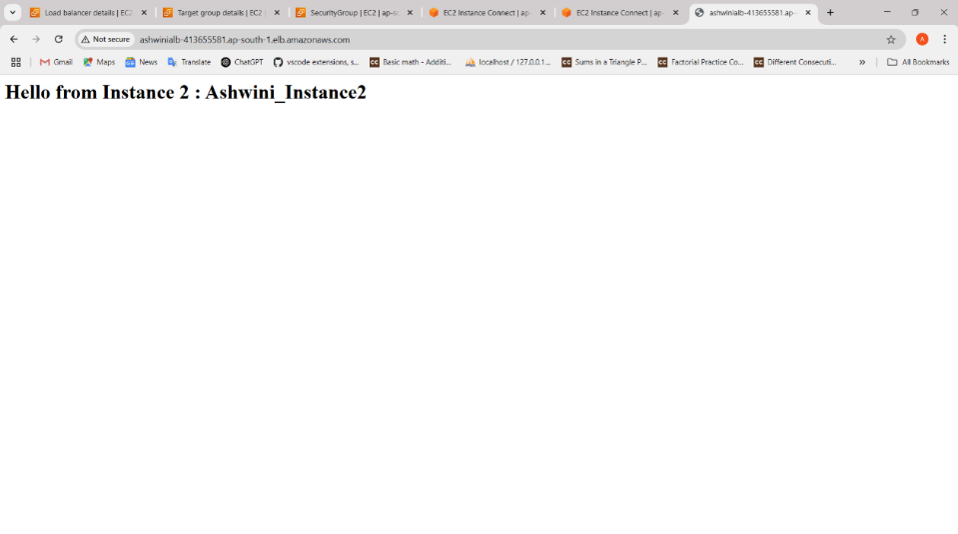

**2. Load Balancer Details**

The Application Load Balancer is created with proper listener configuration (HTTP on port 80), VPC selection, and security settings.

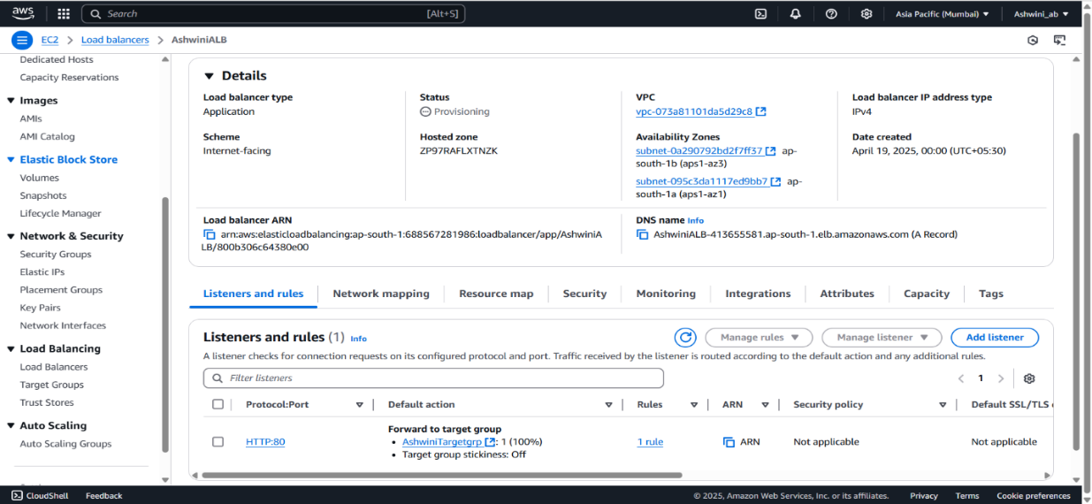

**3. Target Group Details**

The target group is associated with the load balancer and contains both EC2 instances. It shows health status as "healthy" for both.

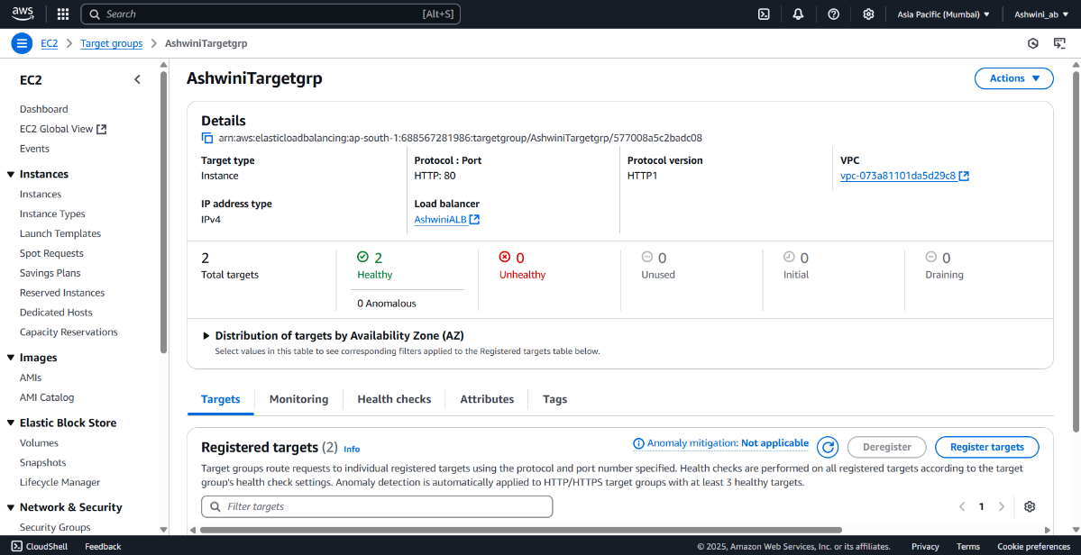

**4. Instances’ Details**

Each EC2 instance has a public IPv4 address and is launched with a specific user data script that customizes its web response.

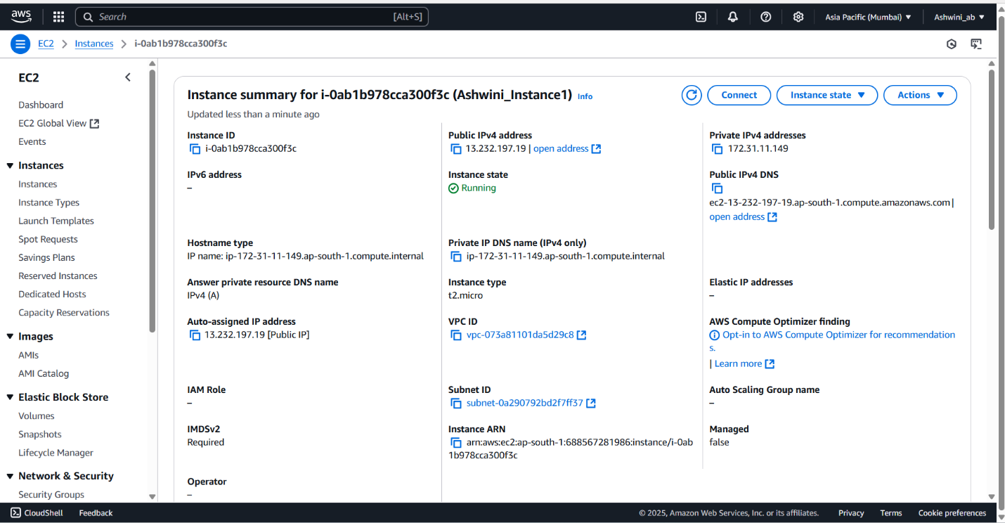

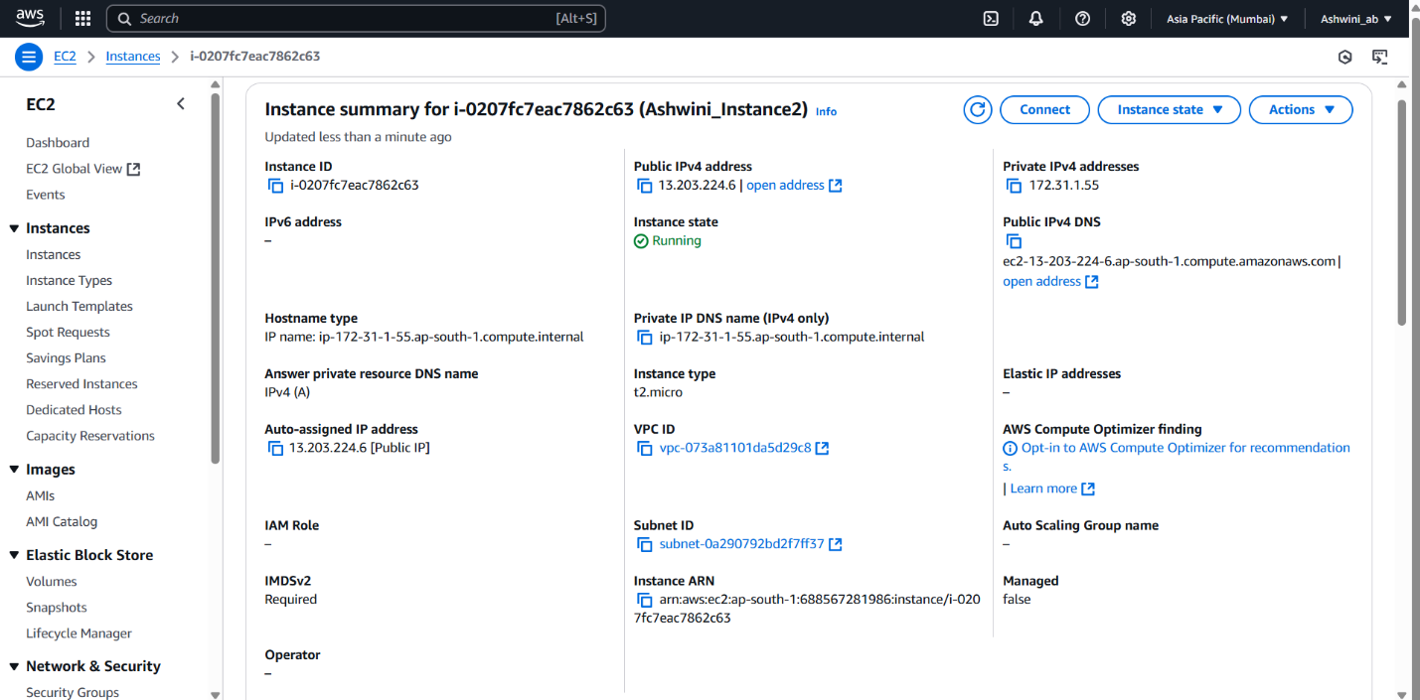

**Conclusion :**

Deployed a simple web page on **two EC2** instances using a user data script and configured an **Application Load Balancer** to distribute traffic evenly between them. The setup demonstrated load balancing by serving **different responses** based on the instance **handling each request**.