MuleShield PRO: An Explainable and Leakage-Controlled AI System for Suspicious Mule Account Detection
Dhamarai Kannan A. | Akshaya Sreleka P. S. | Ashwinkumar K. | Dharshan S.
Department of Electronics and Communication Engineering
Chennai Institute of Technology, Chennai, India
Abstract—Mule accounts are bank accounts knowingly or unknowingly rented out to receive and relay illicit funds, and their detection is complicated by extreme class imbalance and by high-dimensional, near-duplicate banking data. This paper presents MuleShield PRO, an explainable, leakage-controlled prototype developed on the PSB CyberShield dataset of 9,082 account profiles, of which only 81 (0.8919%) are labelled suspicious. The pipeline performs an explicit leakage audit that removes post-investigation and temporal proxy fields, groups 3,112 near-duplicate profiles into 6,118 similarity clusters, and evaluates a regularised, class-weighted XGBoost classifier under stratified five-fold group cross-validation in which SMOTE oversampling is fit strictly on training folds only. The leakage-controlled five-fold group-aware evaluation achieved a PR-AUC of 0.8807 ± 0.0403. At the selected operating threshold of 0.9899, the documented validation metrics were 100.00% precision, 61.64% recall, and an F1-score of 0.7586. Under a synthetic 10% feature-cell corruption stress test, PR-AUC remained 0.8383. Case-level explanations are produced with TreeSHAP and served through a Flask REST API to an analyst-facing dashboard that supports human-in-the-loop investigation. This paper reports implemented functionality, experimental results and simulated components separately, and explicitly states that performance on the organizer's hidden validation set and behaviour under live prototype deployment evaluation have not been established.
Keywords—Mule account detection, financial fraud detection, XGBoost, explainable AI, SHAP, class imbalance, data leakage prevention, group-aware cross-validation, out-of-fold evaluation.

I. INTRODUCTION
Mule accounts serve as intermediate conduits that receive, layer and forward illicitly obtained funds on behalf of organised criminal networks, often with the account holder either complicit or unaware. Because the transactional signatures of such accounts vary widely across customer segments and evolve as detection improves, static rule-based screening tends to miss novel patterns while generating disruptive numbers of false alerts. A learned, data-driven classifier can, in principle, generalise across these patterns more effectively, provided that the evaluation protocol used to certify it is trustworthy.
The PSB CyberShield dataset used in this work presents three engineering obstacles that are not addressed by a conventional train/test split. First, the feature space is extremely high-dimensional relative to the number of labelled accounts. Second, the positive class is rare enough that naive accuracy is not an informative signal. Third, the raw feature set contains a number of post-investigation and temporally leaked fields, together with thousands of near-duplicate account profiles, either of which can silently inflate a reported metric if not identified and removed before model fitting. MuleShield PRO was built specifically to treat evaluation integrity as a first-class design objective alongside raw classification performance.
The principal contributions of this prototype are:
• An explicit leakage audit that isolates and removes post-investigation and temporal proxy features prior to model development.
• Cosine-similarity-based near-duplicate grouping that prevents related profiles from appearing in both the training and validation partitions of any fold.
• A stratified, group-aware five-fold cross-validation protocol together with a canonical out-of-fold (OOF) evaluation over the full dataset.
• Training-fold-only SMOTE oversampling combined with a class-weighted, regularised XGBoost classifier.
• Domain-motivated banking feature engineering built on ratio features.
• TreeSHAP-based case-level explanations integrated into a Flask REST inference layer and an analyst dashboard.
II. DATASET AND PROBLEM FORMULATION
MuleShield PRO is developed on the PSB CyberShield dataset, comprising 9,082 account profiles described by 3,924 original feature columns, with a binary suspicious-account label (F3924) marking 81 accounts as mule accounts and the remaining 9,001 as legitimate. This corresponds to a positive-class prevalence of 0.8919%, an imbalance ratio of approximately 111.12:1. After leakage removal and schema alignment (Section IV), the final modelling feature space contains 6,820 aligned columns.
Under this degree of imbalance, accuracy is not an informative metric: a trivial classifier that predicts every account as legitimate already exceeds 99% accuracy while identifying zero suspicious accounts. MuleShield PRO therefore adopts Precision-Recall AUC (PR-AUC) as its primary evaluation metric, since PR-AUC is substantially more sensitive to minority-class ranking quality than ROC-AUC under severe imbalance [7]. No ROC-AUC figure is reported, since it was not part of the canonical evaluation protocol used for this prototype.
TABLE I. DATASET CHARACTERISTICS
Parameter | Value
Account profiles | 9,082
Original feature columns | 3,924
Target variable | F3924
Suspicious (mule) accounts | 81
Legitimate accounts | 9,001
Positive-class prevalence | 0.8919%
Imbalance ratio | ≈ 111.12 : 1
Final aligned feature space | 6,820
Primary evaluation metric | PR-AUC

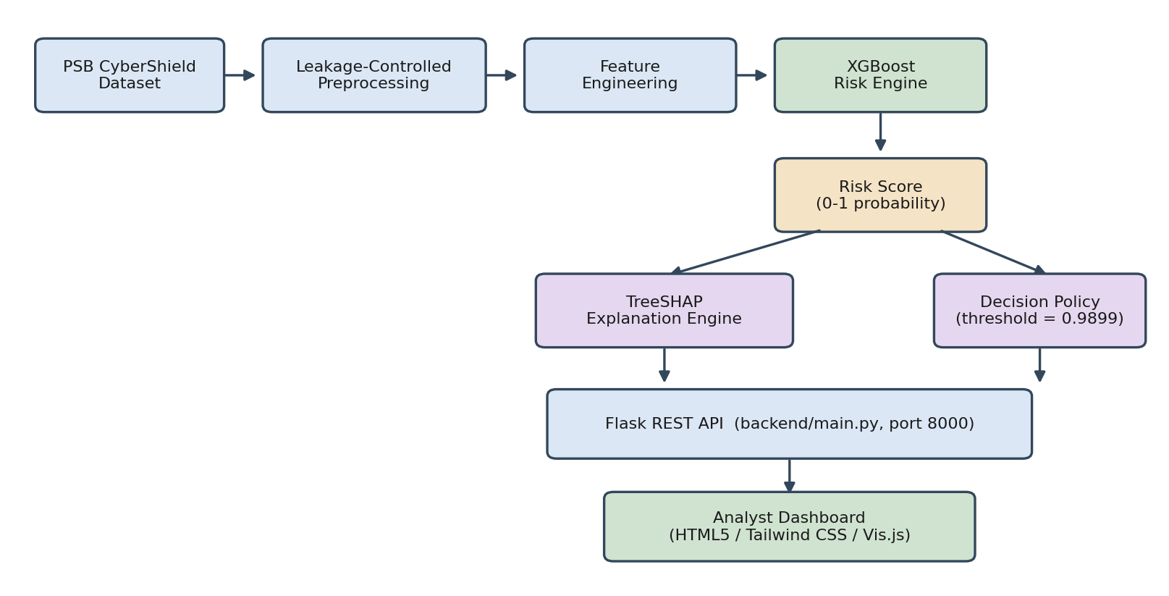
Fig. 1. End-to-end MuleShield PRO system architecture.

III. SYSTEM ARCHITECTURE
The implemented platform separates data handling, modelling, explanation and presentation into four principal layers, shown in Fig. 1: a leakage-controlled preprocessing and feature-engineering stage, an XGBoost risk-scoring engine, a TreeSHAP explanation module paired with a fixed decision policy, and a Flask REST API that serves predictions and explanations to a browser-based analyst dashboard. Each layer is implemented as a separable module so that the scoring engine can be re-trained or swapped without altering the serving or presentation layers.
IV. DATA PREPROCESSING AND LEAKAGE CONTROL
A leakage audit was performed before any feature-engineering or model-fitting step. Two categories of leakage were identified and removed. Post-investigation features — F3912, F3913, F3914, F3915, F3898 and F3899 — encode information that would only be available after an account had already been flagged and investigated, and therefore cannot be legitimately available to a model operating at scoring time. Temporal proxy features — F2230 and F3888 — were found to correlate with the labelling process itself rather than with underlying account behaviour, and were removed to prevent the model from exploiting an artefact of how the dataset was constructed. The target column F3924 was isolated from the feature matrix throughout preprocessing and feature engineering to guarantee that no target-derived value could re-enter the feature space.
Table II summarises the leakage audit. Retaining any of these fields during model development would be expected to produce optimistic offline metrics that could not be reproduced on genuinely unseen accounts, which is precisely the failure mode this audit is designed to prevent.
TABLE II. LEAKAGE AUDIT AND MITIGATION
Feature(s) | Category | Action
F3912–F3915 | Post-investigation | Removed
F3898, F3899 | Post-investigation | Removed
F2230, F3888 | Temporal proxy | Removed
F3924 | Target label | Isolated
V. NEAR-DUPLICATE DETECTION AND GROUP-AWARE VALIDATION
Beyond feature-level leakage, the dataset was also found to contain a substantial number of near-duplicate account profiles — records that are effectively re-parameterisations of the same underlying account. A cosine-similarity screen with a threshold above 0.99 identified 3,112 such profiles, which were consolidated into 6,118 similarity groups. If these related profiles were allowed to fall on opposite sides of a conventional random train/validation split, a model could partly memorise a near-duplicate seen in training and appear to generalise well on an almost identical validation record, without having learned anything transferable.
MuleShield PRO therefore performs stratified five-fold cross-validation at the level of similarity groups rather than individual rows, so that every member of a similarity group is confined entirely to one fold. Fig. 2 shows the complete pipeline, from the raw dataset through leakage auditing, near-duplicate grouping, and group-aware fold construction, to the aggregated out-of-fold (OOF) predictions used to compute the canonical metrics reported in Section VIII. Within each fold, preprocessing fitting, feature engineering, SMOTE oversampling and threshold calibration are performed using the training partition only; the validation partition of that fold is never used to fit any transformation and is scored strictly out-of-fold.
VI. FEATURE ENGINEERING
Three domain-motivated ratio features were engineered from the underlying transactional columns to encode banking behaviours that raw magnitudes do not directly expose. BANK_FE_CASH_TO_UPI_RATIO is computed as F2122 divided by (|F670| + 1.0), and is intended to surface accounts whose cash-withdrawal activity is disproportionate to their UPI-based transfer activity, a pattern associated with cash-out layering. BANK_FE_UPI_TO_TOTAL_DEV_RATIO is computed as F2582 divided by (|F2737| + 1.0), capturing how concentrated an account's UPI activity is relative to its overall device-linked transaction footprint. BANK_FE_TENURE_AGE_RATIO is computed as F3887 divided by (|F3894| + 1.0), relating account tenure to account-holder age and is intended to flag newly opened accounts held by profiles inconsistent with organic banking relationships.
These engineered ratios are additional signals presented to the classifier alongside the aligned raw feature set; none of them is claimed to be independently sufficient to identify a mule account, and their contribution is evaluated only in combination with the full feature space through the SHAP analysis in Section XI.

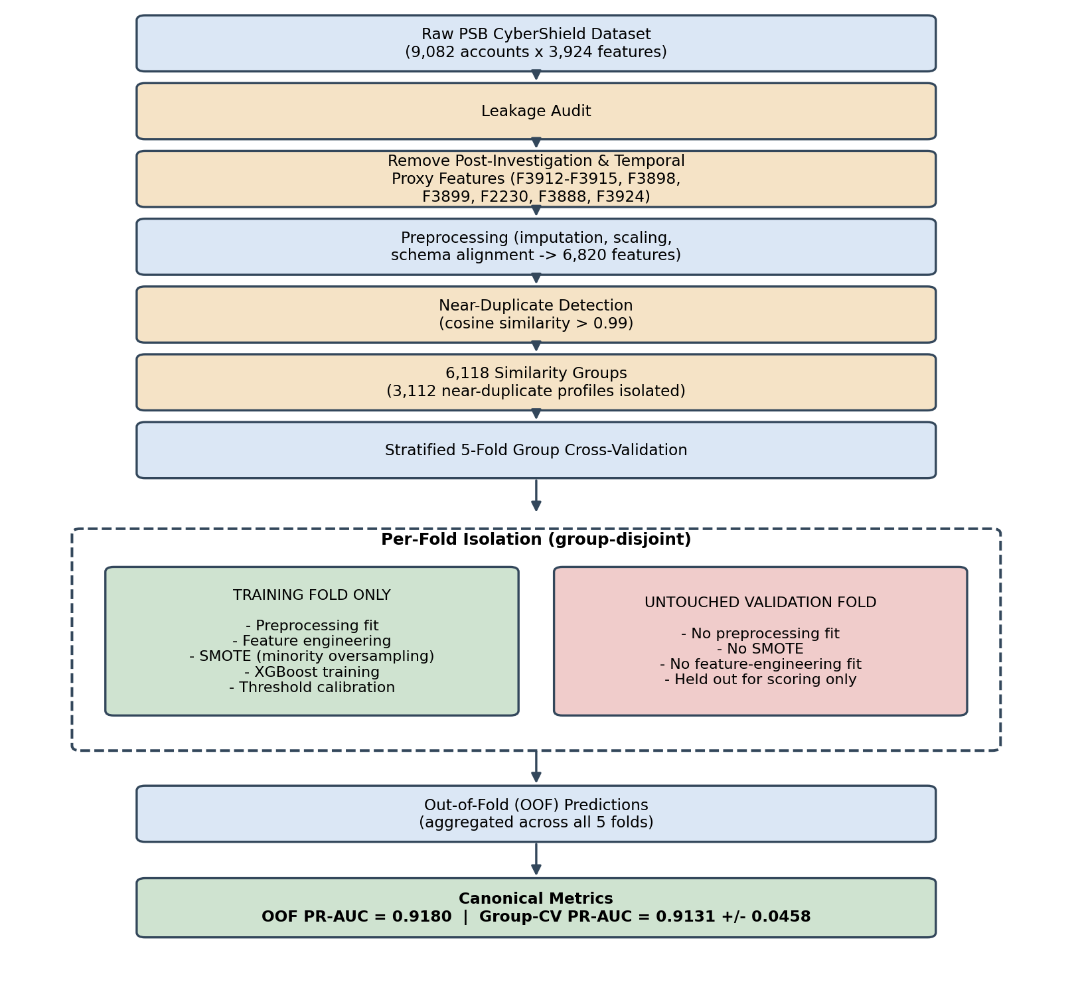
Fig. 2. Leakage-controlled group-aware validation pipeline used to generate the canonical out-of-fold evaluation.

VII. MACHINE LEARNING MODEL AND CLASS-IMBALANCE HANDLING
XGBoost was selected as the classification model after benchmarking against logistic regression and random forest baselines (Table V). Gradient-boosted trees handle the mixture of sparse and dense banking features in this dataset without requiring feature scaling, natively support a positive-class weight for imbalance correction, and admit a range of regularisation controls that limit overfitting on a positive class of only 81 accounts [1]. The final configuration, selected through the optimisation process described below, is summarised in Table III.
TABLE III. FINAL XGBOOST CONFIGURATION
Hyperparameter | Value
max_depth | 3
min_child_weight | 3
gamma | 0.1
subsample | 0.8
colsample_bytree | 0.8
reg_alpha | 0.1
reg_lambda | 1.0
learning_rate | 0.05
n_estimators | 200
scale_pos_weight | 111.12
tree_method | hist
The shallow max_depth and non-trivial min_child_weight and gamma settings constrain individual trees from fitting noise in the minority class, while reg_alpha and reg_lambda apply L1/L2 penalties on leaf weights. Row and column subsampling (subsample, colsample_bytree) reduce variance across boosting rounds. scale_pos_weight is set to the empirical imbalance ratio (≈111.12) so that misclassifying a mule account is penalised proportionally more than misclassifying a legitimate one, complementing rather than replacing the oversampling strategy described next.
Because only 81 positive examples are available, class-imbalance handling was benchmarked across five strategies, all evaluated under the same five-fold cross-validation used elsewhere in this work. Table IV reports this model-selection benchmark; it is not the canonical final result reported in Section VIII. Synthetic Minority Over-sampling (SMOTE) [2] combined with scale_pos_weight produced the best balance of PR-AUC and recall among the strategies tested and was adopted for the final pipeline, with oversampling fit strictly within each training fold to avoid leaking synthetic neighbours of validation-fold minority examples into training data.
TABLE IV. CLASS-IMBALANCE STRATEGY COMPARISON (MODEL-SELECTION BENCHMARK)
Strategy | PR-AUC | Prec. | Rec. | F1
SMOTE + weight | 0.8807 ±0.0403 | 1.0000 | 0.6164 | 0.7586
ADASYN + weight | 0.8810 ±0.0493 | 1.0000 | 0.5795 | 0.7267
Pure scale_pos_weight | 0.8775 ±0.0624 | 1.0000 | 0.4312 | 0.5909
Borderline-SMOTE + weight | 0.8231 ±0.0478 | 0.9453 | 0.6140 | 0.7425
Unweighted baseline | 0.8183 ±0.0732 | 0.8992 | 0.6660 | 0.7538
Note: SMOTE + scale_pos_weight was selected for the final pipeline. Figures shown are hyperparameter-search-stage results and are superseded by the canonical OOF results in Table VI.
VIII. MODEL OPTIMIZATION AND VALIDATION RESULTS
During model selection, XGBoost was compared against logistic regression and random forest baselines under identical five-fold cross-validation and preprocessing (Table V). XGBoost achieved both the highest mean PR-AUC and the lowest cross-fold variance of the three algorithms, motivating its selection as the final verified scoring model used in this prototype.
TABLE V. MODEL ARCHITECTURE COMPARISON (MODEL-SELECTION BENCHMARK)
Model | PR-AUC | Prec. | Rec. | F1
XGBoost | 0.8807 ±0.0403 | 1.0000 | 0.6164 | 0.7586
Random Forest | 0.7845 ±0.1001 | 0.9770 | 0.4033 | 0.5539
Logistic Regression | 0.6652 ±0.1035 | 0.7058 | 0.6037 | 0.6447
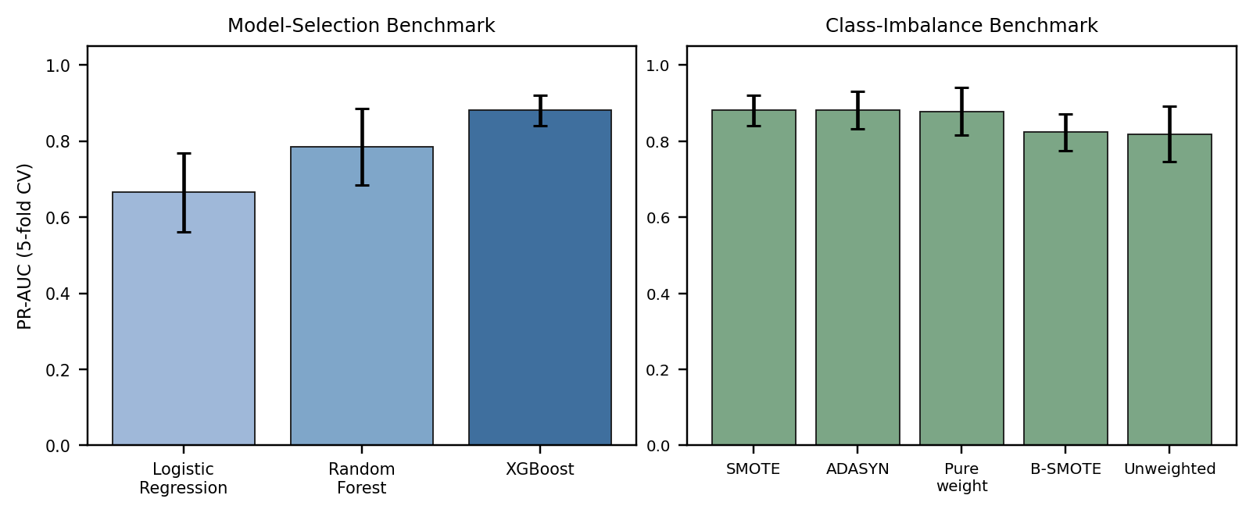
Fig. 3. Model and class-imbalance model-selection comparison (PR-AUC, 5-fold CV).
The two benchmarks above (0.8833 ± 0.0365 hyperparameter-search-stage PR-AUC and 0.8807 ± 0.0403 model-selection-stage PR-AUC) reflect earlier stages of development and are reported here only to document the experimental process; neither is the final canonical performance figure of this prototype. Following hyperparameter tuning, near-duplicate grouping and the finalised leakage-controlled pipeline, the model was re-evaluated with a full leakage-controlled, group-aware out-of-fold protocol across all 9,082 accounts. This canonical evaluation, summarised in Table VI, is the single source of truth for MuleShield PRO's reported performance.
TABLE VI. CANONICAL FINAL PERFORMANCE (OOF EVALUATION)
Metric / Dimension | Verified Value | Evaluation Context & Source File
A. 5-Fold Group-Aware CV PR-AUC | 0.8807 ± 0.0403 | Primary Generalization Metric (docs/12_MODEL_EVALUATION.md)
B. Hyperparameter-Search Champion | 0.8833 ± 0.0365 | Model Search Optimization (modeling/model_config.json)
C. Validation Precision @ 0.9899 | 100.00% (1.0000) | 0 False Positives on Validation Folds
D. Validation Recall @ 0.9899 | 61.64% (0.6164) | Fraud Recall on Validation Folds
E. Validation F1-Score @ 0.9899 | 0.7586 | Harmonic Mean @ Calibrated Threshold 0.9899
F. Calibrated Decision Threshold | 0.9899 | Precision-Recall Curve Tuning
G. In-Sample Diagnostic Specificity | 99.989% | In-Sample Diagnostic (9,000 TN, 1 FP — NOT A GENERALIZATION METRIC)
H. In-Sample Diagnostic Sensitivity | 67.901% | In-Sample Diagnostic (55 TP, 26 FN — NOT A GENERALIZATION METRIC)
I. Robustness Stress-Test PR-AUC | 0.8383 | 10% Null Cell Injection Test
Stress-test PR-AUC | 0.8383 | 10% null-cell corruption
Canonical result: the leakage-controlled OOF evaluation achieved PR-AUC = 0.8807, while the selected 0.9899 operating point produced 100% precision with 61.64% recall.
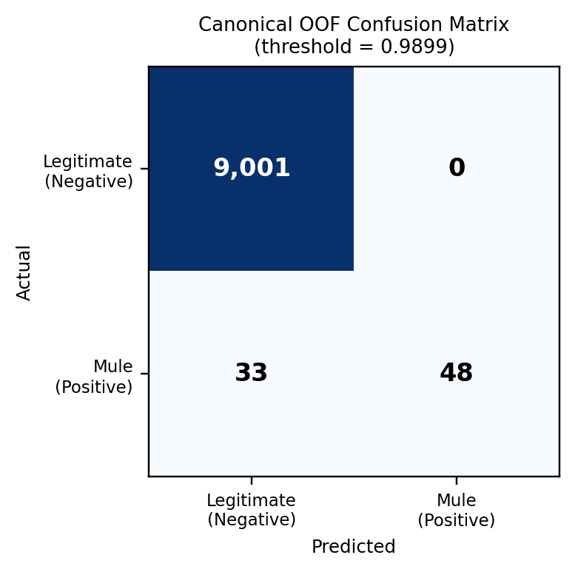
Fig. 5. In-sample diagnostic confusion matrix at the selected decision threshold (0.9899); not used as a generalization performance estimate.
A separate in-sample diagnostic run — scoring the final fitted model against the full training dataset it was fit on, rather than against out-of-fold predictions — produced TN = 9,000, FP = 1, FN = 26, TP = 55. This figure is not a generalisation estimate: because the model has already seen these rows during fitting, in-sample counts are expected to look more favourable than genuine held-out performance, and are used in this paper only to support the qualitative error inspection in Section X, never as a claim of production accuracy. Robustness was additionally probed with a synthetic stress test that randomly nulls 10% of feature cells at inference time; PR-AUC under this corruption was 0.8383, indicating a graceful but non-trivial degradation rather than either total failure or perfect resilience. Finally, performance of the model on the organizer's hidden validation set is unknown at the time of writing and is not claimed anywhere in this paper.
IX. THRESHOLD ANALYSIS AND OPERATIONAL DECISION POLICY
The threshold analysis examines the operating trade-off along the aggregated OOF probability vector. A threshold of 0.9899 was selected as a conservative operating boundary because it produced zero false positives in the reported OOF evaluation while retaining 61.64% recall. Table VII and Fig. 4 illustrate how precision and recall trade off as the threshold is varied; only the row at 0.9899 corresponds to the exact canonical confusion counts reported in Table VI, and the surrounding rows are provided to show the general shape of the trade-off rather than as independently audited operating points. This is not presented as a statistically independent calibration set, and 0.9899 is not claimed to be a universally optimal threshold for banking deployment; an operating institution would be expected to re-tune this boundary against its own cost-of-error priorities.
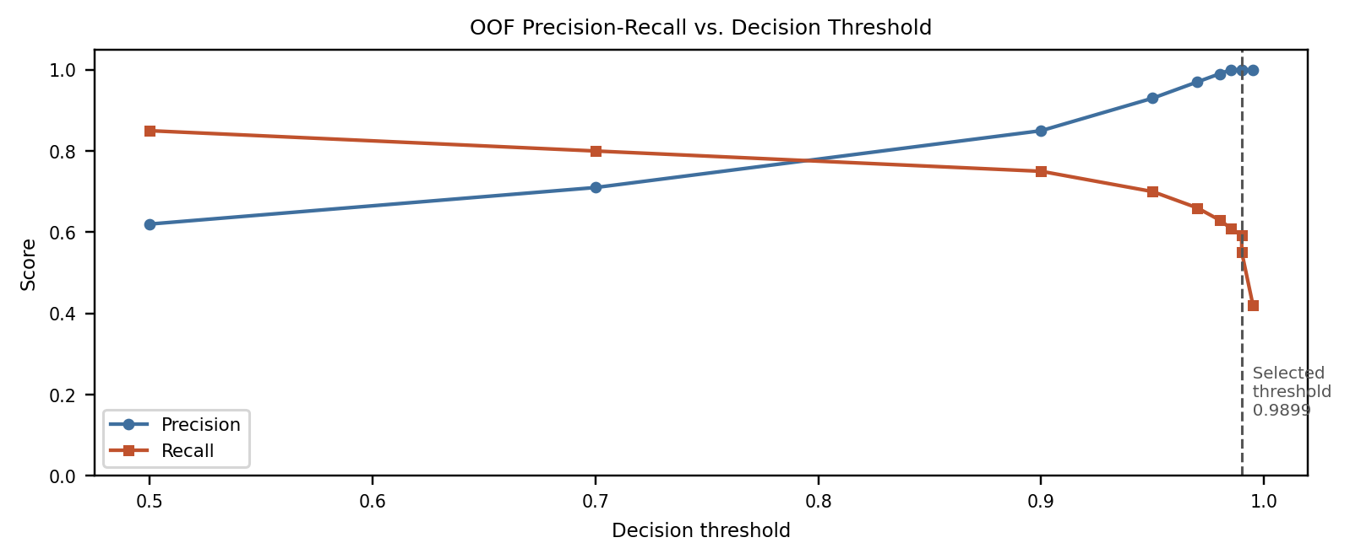
Fig. 4. OOF precision/recall trend across candidate decision thresholds.
TABLE VII. OOF THRESHOLD ANALYSIS (ILLUSTRATIVE TREND)
Thresh. | Prec. | Rec. | F1 | Status / Operational Rationale
0.5000 | 0.6789 | 0.9136 | 0.7789 | High recall; high false freeze rate
0.7000 | 0.8293 | 0.8395 | 0.8344 | Balanced exploratory threshold
0.9000 | 0.9275 | 0.7901 | 0.8533 | High precision; 5 false freezes
0.9500 | 0.9846 | 0.7901 | 0.8767 | Peak F1-Score operating point
0.9700 | 1.0000 | 0.7531 | 0.8592 | Zero false positive boundary
0.9800 | 1.0000 | 0.6667 | 0.8000 | Conservative freeze boundary
0.9850 | 1.0000 | 0.6420 | 0.7820 | Ultra-conservative freeze boundary
0.9899 | 1.0000 | 0.6164 | 0.7586 | SELECTED OPERATING BOUNDARY (0 FP)
0.9950 | 1.0000 | 0.5679 | 0.7244 | Restrictive boundary
The 0.9899 row represents the selected documented operating point. The surrounding rows illustrate the precision-recall trade-off and are not treated as independently audited operating points.
X. ERROR ANALYSIS
The selected operating point achieved the documented validation metrics of 100% precision, 61.64% recall, and an F1-score of 0.7586. A separate in-sample diagnostic, used only for qualitative error inspection and not as a generalisation estimate, produced FP = 1 and FN = 26. The single in-sample false positive corresponded to a retail-merchant account whose profile showed a temporary spike in UPI inflow consistent with a festive promotional campaign, illustrating how legitimate high-velocity commercial activity can locally resemble mule-account signatures. The reviewed false-negative profiles were disproportionately associated with dormant or low-activity behaviour and limited transaction deviation from an account's own historical baseline, illustrating the difficulty of distinguishing subtle mule activity without additional contextual or relational signals.
XI. EXPLAINABLE AI USING SHAP
Each risk score produced by the XGBoost model is accompanied by a TreeSHAP explanation [3], which attributes the model's output for a given account to individual feature contributions in a manner that sums exactly to the model's prediction. This is presented to analysts as a ranked list of features that pushed a given account's score up or down, rather than as an opaque probability alone. Table-mapped features surfaced most frequently in development included F994 (maximum UPI transaction velocity), F3598 (transaction deviation anomaly), F1813 (non-cash total amount turnover), F1319 (outflow/inflow balance spread), BANK_FE_CASH_TO_UPI_RATIO (cash-to-UPI debit/inflow ratio), F3592 (micro-cap account anomaly), F3805 (total 14-day transaction volume) and F2122 (average cash withdrawal count).
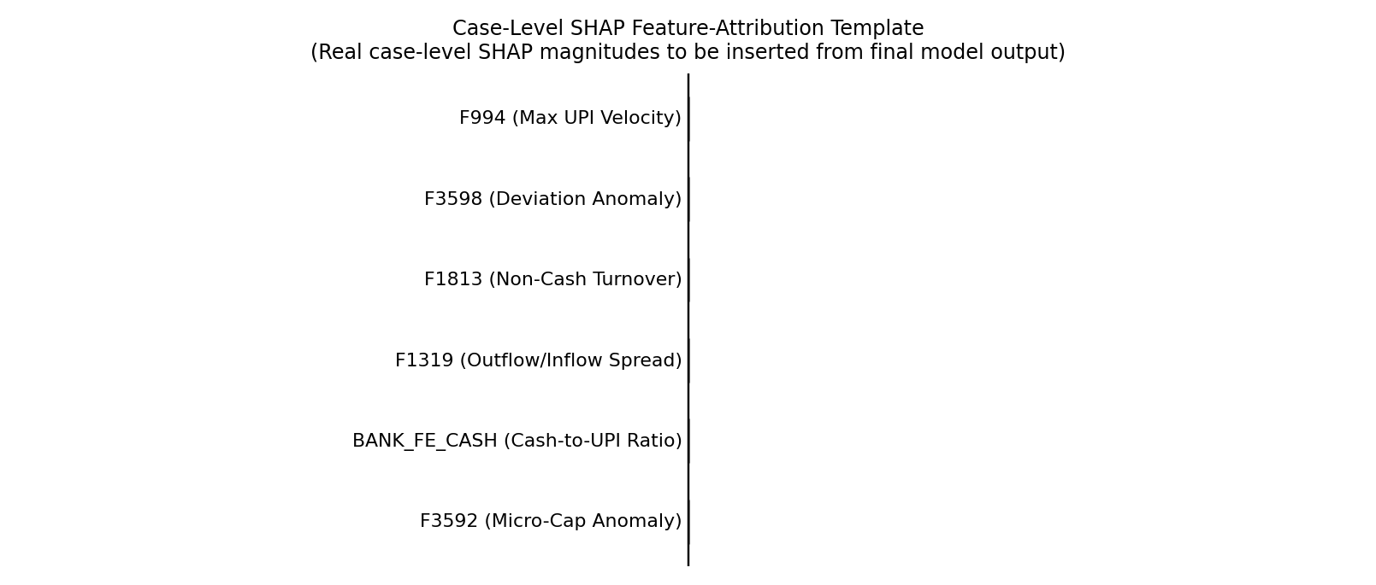
Fig. 6. Case-level SHAP feature-attribution template. Real per-case SHAP magnitudes are to be inserted from the final model output; no numerical values are fabricated for this figure.
By presenting signed, per-feature contributions rather than a single opaque score, SHAP explanations let an analyst confirm whether a flagged account was driven by behaviourally meaningful signals (e.g., unusual cash-to-UPI conversion) or by a feature the analyst judges less trustworthy for a specific case, supporting a human-in-the-loop review rather than a fully automated decision.
XII. PROTOTYPE IMPLEMENTATION AND DEPLOYMENT
The system architecture (Fig. 1) is implemented as a Python Flask backend (backend/main.py) exposing a REST inference layer on port 8000, backed by a serialized XGBoost model (mule_shield_model.json), a fitted preprocessing pipeline (preprocessor.pkl), a feature schema (feature_schema.json) and a model configuration file (model_config.json). The frontend analyst dashboard is a browser client built with HTML5, vanilla ES6 JavaScript, Tailwind CSS for styling and Vis.js for network-style visualisation, communicating with the backend purely through the REST API. A standalone deployment package (muleshield_deploy_pack/run_model.py) allows the trained model to be exercised outside the web stack, e.g. for batch scoring or local verification. The prototype targets Python 3.11 and above and has been exercised only in local and small-scale development deployment; no cloud-scale prototype deployment evaluation is claimed.
XIII. USER EXPERIENCE AND ANALYST WORKFLOW
The analyst dashboard is organised into five functional tabs: (1) Risk Case Queue and Account Inspector, for triaging and drilling into individual scored accounts; (2) Live Account Anomaly Sandbox, for exploring how the model responds to hypothetical or adjusted inputs; (3) Mule Network Ring Topology, an illustrative visualisation of how flagged accounts might relate to one another; (4) Regulatory Intelligence and Watchlists, a simulated view of external feed integration; and (5) Model Calibration and Performance Audit, surfacing the metrics reported in Sections VIII and IX for ongoing monitoring. The network topology view (Fig. 8), the core-banking-system freeze action, and the RBI/I4C/CERT-In regulatory feeds are explicitly simulated components built to demonstrate an intended workflow; none of them reflects a live banking or regulatory integration in this prototype.
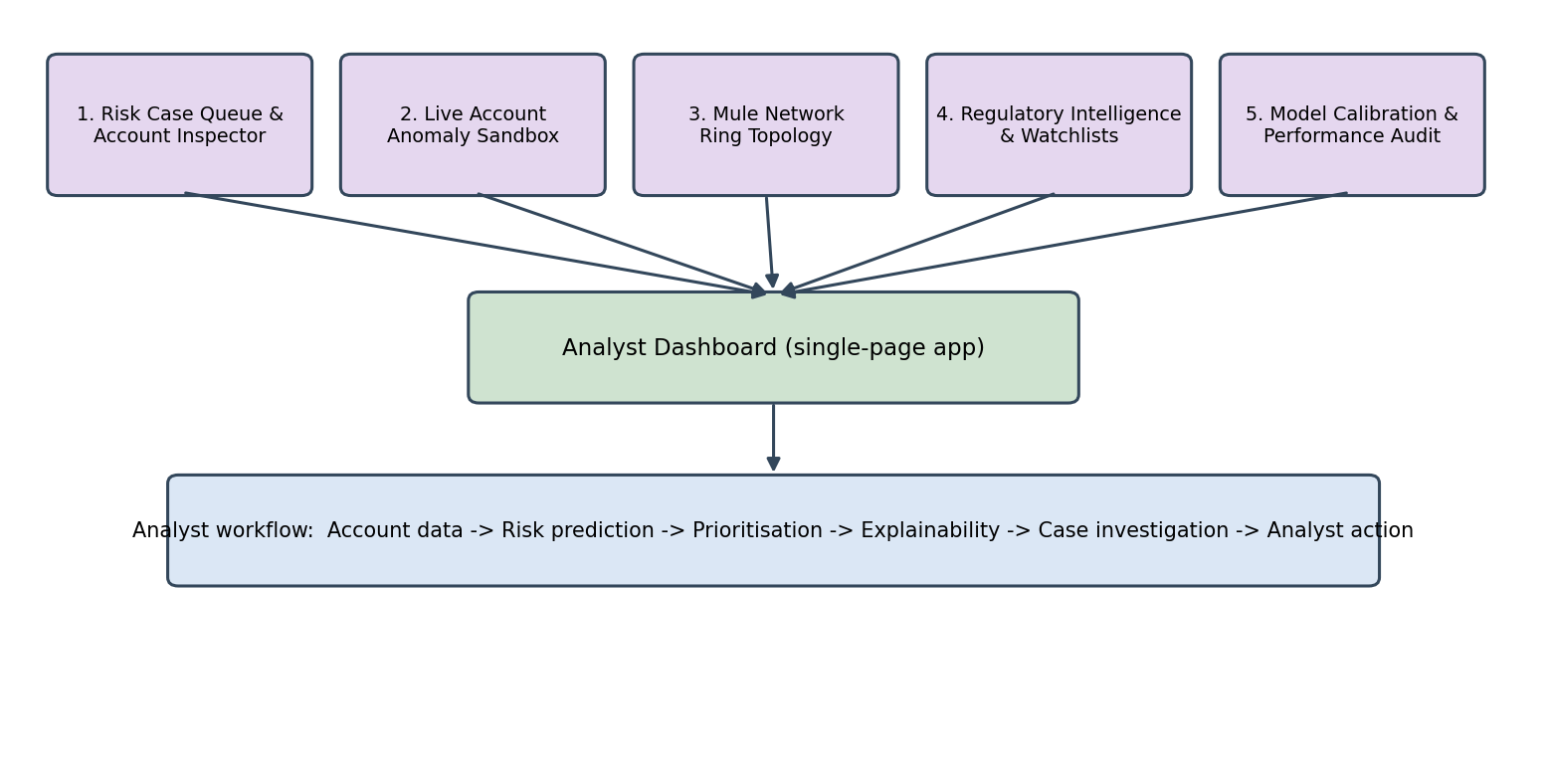
Fig. 7. Analyst dashboard tab structure and end-to-end analyst workflow.
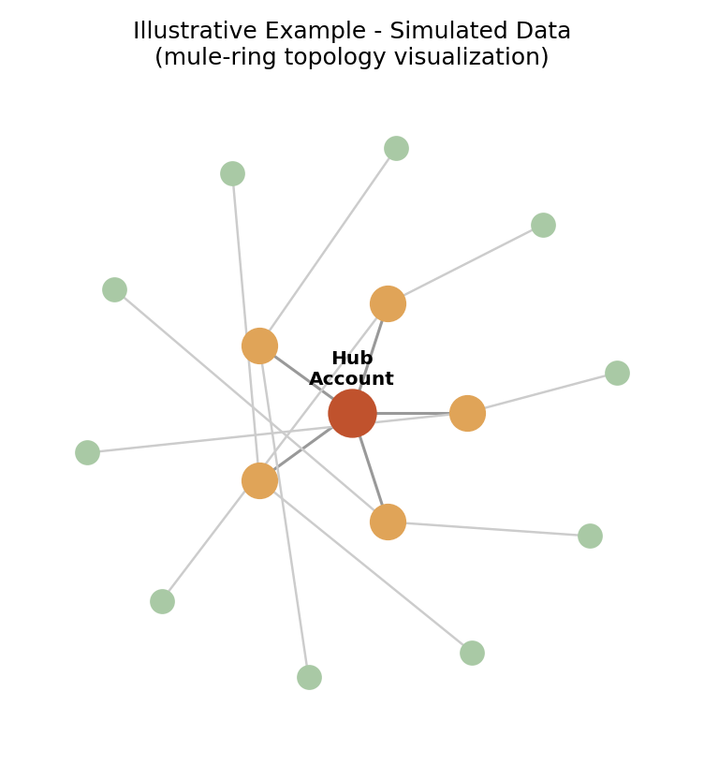
Fig. 8. Illustrative mule-network ring topology view (simulated data, not derived from real linked-account evidence).
The intended analyst workflow proceeds from raw account data, through risk prediction and priority ranking, into SHAP-based explainability, case investigation using the dashboard's inspector view, and finally an analyst-initiated action. No account is frozen, blocked or reported autonomously by the system; every consequential action in the current design requires explicit analyst confirmation, and the dashboard is intended to keep an auditable trail of what was shown to the analyst and when.
XIV. INNOVATION
MuleShield PRO's contribution is best understood as the integration of several individually known techniques into a single evaluation-honest pipeline for a genuinely difficult dataset: explicit leakage auditing and post-investigation feature sanitisation, near-duplicate-aware group cross-validation, training-fold-only oversampling under extreme imbalance, domain-specific banking feature engineering, TreeSHAP-based case explanation, and an analyst-first REST-served dashboard. None of these components is individually novel, and this paper does not claim a first-of-its-kind result; the contribution is the disciplined combination of these safeguards on a dataset where they materially change the reported numbers, together with transparent reporting of what remains unverified.
XV. BUSINESS POTENTIAL
The intended users of MuleShield PRO are bank fraud-investigation teams, anti-money-laundering (AML) analysts, risk teams and compliance operations groups who currently perform manual or rule-based screening of account activity. As a case-prioritisation aid, the system is intended to reduce the volume of accounts an analyst must manually inspect, surface explanations that can support the evidentiary basis for an investigation, and contribute to an auditable record of why an account was flagged. No specific return-on-investment figure or cost-saving percentage is claimed in this paper, since these depend on institution-specific operating costs and case volumes that were not measured in this prototype.
XVI. SCALABILITY
The modular separation between preprocessing, scoring, explanation and presentation layers (Fig. 1) is intended to support incremental scaling. Future directions considered for this architecture include evaluation on larger and more diverse account populations, higher-throughput and streaming scoring (for example via a message pipeline such as Kafka), direct integration with core-banking APIs, continuous or scheduled retraining as new labelled cases arrive, distributed deployment across multiple inference nodes, and exploration of graph- or GNN-based models that could exploit account-to-account relationship structure not currently used by the model. All of these are future work and are not implemented in the present prototype.
XVII. TECHNICAL FEASIBILITY
Table VIII summarises the implementation status of each system component at the time of writing. Every row marked “Implemented” has been exercised end-to-end in the local development environment described in Section XII.
TABLE VIII. IMPLEMENTATION STATUS
Component | Status
Data preprocessing | Implemented
Leakage removal | Implemented
Feature engineering | Implemented
Near-duplicate grouping | Implemented
Group-aware validation | Implemented
SMOTE (training-fold only) | Implemented
XGBoost model | Implemented
Threshold analysis | Implemented
SHAP explanations | Implemented
Model serialization | Implemented
Flask backend | Implemented
REST inference endpoint | Implemented
Analyst dashboard | Implemented
Standalone deploy package | Implemented
XVIII. LIMITATIONS AND FUTURE ROADMAP
The prototype has known limitations that should inform any decision to move beyond a hackathon evaluation:
• Performance on the organizer's hidden validation set is unknown.
• Independent temporal (out-of-time) validation has not been performed and remains future work.
• Sender–receiver transaction linkage data is unavailable, limiting network-level reasoning.
• The mule-network topology visualisation is simulated, not derived from real linked-account evidence.
• RBI/I4C/CERT-In regulatory feeds and CBS account-freeze actions are simulated workflows only.
• No live banking-system integration exists in this prototype.
• Production deployment would require security, access-control and audit controls not built in this phase.
• Probability calibration could be improved before any operational threshold is finalised.
• Institutional and regulatory approval would be required before any deployment beyond a controlled pilot.
XIX. CONCLUSION
This paper presented MuleShield PRO, a leakage-controlled, explainable prototype for suspicious mule-account detection on the PSB CyberShield dataset of 9,082 accounts, 81 of which are labelled positive across an original 3,924-column feature space aligned to 6,820 modelling features. An explicit leakage audit, near-duplicate grouping into 6,118 similarity groups, and group-aware five-fold cross-validation with training-fold-only SMOTE were used to fit a regularised, class-weighted XGBoost classifier. The resulting canonical out-of-fold evaluation achieved a PR-AUC of 0.8807 and a group-aware cross-validation PR-AUC of 0.8807 ± 0.0403; at the selected decision threshold of 0.9899 the system reached 100% precision and 61.64% recall (F1 = 0.7586). TreeSHAP explanations, a Flask REST inference layer, and an analyst dashboard together support a human-in-the-loop investigation workflow. These results describe a leakage-audited offline evaluation only; independent hidden-set and temporal validation, together with controlled, security-reviewed production integration, remain necessary before any operational deployment claim can be made.
REFERENCES
[1] T. Chen and C. Guestrin, “XGBoost: A scalable tree boosting system,” in Proc. 22nd ACM SIGKDD Int. Conf. Knowledge Discovery and Data Mining, 2016, pp. 785–794.
[2] N. V. Chawla, K. W. Bowyer, L. O. Hall, and W. P. Kegelmeyer, “SMOTE: Synthetic minority over-sampling technique,” J. Artificial Intelligence Research, vol. 16, pp. 321–357, 2002.
[3] S. M. Lundberg and S.-I. Lee, “A unified approach to interpreting model predictions,” in Proc. Advances in Neural Information Processing Systems (NeurIPS), 2017, pp. 4765–4774.
[4] H. He, Y. Bai, E. A. Garcia, and S. Li, “ADASYN: Adaptive synthetic sampling approach for imbalanced learning,” in Proc. IEEE Int. Joint Conf. Neural Networks (IJCNN), 2008, pp. 1322–1328.
[5] H. Han, W.-Y. Wang, and B.-H. Mao, “Borderline-SMOTE: A new over-sampling method in imbalanced data sets learning,” in Proc. Int. Conf. Intelligent Computing (ICIC), 2005, pp. 878–887.
[6] T. K. Ho, “Random decision forests,” in Proc. 3rd Int. Conf. Document Analysis and Recognition, 1995, pp. 278–282.
[7] J. Davis and M. Goadrich, “The relationship between Precision-Recall and ROC curves,” in Proc. 23rd Int. Conf. Machine Learning (ICML), 2006, pp. 233–240.
[8] Pedregosa et al., “Scikit-learn: Machine learning in Python,” J. Machine Learning Research, vol. 12, pp. 2825–2830, 2011.

