Sepsis Prediction Using Machine Learning and Deep Learning with Digital Twin Integration
Reeja S R (✉), Ashwin Nair, Anjith Thomas Jose, Abin Binu, and Atharva Gore
VIT-AP University Amaravathi, Andhra Pradesh, India
reeja.sr@vitap.ac.in, {ashwin.22bce7968, anjith.22bce7289, binu.22bce9401, atharva.22bce9298}@vitapstudent.ac.in
Abstract. Sepsis is a life-threatening condition characterized by a dysregulated host response to infection and remains a major cause of mortality in intensive care units worldwide. Early detection of sepsis is challenging due to its heterogeneous clinical presentation and rapid progression. Traditional clinical scoring systems rely on static thresholds and often fail to capture complex temporal patterns present in intensive care unit data. In this work, we propose a comprehensive sepsis prediction framework that integrates machine learning and deep learning models with a Digital Twin architecture for hourly patient monitoring. The proposed system leverages multivariate time-series data to estimate the risk that sepsis onset occurs within the next 6 hours while providing hourly risk trajectories to support clinical decision-making. Multiple predictive models, including classical machine learning algorithms and deep learning architectures such as LSTM, GRU-D, CNN-LSTM, and Transformer models, are evaluated and compared. Feature attributions are computed for the GRU-D sequence model with GradientSHAP. Under a leakage-safe protocol (patient-level split, post-onset hours removed, preprocessing fitted on training patients only), eleven models reach a test AUROC of 0.696–0.787 for sepsis onset within 6 hours on 14,057 ICU stays, and deep sequence models perform comparably to gradient boosting. We further add a privacy-preserving surveillance layer in which hospitals share only noisy daily counts of high-risk alerts and influenza-like-illness (ILI) visits; in a simulated 12-hospital network driven by real ICU risk scores and a real CDC influenza series, pooled signals detected all simulated outbreaks 3–4 days earlier than a single hospital.
Keywords: Sepsis Prediction · Digital Twin · Machine Learning · Deep Learning · LSTM · Explainable AI · Clinical Decision Support · Syndromic Surveillance · Privacy-Preserving Aggregation

1 Introduction
Sepsis is a major global health challenge that arises from an extreme immune response to infection and frequently progresses to organ dysfunction and high mortality. Clinical studies have consistently shown that patient survival decreases significantly with every hour of delayed diagnosis and treatment, making early detection a critical priority in intensive care units. Despite advances in critical care, the heterogeneous presentation of sepsis continues to complicate timely recognition, particularly during early stages when symptoms are subtle and nonspecific [1,2,12].
Modern hospitals generate continuous streams of physiological and clinical data, including vital signs, laboratory measurements, and device outputs. However, manual monitoring and traditional rule-based scoring systems such as SIRS and SOFA are often insufficient to identify complex, multivariate temporal patterns that precede sepsis onset. Machine learning and deep learning techniques provide the capability to analyze high-dimensional ICU data and detect early warning signals that are difficult to capture using conventional approaches [5–7].
In this work, we propose an end-to-end framework that integrates multiple machine learning and deep learning models within a Digital Twin system. The Digital Twin functions as a dynamic, data- driven virtual representation of a patient whose state is continuously updated as new data becomes available. By combining predictive modeling with hourly risk trajectories and a clinician-facing dashboard, the proposed system is designed to give clinicians early alerts and context to support decision-making [11,13]; its effect on patient outcomes has not been evaluated. We further extend the framework to multi-hospital surveillance, in which hospitals share only privacy-protected daily counts of high-risk alerts and influenza-like-illness visits for early regional outbreak warning. The core contribution remains individual-level: each Digital Twin predicts sepsis for one patient. The surveillance layer is a population-level extension, evaluated on a simulated hospital network, and is not a deployed epidemiological surveillance system.

2 Literature Review
Early efforts in sepsis detection relied predominantly on rule-based clinical scoring systems such as the Systemic Inflammatory Response Syndrome score and the Sequential Organ Failure Assessment score. These approaches are interpretable and easy to apply in practice but often lack sensitivity for early detection and fail to generalize across diverse patient populations. Subsequent research introduced machine learning models based on logistic regression and decision trees, which improved predictive performance by learning patterns directly from electronic health record data. Ensemble methods, including Random Forests and gradient boosting techniques such as XGBoost, further enhanced predictive accuracy, particularly on structured tabular features [1,2,5,12].
Deep learning methods have gained prominence due to their ability to model temporal dependencies in sequential clinical data. Recurrent architectures such as recurrent neural networks, long short-term memory networks, and gated recurrent units have demonstrated strong performance in sepsis prediction tasks by capturing evolving physiological trends over time. Hybrid architectures, including CNN–LSTM models, have been proposed to extract local temporal patterns before modeling longer-term dependencies. More recently, Transformer-based models employing self-attention mechanisms have shown promise in capturing long-range temporal relationships without recurrence, albeit at higher computational cost [6,7,10].
Despite strong predictive performance, many high-capacity models remain black boxes, limiting their acceptance in clinical settings. Explainable artificial intelligence techniques, particularly SHAP, address this limitation by attributing model predictions to individual input features. In parallel, the concept of Digital Twins has emerged in healthcare to support simulation, personalization, and continuous patient state modeling. Prior studies have explored Digital Twins for treatment planning and physiological simulation in sepsis. The present work builds on this foundation by embedding multiple machine learning and deep learning predictors within a Digital Twin that presents hourly risk through a clinician-facing dashboard [3,11,14]; a web application for ICU risk prediction is described in [9].
Sepsis is a syndrome caused by infection, with an estimated 48.9 million cases and 11.0 million deaths worldwide in 2017 [24], so regional rises in infection can foreshadow rises in sepsis. Syndromic surveillance systems such as ESSENCE II pool pre-diagnostic data, including emergency and outpatient visits, from many sources and apply temporal and spatio-temporal algorithms to give early warning of outbreaks [25]. Reviews show that detection depends on how representative the data are, on the specificity of the algorithm and on the size and shape of the outbreak signal [26], and statistical process-control methods such as CUSUM and EWMA are standard detectors [27,28]. Sharing data across sites raises privacy concerns: secure multi-party protocols can pool surveillance counts without revealing provider or patient data [29], and federated learning trains shared models without centralising records [30]. We are not aware of prior work that pools alerts from bedside sepsis-risk models across hospitals with calibrated noise added to the released counts; our surveillance layer addresses this gap.
Table 1. Literature Survey
Ref no | Category | Methods/Models | Data Type Used | Key Contributions | Strengths | Limitations
[1,2] | Rule-Based Clinical Scores | SIRS, SOFA, qSOFA | Vital signs, lab values, clinical rules | Early standardized tools for sepsis screening and severity assessment | Interpretable, simple, easy to implement in clinical workflows | Low sensitivity for early detection, poor generalization across populations, static thresholds
[5,12] | Traditional Machine Learning | Logistic Regression, Decision Trees | Structured EHR data (labs, vitals, demographics) | Learned data-driven risk patterns beyond fixed rules | Better predictive power than rule-based methods, relatively interpretable | Limited ability to model temporal dependencies, performance plateaus with complex data
[1,2,5,12] | Ensemble Learning | Random Forests, Gradient Boosting, XGBoost | Structured tabular EHR data | Improved robustness and accuracy through ensemble decision-making | High accuracy, handles feature interactions well, resistant to overfitting | Limited temporal modeling, reduced interpretability without XAI
[6,7] | Recurrent Deep Learning Models | RNN, LSTM, GRU | Time-series EHR data | Modeled sequential physiological trends for early sepsis prediction | Captures temporal dependencies, strong performance in dynamic patient monitoring | Training instability, vanishing gradients (RNN), computationally intensive
[10] | Hybrid Deep Learning Models | CNN–LSTM, CNN–GRU | Multivariate time-series data | Combined local pattern extraction with long-term temporal modeling | Improved feature learning, better handling of noisy signals | Complex architecture design, reduced interpretability
[6,7,10] | Attention-Based Models | Transformer-based architectures | Long clinical time-series |  | Parallel processing, superior long-term dependency modeling | High computational cost, large data requirements
  Captured long-range temporal relationships via self-attention
[3,11] | Explainable AI (XAI) | SHAP, Feature Attribution Methods | Model predictions + input features | Provided feature-level explanations for predictions | Increased clinician trust, regulatory acceptability | Post-hoc explanations may not reflect true causality
[3,11,14] | Digital Twin Approaches | Patient-specific Digital Twins | Continuous EHR streams, model outputs | Simulated and updated patient states for monitoring and decision support | Personalization, real-time tracking, scenario simulation | System complexity, integration challenges in hospitals
[24]–[30] | Multi-site Surveillance | Syndromic surveillance, CUSUM/EWMA, secure aggregation, federated learning | Aggregated counts from many sites (visits, tests, cases) | Early regional outbreak warning from pooled signals | Earlier, more reliable alarms than single sites | Privacy limits on sharing; not linked to patient-level sepsis risk
Present Work | Integrated Digital Twin + AI Systems | Multi-model predictors + XAI dashboards | Retrospective hourly ICU data | Unified prediction, explanation, and visualization framework, plus privacy-preserving multi-site surveillance | Hourly risk estimation, clinician-facing dashboard | Requires robust infrastructure, validation in real-world settings

3 Dataset and Feature Engineering
This study uses a single ICU dataset in the format of the PhysioNet/Computing in Cardiology Challenge 2019 [5,16], comprising 14,057 ICU stays and 546,123 hourly records. Each record contains vital signs (heart rate, oxygen saturation, temperature, systolic, diastolic and mean arterial pressure, respiratory rate), laboratory values (including lactate, creatinine, bilirubin, white blood cell count and platelets), demographics (age, sex), ICU unit indicators, hospital admission time and ICU length of stay. Other widely used ICU databases, such as MIMIC-III [4], were not used in this study. 2.2% of hourly records and 8.8% of patients carry a positive sepsis label.
Sepsis prediction is framed as hourly binary classification. For hour t of a stay, the target is 1 if the labelled sepsis onset (the first hour with SepsisLabel = 1) falls within the next H hours, and 0 otherwise; H = 6 hours is the main horizon, with 3 and 12 hours reported as extras. In this dataset the label is set about 6 hours before clinical onset and never reverts, so 89.5% of positive records are post-onset continuations, and a model that copies the previous hour’s label reaches a row-level AUROC of 0.948. All hours at or after onset are therefore removed, and stays that are positive from their first hour are excluded.
The model inputs are 44 recorded and derived variables, including five pre-computed features: the 6-hour rolling mean of MAP, its 1-hour change, the qSOFA respiratory-rate and MAP criteria, and a simplified qSOFA score. Classical models receive the current hour’s values. Sequence models receive the previous 24 hours, zero-padded at the start of a stay, together with a binary mask that marks observed values.
The dataset reached us already imputed: every missing hour holds the median of its column computed over the whole dataset, with no carry-forward, so the data contain no missing cells and the mask is 1 everywhere except in the padded start of a window. Consequently a value equal to the column median acts as a measurement indicator (models given only these indicators reached AUROC 0.58), the median was computed before the patient split, and the missing-data handling of GRU-D is not exercised. The median imputer and the standard scaler used here are fitted on the training patients’ pre-onset hours only, so the imputer has no effect on this file.

4 Methodology
Patients are split at the patient level into training, validation and test sets in a 70/15/15 ratio with a fixed random seed; the split is stored with the code so that every experiment uses the same patients. The test set contains 2,092 patients and 80,098 pre-onset hours, of which 860 (1.1%) are positive. Early stopping, probability calibration (Platt scaling [8,23]) and the alert threshold (the F1-optimal threshold) are chosen on the validation set only; the test set is used once, for the reported results. We report AUROC, AUPRC, sensitivity at 80% specificity and the Brier score, with 95% confidence intervals from 1,000 bootstrap resamples of test patients.
Eleven models are trained and evaluated under this single protocol. Class imbalance is handled with class weights and by keeping one in four negative hours in the training set only; no oversampling is used, and validation and test sets keep every hour at the true prevalence. Sequence models are trained with the AdamW optimiser (learning rate 0.001, weight decay 0.0001), a cosine learning-rate schedule and class-weighted binary cross-entropy, with batch size 256 and up to 25 epochs, stopping early on validation AUPRC (patience of 5 epochs). Every stochastic model is trained with three seeds (42, 43 and 44), and we report the mean and standard deviation.

5 Models Used
Logistic regression is used as a baseline due to its simplicity, interpretability, and probabilistic outputs. Decision trees provide an interpretable non-linear baseline with human-readable decision rules. Random Forests improve robustness through ensembling and offer feature importance estimates useful for clinical discussion. XGBoost provides state-of-the-art performance on structured data through optimized gradient boosting. K-nearest neighbors serves as a diagnostic baseline offering intuitive similarity-based reasoning. HistGradientBoosting, a histogram-based gradient-boosting implementation, is included as a second boosting baseline.
A feed-forward artificial neural network (multilayer perceptron) is trained on the current hour’s features. Sequence models, including a unidirectional LSTM and GRU-D [17], are trained on 24-hour windows; GRU-D is designed to model missingness and the time since the last observation; this is not exercised here because the data are already imputed. CNN–LSTM and Transformer variants capture local temporal structure and longer-range dependencies, respectively. Two controls are added: ICU length of stay as the only predictor, and models trained on shuffled labels.

6 Digital Twin Framework
A Digital Twin for sepsis is a patient-level model whose risk estimate is updated as new vital signs and laboratory values arrive. In this work the twin scores hourly windows of a retrospective dataset: incoming hours are preprocessed with the training-set imputer and scaler, the 24-hour window is updated, and classical and sequence models compute a calibrated probability that onset occurs within 6 hours. A dashboard shows the hour-by-hour risk trajectory against validation-derived Medium and High operating points and lists the largest deviations of the current values from reference ranges. GradientSHAP attributions are computed offline for the GRU-D model, with exact TreeSHAP for XGBoost as a cross-check. Streaming ingestion and deployment in a live clinical environment were not evaluated.

6.1 End-to-End System Architecture
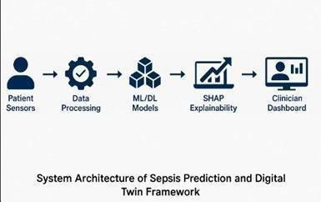
Fig. 1. System Architecture of Sepsis Prediction and Digital Twin Framework (conceptual architecture). The pipeline begins with patient sensor data collection, followed by preprocessing, machine learning and deep learning model inference, SHAP- based explainability, and visualization through a clinician-facing dashboard.
Fig. 1 shows the intended architecture; this paper evaluates the modelling and surveillance components offline on retrospective data.
The end-to-end architecture shown in Fig. 1 represents the core operational flow of the proposed Sepsis Digital Twin system. The framework begins with continuous data collection from patient sensors, including vital signs such as heart rate, respiratory rate, blood pressure, oxygen saturation, and temperature, along with laboratory measurements when available. This raw multivariate time-series data is passed to a data processing module, where cleaning, imputation, normalization, and feature engineering steps are applied hourly to ensure reliable downstream inference.
Next, the processed data flows into the machine learning and deep learning model layer, which includes classical models such as Logistic Regression, Random Forest, and XGBoost, as well as deep sequence models including LSTM, GRU-D, CNN–LSTM, and Transformer architectures. These models compute a continuous sepsis risk score at each time step. The architecture includes an explainability stage; in the current implementation it provides offline GradientSHAP attributions for GRU-D (TreeSHAP for XGBoost) and reference-range deviations in the dashboard.
Finally, the predictions and explanations are displayed in a clinician-facing dashboard that visualizes risk trajectories, vital signs, and key driver features in an intuitive and actionable manner. This interface is intended to support clinical decision-making by helping to identify high-risk patients and to make alerts understandable; its clinical effect was not evaluated here. The modular nature of this pipeline forms the backbone of the proposed Sepsis Digital Twin framework, enabling continuous monitoring and dynamic patient state modeling.

6.2 Architectural Components
Intended deployment architecture (not evaluated here): Ingestion and Storage: A streaming collector writes to a time-series store (or message queue). Raw data is retained for replay. Preprocessing service: Applies normalization, imputation, and feature computation hourly.
Model serving: Lightweight tabular models (LR, RF, XGBoost) are served for near-instant responses; heavier LSTM/Transformer models run on GPUs or batched CPU inference for hourly predictions. Explainability engine: GradientSHAP values for GRU-D and TreeSHAP values for XGBoost are computed offline; the dashboard reports deviations from reference ranges. Dashboard / Clinician UI: Shows current risk, 24-hour trajectory, largest deviations from reference ranges, recent vitals, and recommended actions.

7 Implementation Details
The system is implemented in Python, with pandas and NumPy for data handling, scikit-learn (version 1.7.2) for the classical models and calibration, XGBoost (version 2) for gradient boosting and PyTorch for the sequence models. GradientSHAP attributions for GRU-D were computed with Captum (version 0.9) and TreeSHAP values with XGBoost’s built-in exact implementation; FastAPI serves the models and Streamlit provides the clinician-facing dashboard. Exact package versions are pinned in the code repository.
Training procedure: all reported results come from one evaluation script that applies the protocol above to every model: the patient split, label construction with post-onset hours removed, preprocessing fitted on training patients, training with three seeds, Platt calibration and threshold selection on validation, and bootstrap evaluation on test. A second author re-ran the script on a different machine. The data, split, test counts, all classical models and GRU-D reproduced exactly; at the 6-hour horizon, Transformer, CNN–LSTM and neural-network results differed between machines by less than one standard deviation across seeds.

8 Experimental Setup
Performance is measured as a function of the prediction horizon H (3, 6 and 12 hours), with H = 6 hours as the main result. Because positive hours fall late in long stays, ICU length of stay alone is reported as a reference that every model must beat, and models trained on shuffled labels are reported as a check for leakage.

9 Results
Table 2 reports test performance at a 6-hour horizon. All models fall between AUROC 0.696 and 0.787, and the best seven, from GRU-D (0.787) to LSTM (0.770), have overlapping 95% confidence intervals: deep sequence models do not outperform gradient boosting. ICU length of stay alone reaches AUROC 0.673, so part of every model’s discrimination comes from time in the ICU.
Table 2. Test performance at a 6-hour prediction horizon (2,092 test patients, 1.1% positive hours). AUROC: mean ± standard deviation over seeds; 95% CI: 1,000 patient-level bootstrap resamples of the seed-ensemble prediction.
Model | Seeds | AUROC | AUROC 95% CI | AUPRC | Sensitivity at 80% specificity
GRU-D | 3 | 0.787 ± 0.009 | 0.761–0.829 | 0.056 | 0.64
XGBoost | 3 | 0.784 ± 0.003 | 0.753–0.820 | 0.058 | 0.62
CNN–LSTM | 3 | 0.782 ± 0.010 | 0.759–0.824 | 0.050 | 0.62
HistGradientBoosting | 3 | 0.777 ± 0.003 | 0.745–0.818 | 0.059 | 0.63
Random Forest | 3 | 0.775 ± 0.000 | 0.741–0.811 | 0.057 | 0.62
Transformer | 3 | 0.772 ± 0.006 | 0.750–0.817 | 0.056 | 0.59
LSTM | 3 | 0.770 ± 0.012 | 0.741–0.809 | 0.050 | 0.60
Decision Tree | 1 | 0.757 | 0.724–0.792 | 0.053 | 0.55
Logistic Regression | 1 | 0.744 | 0.706–0.779 | 0.063 | 0.57
Neural network (MLP) | 3 | 0.741 ± 0.024 | 0.715–0.784 | 0.054 | 0.58
K-nearest neighbours | 1 | 0.696 | 0.664–0.733 | 0.042 | 0.40
ICU length of stay only | 1 | 0.673 | 0.621–0.728 | 0.067 | 0.55
At 1.1% prevalence, AUPRC values of 0.04–0.07 are about four to six times the chance level, and precision at the F1-optimal threshold is 9–11%: most alerts are false, so the system suits triage rather than diagnosis. Brier scores are only 2–3% better than predicting the base rate. Models trained on shuffled labels reach AUROC 0.40–0.41, and 0.69 when labels are shuffled only within 6-hour bins of ICU time, confirming that time in the ICU carries much of the signal. At 3 and 12 hours the same group of models leads (seed-mean AUROC: CNN-LSTM 0.796 and GRU-D 0.793 at 3 hours; XGBoost 0.799 at 12 hours; XGBoost 0.780, 0.784, 0.799 and GRU-D 0.793, 0.787, 0.793 at 3, 6 and 12 hours).
To explain the GRU-D predictions, GradientSHAP [3], as implemented in Captum, was applied to each of the three seed models and the attributions were averaged. It explained 1,000 test windows (500 positive, 500 negative) against 200 random training windows, with 200 samples per window. Attributions are on the log-odds scale; for each window they add up to the change in the model output relative to the background (correlation 0.997). Fig. 2 shows the 15 most important features. Time in the ICU (ICULOS) dominates, with a mean absolute SHAP value of 1.30, about six times that of any other feature: it raises the predicted risk late in a stay and lowers it early. This matches the length-of-stay-only reference (AUROC 0.673) and reflects that labelled onsets fall late in a stay, so part of what the model has learnt is when sepsis is labelled rather than how patients deteriorate. Among physiological variables, respiratory rate (0.21), heart rate (0.19), the 6-hour mean arterial pressure (0.18), oxygen saturation (0.15) and temperature (0.13) contribute most. Higher respiratory and heart rates raise the risk and a higher mean arterial pressure lowers it, consistent with the qSOFA criteria. Gender and the ICU-unit indicators also rank highly (0.14–0.19), which suggests that the model partly relies on patient mix and unit rather than physiology alone. Lactate ranks 40th of 44 features. Exact TreeSHAP on the XGBoost baseline gives the same top feature (ICULOS, mean |SHAP| 0.74), with administrative variables ranked higher still: hours since hospital admission (0.32), ICU unit (0.21) and age (0.21). Because the data were imputed before release (Sect. 3), the observation-mask attributions only reflect the padded start of short stays, not missing measurements.
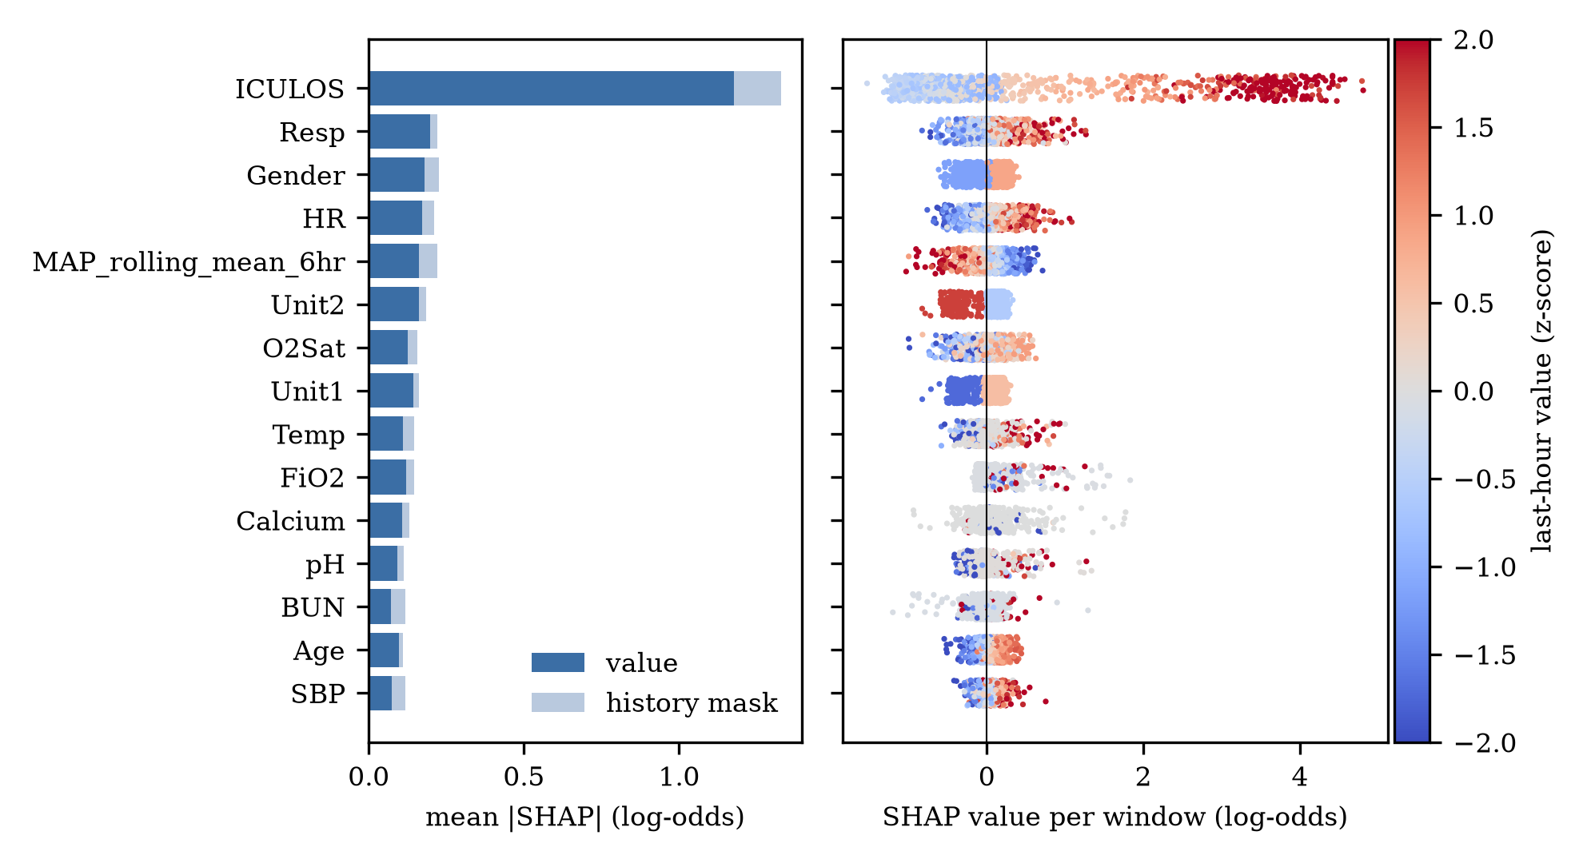
Fig. 2. GradientSHAP explanation of the leakage-safe GRU-D model (three seeds) on held-out test windows. Left: mean absolute SHAP value per feature (log-odds), split into the value and observation-mask parts. Right: SHAP value per window, coloured by the feature's last-hour value (z-score).
Fig. 3 follows one septic test patient chosen by a fixed rule: among the 98 septic test patients with at least 24 pre-onset hours, the one with the median peak risk in the 6 hours before onset, so the example is typical rather than the best case. The calibrated GRU-D risk passes the Medium threshold (80% specificity on validation) 27 hours before the labelled onset and first reaches the High threshold (95% specificity) 19 hours before onset; it then falls back below High and stays above it from 7 hours before onset. Heart rate and respiratory rate drive the increase between 25 and 18 hours before onset, platelets lower the risk in the middle hours and haematocrit lowers it close to onset, while the contribution of ICULOS grows steadily with time in the ICU. This is a single illustrative case and not an estimate of average lead time, which was not measured.
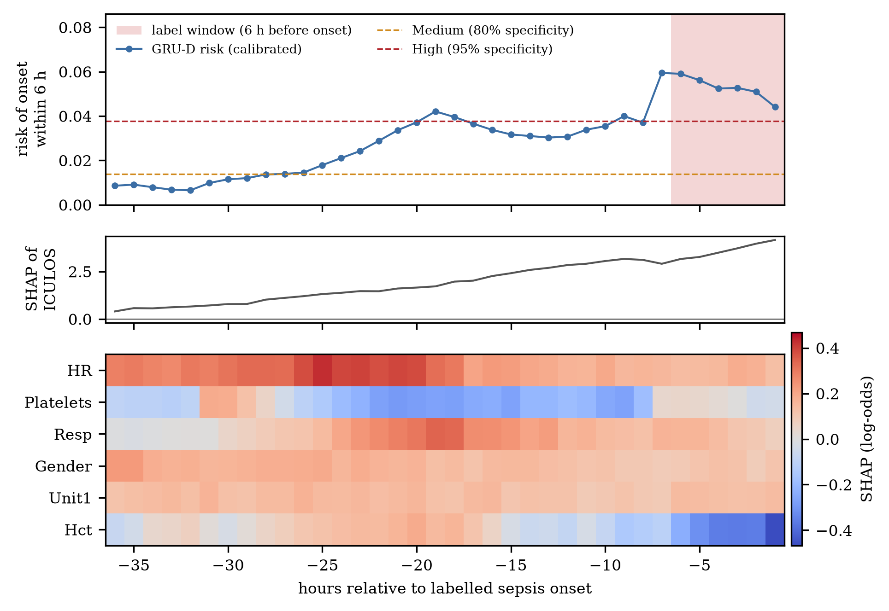
Fig. 3. Risk trajectory and explanation for one septic test patient over the 36 hours before the labelled onset. Top: calibrated GRU-D risk with the Medium (80% specificity) and High (95% specificity) thresholds; shading marks the 6-hour label window. Middle: SHAP value of time in the ICU (ICULOS). Bottom: hourly SHAP values of the six other most influential features.

10 Discussion
Under a leakage-safe protocol the evaluated models are statistically comparable. GRU-D, XGBoost and CNN–LSTM have the highest mean AUROC, but their confidence intervals overlap with those of Random Forest, HistGradientBoosting, Transformer and LSTM.
Sequence-based models therefore offer no clear advantage over tree-based ensembles on this dataset, while ensembles are cheaper to run and easier to explain through feature importance. Logistic regression remains a useful interpretable baseline. SHAP-based explanations can show which variables drive a prediction, but they describe model behaviour, not causes.
As a design recommendation (not evaluated here), an effective Digital Twin deployment should prioritize high recall to minimize missed sepsis cases; however, excessive false alarms can lead to alert fatigue and reduced trust in the system. To balance sensitivity and usability, a tiered alerting strategy is recommended. Low-risk increases are presented as informational signals on the dashboard to support passive monitoring, while medium-risk predictions trigger warning-level alerts that prompt clinician review. High-risk predictions, optionally accompanied by the largest reference-range deviations, generate action-level alerts that recommend immediate clinical intervention. Alert thresholds and probability calibration must be carefully tuned to align with local clinical workflows and acceptable false-alarm rates.
Several limitations apply. Only one dataset and one patient split are used, and the number of positive test patients is small (155 patients contribute the 860 positive hours), so differences between models are uncertain. The dataset’s labelled onset precedes clinical onset by about 6 hours, and lead time before clinical onset was not measured. Precision at useful sensitivity is low, and calibration skill is modest [15]. Deep learning models need substantial computation and, like all models here, external and prospective validation before clinical use. SHAP explanations approximate model behaviour and should not be read as causal evidence. The dataset was imputed with column medians before we received it, so measurement patterns carry some signal and GRU-D’s missing-data handling is untested.

11 Practical Deployment Considerations
From a computational and latency perspective, tabular models such as Logistic Regression, Random Forest, and XGBoost provide near-instant inference and are therefore well suited for frequent prediction updates in a clinical environment. In contrast, sequence-based models such as LSTM and Transformer architectures benefit from GPU acceleration due to their higher computational complexity; however, for early sepsis warning applications, batched inference at hourly intervals is typically sufficient; clinical utility was not evaluated here.
With respect to data governance and privacy, all data flows within the system must comply with applicable local and international healthcare regulations, such as HIPAA-equivalent standards. Patient data should be anonymized, encrypted at rest, and protected through strict access control mechanisms. In multi-institutional settings, federated learning approaches can be adopted to enable cross-hospital model training while avoiding the transfer of raw patient data, thereby enhancing privacy and regulatory compliance. The next section extends this idea to privacy-preserving surveillance across hospitals.
Ongoing monitoring and maintenance are essential to ensure sustained model performance after deployment. Models should be continuously evaluated for performance drift, with regular retraining schedules and probability calibration checks incorporated into the production pipeline. Drift detection mechanisms should be employed to identify changes in data distributions or clinical practice that may degrade predictive accuracy over time.

12 Multi-site Surveillance and Early Outbreak Warning

12.1 Motivation
Sepsis is most often triggered by infection, and respiratory viruses such as influenza raise both infection and sepsis admissions. A single hospital sees too few cases to separate a real rise from noise. Combining the high-risk alerts from each hospital’s Digital Twin with regional counts of influenza-like illness (ILI) can raise an earlier and more reliable alarm, provided that patient data never leave the hospital.

12.2 Architecture
Each hospital runs its own Digital Twin and releases only three daily counts to a central service: admissions, high-risk alerts and ILI visits (Fig. 4). Two privacy controls are applied at the site before release. Counts below a minimum cell size k (default 3) are suppressed, and Laplace noise calibrated to a privacy budget ε (default 1.0) is added to each released count [20]. A patient contributes to at most two released counts per day (admissions and high-risk alerts), so with one admission per patient, as in the simulation, the per-patient privacy cost is 2ε. Suppression is applied to the noisy counts and does not change this. The central aggregator sums the released counts by region and day.
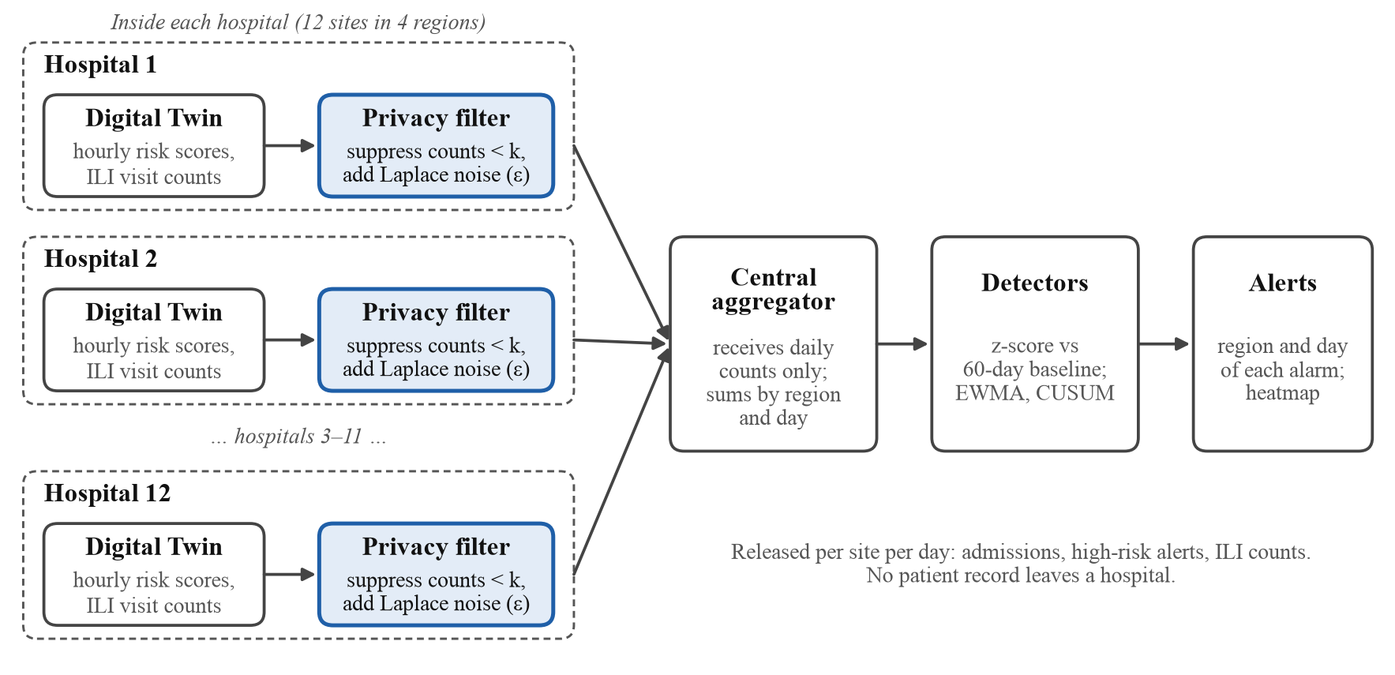
Fig. 4. Data flow of the multi-site surveillance layer. Only noisy daily counts leave each hospital.

12.3 Detection Methods
Each region’s daily rate is converted to a z-score against its first 60 days. Two detectors run on the z-scores: an exponentially weighted moving average (EWMA) [18] and a one-sided cumulative sum (CUSUM) [19]. Four signals are compared: the pooled high-risk-alert rate, pooled ILI counts, a combined sepsis-alert and ILI signal, and a single hospital’s own alert rate. A region-by-day heatmap shows where and when alarms fire. Performance is measured by the detection rate, the median delay from outbreak start to first alarm, and false alarms per 100 region-days outside the outbreak.

12.4 Experimental Setup
The ICU records, their risk scores and the viral series are real; the hospital network and the outbreak are simulated. Risk scores are out-of-fold GRU-D predictions (5-fold, patient-grouped, pre-onset hours only, 6-hour horizon) for 13,920 patients, with a patient-level AUROC of 0.743. The viral series is the weekly weighted influenza-like-illness percentage from CDC FluView ILINet [21] for four US HHS regions (1, 3, 4 and 9) from week 36 of 2024, retrieved through the Delphi Epidata API [22] on 9 October 2026. It is interpolated to daily values and scaled to a baseline of 0.8 cases per site per day, so only its shape is real. ILINet reports syndromic influenza-like illness rather than laboratory-confirmed infection, so the viral signal does not identify a specific pathogen.
Patients are assigned to 12 simulated hospitals in 4 regions over 140 days. A 21-day sepsis-alert surge moves 60% of flagged admissions into an outbreak window that starts where each region’s viral series first stays above 1.3 times its baseline for 7 days (days 63 to 81). Because the ICU data contain no dates or locations, the sepsis surge and the viral rise are aligned by construction. Each configuration is run 30 times.

12.5 Results
Table 3 summarises detection. Pooled high-risk alerts and the combined signal detected every simulated outbreak with a median delay of 4–5 days, against 8 days for a single hospital (Fig. 5). The viral signal alone was slower (14–17 days) and missed about a quarter of outbreaks, partly because influenza-like illness drifts upward through the autumn, so a 60-day baseline is not flat. With simulated instead of real viral counts the conclusions held (combined signal with EWMA: all outbreaks detected, 5-day delay; single hospital: 97% detected, 7-day delay).
Table 3. Outbreak detection over 30 simulated outbreaks (real viral series, leakage-safe GRU-D risk scores). Detection rate / median delay (days) / false alarms per 100 region-days.
Signal | EWMA | CUSUM
Pooled high-risk alerts | 1.00 / 4 / 1.37 | 1.00 / 4 / 1.31
Pooled ILI counts | 0.77 / 17 / 2.16 | 0.77 / 14 / 1.83
Combined | 1.00 / 5 / 1.44 | 1.00 / 4 / 1.76
Single hospital | 0.87 / 8 / 0.98 | 1.00 / 8 / 0.98
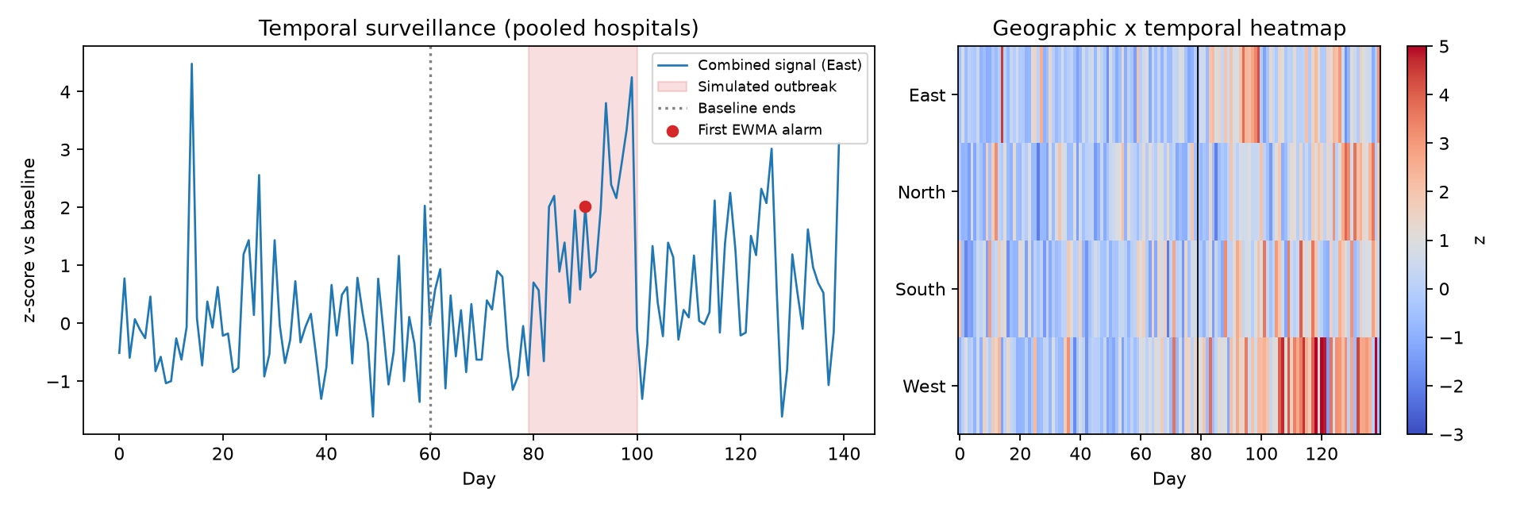
Fig. 5. Left: combined signal (z-score against baseline) for the East region in one simulated outbreak, with the outbreak window shaded and the first EWMA alarm marked. Right: region-by-day heatmap of the combined signal.

12.6 Regional Reproduction Number
To add a measure of transmission, the time-varying reproduction number R_{t} was estimated for each region from the same ILINet series. For each week, the growth rate r of influenza-like illness was estimated by a quasi-Poisson regression of weekly ILI visits on time, with all patient visits as an offset, over the trailing four weeks, so every estimate uses only data available at that time. The growth rate was converted to R_{t} = (1 + rs)^{k} for a gamma-distributed generation interval with shape k and scale s [31], using the influenza serial interval of mean 3.6 days and standard deviation 1.6 days [32]. Fig. 6 shows the estimates. Over the 60-day baseline R_{t} stayed between 0.97 and 1.07 in all regions; it peaked at 1.08–1.15 in the weeks starting 22 and 29 December 2024 and then fell below 1. In the South and West, R_{t} was significantly above 1 (lower 95% bound above 1 for two consecutive weeks) from day 62, 6 and 1 days before the rise in ILI used as the outbreak start; in the North, growth became significant only on day 97, 16 days after the rise, and in the East it never stayed significant for two weeks. R_{t} therefore adds a transmission context to the alarms but is not an earlier detector: the season grows slowly, so R_{t} stays close to 1. Because ILI is a share of all visits and mixes pathogens, R_{t} here describes the growth of influenza-like illness rather than of a single virus, and the late-December peak partly reflects fewer routine visits over the holidays.
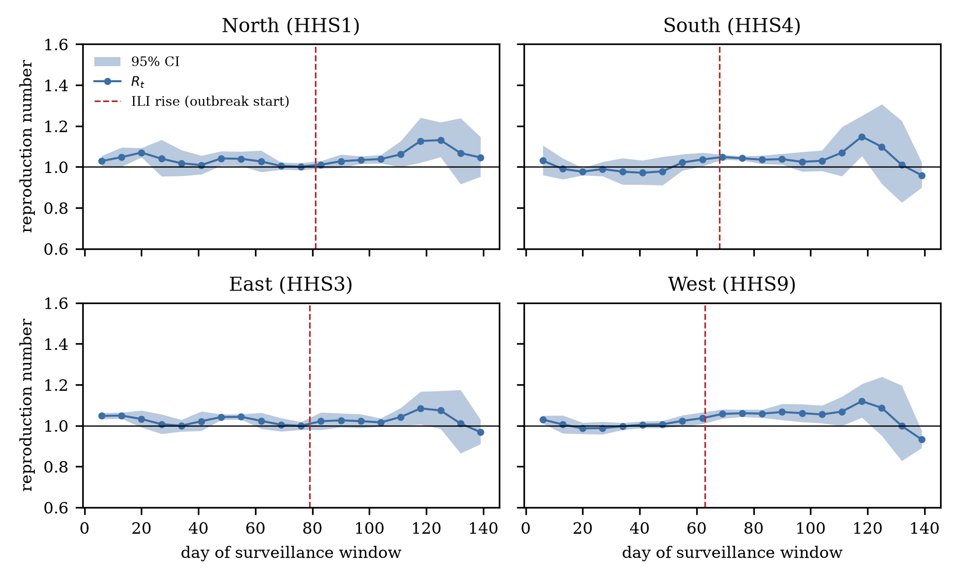
Fig. 6. Time-varying reproduction number R_{t} by region, estimated from CDC ILINet (trailing four-week growth rate, influenza serial interval). Shading: 95% confidence interval; dashed line: rise in ILI used as the outbreak start.

12.7 Sensitivity Analysis
A one-at-a-time sensitivity analysis (30 replicates per setting; EWMA detector, combined signal unless stated) tested the assumptions. Strong privacy noise hurt detection: at ε = 0.1 the combined signal detected 60% of outbreaks with a 17.5-day delay, while at ε ≥ 0.5 it detected all of them, with the delay falling from 8 days to 3 days without noise. Suppression thresholds of k = 1 to 5 changed little, but k = 10 raised false alarms from 0.61 to 2.69 per 100 region-days. With about eight admissions per site per day, k = 10 suppresses two thirds of site-days, so a region has no report on a third of days and on average only one of its three sites reporting; the regional series then rests on few, intermittent reports. Using the viral count per reporting site instead of the sum did not remove the effect (2.84).
Larger outbreaks were caught sooner (9 days at intensity 0.2, 4 days at 0.8), and the viral signal alone needed a strong surge (33% detected at a 1.5-fold surge, 100% at 5-fold). Pooling helped the viral signal (67% detected with one site per region, 100% with five), whereas the single-hospital signal weakened as the fixed patient pool was spread over more sites. In a no-outbreak control the combined signal raised 0.54 false alarms per 100 region-days (0.77 with CUSUM), and an alarm fell inside the placebo outbreak window in 10% (EWMA) to 17% (CUSUM) of replicates, so weak settings sit close to chance-level detection.

12.8 Limitations
The hospital network, admission dates and outbreak are simulated, the sepsis surge is aligned with the real viral rise by construction, and each simulated hospital has few patients. The outbreak is created by moving already-flagged admissions, so the experiment tests the surveillance layer, not how early the risk model warns. Nothing here has been validated clinically or on real multi-site data; federated training across hospitals and a pilot with real hospital data feeds are future work. The advantage over a single hospital depends on how few patients each site has: with one simulated site per region a single site also detected every outbreak, after 3 days. The layer flags unusual rises in pooled counts; it does not identify pathogens or trace contacts, and the reproduction number in Sect. 12.6 is a growth-rate estimate from syndromic data rather than a transmission model. Pathogen-specific feeds, such as laboratory-confirmed influenza, RSV and SARS-CoV-2 results, and coupling with transmission models are also future work.

13 Conclusion
This work presents a Digital Twin framework that scores ICU patients hourly with classical and deep sequence models and extends it to privacy-preserving multi-hospital surveillance. Under a leakage-safe protocol, eleven models predict sepsis onset within 6 hours with a test AUROC between 0.696 and 0.787, and deep sequence models are statistically comparable to gradient boosting. Removing post-onset hours is essential, because a persisted label alone yields an AUROC near 0.95. With precision near 10% at useful sensitivity, the Digital Twin is a triage aid rather than a diagnostic tool. Pooling daily counts of high-risk alerts and ILI visits across simulated hospitals detected every simulated outbreak 3–4 days earlier than a single hospital in the default 12-hospital configuration, and detection held at privacy budgets down to ε = 0.5. GradientSHAP explanations of the GRU-D model show that time in the ICU dominates its predictions, mirroring the length-of-stay-only reference, so part of its discrimination reflects when sepsis is labelled rather than physiological deterioration. A regional reproduction number estimated from the same ILI series adds transmission context to the alarms but gave no earlier warning, because influenza-like illness grew slowly in this season. Future work will focus on external and prospective validation, federated training across institutions, measuring lead time before clinical onset, pilots with real hospital data feeds, and pathogen-specific surveillance data.

14 Data and Code Availability
The evaluation code, result tables, figure scripts and this manuscript’s number-to-source map are available at https://github.com/Ashwinn04/DIGI-TWIN-SEPSIS (release tag paper514-final-lncs). The ICU data used are in the format of the PhysioNet/Computing in Cardiology Challenge 2019 [5]; the 14,057 stays are drawn from the public challenge training data (patient numbers 1 to 20,643), which are released under the Creative Commons Attribution 4.0 licence [5,16]. The rule that selected this subset is not documented, and the file reached the authors with missing hourly values already replaced by column medians and five derived columns added. The data are not redistributed with the code. The weekly influenza-like-illness series was retrieved from the public CDC FluView ILINet system through the Delphi Epidata API on 9 October 2026 [21,22].
References
- Desautels, T., et al.: Prediction of sepsis in the intensive care unit with minimal electronic health record data: a machine learning approach. JMIR Medical Informatics 4(3), e28 (2016)
- Moor, M., et al.: Early prediction of sepsis in the ICU using machine learning: a systematic review. Frontiers in Medicine 8, 607952 (2021)
- Lundberg, S.M., Lee, S.-I.: A unified approach to interpreting model predictions. In: Advances in Neural Information Processing Systems, vol. 30 (2017)
- Johnson, A.E.W., et al.: MIMIC-III, a freely accessible critical care database. Scientific Data 3, 160035 (2016)
- Reyna, M.A., et al.: Early prediction of sepsis from clinical data: the PhysioNet/Computing in Cardiology Challenge 2019. Critical Care Medicine 48(2), 210–217 (2020)
- Nemati, S., et al.: An interpretable machine learning model for accurate prediction of sepsis in the ICU. Critical Care Medicine 46(4), 547–553 (2018)
- Kam, H.J., Kim, H.Y.: Learning representations for the early detection of sepsis with deep neural networks. Computers in Biology and Medicine 89, 248–255 (2017)
- Guo, C., Pleiss, G., Sun, Y., Weinberger, K.Q.: On calibration of modern neural networks. In: Proceedings of the 34th International Conference on Machine Learning. PMLR, vol. 70, pp. 1321–1330 (2017)
- Fabrizzio, G.C., Erdmann, A.L., de Oliveira, L.M.: Web app for prediction of hospitalisation in intensive care unit by covid-19. Revista Brasileira de Enfermagem 76(6), e20220740 (2023)
- Tang, Y., Zhang, Y., Li, J.: A time series driven model for early sepsis prediction based on transformer module. BMC Medical Research Methodology 24, 23 (2024)
- Lauritsen, S.M., et al.: Explainable artificial intelligence model to predict acute critical illness from electronic health records. Nature Communications 11, 3852 (2020)
- Fleuren, L.M., et al.: Machine learning for the prediction of sepsis: a systematic review and meta-analysis of diagnostic test accuracy. Intensive Care Medicine 46(3), 383–400 (2020)
- Topol, E.J.: High-performance medicine: the convergence of human and artificial intelligence. Nature Medicine 25(1), 44–56 (2019)
- Beede, E., et al.: A human-centered evaluation of a deep learning system deployed in clinics for the detection of diabetic retinopathy. In: Proceedings of the 2020 CHI Conference on Human Factors in Computing Systems, pp. 1–12 (2020)
- Van Calster, B., et al.: Calibration: the Achilles heel of predictive analytics. BMC Medicine 17, 230 (2019)
- Goldberger, A.L., et al.: PhysioBank, PhysioToolkit, and PhysioNet: components of a new research resource for complex physiologic signals. Circulation 101(23), e215–e220 (2000)
- Che, Z., et al.: Recurrent neural networks for multivariate time series with missing values. Scientific Reports 8, 6085 (2018)
- Roberts, S.W.: Control chart tests based on geometric moving averages. Technometrics 1(3), 239–250 (1959)
- Page, E.S.: Continuous inspection schemes. Biometrika 41(1–2), 100–115 (1954)
- Dwork, C., McSherry, F., Nissim, K., Smith, A.: Calibrating noise to sensitivity in private data analysis. In: Theory of Cryptography (TCC 2006). LNCS, vol. 3876, pp. 265–284. Springer (2006)
- Centers for Disease Control and Prevention: FluView: U.S. Outpatient Influenza-like Illness Surveillance Network (ILINet). https://www.cdc.gov/fluview/, last accessed 2026/10/09
- Farrow, D.C., Brooks, L.C., Rumack, A., Tibshirani, R.J., Rosenfeld, R.: Delphi Epidata API (2015). https://github.com/cmu-delphi/delphi-epidata, fluview endpoint last accessed 2026/10/09
- Platt, J.C.: Probabilistic outputs for support vector machines and comparisons to regularized likelihood methods. In: Smola, A.J., Bartlett, P., Schölkopf, B., Schuurmans, D. (eds.) Advances in Large Margin Classifiers, pp. 61–74. MIT Press (2000)
- Rudd, K.E., et al.: Global, regional, and national sepsis incidence and mortality, 1990–2017: analysis for the Global Burden of Disease Study. The Lancet 395(10219), 200–211 (2020)
- Lombardo, J., et al.: A systems overview of the Electronic Surveillance System for the Early Notification of Community-Based Epidemics (ESSENCE II). Journal of Urban Health 80(2 Suppl 1), i32–i42 (2003)
- Buckeridge, D.L.: Outbreak detection through automated surveillance: a review of the determinants of detection. Journal of Biomedical Informatics 40(4), 370–379 (2007)
- Unkel, S., Farrington, C.P., Garthwaite, P.H., Robertson, C., Andrews, N.: Statistical methods for the prospective detection of infectious disease outbreaks: a review. Journal of the Royal Statistical Society Series A 175(1), 49–82 (2012)
- Fricker Jr., R.D.: Introduction to Statistical Methods for Biosurveillance: With an Emphasis on Syndromic Surveillance. Cambridge University Press (2013)
- El Emam, K., et al.: A secure protocol for protecting the identity of providers when disclosing data for disease surveillance. Journal of the American Medical Informatics Association 18(3), 212–217 (2011)
- Rieke, N., et al.: The future of digital health with federated learning. npj Digital Medicine 3, 119 (2020)
- Wallinga, J., Lipsitch, M.: How generation intervals shape the relationship between growth rates and reproductive numbers. Proceedings of the Royal Society B 274(1609), 599–604 (2007)
- Cowling, B.J., Fang, V.J., Riley, S., Peiris, J.S.M., Leung, G.M.: Estimation of the serial interval of influenza. Epidemiology 20(3), 344–347 (2009)

