Project Report: Multi-Platform Social Media Dashboard

1. Title of the Project
Social Media Dashboard
Aggregating Developer, Entertainment, and Gaming Profiles into a Centralized Command Center

2. Group Details
Course: ICT 3230
Group Number: Group 13
Student Name | Enrollment Number | Role / Division
Ashwin Singh Kushwaha | 230953208 | Backend Architecture & Integrations
Chirag Sumanth | 230953270 | Core Architecture & User Onboarding
Shreyas Bibhuty | 230953234 | Data Panels & Micro-Interactions

3. Project Abstract
The Unified Social Media Dashboard addresses the problem of platform fragmentation by providing a single, secure portal that aggregates real-time data from GitHub, Reddit, Last.fm, and Steam. Built on the MERN stack, it authenticates users with JWT, stores their linked account identifiers, and concurrently fetches live data from all four external REST APIs on demand — normalizing their heterogeneous JSON responses into a unified interface.
Backend highlights: Node.js/Express server · JWT + bcrypt auth pipeline · MongoDB embedded schema for O(1) retrieval · `Promise.all` concurrent API fetching · sort query parameter support per platform · Steam full library via `include_appinfo=true`
Frontend highlights: React SPA with zero full-page reloads · per-panel sorting dropdowns and manual refresh · Steam `▶ PLAY` quick-launch via `steam://` URI · Reddit subreddit contextual links · shimmer skeleton loaders · platform-colored hover-glow cards · 220ms tab fade-in transitions

4. High-Level Design

4.1 System API & Backend Middleware Routing
The system follows a strict Model-View-Controller (MVC) logic separation, heavily decoupling the React frontend client from the Express API backend server. The backend acts as a protective proxy layer between the client and the third-party platforms. When a React component needs data, it issues an HTTP GET request to our Express server containing a JSON Web Token (JWT) in the authorization header.
Our custom authentication middleware intercepts this request, cryptographically verifies the token, and extracts the user’s MongoDB Document ID. Once authorized, the request is passed to the specialized FeedControllers. This server-side proxy architecture prevents our frontend client from continuously hitting CORS (Cross-Origin Resource Sharing) barriers and ensures our private API keys (like the Steam API key) are never exposed to the user’s browser.
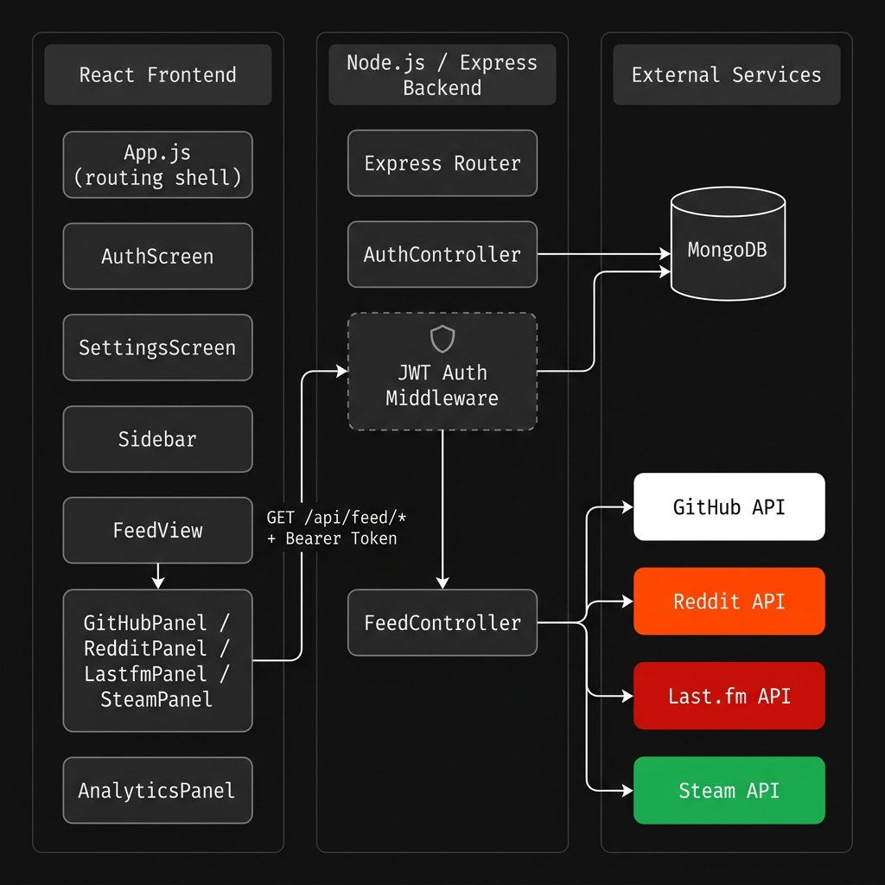

4.2 Frontend Architecture and Modularity
The client software is architected using React component modularity. Rather than a singular monolithic interface, the UI is broken down into highly specific, single-purpose modules. For instance, the FeedView acts merely as a shell routing the user to the GitHubPanel, RedditPanel, LastfmPanel, or SteamPanel. This modularity ensures that if the Reddit API structure changes in the future, only the RedditPanel code needs to be updated, completely isolating the rest of the application interface from potential bugs. Furthermore, all CSS has been abstracted into a centralized theme/styles.js token system, ensuring colors, typographies, and spacing are globally uniform.

4.3 Database Architecture (NoSQL)
A NoSQL approach via MongoDB and the Mongoose Object Data Modeling (ODM) library was chosen for its flexibility and speed. Because the dashboard requires rapid read-access to a user’s third-party usernames, maintaining a relational SQL database with rigid foreign key constraints would introduce unnecessary overhead.
Instead, the system utilizes a primary User document. All relevant third-party identifiers (GitHub username, Steam64 ID) are stored entirely as an embedded accounts object within that primary user document. This structural decision enables $O\left(1\right)$ read complexity; the server can retrieve an entire user profile and configuration state with a single, highly performant database query.
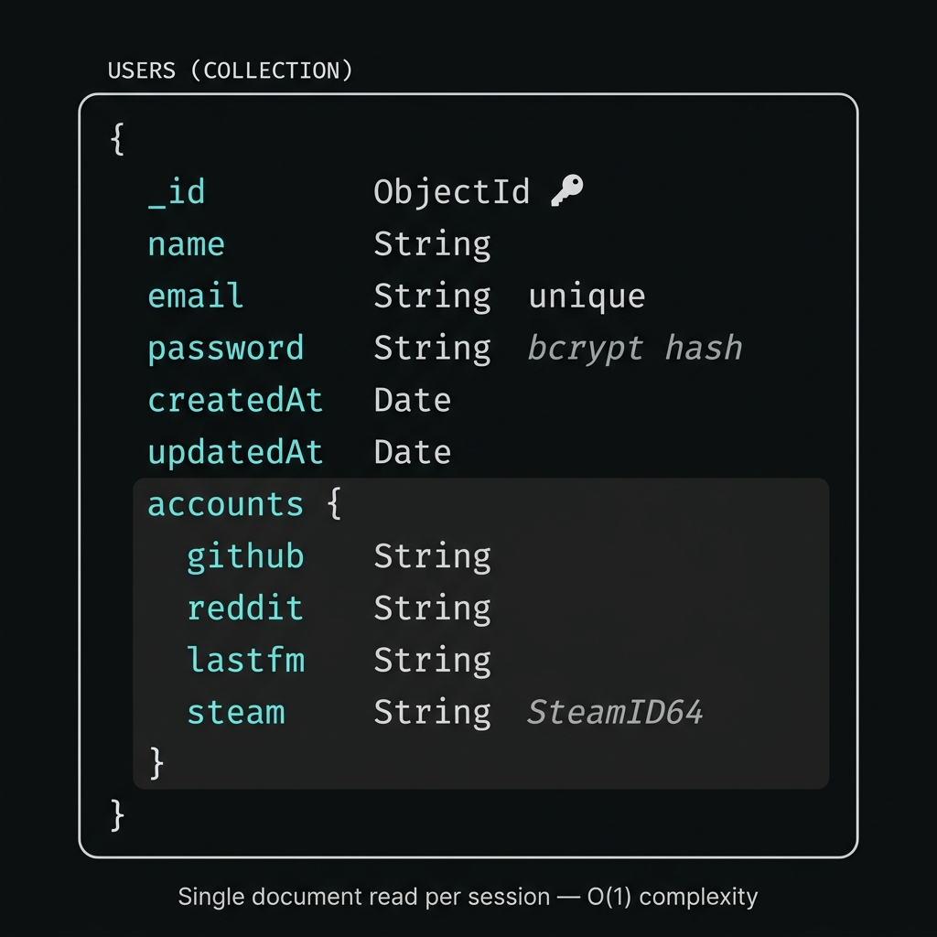

5. Components & Concepts Used
The table below outlines the core components and their strategic purpose.
Concept / Library | Purpose and Implementation Details
JSON Web Tokens (JWT) | Provides stateless, cryptographically signed authentication. Allows the server to verify user identity on every API request without needing to perform slow database lookups to check session tables.
Bcrypt Hashing | A secure password hashing function utilizing randomized salts. This ensures that even in the event of a catastrophic database breach, user passwords remain unreadable to attackers.
React State (useState) | Drives the interactive data controls. State bindings allow the UI to immediately react when a user toggles a sorting dropdown, redrawing the screen with the newly structured logic without reloading the page.
React Effects (useEffect) | Handles the component lifecycle “side effects,” specifically the asynchronous act of fetching external network data the exact moment a visual panel mounts to the screen.
Axios Promise Resolution | The backend utilizes Promise.all() to dispatch multiple Axios HTTP requests simultaneously. For example, fetching Last.fm recent tracks and top artists concurrently cuts network waiting time in half compared to fetching them sequentially.
Mongoose Schemas | Enforces data integrity in a schema-less NoSQL database. It guarantees that parameters like the Steam ID conform to expected string formats before writing to disk.
HoverCard Component | A reusable React wrapper leveraging onMouseEnter/onMouseLeave event handlers to apply platform-specific box-shadow glow effects and a CSS translateY lift, creating tactile hover feedback across all data cards.
Skeleton Component | A set of shimmer-animated placeholder shapes (SkelLine, SkelCircle, SkelRect) driven by a CSS @keyframes gradient sweep. Each panel renders a layout-accurate skeleton that mirrors the dimensions of its real content during the API loading phase.
CSS @keyframes Animations | Global animations defined in index.css power three interaction layers: the skeleton shimmer, the panel fade-in on tab switch, and the .hover-card CSS transition timing.
steam:// URI Protocol | An OS-level deep-link protocol registered by the Steam desktop client. A hyperlink prefixed with steam://run/[appid] triggers the client to directly launch the corresponding game, turning the dashboard into a functional quick-launcher.

6. Screenshots and Descriptions

1. Authentication / Registration Gateway
This view showcases the minimalist, monospace-themed authentication portal. It demonstrates the initial entry point where a user’s credentials are encrypted before being passed to the Express backend. Error handling is also displayed here, preventing bad data from entering the database.
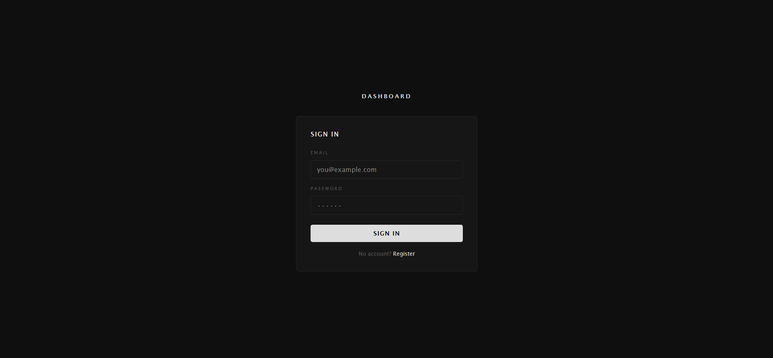

2. Connected Accounts Settings Menu
This screenshot highlights the configuration panel where the embedded User.accounts document is dynamically updated. Users provide their specific alphanumeric identifiers for the individual platforms. The input fields utilize controlled React components to manage state prior to submission.
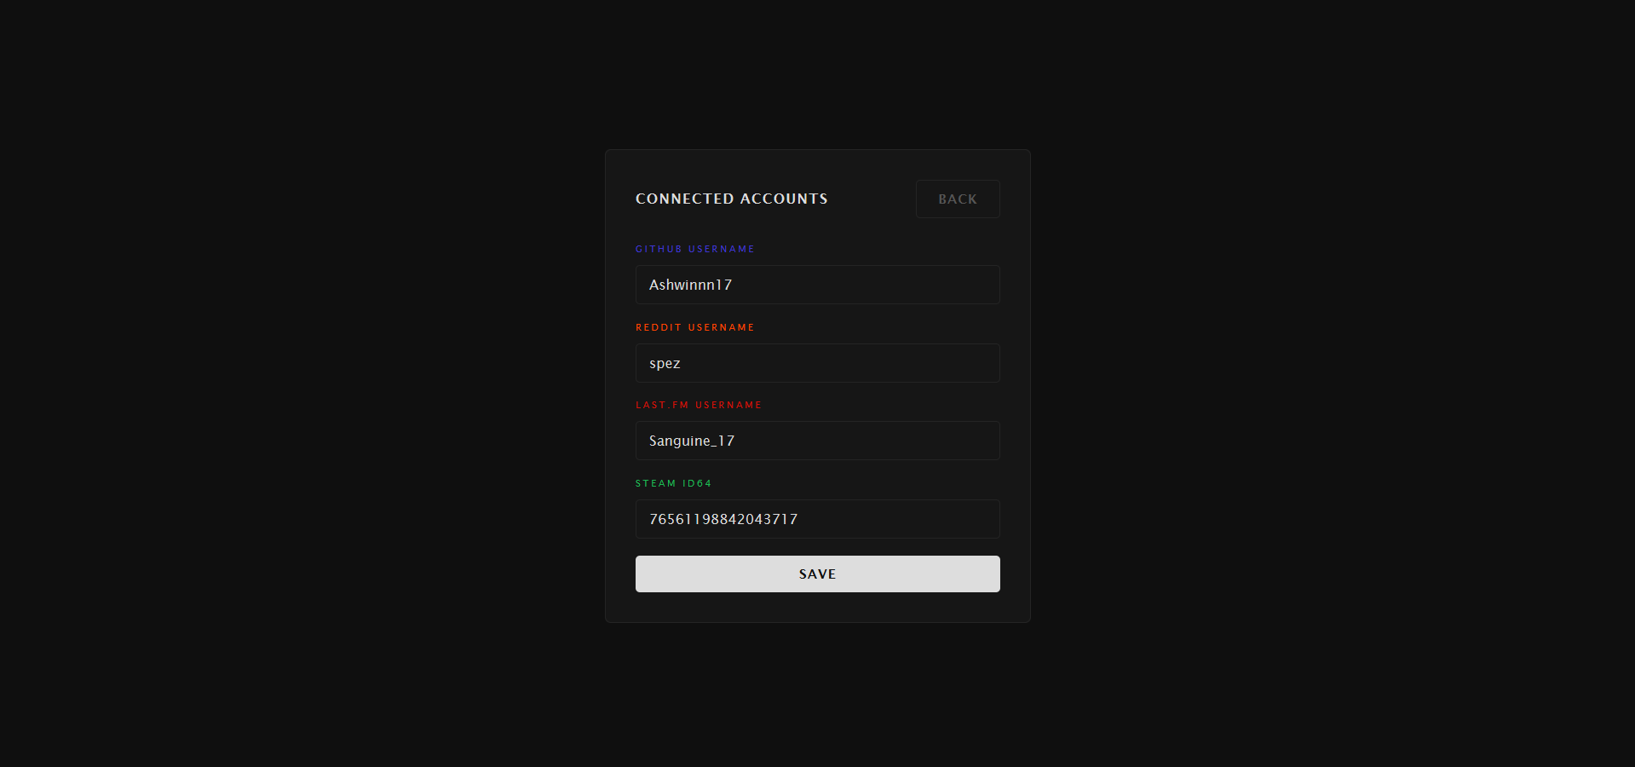

3. Interactive Feed Panels with Micro-Interactions
This screenshot demonstrates the interactive controls and visual micro-interaction system. It showcases the per-panel sorting dropdowns (e.g., GitHub: “Most Stars” / “Recently Updated”; Steam: “Last 2 Weeks” / “All Library”), the shimmer skeleton loading state visible before data arrives, and the platform-accented hover-glow effect on individual cards. It also highlights the Quick Action ▶ PLAY button on the Steam panel and the clickable subreddit tags in the Reddit panel.
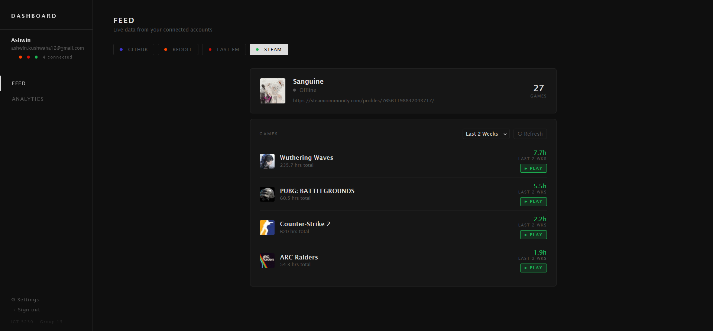
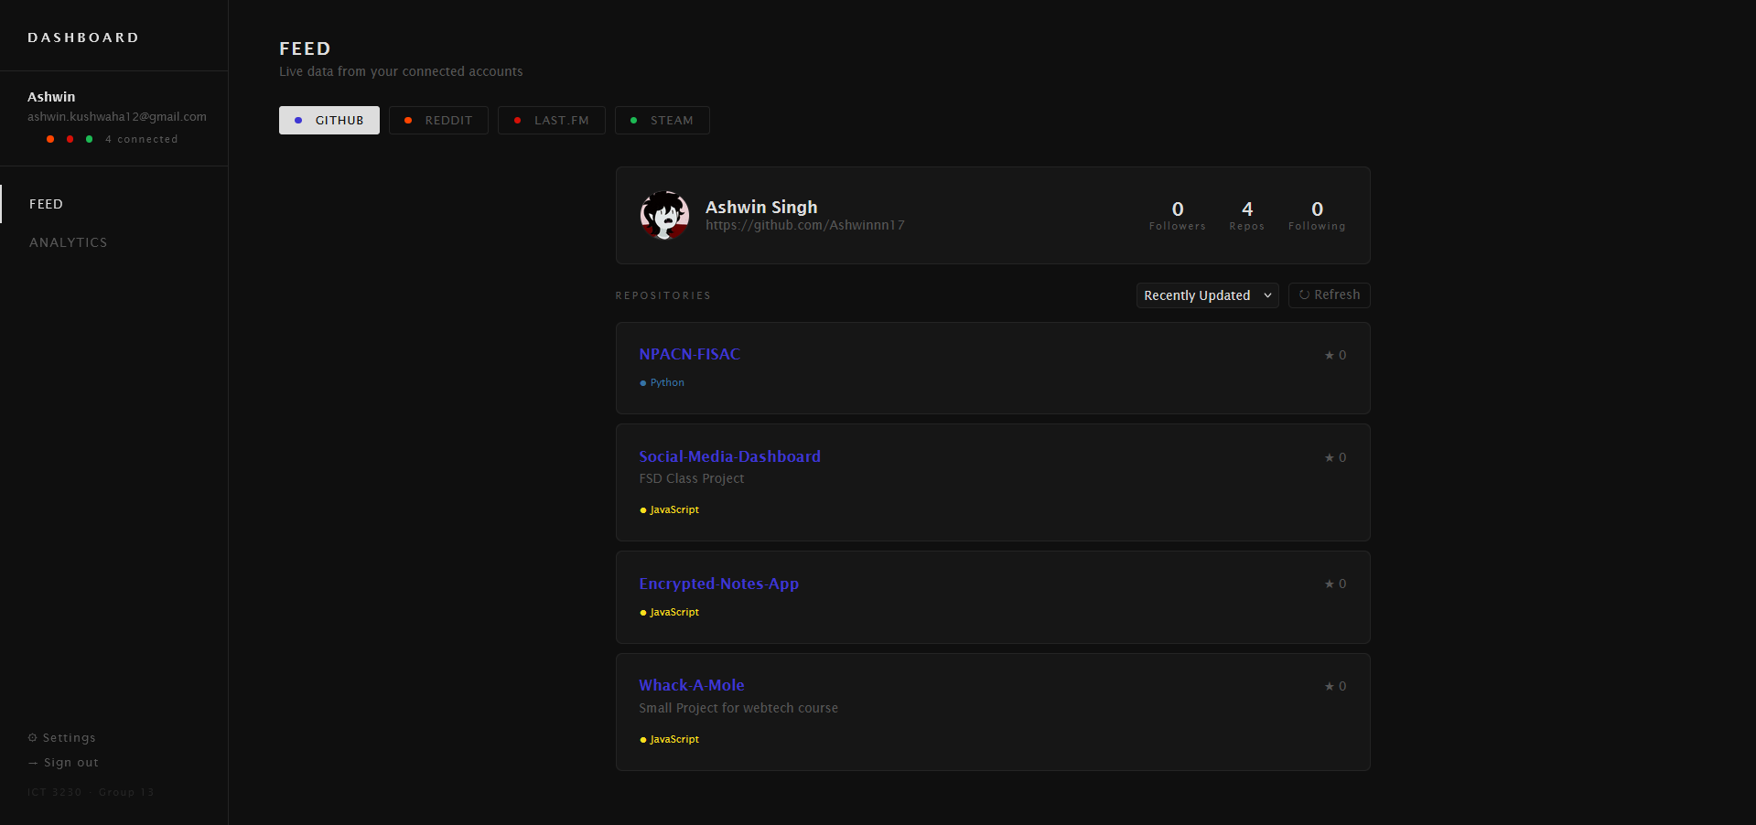

4. Aggregated Analytics Dashboard
This view illustrates the four-column grid system utilized by the Analytics module. This screen fires API calls to all four platforms concurrently. It displays the seamless normalization of wildly different data sets—such as GitHub repository commit counts paired directly alongside Reddit karma scores and Last.fm scrobble histories—into a single, easy-to-read comparative interface.
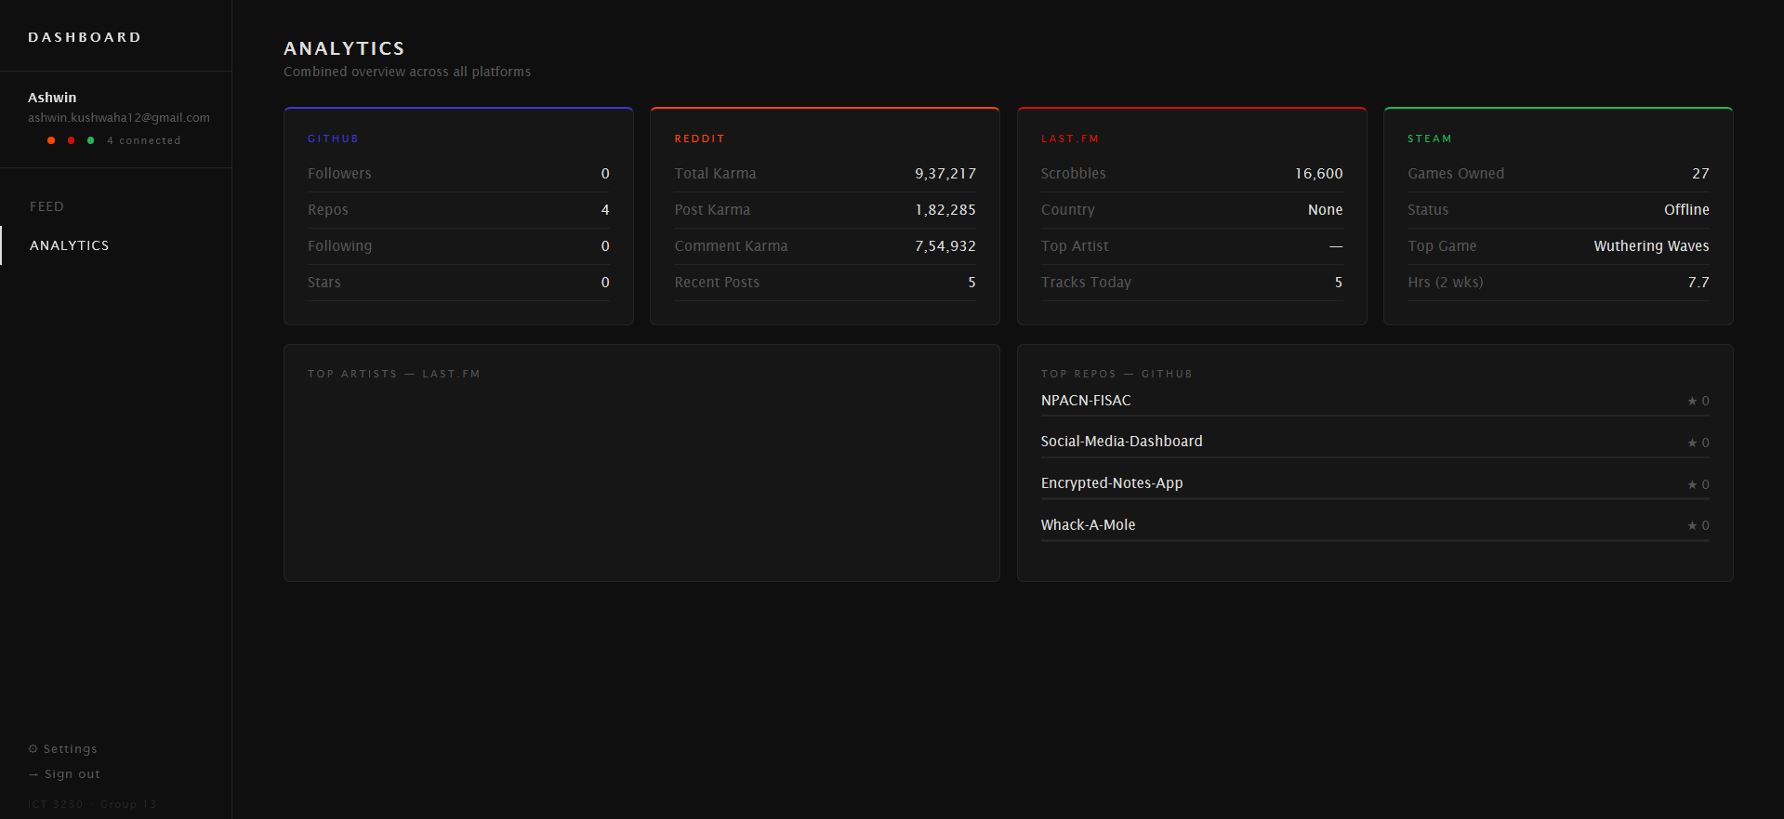

7. Details of Individual Contributions
- Ashwin Singh Kushwaha — Backend Architecture, Database Design & All API Integrations (50%)
- Designed and deployed Node.js/Express server with CORS, environment config, and modular routing (`auth`, `user`, `feed`)
- Built MongoDB `User` schema with Mongoose, using an embedded `accounts` sub-document for O(1) retrieval
- Implemented full auth pipeline: JWT generation, `bcrypt` password hashing, and `protect` middleware for all secured routes
- Integrated all four external APIs (GitHub, Reddit, Last.fm, Steam) in `feedController.js` using Axios and `Promise.all` for concurrent fetching
- Added sort query parameter support (GitHub: stars/updated; Reddit: Hot/New/Top) and Steam full library via `include_appinfo=true`
- Built the `apiFetch` frontend utility and managed `.gitignore` to prevent API keys and DB dumps from leaking
Chirag Sumanth — Frontend Part 1: Core Architecture & User Onboarding
- Designed `theme/styles.js` design token system (colors, spacing, component styles) used globally across the app
- Built `App.js` routing shell with `localStorage` JWT persistence and startup token validation
- Developed `AuthScreen`, `SettingsScreen`, and `Sidebar` components
Shreyas Bibhuty — Frontend Part 2: Data Panels & Micro-Interactions
- Built all four feed panels (`GitHubPanel`, `RedditPanel`, `LastfmPanel`, `SteamPanel`) and `AnalyticsPanel`
- Implemented per-panel sort dropdowns, manual refresh buttons, and Steam full library view
- Added Quick Actions: Steam `▶ PLAY` deep-links, Reddit subreddit links, Last.fm artist links
- Designed micro-interaction layer: shimmer skeleton loaders, platform hover-glow cards, and tab fade-in transitions

8. Conclusion
As the digital landscape becomes increasingly splintered, the Unified Social Media Dashboard successfully demonstrates a highly modern, scalable solution to social aggregation. By leveraging a robust MERN stack and a heavily decoupled Model-View-Controller architecture, the development team built a non-blocking application capable of handling complex concurrent requests to external services.
The project overcame several technical hurdles, most notably parsing heterogeneous data structures from diverse APIs and normalizing them perfectly for a cohesive UX. The resulting UI proved highly responsive due to localized React state management, delivering a single-page application that feels both premium and instantaneous.

