Social Media Dashboard
ICT 3230 – Full Stack Web Development Tools · IA2 Group Assignment

1. Title of the Project

Social Media Dashboard – A React-Based Feed and Analytics Application for GitHub, Reddit and Last.fm

2. Group Details

Group Number | Enrollment No. | Student Name
Group 13 | 230953208 | Ashwin Singh Kushwaha
 | 230953234 | Shreyas Bibhuty
 | 230953270 | Chirag Sumanth
Subject: ICT 3230 Full Stack Web Development Tools · VI Semester B.Tech.

3. Project Abstract

The Social Media Dashboard is a single-page front-end application built using React 18. It aggregates a user's activity across three platforms — GitHub, Reddit, and Last.fm — into a unified interface with two core views: a Feed and an Analytics panel.
The Feed view displays platform-specific content: GitHub repositories with language tags and star counts, Reddit posts with subreddit, score and comment data, and Last.fm recent tracks with a now-playing indicator. The Analytics view presents per-platform stat summaries alongside bar charts for top GitHub repos by stars and top Last.fm artists by play count. Technologies used: React 18, JavaScript ES6+, React Hooks (useState), CSS-in-JS.

4. High-Level Design

Architecture
The application is a client-side React SPA with no external dependencies beyond React itself. All data is defined as in-memory JavaScript objects. A single App component manages navigation and platform filter state, conditionally rendering the Feed or Analytics view.
Layer | Technology | Role
View | React JSX | Render UI from state
State | useState Hook | Active view, active platform filter
Data | JS module constants | Mock data objects for GitHub, Reddit, Last.fm
Styling | CSS-in-JS | Inline style objects; dark theme constants

Component Hierarchy
Component | Description
App | Root component; holds view and platform state; renders Sidebar + active view
Sidebar | Fixed left nav with user info, platform dots, Feed and Analytics links
Feed View | Platform switcher tabs; renders GitHub, Reddit or Last.fm feed based on selection
GitHub Feed | Profile card with stats; list of repo cards with name, description, stars, language
Reddit Feed | Karma summary card; list of post cards with subreddit, title, score, comments
Last.fm Feed | Now Playing banner; recent tracks list with artist and timestamp
Analytics View | 3 platform summary cards; Top Artists bar chart; Top Repos bar chart

5. Components / Concepts Used

Component / Concept | Purpose
React Functional Components | All UI built as functions; no class components used
useState Hook | Manages active view (feed/analytics) and active platform filter
Conditional Rendering | Switches between Feed and Analytics views; renders correct platform panel
Array.map() | Renders repo cards, post cards, track rows, and bar chart items from data arrays
CSS-in-JS (Inline Styles) | Style objects defined as constants; supports computed and conditional styles
Platform Colour Coding | Each platform assigned a distinct accent colour (GitHub: white, Reddit: orange, Last.fm: red)
Bar Charts (div-based) | Width percentage calculated from max value; no chart library used
Now Playing Indicator | Conditionally rendered banner with platform accent border for Last.fm
Language Colour Badges | Repo language displayed with colour dot matching GitHub language colours
Platform Filter Tabs | Toggle buttons update platform state to switch feed content
Sidebar Navigation | Fixed left panel with active-state border highlight for view switching
Mock Data Constants | All platform data defined as JS objects at module level; easily replaceable with API calls

6. Screenshots and Descriptions

Feed – GitHub
[ Screenshot: Feed – GitHub ] 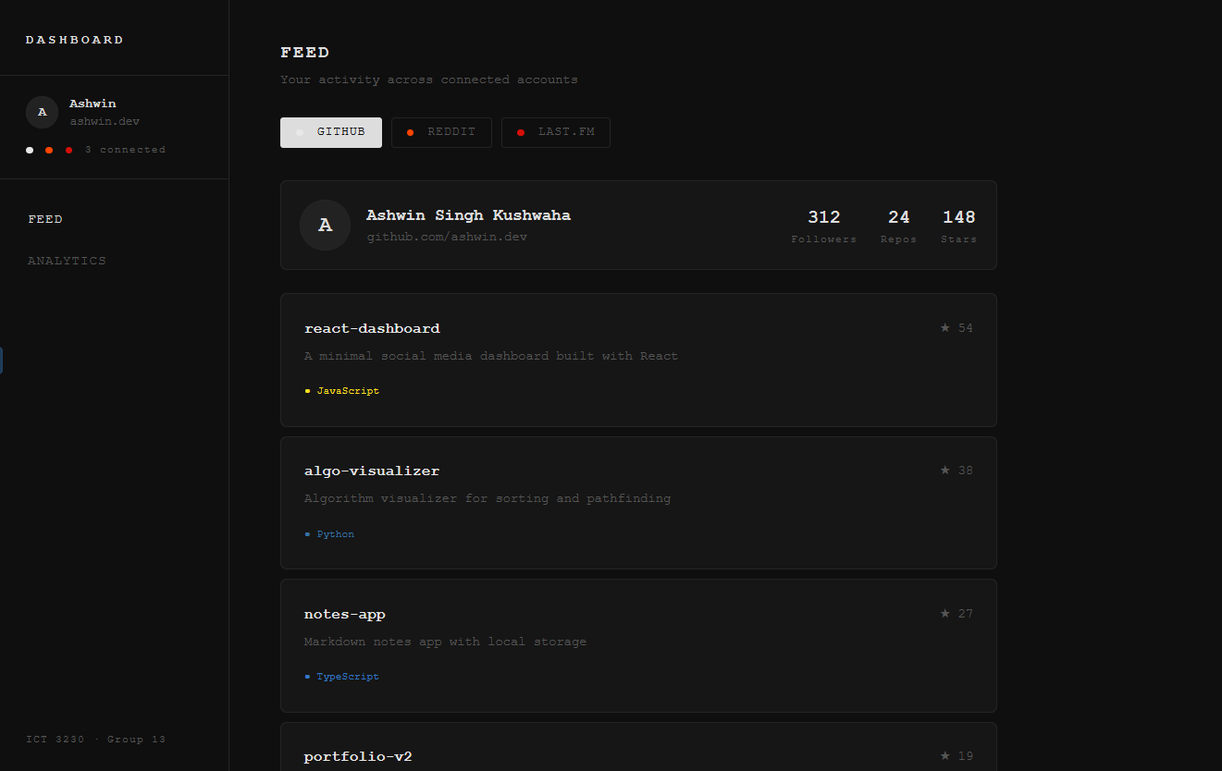
Displays the user's GitHub profile card showing followers, repo count and stars. Below it, a list of repositories with name, description, star count and language colour badge.

Feed – Reddit
[ Screenshot: Feed – Reddit ]
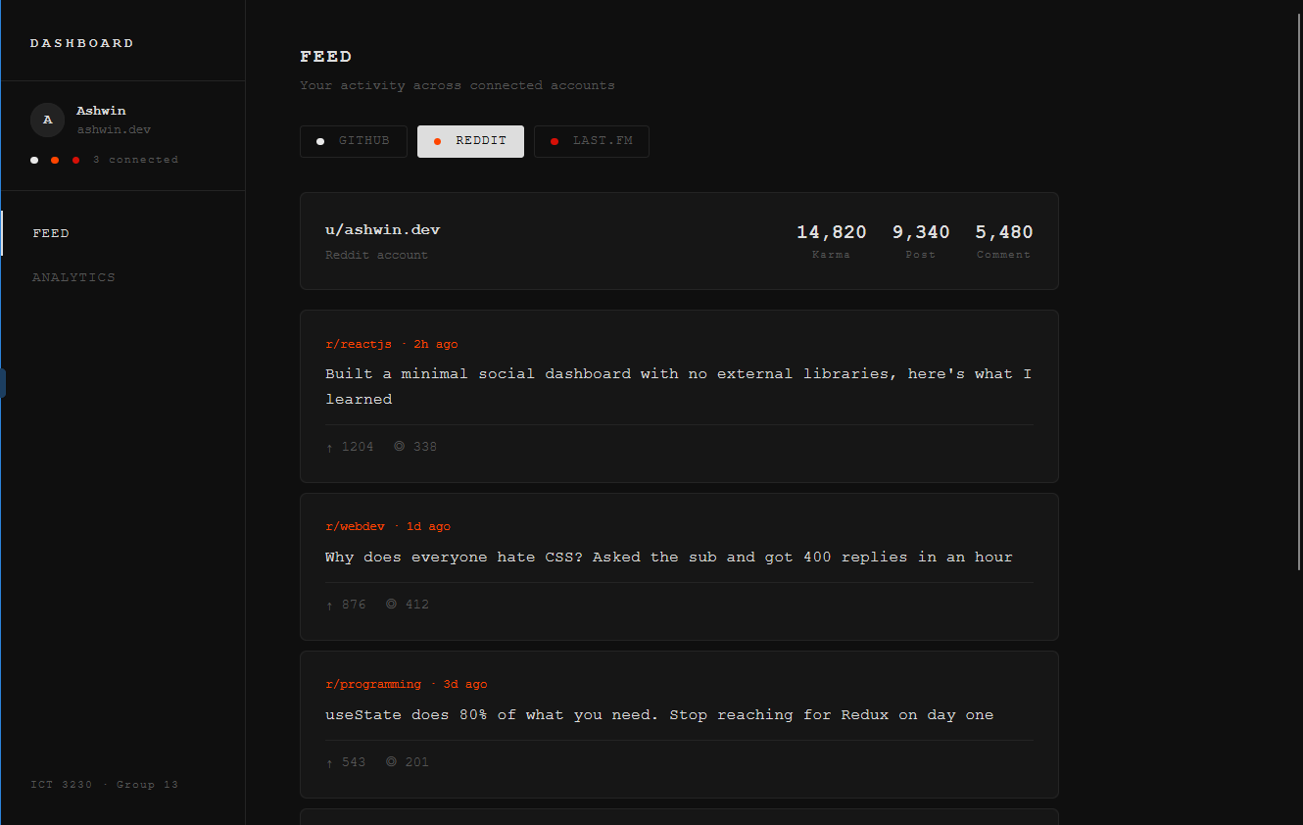
Shows a karma summary card (total, post, comment karma) followed by recent posts. Each post card displays the subreddit, title, upvote score and comment count.
Feed – Last.fm
[ Screenshot: Feed – Last.fm ]
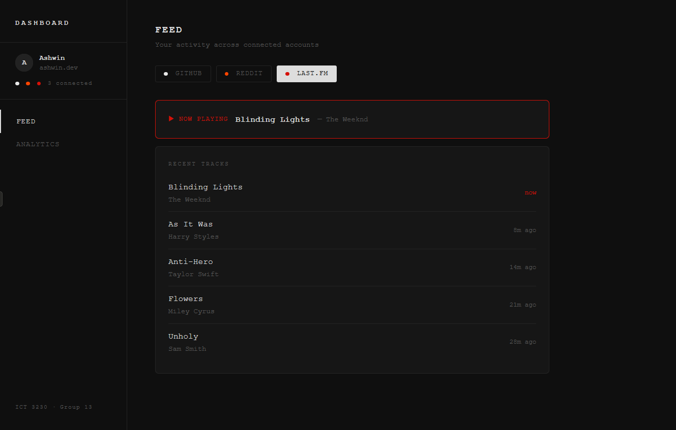
A now-playing banner with a red accent border appears at the top showing the currently playing track. Below it, a recent tracks list with artist name and relative timestamp.
Analytics View
[ Screenshot: Analytics View ] 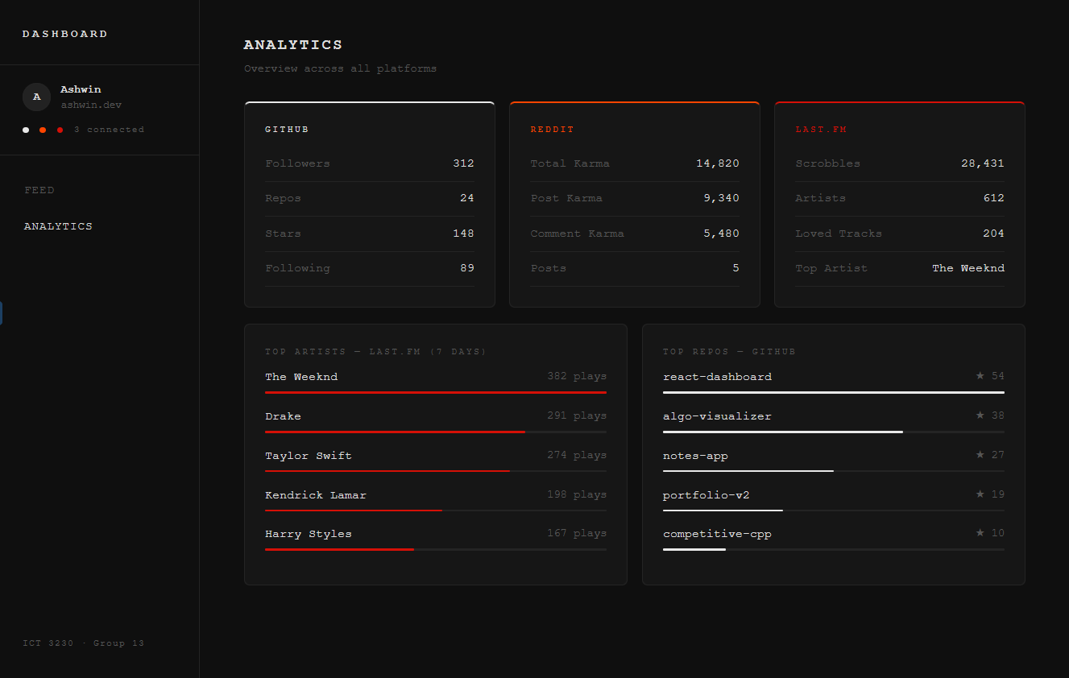
Three platform summary cards side by side, each with a coloured top border. Below, two bar charts: top Last.fm artists by play count and top GitHub repos by star count.

7. Details of Individual Contributions

Student | Enrollment No. | Contributions
Ashwin Singh Kushwaha | 230953208 | App structure, sidebar navigation, GitHub feed panel (profile card, repo list, language badges), overall CSS-in-JS theme system
Shreyas Bibhuty | 230953234 | Reddit feed panel (karma card, post cards), Last.fm feed panel (now playing, recent tracks), platform filter tab logic
Chirag Sumanth | 230953270 | Analytics view (platform summary cards, bar charts for repos and artists), mock data design, report writing

8. Conclusion

The Social Media Dashboard demonstrates practical use of React's component model and useState hook to build a multi-platform, data-driven interface. The project covers core front-end concepts including conditional rendering, dynamic list rendering, and component-based architecture within a cohesive dark-themed UI.
The choice of GitHub, Reddit, and Last.fm as platforms reflects a developer-focused use case that is realistic and relevant. Future work could replace the mock data with live API calls — GitHub's public REST API, Reddit's JSON endpoints, and Last.fm's free API — and add a Node.js/Express backend to handle authentication, completing the full MERN stack.

Group 13 · ICT 3230 · Manipal Institute of Technology · Submission: 06/03/2026

