**TO DEVELOP OR DESIGN A MOBILE OR WEB APPLICATION TO CHANGE THE BACKGROUND COLOUR AND MENU**

**AIM:**

**TO DEVELOP OR DESIGN A MOBILE OR WEB APPLICATION TO CHANGE THE BACKGROUND COLOUR AND MENU**

**PROCEDURE:**

•       Create a wireframe according to the mobile application

•       Select the basic theme for page to be created

•       Use different shapes to create layout as menu icons

•       Use assessts options to get different components to implement

•       Get the needed images to make it look unique

•       Now,after completion change the background to show comparison

SCREENSHOTS: 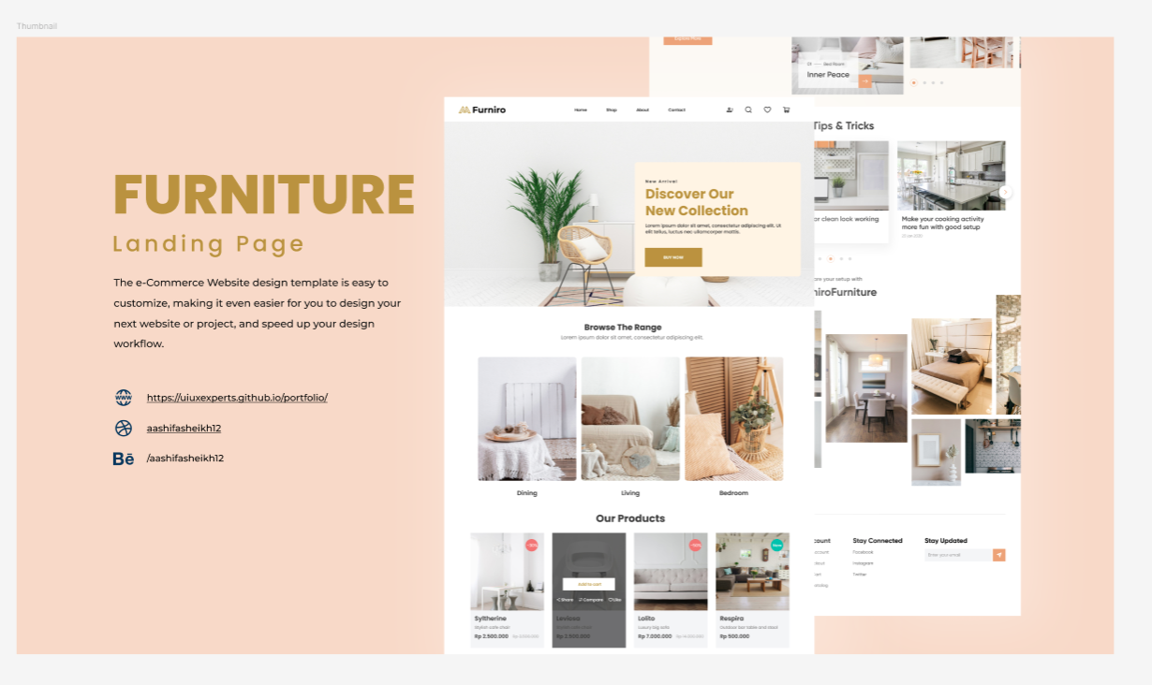

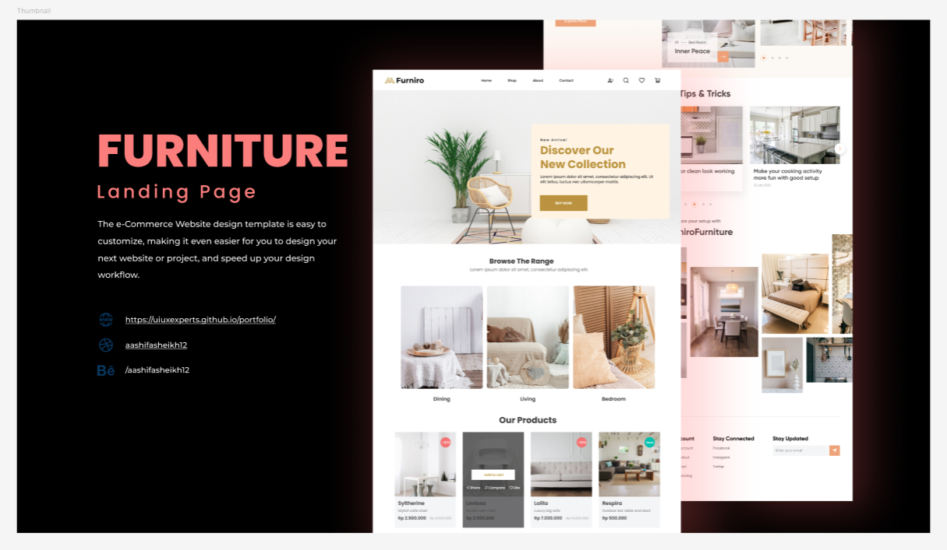

**RESULT:**

**The background color of the design is successfully changed.**