Hobby App

Aim:

To create Hobby app

Procedure:

-First create a rough sketch of the design your going for in a sheet

-After that create wire frames for your platform of choice

-After crating wire frames create the design

-Then give prototype to the design

-You have the final product

Screen shots:

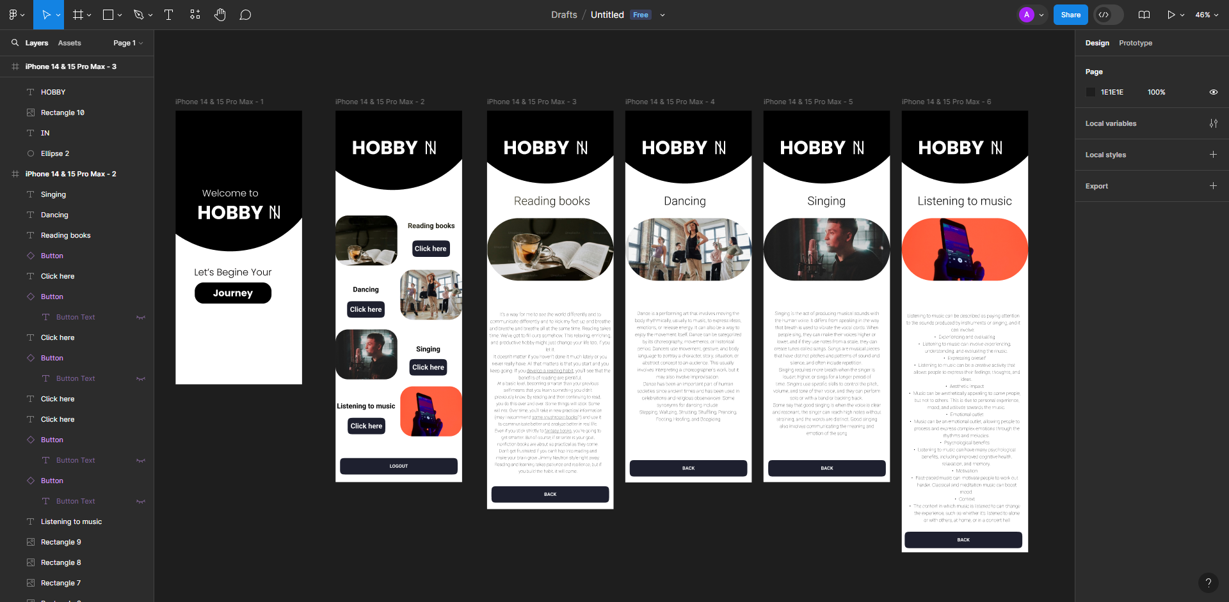

Result:

Hobby app has been successfully created.