**Re-design of canteen menu**

**AIM:**

**To re-design the canteen menu in different style**

**PROCEDURE:**

**-Draw a frame work roughly**

**-Create a work space in figma**

**-Create frame and design the frame work**

**-Insert the necessary icons and images in the design**

**-Give prototype**

**SCREEN SHOTS:**

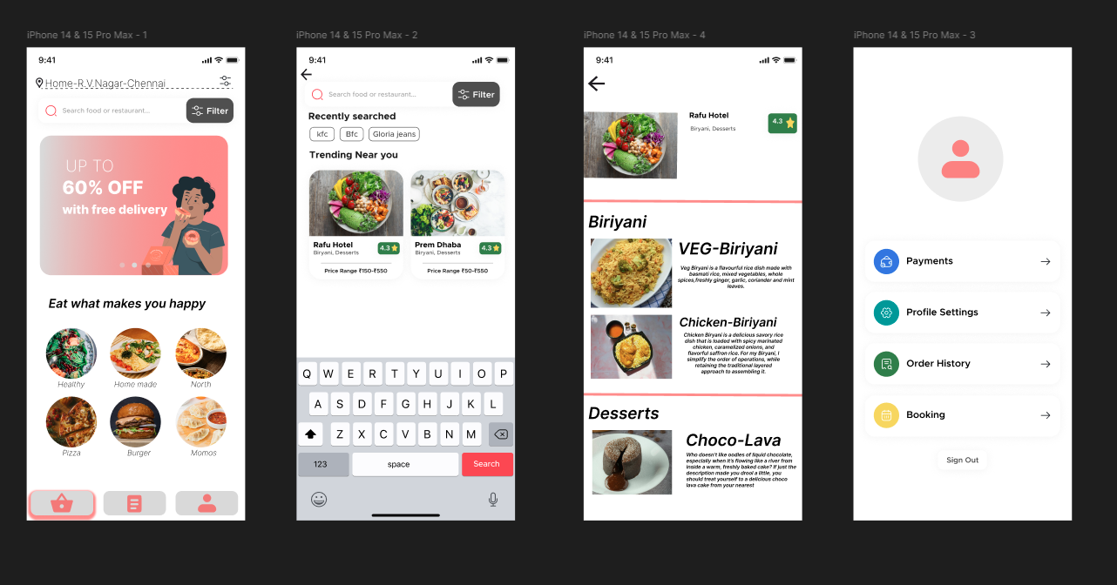

**RESULT:**

**The canteen menu is Re-designed**