**Wayanad Donation**

Aim:

To create an donation page design for wayanad

Procedure:

**Create a New File:** Start a new design and set up your frame (e.g., mobile or desktop).

**Wireframe:** Use basic shapes and text to outline the layout.

**Add Colors & Styles:** Apply your color palette and text styles.

**Use Components:** Turn repeating elements (buttons, icons) into reusable components.

**Prototype:** Link frames to show interactions and transitions.

**Collaborate:** Share your design and get feedback from teammates.

**Finalize:** Refine the design and hand it off to developers.

Output:

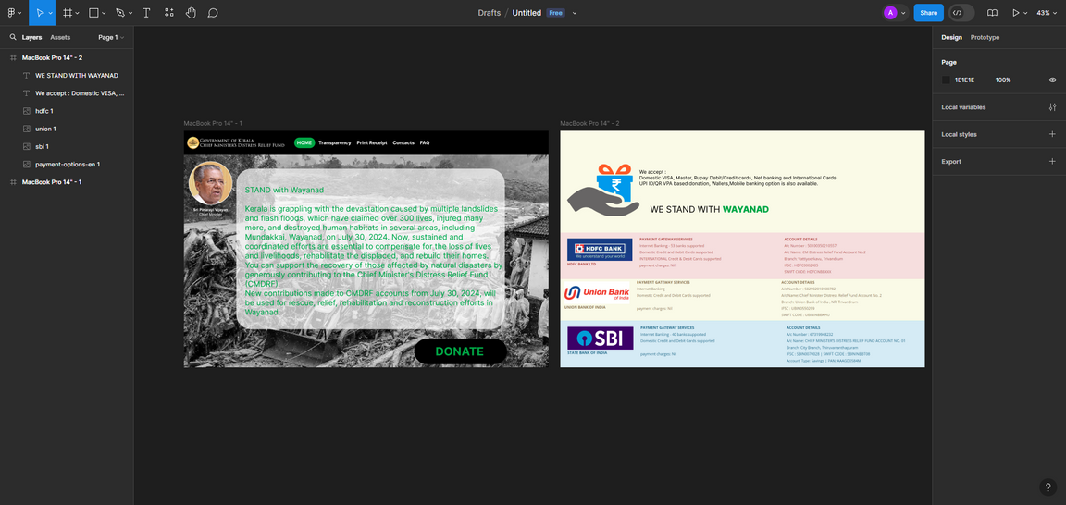

Result:

Successfully created an donation page design for wayanad