LAB ASSIGNMENT-7.5
NAME:R.Ashwitha
HALL TICKET:2303A51340
Task 1: Mutable Default Argument – Function Bug
Prompt: “Analyze the given Python function where a mutable default argument causes unexpected behavior and correct the error.”
CODE:
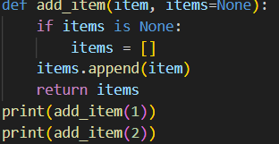
Output:
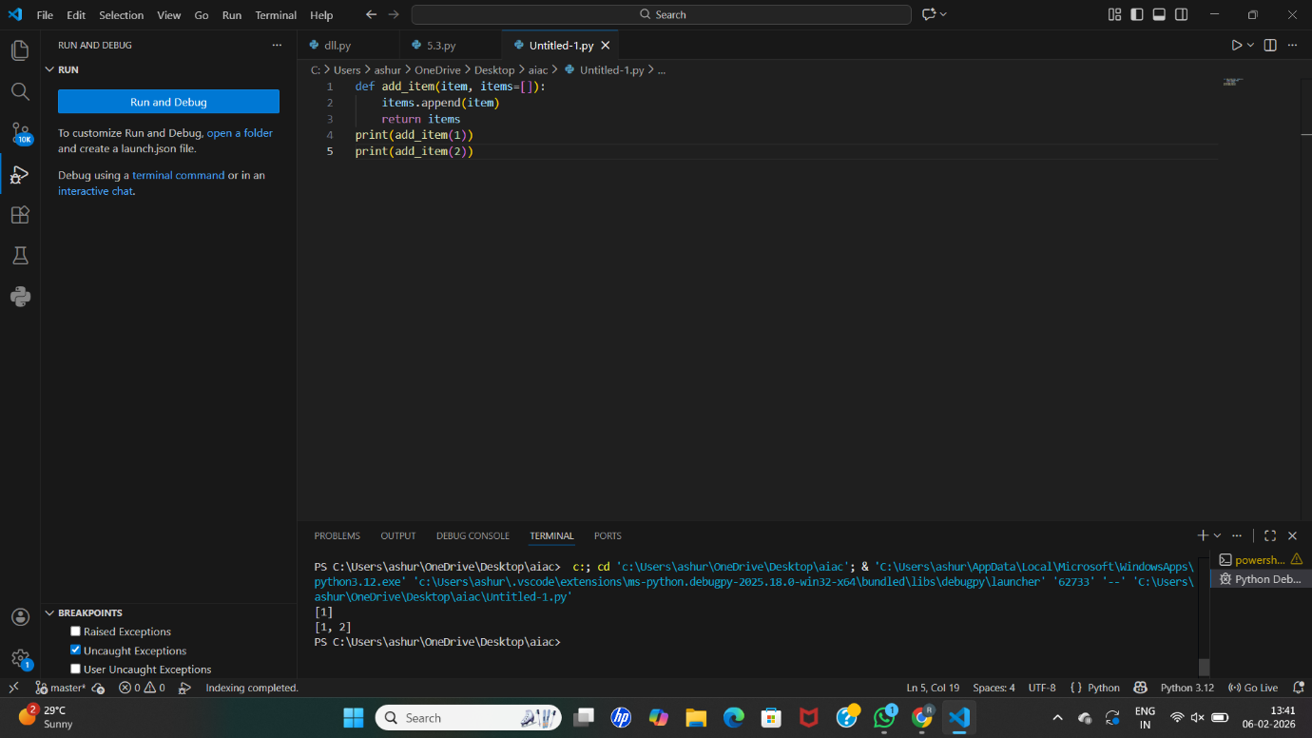

Analysis: The AI identifies that using a list as a default argument causes data to be shared across function calls.
It explains how the list persists in memory and leads to incorrect results.
The AI suggests replacing the default list with None.
A new list is created inside the function when required.
This fix ensures independent function execution and correct output.

Task 2: Floating-Point Precision Error
Prompt: “Analyze the floating-point comparison issue in the given Python code and correct it using a tolerance approach.”

CODE:
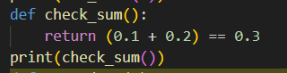
Output:
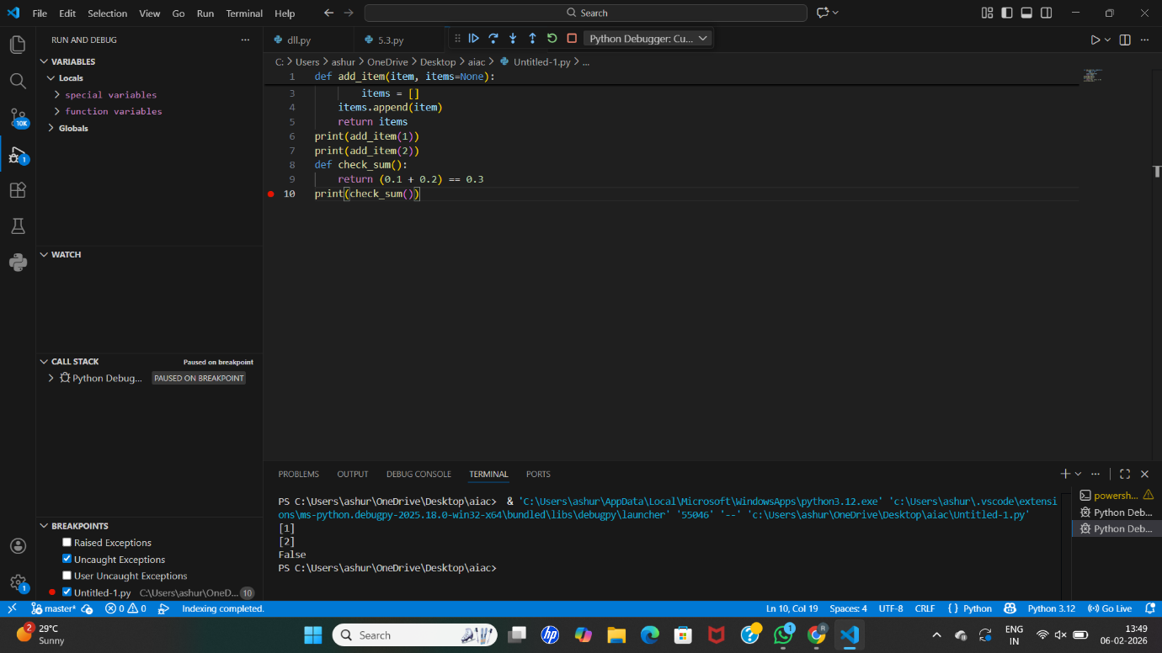

Analysis: the AI explains that floating-point numbers cannot be represented exactly in binary form.
It identifies why direct equality comparison fails.
The AI suggests using a small tolerance value for comparison.
This method checks whether the difference is within an acceptable range.
The corrected approach produces reliable and accurate results.
Task 3: Recursion Error – Missing Base Case
Prompt: “Analyze the recursive Python function that runs infinitely and fix it by adding a proper base case.”

CODE:
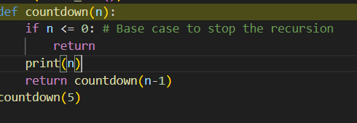

Output: 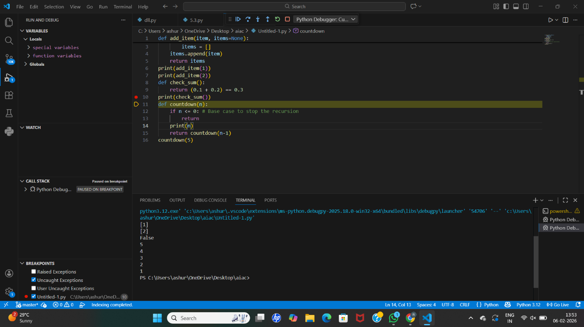

Analysis: The AI detects that the recursion has no stopping condition.
It explains how this causes infinite recursive calls and stack overflow.
A base case is suggested to terminate recursion at the correct point.
The recursive call is then executed only when the condition is met.
This correction ensures safe and controlled recursion execution.
Task 4: Dictionary Key Error
Prompt: “Analyze the Python code that accesses a missing dictionary key and correct the error.”
CODE:
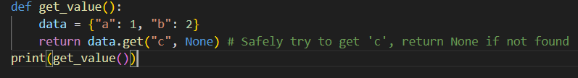

Output: 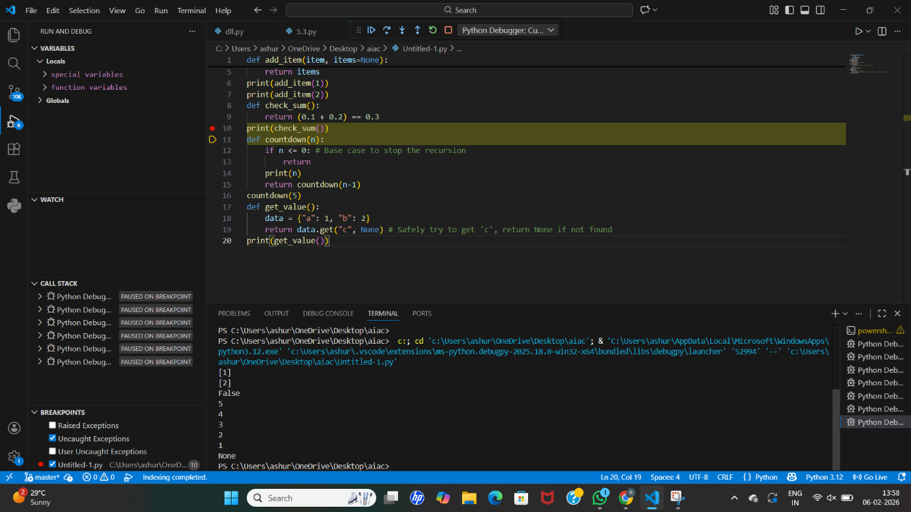

Analysis: The AI identifies that accessing a non-existing key raises a runtime error.
It explains the importance of safe dictionary access.
The AI suggests using the .get() method or exception handling.
This prevents the program from crashing unexpectedly.
The corrected code ensures robust and error-free execution.

Task 5: Infinite Loop – Wrong Condition
Prompt: “Analyze the given Python loop that runs infinitely and correct the loop condition.”
CODE:
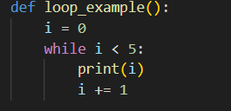
OUTPUT: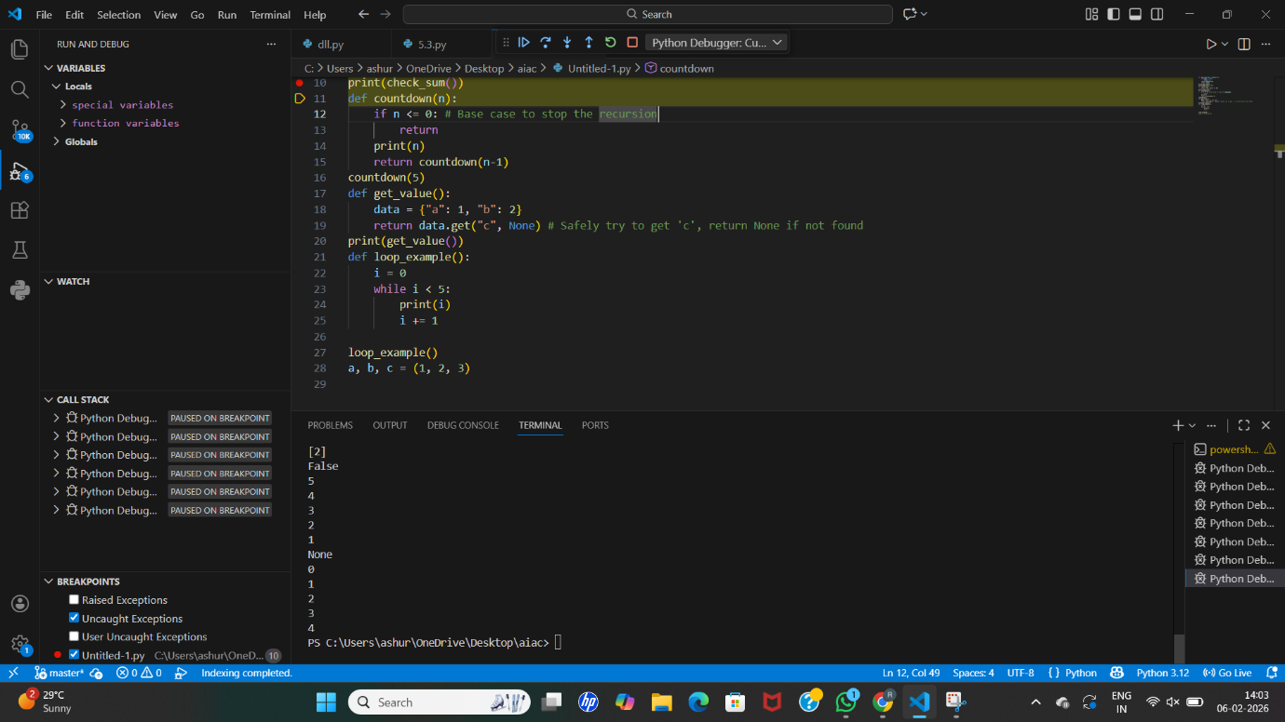

Analysis:
The AI identifies that the loop variable is never updated.
It explains why the condition always remains true.
The AI suggests incrementing the loop variable properly.
This ensures that the loop reaches its termination condition.
The corrected loop executes the expected number of iterations.

Task 6: Unpacking Error – Wrong Variables
Prompt:
“Analyze the tuple unpacking error in the given Python code and correct it.”
CODE:
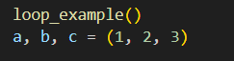OUTPUT: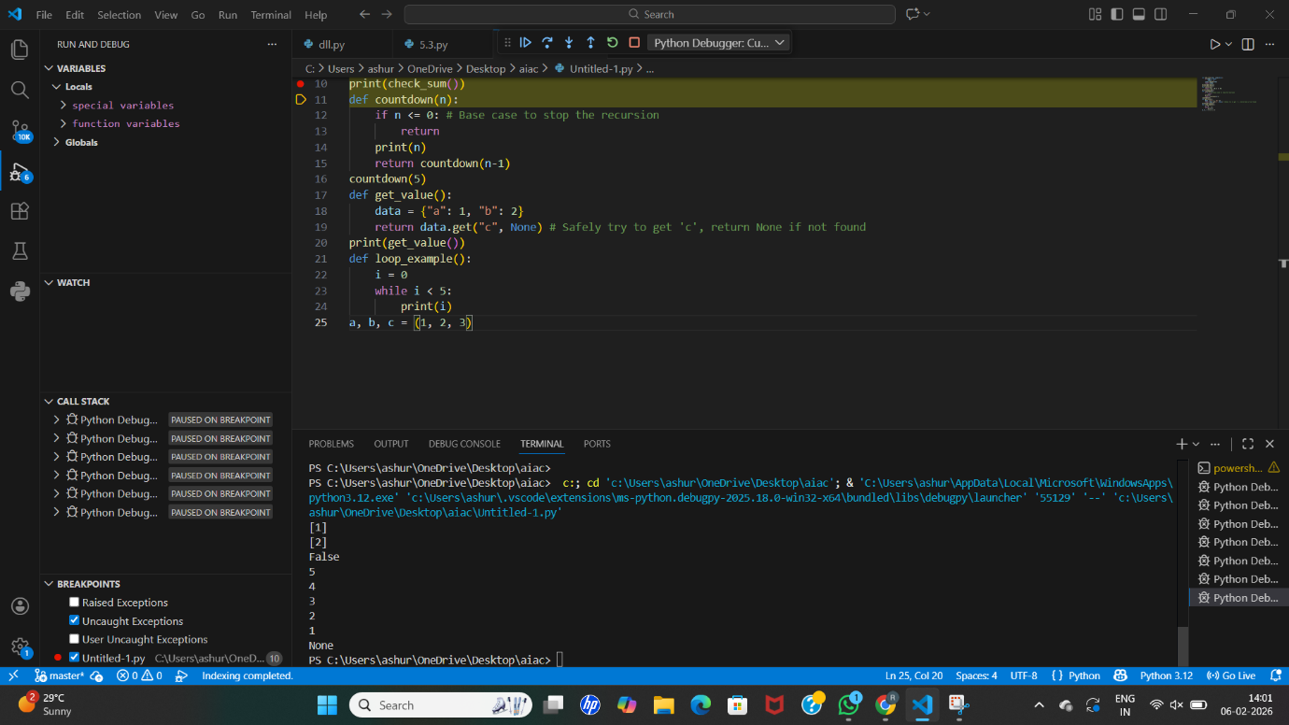

Analysis:
The AI explains that the number of variables does not match the tuple elements.
It identifies this mismatch as the cause of the unpacking error.
The AI suggests adding additional variables or using _ for unused values.
This aligns variables correctly with tuple elements.
The fix ensures successful and error-free unpacking.

ask 7: Mixed Indentation – Tabs vs Spaces
Prompt:
“Analyze the Python code with mixed indentation issues and correct it.”
CODE:
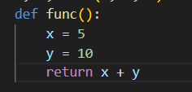

OUTPUT:
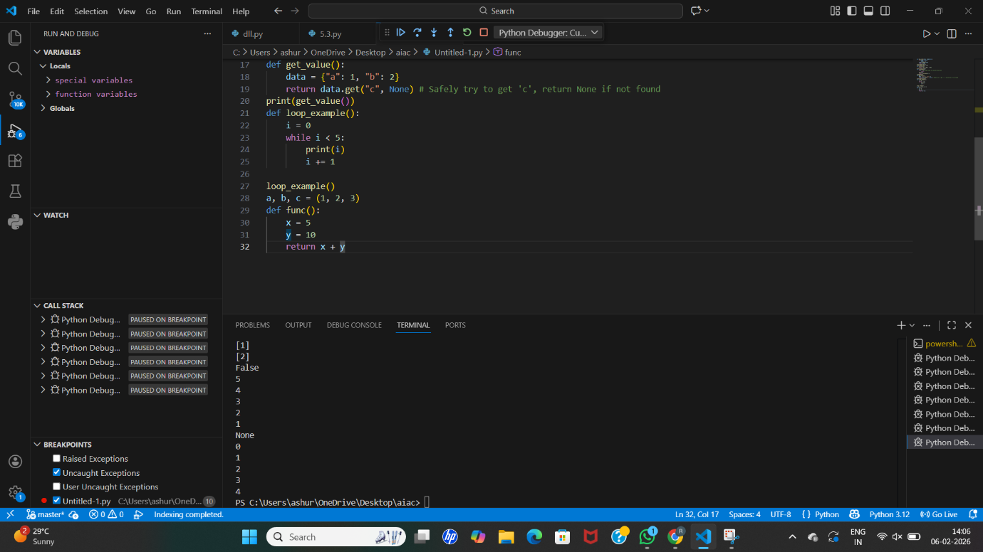

Analysis:
The AI detects inconsistent indentation in the function block.
It explains how Python strictly follows indentation rules.
The AI suggests using consistent spaces throughout the code.
This removes syntax errors caused by improper alignment.
The corrected code executes smoothly without indentation errors
Task 8: Import Error – Wrong Module Usage
Prompt:
“Analyze the incorrect Python import statement and fix the module usage.”
CODE:
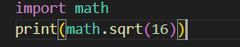

OUTPUT:
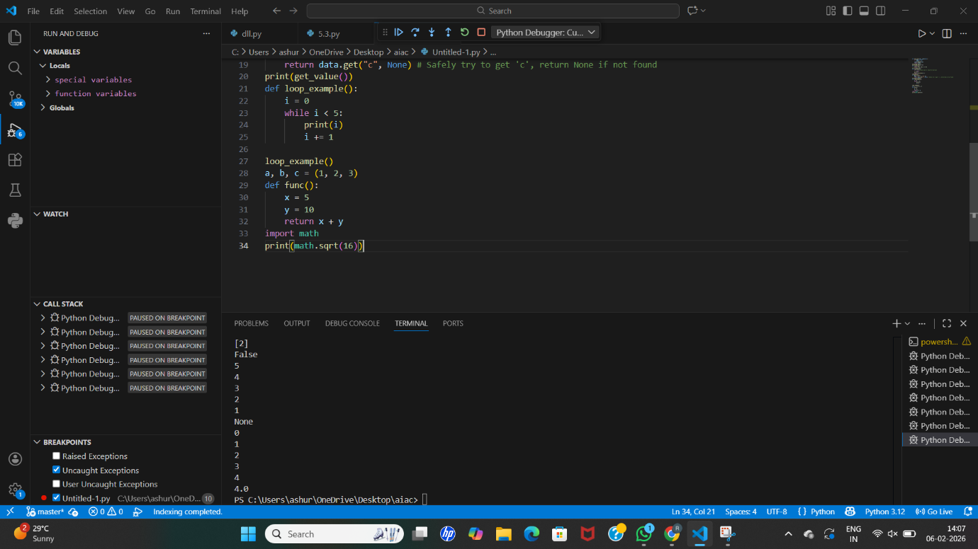

Analysis:
The AI identifies that the imported module name is incorrect.
It explains the correct standard library module to use.
The AI suggests replacing the wrong import with the correct one.
This allows access to the required mathematical functions.
The corrected import ensures proper program execution.

.

