ASSIGNMENT-12.5
Name:Ashwitha.R
Roll No:2303A51340
Batch:20
TASK1
Prompt
Generate a detailed explanation of the Merge Sort algorithm. Include its working principle, step-by-step breakdown, time complexity (best, average, worst case), and space complexity. Explain why it is suitable for large datasets.
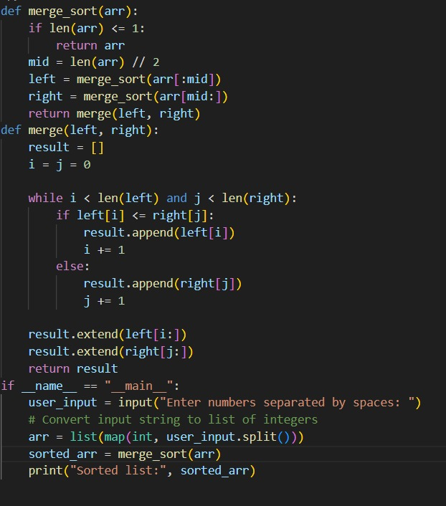
Analysis
Selected Algorithm: Merge Sort
Why Merge Sort?
Uses Divide and Conquer strategy.
Provides consistent performance.
Stable sorting algorithm (maintains order of equal elements).
Time Complexity:
Best Case: O(n log n)
Average Case: O(n log n)
Worst Case: O(n log n)
Space Complexity:
O(n)
Suitability:
Ideal when predictable performance and stability are required.
TASK 2
Prompt
Explain the Binary Search algorithm used to search an element in a sorted list. Include step-by-step logic and time complexity analysis for best, average, and worst cases. Compare it with linear search.
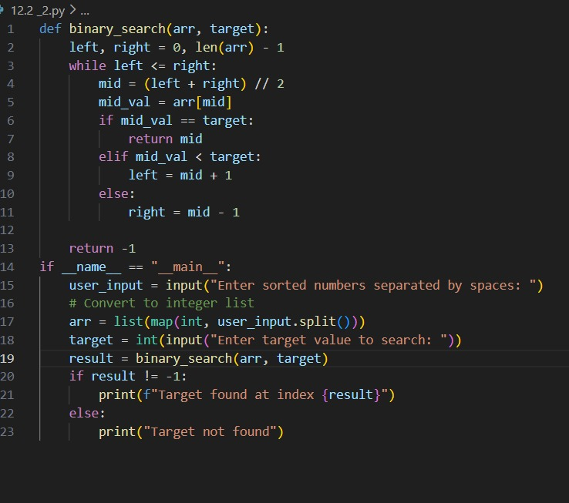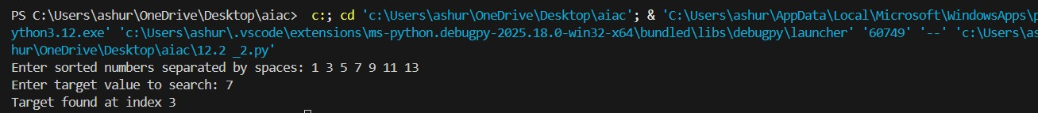
🔹 Analysis & Justification
Selected Algorithm: Binary Search
Efficient for sorted data.
Reduces search space by half each step.
Time Complexity:
Best Case: O(1)
Average Case: O(log n)
Worst Case: O(log n)
Space Complexity:
O(1) (iterative)
Suitability:
Highly efficient for large sorted datasets compared to linear search (O(n)).
Task 3: Smart Healthcare Appointment Scheduling System
Prompt
Recommend suitable searching and sorting algorithms for an appointment management system where appointments must be searched by appointment ID and sorted by appointment time or consultation fee. Justify the selection based on efficiency and stability.
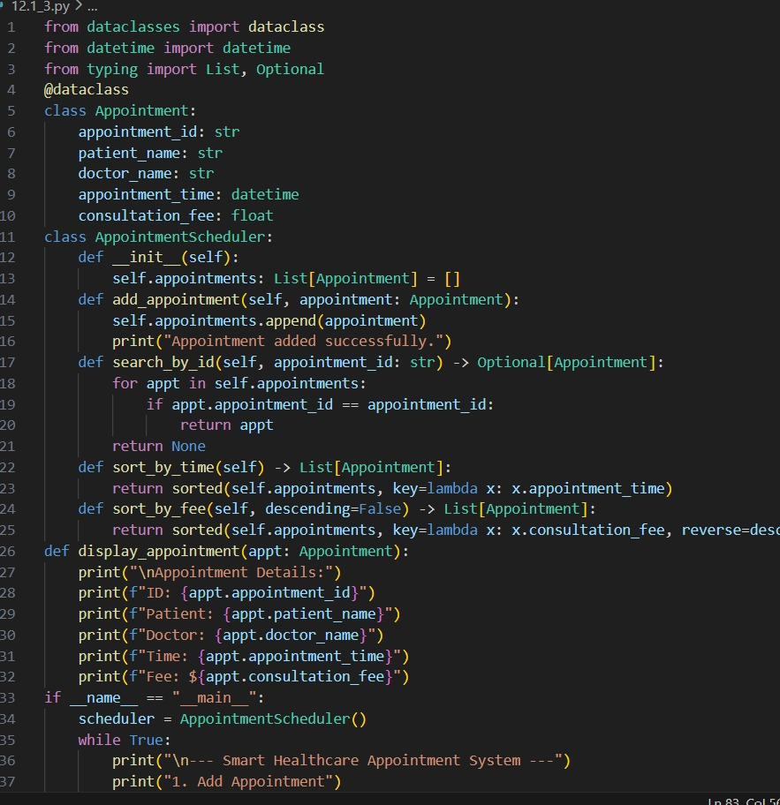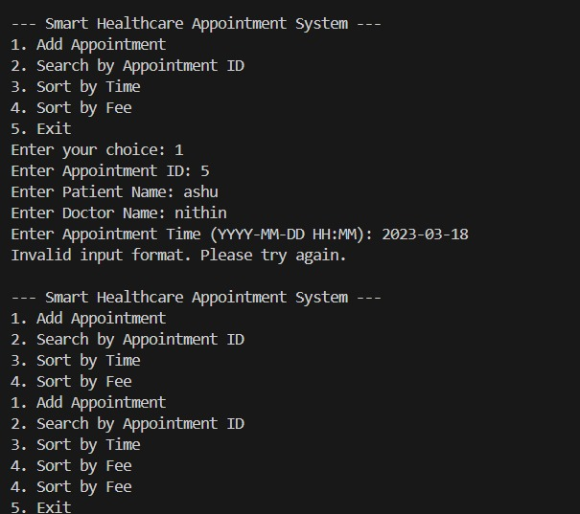
🔹 Analysis & Justification
Searching Algorithm: Binary Search
Sorting Algorithm: Merge Sort
Appointment IDs are unique.
Fast lookup in sorted records.
Why Merge Sort?
Sorting by time requires stable ordering.
Predictable performance for growing records.
Complexities:
Search: O(log n)
Sort: O(n log n)
Task 4: Railway Ticket Reservation System
Prompt
Suggest efficient algorithms for searching tickets by ticket ID and sorting bookings by travel date or seat number. Provide justification considering performance and scalability.
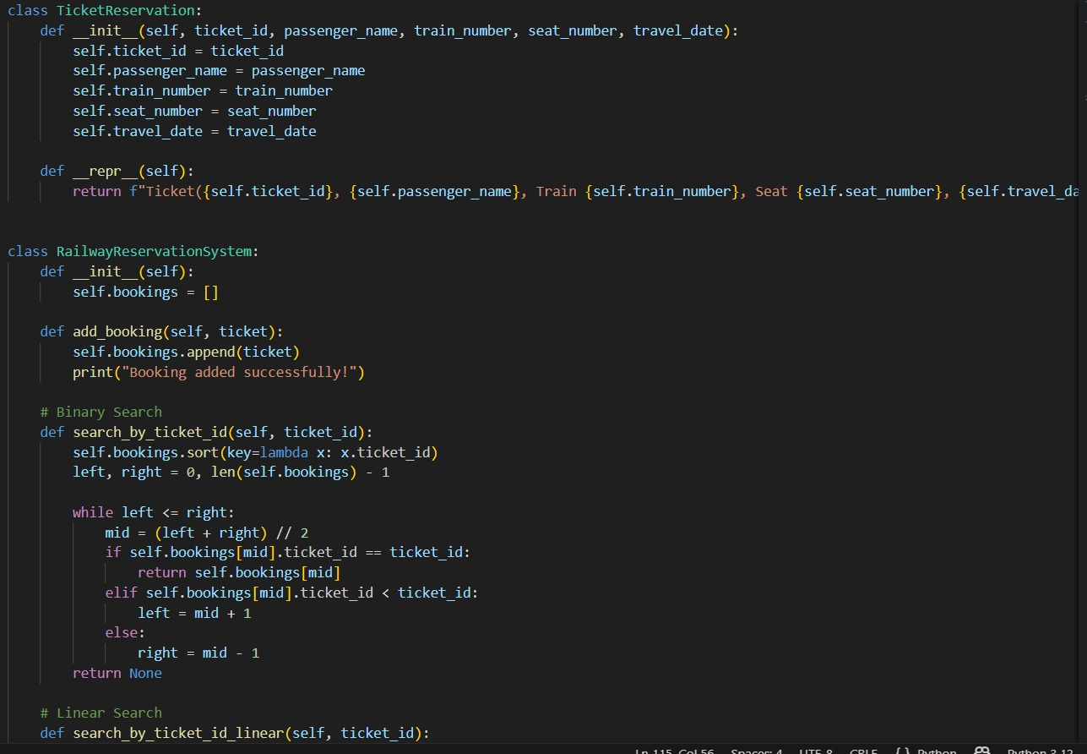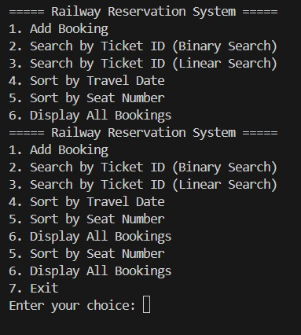
🔹 Analysis & Justification
Searching: Binary Search
Sorting: Merge Sort
Reasoning:
Ticket ID is unique → Binary Search efficient.
Travel dates require stable sorting → Merge Sort suitable.
Performance:
Search → O(log n)
Sort → O(n log n)
Task 5: Smart Hostel Room Allocation System
Prompt
Identify optimized searching and sorting algorithms for a hostel room allocation system where records are searched using student ID and sorted by room number or allocation date. Justify your answer. 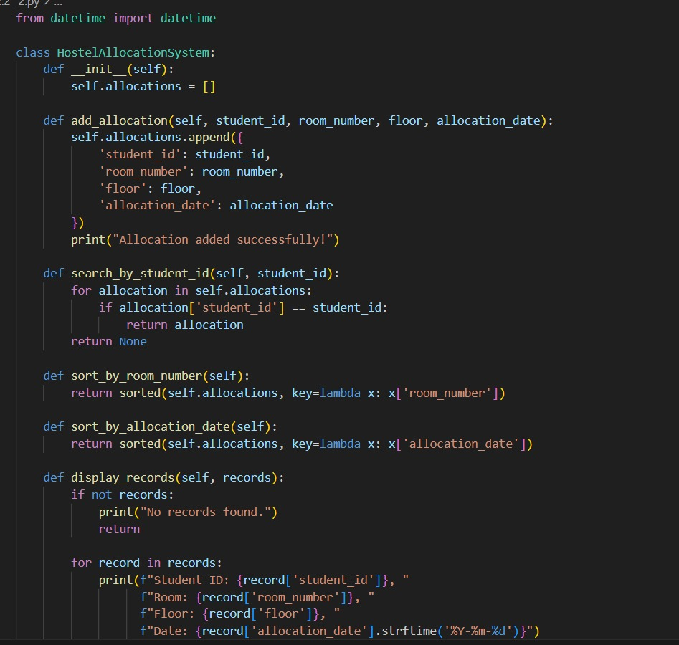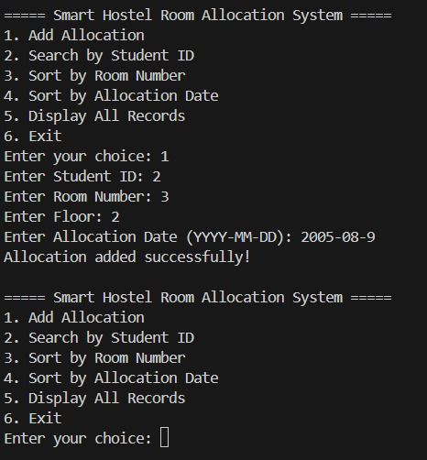
🔹 Analysis & Justification
Searching: Binary Search
Sorting: Quick Sort / Merge Sort
Justification:
Student ID unique → Binary Search ideal.
Room number sorting → Quick Sort fast in practice.
Allocation date sorting → Stable Merge Sort preferred.
Complexities:
Search → O(log n)
Sort → O(n log n)
Task 6: Online Movie Streaming Platform
Prompt
Recommend suitable searching and sorting algorithms for a movie database where movies are searched by movie ID and sorted by rating or release year. Explain algorithm suitability.
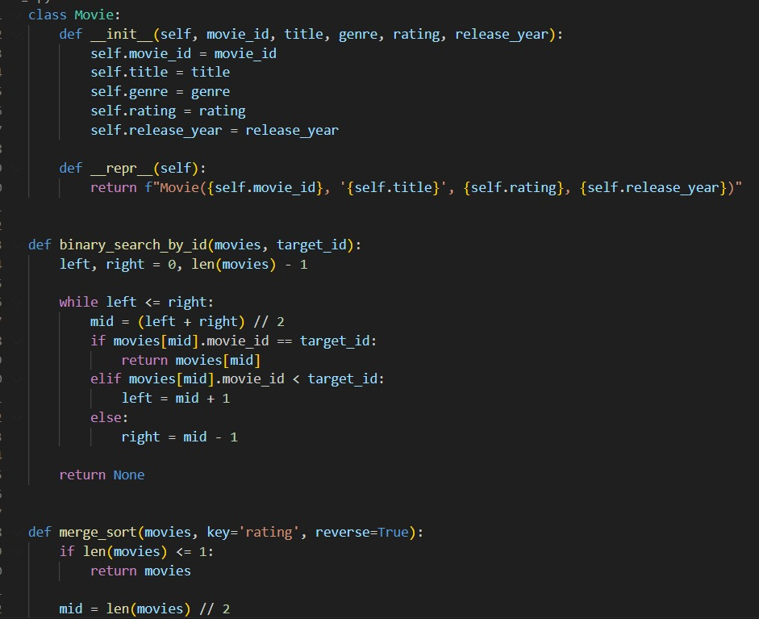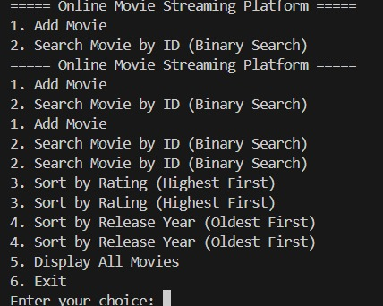
Analysis & Justification
Searching: Binary Search
Sorting: Merge Sort
Task 7: Smart Agriculture Crop Monitoring System
Prompt
Use AI-assisted reasoning to select appropriate searching and sorting algorithms for crop data where crops are searched by crop ID and sorted by moisture level or yield estimate. Provide justification. 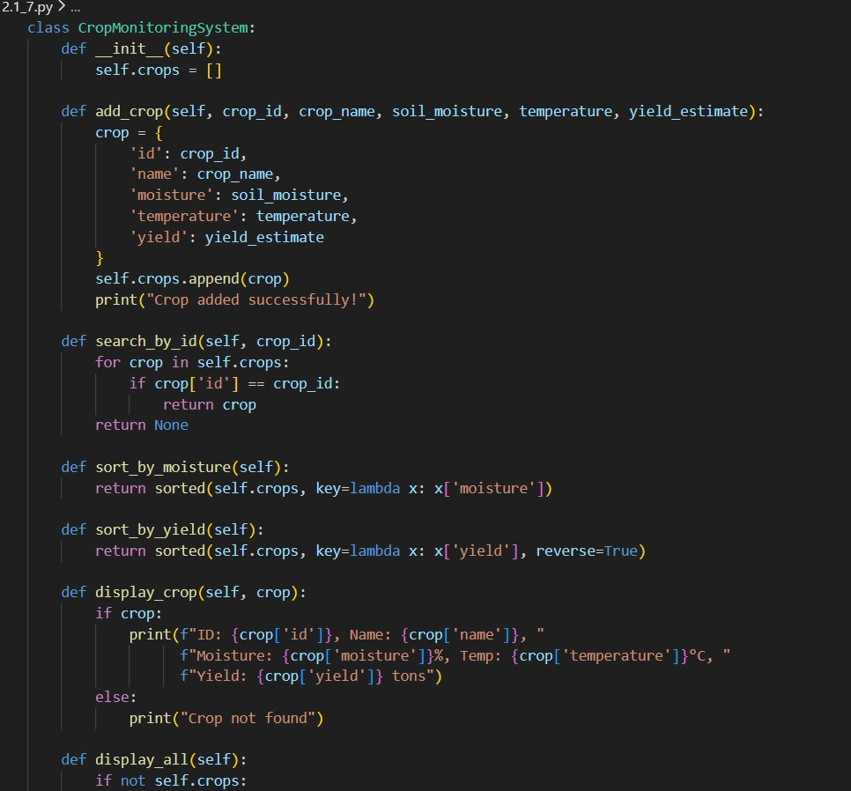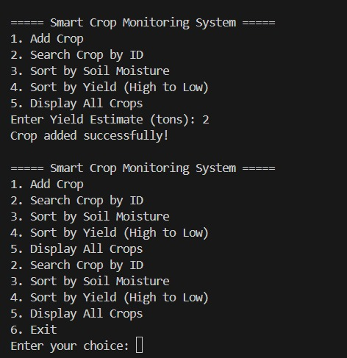

Analysis & Justification
Searching: Binary Search
Sorting: Merge Sort
Task 8: Airport Flight Management System
Prompt
Recommend efficient searching and sorting algorithms for managing flight data where flights are searched by flight ID and sorted by departure or arrival time. Justify your algorithm choices.
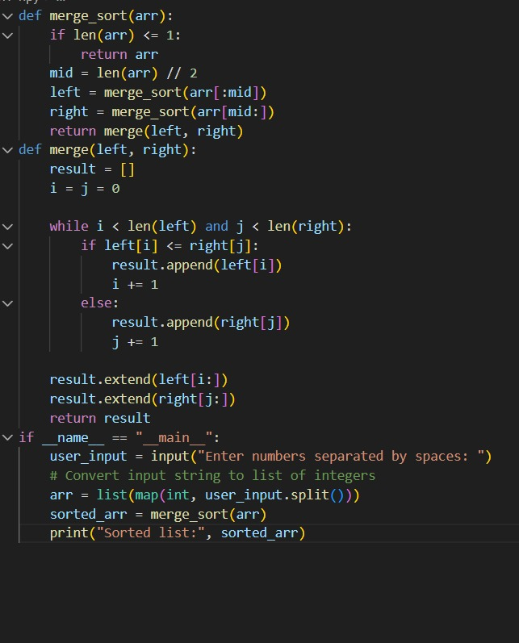
Analysis & Justification
Searching: Binary Search
Sorting: Merge Sort

