LAB ASSIGNMENT-9.3
NAME:R.Ashwitha
Roll:2303A51340

Task-1:
Prompt: Generate a Google Style docstring for a Python function that calculates
the sum of even numbers and the sum of odd numbers from a list of integers.
The docstring should include a short description, Args, Returns,
and Raises sections. Ensure the documentation is clear and concise.
Analysis: The manual docstring is more detailed and includes error handling, making it more complete. The AI-generated docstring is clear and correctly formatted but may miss edge cases like type validation. AI is useful for quick documentation, but manual refinement improves clarity and completeness.
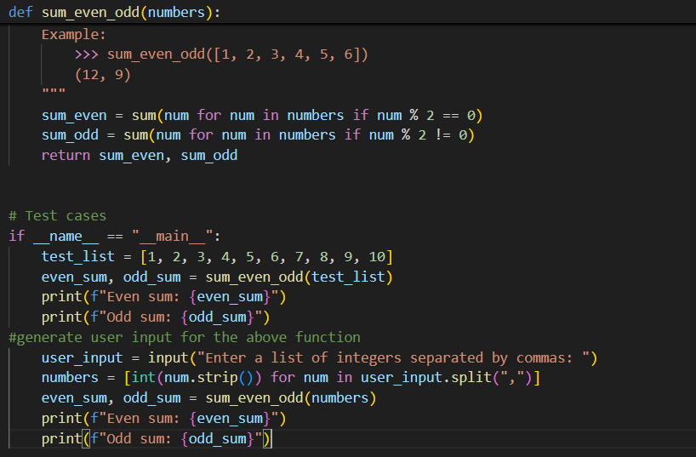
Task-2:
Prompt: Add inline comments to the following Python class.
Explain each logical block and important operation in simple language.
Avoid redundant comments and focus on improving readability for new developers.
Analysis: Manual comments explain both what the code does and why it does it, improving understanding. AI-generated comments are accurate but often basic and sometimes redundant. AI helps speed up documentation, but developers must review comments for meaningful context.
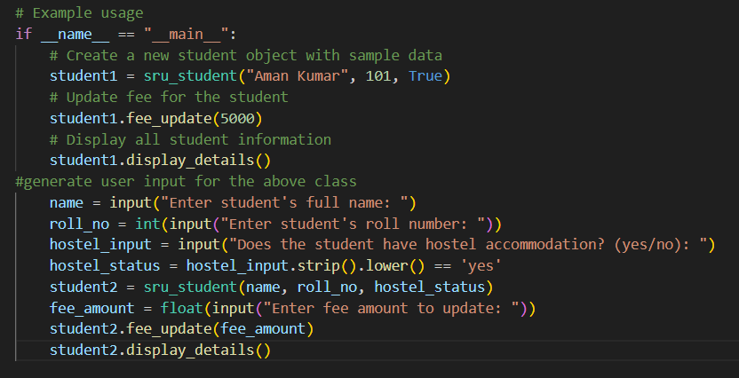
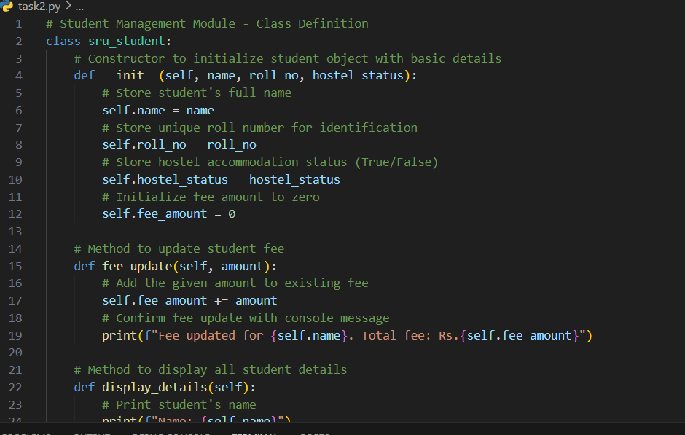
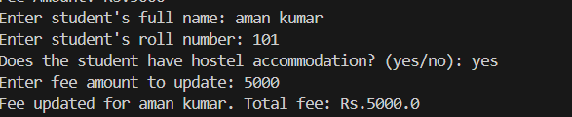
Task 3:
Prompt: Generate a NumPy-style module-level docstring and function-level
docstrings for a Python calculator module containing functions:
add, subtract, multiply, and divide.
Include sections for Parameters, Returns, and Raises where applicable.
Ensure the documentation follows structured scientific documentation style.
Analysis: Manual NumPy-style documentation follows strict structure and includes exceptions clearly. AI-generated documentation is readable and well-formatted but may lack detailed explanations or special case handling. AI is effective for generating structured drafts, but manual review ensures accuracy and professional quality.

