**Practical-5**

Date: 30 - 08 - 2021

**AIM: Understand and identify Layer-3 functionality.**

**Tools required:**

1. Desktop Computer
2. Cisco Packet Tracer

**Time distribution**

|  |  |
| --- | --- |
| Exercise-1 | 30 minutes |
| Exercise-2 | 30 minutes |
| Exercise-3 | 45 minutes |
| Questions and answer | 15 minutes |

Simulate different scenarios (Exercises-1 to 3) given below in Cisco packet tracker. Fill up respective tables, justify statements and write conclusion in your words.

**Exercise-1**

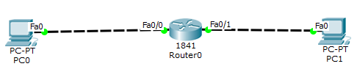

Redraw above diagram which includes IP address and MAC address. Take IP address and MAC address as per your knowledge.

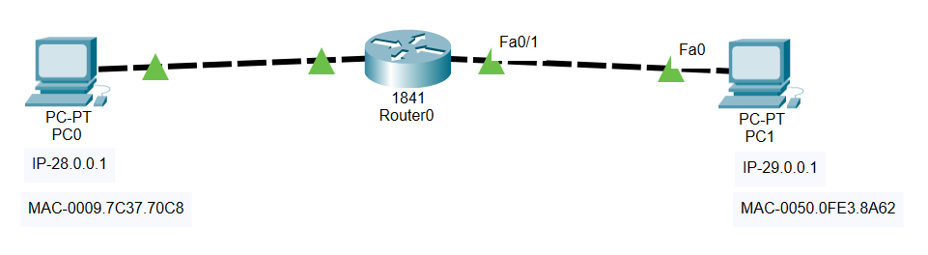

Write down ARP table of PC0 and PC1. Write down Routing table Router0.

ARP table entry of PC0

|  |  |
| --- | --- |
| **IP address** | **MAC Address** |
| 28.0.0.2 | 00D0.FFB83.B401 |

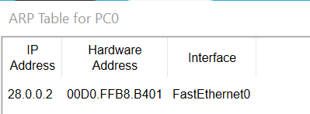

ARP table entry of PC1

|  |  |
| --- | --- |
| **IP address** | **MAC Address** |
| 29.0.0.2 | 00D0.FFB8.B402 |

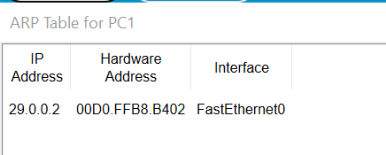

Routing table of Router0:

|  |  |  |  |  |
| --- | --- | --- | --- | --- |
| **Type** | **Destination Network ID** | **Port** | **Next Hop IP address** | **Hop Count** |
| C | 28.0.0.0/8 | FastEthernet0/0 | --- | 0/0 |
| C | 29.0.0.0/8 | FastEthernet0/1 | --- | 0/0 |

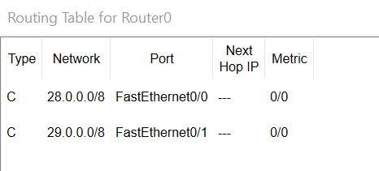

**Which are the following statements correct? Also justify each statement.**

1. **Is PC0 having Ethernet Card?**

**Ans.** YES

**Justification:** Because without Ethernet card there is no NIC and without NIC we cannot connect our device (PC0) with any other node or network or device.

1. **PC1 is having Ethernet Card.**

**Ans.** YES

**Justification:** Because without Ethernet card there will no NIC and without NIC we cannot connect PC1 to any other device.

1. **Router0 is having two NIC card.**

**Ans.** YES

**Justification:** Generally routers are made for communication of two different networks and for that at least two NIC cards (Ethernet Cards) are required. There is often more than one NIC cards in single router.

1. **Router 0 is having two Mac address**

**Ans.** YES

**Justification:** Router 0 has two NIC cards so it will be having 2 MAC addresses. In general any device can have more than one MAC address if it is having more than one NIC cards.

1. **Router0 is having TWO IP address**

**Ans.** YES

**Justification:** The reason for this is that router actually connects two or more different networks together that’s why for all those different network there will be common gateway.

1. **MAC address pair on link 0(between PC0 and Router0) is different than MAC address pair in link 1(between Router0 and PC1) for message transfer.**

**Ans.** YES

**Justification:** because that both PC’s PC0 and PC1 belongs to different networks and that is why MAC address pairs will be different for link 0(between PC0 and Router0) and link 1(between PC1 and Router0).

1. **Router0 is having switching table**

**Ans.** NO

**Justification:** switches communicate on data link layer and that is why switch uses “Switching Table” which is made up of IP and MAC addresses while router communicates on network layer so it uses “Routing Table” which is made up of Network ID’s.

1. **Speed of Link 0 is 10 Mbps.**

**Ans.** NO

**Justification:** By default the bandwidth or speed of link 0 (between PC0 and Router0) is set to auto it can be changed according to condition and data traffic and other parameters but we can set speed to link 0 as 10Mbps constant.

1. **Speed of Link1 is 100 Mbps.**

**Ans.** NO

**Justification:** By default the bandwidth or speed of link 0 (between PC0 and Router0) is set to auto it can be changed according to condition and data traffic and other parameters but we can set speed to link 0 as 10Mbps constant.

1. **Router0 takes decision based on MAC address.**

**Ans.** NO

**Justification:** Generally routers are used when we need to connect more than one type of network and that is why router examine IP address of destination device and based on that it will determine that how to route the packets and that is why it uses “Routing Tables” not “Switching Tables”.

1. **PC0 and PC1 can communicate because they are having same Ethernet cards i.e. Fa0.**

**Ans.** NO (Reason in wrong)

**Justification:** Yes, PC0 and PC1 can communicate in this exercise but it is not valid reason that it is because of same Ethernet card. It is happening because there is router over there that is routing the data packets over different networks.

1. **PC1 and Router0 cannot communicate as they are having different Ethernet cards.**

**Ans.** NO

**Justification:** In this situation, they do have different NIC cards but it is because of they both are different machines and for communication of PC1 and Router0 they both needs to be on same gateway and it is indeed so that can communicate even if different NIC cards.

**Conclusions(Inference):**

1. In these linear topology layer3 functionality is used. As two or more computers are connected to router for a communication, we need to provide a gateway of the router respectively.
2. Different subnets mean different networks. In order for two different networks to communicate, you need a layer3 networking device, such as a layer3 a router.
3. Fa0/0 : It only sends the freames to pc0.
4. Fa0/1 : It only sends the freames to pc1.

**Exercise-2**

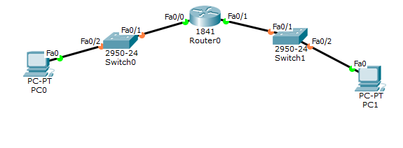

Redraw above diagram which includes IP address and MAC address. Take IP address and MAC address as per your knowledge.

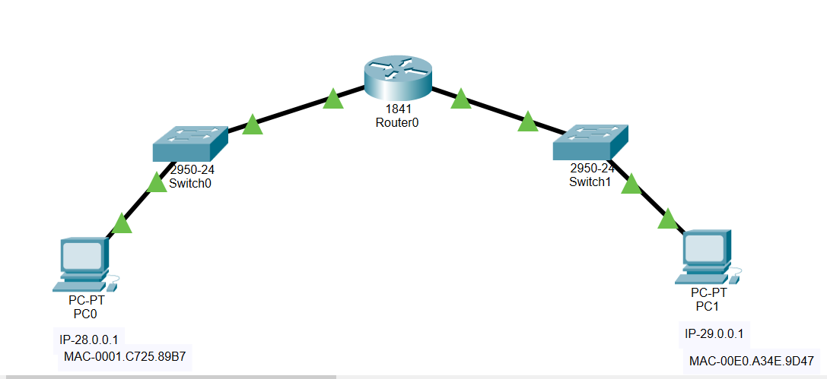

Write down ARP table of PC0 and PC1. Write down switch table of switches. Write down Routing table of routers.

ARP table entry of PC0

|  |  |
| --- | --- |
| **IP address** | **MAC Address** |
| 28.0.0.2 | 00E0.F7B9.E901 |
|  |  |

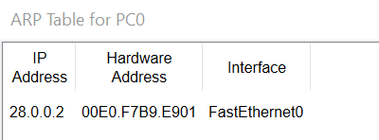

ARP table entry of PC1

|  |  |
| --- | --- |
| **IP address** | **MAC Address** |
| 29.0.0.2 | 00E0.F7B9.E902 |

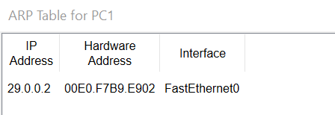

Switch table entry of Switch0:

|  |  |
| --- | --- |
| **MAC Address** | **Ethernet port no** |
| 0001.C725.89B7 | FastEthernet0/2 |
| 00E0.F7B9.E901 | FastEthernet0/1 |

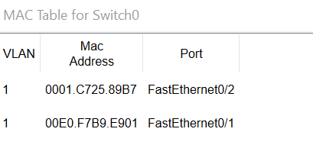

Switch table entry of Switch1:

|  |  |
| --- | --- |
| **MAC Address** | **Ethernet port no** |
| 00E0.A34E.9D47 | FastEthernet0/1 |
| 00E0.F7B9.E902 | FastEthernet0/2 |

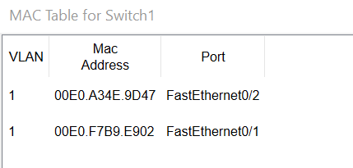

Routing table of Router0:

|  |  |  |  |  |
| --- | --- | --- | --- | --- |
| **Type** | **Destination Network ID** | **Port** | **Next Hop IP address** | **Hop Count** |
| C | 28.0.0.0/8 | FastEthernet0/0 | --- | 0/0 |
| C | 29.0.0.0/8 | FastEthernet0/1 | --- | 0/0 |

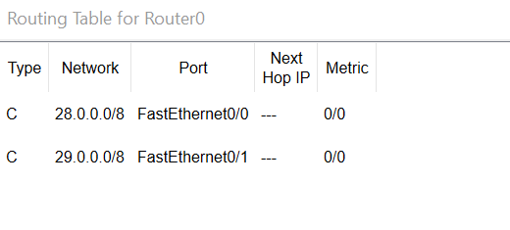

**Which are the following statements correct? Also justify each statement.**

1. **Switch0 contains MAC address of PC1 in their switching table.**

**Ans.** NO

**Justification:** Switch0 is in different network or you can say that it is connected to router and PC0 via NIC cars and that is why it will only contain MAC addresses of those devices not of PC1.

1. **Switch1 contains MAC address of PC1 in their switching table.**

**Ans.** YES

**Justification:** Here switch1 is connected to PC1 via NIC card and that is why it will contain MAC address of PC1 in it’s switching table.

1. **Any computer or device can be Router if it has two NIC cards.**

**Ans.** NO

**Justification:** Hubs also have two or more than two NIC cards but it is not router. Router contains Memory (ROM) + RAM + PROCESSOR and all that stuff for routing the packets in smarter way and that is the reason only two NIC cards it not sufficient for any device to become router. In case of computer we might need some program to host the and share network and that way it is possible to convert computer into router.

1. **Switch0 and Switch1 may take decision based on IP address.**

**Ans.** NO

**Justification:** As switches works on layer 2 (Data-link layer) it will not look into IP addresses it will forward traffic based on MAC addresses while some switches works on layer 3 (Network layer) and those switches can take decision based on IP addresses, Those are called layer 3 switches typically.

1. **Router0 works at layer 3, while switches work at layer 2.**

**Ans.** YES

**Justification:** Router is layer 3 device which will look in IP addresses and on the bases of that it will route the data packets while switches passes frames based on MAC addresses and that is why it is layer 2 device.

1. **By default, Network ID of NIC cards are routing table entries.**

**Ans.** NO

**Justification:** In real scenario the default entry in routing table is address of some other router which treats that data packets as same as first one but in simulator it is true.

1. **MAC address pair on link 0(between PC0 and Router0) is different than MAC address pair in link 1(between Router0 and PC1) for message transfer.**

**Ans.** YES

**Justification:** As both PC0 and PC1 are from different networks they both will have different host / gateway that is why different MAC addresses are there for link 0 and link 1.

**Exercise-3**

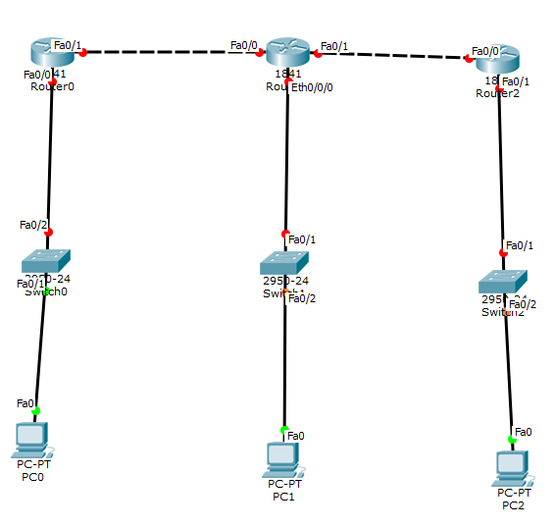

Redraw above diagram which includes IP address and MAC address. Take IP address and MAC address as per your knowledge.

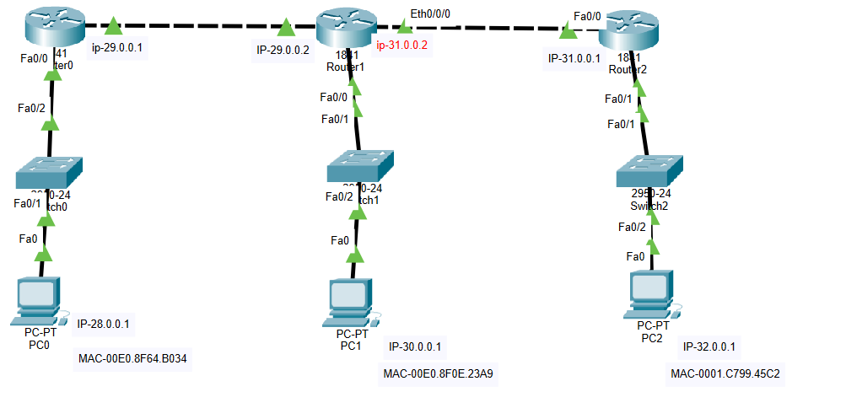

Write down ARP table of PC0, PC1 and PC3 after successful ping. Write down switch table of switches. Write down Routing table of routers.

ARP table entry of PC0

|  |  |
| --- | --- |
| **IP address** | **MAC Address** |
| 28.0.0.2 | 0060.70A4.C401 |

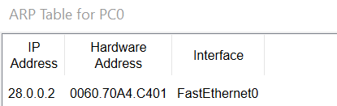

ARP table entry of PC1

|  |  |
| --- | --- |
| **IP address** | **MAC Address** |
| 30.0.0.2 | 0001.433C.6701 |

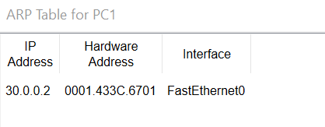

ARP table entry of PC2

|  |  |
| --- | --- |
| **IP address** | **MAC Address** |
| 32.0.0.2 | 00E0.B055.4402 |

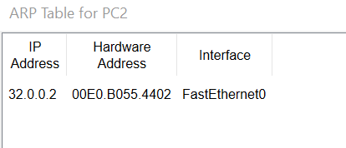

Switch table entry of Switch0:

|  |  |
| --- | --- |
| **MAC Address** | **Ethernet port no** |
| 0060.70A4.C401 | FastEthernet0/2 |
| 0090.2B21.3D13 | FastEthernet0/1 |

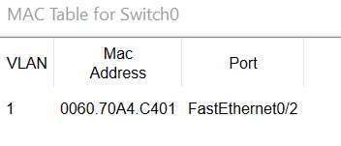

Switch table entry of Switch1:

|  |  |
| --- | --- |
| **MAC Address** | **Ethernet port no** |
| 0001.433C.6701 | FastEthernet0/1 |
| 0030.A398.8A01 | FastEthernet0/2 |

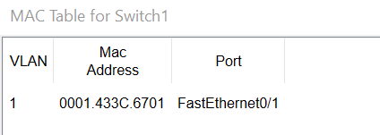

Switch table entry of Switch2:

|  |  |
| --- | --- |
| **MAC Address** | **Ethernet port no** |
| 00E0.B055.4402 | FastEthernet0/1 |
| 0030.F2EC.4E01 | FastEthernet0/2 |

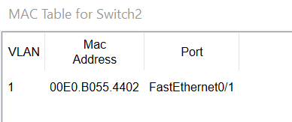

Routing table of Router0:

|  |  |  |  |  |
| --- | --- | --- | --- | --- |
| **Type** | **Destination Network ID** | **Port** | **Next Hop IP address** | **Hop Count** |
| C | 28.0.0.0/8 | FastEthernet0/0 | --- | 0/0 |
| C | 29.0.0.0/8 | FastEthernet0/1 | --- | 0/0 |
| S | 30.0.0.0/8 | --- | 29.0.0.2 | 1/0 |
| S | 31.0.0.0/8 | --- | 29.0.0.2 | 1/0 |
| S | 32.0.0.0/8 | --- | 29.0.0.2 | 1/0 |

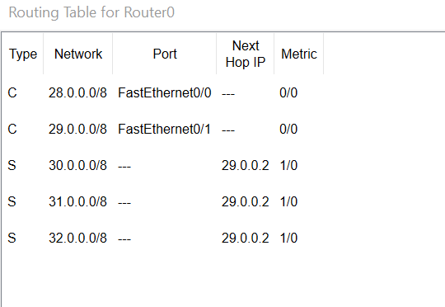

Routing table of Router1:

|  |  |  |  |  |
| --- | --- | --- | --- | --- |
| **Type** | **Destination Network ID** | **Port** | **Next Hop IP address** | **Hop Count** |
| S | 28.0.0.0/8 | --- | 30.0.0.1 | 1/0 |
| C | 29.0.0.0/8 | Ethernet0/0/0 | --- | 0/0 |
| C | 30.0.0.0/8 | FastEthernet0/0 | --- | 0/0 |
| C | 31.0.0.0/8 | FastEthernet0/1 | --- | 0/0 |
| S | 32.0.0.0/8 | --- | 30.0.0.1 | 1/0 |

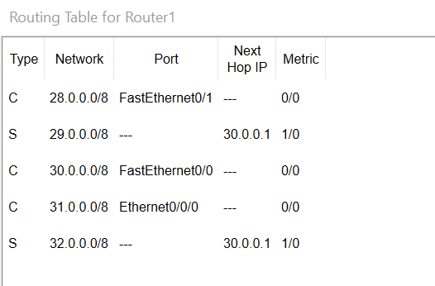

Routing table of Router2:

|  |  |  |  |  |
| --- | --- | --- | --- | --- |
| **Type** | **Destination Network ID** | **Port** | **Next Hop IP address** | **Hop Count** |
| S | 28.0.0.0/8 | --- | 32.0.0.2 | 1/0 |
| S | 29.0.0.0/8 | --- | 32.0.0.2 | 1/0 |
| S | 30.0.0.0/8 | --- | 32.0.0.2 | 1/0 |
| C | 31.0.0.0/8 | FastEthernet0/0 | --- | 0/0 |
| C | 32.0.0.0/8 | FastEthernet0/1 | --- | 0/0 |

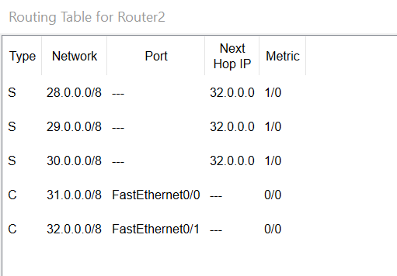

**Conclusions (Inference):**

1. this tree topology has layer2 and layer3 functionalities together.
2. Layer 3 refers to the third layer of the Open Systems Interconnection (OSI) Model, which is the network layer.
3. Layer 3 is responsible for all packet forwarding between intermediate routers, as opposed to Layer 2 (the data link layer), which is responsible for media access control and flow control, as well as error checking of Layer 1 processes.
4. By default, router has two NIC cards and to make this tree topology we have to insert another NIC card. Router has two slot empties for these types of connections.
5. Fa0 : Pc sends and receive the frame to/from switch via MAC address.
6. Fa0/1(for switch) : switch sends and receive the packet to/from router via IP address.
7. Fa0/1(for router) : router sends the packet to/from next hop via IP address.