**UNIVERSITY OF MAKATI**

J.P Rizal Ext. West Rembo Makati City

IT PROGRAMS

**Server Administration and Maintenance**

**Laboratory Activity #2:**

**Adding the Role of DHCP Server and Configure the Scope**

Student Name: CAMACHO, DAHREN R

Yr & Sec: III-BINS

Submitted to: Anna Charisma F. Dechavez

Date of Submission: 10/18/2024

1. **INTENDED LEARNING OUTCOMES**

At the end of this exercise, students should be able to:

1. Add the Role of DHCP Server and Configure the necessary parameters for the settings of the DHCP Server.
2. Distribute IP Address to the client computer from the DHCP Server.
3. **OVERVIEW**

**PROCEDURES:**

**Instructions:**

1. Submit a recorded video (individual) based on the given scenario of the step-by-step configuration adding and configuration of the DHCP Server.
2. Deadline: October 26, 2024
3. Upload this file in pdf format with the filename: LabAct2-Surname1-Fname.pdf

**Configuration of Network and Computer properties**

1. **Windows Server 2022 R2**

**A. Adding the Role of DHCP Server.**

1. Using the Server Manager, install the DHCP role on Server1. Add all of the necessary features for the role.

2. After the installation is complete, you will need to Complete the DHCP Configuration. Click on the yellow triangle at the top of the Server Manager window and then click Complete DHCP Configuration.

3. The DHCP Post-Installation Configuration Wizard will start and guide you through the configuration. Take all of the default settings to complete the configuration.

**B. Configuring the DHCP Scope**

1. Open the DHCP Manager from the Tools menu.
2. Click on the arrow next to the server name in the left pane to expand it.
3. Right-click on IPv4 and select New Scope from the menu.
4. The New Scope Wizard will start. Click Next.
5. Give the scope a name BINS_Scope_DHCP. Click Next.
6. Enter the start and end IP addresses for the scope.
7. Use the **NETWORK ADDRESS = 18.0.0.0/8**
8. Specify scope based on the assigned NETWORK ADDRESS. Click Next.

**Starting IP Address : 18.0.0.1**

**Ending IP Address : 18.255.255.254**

1. Specify exclusion assigned for TEN (10) Computers. **18.0.0.1 – 18.0.0.10**
2. Use the default settings for **LEASE DURATION**. Click Next.
3. Select that you want to Configure the DHCP options now. Click Next.
4. Enter **18.0.0.2** for the router address. Click Add. Click Next.
5. The Domain Name and DNS Servers fields should be automatically filled in from the server’s settings. Click Next.
6. Configure WINS Server settings (Since, the server will also be assigned as the WINS Server). Click Next.
7. Select to Active the Scope. Click Next.
8. Click Finish.
9. Take a SCREENSHOT of the DHCP Server Manager.
10. **Windows 10 Host Computer**

**A. Acquiring IP Address from the DHCP Server.**

1. Boot Client computer and login to the administrator account.
2. Open the TCP/IP IPv4 Properties and change the settings from manual to Obtain an IP address automatically and to Obtain DNS server address automatically. Click OK.
3. Use **ipconfig /all** to view the configuration and confirm that this computer is getting an IP address from the DHCP server.
4. If the client computer is not acquiring any ip address, use the following tool:

* **ipconfig /release** – to refresh the ip address to 0.0.0.0
* **ipconfig /renew** – to acquire an ip address from the server
* **ipconfig /all** – to check the ip address acquire is within the scope specified in the range of the DHCP Server.

1. Take a SCREENSHOT of the result of the **ipconfig /all**.
2. **Test the Connection**
3. **OBTAIN AN IP ADDRESS AUTOMATICALLY**
4. Test the connection of the following using the command tool “PING”:

* **PING server to client using IP ADDRESS (Take a SCREENSHOT)**
* **PING client to server using IP ADDRESS (Take a SCREENSHOT)**
* **PING server to client using computer name (Take a SCREENSHOT)**
* **PING client to server using computer name (Take a SCREENSHOT)**

1. Check the physical address of the client computer from the result of the “ipconfig /all” and compare it in the DHCP Server manager (look for UNIQUE ID, this is where we can compare if the UNIQUE ID and PHYSICAL ADDRESS) if they are the same, if not perform the ipconfig checking, using the /release and /renew tools.
2. **Screenshot (Placed the screenshots in this portion. You have to place six (6) screenshots)**

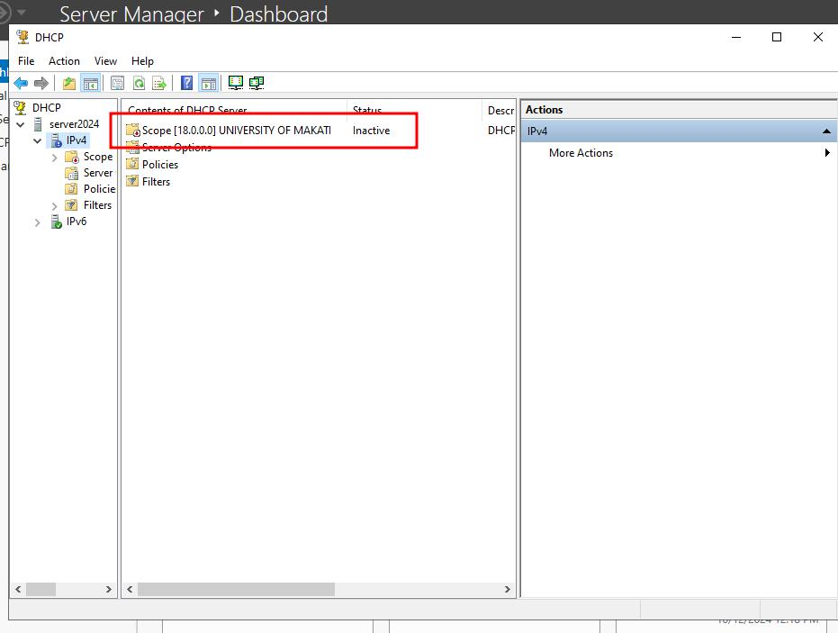

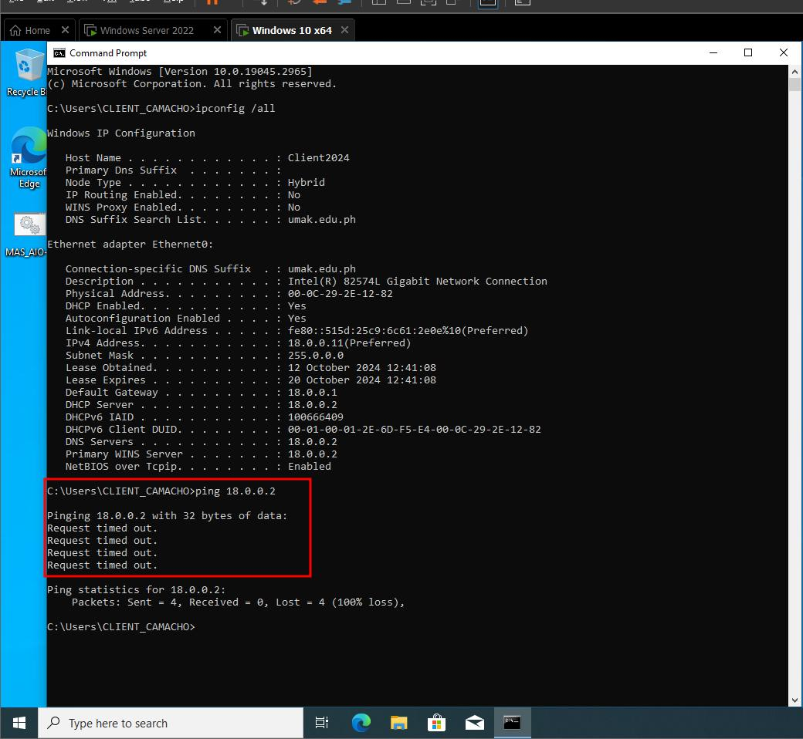

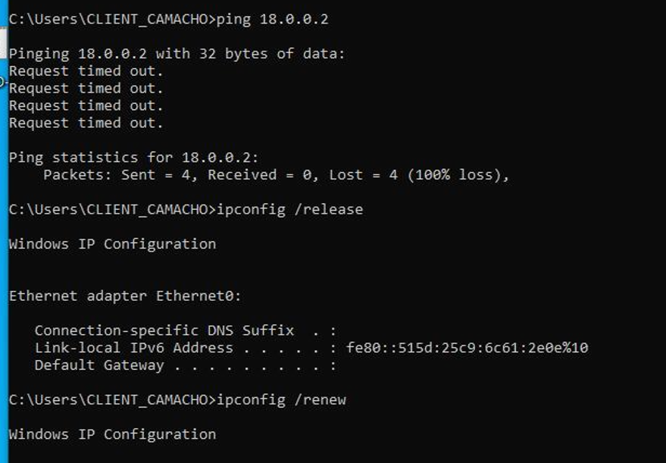

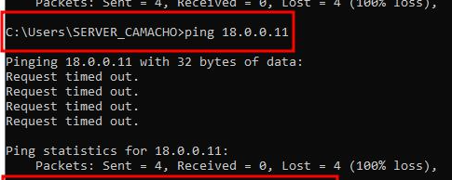

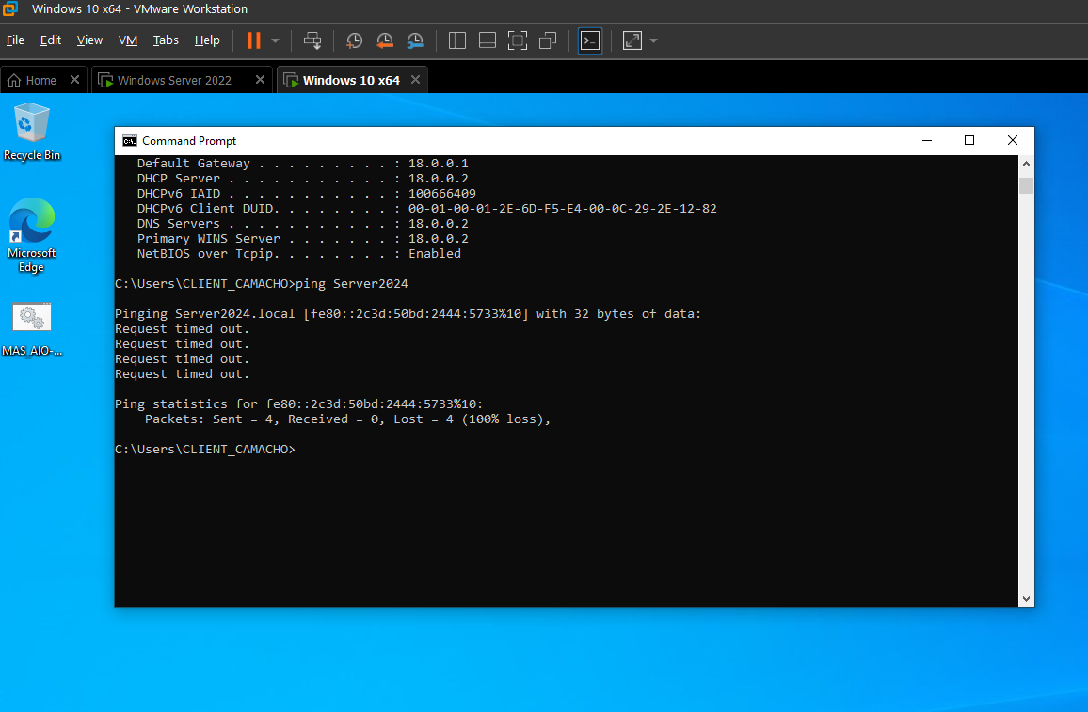

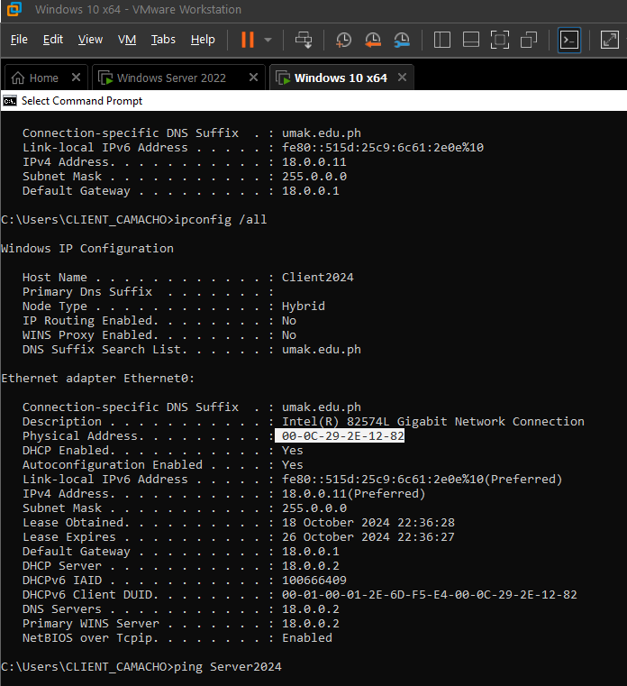

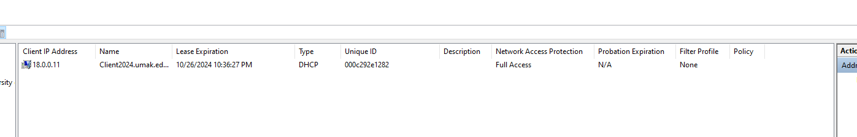

1. **OBTAIN AN IP ADDRESS VIA RESERVATION**
2. Test the connection of the following using the command tool “PING”:

* **PING server to client using IP ADDRESS (Take a SCREENSHOT)**
* **PING client to server using IP ADDRESS (Take a SCREENSHOT)**
* **PING server to client using computer name (Take a SCREENSHOT)**
* **PING client to server using computer name (Take a SCREENSHOT)**

1. Check the physical address of the client computer from the result of the “ipconfig /all” and compare it in the DHCP Server manager (look for UNIQUE ID, this is where we can compare if the UNIQUE ID and PHYSICAL ADDRESS) if they are the same, if not perform the ipconfig checking, using the /release and /renew tools.
2. **Screenshot (Placed the screenshots in this portion. You have to place four (4) screenshots)**

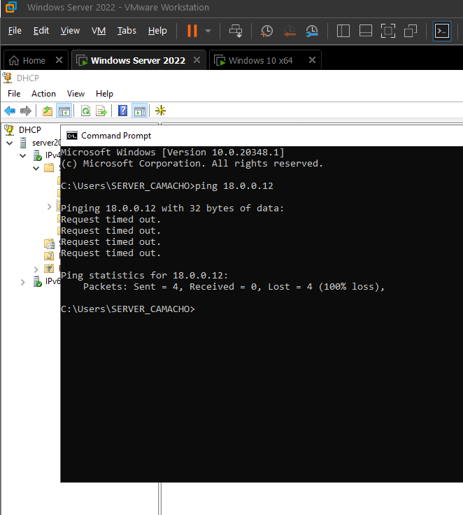

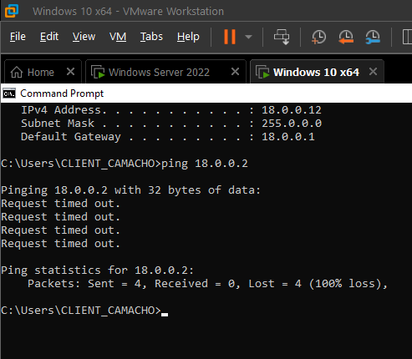

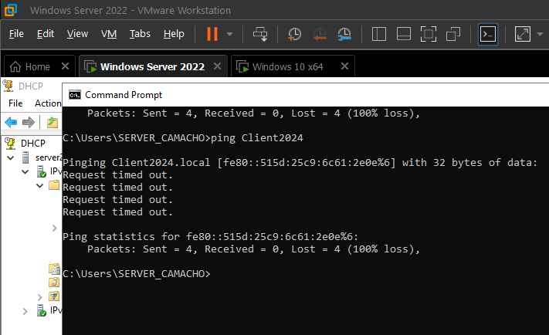

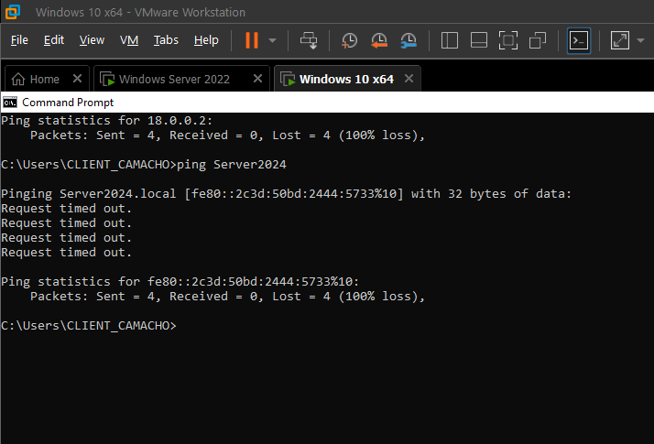

1. **Step-by-Step Procedure. *Provide a description for each figure.***

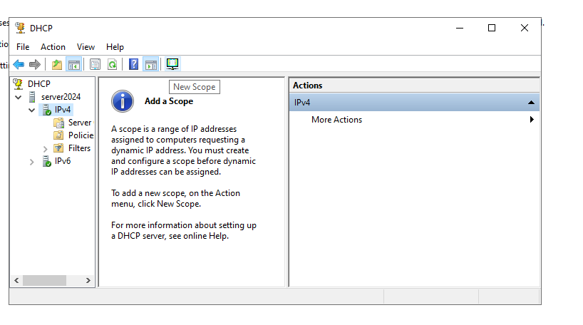

Server:

* Go to server manager, right click on tools, click DHCP, and click your server name > ipv4 : then click New Scope

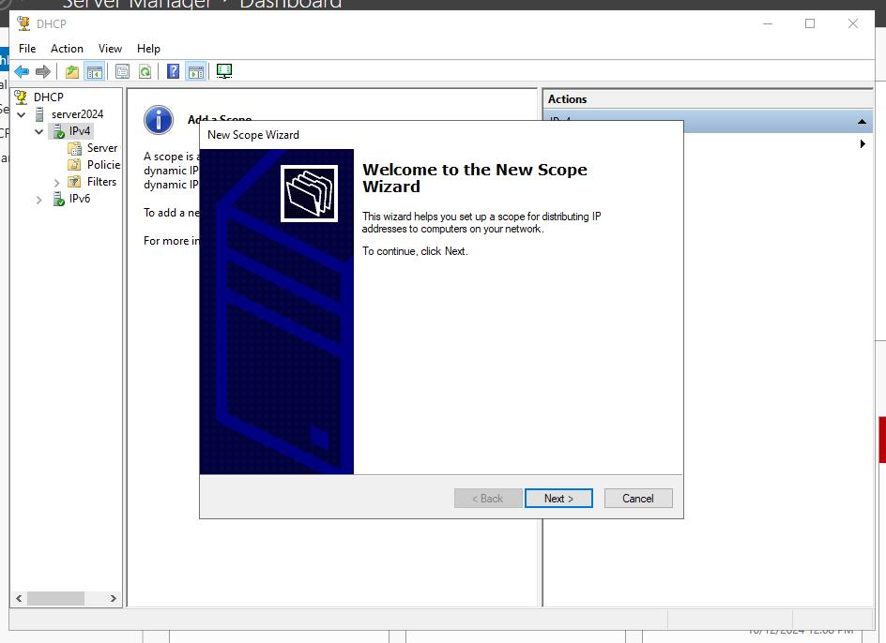

* Click Next

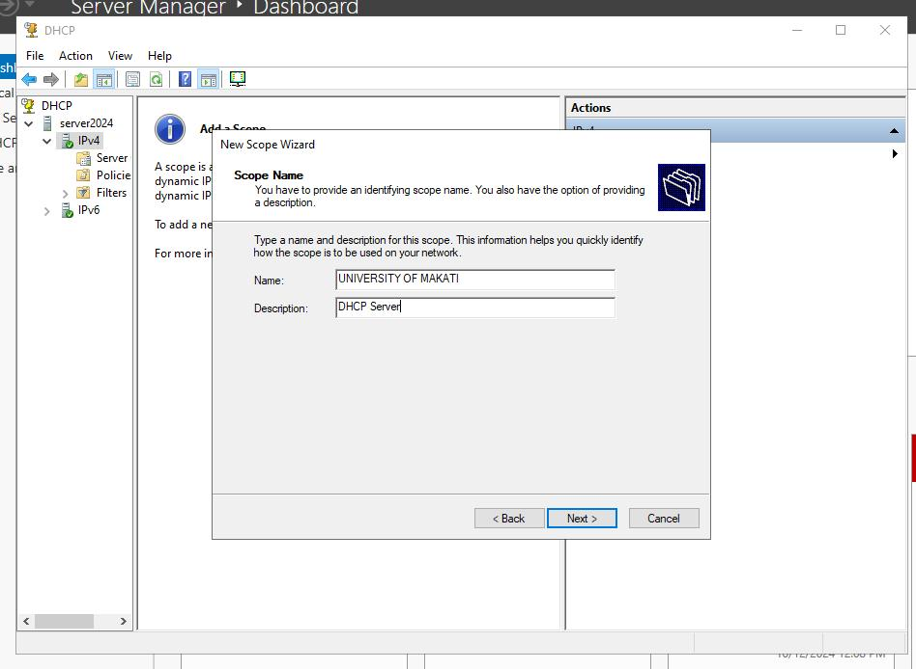

* Add name and description for your scope or as instructed

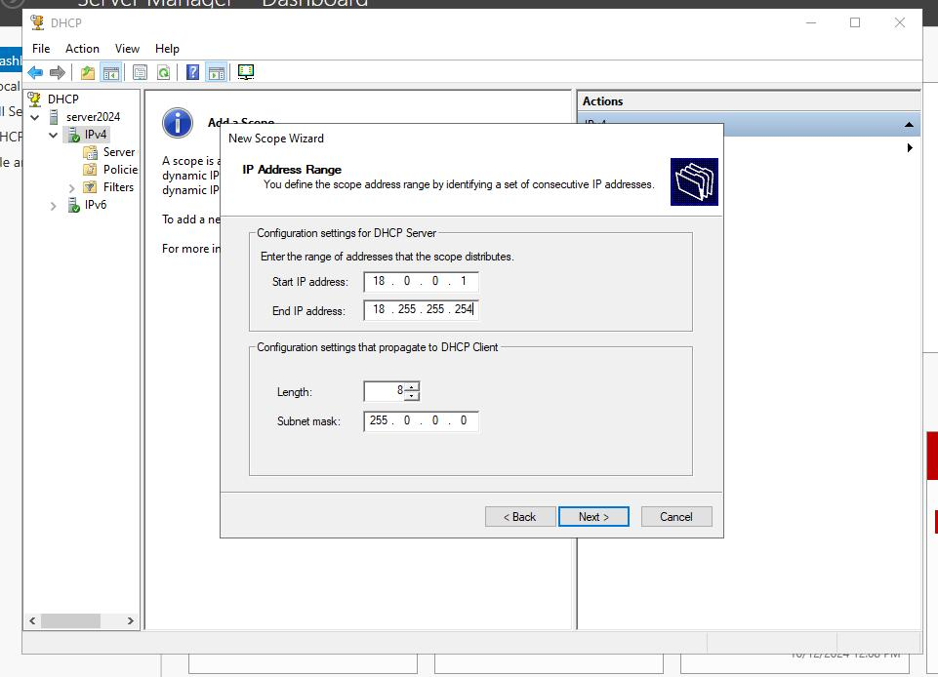

* Configure the Start and End IP from the network address assigned to you

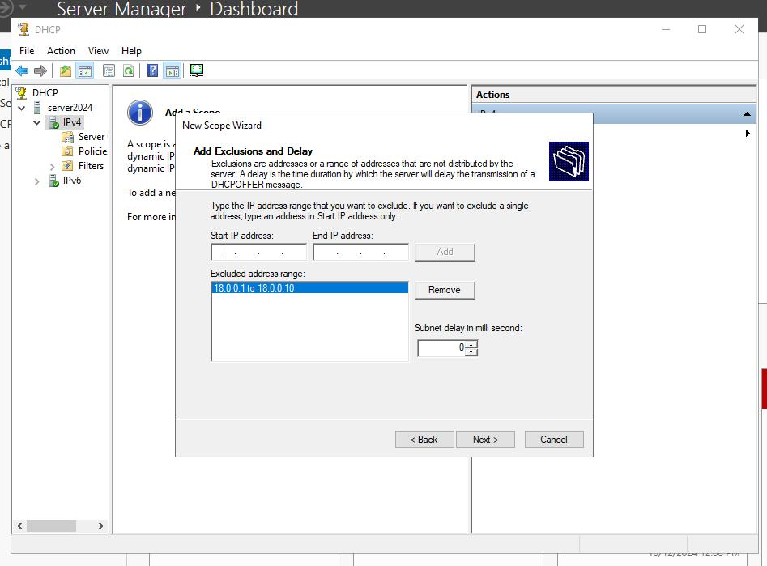

* Configure the excluded IP address range from your network address

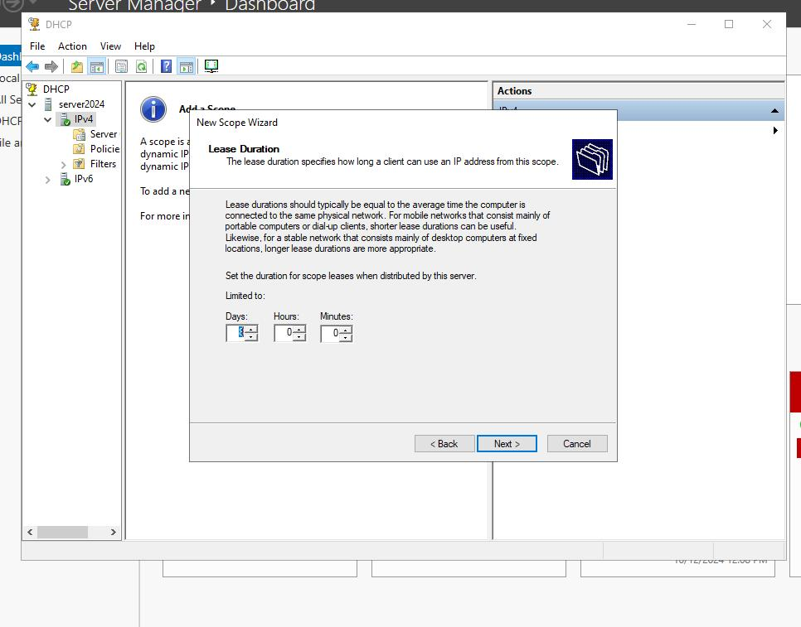

* Configure the duration of address lease from your DHCP Server

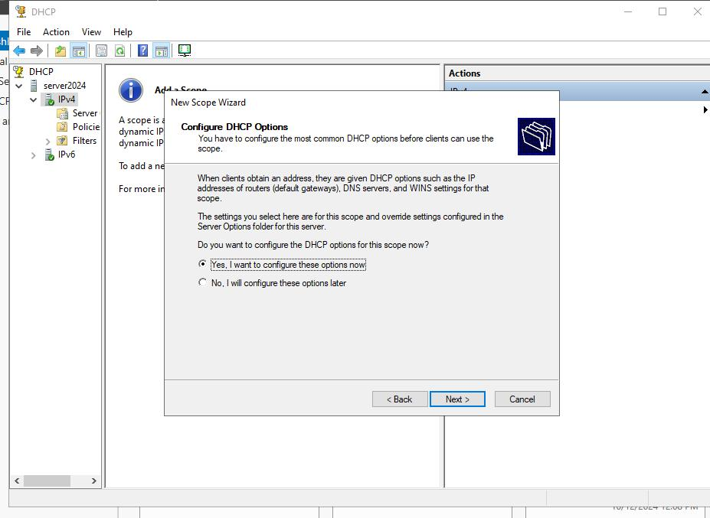

* Click yes on DHCP options

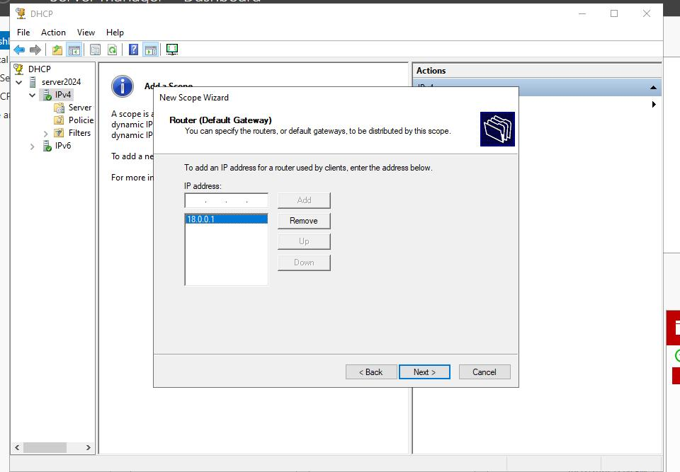

* Specify the address of the default gateway or your router

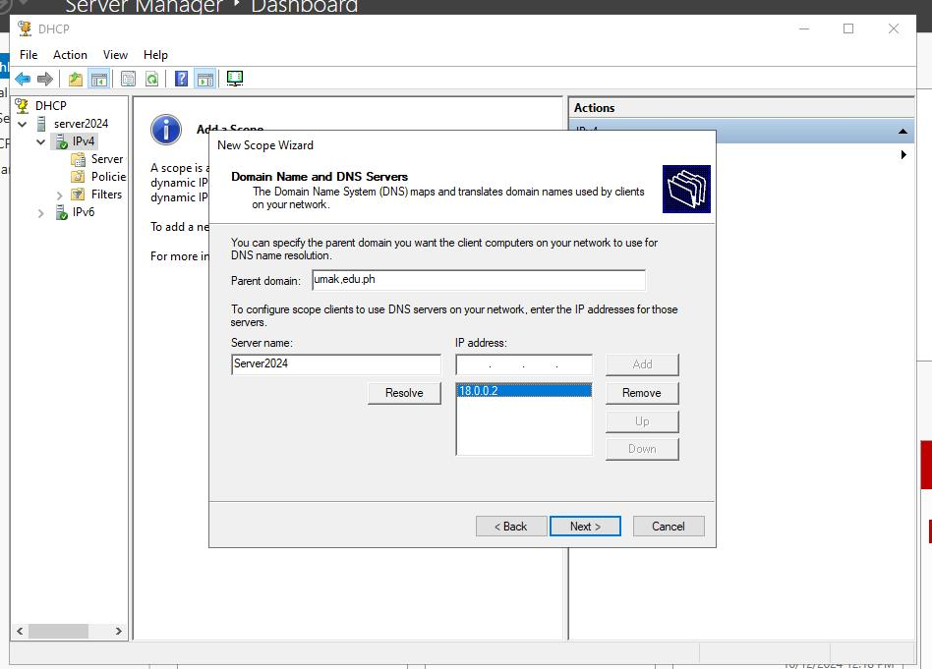

* Specify the DNS server address, this will typically be the address of your server.

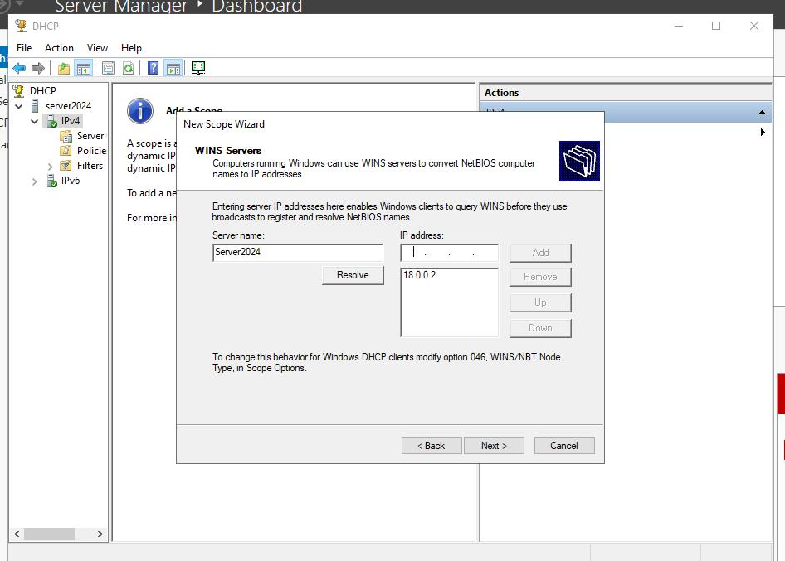

* After DNS, the configuration will be the same for WINS

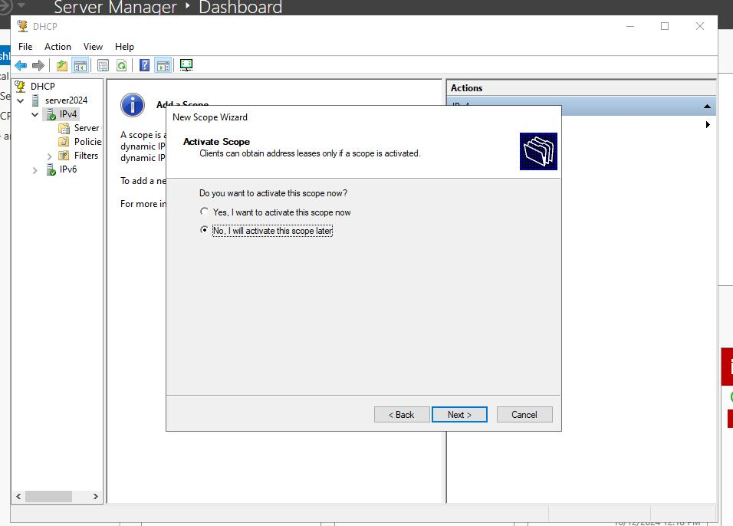

* You can opt to choose yes or no, but to test as soon as possible, click Yes on activate scope



* After finishing the configuration, take a look at the information on your DHCP server, see to it that there is no misconfiguration.

Client

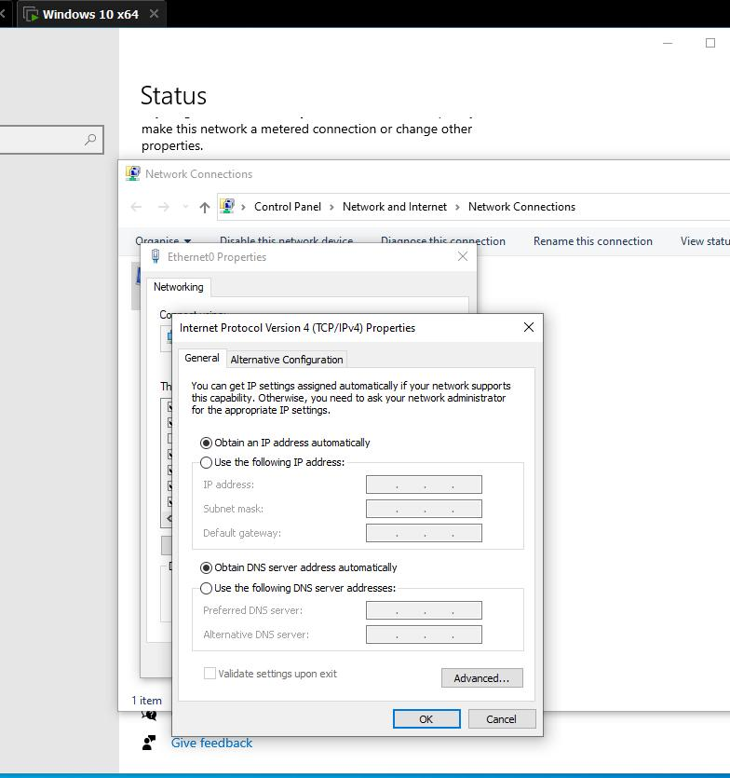

* Open your client computer/ OS on virtual machine
* Right click on the network indicator
* Click Network and Internet settings
* Right click on the Ethernet
* Double click TCP IPV4 on options
* Click obtain an IP address automatically on the the options above and below



* After the steps above, go to CMD
* Type ipconfig /all to see if the DHCP Server successfully leased the client an IP address
* If not, try to type ipconfig /release and then ipconfig /renew, then wait for it.
* You should see an IP configuration from DHCP server, if not, make sure to check the configuration of your server.

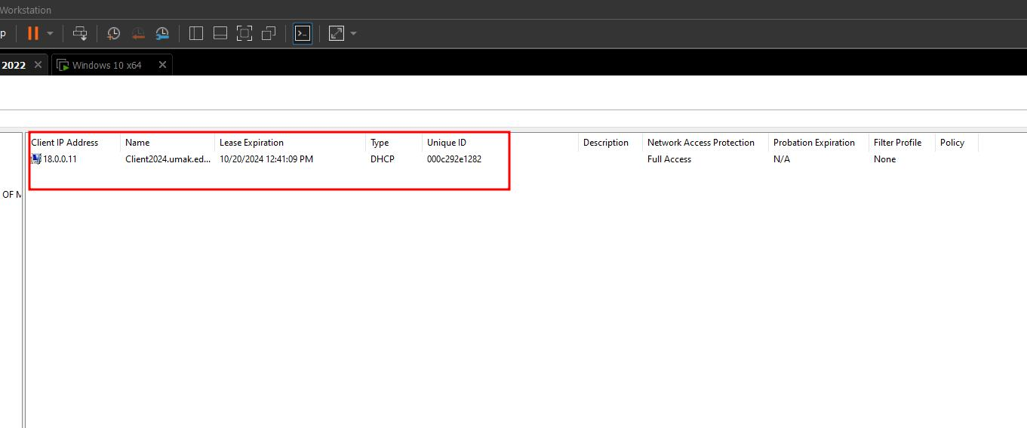

* You should see the address lease of a client on your DHCP server

RESERVATION

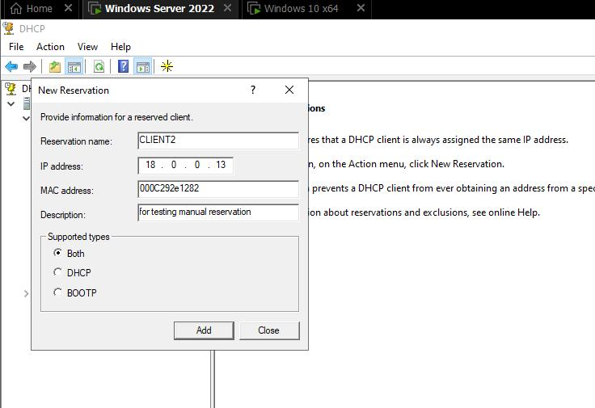

* Go to your DHCP Server, click on the dropdown options, and look for Reservation and click on it
* Click the yellow asterisk on the top, as it creates a new reservation
* Specify the name, the preferred IP address reservation for the client, and the PHYSICAL ADDRESS OF THE CLIENT., it usually looks like this: 00-0C-29-2E-12-82
* Click add

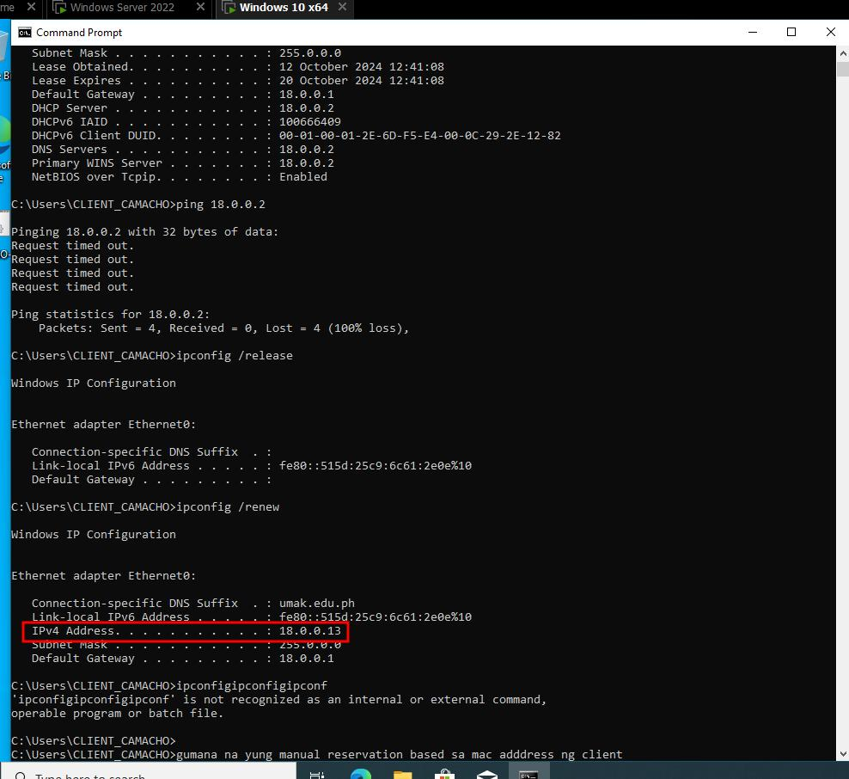

* On your client PC, go to CMD. Type ipconfig /release and then ipconfig /renew. Wait for it to load, if the configuration has no error, it should successfully change the IP configuration to the desired IP you have specified in your reservation.

1. **Takeaway/Learnings.** *Provide at least three sentences.*

My takeaway is as simple and straightforward, by making this handful of tasks, I have tried to configure the DHCP server and the client from start to end multiple times. By repeating the step-by-step process, I have learned the workaround. And it was effective, I have realized the importance of why we need to do it, and as well as the underlying technicality of how DHCP work. You can definitely grasp a concept if you try to apply the actual work alongside the theory, practical application indeed helps us understand the conceptual idea of how it works.

1. RUBRICS:

|  |  |  |
| --- | --- | --- |
| Windows Server DHCP configuration | 20% |  |
| Windows 10 Acquring IP | 20% |  |
| Test Connection | 40% |  |
| Conclusion | 20% |  |
| Total | |  |