# Website Description

<https://www.allrecipes.com/> is a food and cooking-themed website with the main feature being the ability for users to view a large variety of recipes and cooking techniques which are uploaded and maintained by other users of the platform in order to efficiently share culinary knowledge online. The website organizes its large database of information by reasonable categories such as type of cuisine, main ingredients, cooking methods, etc.

# Comparison and Evaluation

## Home Page

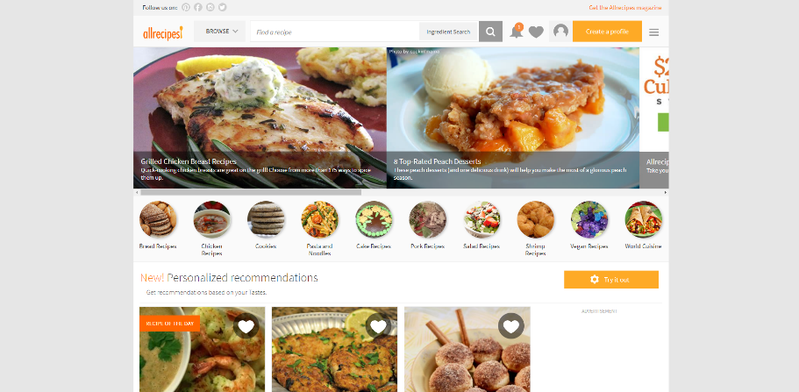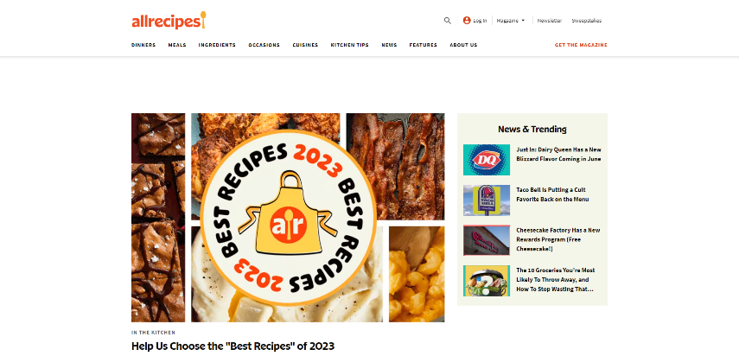The homepage of the old website is drastically different from the current day version. As shown in Figure 1, the website has a style similar to social media websites with the navbar having an equal focus on the user’s profile and browsing recipes. In contrast with the newer version, there is a cleara divide between the different functions, and thus the consistency of the current version is much better matched with the separate functions of the main page. The spacing, capitalization, and font size of the two sections in the navbar are also consistent with each other. Comparatively, the 2018 site contains many different button assets and text styles within the navbar. All buttons on the present-day site are responsive using contrasting colours for an easy-to-understand home interface. None of which is present on the 5-year-old site. In fact, many of the elements at the beginning of the main page could be mistaken for banners or other non-interactable items. The newer site clearly caters more to usability by using larger text, putting emphasis on the recipes, omitting unnesscessary details on the recipe cards for better readability, responsive elements (this, in particular, is very important for feedback for user actions and potential actions), and removing the infinite scroll from the old version. An infinite scroll doesn’t really feel like it belongs on a recipe browser app unless a use case is specifically needed for users who want to just browse random recipes for an indeterminant amount of time.

Figure : 2018 Allrecipes homepage

Figure : Current Allrecipes homepage

## Recipe Page

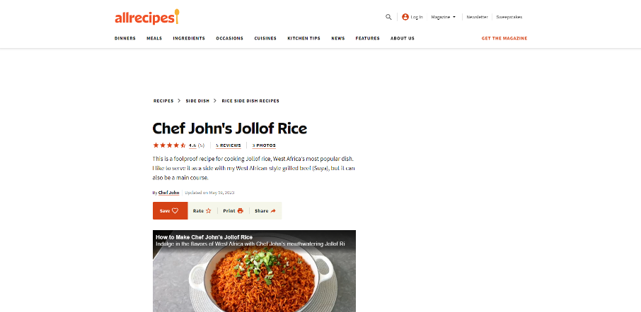The information on the recipe page is about the same as five years prior, the difference lies in the way it is presented. The current-day page is presented in a more vertical format in this order: overview, ingredients, directions, nutrition, reviews, and other recommended recipes. This order makes logical sense for laying out the steps chronologically for someone who would want to cook the recipe. The 2018 version has nearly identical order, with the difference of using more horizontal space, reading left to right then top to bottom. The current version also uses a larger variety of text sizes and weights to showcase the key info. Also exclusive to the current version is a shortcut to the nutrition information; should improve the usability for frequent users who are looking to cook recipes of a certain nutritional quality. Upon pressing any data input-related elements such as rating a recipe, printing a recipe, and rating a recipe; the user will receive either a small pop-up window to sign in for an authentication required action, or open a new page for other actions with an option to return to the recipe page or it expands a collapsable menu relating to the action. Both pathways do not execute actions immediately, thus allowing for easy reversal of actions. An interesting removed feature from the 2018 version is the ingredient checklist. The old version allowed users to mark any ingredient so they can keep track of what they already own, in theory this should help users reduce their short-term memory of ingredients they potentially need without needing to copy the information into a document or writing on a physical note. There are not many complicated actions on Allrecipes but for important actions like saving a recipe (Figure 6), you get a pop-up with a clear dialogue with closure to signify the action was complete. An interesting aspect of the review system is the lack of a deletion operation. Typically for actions involving a backend (database), the user gets all CRUD operations of creation, read, update, and delete. Though the user can see, edit, and update their review, there is no obvious option for deletion. While most of the rest of the app gives second chances or confirmations for important actions, there is no such thing for reviews and no option for deletion. This doesn’t give users the best grain of control and can be easily improved by just providing the last CRUD option.

Figure 5: Saved Recipe Image

Figure : 2018 Recipe page

Figure : Current recipe page

# Improvement

## Review Component

A sample improvement to the review component is shown in Figure 6. The image shows the existing review component on a recipe with a delete button added in a reasonable location. With only the addition of one delete button in the bottom left we immediately adhere more to keeping users in control with the web interface. Additionally has the benefit of preventing any accidental reviews by giving users the ability to revert their actions (could be argued as permitting easy reversal of action rule). There is practically no downside to having this feature accessible to the user since there is ample space on the card and the intention of the button is clear with the surrounding context.

Figure 6: Example Improved Review Element

## Ingredient Checklist

Figure 7: Sample Ingredient Checklist

I mentioned in the comparison section that I was surprised the feature to mark ingredients in the ingredient list was removed from the old version. This is a purely UI-related change, yet has the potential to greatly relieve the user’s short-term memory. The sample implementation (Figure 7) adds a button inline of the ingredient section which can toggle a collapsible menu showing a copy of the corresponding list of ingredients. The reason for the duplication of lists is to really make the intention of the checklist clear and not potentially create any misunderstanding relating to the recipe itself. Since a person’s short-term memory can only store around five items, helping the user remember what ingredients they need to procure can greatly relieve that memory load.