**Theory-based case study design**

*Asieh Mirzabagherian*

HPI University, Germany

Mirzabagherian.asieh@gmail.com

*Literature Review*

**1 Introduction**

Relying on rich qualitative data (Eisenhart,2007), Case study research (CSR) has become much more popular, especially in new topic areas (Eisenhart, 1989), since it can embrace several methods while building, developing or testing procedure, it can attract a wider audience whom may not even be predicted beforehand (Yilkoski, 2019). Eisenhart (1989) named frame-breaking insights, the tests of good theory (e.g., parsimony, logical coherence), and convincing grounding in the evidence as to the key criteria from the evaluation perspective which can be the reasons of high cited (Ridder,2017) of this kind of research.

Most of the reviewed articles (ref?) sorted CSR under the qualitative research due to its association with data collection methods such as archives, interviews, questionnaires, and observations(Eisenhart,1989) but this approach is methodologically flexible (Merriam (1998,2009)) enough to integrate quantitative methods as well for reporting its evidence (Eisenhart,1989) for instance in data sourcing or data analyzing (Ylikoski,2019). Thus we can consider this approach for both types of research (Wiliams, 2007). However, Ridder (2017), discussed that seeing this approach just for two functions of exploring and testing is “oversimplification” of this holistic methodology and he believes that this is a “classic understanding” of CSR.

CSR is highly recommended for in-depth exploratory research (Creswell 2003, Fiss 2009, Yoloski 2019), especially on complex issues (Harrison, 2017) where learning “more about a little known or poorly understood situation” (Yin, 1994; Leedy and Ormrod (2001) is important. In this kind of research not only the interpretive role of the researcher in analyzing the collected data is essential (Stake 1995, 2006) but also the importance of designing the research process should be considered.

Eisenhart (1989) declares the case study is “a research strategy which focuses on understanding the dynamics present within single settings”. Thus, for coming with rigor and valid Analytics, a researcher should recognize what is available and what should be explored. For achieving a better result, this study intends to see the narrated issues from the strategic research design perspective.

Consequently, the guiding research question of this paper is “what is the Theory-based CSR types?” and respectively” How is the application conditions of each one?”

To answer these questions, the remainder of this paper is structured as follows. In section 2 the methodology of this study will be presented. Subsequently, in section 3, all findings will be discussed under the subcategories related to theory-based CSR which will exclusively dedicate a special discussion on the contribution of the Case study types and strategies which will be followed by the theory spectrum of CSR and the design process framework. Finally, in section four, a conclusion of the discussion will summarize the findings.

**2 Methodology**

This study is a literature review followed by the literature search model of Brocke (2009, p10 fig.5) by the querying of scholarly databases on CSR in addition to keywords research with the study interest. The first phases have been done to form the concept and gather the literature outcomes on “case study definitions and elements”.

Although the search review was mostly on the keywords combination, the high cited literature screened mostly by title and abstract in the first step and investigated by the full text after the first relevant literature evaluation. In this phase, forward and backward research (Webster and Watson (2002)) also conducted. Reviewing founded literature’s full text, some of them were decided to be the main influencers of this study.

For conducting this paper, numerous arterials with different philosophical assumptions and orientations of case study research have been reviewed and key elements and characteristics of the different case studies are extracted. Regarding Cooper’s Taxonomy (1988, pp. 110), this review is conceptual integration of the relevant literature and attempts to have a pivotal coverage toward the topic.

|  |  |  |
| --- | --- | --- |
|  | Phase 1 | Phase 2 |
|  | CSR | CSR features |
| Search string or keyword | CSR Design | CS typology |
|  | CSR criteria | Theory-based CSR |
|  | CSR vs … |  |

Table-1 Search review phases

As it mentioned phase 1 was carried out by screening the title, abstracts and keywords of relevant articles to CSR. The ones which had this approach only as their methodology but had no proper explanation for finding out the answer for this study question were excluded. This event happened another time for the next phase iteratively.

**3 Finding and Discussion**

As discussed in the previous section there is a variety of studies in this field which could be referred but the interest of this paper limited them into the bunch of literature which despite their different perspectives can be productive in shaping a framework for decision making of this study reviewers. (Used literature?)

As a result, the contribution to the literature is divided into some sections due to the characteristics of CSR design: the first section is about Case study types (sampling), the second part is about CSR theory spectrum and the final discussion will be on the CSR design process.

3.1 CSR Sampling strategy

There is a wide range of sampling types and strategies (Patton, 1990, pp.182-183), being of research interest (Stake 2005), and theoretical relevance (Eisenhardt and Graebner 2007) are just two reasons why a researcher should decide on the sampling type and strategy for his/her CSR. For a better decision which leads to a better CSR design, tow issues are important:

Appropriateness: it should be fit to both the purpose of the research and the phenomenon of inquiry; to fulfill this issue, the researcher has to know how to sample the case studies. (Kuzel, 1999; Miles and Huberman, 1994; Patton, 1990)

Adequacy: it is related to how many cases are enough. In this regard, Kuzel (1999) suggested a flexible selection of the cases in addition to saturated information of evidence and a rich explanation of the cases. Saturation is a subjective concept and from the CSR's view can be interpreted by means of the theoretical framework and the research purpose (Shakir,2002).

Yin (1994) defined selection strategies for the single case and multi case which are referred by number of reviewed literature. Some of these strategies will be mentioned in the framework of this study.



Table2 –Case study types and strategies

3.2 CSR theory spectrum

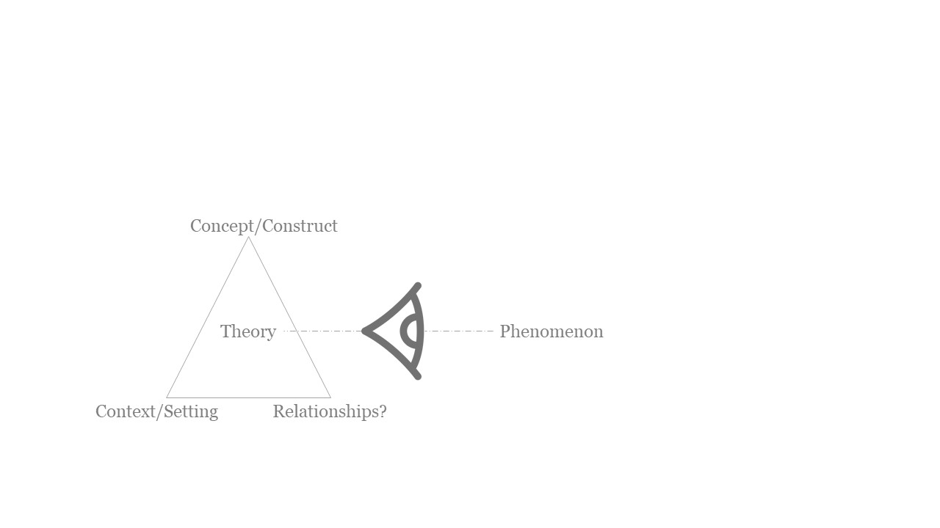In the reviewed literature, there are various views and descriptions of the CSR theory, however, the most abstract but comprehensive one from this study view is declared by Corley and Gioia (2011) ‘‘… theory is a statement of concepts and their interrelationships that shows how and/or why a phenomenon occurs’’. According to this definition, we can have an imagination of the relationship of each element of the theory and the observed phenomena (Image-1).

Image-1 Theory elements

As it is depicted, theory comprises three basic elements (Alvesson and Ka¨rreman 2007; Bacharach 1989; Dubin 1978; Kaplan 1998; Suddaby 2010; Weick 1989, 1995; Whetten 1989)

Concepts and constructs: “concept” is more general and descriptive while” construct” is more specified and operational. (Gioia et al., 2013; Ridder, 2017)

Relationships between concepts or constructs: the underlying how and whys for explaining or predicting the behavior of a specified set of phenomena (Weick, 1995)

Boundaries /setting (temporal and contextual) which affects the generalizability of the theory.

This theory cycle is described as a continuum than a product (Weick, 1995) or a process than an outcome (Gilbert and Christensen, 2005). This process will start with a careful description of phenomena, then classification in the similar phenomena category. After that, researchers can specify a model for the 3 elements of the theory i.t. what factors drive the phenomena and under what circumstances. The categorization scheme will assist the researchers in their predictions or confirmations. (Gilbert and Christensen, 2005).

Following Ridder (2017), we name this process as the “theory spectrum” since base on the three elements of the theory, the steps can become more inclusive or limited. This spectrum comprises 3statuses: Building, Developing, and Testing.

3.3 CSR theory-based design process

Eisenhardt 1989 illustrated a 6 steps process for CSR which includes: Start point(question), Selecting case (sampling), crafting Instruments and Protocols, Entering the field, Analyzing Data, Shaping Hypotheses, and Enfolding Literature. Although this process from the exploratory view is complete, for this research some of the steps will be omitted and the remainders will rephrase as Input, Sampling/ Research strategy, Data collecting and analytics, and Output.

The combination of the design process and the theory spectrum is depicted in Diagram 1, which is aimed to be a guiding framework for the theory-based CSR design. A researcher can apply a part of this spectrum or the whole parts of it, depending on the phenomenon and theory relations (Ridder, 2017).

3.3.1 Building

In this phase of the spectrum, the researcher has an assumption of the phenomena (Yin, 1994)and s/he wants to create a theory based on his/her interpretation. Respectively, the eliciting of concepts, relationships, and prior constructs are crucial in defining the research strategy. Although Eisenhardt (1989) believes researchers should avoid assuming relation between variables and theories, Ridder (2017) admits the assumption defines the research focus area and possible prior construct provides a better grounding of construct measures (Ridder, 2017; Eisenhart,1989). This exploration is aiming at the generating of tentative theories. The research strategy is synced with an investigation of a new phenomenon, so the protocol will be detailed descriptions of the phenomenon existence (how and why) (Ridder, 2017).

For sampling, emerging status retains theoretical flexibility (Eisenhart,1989). In a single case study researcher will expand constructs and relationships within a distinct setting (in-case analysis) while in multi-case cross-analysis, s/he compares similarities and differences among cases case respectively the result of first is creating theory and the second advancing the theory by revealed emerging patterns (Ridder, 2017). In other words, utilizing cross-case analysis, the researcher can have a comparison of the identified mechanisms from each case to another to shape the theoretical conclusion (Vaughan, 1992).

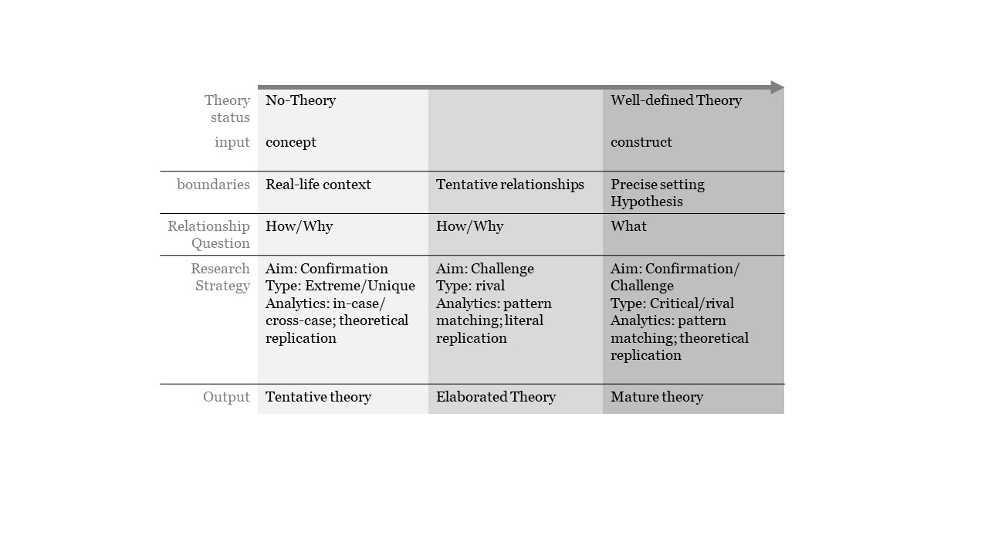Diagram1. Interplay of theory spectrum and CSR design elements

Data collection is based on triangulation, (Burns 2000; Dooley 2002; Eisenhardt 1989; Ridder 2016; Stake 2005: 454) and draws from multiple sources such as observations, interviews, archival records or documents, physical artifacts, and audiovisual materials. (Williams,2007; (Flick 2009: 257; Mason 2002: 84). The confirmation on the constructs as the research progress can lead to replication or corroboration of propositions (Eisenhardt 1991; (Eisenhart,1989). These within-case patterns and cross-case patterns can eventually lead to new theory (Ridder,2017).

3.2 Developing

This process will start with a tentative theory which can provide a “lacks and gaps” (Ridder,2017) of existing theory demonstration. This CSR design type aims at theory extension or modification (Edmondson and McManus 2007); thus during the investigation, new theory-based propositions will be developed for evaluation of the elements, relationships, and mechanisms. Therefore, as a theoretical refinement, this process will add a new component to the existing construct/ concept.

This status starts with the partially understood phenomenon, thus there is an existing theory which some predictions on the existing literature and the preexisting constructs will be confronted by pattern-matching[1]. Furthermore, with Data triangulation, the researcher can narrow down the problems of construct validity, by using multiple measures of the same phenomenon (Ridder,2017).

‘how’ and ‘why’ questions will be confirmed by literal replication for rival theories of the multi-cases and contributes to the analytical generalization of the theory. This theory extension can enhance the explanation power of tentative theory and upgrade it to an intermediate one.

3.3.3 Testing

In this status, the research question is more precise while the constructs and relationships are well developed and mature based on the previous variables, therefore, measuring of the propositions will conduct precisely.

Having specific testable hypotheses, the researcher is capable of testing the predicted relations in a clearly defined condition, e.g. time and space (Gilbert and Christensen, 2005) with the quantities data analysis.

This kind of research is applicable both with single case study and with multiple one, in the first one confirmation or challenging the theory and for the second theoretical replication will reveal the pattern-matching. The research strategy is with rival theories, different conditions and circumstances (Ridder, 2017).

**4 Conclusion**

Case studies are a valuable way of looking around us while it is capable of investigation a phenomenon in its real-life context Yin (1994). So it is unnecessary to undertake this type of study in a laboratory with a specified setting. Ridder (2017) CSR can be based on any mix of quantitative and qualitative approaches. It has extensive involvement with theory-based on the phenomenon Swedberg (2012) from the emerging till the mature phase of it.

The distinct from the theory building to theory refinement is so obvious since the input and output are distinguishably different. In spite the boundary between theory development and theory testing may not be as clear while both inputs can be intermediate theory in some cases. However, the difference appears in the question and strategy of design research.

This study seeks to uncover relevant sources for the aim of providing a literature review on Theory-based CSR types and the application conditions of each one with the intention of increasing the awareness of this research approach for the interested researchers. However, gaps in the studies are inevitable.

**5 References**

Eisenhart, K. 1989. “Building Theory from Case Study Research,” Academy of Management Review (14:4), pp. 532-550. (<http://www.jstor.org/stable/258557>)

Eisenhart, K. Graebner, M. 2007. “Theory Building from Cases: Opportunities and Challenges,” Academy of Management Journal (50:1), pp. 25-32.

Rowley, J. 2002. “Using Case Studies in Research,” Management Research News (25:1), pp. 16-25.

Ylikoski, P. 2019. “Mechanism-based Theorizing and Generalization from Case Studies,” Studies in History and Philosophy of Science (78), Elsevier, pp. 14-22.

Ridder, H. 2017. “The Theory Contribution of Case Study Research Designs,” Business Research (10), Springer, pp. 281-305. (<http://hdl.handle.net/10419/177270>)

Burawoy, M. 1998. The extended case method. Sociological Theory 16: 4–33.

Flick, U. 2009. An introduction to qualitative research, 4th ed. London: SAGE.

Mason, J. 2002. Qualitative researching, 2nd ed. London, Thousand Oaks: Sage Publications.

Weick, K.E. 1989. Theory construction as disciplined imagination. Academy of Management Review 14: 516–531.

Gilbert, C.G., and C.M. Christensen. 2005. Anomaly-seeking research: thirty years of development in resource allocation theory. In From resource allocation to strategy, ed. J.L. Bower, and C.G Gilbert, 71–89. Oxford: University Press, Oxford.

Gioia, D.A., K.G. Corley, and A.L. Hamilton. 2013. Seeking qualitative rigor in inductive research: note on the Gioia methodology. Organizational Research Methods 16: 15–31.

Yin, R.K. 2014. Case study research. Design and methods, 5th ed. London, Thousand Oaks: Sage Publications.

Harrison, K. 2017. “Mechanism-based Theorizing and Generalization from Case Studies,” Forum: Qualitative Social Research (18:1), Elsevier, pp. 14-22.(<http://www.qualitative-research.net/index.php/fqs/article/view/2655/4079>)

World Economic Forum 2018. “The Future of Jobs Report 2018,” *Insight report,* Centre for the New

Economy and Society; Weltwirtschaftsforum, Cologny/Geneva.

Williams, P. 2007. “Research Method,” Journal of Business & Economic Research (5:3), pp. 65-71.

Creswell, J. 2003. “Research design: Qualitative, quantitative and mixed methods approaches,” (2nd ed.). Thousand Oaks, CA: SAGE Publications.

Leedy, P. & Ormrod, J. 2001. “Practical research: Planning and design,” (7th ed.). Upper Saddle River, NJ: Merrill Prentice Hall. Thousand Oaks: SAGE Publications.

Shakir, M. 2002. “'The selection of case studies: Strategies and their applications to IS implementation cases studies,” Res. Lett. Inf. Math. Sci. (3), pp. 191-198. (<http://www.massey.ac.nz/~wwiims/research/letters>)

Miles and Huberman, 1994; Miles, M.B. and Huberman, A.M. Qualitative Data Analysis: An Expanded Sourcebook, Sage Publications, Thousand Oaks, 1994.

Patton, 1990 Patton, M.Q. Qualitative Evaluation and Research Methods, Sage Publications, Newbury Park, California, 1990.

(Kuzel, 1999; Kuzel, A.J. "Sampling in Qualitative Inquiry," In Doing Qualitative Research, B. F. Crabtree and W.L. Miller (Ed.), Sage Publications, Thousand Oaks, CA, 1999, pp. 33-45.

Creswell, J.W. Research Design: Qualitative and Quantitative Approaches, Sage Publications, London, 1994.

1. 2. pattern-matching: one of the most preferred techniques (Ridder, 2017) compare the theoretically based predictions with the empirical data in the site (Yin 2014);