# AI-powered Smart Stick Enhancing Mobility and Safety for the Visually Impaired

##### **Asia Said*, Aya Abdelaty\*\***

* High School Students, Menofia STEM School for Girls

** Department, Institute Name, if any

***Abstract*-** The visually impaired face enough challenges in the realms of mobility, safety, and independence. For an improved quality of life and to make them integrative into modern society, these challenges have to be met. This research paper proposes enhancing the mobility and safety of visually impaired persons by the development of an intelligent white stick integrated with advanced technologies. In this regard, the proposed solution is equipped with an ultrasonic, water, infrared, and health sensor, together with AI-powered cameras and GSM communication for holistic assistance. The device depends on ultrasonic sensors to continuously scan the surroundings for obstacles in real-time, while the water sensors detect slippery surfaces and IR sensors detect changes in elevation, such as stairs or sudden drops. The heart rate and temperature sensors of the device will monitor the user's health while navigating, and an AI-powered camera recognizes the scene, detects objects, and recognizes traffic lights. The feedback is achieved through sound, vibration, and voice commands. Additionally, the GSM functionality allows for emergency calls, which makes the device vital in terms of safety. The most important design considerations for the device were to deliver intuitive feedback with substantial safety mechanisms to ensure safe navigation.

***Index Terms***- Smart Stick, Artificial intelligence, Health Monitoring, Mobility aid, visually impaired.

1. **INTRODUCTION**

Imagine navigating a world where every step you take is uncertain and every path is filled with unseen obstacles. For millions of visually impaired people, this is what everyday life goes by and it requires innovative solutions to gain the lost confidence and independence. Blindness is a big problem globally, affecting millions. Out of the total number of blinds, it is estimated that about 90% are from developing countries. This is because blindness itself limits their mobility and independence to a great extent and affects their quality of life.

So, our project can contribute to achieving several Sustainable

Development Goals (SDGs), including:

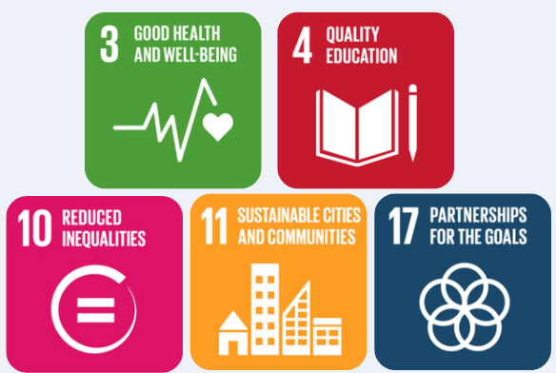

[figure 1 ]

The smart-blind stick development combines affordable costs in practicality and advanced technology to empower the visually impaired. It includes essential components, which are ultrasonic sensors for detecting obstacles; two infrared (IR) sensors for sensing elevation such as stairs or drops; a water detection sensor for wet surfaces; a GSM communication module for emergency alerts; a Husky Lens for advanced functionalities like color recognition, face recognition, object tracking, object recognition, and line tracking; an alarm to the user for detection of hazards with a vibration sensor; and a speaker that gives voice feedback in real-time such as "There is an obstacle on the right side," ensuring the user stays informed. Besides this, the health monitoring sensors in this system will measure vital parameters like heart rate and body temperature, which can be logged and made available for testing to ensure well-being while navigating. The whole circuit uses the Arduino UNO microcontroller for intuitive feedback through sound, vibration, and emergency communication, providing a safe, health-conscious, and reliable option. Mobility, safety, and health barriers for visually impaired individuals have a perfect all-in-one assistive tool that allows trust, and independence and promotes a society more inclusive and accessible.

1. **RELATED WORK**

In the past, individuals with visual impairments have relied on traditional white canes, which help detect obstacles through tactile feedback. While effective to some extent, these canes have limitations, such as the inability to detect obstacles above the waist, limited ability to identify specific objects, and lack of features that can assist with health monitoring.

Additionally, electronic devices such as ultrasonic sensors or smart canes with basic obstacle detection have been developed. These devices provide feedback on obstacles using sound or vibrations, offering more advanced features than traditional canes. However, many of these solutions are either bulky, expensive, or lack advanced features that cater to both safety and health needs.

1. **METHODOLOGY**

This particular section shall entail the details involving the steps in designing, developing, and prototyping the smart cane prototype. It also addresses the needs of visually impaired users by enhancing their mobility, safety, and independence.

Structural Design:

- The frame of the smart cane prototype has been designed using 3D printing technology with dimensions:

Height: 80cm

Wight: 15cm

Length: 10cm

Dimensions of the box and the seat:

So that it remains unnoticeably lightweight, durable, and ergonomic to be used regularly, thereby giving it an advantage in comfort and ease of handling by users.

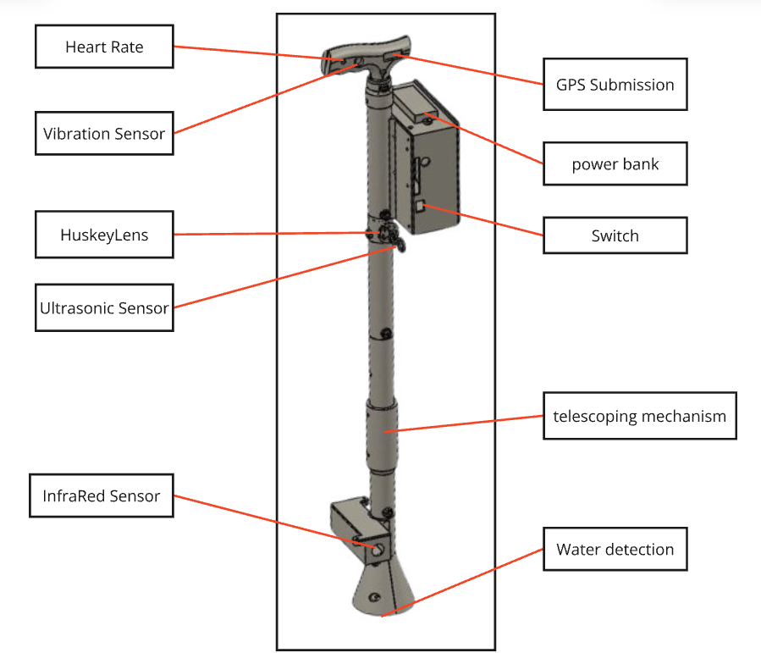

Obstacle Detection:

- Ultrasonic sensors have been mounted at two sides of the cane to sense mid-range obstacles such as walls, furniture, or even persons that the user can avoid while moving freely.

- Also, infrared sensors have been installed with its bottom at the cane so that it can detect sudden height changes from stairs or curbs to avoid uneven walking surfaces (Fig. 1).

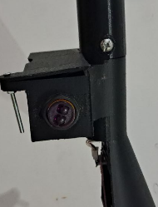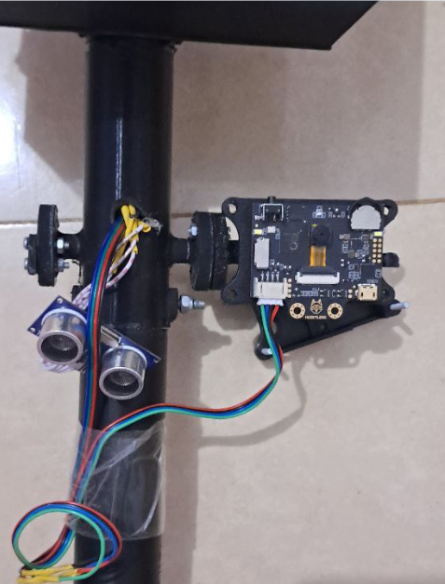

AI-Driven Extensions:

- An AI-enabled camera was attached to provide advanced features, including recognition of faces from familiar and strange faces at the location recognition (Fig. 2).

- Each face detected thus far gets assigned an identity by its unique ID, which ensures that individual differences can be established (Figs. 3, 4).

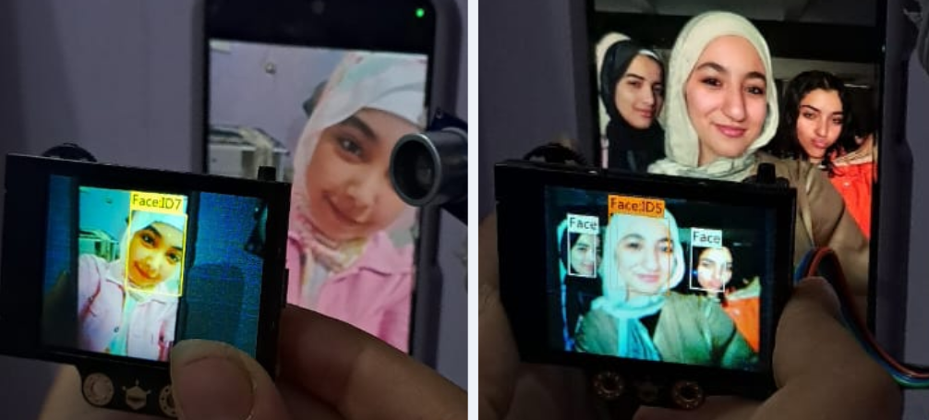

Tactile and Voice Responses:

- In the handle, there is a vibration motor intended to sense gestures. The user is warned as he nears the obstacle by the motor vibrating at increasing intensities (Fig. 5).

- The voice feedback and voice alert to the user for obstacle detection and direction guidance are provided by a speaker system.

Health Monitoring:

- A heart-rate sensor was embedded in the help handle that allowed the monitoring of pulses in real time with wireless data transmission to a dedicated mobile application where the user or caregiver can trace the health metrics. (Fig 5).

- Temperature sensors were fairly added to continuously monitor the body temperature of users.

- A blood oxygen saturation (SpO2) sensor is incorporated into the technical specifications based on precise information regarding the user's oxygen level.

- A GSR sensor is incorporated to assess the level of tension in the skin, shedding light on the user's stress levels.

Environmental Awareness:

- Incorporated in the moisture or drip detection sensor is an alarming signal of the presence of any moisture or water, thus providing enhanced security in a wet environment (Fig. 6).

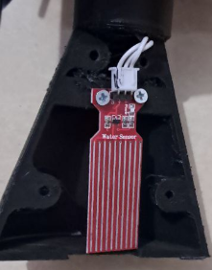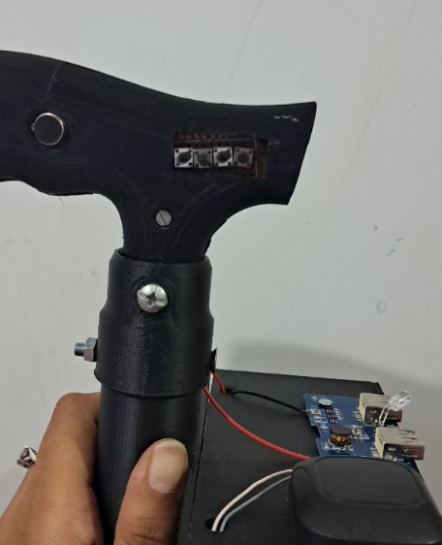

Location tracking and safety:

- The automatic transition cane is built with a location-tracking system to get the present location of the user in real-time, topped with an added degree of protection and safety, especially in emergencies.

Feedback and Refinement:

- The designed prototype is used by blind test subjects to gather feedback for further improvement of the design and its functions.

- A mobile application developed that would read health data, give real-time location, and update alerts on falls or detected obstacles. This mobile application is said to be part of the whole system as it could provide more references for users and caregivers.

1. **cooperative technologies**

With continuous modifications, the Smart Blind Stick aims to enhance the navigation of blind people through better support.

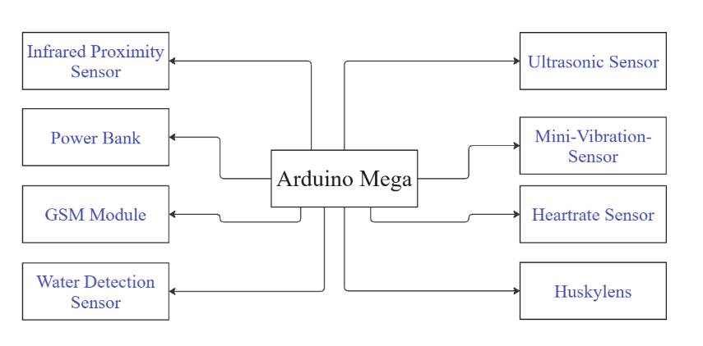Analyze and understand all the provided review comments thoroughly. Now make the required amendments to your paper. If you are not confident about any review comment, then don't forget to get clarity about that comment. And in some cases, there could be chances where your paper receives many critical remarks. In that case, don't get disheartened and try to improvise to the maximum.

**Arduino mega**

It has multiple interfaces for communication like UART, SPI, and I2C and has 54 digital I/O pins, 16 analog inputs, and 256 KB flash The Arduino Mega 2560 is a versatile microcontroller. The ATmega2560 powers it up and runs with an operational voltage of 5V at a clock speed of 16 MHz. It is apt for complex projects where many sensors and modules are used.

The Arduino Mega is used in a smart stick to put in ultrasonic sensors for obstacle detection, GPS for locating, and feedback devices, like buzzers or vibration motors. The number of pins and memory makes it very well-suited to process many things on a high level for the delivery of an excellent performance scenario with the user. This will give confidence to a user with a visual impairment.

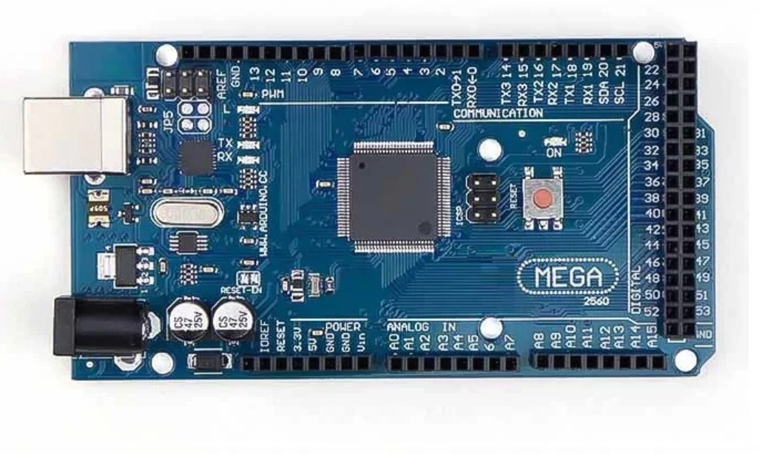

**Ultrasonic sensor:**

Ultrasonic Sensors are usually called as the non-contact distance measurement devices. An ultrasonic sensor emits ultrasonic waves which are reflected by the objects. The sensor determines the distance from the time that elapsed for the wave to return and the speed of sound. In the implementation of Blind Stick system, a single ultrasonic sensor positioned at the front will be able to detect any obstacle directly in the path of movement of a user. The sensor has a frequency of 40 kHz, it is a supply voltage of 5 volts and it has got a global current consumption of 15 mA. It has a maximum range of 200 meters which is a minimum range of 0.1 meters.

The distance can be calculated with the following formula using:

**L (distance) = 1/2 × T × C**

Where:

**T:** is the total time for the sound to travel to the object and back (round trip).

**C:** is the speed of sound in the medium, which depends on factors like temperature and humidity. For instance, the speed of sound in air is approximately 343 m/s at 20°C.

**The factor½:**

1/2 accounts for the fact that 𝑇 is for the round trip, but we only need the one-way distance.

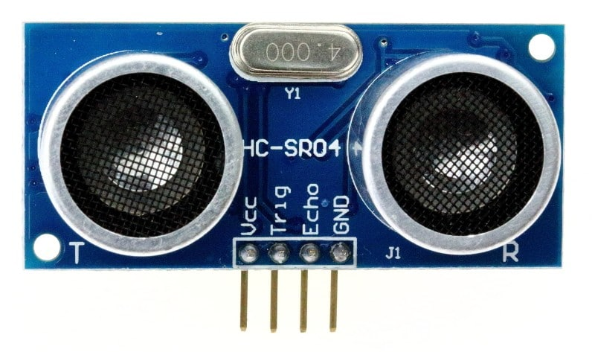

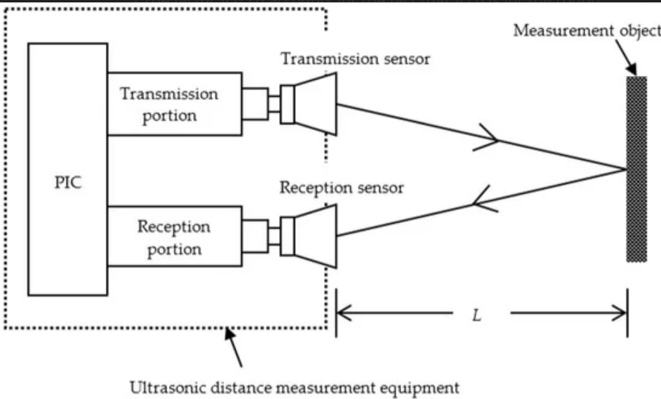

**Emergency Alert Button:**

It is an emergency button connected to a GSM module in this blind stick device so that it sends real-time location when pressed for help.

**Voice Command Button:**

This is a button provided on the blind stick device that the user can use to switch voice commands either on or off. It allows the user to operate the device while using the voice command feature or not.

**Infrared proximity Sensor (5V):**

The IR, or infrared, sensor projects infrared light, generally rising in wavelengths, typically between 700 nm and 1 mm. It measures the distance based on the time the light takes to reflect and return to the sensor. They cover obstacles at foot level and on the user's sides using two IR sensors attached at the lower end of the stick: one to the right and one to the left. With the normal detection range of 10 cm to 80 cm, some sensors can reach up to 1 m depending on specs. The sensors have a beam angle of around 15° to 30°, which would determine the coverage area. They run at 3.3V to 5V and draw about 20-30 mA current, so they can be described as low-power sensors that complement the overall system. The sensitivity helps in detecting surrounding obstacles and ensures safer navigation feedback as compared to conventional methods.

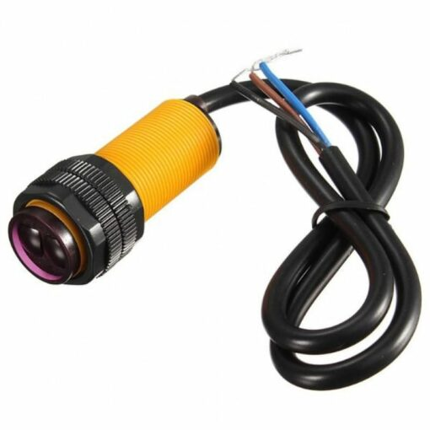

**Mini Vibration motor:**

Mechanical vibrations are what a vibration sensor is typically designed to detect, such as accompanying the production of an electrical signal-an ideal case for application into the handle of a smart stick used as an alerting mechanism. The fact that these sensors are, generally speaking, operating on 3.3V or 5V coupled with the characteristics of the SW-420 as a vibration sensor module-Digital Output compatible to Arduino boards, makes them have a much wider application. In this application, almost all data received from ultrasonic sensors detecting obstacles trigger the sensor. Using this method, the vibration sensor will create a tactile feedback at the handle on the vibration reported when it links an earlier robotic part. This feedback is silent and effective-so users who may otherwise not hear the alert would still be made aware of issues with potential hazards without the distraction of noise in their environment.

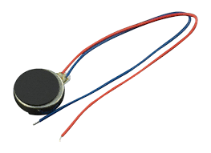

**XL6009 DC-DC Power Converter:**

The exemplary aspect of the XL6009 is that it combines a highly efficient DC-DC booster converter that boosts lower input voltages to a stable higher output voltage. For operation, it functions in the following manner: Initially, it stores energy in an inductor when the switch is on, and when the switch is off, that energy is released through a diode thus thereby boosting the voltage. The module works with an input range of 5V to 32V and an adjustable output voltage range of typically 5V to 35V. This device has high efficiency, putting it at about 92% utilization, and offers the user a supply of current up to 4A at lower output voltages. This makes the tool suitable for applications such as battery-powered systems or projects requiring steady high voltage without too much heat generation.

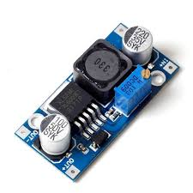

**The GSM module SIM900A:**

The GSM module SIM900A is used for communication between microcontrollers and mobile networks for sending and receiving SMS, receiving and making calls, as well as accessing the internet. It emits voice or data through GSM cellular networks using a SIM card and is controlled by AT commands. It works under a voltage of 3.4V to 4.4V and offers speed up to 85.6 kbps for data transfer. In the present system, this module is SIM900A used to send the messages about real-time location through SMS to the previous recipient, on pressing a specific button. It allows the user to send his GPS coordinates in case of emergency or lost, thus providing a good way of notifying a particular person to help. Used for remote monitoring, security systems, and IoT 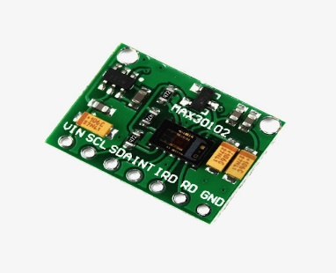projects, SIM900A finds a place in most applications where it is 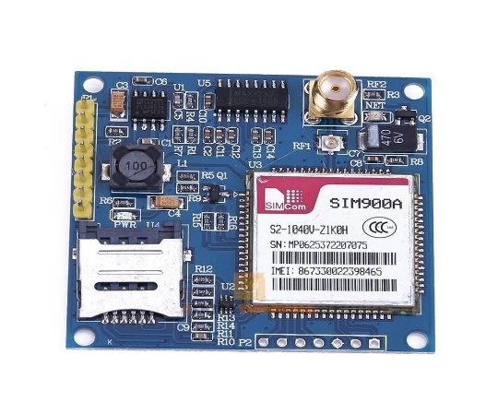able to provide wireless connection to many devices.

**Mini MP3 Player Module:**

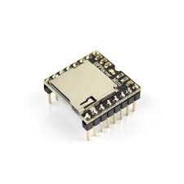Mini MP3 player module can store audio files, including MP3s, on micro SD cards. File decoding and outputting sound directly into a speaker for play back have been done through a microcontroller via serial commands. This module is integrated into the system to perform "Beware, there is an obstacle in front of you" playback when it detects noise from an ultrasonic sensor, or "Beware, wet ground" is activated when moisture is detected. Recorded in Arabic and stored on a memory card, the messages are triggered when someone presses a specific button on the stick. Thus, the feature makes the user aware of his surroundings while providing real-time attention to obstacles and gross condition changes to improve navigation and safety for blind users.

**Heart rate sensor:**

Heart rate sensors generally use optical technology. They usually have an LED and a photo detector. Light is emitted from LED which penetrates the skin; then the photo detector measures the light reflected from the skin. When blood vessels widen and narrow as the blood gets pumped by the heart, the amount of light reflected changes. The sensor uses these fluctuations to determine the heartbeat per minute. The sensor keeps on monitoring the pulse of the user and gives real-time info. In such a system, the heart rate data is forwarded along with the real-time location message to the pre-defined recipient whenever the emergency alert button is pressed. This information is passed through a GSM module which sends an SMS to the specific person along with the heart rate of the user and current location. It provides enhanced safety and health monitoring of the user by sending very relevant information in case of an emergency.

**Husky lens:**

Husky Lens is an AI vision sensor module that builds on functions that implement particular systems for detecting and recognizing certain features. The Face Recognition with ID Storage functions by holding images of faces via its camera, and then processing those images for analysis; it learns and stores these unique facial features as IDs so that when it compares them to other stored IDs, it can recognize and track said known face in real-time. Another feature is Object Tracking-it captures objects placed within its field view, then analyzes their shape, size, and movement to track them. Husky Lens can then continuously track an object with just a potential movement within its frame and be able to provide real-time coordinates and tracking information. Color This form of recognition lets Husky Lens detect colors by analyzing the RGB values further, comparing those against preset values to denote particular colors, making it useful for sorting or detecting colors. Gesture Recognition uses matched pattern recognition to capture hand images or movements and recognize particular gestures like swiping or waving for action triggers. Tag Recognition will enable the module to detect pre-defined patterns - QR codes or even custom tags using image capture processing to identify and interact. Even more, it performs Line Tracking, which facilitates Husky Lens detection and tracking along a line or path in which the camera can detect the contrast with the line to the background to track the location left by the line and change its movement accordingly and ideally suits robotic applications. For all the above features, its general mechanism consists of grabbing images using the onboard camera, processing them, and rendering the real-time output, which can then be coupled with microcontrollers to carry out effects based on detected objects, colors, faces, gestures, tags, or lines. So it can be said that camera images are processed and given in real-time, which is interconnected with microcontrollers to act upon the given features, objects, colors, faces, gestures, tags, or lines.

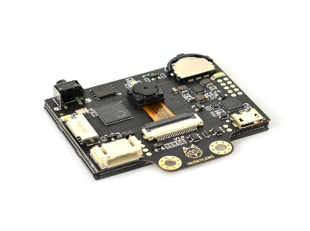

1. 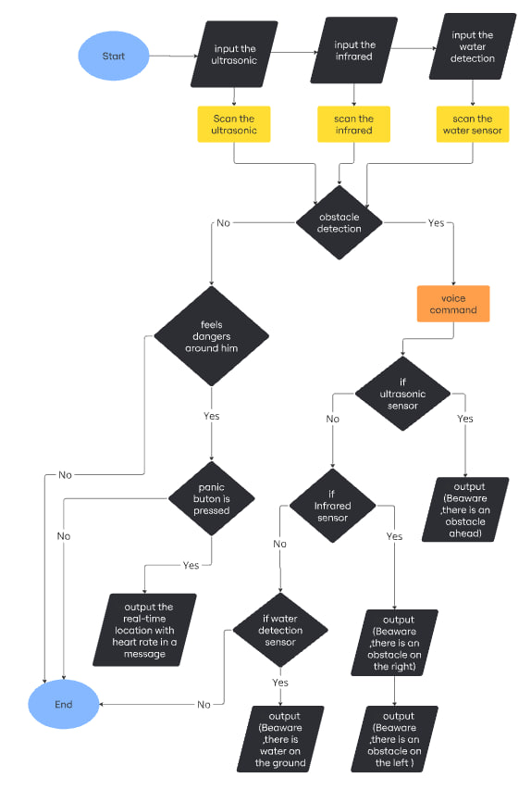results

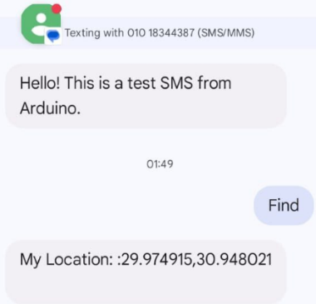When the second button is pressed, the system sends the current location to the pre-determined phone number. If the button is not pressed, a “find” message is automatically sent to the confirm communication and ensure the system is functioning correctly.

We conducted interviews with visually impaired individuals and asked them questions to understand their daily needs. These:

1- Do you feel that the Smart Cane has helped you improve your daily mobility?

2- Have you felt a difference in your level of safety and independence since using our Smart Cane?

3- Do you find that systems such as audible and haptic alerts are effective in helping you avoid obstacles?

4- Do you find that the Smart Cane contributes to your comfort when moving around in public places or at home?

5- Would you like to use the Smart Cane daily in your life?

6- Do you find that the Smart Cane provides sufficient support in emergencies?

7- Have you faced any difficulties or challenges while using the Smart Cane?

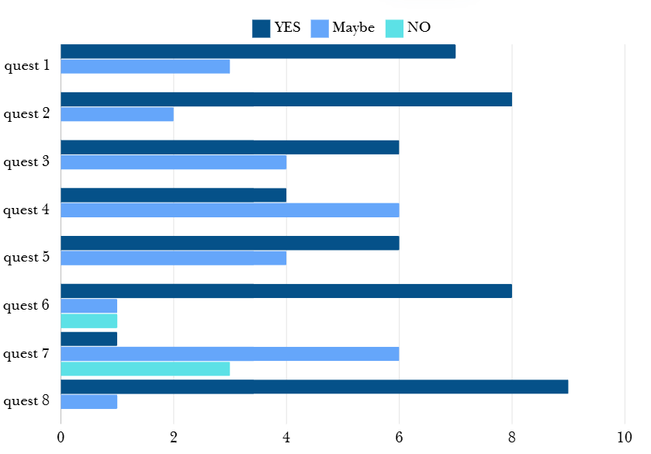8- Would you recommend the Smart Cane to others?

1. conclusion

With this new assistant for blind people, the Blind Walking Stick is a technology breakthrough that will help blind users regain their mobility and safety. The working prototype of the system has been developed that would remind the blind individuals of their imminent needs to attend to daily routines of navigation. This system addresses the common-sighted mobility barriers and associated risks created. Real-time obstacle detection, environment monitoring, and emergency location features will greatly benefit blind users by making them more independent and improving their quality of life. Lastly, this project will help blind people around the world to navigate with greater ease and confidence as it will provide them with a reliable tool for safer and more efficient movement.

1. Acknowledgment

The team members would like to acknowledge the efforts of our project guide, Mr. Haytham Makshat, his continuous efforts have propelled us to achieve our ideas. We would also like to thank all of our friends who have given valuable inputs in the pursuit of this project. We would also like to thank our Fablap teacher: Shokry George for providing all the essential resources and assistance that we need to carry out the project effectively

1. References
2. Grover, S., Hassan, A., Yashaswi, K., & Shinde, N. K. (2020). Smart blind stick. SSRG International Journal of Electronics and Communication Engineering, 7(5), 19-23.
3. Apu, A. I., Nayan, A. A., Ferdaous, J., & Kibria, M. G. (2022). IoT-based smart blind stick. In Proceedings of the International Conference on Big Data, IoT, and Machine Learning: BIM 2021 (pp. 447-460). Springer Singapore.
4. Dhanuja, R., Farhana, F., & Savitha, G. (2018). Smart blind stick using Arduino. International Research Journal of Engineering and Technology (IRJET), 5(03).‏
5. Loganathan, N., Lakshmi, K., Chandrasekaran, N., Cibisakaravarthi, S. R., Priyanga, R. H., & Varthini, K. H. (2020, March). Smart stick for blind people. In 2020 6th International Conference on Advanced Computing and Communication Systems (ICACCS) (pp. 65-67). IEEE
6. Bele, S., Ghule, S., Gunjal, A., & Anwat, N. (2020, April). Design and implementation of smart blind stick. In 2nd International Conference on Communication & Information Processing (ICCIP).‏
7. Chavan, P., Ambavade, K., Bajad, S., Chaudhari, R., & Raut, R. (2022, August). Smart blind stick. In 2022 6th International Conference On Computing, Communication, Control And Automation (ICCUBEA (pp. 1-4). IEEE.‏
8. O. O. Olakanmi, A Multidimensional Walking Aid for Visually Impaired Using Ultrasonic Sensors Network with Voice Guidance, International Journal of Intelligent Systems and Applications, 6( 8),53-59, DOI: 10.5815/ijisa.2014.08.06.14. E. J. Chukwunazo and G. M. Oneng.
9. G. Prasanthi and P. Tejaswitha (2015). Sensor Assisted Stick for the Blind People, Transactions on Engineering and Sciences,3(1), 12-16
10. B. G. Roopashree, B. S. Patil and B. R.Shruthi (2015). Smart Electronic Stick for Visually Impaired, International Journal of Innovative Research in Science, Engineering and Technology, 4(7), 6389-6395.
11. A. Jose, G. George, M. R. Nair, M J. Shilpa and M. B. Mathai (2016). Voice-Enabled Smart Walking Stick for Visually Impaired, International Journal of Advanced Research in Electrical, Electronics and Instrumentation Engineering, 5, 80-85,

Authors

**First Author** – Aya Abdelaty Mohamed, High School Student, Menofia STEM School, <aya.2023511@stemmenof.moe.edu.eg>.

**Second Author** – Asia Said Abdelarasol, High School Student, Menofia STEM School, <asia.2023501@stemmenof.moe.edu.eg>.

**Correspondence Author** – Aya Abdelaty, <ayaabdelaty2008@gmail.com>, +20 01272587074.