FREE COMMUNITY SEMINAR
The Body's Natural, Non-Specific Medicine
The Science and Restoration of Sleep
What treats everything, non-specifically? Come find out why, and what to do about it.
Why This Matters
About 1 in 3 adults live with insufficient sleep, and 50–70 million Americans live with a chronic sleep disorder. Poor sleep is a foundational risk factor for cardiovascular disease, hypertension, type 2 diabetes, obesity, anxiety and depression, cognitive decline, and immune dysfunction.
What You'll Learn
- How sleep works as an anabolic process that repairs and restores the body。
- The circadian rhythm and the cortisol–melatonin relationship that governs your sleep.
- The four stages of sleep, and why deep sleep before midnight is worth more than sleep after.
- The functional test to uncover your sleep disturbance patterns
- The everyday saboteurs working against your sleep.
- A practical action plan to build your sound sleep.
About Your Presenter
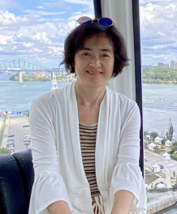 | Dr. Chen, Ph.D., FDNP  Founder, Soluvia Integrative Health, LLC  A certified Functional Health Practitioner and Ph.D. pathologist, Dr. Chen combines clinical insight with deep medical science expertise to help clients uncover the hidden, root-cause stressors behind chronic health conditions — using structured, whole-body assessment and advanced functional testing to guide personalized, evidence-based care.

EVENT DETAILS
Date: Saturday, August 22, 2026 (tentative)
Time: 2:00 PM (tentative)
Location: [Location]
Struggling with chronic health conditions? Let's find your healing opportunities together.
Soluvia Integrative Health, LLC
Dr. Chen, Ph.D., FDNP
soluviahealth@gmail.com · soluviahealth.com

