Progress Report; Created SSMS Tables  
To: National Education Associates

Hope you are having a great day!

It was quite an adventure adding the data into the tables. The basic data like RACE, GENDER, and etc. were very easy to add. Just has to put a single data. The medium size tables were a bit complicated. I forgot to set the data type for integers for the primary key. Which made had to restart my table. I was only a few lines down so it wasn’t a total pain. The real problem came with the massive data tables. Adding all of them together found many errors. Things wouldn’t transfer properly, mostly from a duplication error. I couldn’t directly fix the errors as they already had data in it. I had to create alternative columns or fully remake a table.

The main changes were data types. I realized some primary keys could be put as integers instead of characters. Some columns I would have to expand the amount of characters allowed as the data had large course names. There was a lot of converting data. For example, ApllicationDate was made to have “/” instead of “-“ between month, day, and year. This helped with quality of life improvements, making it easier to insert and read the tables.

You may be wondering where is the GPA data. Since GPA is always fluctuating, it is easier to calculate then having to manually change every persons’ GPA. I personally would place it in the STUDENT_INFO table as GPA is under the topic of student. Calculating GPA is like creating an equation. First we would need to convert any letter grades into a number value. We would then add the number values and total amount of credit. This value will be known as Grade Point. You will then take Grade Point and divide by total amount of credits. This will calculate your Grade Point Average (GPA).

Here are a few data tables for you to look at. *NULL* is not actually filled as the text “NULL”. It is a space to mean empty. This goes in for any information not was not given or found. Instead of assuming, you would put *NULL* instead to mean empty.

Student Info:

(This query selects all the columns in the table [STUDENT_INFO]. The table is found in [Project4].[dbo] database)

Input: SELECT *

FROM [Project4].[dbo].[STUDENT_INFO]

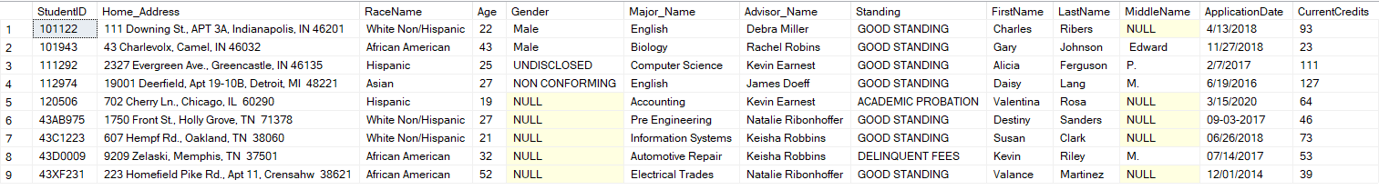  
Faculty Info:

(This query selects all the columns in the table [FACULTY_INFO]. The table is found in [Project4].[dbo] database)

Input: SELECT *

FROM [Project4].[dbo].[FACULTY_INFO]

Output:

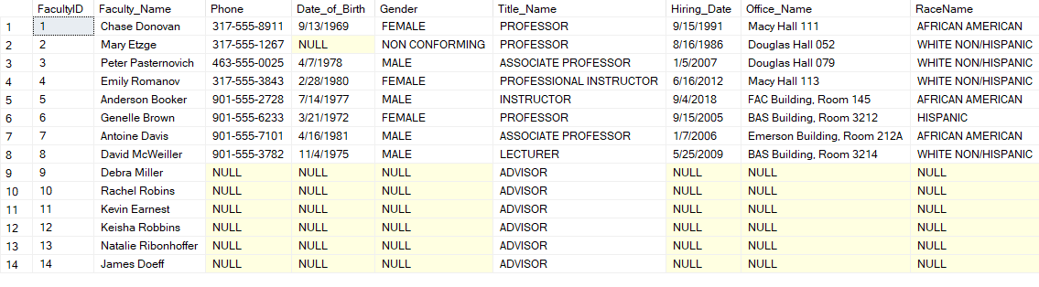

I can see the finish line, only one more project to go then we can all go to Applebees!

Contact me if you have any questions!

From,

Saanil Rao