Progress Report; Created SSMS Tables  
To: National Education Associates

We finally made it!

I added Raymond Johnson data into the database. Even though he was a Canadian student with a few different data types, it worked out. It helped that my data table were mainly made up from NVARCHAR(#), letting me able to put in any information. I also had all the tables I needed for this project. A lot of these contingencies came from the difficulties from Project 5. This help prepared me for Project 6.

The first query is used to show the student’s name, address, and courses he is currently taking. Details about the student was taken from STUDENT_INFO table. I used a left join table to grab the Course_Name from CourseDetails.I filter the Canadian student by only searching for Raymond on FirstName column.

select STUDENT_INFO.StudentID, STUDENT_INFO.FirstName,STUDENT_INFO.MiddleName, STUDENT_INFO.LastName ,STUDENT_INFO.Home_Address, CourseDetails.Course_ID, CourseDetails.Course_Name

from dbo.STUDENT_INFO

INNER JOIN dbo.CourseDetails on Student_ID=Student_ID

where FirstName='Raymond';

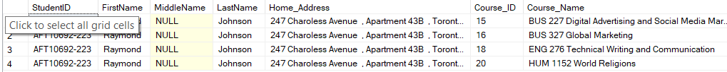

The second query is used to show the student’s name, major, course name, courseID, and grade. Details about the student was taken from STUDENT_INFO table.I used a left join table to grab the Course_Name from StudentID. I filter the Canadian student by only searching for Raymond on FirstName column and AFT10692-22 (his student ID number) on Student_ID.

select STUDENT_INFO.FirstName, MiddleName, LastName, Major_Name, CourseDetails.Course_Name,OfferedCoursesID, grade

from STUDENT_INFO

left join CourseDetails on Student_Info.StudentID=Student_Info.StudentID

where FirstName='Raymond'and Student_ID = 'AFT10692-223';

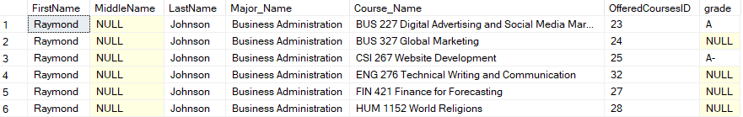

The third query can be used for both assignment c and d. It shows OfferedCoursesID, faculty name, course name, room number, department name, semesters offered, and class status. I used a left join table to grab class details like SemestersOffered by using the link from OfferedCoursesID. Since it is currently the ‘WINTER/SPRING’ season, I searched for class which offered ‘WINTER/SPRING’ classes. I created another SemestersOffered column and replaced any ‘WINTER/SPRING’ with ‘ACTIVE’. I made the column name ‘Status’. The reason is this decision is to show these classes are active. Since we already searched any classes during ‘WINTER/SPRING’, this means they are active.

select c.OfferedCoursesID, c.Faculty_Name, c.Course_Name, c.Room_Number, c.Department_Name, o.SemestersOffered, REPLACE(o.SemestersOffered, 'WINTER/SPRING', 'ACTIVE') 'Status'

from CourseDetails as c

left join OfferedCourses as o on c.OfferedCoursesID = o.OfferedCoursesID

where o.SemestersOffered = 'WINTER/SPRING'

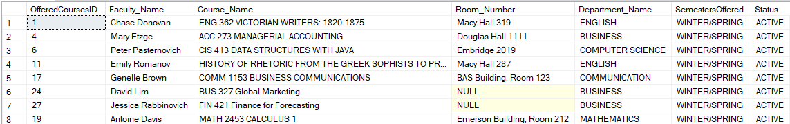

Looks like this is the end! This was quite a journey. This database will help sort through classes, students, and faculty. If you have any questions, don’t hestitate to ask! I’ll be glad to answer anything, even if it has been 50 years!

See you at Applebees!

From,

Saanil Rao