Progress Report; Created SSMS Tables  
To: National Education Associates

Hope you are having a great day!

I have finished making the tables in SSMS. I also connected the tables with relationships in SSMS. I used draw.io to make my sketch (photo down below). This will be the main backbone of the database. I had to separate many datasets into their own tables. And slowly combine them back together. All datasets are nvarchar(50), meaning it has a character length of 50. This will let different types of data be readable as it will allow numbers, letters, and symbols. This can easily be changed whenever needed. After creating the tables in SMSS, I then added the relationships between foreign keys. In the photos below, you will see all the primary and foreign key relationships. 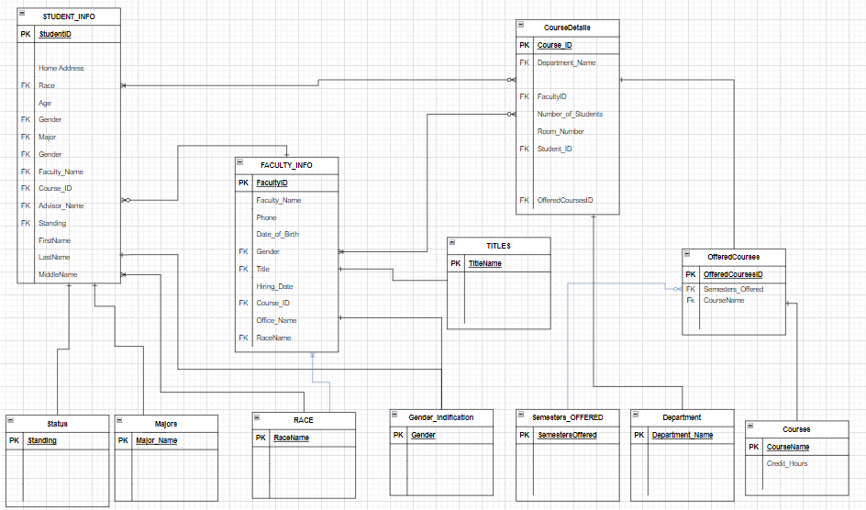

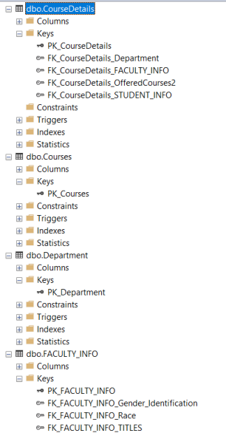 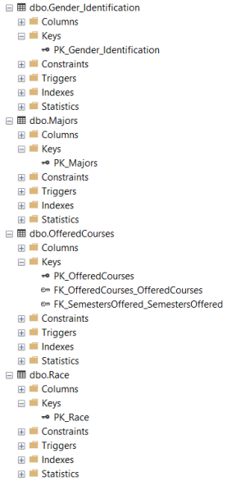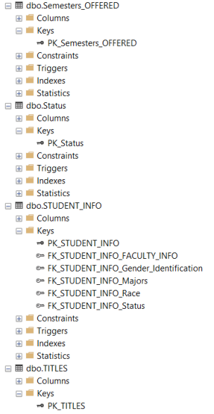

We are at the home stretch! I just have to add all the data into SSMS. I will most likely have to tweak the tables a bit, but the structure will stay the same. Thanks for your patience. If you have any questions, don’t hesitate to email me. I’ll be glad to answer anything you need.

From,

Saanil Rao