**Recitation11**

**1.**Consider the following tree:

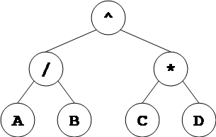

a. What is the in-order traversal of this tree?

b.   What is the pre-order traversal of this tree?

c.   What is the post-order traversal of this tree?

**2**.      Given the following traversals, construct the general binary tree.

Pre-order: **KXLAM**

In-order: **XLKMA**

Post-order: **LXMAK**

**3.**Binary Trees

a.  The height of a binary tree is the length of the longest root-to-leaf path in it. What is the maximum number of nodes in a binary tree of height h?

b.  The height of a binary tree is the length of the longest root-to-leaf path in it. The maximum and minimum number of nodes in a binary tree of height 5 are?

c. A full binary tree with n leaves contains how many nodes?

**4.**   
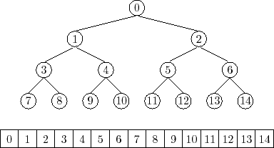

Given the above tree and its implementation using an array. Write down the methods to return the left child, the right child and the parent of a particular node with the given index.