1 - Go to phpmyadmin on localhost and click on new

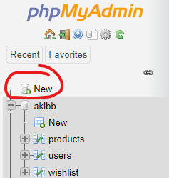

2- Then type db name “akibb” as shown in figure and then click on create

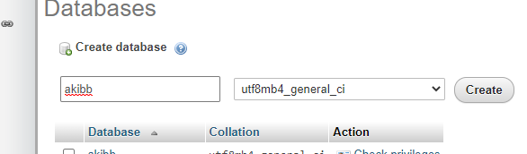

3- Now finally click on import and choose file and simple click on go.

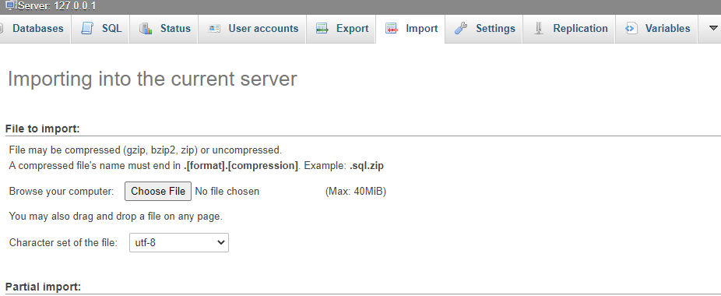

4 – You can find user and credentials in user table OR you create a new user from register page