DataBase Design

1. Tables name and purpose
We design 5 tables, show table's property an relation as below

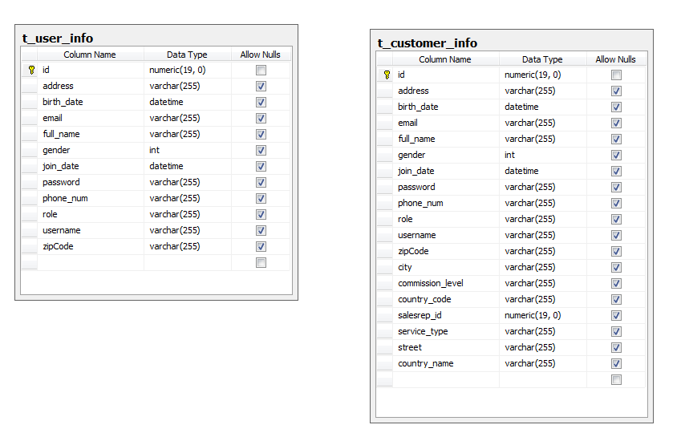

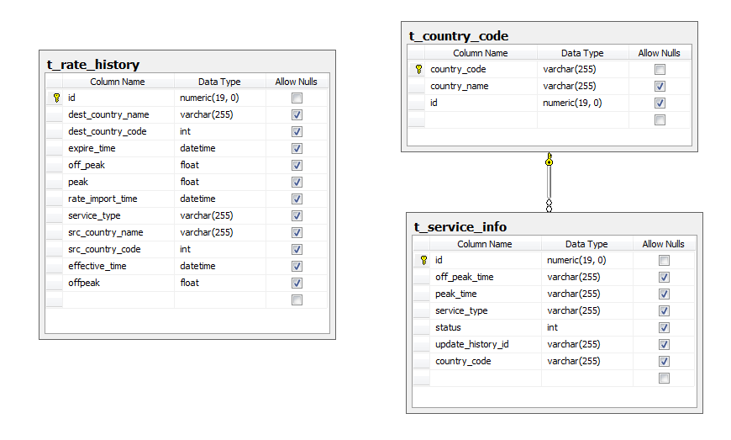

t_customer_info is for storing customer's info and corresponding sale representative
t_user_info is for storing user's(including administrator and sale representative) info
t_rate_history is for storing all rate rules imported from excel files.
t_country_code is for storing country name and country code mapping.
t_service_info is for storing service related info(peak_time, off_peak_time, etc)

2. Store Procedures
we make four store procedures.
1) update_rate : store rate rules imported by administrator
2) get_service_summary: get monthly all service traffic summary.
3) get_month_cost_detail : get monthly all customers phone bill
4) get_commission_detail : get monthly all sale representatives commission

/*test sp for update rates*/
Create PROC get_commission_detail
@start_date datetime,
@end_date datetime,
@Return_Message VARCHAR(1024) = '' OUT
AS
BEGIN
set nocount on

DECLARE @ErrorCode int
--DECLARE @ErrorStep varchar(200)
SELECT @ErrorCode = @@ERROR

begin try
truncate table t_month_commission_detail;
--create a temporaty table to store t_customer_info join t_call_detail result
create table #t_month_commission_temp_1
(
id int identity(1,1),
full_name varchar(60) ,
service_type varchar(40) ,
salesrep_id int ,
commission_level float,
src_phone_num varchar(50) ,
dest_phone_num varchar(50) ,
src_country_code int ,
dest_country_code int ,
duration int ,
call_date datetime ,
call_time smallint
)

Insert into #t_month_commission_temp_1
SELECT t.full_name, t.service_type, t.salesrep_id, CONVERT(float, t.commission_level) as commission_level,
s.src_phone_num, s.dest_phone_num, s.src_country_code,
s.dest_country_code, s.duration, s.call_date, s.call_time
FROM t_customer_info t
right JOIN t_call_detail s ON t.phone_num = s.src_phone_num
--where s.call_date between '11/01/2013' and '11/30/2013'
where s.call_date between @start_date and @end_date

create table #t_month_commission_temp_2
(
id int identity(1,1),
customer_full_name varchar(60) ,
salesrep_id int,
salesrep_name varchar(60) ,
commission_level float,
src_phone_num varchar(50) ,
dest_phone_num varchar(50) ,
service_type varchar(40) ,
src_country_code int ,
src_country_name varchar(50),
dest_country_code int ,
dest_country_name varchar(50) ,
duration int ,
call_date datetime ,
call_time smallint ,
off_peak_time smallint ,
peak_time smallint ,
peak float ,
off_peak float ,
cost float ,
commission as cost * commission_level
)

--drop table #t_month_commission_temp_2
--select * from #t_month_commission_temp_2

--#t_month_call_temp join
Insert into #t_month_commission_temp_2
SELECT t.full_name as customer_full_name, t.salesrep_id, u.full_name as salesrep_name,
t.commission_level, t.src_phone_num, t.dest_phone_num, t.service_type, t.src_country_code, r.src_country_name,
t.dest_country_code, r.dest_country_name, t.duration,
t.call_date, t.call_time, CONVERT(smallint, s.off_peak_time) as off_peak_time,
CONVERT(smallint,s.peak_time) as peak_time, r.peak, r.off_peak,
case
--peak cost calculation
when t.call_time >= peak_time and t.call_time <= off_peak_time
then round(cast(t.duration as float) /60 * peak, 2)
else
round(cast(t.duration as float) / 60 * off_peak, 2)
end as cost

FROM #t_month_commission_temp_1 t
join t_service_info s on t.src_country_code = s.country_code and
t.service_type = s.service_type
join t_rate_history r on t.src_country_code = r.src_country_code
and t.service_type = r.service_type and t.dest_country_code = r.dest_country_code
and (t.call_date between r.effective_time and r.expire_time)
join t_user_info u on t.salesrep_id = u.id

--import commission table
insert into t_month_commission_detail( salesrep_id, salesrep_name,
commission_level)
select salesrep_id, salesrep_name, sum(commission)
from #t_month_commission_temp_2
group by salesrep_id,salesrep_name

--for hibernate, return a reslut set
select top 2 * from t_month_commission_detail ;
end try

BEGIN CATCH
-- Get the Error Message for @@Error
SELECT @ErrorCode = ERROR_NUMBER()
-- , @Return_Message = @ErrorStep + ' '
, @Return_Message = ' '
+ cast(ERROR_NUMBER() as varchar(20)) + ' line: '
+ cast(ERROR_LINE() as varchar(20)) + ' '
+ ERROR_MESSAGE() + ' > '
+ ERROR_PROCEDURE()

RETURN @ErrorCode -- =0 if success, <>0 if failure
END CATCH
end

/*test sp for bill calculation*/
Create PROC get_month_cost_detail
@start_date datetime,
@end_date datetime,
@Return_Message VARCHAR(1024) = '' OUT
AS
BEGIN
set nocount on

DECLARE @ErrorCode int
--DECLARE @ErrorStep varchar(200)
SELECT @ErrorCode = @@ERROR

begin try
truncate table t_month_call_detail;
--create a temporaty table to store t_customer_info join t_call_detail result
--drop table #t_month_call_temp
create table #t_month_call_temp
(
id int identity(1,1),
full_name varchar(60) ,
service_type varchar(40) ,
src_phone_num varchar(50) ,
dest_phone_num varchar(50) ,
src_country_code int ,
dest_country_code int ,
duration int ,
call_date datetime ,
call_time smallint
)

Insert into #t_month_call_temp
SELECT t.full_name, t.service_type, s.src_phone_num, s.dest_phone_num, s.src_country_code,
s.dest_country_code, s.duration, s.call_date, s.call_time
FROM t_customer_info t
right JOIN t_call_detail s ON t.phone_num = s.src_phone_num
--where s.call_date between '11/01/2013' and '11/30/2013'
where s.call_date between @start_date and @end_date

--#t_month_call_temp join
Insert into t_month_call_detail(full_name, src_phone_num, dest_phone_num, service_type,
src_country_code, src_country_name, dest_country_code, dest_country_name, duration,
call_date, call_time, off_peak_time, peak_time, peak,off_peak, cost)
SELECT t.full_name, t.src_phone_num, t.dest_phone_num, t.service_type, t.src_country_code,
r.src_country_name,
t.dest_country_code, r.dest_country_name, t.duration,
t.call_date, t.call_time, CONVERT(smallint, s.off_peak_time) as off_peak_time,
CONVERT(smallint,s.peak_time) as peak_time, r.peak, r.off_peak,
case
--peak cost calculation
when t.call_time >= peak_time and t.call_time <= off_peak_time
then round(cast(t.duration as float) /60 * peak, 2)
else
round(cast(t.duration as float) / 60 * off_peak, 2)
end as cost

FROM #t_month_call_temp t
left join t_service_info s on t.src_country_code = s.country_code and
t.service_type = s.service_type
left join t_rate_history r on t.src_country_code = r.src_country_code
and t.service_type = r.service_type and t.dest_country_code = r.dest_country_code
and (t.call_date between r.effective_time and r.expire_time)

--for hibernate, return a reslut set
select top 2 * from t_month_call_detail ;
end try

BEGIN CATCH
-- Get the Error Message for @@Error
SELECT @ErrorCode = ERROR_NUMBER()
-- , @Return_Message = @ErrorStep + ' '
, @Return_Message = ' '
+ cast(ERROR_NUMBER() as varchar(20)) + ' line: '
+ cast(ERROR_LINE() as varchar(20)) + ' '
+ ERROR_MESSAGE() + ' > '
+ ERROR_PROCEDURE()

RETURN @ErrorCode -- =0 if success, <>0 if failure
END CATCH
end

-- service traffic summary
Create PROC get_service_summary
@start_date datetime,
@end_date datetime,
@Return_Message VARCHAR(1024) = '' OUT
AS
BEGIN
set nocount on

DECLARE @ErrorCode int
SELECT @ErrorCode = @@ERROR

begin try

--create a temporaty table to store t_customer_info join t_call_detail result
create table #t_month_service_temp
(
id int identity(1,1),
src_country_code int ,
dest_country_code int ,
service_type varchar(40) ,
duration int
)

Insert into #t_month_service_temp
SELECT s.src_country_code, s.dest_country_code, t.service_type, s.duration
FROM t_customer_info t
JOIN t_call_detail s ON t.phone_num = s.src_phone_num
--where s.call_date between '12/01/2013' and '12/31/2013'
where s.call_date between @start_date and @end_date

--##t_month_service_temp join t_country_code to map country_name
create table #t_month_service_1
(
id int identity(1,1),
src_country_code int not null,
src_country_name varchar(50) not null,
dest_country_code int not null,
service_type varchar(40) not null,
duration int not null
)
Insert into #t_month_service_1
SELECT c.country_code as src_country_code, c.country_name as src_country_name, m.dest_country_code,
m.service_type, m.duration
FROM t_country_code c
join #t_month_service_temp m on c.country_code = m.src_country_code

--sum duration for specific service and country name
Insert into t_month_service_summary(src_country_code, src_country_name, dest_country_code,
dest_country_name, service_type, sum_duration)
SELECT m.src_country_code, m.src_country_name, m.dest_country_code, c.country_name as dest_country_name,
m.service_type, sum(duration) as sum_duration
FROM t_country_code c
join #t_month_service_1 m on c.country_code = m.dest_country_code
group by m.src_country_code, m.src_country_name, m.dest_country_code, c.country_name, m.service_type

--for hibernate, return a reslut set
select top 2 * from t_month_service_summary ;
end try

BEGIN CATCH
-- Get the Error Message for @@Error
SELECT @ErrorCode = ERROR_NUMBER()
-- , @Return_Message = @ErrorStep + ' '
, @Return_Message = ' '
+ cast(ERROR_NUMBER() as varchar(20)) + ' line: '
+ cast(ERROR_LINE() as varchar(20)) + ' '
+ ERROR_MESSAGE() + ' > '
+ ERROR_PROCEDURE()

RETURN @ErrorCode -- =0 if success, <>0 if failure
END CATCH
end

/*test sp for commission calculation*/
Create PROC update_rate
@Return_Message VARCHAR(1024) = '' OUT
AS
BEGIN
set nocount on
--count t_rate_history records
declare @count as int
declare @count_temp as int
SELECT @count = COUNT(1) FROM t_rate_history;
SELECT @count_temp = COUNT(1) FROM t_rate_history_temp;
if(@count_temp = 0)
begin
select @Return_Message = 'no records in t_rate_history_temp'
--return;
end

declare @i as int
declare @src_country_code as int
declare @src_country_name as varchar(100)
declare @dest_country_code as int
declare @dest_country_name as varchar(100)
declare @service_type as varchar(50)
declare @peak as float
declare @off_peak as float
declare @effective_time as datetime

DECLARE @ErrorCode int
--DECLARE @ErrorStep varchar(200)

SELECT @ErrorCode = @@ERROR

--if count == 0, insert all records into t_rate_history
begin try
begin tran
if(@count = 0)
begin
set @i = 1;
while(@i <= @count_temp)
begin
/*INSERT INTO t_rate_history(src_country, dest_country, sevice_type, peak, off_peak,effective_time)
SELECT src_country, dest_country, sevice_type, peak, off_peak,effective_time
FROM t_rate_history_temp;
*/
--look up src country code from src country name
--look up des country name from dest country code
select @src_country_name = src_country_name,@dest_country_code = dest_country_code, @service_type = service_type,
@peak = peak, @off_peak = off_peak, @effective_time = effective_time
from t_rate_history_temp WHERE id = @i;

select @src_country_code = country_code from t_country_code where country_name = @src_country_name;
select @dest_country_name = country_name from t_country_code where country_code = @dest_country_code;

--insert new rate
insert into t_rate_history(src_country_code, src_country_name,dest_country_code, dest_country_name,
service_type, peak, off_peak,effective_time)
values (@src_country_code, @src_country_name, @dest_country_code, @dest_country_name, @service_type, @peak, @off_peak, @effective_time);

set @i = @i + 1;
end
end

/*update the record which has the same values of src_country, dest_country, sevice_type
as the record in t_rate_history_temp, using transaction*/
else
begin
set @i = 1;
while(@i <= @count_temp)
begin

--look up src country code from src country name
--look up des country name from dest country code
select @src_country_name = src_country_name,@dest_country_code = dest_country_code, @service_type = service_type,
@peak = peak, @off_peak = off_peak, @effective_time = effective_time
from t_rate_history_temp WHERE id = @i;

select @src_country_code = country_code from t_country_code where country_name = @src_country_name;
select @dest_country_name = country_name from t_country_code where country_code = @dest_country_code;

--update same service between same src and dest country
update t_rate_history set expire_time = @effective_time where src_country_code = @src_country_code and
dest_country_code = @dest_country_code and service_type = @service_type;

--insert new rate
insert into t_rate_history(src_country_code, src_country_name,dest_country_code, dest_country_name,
service_type, peak, off_peak,effective_time)
values (@src_country_code, @src_country_name, @dest_country_code, @dest_country_name, @service_type, @peak, @off_peak, @effective_time);

set @i = @i + 1;
end
end
--delete records in t_rate_history_temp
truncate table t_rate_history_temp;

commit tran
select top 2 * from t_rate_history ;
end try

BEGIN CATCH
-- Get the Error Message for @@Error
IF @@TRANCOUNT > 0 ROLLBACK

SELECT @ErrorCode = ERROR_NUMBER()
-- , @Return_Message = @ErrorStep + ' '
, @Return_Message = ' '
+ cast(ERROR_NUMBER() as varchar(20)) + ' line: '
+ cast(ERROR_LINE() as varchar(20)) + ' '
+ ERROR_MESSAGE() + ' > '
+ ERROR_PROCEDURE()

RETURN @ErrorCode -- =0 if success, <>0 if failure

END CATCH

end

