# PSEC CA2 SPAM Documentation

**Loh Kar Wei P1904204 DISM1B/02**

## Pre-requisites

* Kivy module
* python -m pip install --upgrade pip wheel setuptools
* python -m pip install docutils pygments pypiwin32 kivy.deps.sdl2 kivy.deps.glew
* python -m pip install kivy.deps.gstreamer
* python -m pip install kivy
* asyncio module
* pip install asyncio
* sqlite3 module
* pip install sqlite3
* shlex module
* pip install shlex
* pickle module
* pip install pickle

## Basic Usage

* Run “server.py” under server dir to start the server
* Run “python server.py”
* Run “main.py” under client dir to start the entire application
* You do not need to touch anything else

## Maintenance or Modification of Database

* Head into the server directory and run “admin.py” to modify or view database data like logs, food, promos etc.

## Advanced Features

|  |  |
| --- | --- |
| **Advanced Features** | **Description** |
| Full GUI for Client-side | Built using the kivy module and kivy language together with python, clients have a full GUI interface to interact with when placing orders through spam  Run “main.py” to start the application |
| Server runs asynchronously | Server code is programmed to run asynchronously using the asyncio module to increase efficiency when dealing with client requests as the server is able to use multiple threads  Images are also sent to client through bytes and placed into the client’s “images/” folder |
| All food data is stored in an SQLITE3 database on the server-side | All food/promo data is stored in an Sqlite3 database titled “spam.db” located in the server folder.  Data is fetched from the database and then sent to the client through the socket connection.  You can download the SQLite extension for VSCode to view the database in vscode (see appendix A) OR download DB browser for SQLite to view/modify the database file (see appendix B) |
| Admin Menu for admins to interact with the database and modify server data | Admins can just run “admin.py” in the server folder to start an admin terminal interface to add/del food, modify promos or view logs |
| Logging of purchases | All purchases on the client side are sent to the server to be logged into the database  Logged details include datetime, total items and total costs |
| There’s probably more but I lost track 😊 |  |

## Appendix A

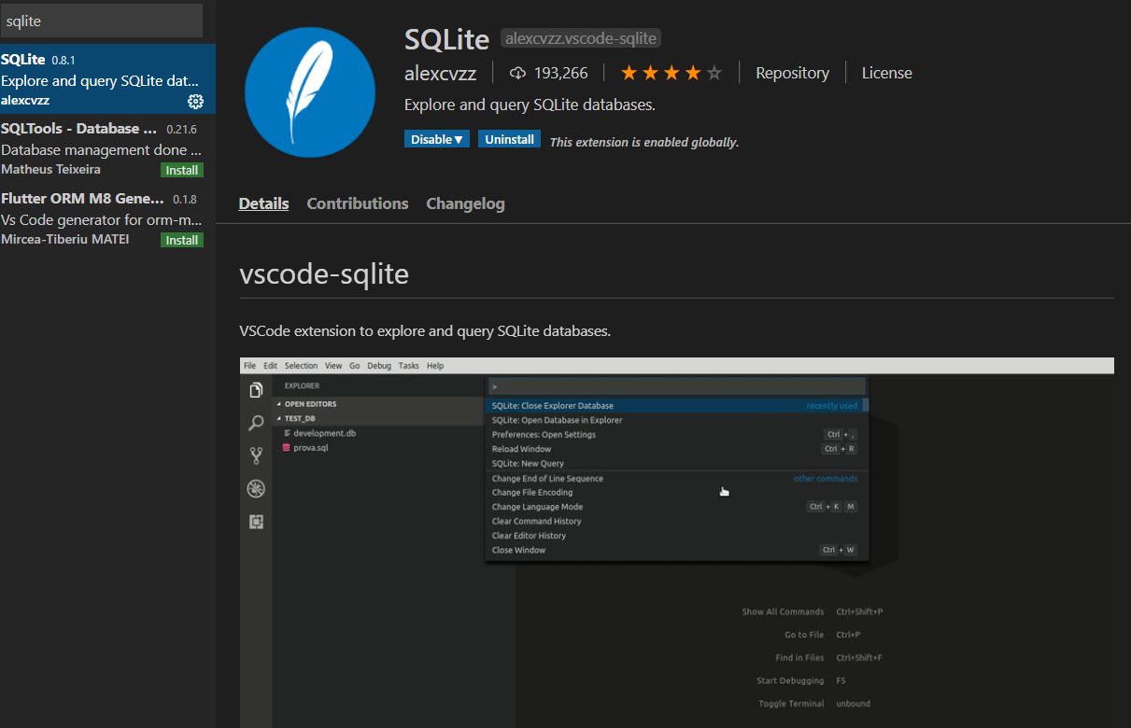

## Appendix B

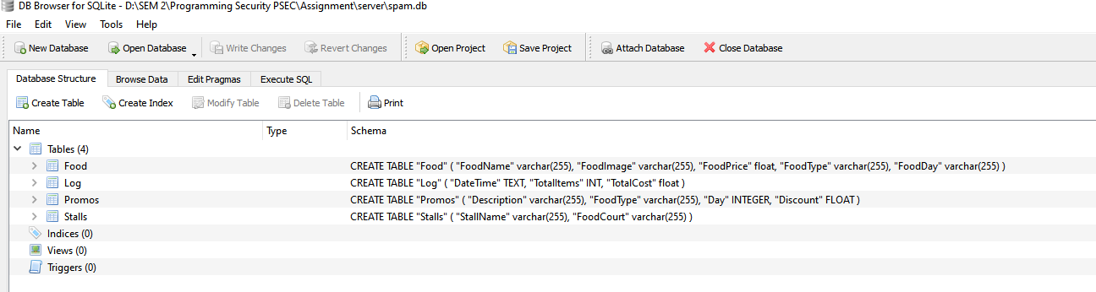

<https://sqlitebrowser.org/>