# **BED Assignment 02 Documentation**

## Team Overview

Class: **DISM/FT/2A/02**

Members:

1. Loh Kar Wei 1904204
2. Jess Kwek 1928934

## Requirements

* Located in package.json file

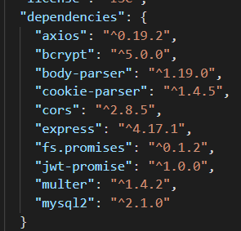

## Setting Up

1. Install the required node modules specified in package.json file
   1. Npm install
2. Run setup.sql included in the file to setup and populate the database
   1. BED_Assignment_02.sql
3. Go into db.js to change the configurations for username and password for database

## Test Accounts

Test accounts that comes with the .sql file for test uses

|  |  |  |
| --- | --- | --- |
| **Email** | **Password** | **Role** |
| admin@email.com | admin | Admin |
| bruh@email.com | bruh | User |
| test@email.com | test | User |

## Bonus features

* Use of asynchronous programming
* Selective filtering of travel listings (remove assumption that all fields are filled)
* Reviews Features
* (jess add more)

## Contributions

|  |  |
| --- | --- |
| **Jess Kwek** | * Persistent login * Checking for access rights * Admin user functionality (add/update listing details) * (add your bonus features) |
| **Loh Kar Wei** | * Frontend GUI Design * Selective search/filter travel listing **(Bonus feature)** * Normal user functionality (viewing listing details) * Review/post reviews by user **(Bonus Feature)** |