**SAMPLES FROM PLATE 1**

PCA WITH SAMPLES COLOURED BASED ON THE COMBINATION OF VARIETY, N LEVEL, STAGE/TIME AND TECHINCAL REPLICATE (“run”)

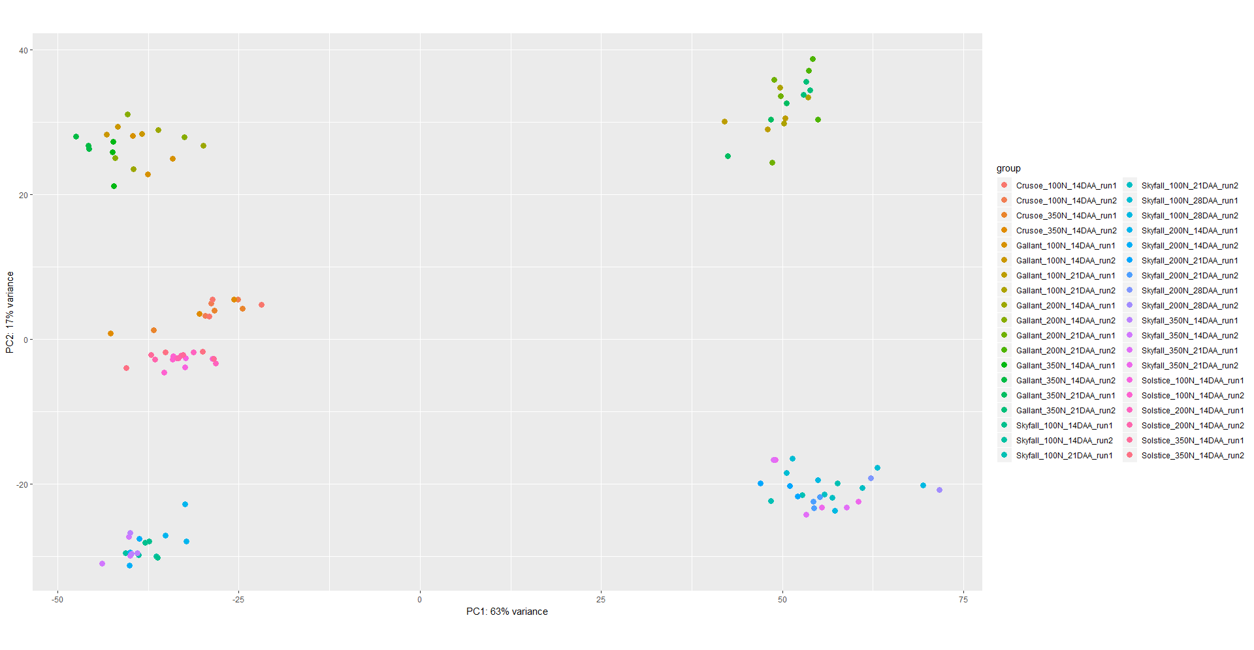

PCA WITH SAMPLES COLOURED BASED ON STAGE/TIME

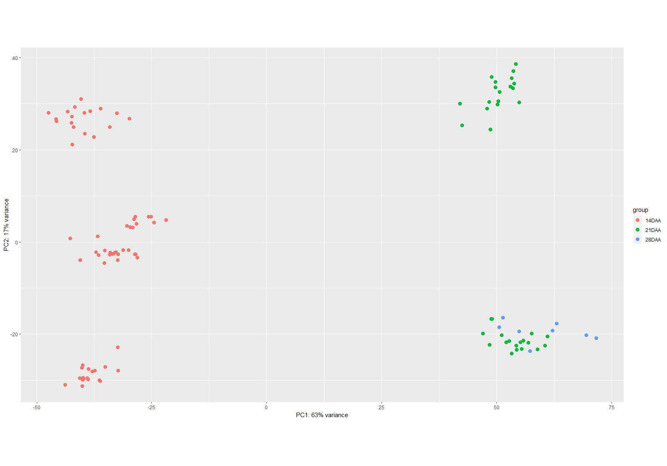

PCA WITH SAMPLES COLOURED BASED ON VARIETY/GENOTYPE

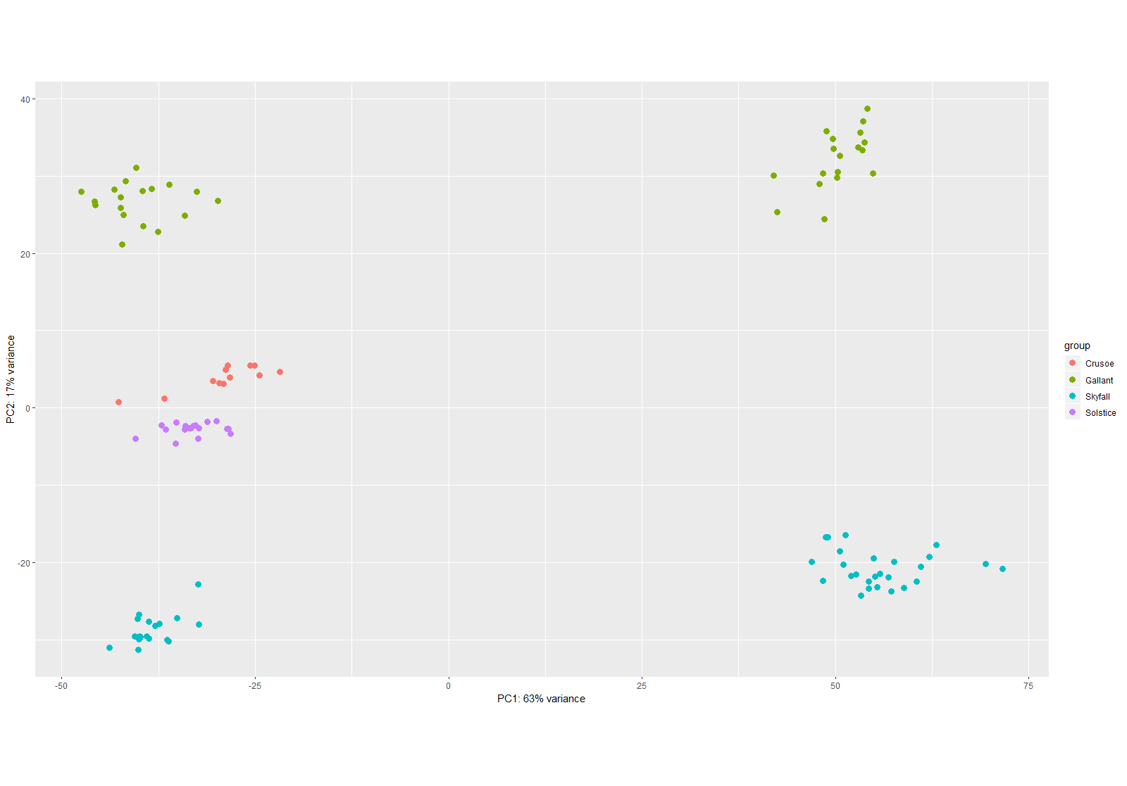

PCA WITH SAMPLES COLOURED BASED ON N LEVEL

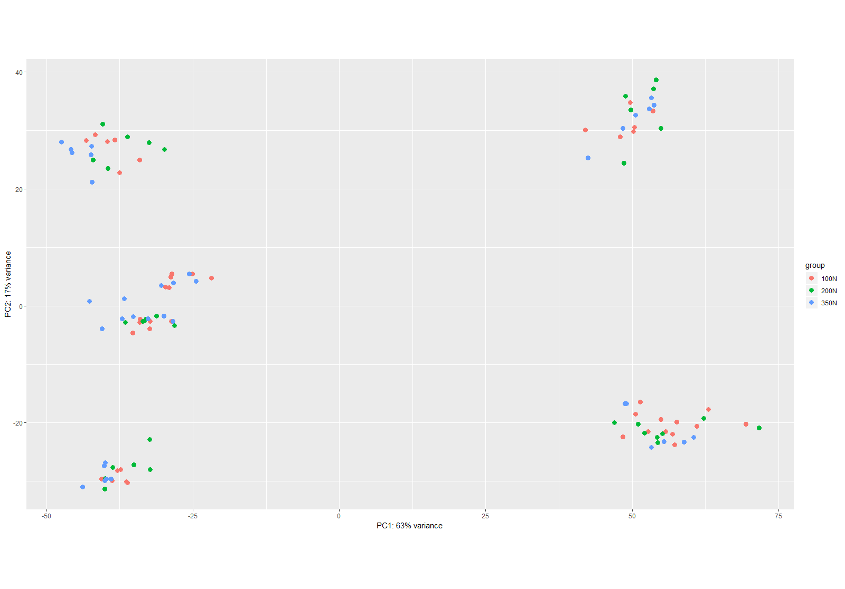

PCA WITH SAMPLES COLOURED BASED ON THE TECHINCAL REPLICATE (“run”)

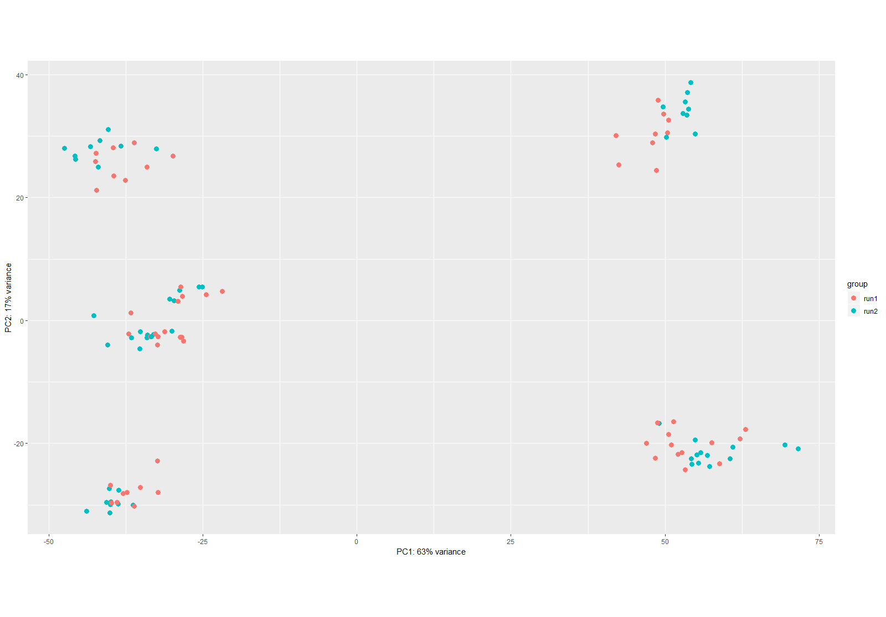

**ALL SAMPLES WITH TECHNICAL REPS**

PCA WITH SAMPLES COLOURED BASED ON THE COMBINATION OF VARIETY, N LEVEL, STAGE/TIME AND TECHINCAL REPLICATE (“run”)

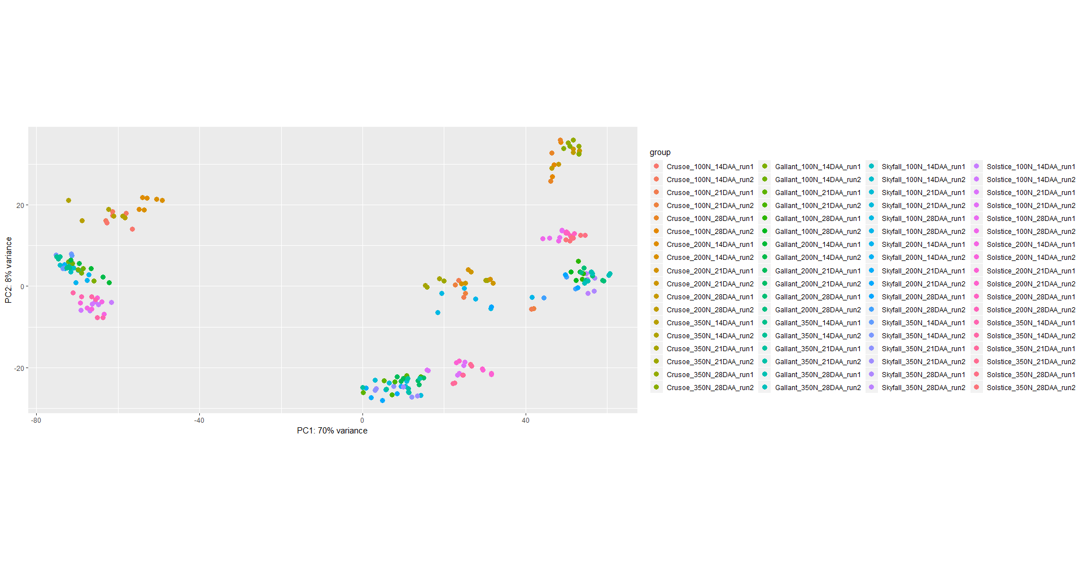  

**ALL SAMPLES AFTER MERGING TECHNICAL REPS**

PCA WITH SAMPLES COLOURED BASED ON THE COMBINATION OF VARIETY, N LEVEL AND STAGE/TIME

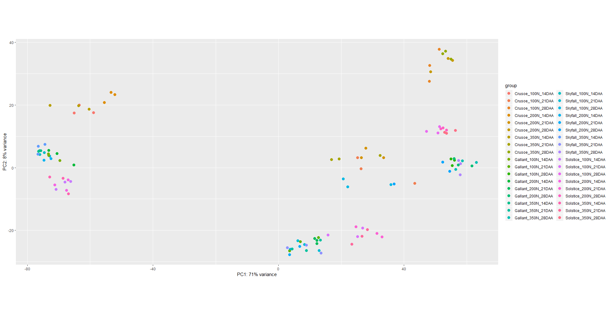

PCA WITH SAMPLES COLOURED BASED ON STAGE/TIME

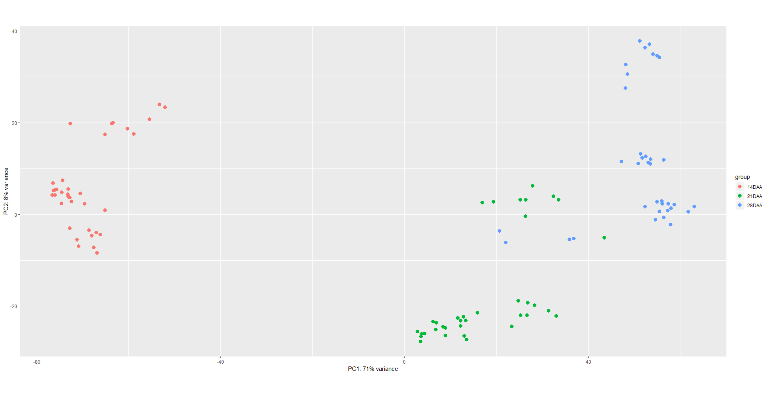

PCA WITH SAMPLES COLOURED BASED ON VARIETY/GENOTYPE

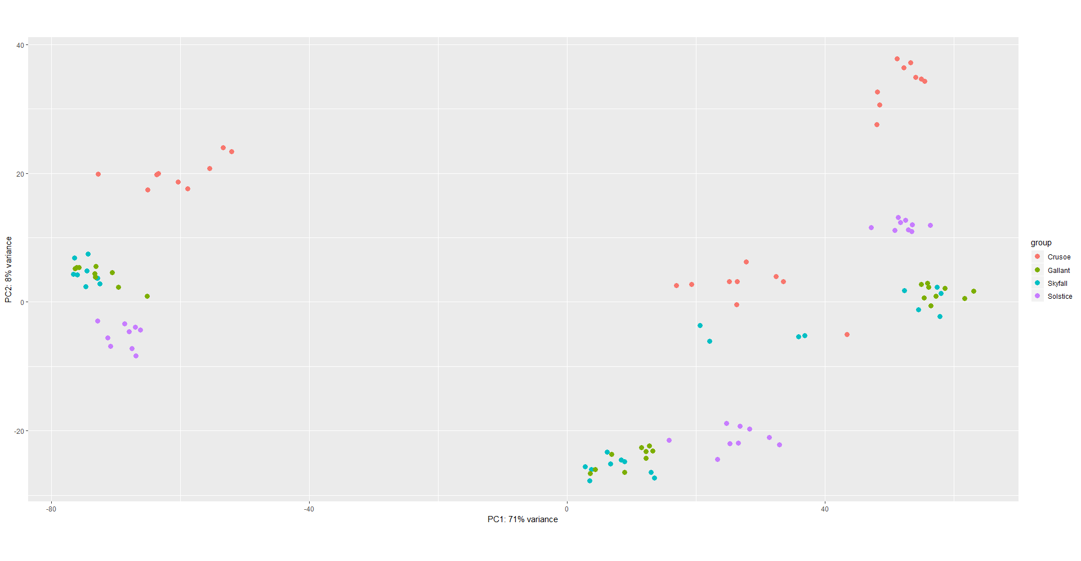

PCA WITH SAMPLES COLOURED BASED ON N LEVEL

