**Deep learning**

**Assignment 5 Report**

**Asif Ejaz -MSDS19010**

4/25/2020

**GitHub** link <https://github.com/Asif-Ejaz/MSDS19010_COVID19_DLSpring2020/>

**Task-1**

I have run 6 experiments for this task. I run both Vgg16 and Resnet18 for three different learning rates and constantly 10 number of epochs for each experiment.

**Model 1- Vgg16**

**Parameters FC layers**

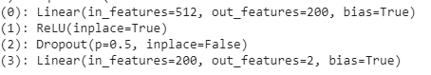

**Epochs = 10**

**Three different learning rates**

**1. 0.001 (best learning rate)**

Epoch 10/10,train ==> Loss: 0.3439 , Acc: 91.67 %

Epoch 10/10,valid ==> Loss: 0.3350 , Acc: 91.80 %

Best Validation Accuracy: 91.933333 %

Testing accuracy : 97 %

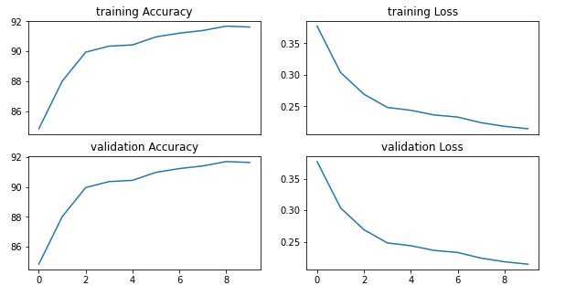

**2. 0.0001**

Epoch 10/30,train ==> Loss: 0.3078 , Acc: 9.27 %

Epoch 10/30,valid ==> Loss: 0.3105 , Acc: 90.00 %

Best Validation Accuracy: 89.33333 %

Testing accuracy : 94 %

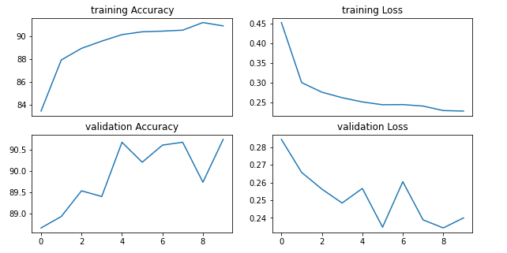

**3. 0.00001**

Epoch 10/10,train ==> Loss: 0.3236 , Acc: 86.72 %

Epoch 10/10,val ==> Loss: 0.2898 , Acc: 88.53 %

Best Validation Accuracy: 88.533333 %

Testing accuracy : 94 %

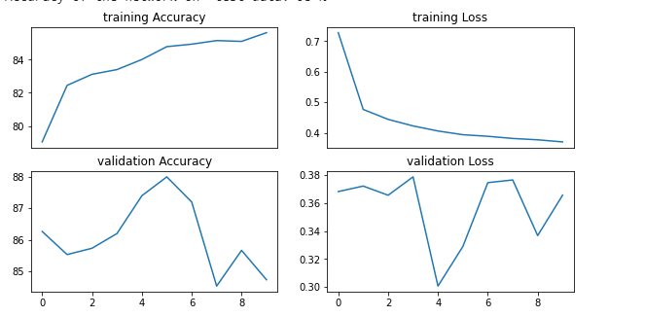

**Model 2- Resnet18**

**Parameters FC layers**



**Epochs = 10**

**Three different learning rates**

**1. 0.001 (best learning rate)**

Epoch 10/10,train ==> Loss: 0.3639 , Acc: 84.67 %

Epoch 10/10,valid ==> Loss: 0.3550 , Acc: 84.80 %

Best Validation Accuracy: 84.933333 %

Testing accuracy : 92 %

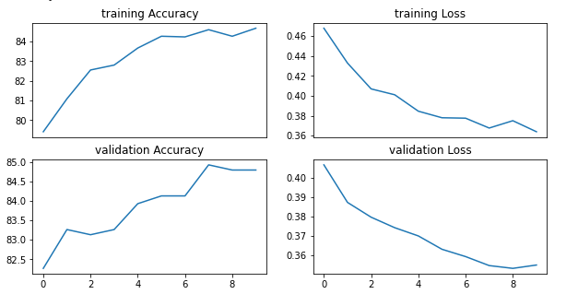

**2. 0.0001**

Epoch 10/10,train ==> Loss: 0.4944 , Acc: 78.21 %

Epoch 10/10,valid ==> Loss: 0.4535 , Acc: 79.73 %

Testing accuracy : 87 %

Best Validation Accuracy: 79.733333 %

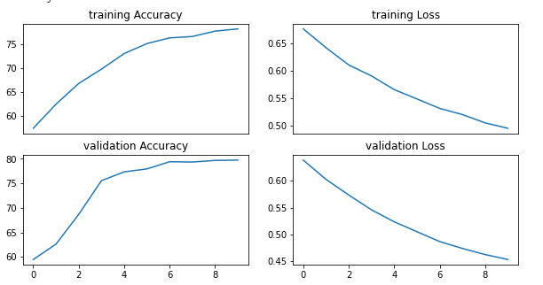

**3. 0.00001**

Epoch 10/10,train ==> Loss: 0.6529 , Acc: 60.92 %

Epoch 10/10,valid ==> Loss: 0.6196 , Acc: 61.07 %

Best Validation Accuracy: 61.066667 %

Testing accuracy : 61 %

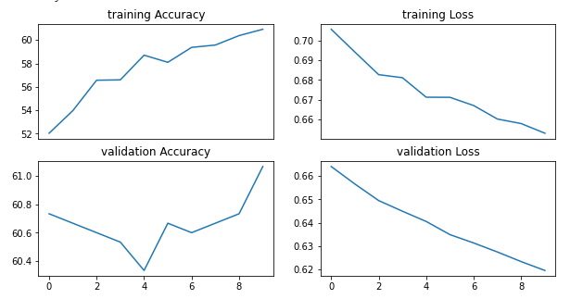

**Task-2**

**Model 1. Vgg16**

In this task learning rate (0.0001) and epochs are constant while tune able parameters varies.

**1. Parameters last 1 CONV layers + FC layers**

features.28.weight

features.28.bias

classifier.0.weight

classifier.0.bias

classifier.3.weight

classifier.3.bias

Epoch 10/10,train ==> Loss: 0.2741 , Acc: 88.95 %

Epoch 10/10,val ==> Loss: 0.2691 , Acc: 88.80 %

Best Validation Accuracy: 89.666667 %

Testing accuracy : 95 %

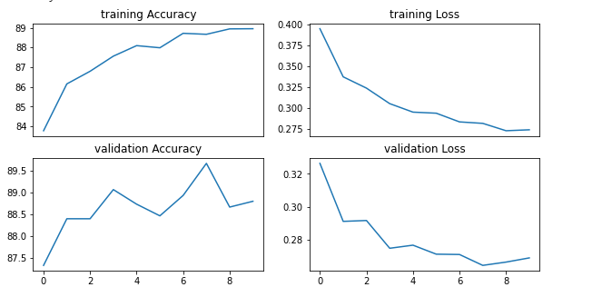

**2. Parameters last 3 CONV layers + FC layers**

Epoch 10/10,train ==> Loss: 0.2093 , Acc: 90.97 %

Epoch 10/10,valid ==> Loss: 0.2034 , Acc: 90.73 %

Best Validation Accuracy: 89.733333 %

Testing accuracy : 96 %



1. **Parameters : All parameters**

Epoch 10/10,train ==> Loss: 0.2093 , Acc: 91.97 %

Epoch 10/10,valid ==> Loss: 0.2034 , Acc: 91.73 %

Best Validation Accuracy: 91.733333 %

Testing accuracy : 96 %

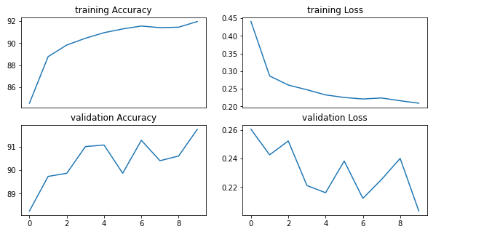

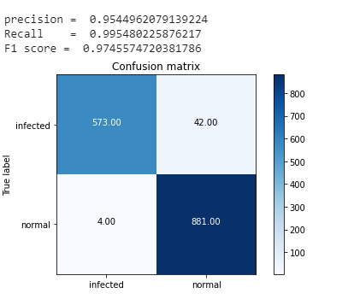

**Model 2. Resnet18**

1. **Parameters (Layer 4+ FC layers)**

Epoch 10/10,train ==> Loss: 0.6462 , Acc: 61.72 %

Epoch 10/10,val ==> Loss: 0.6202 , Acc: 61.67 %

Best Validation Accuracy: 61.666667 %

Testing accuracy : 61 %

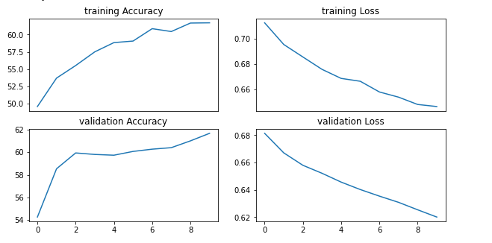

1. **Parameters (Layer 3, 4+ FC layers)**

Epoch 10/10,train ==> Loss: 0.6179 , Acc: 66.61 %

Epoch 10/10,valid ==> Loss: 0.5955 , Acc: 64.60 %

Best Validation Accuracy: 64.600000 %

Testing accuracy : 67 %

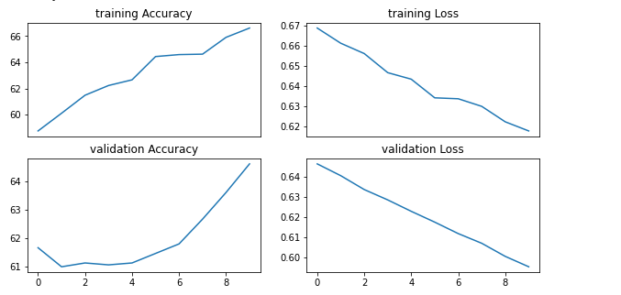

1. **Parameters (All layers)**

Epoch 10/10,train ==> Loss: 0.6177 , Acc: 65.78 %

Epoch 10/10,val ==> Loss: 0.5842 , Acc: 67.87 %

Best Validation Accuracy: 67.866667 %

Testing accuracy : 67 %

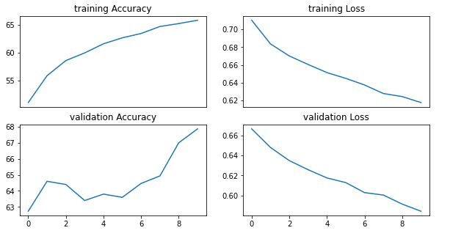

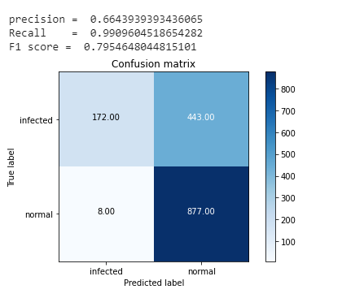

**Comparison**

**Accuracies and F1 Score**

|  |  |
| --- | --- |
| **VGG16** | **ResNet18** |
| **Only 2 FC Layer** | |
| |  |  |  | | --- | --- | --- | | **LR** | **validation** | **test** | | 0.001 | 91 | 97 | | 0.0001 | 89 | 94 | | 0.00001 | 88 | 94 | | |  |  |  | | --- | --- | --- | | **LR** | **validation** | **test** | | 0.001 | 84 | 92 | | 0.0001 | 87 | 79 | | 0.00001 | 61 | 61 | |
| **One last layer + FC layer** | |
| **Train =** 88  **Test =** 89  **Valid =** 95 | **Train =** 61  **Test =** 61  **Valid =** 61 |
| **All layers** |  |
| **Train =** 91  **Test =** 91  **Valid =** 96 | **Train =** 67  **Test =** 67  **Valid =** 67 |
| **F1 score** | |
| 0.97 | 0.80 |

**Discussion :**

VGG gives more accuracy than Resnet but it requires more training time than Resnet. It is costly in terms of parameters so it provides that much high accuracy easily.

Resnet requires less training time than VGG but due to less parameters it is not able to provide that high accuracy in comparison to vgg. But setting optimal parameters like learning rate we can tune this to work better