JAMAN AGRO
Tea Factory Management System
User Manual
How to use every screen, menu and field
For the factory manager, the owner and the system administrator
Version 1.1 · October 2026
Contents
About this manual 5
Who should read what 5
How this manual is written 5
1. Introduction 6
1.1 What the system does 6
1.2 Who uses the system 6
1.3 Ideas used throughout the system 7
2. Getting started 9
2.1 Opening the system 9
2.2 Signing in 10
2.3 The screen layout 11
2.4 Bangla or English 12
2.5 Using the system on a phone 12
2.6 Things that work the same everywhere 14
3. The dashboard 15
4. The daily, weekly and monthly routine 17
4.1 Before the first day: the go-live checklist 17
4.2 Every day 18
4.3 Every week 18
4.4 Every month 19
5. Suppliers 20
5.1 The supplier list 20
5.2 Adding a supplier 21
5.3 Changing or switching off a supplier 22
5.4 The supplier statement 22
6. Green leaf intake 25
6.1 The day page 25
6.2 Setting the day’s leaf rates 26
6.3 Recording a delivery 27
6.4 The weighing slip 30
6.5 Correcting or deleting a delivery 31
6.6 Factory vehicles 31
7. Supplier payments and advances 33
7.1 The payment list 33
7.2 Recording a payment or advance 33
7.3 Correcting or deleting a payment 35
8. Production 36
8.1 The month page 36
8.2 Recording a batch 36
8.3 Correcting or deleting a batch 38
9. Made tea stock and tea grades 39
9.1 The stock page 39
9.2 Adjusting stock 40
9.3 Tea grades 41
10. Auction sales 43
10.1 The life of an invoice 43
10.2 The invoice list 44
10.3 Packing a new invoice 44
10.4 Recording dispatch, the auction result and payment 46
10.5 Deleting an invoice 48
10.6 Brokers 48
10.7 Warehouses 49
11. Retail sales and customers 51
11.1 Customers 51
11.2 Writing a sale memo 52
11.3 The sale memo 53
11.4 Cancelling a sale 54
11.5 The sales list and the customer statement 55
11.6 Receiving money from a customer 56
12. Expenses 58
12.1 The month page 59
12.2 Recording an expense 60
12.3 Expense categories 61
13. Workers and wages 64
13.1 Workers 64
13.2 Attendance 66
13.3 Contract work 67
13.4 Job rates 67
13.5 Wages: the pay sheet 68
14. The cash book 71
15. Reports 73
15.1 The summary boxes 74
15.2 The charts 74
15.3 The month-by-month table 74
16. Locked entries and the “edited” mark 75
16.1 The three-day rule 75
16.2 Asking for an entry to be unlocked 76
16.3 The “edited” mark 76
17. Administration (administrator only) 78
17.1 Users 78
17.2 The activity log 80
17.3 Unlock requests 81
18. Your own settings 83
18.1 Profile 83
18.2 Security: changing your password 84
18.3 Appearance 85
19. Rules the system enforces, and messages you may see 86
20. Frequently asked questions 88
Appendix A. Who can use which screen 90
Appendix B. Menu names in English and Bangla 91
Common buttons 92
Appendix C. Glossary 93
Appendix D. Quick reference card 95

About this manual
This manual explains how to use the Jaman Agro tea factory management system: what every menu does, what every field on every form means, and what to do day by day. It is written for the people who will use the system at the factory. You do not need any computer knowledge beyond using a web browser.

Who should read what
If you are… | Read these chapters first | Then, when needed
The factory manager (enters the daily work) | 1–4, then 5–13 and 16 | Chapters 14–20 as needed
The owner (watches the business) | 1–3, 5.4, 14, 15 | Chapter 19 for the rules behind the numbers
The administrator (looks after accounts) | 1–3, 16, 17 | The whole manual

How this manual is written
- Names on the screen — menus, buttons and field labels — are written in bold green, for example Record delivery.
- A path such as Green leaf → Leaf intake means: in the left-hand menu, under the heading “Green leaf”, click “Leaf intake”.
- Step-by-step instructions are numbered. Do the steps in order.
- Coloured boxes mark tips, notes, important warnings and worked examples with real numbers.
- The screenshots use made-up sample data (suppliers such as “Rahim Uddin”, customers such as “Karim Store”). Your screens will show your own factory’s data.
- The screenshots are in English. Every screen can also be shown in Bangla — see section 2.4. Appendix B lists every menu name in both languages.
Note: All amounts are in Bangladeshi taka (৳) and all weights are in kilograms (kg). The system keeps two decimal places and rounds .5 upwards, so ৳9,200.975 becomes ৳9,200.98.

1. Introduction

1.1 What the system does
Jaman Agro buys green leaf from tea gardens, makes CTC tea, and sells it at auction and to retail buyers. The system follows every kilogram along that path and every taka that goes with it:
Step | Where in the system | What is recorded
1. Leaf arrives at the gate | Leaf intake | Each delivery: supplier, whether the supplier brought it or a factory vehicle collected it, weight, moisture deduction and net weight. The day’s rate (or site rate) prices it.
2. Suppliers are paid | Supplier payments | Payments for leaf and advances. Each supplier has a running account.
3. Tea is made | Production | Each batch: green leaf used and made tea sorted by grade. Recovery % is worked out.
4. Tea is stored | Made tea stock | A ledger of every kilogram of each grade coming in and going out.
5. Tea is sold at auction | Auction invoices | Packing, dispatch, the auction result and the broker’s payment.
6. Tea is sold directly | Retail sales, Customers | Sale memos, credit sales and money received from customers.
7. Workers are paid | Attendance, Contract work, Wages | Hours of the hourly workers, piece work of the contract workers, bonuses and the twice-weekly pay.
8. Running costs are paid | Expenses | Factory costs (fuel, electricity, repairs…) and the running costs of the factory’s own vehicles.
9. The owner checks the business | Dashboard, Reports, Cash book | Daily figures, monthly trends, profit, cost per kg and cash flow.

Because each step uses the figures from the step before, a kilogram weighed at the gate shows up all the way through to the sale and the year-end report. You enter each fact once; the system does the arithmetic.

1.2 Who uses the system
Every person who uses the system has their own account with one of three roles. The role decides what that person can see and do.
Role | Who | What they can do
Admin | The system administrator (developer) | Everything. Creates and manages all accounts, sees the activity log of every change, and approves or rejects requests to unlock old entries.
Manager | The factory manager | Records all daily work: leaf, payments, production, stock, sales, workers, expenses — and corrects it for three days, after which a correction needs the administrator’s approval. Manages suppliers, grades, vehicles, warehouses, brokers, customers, workers, job rates and expense categories.
Owner | The owner of Jaman Agro | Sees every page, statement and report, and can print them. Cannot enter or change anything.

Appendix A has a full table of which role can use which screen.

1.3 Ideas used throughout the system
Term | Meaning
Green leaf | Fresh tea leaf bought from the gardens.
Gross weight | What the scale shows for a delivery, including the bags or baskets.
Bags / basket weight (tare) | The weight of the bags or baskets, taken off the gross weight.
Moisture deduction | Weight taken off a delivery for excess water, measured at the factory. It is entered in kg (the usual way) or as a percentage of the leaf weight.
Net weight | What the supplier is paid for: gross − bags − moisture deduction.
Leaf rate | The price per kg of green leaf for a day, for leaf the supplier brings to the factory. It is set once per day and prices every such delivery of that day.
Site rate | A second, lower price per kg for the same day, for leaf the factory collects from the garden with its own vehicle. The factory carries the transport, so the garden is paid less.
Made tea | Finished, dried and sorted tea.
Grade | The size class tea is sorted into, such as BOP, PF or Dust.
Recovery | Made tea as a percentage of the green leaf used. For CTC it is usually 20–24%.
Balance | What one side owes the other on an account. For a supplier, a positive balance is what the factory owes them; a balance marked “advance” is money they have taken ahead of their leaf.
Invoice (auction) | A lot of packages of one grade sent to the auction through a broker.
Memo (retail) | A sale document for tea sold directly to a buyer.
Locked entry | An entry recorded more than three days ago. The manager can no longer change or delete it without the administrator’s approval (chapter 16).

Important: Nothing in the system changes quietly. Every sign-in and every change — who made it, when, and the old and new values — is written to the activity log, which the administrator can read (chapter 17.2). An entry changed after it was first saved also carries a small edited mark.

2. Getting started

2.1 Opening the system
The system runs in a web browser such as Google Chrome, Microsoft Edge or Firefox, on a computer, tablet or phone. Open the address your administrator gave you. You will see the Jaman Agro front page (Figure 1). Click Staff login at the top right.
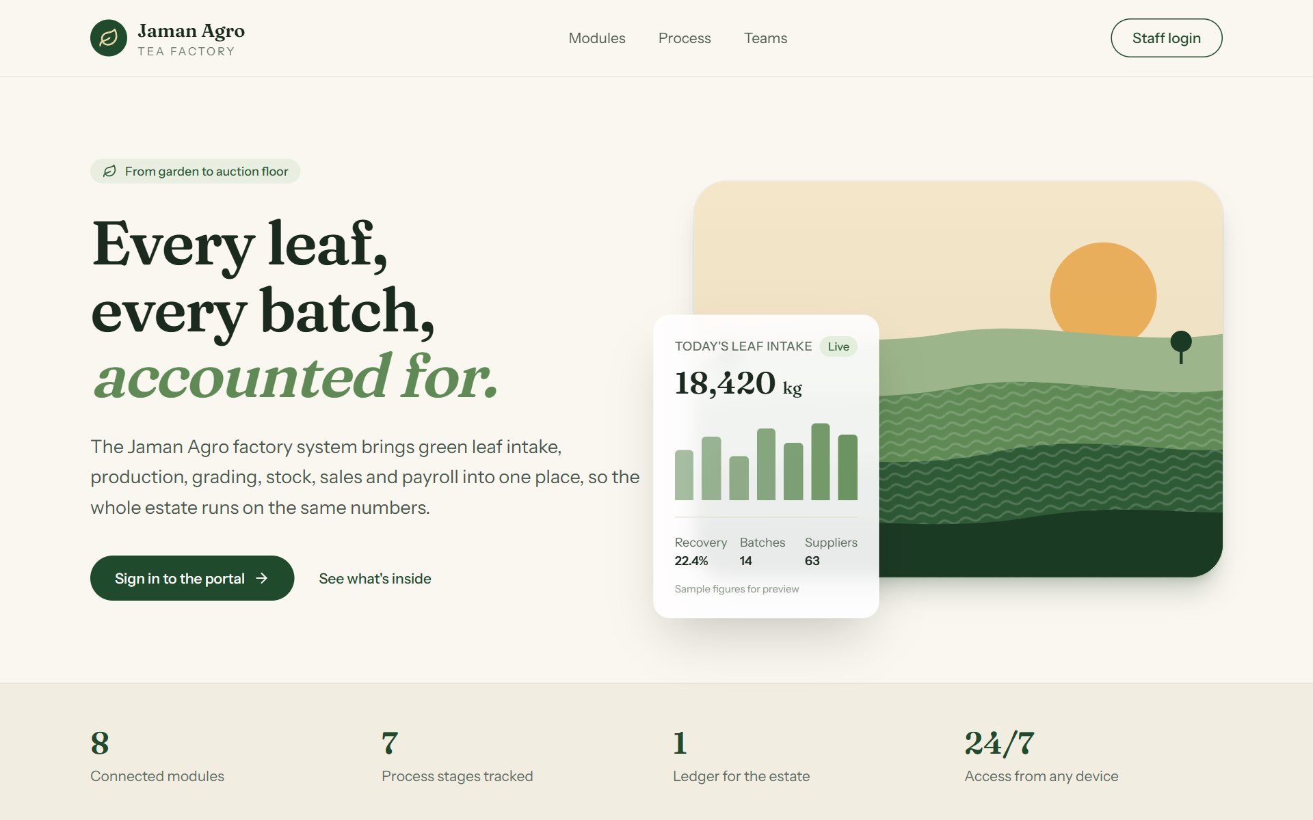
Figure 1. The Jaman Agro front page. Click Staff login to sign in.

2.2 Signing in
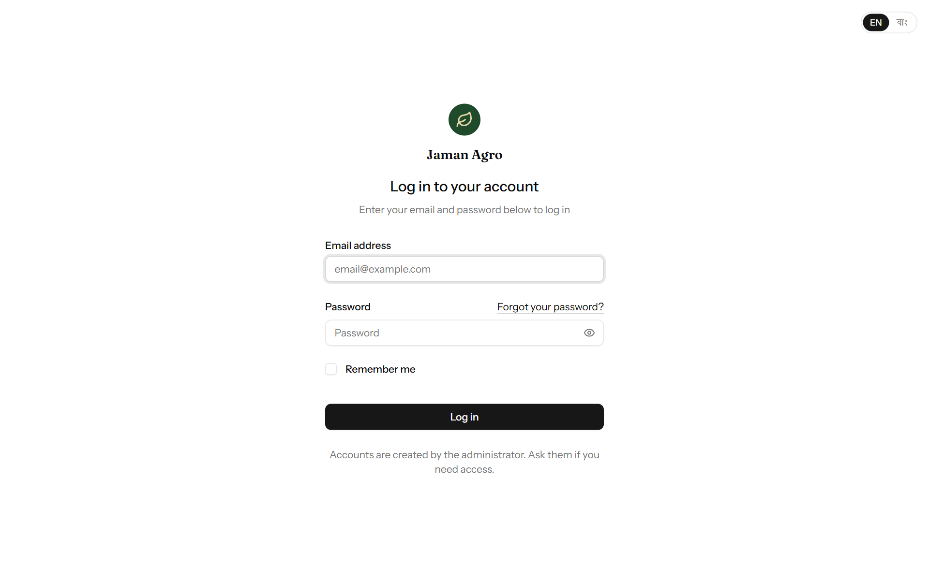
Figure 2. The sign-in page.
- Type your email address in Email address.
- Type your password in Password. Click the eye symbol to see what you typed.
- Tick Remember me only on your own computer. It keeps you signed in after the browser closes.
- Click Log in. You arrive at the dashboard.
Field | What it means | Required?
Email address | The email address your account was created with. | Yes
Password | Your password. It is case-sensitive. | Yes
Remember me | Stay signed in on this device. | No

Note: Accounts are made only by the administrator. There is no sign-up page. If you need an account, ask the administrator.
If you forget your password, ask the administrator to set a new one for you (chapter 17.1). Then change it yourself (chapter 18.2).
If your account has been switched off, signing in will fail with the message that no active account matches. Speak to the administrator.
To sign out, click your name at the bottom of the left-hand menu and choose Log out. Always sign out on a shared computer.

2.3 The screen layout
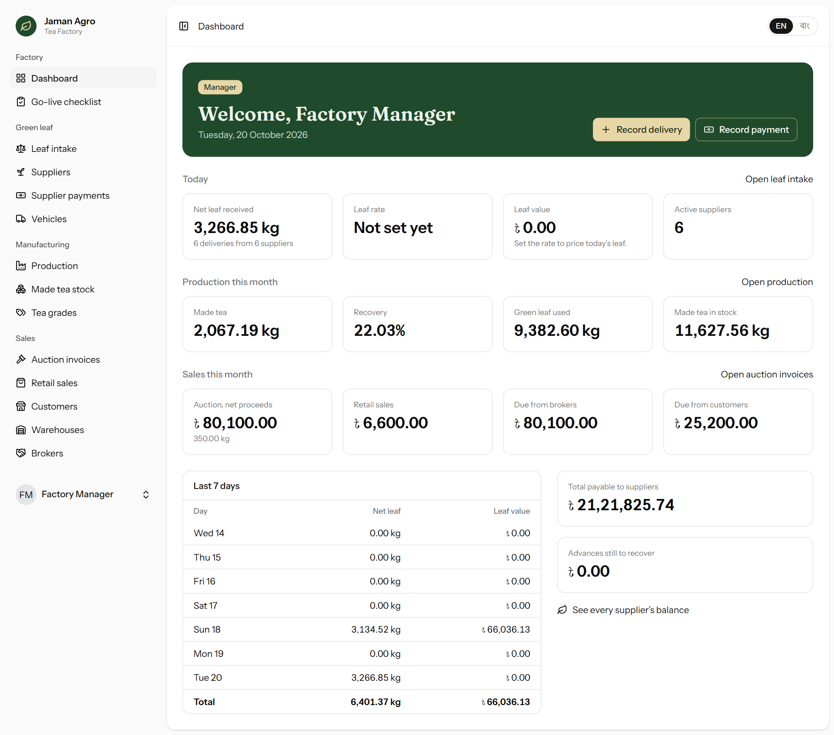
Figure 3. The main screen: menu on the left, page title and language switch at the top, the page in the middle.
- Left-hand menu — every part of the system, grouped under Factory, Green leaf, Manufacturing, Sales, Workforce, Accounts and, for the administrator, Administration. The page you are on is highlighted. The owner does not see the menu items for things they cannot change (such as Tea grades).
- Your name at the bottom of the menu — click it for Settings and Log out.
- Top bar — the button at the far left hides or shows the menu. Next to it is the page trail (for example Retail sales > New sale); click an earlier part to go back.
- Language switch (EN | বাং) at the top right — see 2.4.
- Messages — after you save, a short green message appears at the bottom of the screen confirming what happened. If something is wrong, a red message appears under the field that needs attention.

2.4 Bangla or English
Click EN or বাং at the top right of any page, including the sign-in page, to switch language. Your choice is remembered for your account, so the system opens in your language next time. In Bangla, numbers and dates are also shown with Bangla digits.
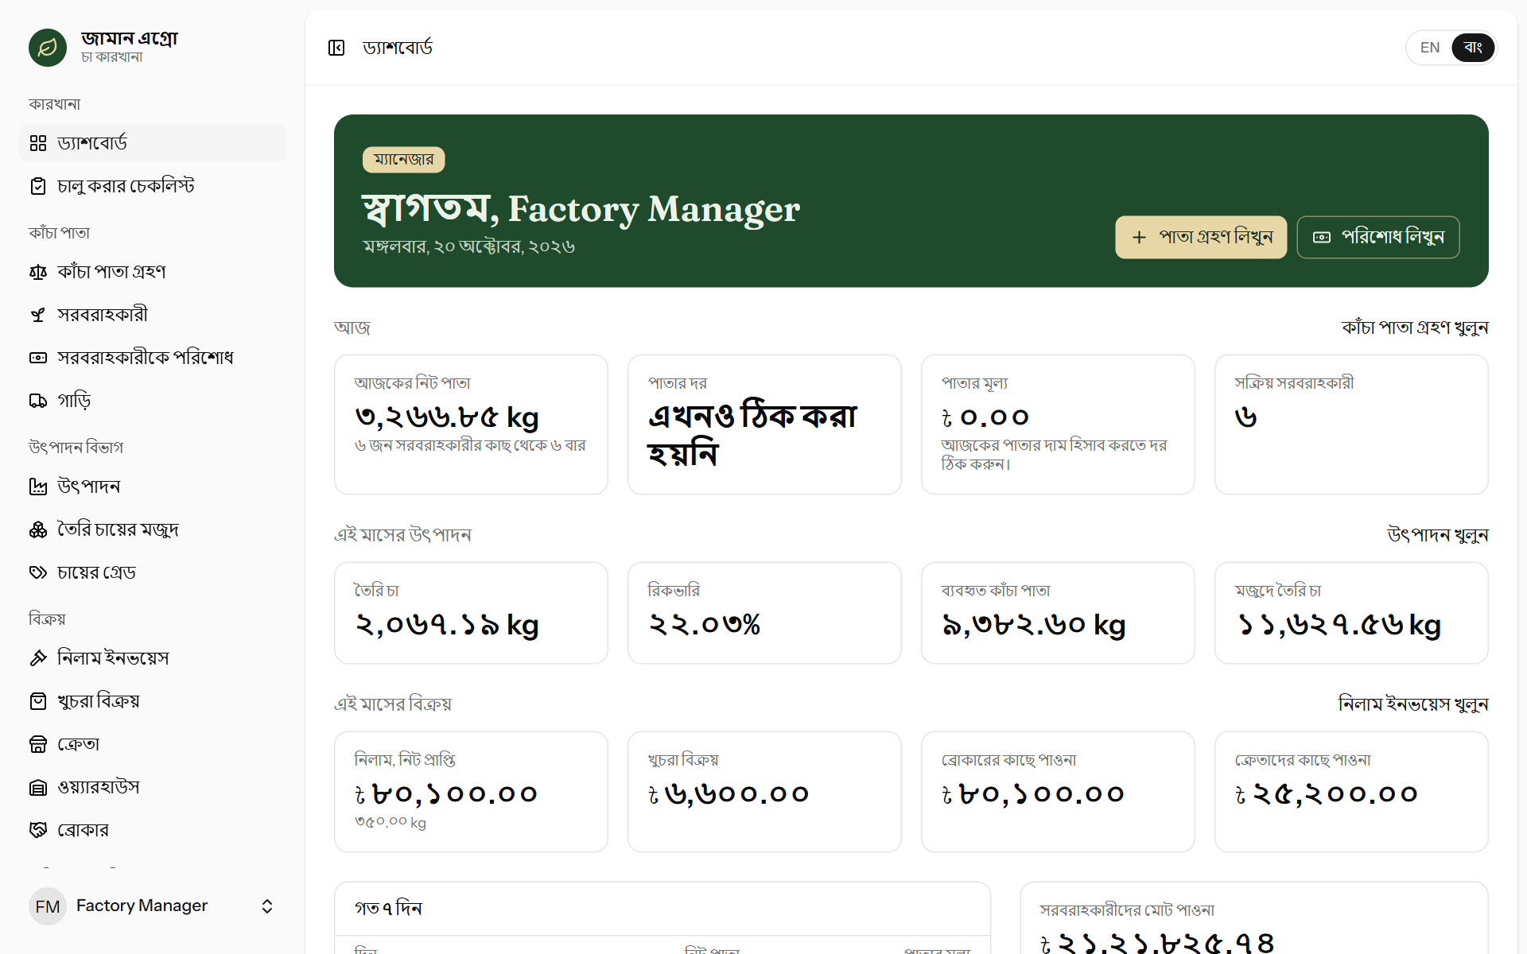
Figure 4. The same dashboard in Bangla.
Note: The administrator chooses each person’s starting language when creating the account. The manager and owner accounts start in Bangla. Anyone can change their own language at any time with the switch.

2.5 Using the system on a phone
Every page works on a phone. The menu folds away behind the button at the top left; tap it to open the menu. Wide tables can be scrolled sideways with a finger. The leaf intake page is designed so the gate clerk can record deliveries from a phone.
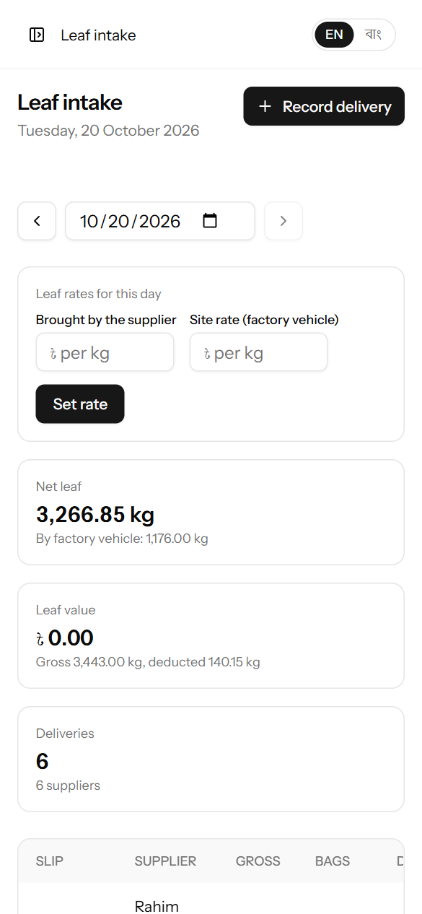
Figure 5. The leaf intake page on a phone.

2.6 Things that work the same everywhere
You see | What it does
A date box with a calendar symbol | Type a date or click the symbol to pick one. Dates in the future are not allowed for anything that has already happened.
‹ and › beside a date or month | Go to the previous or next day or month.
Search / Show with filters | Narrow a list. Fill in the filters, then click the button.
Numbers at the bottom of a long list (‹ 1 2 3 ›) | The list has more pages. Click a number to see that page.
Pencil symbol | Edit (correct) that line.
Red bin symbol | Delete that line. The system always asks you to confirm first.
Locked with a padlock | The entry was recorded more than three days ago and can no longer be changed. Click it to ask the administrator to unlock it (chapter 16).
Waiting with an hourglass | An unlock has been asked for and the administrator has not answered yet.
A small orange edited mark | The entry was changed after it was first saved. Point at the mark to see when.
Printer symbol or Print | Print the page. Only the page content is printed, not the menu. In the print window you can also choose “Save as PDF”.
Cancel | Leave the form without saving anything.

3. The dashboard
The dashboard is the first page after signing in (Factory → Dashboard). It shows how the factory is doing today and this month. Every figure is up to date the moment you open it.
Section | What it shows
Welcome band | Your name, your role and today’s date. The manager and administrator also see quick buttons: Record delivery and Record payment.
Today | Net leaf received (and from how many deliveries and suppliers), today’s Leaf rate, the Leaf value of today’s leaf, and the number of Active suppliers. If the rate is not set yet, the leaf value stays at ৳0 and a reminder appears.
Production this month | Made tea, Recovery, Green leaf used, and the Made tea in stock right now.
Sales this month | Auction, net proceeds (with kg sold), Retail sales, money Due from brokers (sold at auction but not yet paid) and money Due from customers.
Last 7 days | Net leaf and leaf value for each of the last seven days, with a total. Click a day to open that day’s leaf intake.
Supplier balances | Total payable to suppliers and Advances still to recover. Click See every supplier’s balance for the full list.

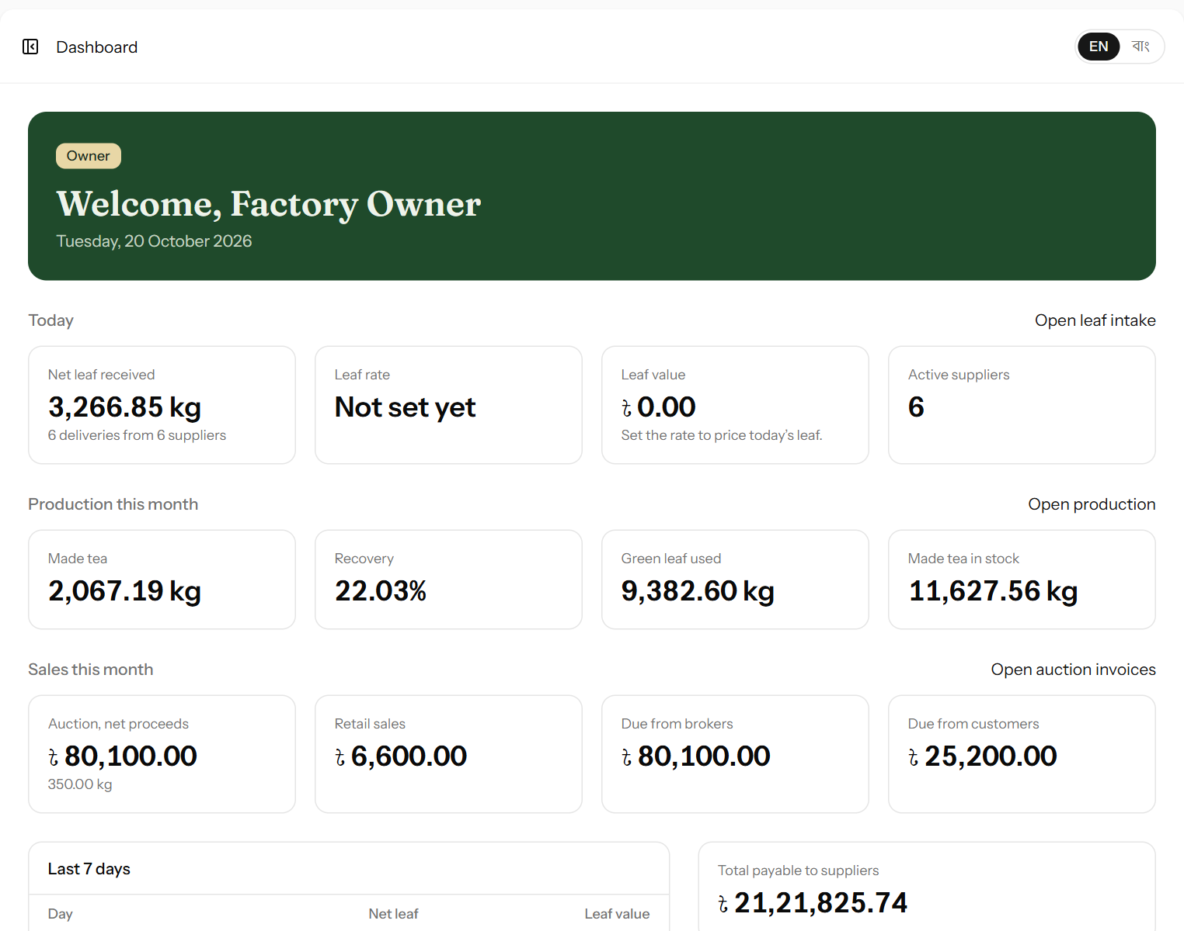
Figure 6. The owner’s dashboard: the same figures, without the buttons for entering work.

4. The daily, weekly and monthly routine
This chapter is a checklist for the factory manager. Each line points to the chapter that explains it.

4.1 Before the first day: the go-live checklist
Before the factory starts using the system for real, a few lists and opening figures must be entered once. Open Factory → Go-live checklist (manager and administrator). Each line shows how many have been entered so far and gets a green tick when something is there; click a line to go to that page.
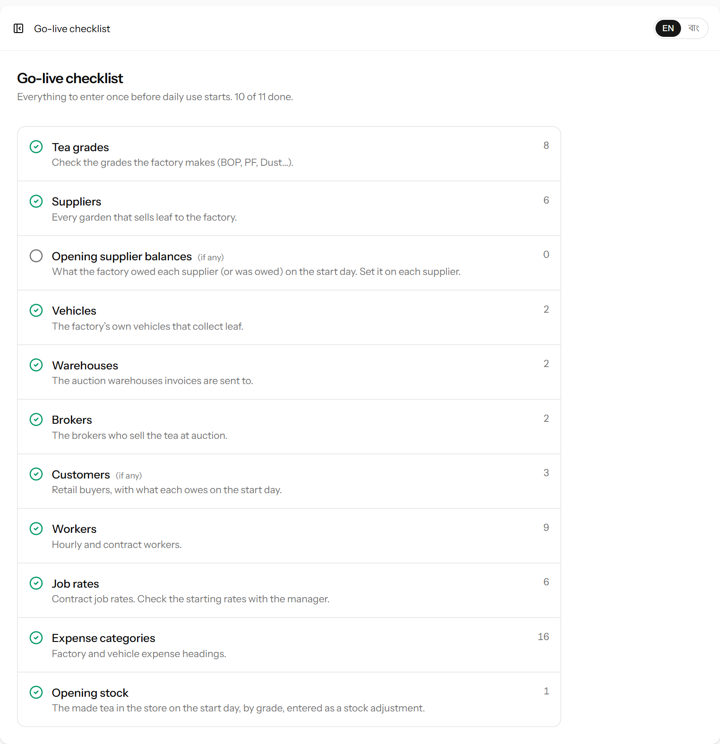
Figure 7. The go-live checklist.
Step | What to enter | Chapter
Tea grades | Check the grades the factory makes. | 9.3
Suppliers and opening balances | Every garden, with what the factory owed it (or was owed) on the start day. | 5.2
Vehicles | The factory’s own vehicles that collect leaf. | 6.6
Warehouses and brokers | Where auction tea goes and who sells it. | 10.6, 10.7
Customers | Retail buyers, with what each owed on the start day. | 11.1
Workers and job rates | Hourly and contract workers; the rate of every contract job. | 13.1, 13.4
Expense categories | Factory and vehicle expense headings. | 12.3
Opening stock | The made tea in the store on the start day, by grade, as a stock adjustment (Add to stock). | 9.2

Important: The starting job rates (for example ৳0.45 per kg for leaf unloading and ৳8 per bag for bagging) were taken from the planning meeting. Check every rate with the manager before the first pay day and correct it in Job rates.

4.2 Every day
When | Task | Chapter
As leaf arrives | Weigh each delivery, note whether the supplier brought it or a factory vehicle collected it, measure moisture, record it in Leaf intake and give the supplier the printed slip. | 6.3, 6.4
When the day’s rates are decided | Set the rate and the site rate on the Leaf intake page. Every delivery of the day is priced at once. | 6.2
After manufacture | Record the production batch: green leaf used and made tea by grade. | 8.2
During and after the shift | Fill in the attendance sheet for the hourly workers and record the contract work done. | 13.2, 13.3
Next morning | Look over yesterday’s entries and correct any mistakes while they are still open (three days). | 16
When money changes hands | Record supplier payments and advances, money received from customers, and expenses. | 7, 11.6, 12
When tea is sold | Pack auction invoices, or write retail sale memos. | 10, 11
End of day | Open the dashboard and check that today’s figures look right. | 3

4.3 Every week
- Pay the workers on Sunday (for Thursday–Saturday) and on Thursday (for Sunday–Wednesday) from the Wages page (13.5).
- Update auction invoices as they move: dispatch dates, sale and lot numbers, auction results, broker payments (10.4).
- Print supplier statements for suppliers being paid this week (5.4).
- Check Made tea stock against what is physically in the store. Correct any difference with Adjust stock, giving the reason (9.2).

4.4 Every month
- Make sure all of the month’s expenses are recorded, including each vehicle’s fuel, driver and repairs (12).
- Print the Cash book for the month and compare it with the cash in hand and the bank statement (14).
- Open Reports with the owner and review sales, costs, landed leaf cost, recovery and cost per kg (15).
- Send customers their statements and follow up on money due (11.5).

5. Suppliers
Suppliers are the garden owners the factory buys green leaf from. Each supplier has an account that shows what the factory owes them. Open Green leaf → Suppliers.

5.1 The supplier list
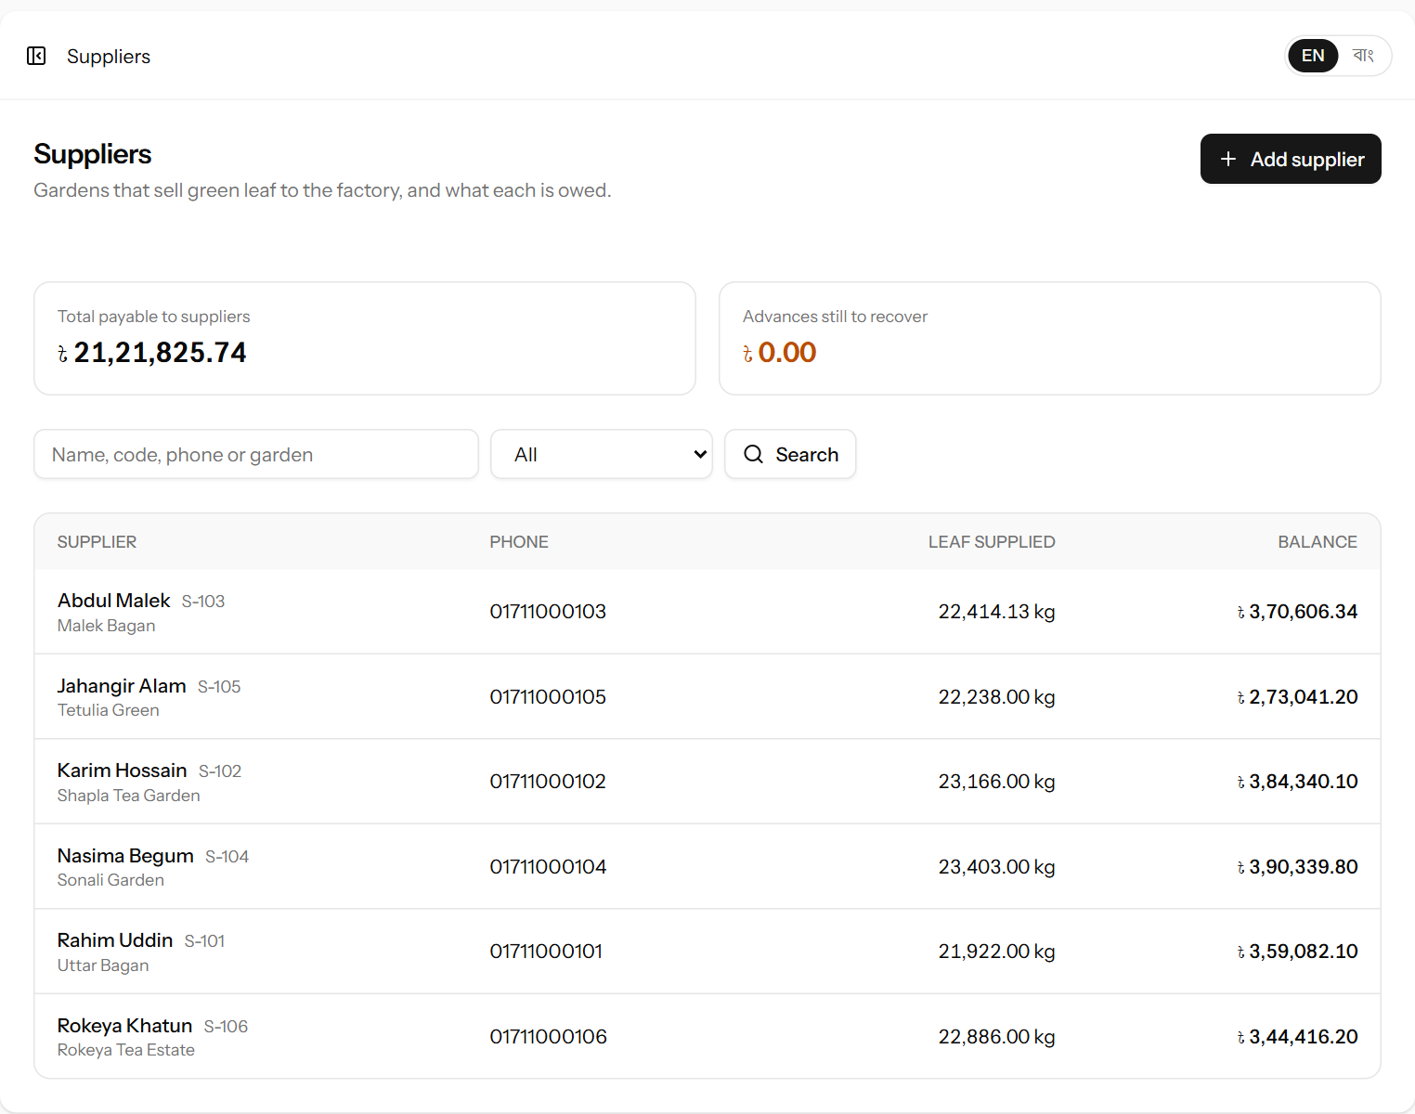
Figure 8. The supplier list with each supplier’s leaf supplied and balance.
Part of the page | Meaning
Total payable to suppliers | The sum of what the factory owes all suppliers whose balance is positive.
Advances still to recover | The sum of advances given to suppliers that their leaf has not yet covered.
Search box and status filter | Find a supplier by name, code, phone or garden; show only active or inactive suppliers.
Leaf supplied | Total net kg of leaf this supplier has ever delivered.
Balance | What the factory owes the supplier now. If the amount is followed by “(advance)” in orange, the supplier has been paid more than their leaf is worth so far and the extra will be recovered from future leaf.

Click a supplier’s name to open their statement (5.4).

5.2 Adding a supplier
- Click Add supplier at the top right.
- Fill in the form (see the table below).
- Click Add supplier. The supplier’s statement opens.
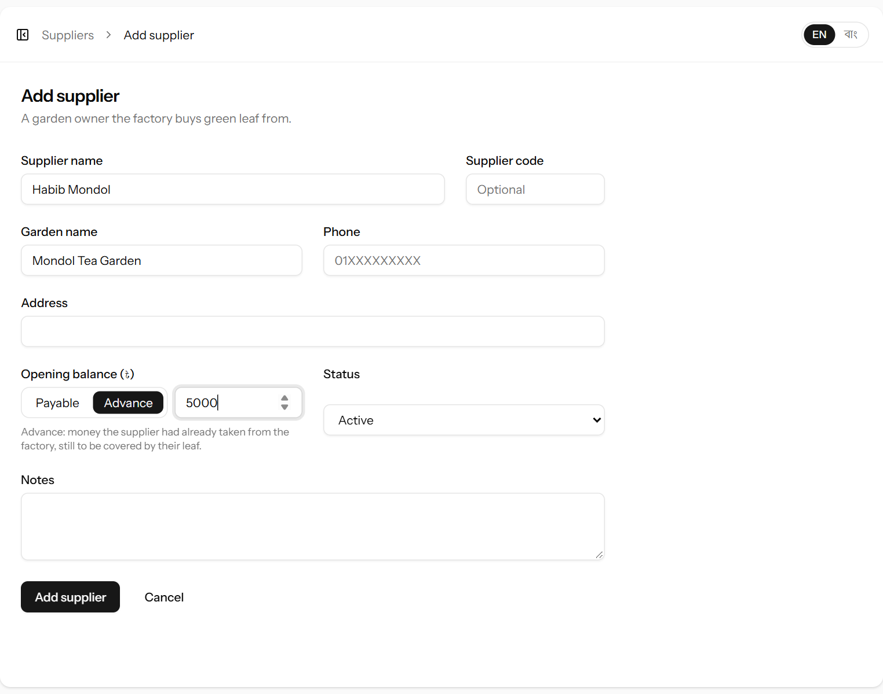
Figure 9. The form for adding a supplier.
Field | What it means | Required?
Supplier name | The person’s or garden’s name as it should appear on slips and statements. | Yes
Supplier code | Your own short code (for example S-101), if the factory uses supplier numbers. No two suppliers can have the same code. | No
Garden name | The name of the garden the leaf comes from. | No
Phone | Mobile number, for example 01711000101. | No
Address | Village, union, upazila. | No
Opening balance (৳) | Only for suppliers who already had money owing when you started using the system. First click which kind it is: Payable — the factory owed the supplier this amount; Advance — the supplier had already taken this amount from the factory (for example an old advance), to be covered by their leaf. Then type the amount as a plain number, for example 5000. Never type a minus sign. | No
Status | Active suppliers can be chosen on new deliveries and payments. Choose Inactive for a supplier who has stopped supplying. | Yes
Notes | Anything else worth remembering. | No

5.3 Changing or switching off a supplier
Open the supplier’s statement and click Edit. Change what is needed and click Save changes. A supplier cannot be deleted once they have any deliveries or payments — this protects the history. Set them to Inactive instead: they disappear from the choices on new entries but their history stays.

5.4 The supplier statement
The statement is the supplier’s bill: every delivery and payment in a period, with a running balance. Click a supplier’s name in the list to open it.
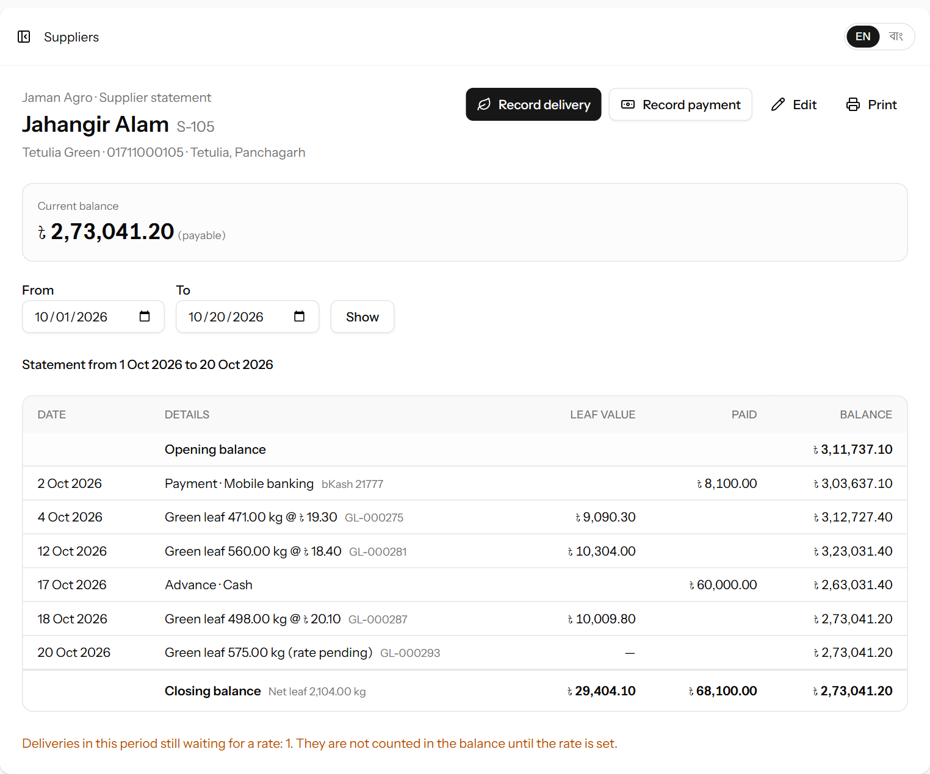
Figure 10. A supplier statement: deliveries, a payment and an advance, with the running balance. The last delivery is still waiting for the day’s rate.
Part | Meaning
Buttons at the top | Record delivery and Record payment open those forms with this supplier already chosen. Edit changes the supplier’s details. Print prints the statement.
Current balance | What the factory owes the supplier today, across all time.
From / To | The period of the statement. It starts as the 1st of this month until today. Change the dates and click Show.
Opening balance | The balance at the start of the period: the supplier’s opening balance plus all leaf before the period, minus all payments before the period.
Each line | A delivery (“Green leaf 375.55 kg @ ৳24.50”, with the slip number) or a payment/advance (with how it was paid). Leaf value adds to the balance, Paid takes away from it.
Balance column | The running balance after each line.
Closing balance | The balance at the end of the period, with the total net leaf, total leaf value and total paid in the period.

Note: Deliveries whose day has no rate yet are listed with “(rate pending)” and are not added to the balance until the rate is set. A message under the statement tells you how many such deliveries there are.
Worked example: A supplier starts the month owing nothing. On the 3rd they take a ৳60,000 advance: the balance shows ৳60,000 (advance).
On the 4th they deliver 600 kg net at ৳20: ৳12,000 is added, so the balance becomes ৳48,000 (advance).
Once their deliveries pass ৳60,000 in value, the balance turns positive and the factory owes them the difference.

6. Green leaf intake
This is the busiest screen in the system. Every delivery of green leaf is recorded here as it is weighed at the gate. Open Green leaf → Leaf intake.

6.1 The day page
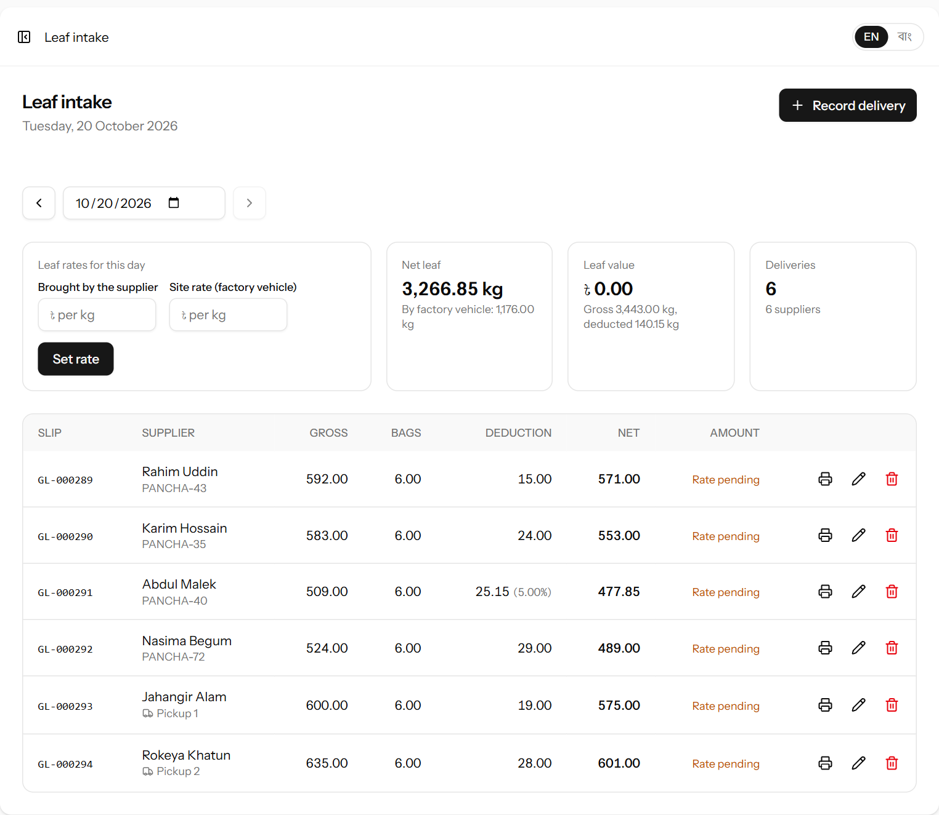
Figure 11. Today’s leaf intake. The rate is not set yet, so the deliveries show “Rate pending”.
Part | Meaning
Date and ‹ › | The page always shows one day. It opens on today. Use the arrows or the date box to look at another day; Today brings you back.
Leaf rates for this day | The two prices per kg for this day: the rate for leaf the supplier brought, and the site rate for leaf a factory vehicle collected. Set or change them here (6.2).
Net leaf | Total net kg received this day, and how much of it came in factory vehicles.
Leaf value | Total money owed for this day’s leaf, with the gross weight and how much was deducted. Deliveries without a rate are not counted until it is set.
Deliveries | How many deliveries came in and from how many suppliers.
The table | One line per delivery: slip number (with an edited mark if it was changed); supplier with the vehicle number — or, for factory-collected leaf, a truck symbol and the vehicle’s name; gross; bags; deduction in kg (and the percentage, if it was entered as one); net and amount. On the right: print the slip, and edit or delete — or Locked once the delivery is more than three days old (chapter 16).

6.2 Setting the day’s leaf rates
Each day has two rates. The rate is paid for leaf the supplier brings to the factory. The site rate is paid for leaf the factory collects from the garden with its own vehicle — it is lower, because the factory carries the transport cost. Both are set once per day, before, during or after the deliveries — whenever the factory decides them.
- On the Leaf intake page, make sure the right day is showing.
- In the Leaf rates for this day box, type the rate under Brought by the supplier, for example 21.50, and the site rate under Site rate (factory vehicle), for example 20.00. The site rate can be left empty on a day when no leaf was collected.
- Click Set rate. Every delivery of that day is priced at once — each at the rate that fits how it arrived — and a message says how many were priced.
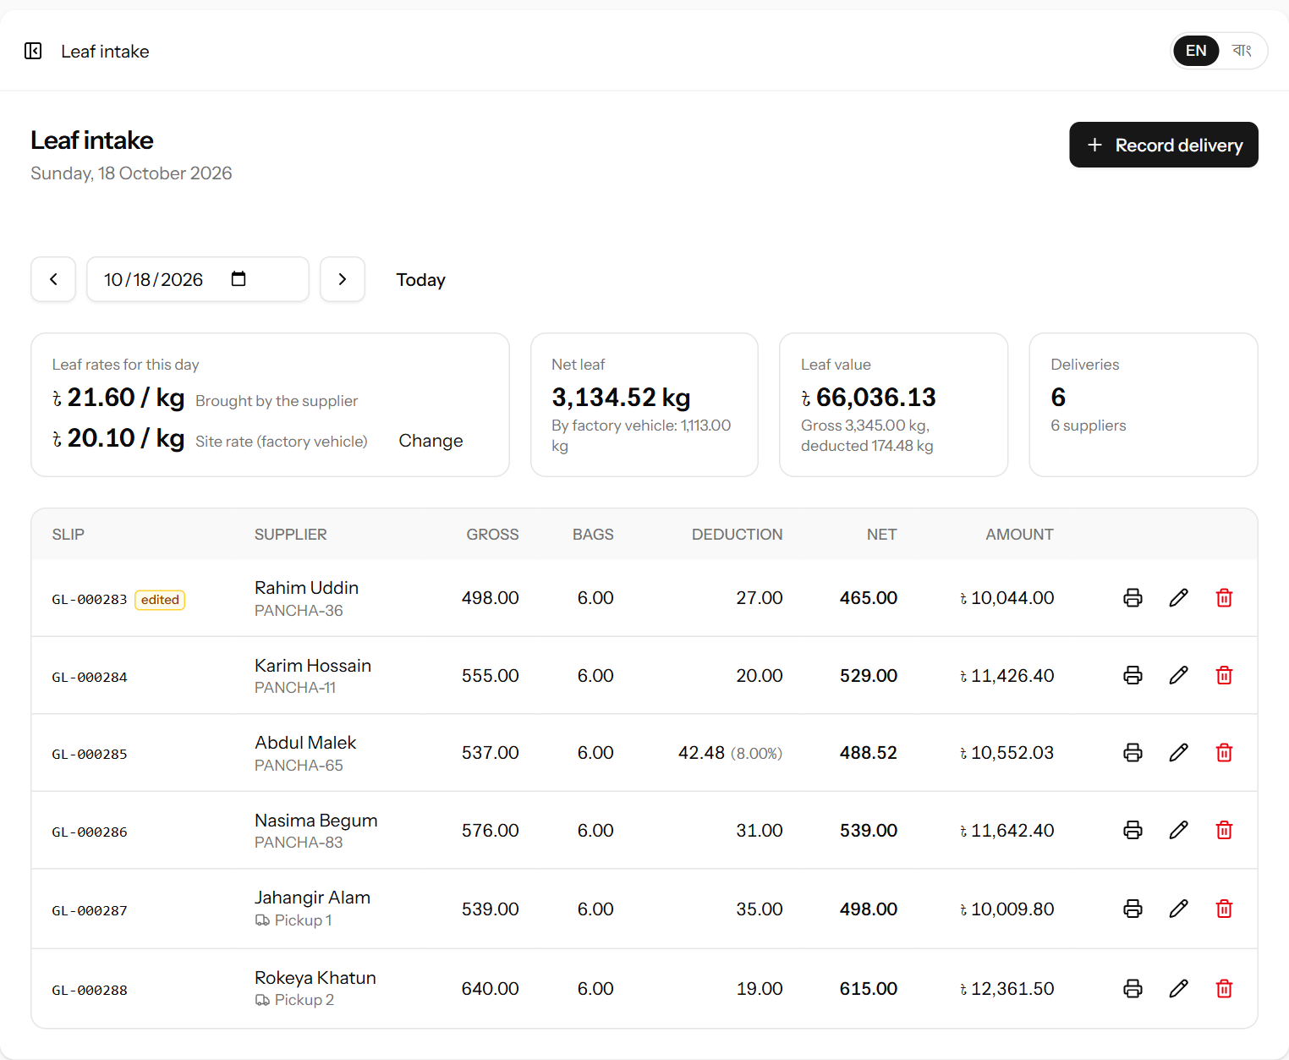
Figure 12. A day with both rates set: every delivery has an amount. The last two gardens’ leaf came in the factory’s pickups.
To change the rates, click Change next to them, type the new figures and click Set rate.
Important: Changing a day’s rates re-prices every delivery of that day, including deliveries already shown on printed slips and statements. Only change a rate if the original one was wrong, and tell the suppliers concerned.
Leaf collected by a factory vehicle stays “Rate pending” until the site rate is set — it is never priced at the supplier rate by mistake. The site rate cannot be higher than the rate.
Rates cannot be set for a future day. Like other entries, a day’s rates lock three days after they were set (chapter 16).

6.3 Recording a delivery
- Click Record delivery (on the dashboard or the leaf intake page).
- Check the Date — it starts as today.
- Choose the supplier. With many suppliers, type part of the name, code or garden in the Find… box first to shorten the list.
- Under How did the leaf arrive? click Brought by the supplier or Collected by a factory vehicle. For a factory vehicle, choose which one in Factory vehicle; otherwise the supplier’s Vehicle no. can be typed in, if useful.
- Enter Gross weight (kg) from the scale and Bags / basket weight (kg). Then enter the Moisture deduction: in kg (the default), or click % beside the box to enter a percentage instead.
- Check the Calculation box on the right: it shows the deduction, the net weight, the rate that applies (rate or site rate) and, if that rate is set, the amount, as you type.
- Click Save & print slip to save and open the slip for printing — or Save & add another to save and start the next delivery for the same day straight away.
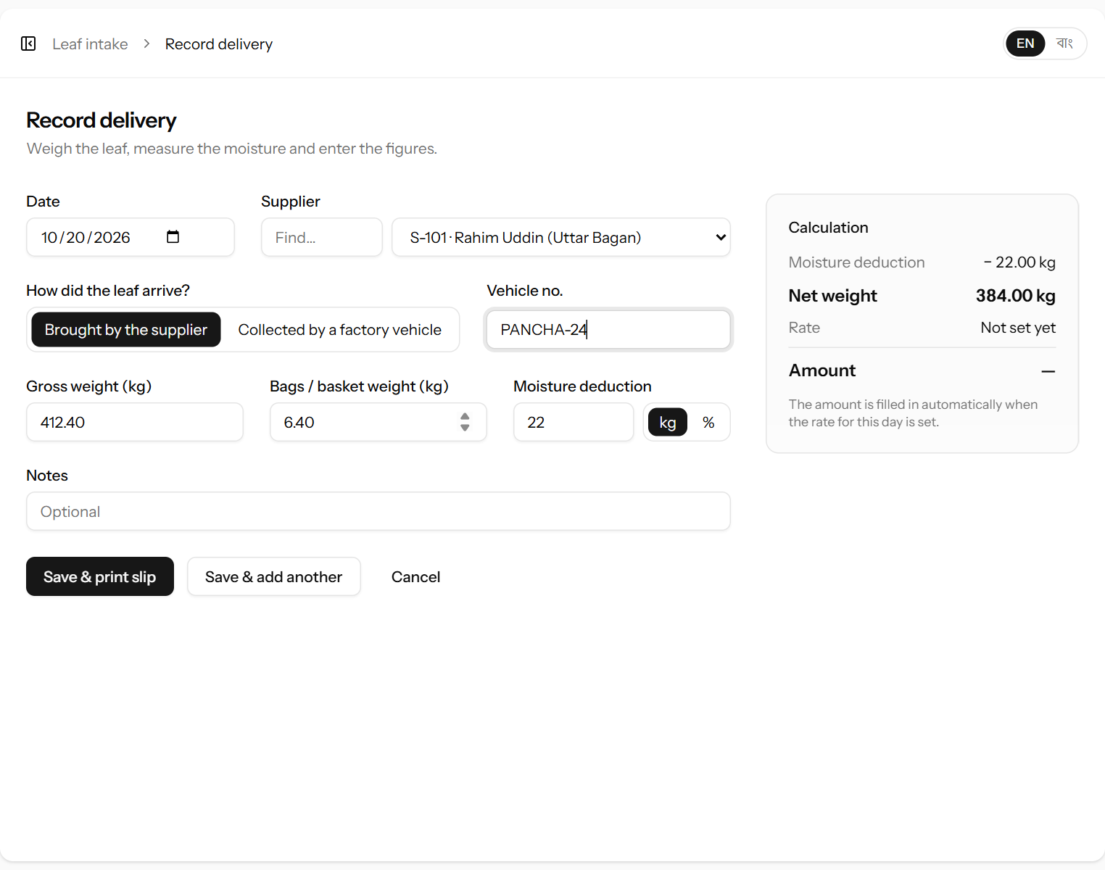
Figure 13. Recording a delivery the supplier brought, with 22 kg deducted for moisture. The Calculation box works out the net weight as you type.
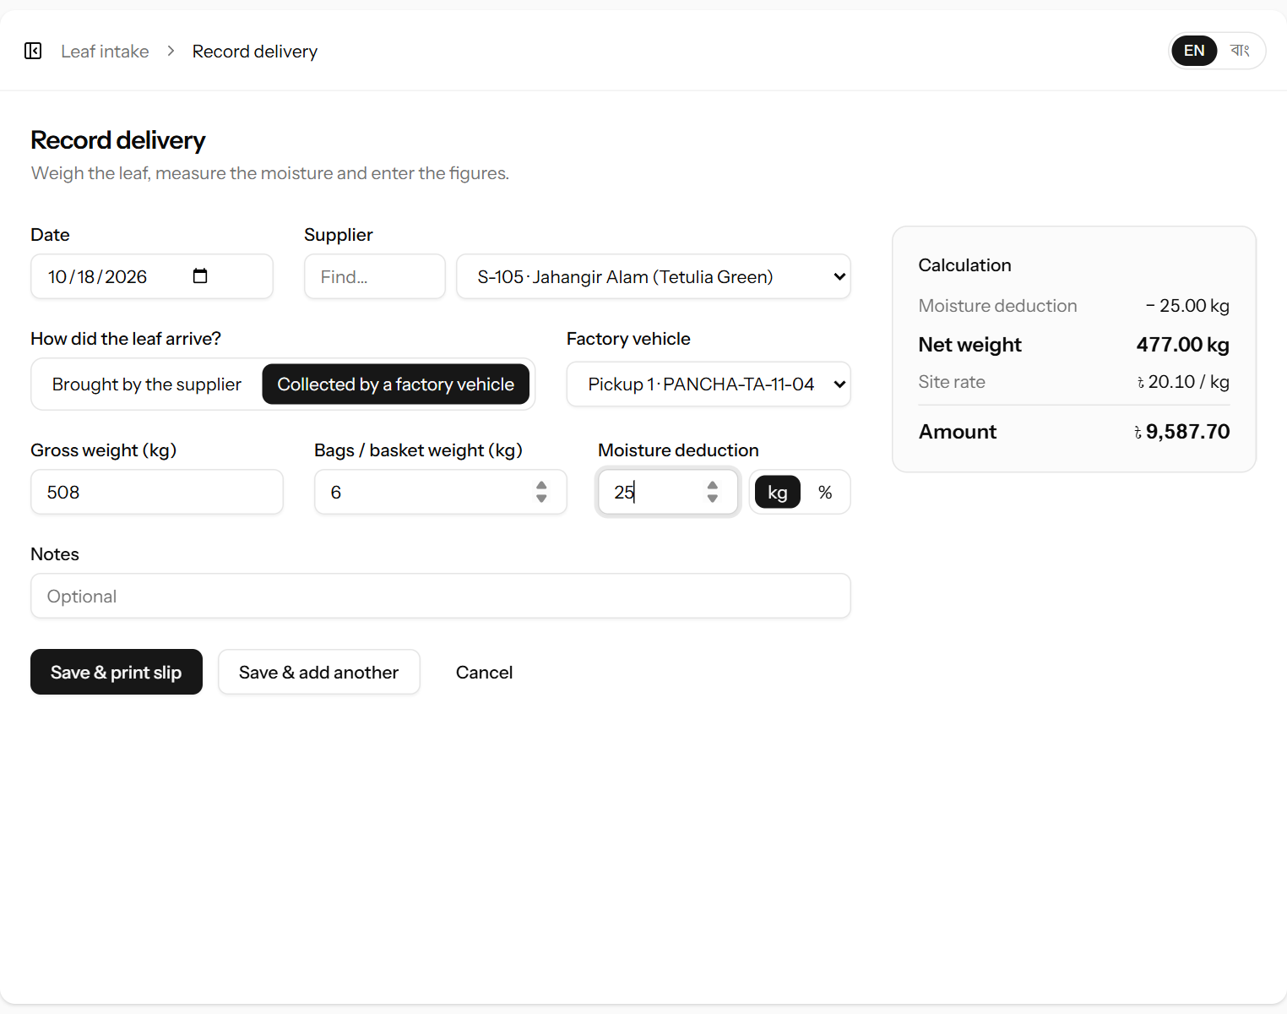
Figure 14. A delivery collected by the factory’s Pickup 1. It is priced at the day’s site rate.
Field | What it means | Required?
Date | The day the leaf was received. Cannot be in the future. | Yes
Supplier | Whose leaf it is. Only active suppliers are listed. | Yes
How did the leaf arrive? | Brought by the supplier — priced at the day’s rate. Collected by a factory vehicle — priced at the day’s site rate. | Yes
Factory vehicle | Which of the factory’s vehicles collected the leaf. Shown only for factory-collected leaf. The list comes from Vehicles (6.6). | For a factory vehicle
Gross weight (kg) | The full weight on the scale, including bags or baskets. Must be more than 0. | Yes
Bags / basket weight (kg) | The weight of the empty bags or baskets. Must be less than the gross weight. Leave 0 if the scale was zeroed with the bags. | No
Moisture deduction | What is taken off for moisture. With kg selected (the default): the kilograms deducted, which must be less than the leaf weight. With % selected: the percentage of the leaf weight, between 0 and 100. Enter 0 if nothing is deducted. | Yes
Vehicle no. | For leaf the supplier brought: the number plate or van number, if useful. | No
Notes | Anything unusual about this delivery (for example poor leaf quality). | No

Worked example: Gross weight 412.40 kg, bags 6.40 kg, 22 kg deducted for moisture.
Leaf weight = 412.40 − 6.40 = 406.00 kg. Net weight = 406.00 − 22 = 384.00 kg.
Brought by the supplier, rate ৳24.50: amount = 384.00 × 24.50 = ৳9,408.00.
Collected by a factory vehicle, site rate ৳23.00: amount = 384.00 × 23.00 = ৳8,832.00.
With the deduction as a percentage instead, 7.5% of 406.00 kg = 30.45 kg, so the net weight is 375.55 kg; at ৳24.50 that is ৳9,200.975, rounded to ৳9,200.98.
Tip: At a busy gate, use Save & add another. The form clears for the next delivery but keeps the date, how the leaf arrived and the kg/% choice, so the clerk can enter one delivery after another without leaving the form.

6.4 The weighing slip
After Save & print slip, the slip opens. Click Print slip to print it and give it to the supplier. You can print any slip again later with the printer symbol on the leaf intake page.
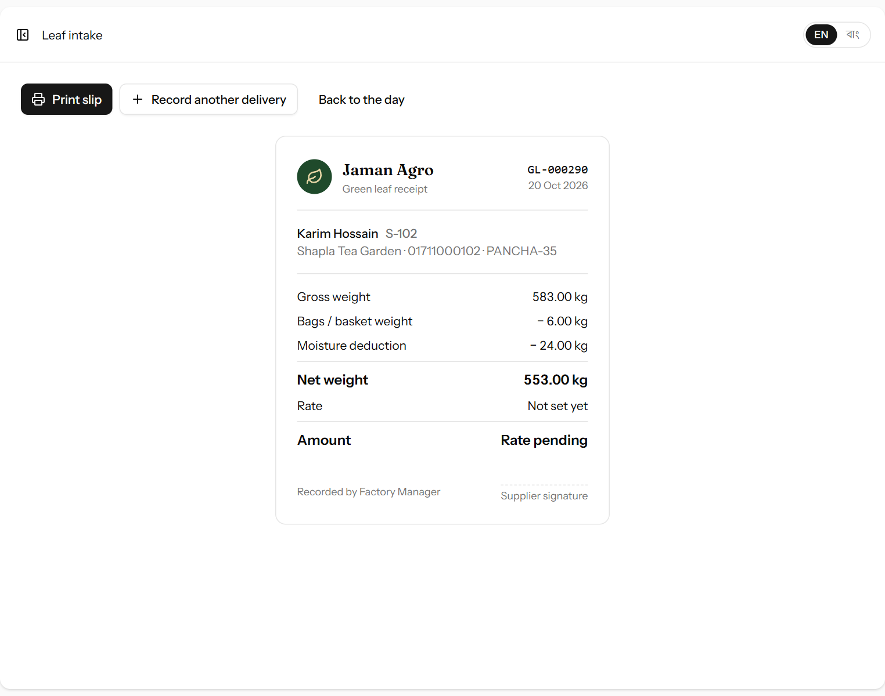
Figure 15. The weighing slip, with a space for the supplier’s signature.
Each slip has a number such as GL-000289 (GL = green leaf). The number never changes and appears on the supplier’s statement, so a slip can always be matched to the account. For factory-collected leaf the slip names the vehicle.

6.5 Correcting or deleting a delivery
- To correct a mistake, click the pencil symbol on the delivery’s line, fix the figures and click Save changes. If you change the date, the delivery takes the rate of its new day.
- To remove a delivery entered by mistake, click the red bin symbol and confirm. This cannot be undone, but it stays recorded in the activity log.
- Both are possible for three days after the delivery was recorded. After that the pencil and bin are replaced by Locked; chapter 16 explains how to have an old entry unlocked.

6.6 Factory vehicles
Open Green leaf → Vehicles (manager and administrator only) to keep the list of the factory’s own vehicles that collect leaf from the gardens. Each vehicle can then be chosen on a delivery and on its running expenses — fuel, driver and repairs (chapter 12).
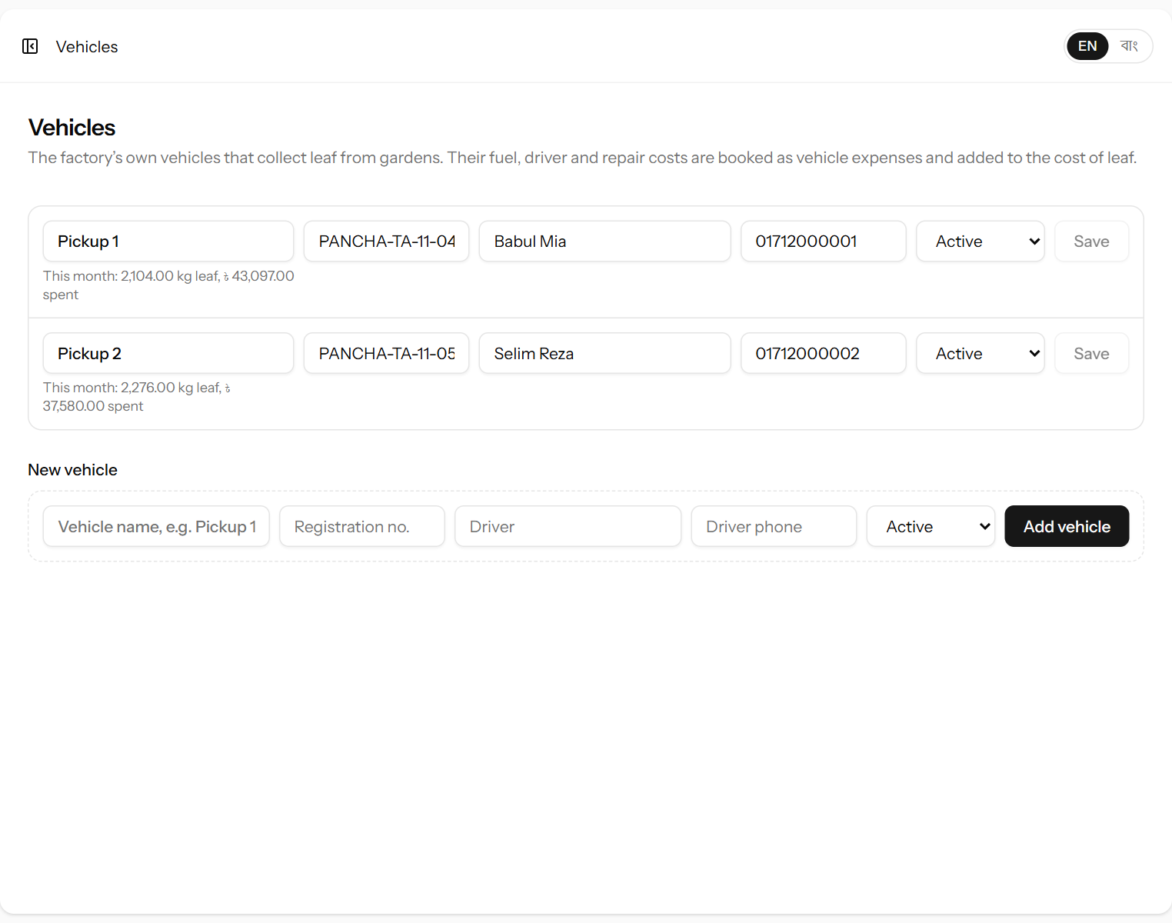
Figure 16. The factory’s vehicles, with this month’s leaf collected and money spent on each.
Field | What it means | Required?
Vehicle name | A short name everyone uses, for example “Pickup 1”. | Yes
Registration no. | The number plate. No two vehicles can have the same one. | No
Driver / Driver phone | Who usually drives it. | No
Status | Inactive vehicles are not offered on new deliveries and expenses. | Yes

Edit a vehicle on its line and click Save; add one on the New vehicle line. Under each name the page shows the net leaf the vehicle brought in this month and the vehicle expenses booked to it. Together with the site rate, this shows whether collecting leaf pays: the reports add the vehicle costs to the leaf cost to give the landed leaf cost per kg (15.1).

7. Supplier payments and advances
Every taka paid to a supplier is recorded here — both payment for leaf already delivered and advances against future leaf. Open Green leaf → Supplier payments.

7.1 The payment list
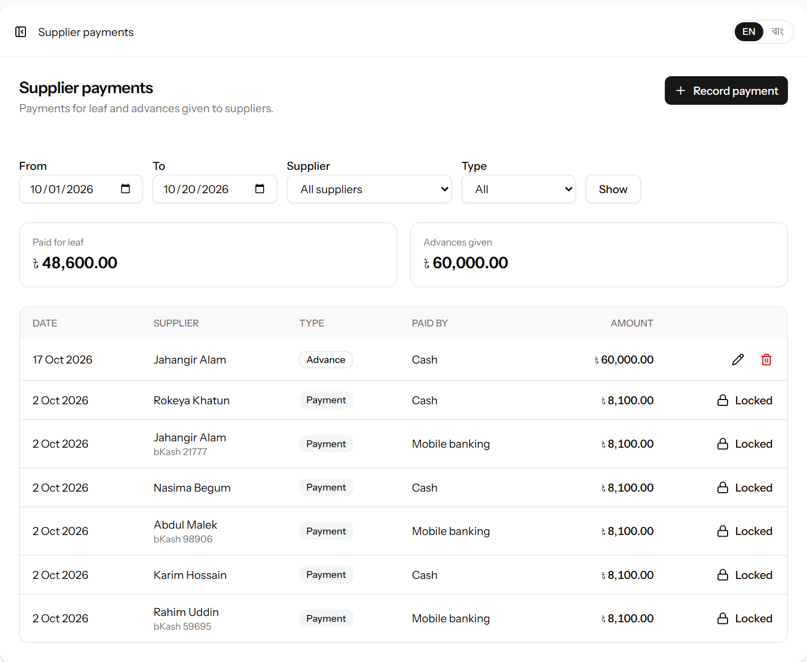
Figure 17. Supplier payments for the month, with totals for payments and advances.
Choose a period with From and To, and if you like a single supplier or a type (Payment or Advance), then click Show. The two boxes total what was paid for leaf and what was given as advances in the period. Click a supplier’s name to open their statement.

7.2 Recording a payment or advance
- Click Record payment — or, better, open the supplier’s statement and click Record payment there, which fills in the supplier and shows their current balance.
- Fill in the form and click Record payment. The supplier’s statement opens with the payment on it.
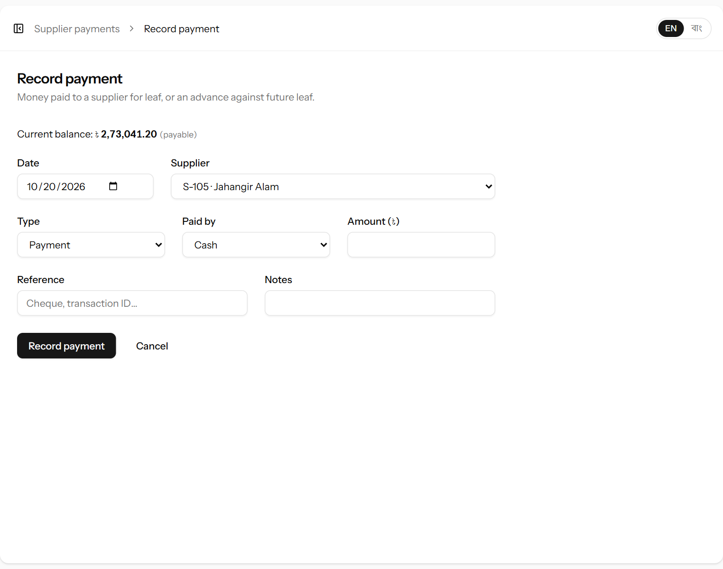
Figure 18. Recording a payment. The supplier’s current balance is shown at the top.
Field | What it means | Required?
Date | The day the money was paid. Cannot be in the future. | Yes
Supplier | Who was paid. | Yes
Type | Payment — for leaf already delivered. Advance — money given ahead of leaf (for fertiliser, festivals and so on). Both reduce what the factory owes; the type is kept so reports can show advances separately. | Yes
Paid by | Cash, Bank or Mobile banking (bKash, Nagad, Rocket…). This decides where the payment appears in the cash book. | Yes
Amount (৳) | How much was paid. Must be more than 0. | Yes
Reference | Cheque number, bank or mobile banking transaction ID. | No
Notes | The purpose of the payment, for example “Advance for fertiliser”. | No

Tip: Before paying a supplier, print their statement for the period (5.4). It shows exactly how much is owed and is the supplier’s record of the payment.

7.3 Correcting or deleting a payment
In the payment list, click the pencil symbol to correct a payment or the red bin symbol to delete one entered by mistake. The supplier’s balance updates at once. This is possible for three days after the payment was recorded (chapter 16).

8. Production
Each manufacture is recorded as a production batch: how much green leaf went in, and how much made tea of each grade came out. Open Manufacturing → Production.

8.1 The month page

Figure 19. A month of production with made tea by grade and recovery.
Part | Meaning
Month and ‹ › | The page shows one month at a time.
Made tea | Total made tea this month and the number of batches.
Recovery | Made tea ÷ green leaf used × 100 for the whole month.
Green leaf used | The leaf that went into the batches.
Net leaf received | The leaf bought this month, for comparison. A large gap between received and used is worth checking.
The table | One line per batch, with a column for each grade, the total made tea and the recovery of that batch. The last line totals the month.

8.2 Recording a batch
- Click Record production.
- Check the Date and enter the Green leaf used (kg). Under the box the system shows the net leaf received that day; click Use this to copy it.
- Optionally enter the process readings: withering hours, fermentation minutes and dryer temperature.
- Under Made tea by grade (kg), enter the kg sorted into each grade. Leave grades that were not made empty.
- Check the Out-turn box on the right — made tea and recovery are worked out as you type.
- Click Save batch. The made tea is added to stock straight away.
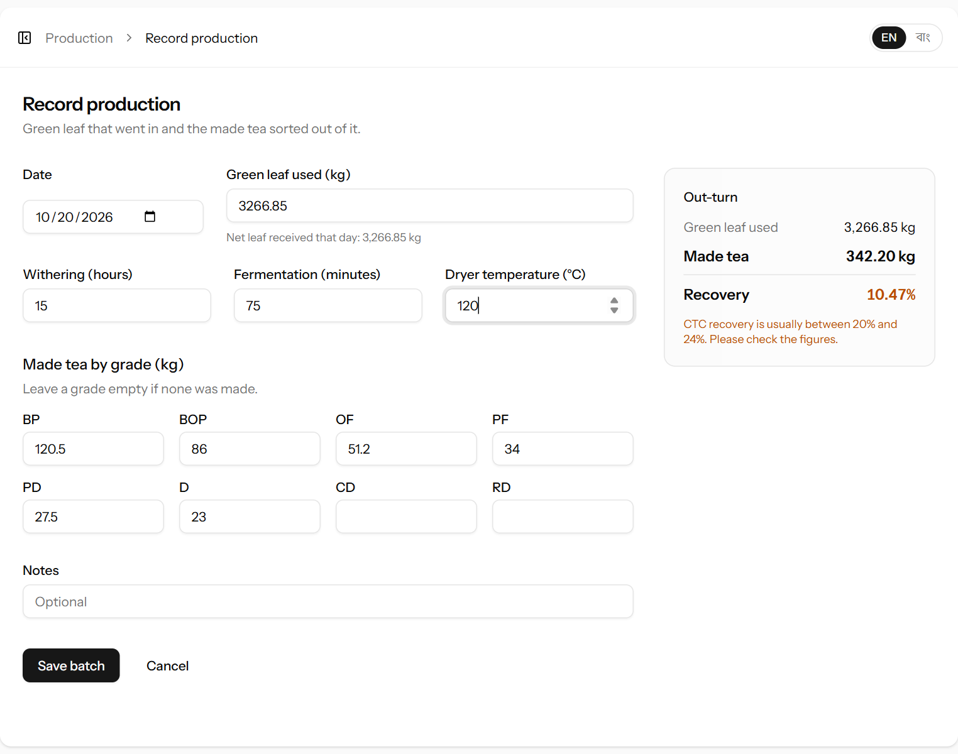
Figure 20. Recording a batch. The Out-turn box shows recovery as you type.
Field | What it means | Required?
Date | The day of manufacture. Cannot be in the future. | Yes
Green leaf used (kg) | The net green leaf that went into this batch. | Yes
Withering (hours) | How long the leaf was withered. | No
Fermentation (minutes) | How long the leaf was fermented. | No
Dryer temperature (°C) | The dryer’s temperature. | No
A box per grade | The kg of made tea sorted into that grade. At least one grade must have tea. | At least one
Notes | Anything unusual (machine breakdown, power cut…). | No

Worked example: Green leaf used 1,000 kg; made tea BP 80, BOP 60, OF 35, PF 25, PD 12, D 8 = 220 kg. Recovery = 220 ÷ 1,000 × 100 = 22.00%.
Important: If the recovery comes out below 15% or above 30%, it turns orange with a warning. CTC recovery is usually 20–24%, so a figure far outside that almost always means a typing mistake. Check the figures before saving.

8.3 Correcting or deleting a batch
Click the pencil symbol on the batch line to correct it, or the red bin symbol to delete it. The stock of each grade is updated to match. As with all entries, this is possible for three days (chapter 16).
Note: If some of a batch’s tea has already left the store (packed for auction, sold or adjusted), the system will not let you reduce or delete the batch below what is left. You will see a message such as “This would leave less than zero kg in stock for PF”.

9. Made tea stock and tea grades

9.1 The stock page
Open Manufacturing → Made tea stock to see how much made tea of each grade is in the store right now.
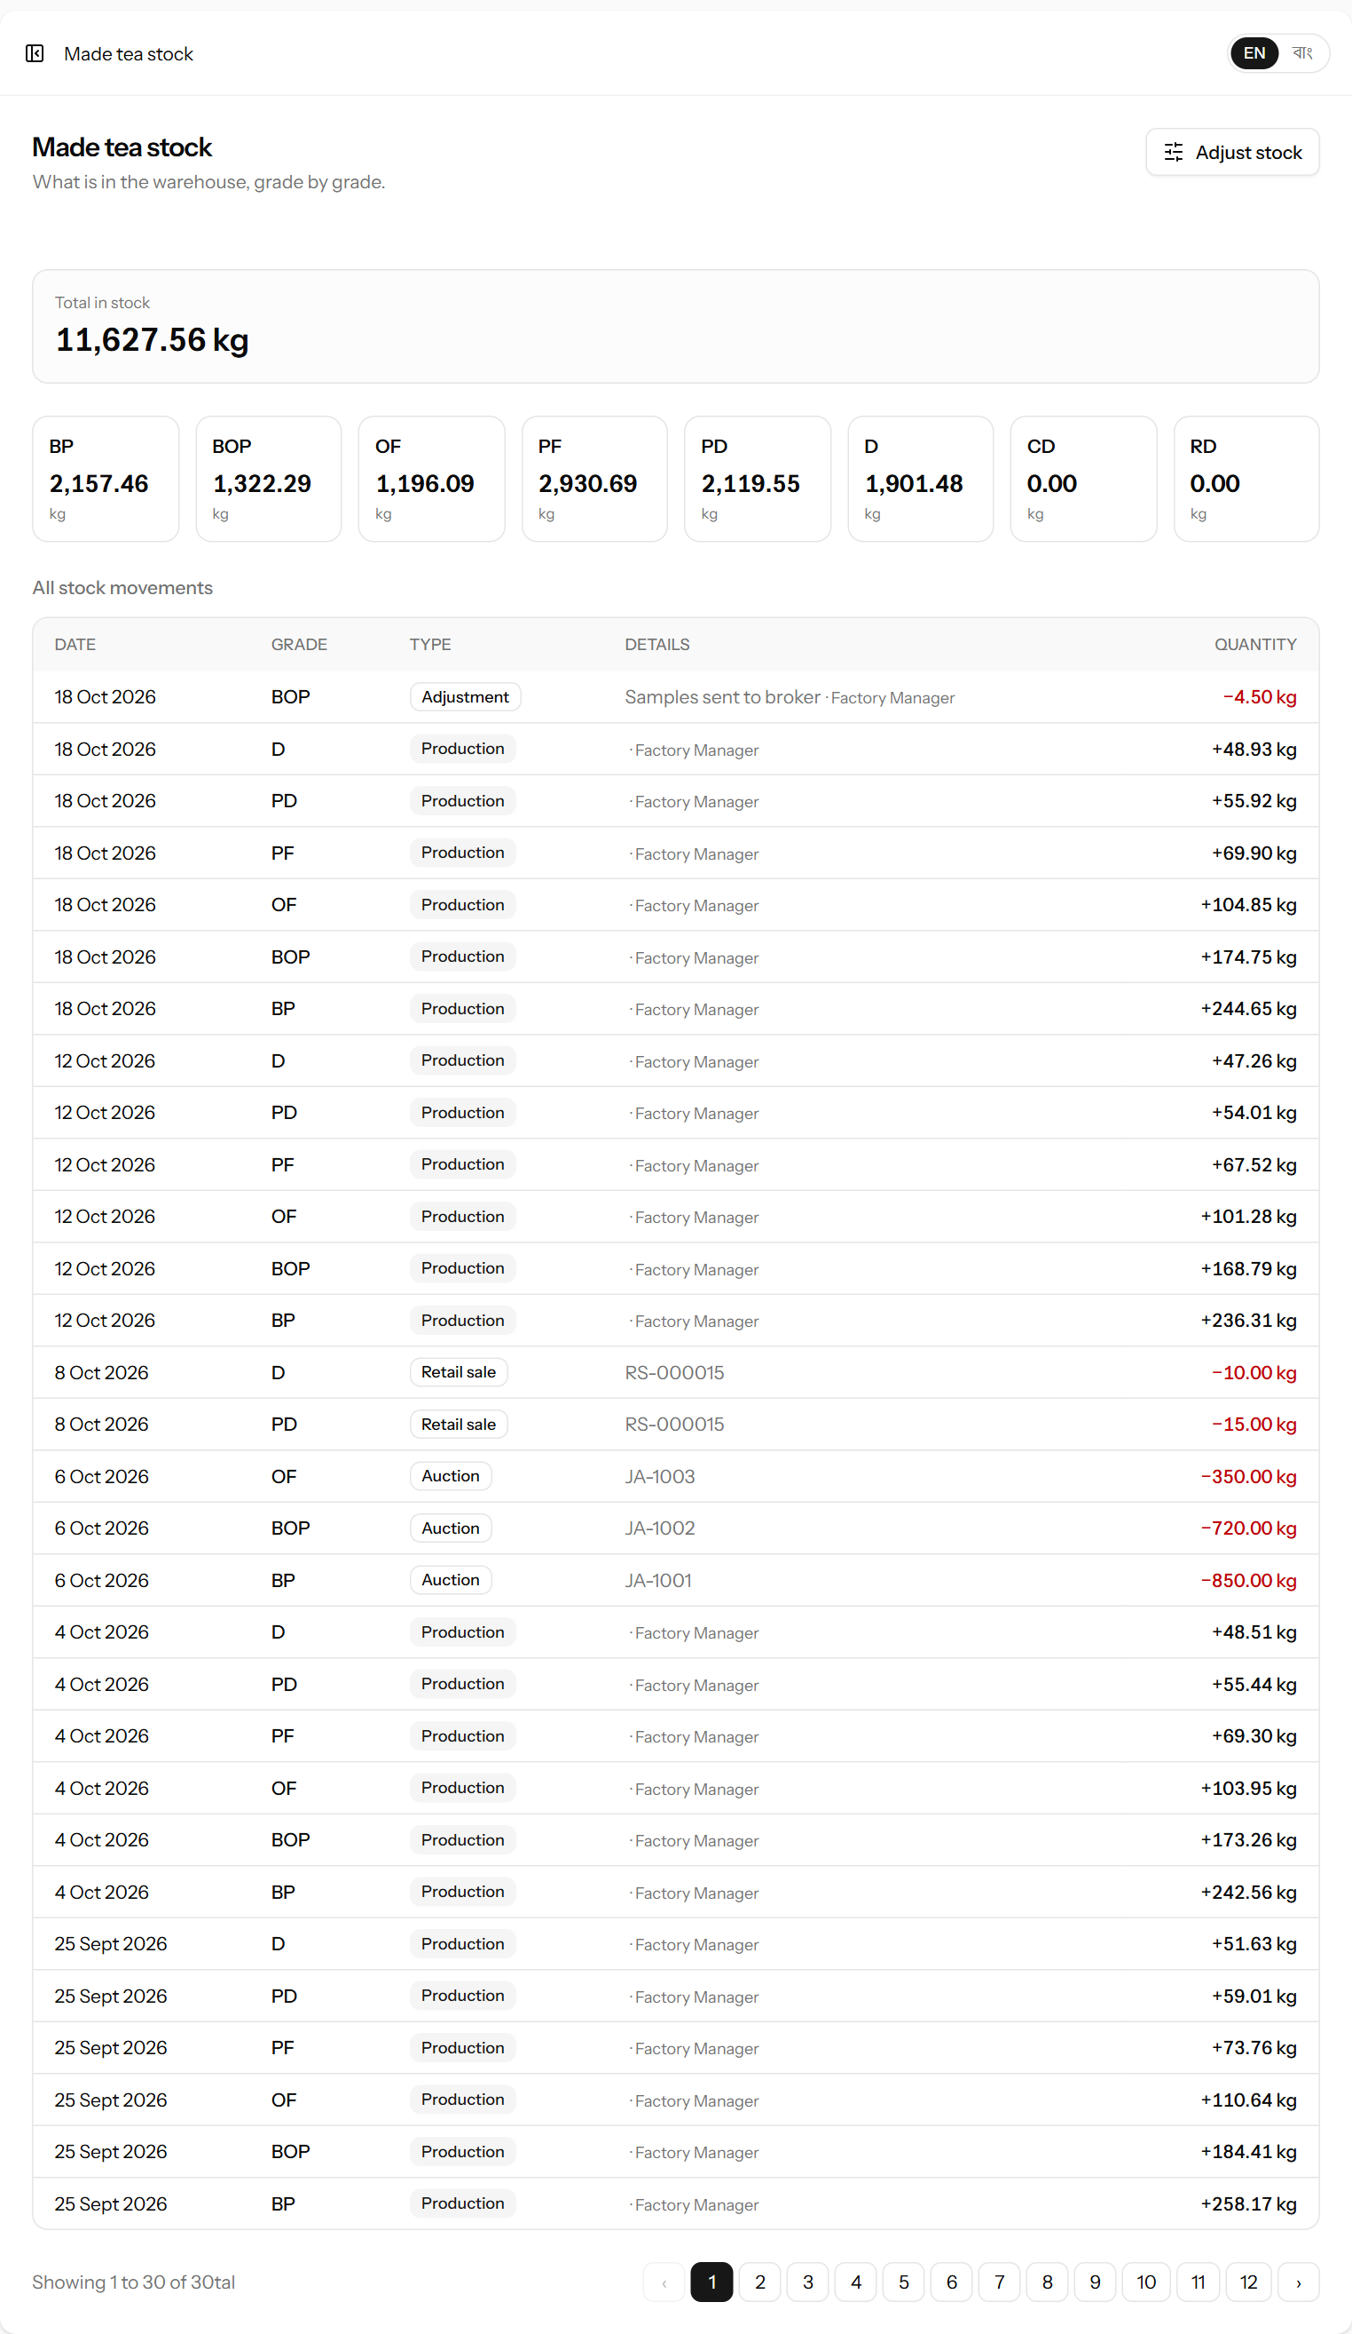
Figure 21. Made tea in stock by grade, with every stock movement below.
Each grade box shows the kg in stock. Click a grade to show only its movements; click it again to show all. The list below is the stock ledger: every kilogram in and out. Stock can never go below zero — the system refuses any entry that would cause it.
Type | Added or taken? | Comes from
Production | Added (+) | Each production batch, one line per grade (chapter 8).
Auction | Taken (−) | Packing an auction invoice (chapter 10). The detail column shows the invoice number.
Retail sale | Taken (−) | Each grade on a retail sale memo (chapter 11). The detail shows the memo number.
Adjustment | Added or taken | Corrections made by hand with a reason (9.2).

9.2 Adjusting stock
Use an adjustment when the stock in the system does not match the store: after a recount, when tea is damaged, or when samples are sent to a broker.
- On the stock page, click Adjust stock.
- Fill in the form and click Save adjustment.
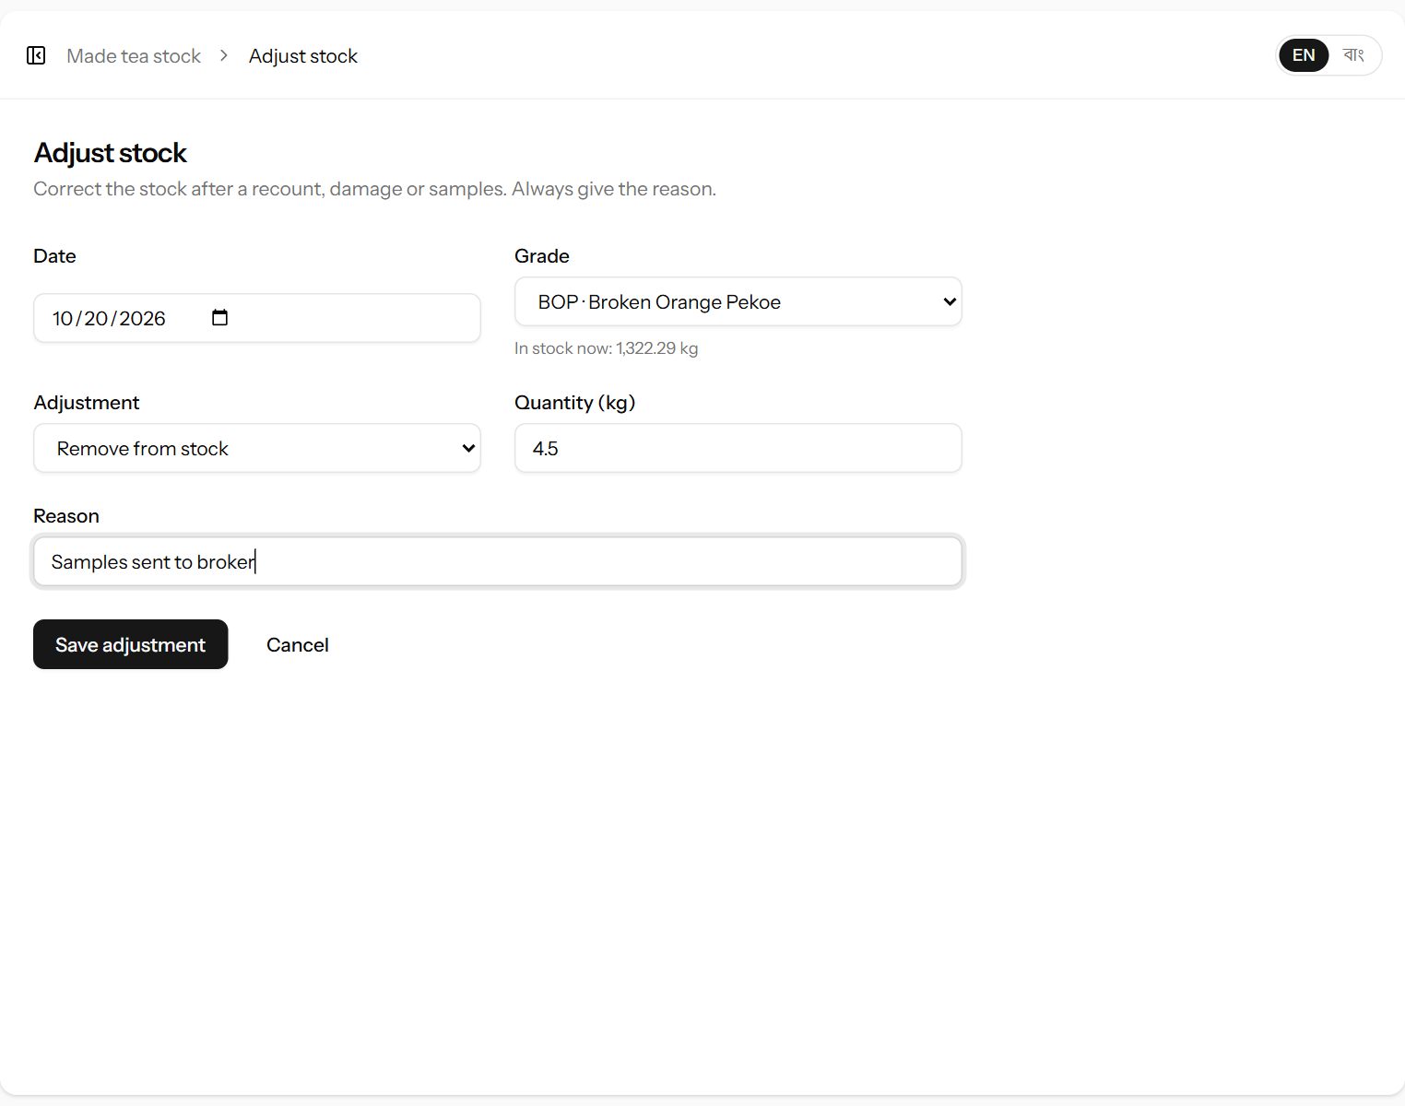
Figure 22. Taking 4.5 kg of BOP out of stock for broker samples.
Field | What it means | Required?
Date | The day of the adjustment. | Yes
Grade | Which grade to adjust. The kg now in stock is shown under it. | Yes
Adjustment | Remove from stock or Add to stock. | Yes
Quantity (kg) | How many kg to add or remove. | Yes
Reason | Why — for example “Monthly recount”, “Samples sent to broker”, “Water damage”. A reason is always required. | Yes

9.3 Tea grades
Open Manufacturing → Tea grades (manager and administrator only). The system starts with the usual CTC grades: BP, BOP, OF, PF, PD, D, CD and RD.
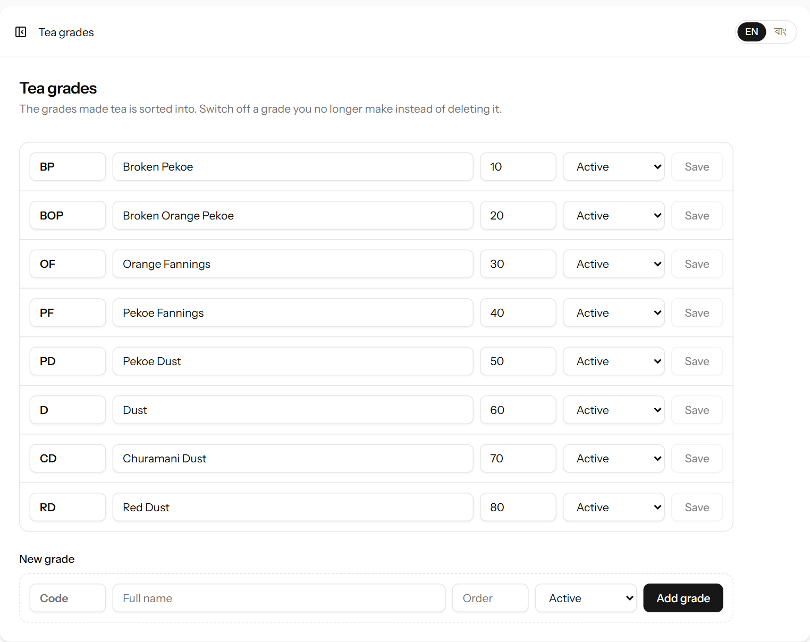
Figure 23. The list of tea grades. Each line can be edited in place.
- To change a grade, edit its Code, full name or Order (the position in lists — lower numbers first) and click Save on that line.
- To add a grade, fill in the New grade line at the bottom and click Add grade.
- Grades cannot be deleted, because old batches and sales refer to them. If the factory stops making a grade, set it to Inactive: it disappears from new forms but stays in the history.

10. Auction sales
Tea sold at auction is handled as invoices. An invoice is a number of packages of a single grade, sent to the auction through a broker. Open Sales → Auction invoices.

10.1 The life of an invoice
An invoice moves through four stages. You record each stage as it happens by opening the invoice and filling in the next part. The status is worked out by the system from what you have filled in.
Status | What has happened | What you fill in
Packed (grey) | The tea is packed in chests or bags and has left the made tea stock. | Invoice number, grade, packages and kg per package (10.3).
Dispatched (blue) | The invoice has been sent to the broker’s warehouse and catalogued. | Dispatched on, Sale no., Lot no. (10.4).
Sold, payment due (amber) | The tea has been sold at the auction; the broker has not paid yet. | Sold on, Buyer, Price per kg (৳), Broker deductions (৳) (10.4).
Paid (green) | The broker has paid the net proceeds. | Payment received on, Payment reference (10.4).

10.2 The invoice list
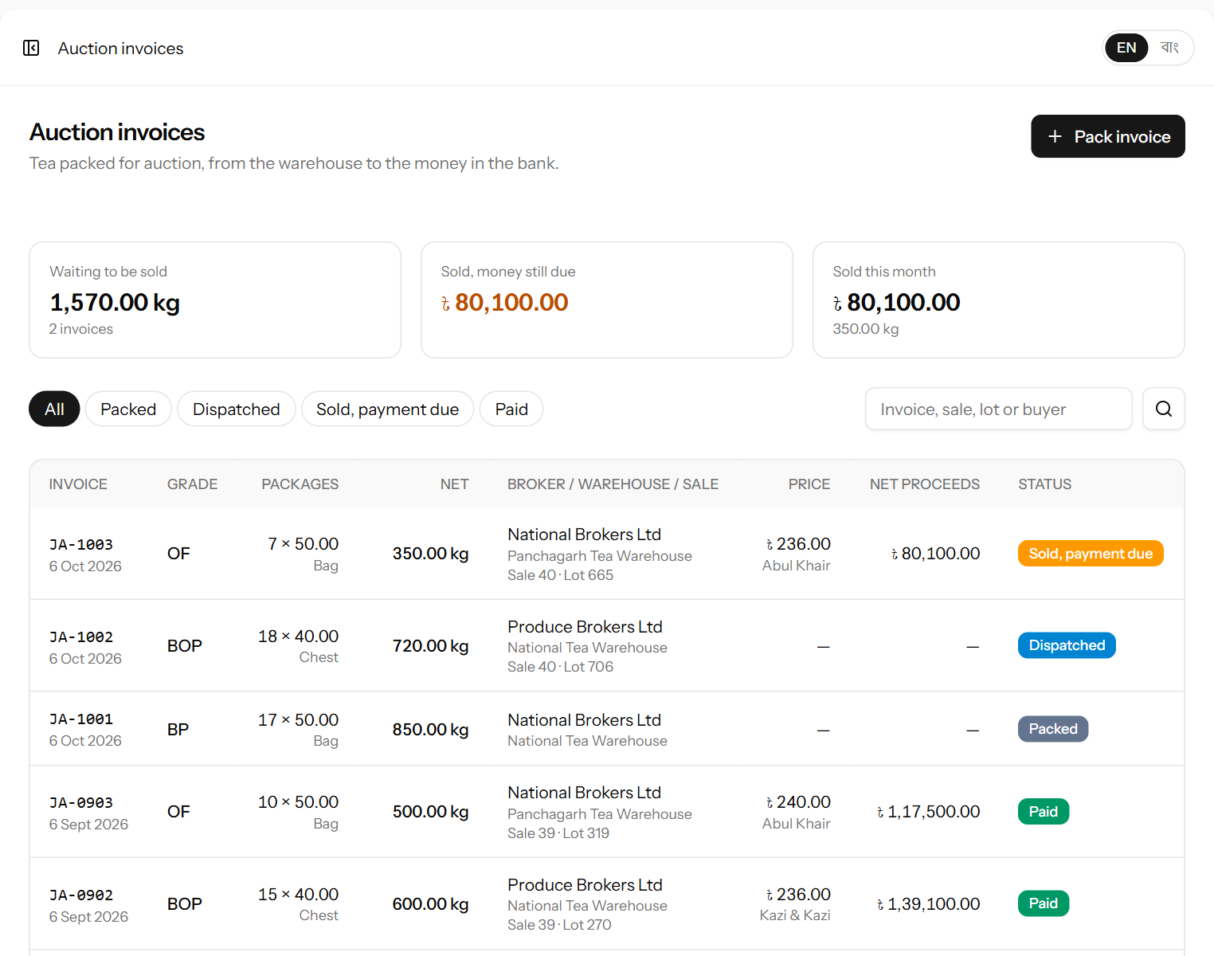
Figure 24. Auction invoices at every stage, with the money still to come in (top of the list).
Part | Meaning
Waiting to be sold | kg and number of invoices packed or dispatched but not yet sold.
Sold, money still due | Net proceeds of invoices sold but not yet paid by the broker.
Sold this month | Net proceeds and kg of invoices sold since the 1st of this month.
Status buttons | Show only invoices in one stage, or All.
Search | Find an invoice by invoice, sale or lot number or buyer.
Table | Each invoice: number and packing date, grade, packages × kg, net weight, broker, warehouse and sale/lot, price and buyer, net proceeds and status. Click the invoice number to open it.

10.3 Packing a new invoice
- Click Pack invoice.
- Check the Invoice no. — the next number (for example JA-0007) is suggested; change it if the factory uses another numbering.
- Choose the Grade. The kg available in stock is shown under it.
- Choose Packed in (chest or bag) and enter the Number of packages and Net kg per package. The net weight is shown on the right.
- Choose the Warehouse, the Broker and the Auction centre if already known.
- Click Pack invoice. The tea is taken out of stock.
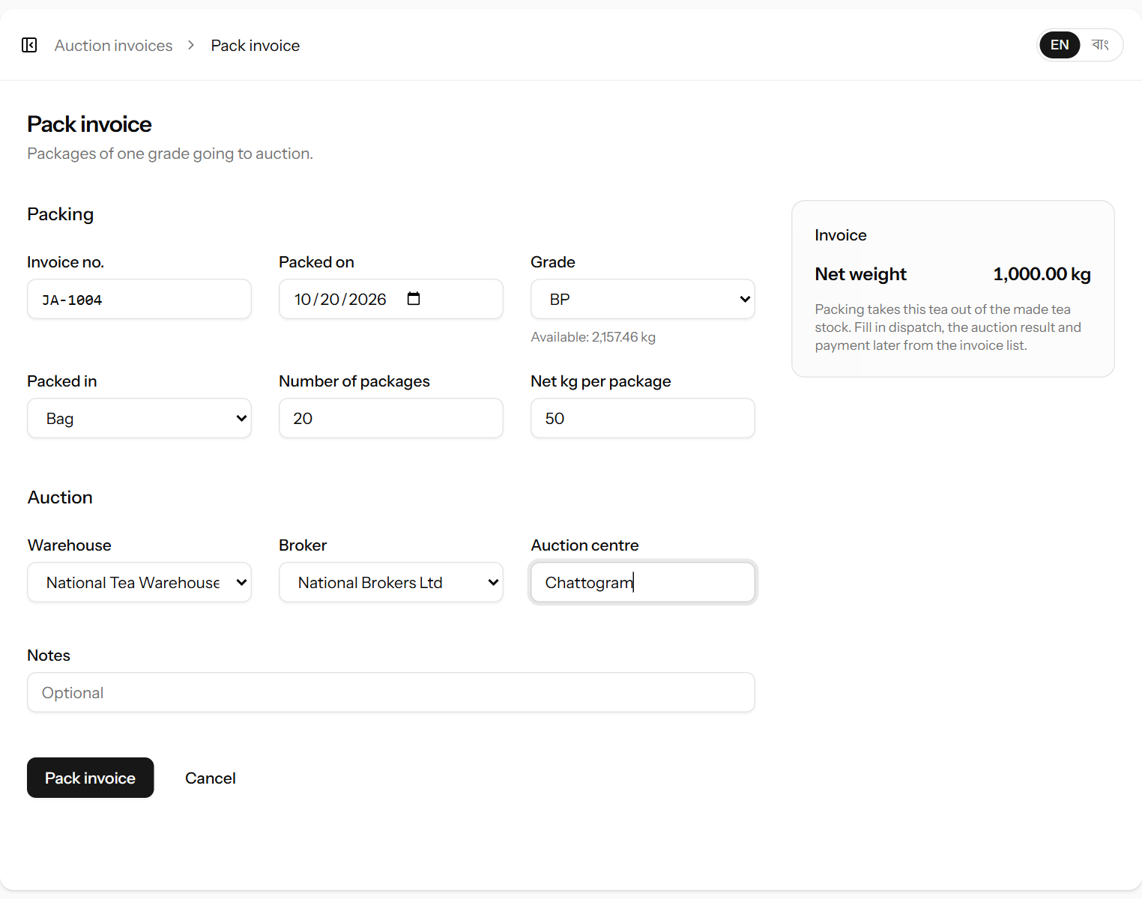
Figure 25. Packing 20 bags of 50 kg of BP for the National Tea Warehouse.
Field | What it means | Required?
Invoice no. | The garden invoice number. Each invoice number can be used only once. | Yes
Packed on | The date the tea was packed. | Yes
Grade | The grade of tea in this invoice. One invoice = one grade. | Yes
Packed in | Chest or Bag. | Yes
Number of packages | How many chests or bags. | Yes
Net kg per package | The net tea weight in each package. | Yes
Warehouse | The auction warehouse the invoice is sent to (see 10.7). | No
Broker | The broker who will sell the invoice (see 10.6). | No
Auction centre | Where it will be sold, for example Chattogram, Srimangal or Panchagarh. | No
Notes | Anything else. | No

Note: If the net weight is more than the stock of that grade, a red warning appears and the system will not save the invoice.

10.4 Recording dispatch, the auction result and payment
Open the invoice by clicking its number in the list. The packing part stays at the top; the auction parts are below it. Fill in what has happened and click Save changes. You can do this in several visits, one stage at a time.
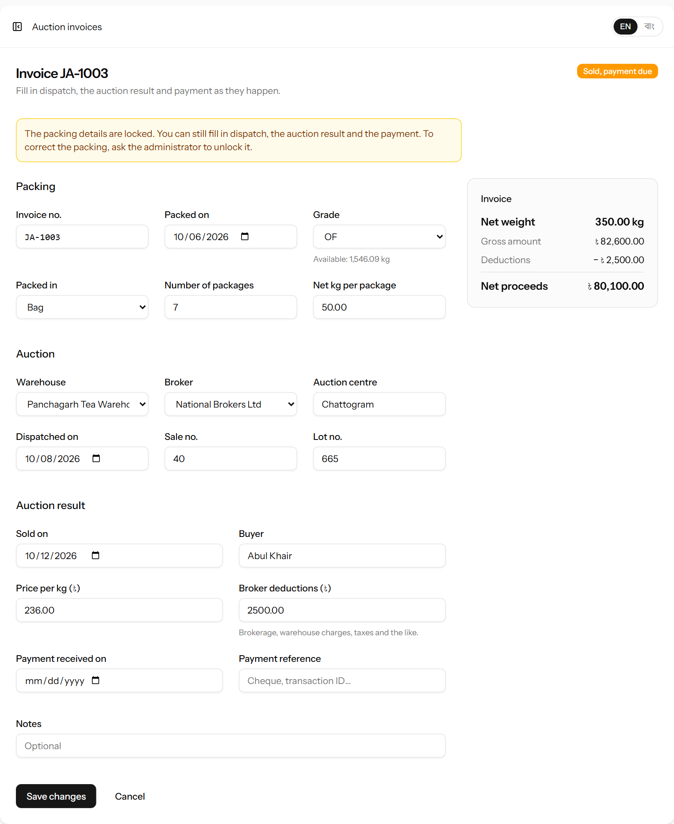
Figure 26. An invoice sold at auction, waiting for the broker’s payment.
Field | What it means | Required?
Dispatched on | The day the invoice left for the broker’s warehouse. Not before the packing date. | No
Sale no. / Lot no. | The auction sale number and the lot number from the broker’s catalogue. | No
Sold on | The auction date. Must be filled together with the price. | With price
Buyer | The company that bought the tea. | No
Price per kg (৳) | The auction price. Must be filled together with the sold date. | With date
Broker deductions (৳) | Everything the broker takes out of the proceeds: brokerage, warehouse charges, taxes and the like, as one total. | No
Payment received on | The day the broker’s money arrived. Only possible once the price is recorded. | No
Payment reference | Cheque number or bank transaction ID. | No

Worked example: 20 bags × 40.50 kg = 810 kg net. Sold at ৳215.50 per kg.
Gross amount = 810 × 215.50 = ৳174,555.00.
Broker deductions ৳3,500 → Net proceeds = 174,555 − 3,500 = ৳171,055.00.
Note: In the cash book (chapter 14), auction money is always counted as received by bank.
Three days after packing, the packing details (invoice number, date, grade, packages and kg) lock like other entries (chapter 16). Dispatch, the auction result and the payment can still be filled in at any time, because they happen weeks later.

10.5 Deleting an invoice
An invoice packed by mistake can be deleted while it is not yet sold and within three days of packing: open it and click Delete. Its tea goes back into stock. Once an auction price is recorded the invoice can no longer be deleted.

10.6 Brokers
Open Sales → Brokers (manager and administrator only) to keep the list of brokers the factory sells through.
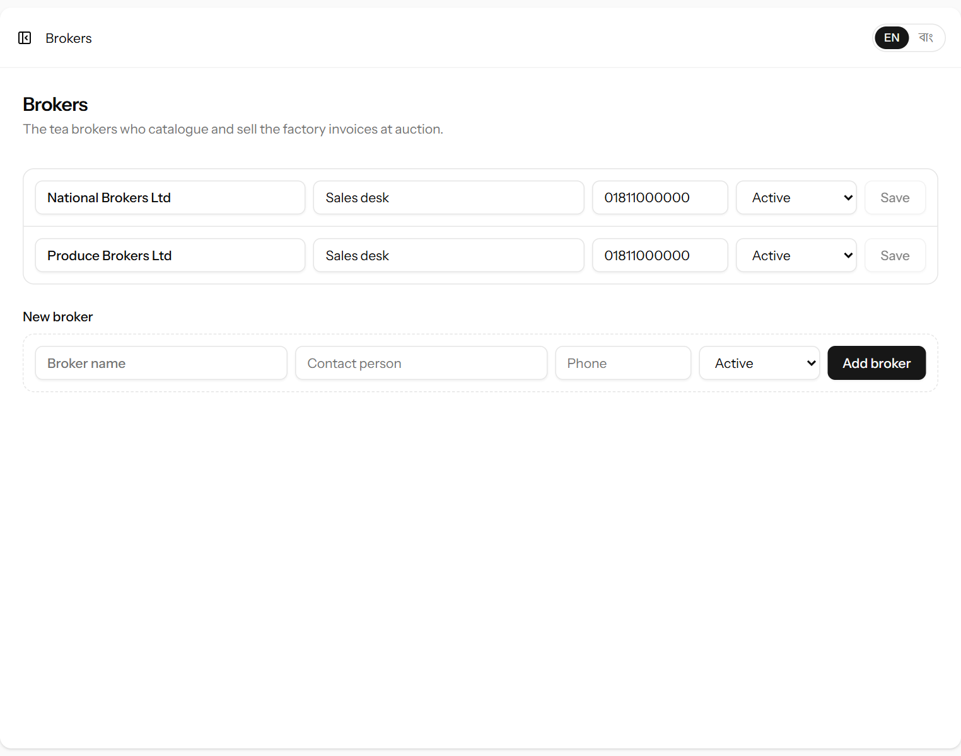
Figure 27. The list of brokers.
Edit a broker’s Broker name, Contact person, Phone or status on its line and click Save; add a broker on the New broker line. A broker the factory no longer uses can be set to Inactive.

10.7 Warehouses
Open Sales → Warehouses (manager and administrator only) to keep the list of auction warehouses the factory sends its invoices to. Under each name the page shows how many invoices there are still waiting to be sold, and their kg.
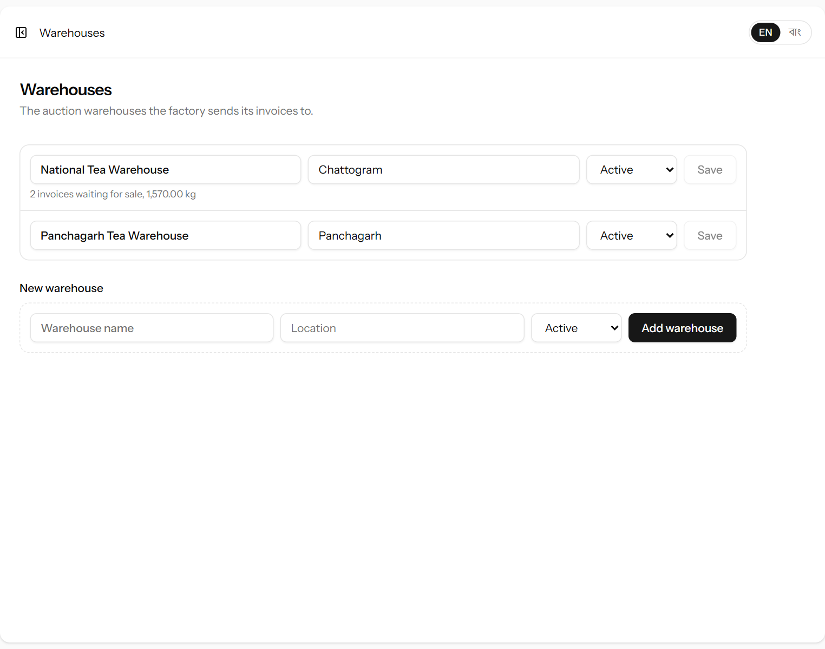
Figure 28. The auction warehouses.
Edit a warehouse’s Warehouse name, Location or status on its line and click Save; add one on the New warehouse line. A warehouse no longer used can be set to Inactive.

11. Retail sales and customers
Tea sold directly to shops and buyers is recorded as sale memos. Buyers who buy on credit are kept as customers with an account, like suppliers.

11.1 Customers
Open Sales → Customers. The list shows each customer’s total purchases and their balance — what they still owe the factory. At the top is the Total due from customers.
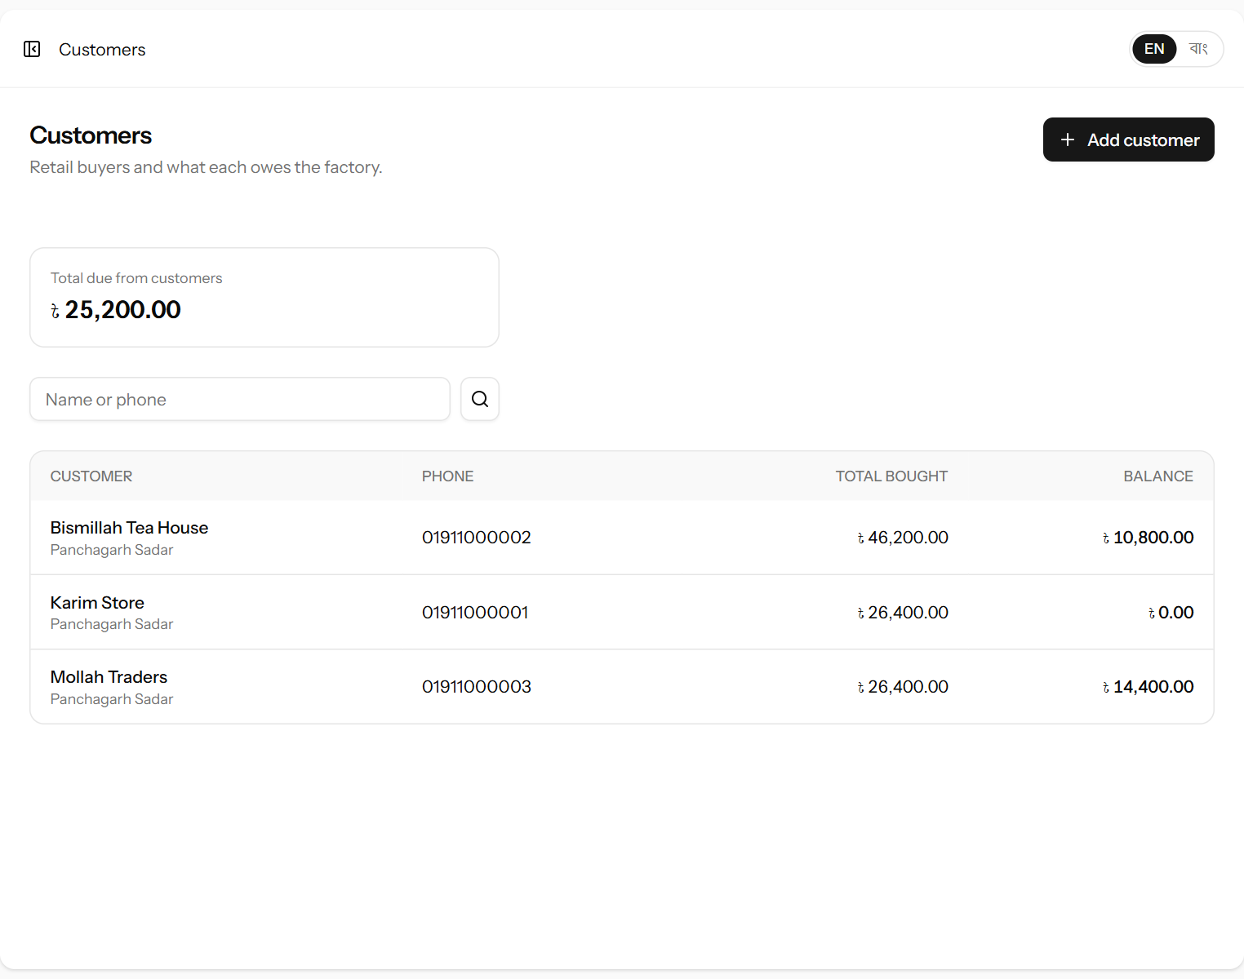
Figure 29. The customer list with what each customer owes.
To add a customer, click Add customer, fill in the form and click Add customer.
Field | What it means | Required?
Customer name | The shop or buyer’s name. | Yes
Phone | Mobile number. | No
Address | Where they are. | No
Opening balance (৳) | What the customer already owed the factory when you started using the system. | No
Status | Inactive customers are not offered on new sales. | Yes
Notes | Anything else. | No

11.2 Writing a sale memo
- Open Sales → Retail sales and click New sale (or click New sale on a customer’s statement).
- Check the Date and choose the Customer. For a buyer who is not a regular customer, leave Walk-in (cash, paid in full).
- Under Tea sold, choose a grade (the kg in stock is shown in the list), and enter the kg and the rate per kg. Click Add another grade for each further grade on the same memo.
- Under Payment, enter what was Received now (৳) and how it was paid. Click Paid in full if the whole amount was paid.
- Check the Memo box on the right: total, received now and what will be added to the customer’s due.
- Click Save & print memo.
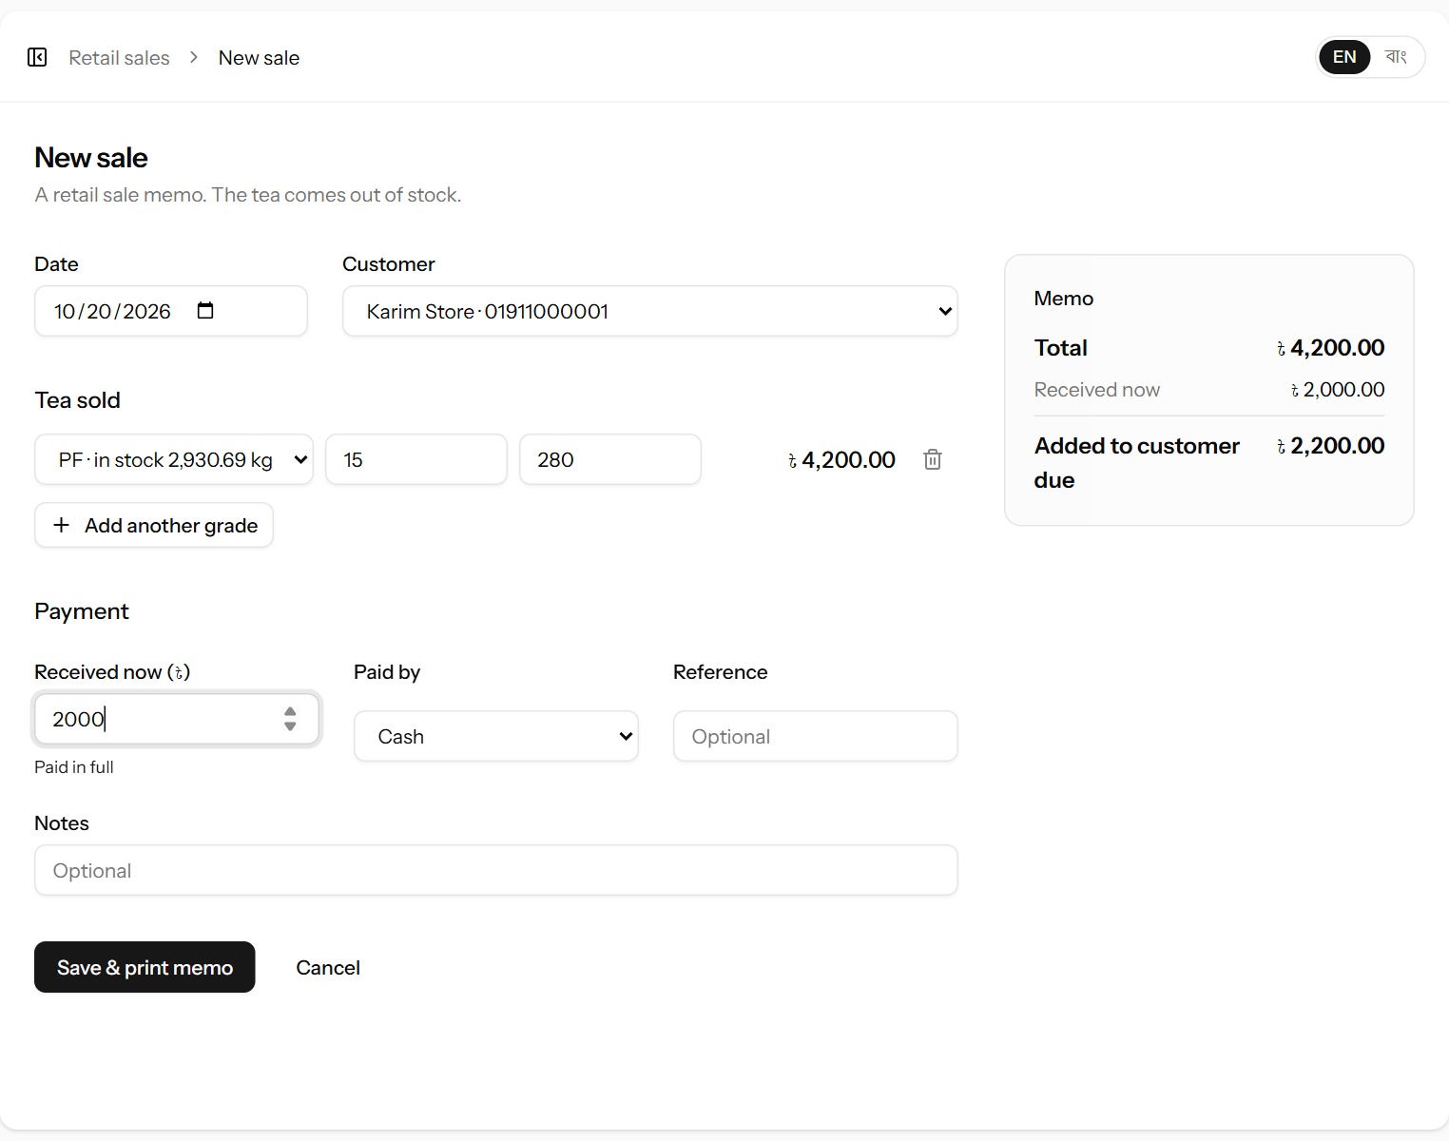
Figure 30. A credit sale: ৳4,200 of PF, ৳2,000 paid now, ৳2,200 added to the customer’s due.
Field | What it means | Required?
Date | The day of the sale. | Yes
Customer | Who bought. Walk-in sales have no customer. | No
Grade (per line) | The grade sold. The same grade cannot appear twice on one memo. | Yes
kg (per line) | How many kg of that grade. | Yes
৳ per kg (per line) | The selling price. | Yes
Received now (৳) | Money taken at the time of the sale. For a walk-in sale this is always the full total. | No
Paid by | Cash, Bank or Mobile banking. | Yes
Reference | Transaction ID for bank or mobile payments. | No
Notes | Anything else. | No

Important: A walk-in sale (no customer) must be paid in full — there is nobody to owe the money.
A sale cannot take more tea than is in stock. If one grade is short, nothing on the memo is saved.

11.3 The sale memo
After saving, the memo opens. Click Print memo to print it for the buyer. Each memo has a number such as RS-000015 (RS = retail sale).
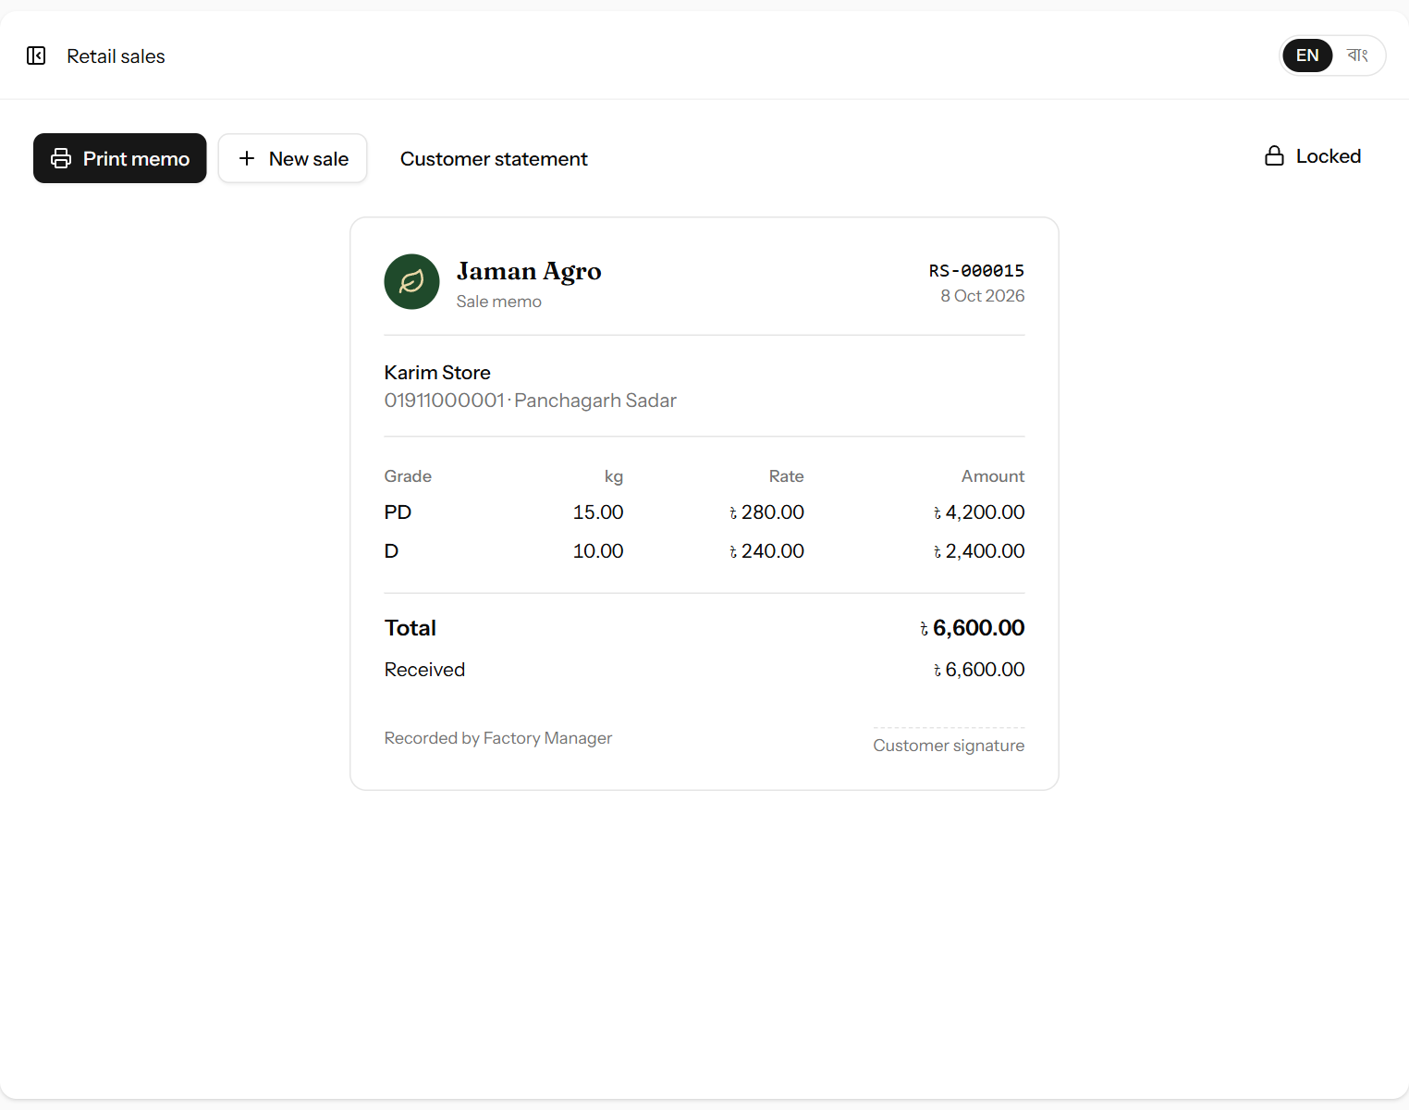
Figure 31. A printed sale memo with the amount due.

11.4 Cancelling a sale
Retail sales cannot be edited. If a memo is wrong, open it, click Cancel sale and confirm, then write it again correctly. Cancelling puts the tea back into stock and removes the money taken with the sale. A sale can be cancelled for three days; after that the button shows Locked (chapter 16).

11.5 The sales list and the customer statement
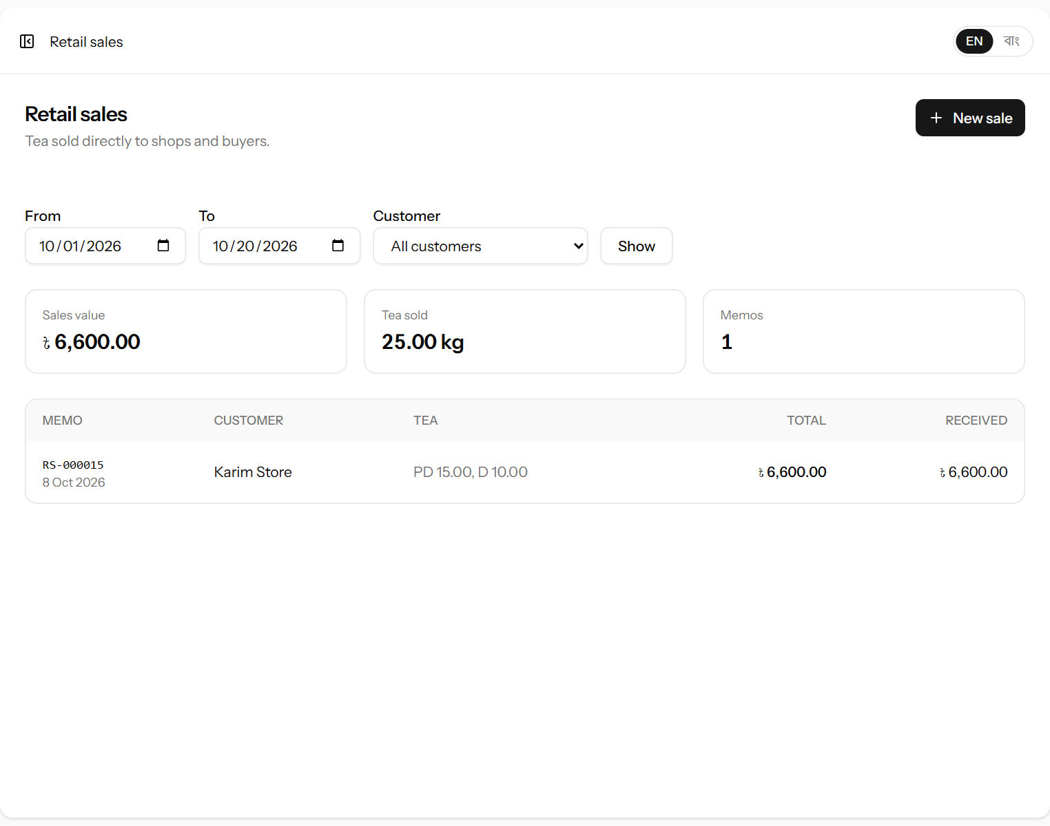
Figure 32. Retail sales for a period with totals.
The Retail sales list shows every memo in a period (choose From, To and optionally a customer, then Show), with the sales value, kg sold and number of memos at the top.
Click a customer’s name in the Customers list to open their statement. It works like the supplier statement: opening balance, each sale (which adds to what they owe) and each payment (which reduces it), a running balance and the closing balance. Print it to send to the customer.
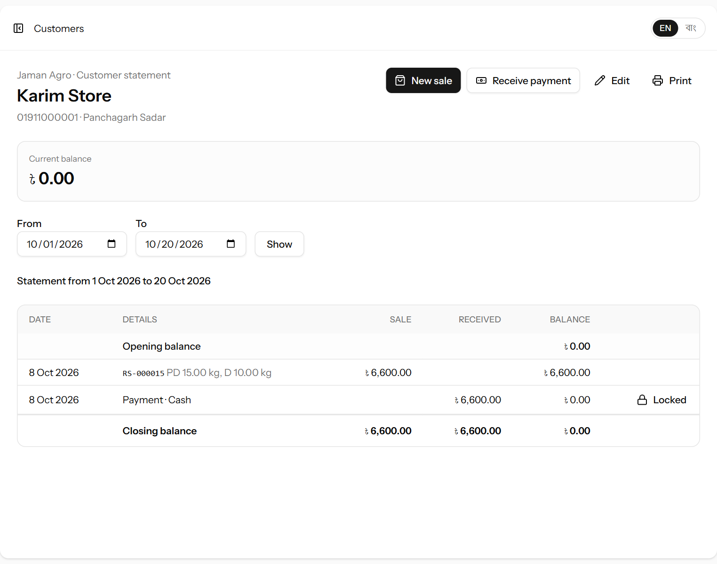
Figure 33. A customer statement.

11.6 Receiving money from a customer
- On the customer’s statement, click Receive payment. The customer is filled in and their current balance shown.
- Enter the date, amount, how it was paid and any reference.
- Click Receive payment. The statement opens with the payment on it.
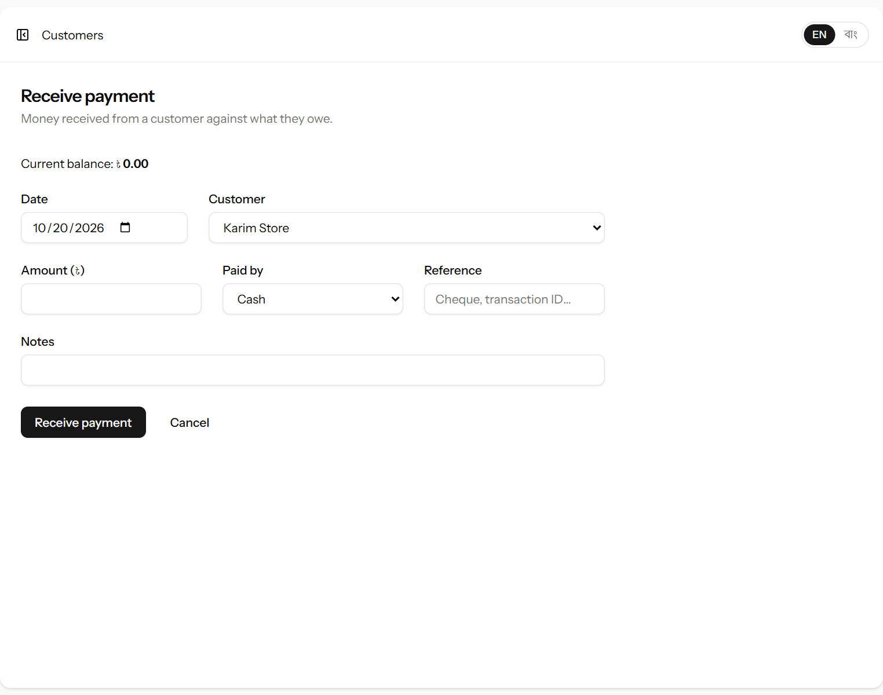
Figure 34. Receiving a payment from a customer.
A payment received later can be deleted from the customer’s statement with the red bin symbol, within three days of recording it. Money taken together with a sale can only be removed by cancelling that sale.

12. Expenses
Record every running cost here — both the factory’s costs (fuel, electricity, repairs, machine parts, packing materials, loading and so on) and the running costs of the factory’s own vehicles (fuel, driver salary, repairs). Open Accounts → Expenses.

12.1 The month page
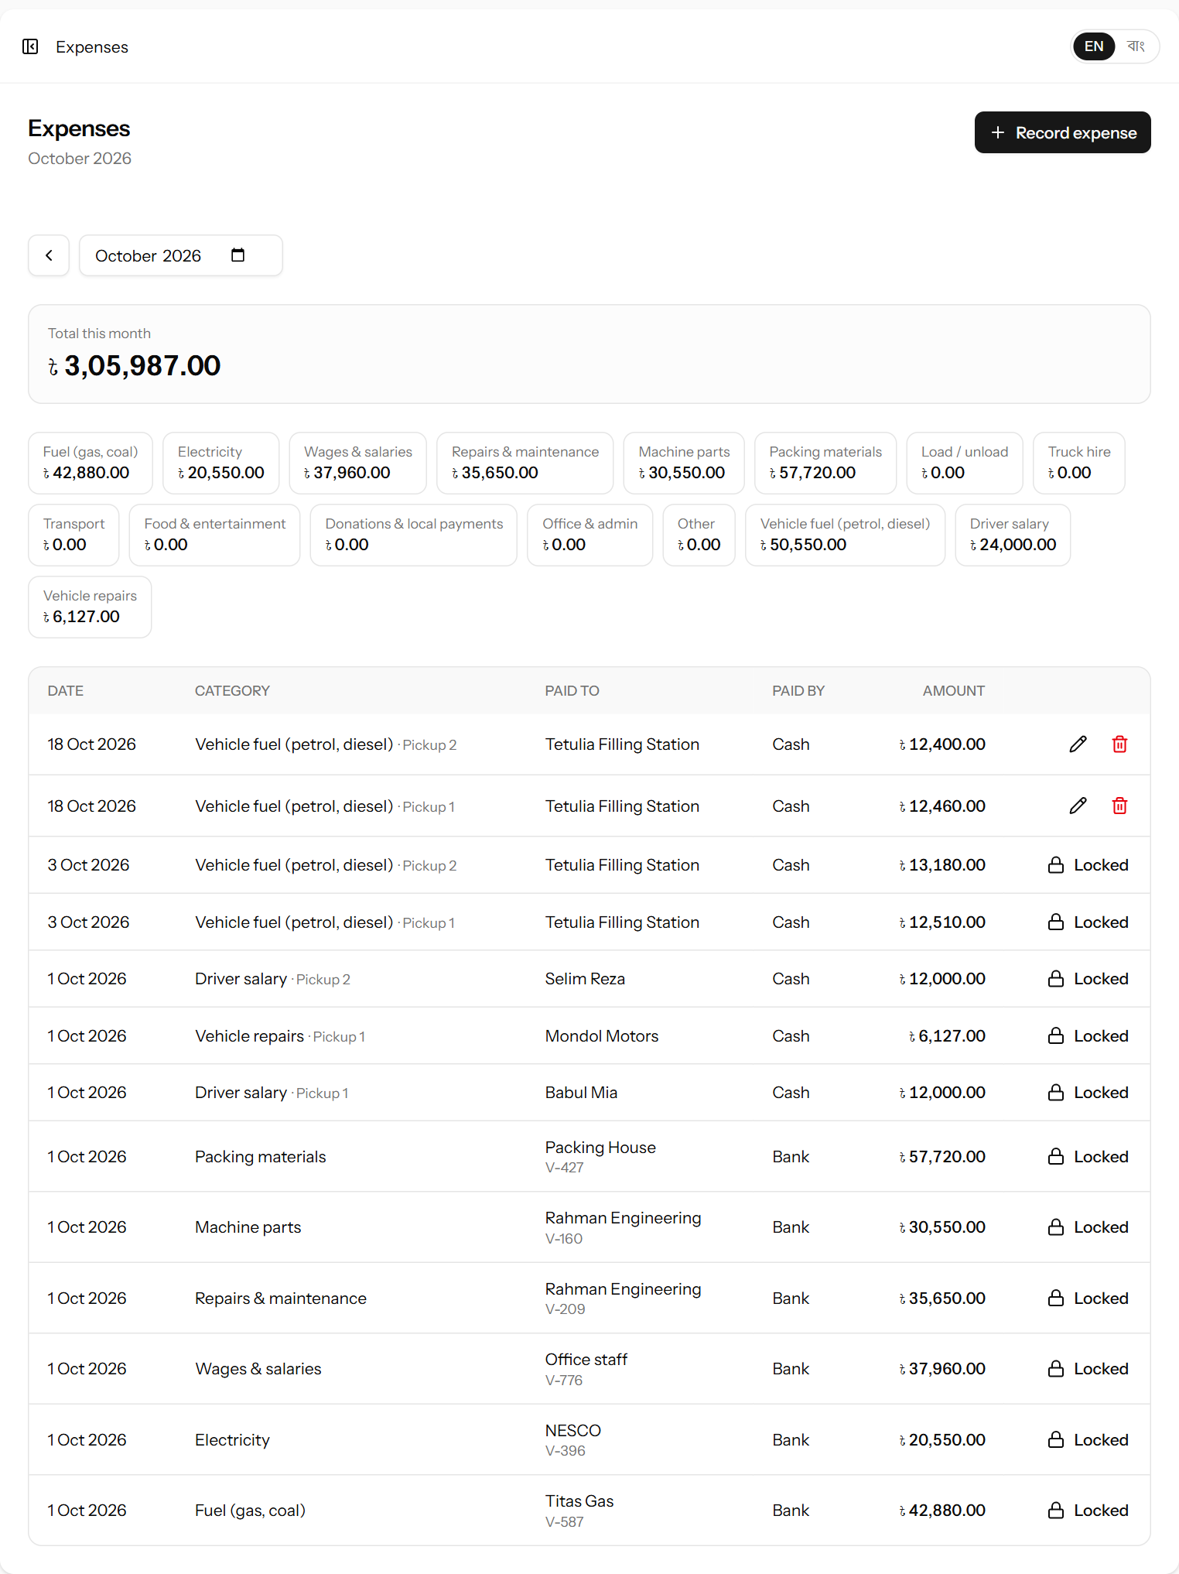
Figure 35. A month of expenses with a total per category.
The page shows one month (use ‹ › or the month box). At the top is the total for the month, then one box per category with its total — click a category to see only its expenses, click it again to see all.

12.2 Recording an expense
- Click Record expense.
- Fill in the form and click Record expense.
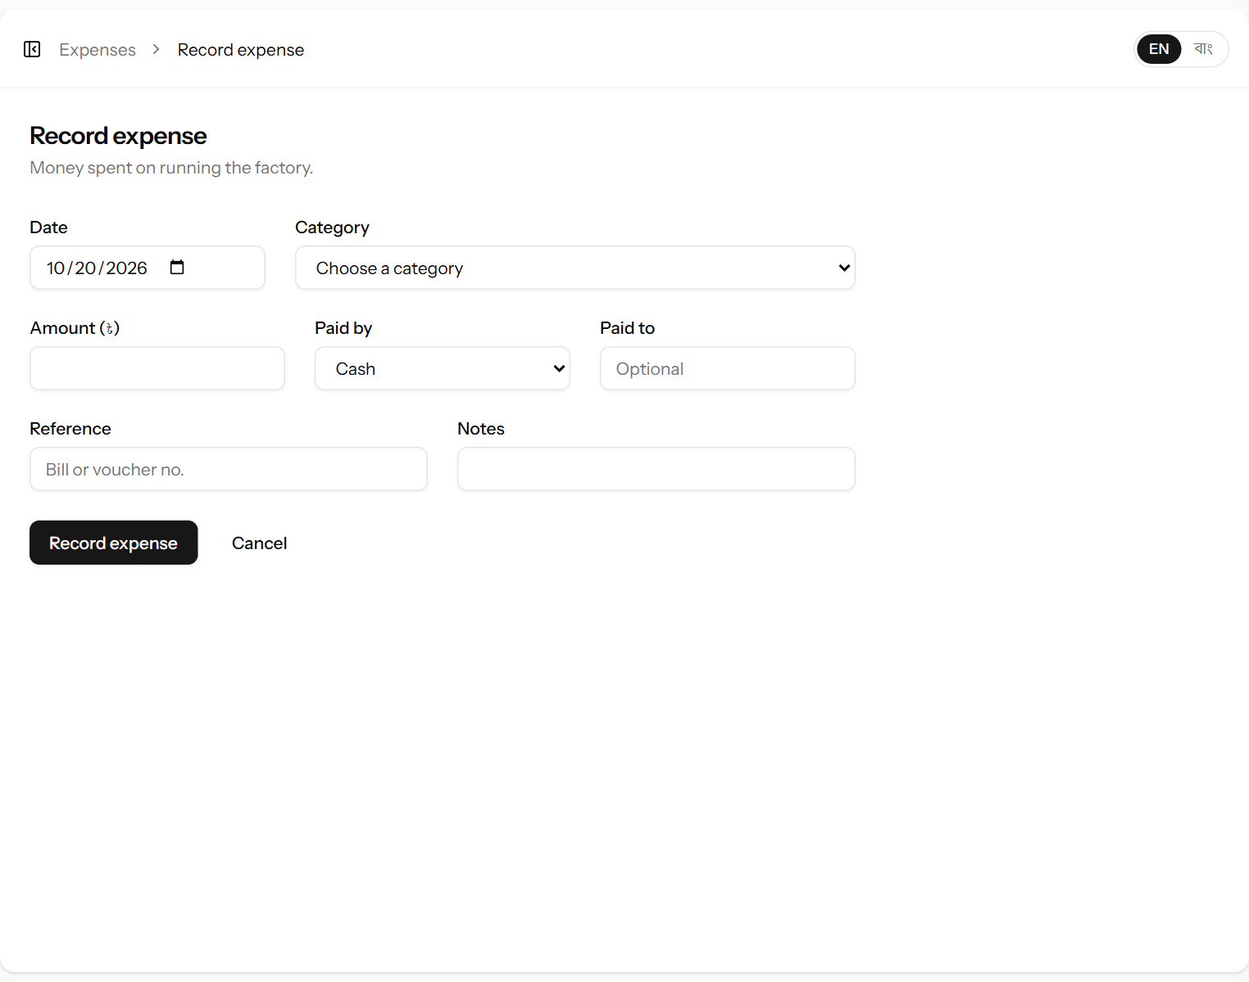
Figure 36. Recording an expense.
Field | What it means | Required?
Date | The day the money was spent. | Yes
Category | What the money was spent on (see 12.3). The list is split into Factory and Vehicle categories. | Yes
Factory vehicle | Appears only for a vehicle category: which vehicle the money was spent on. | For vehicle costs
Amount (৳) | How much was spent. | Yes
Paid by | Cash, Bank or Mobile banking. | Yes
Paid to | Who was paid, for example “Titas Gas”. | No
Reference | Bill or voucher number. | No
Notes | Anything else. | No

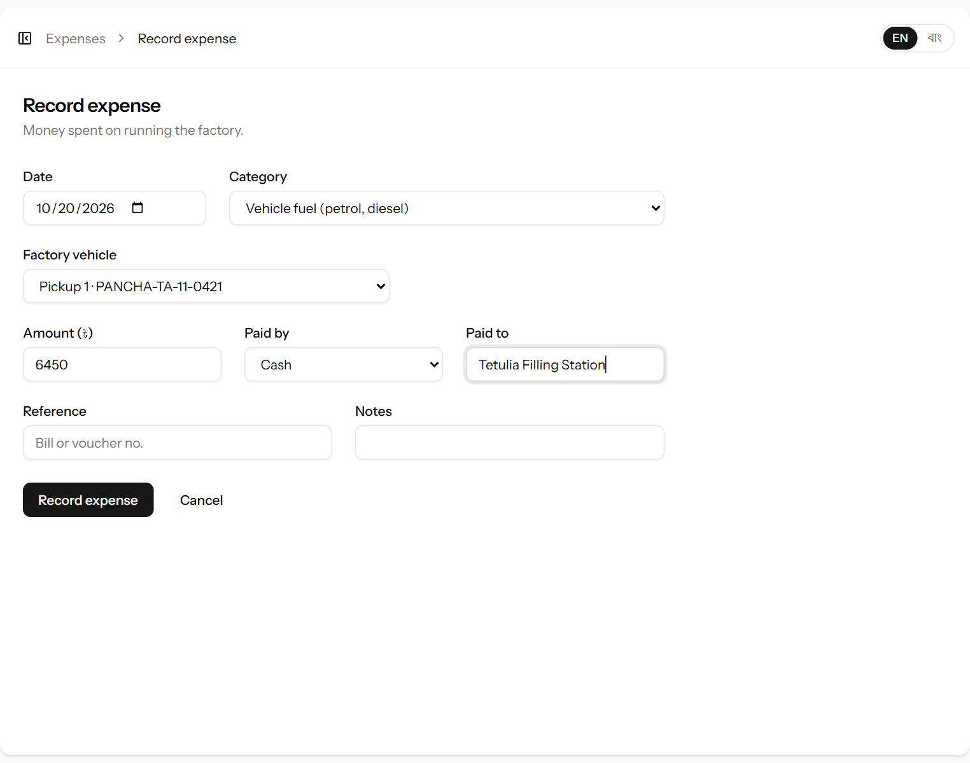
Figure 37. A vehicle expense: diesel for Pickup 1.
In the list, a vehicle expense shows the vehicle’s name next to its category. Use the pencil symbol to correct an expense and the red bin symbol to delete one entered by mistake — within three days of recording it (chapter 16).

12.3 Expense categories
Open Accounts → Expense categories (manager and administrator only). Each category has a Kind: Factory or Vehicle. Vehicle costs are reported as transport cost and added to the cost of the leaf (15.1).
Kind | Categories the system starts with
Factory | Fuel (gas, coal), Electricity, Wages & salaries, Repairs & maintenance, Machine parts, Packing materials, Load / unload, Truck hire, Transport, Food & entertainment, Donations & local payments, Office & admin, Other
Vehicle | Vehicle fuel (petrol, diesel), Driver salary, Vehicle repairs

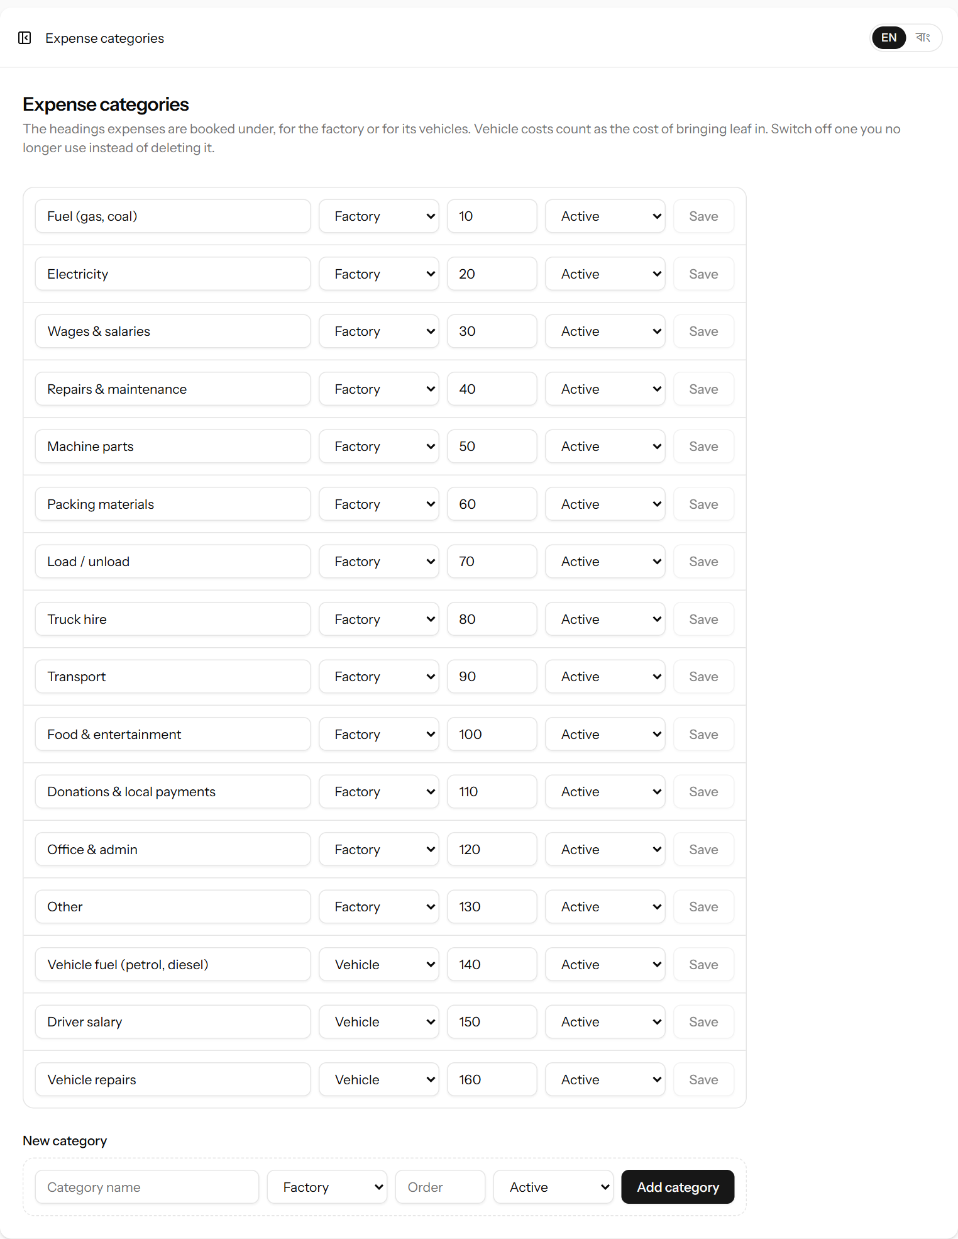
Figure 38. The expense categories, each marked Factory or Vehicle.
Rename, reorder or change the kind of a category on its line and click Save, or add one on the New category line. A category that is no longer used can be set to Inactive; it cannot be deleted because old expenses refer to it.
Important: Daily workers are paid from the Wages page (chapter 13), and their pay is counted in the reports from there. Use the Wages & salaries expense category only for salaried staff who are not on the attendance sheet or contract work — otherwise the same wages would be counted twice.

13. Workers and wages
The factory pays two kinds of daily workers. Hourly workers are paid for the hours between their time in and time out. Contract workers are paid for the work they do — per kg of leaf unloaded, per bag filled or loaded, per ton of coal and so on. Both are paid twice a week. Everything is under Workforce in the menu.

13.1 Workers
Workforce → Workers lists every worker, how they are paid, their hourly rate and what the factory owes them right now.
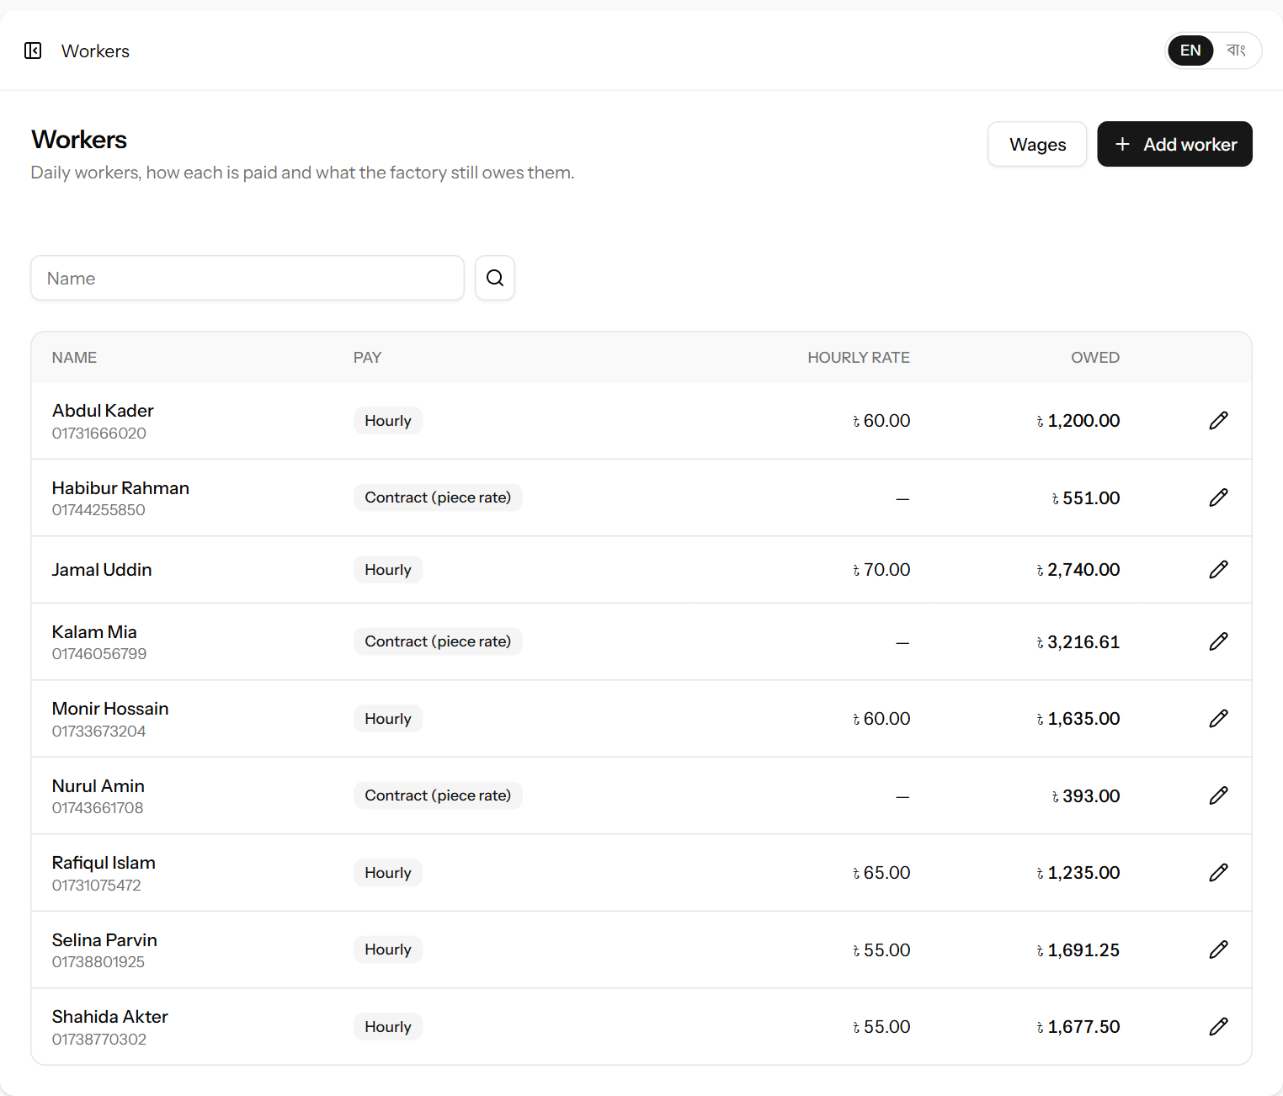
Figure 39. The list of workers with what each is owed.
- Click Add worker.
- Fill in the form and click Add worker.
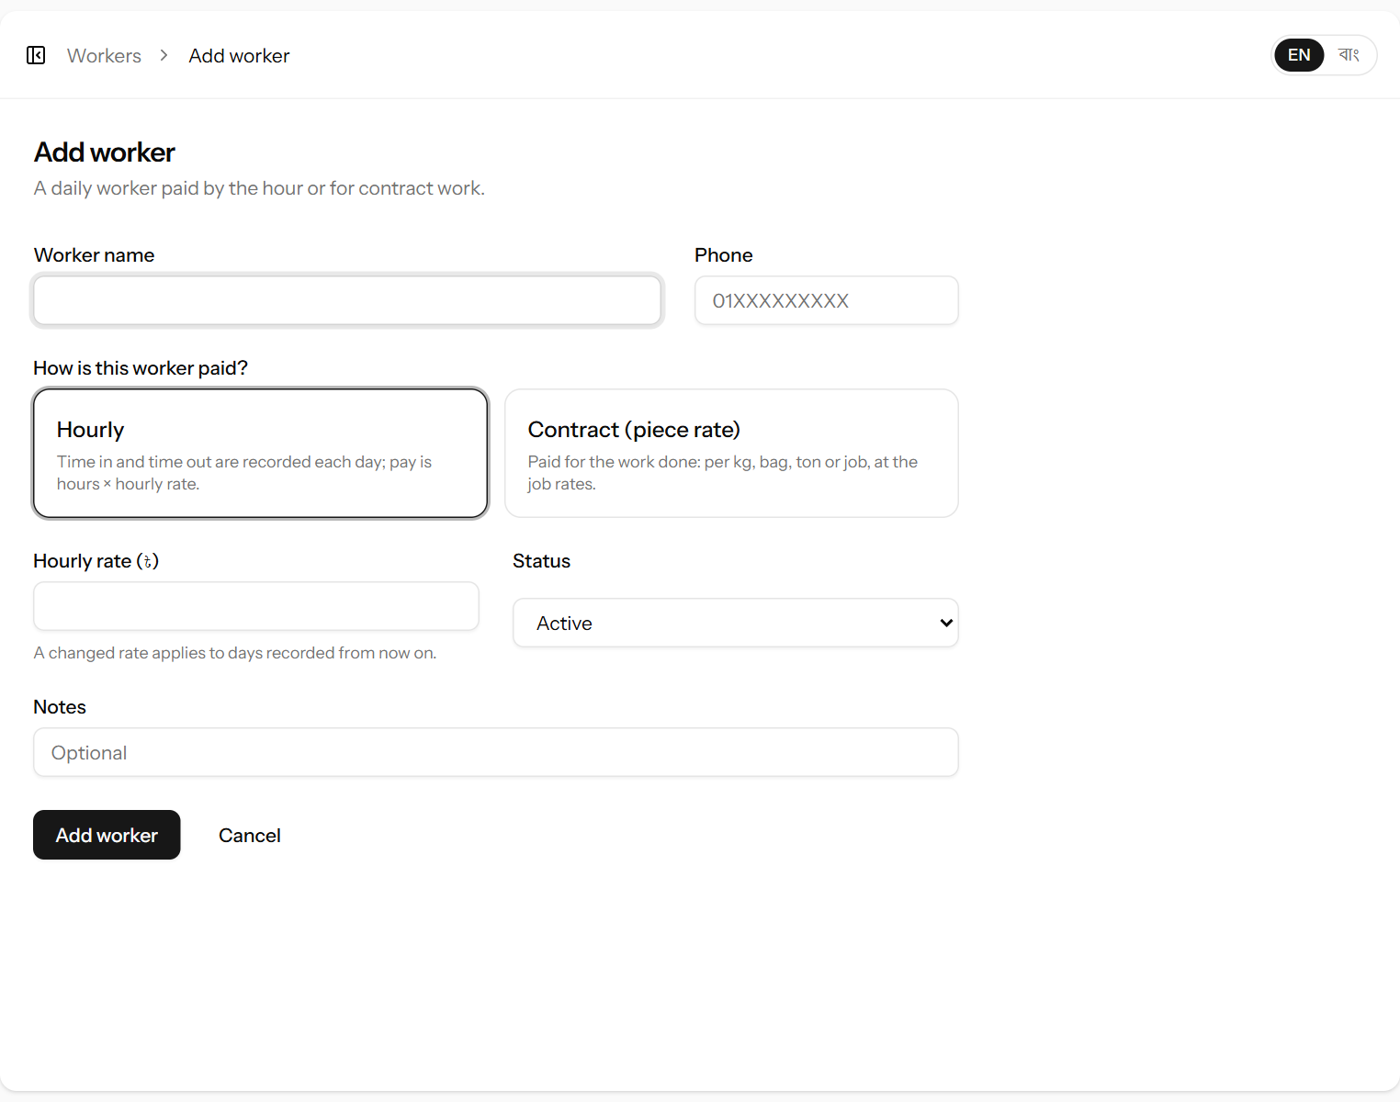
Figure 40. Adding a worker. Click the box that describes how the worker is paid.
Field | What it means | Required?
Worker name | The worker’s name as it should appear on the sheets. | Yes
Phone | Mobile number. | No
How is this worker paid? | Hourly — on the attendance sheet, paid hours × hourly rate. Contract (piece rate) — paid for contract work at the job rates. | Yes
Hourly rate (৳) | What an hourly worker earns per hour. Shown only for hourly workers. | For hourly
Status | Inactive workers no longer appear on the attendance sheet or in the contract-work list. | Yes
Notes | Anything else, for example “Night dryer shift”. | No

To change a worker, click the pencil symbol. A new hourly rate applies to days recorded from then on; days already recorded keep their rate. Workers are never deleted — set someone who has left to Inactive.

13.2 Attendance
Workforce → Attendance is the sheet for one day, with a line for every active hourly worker.
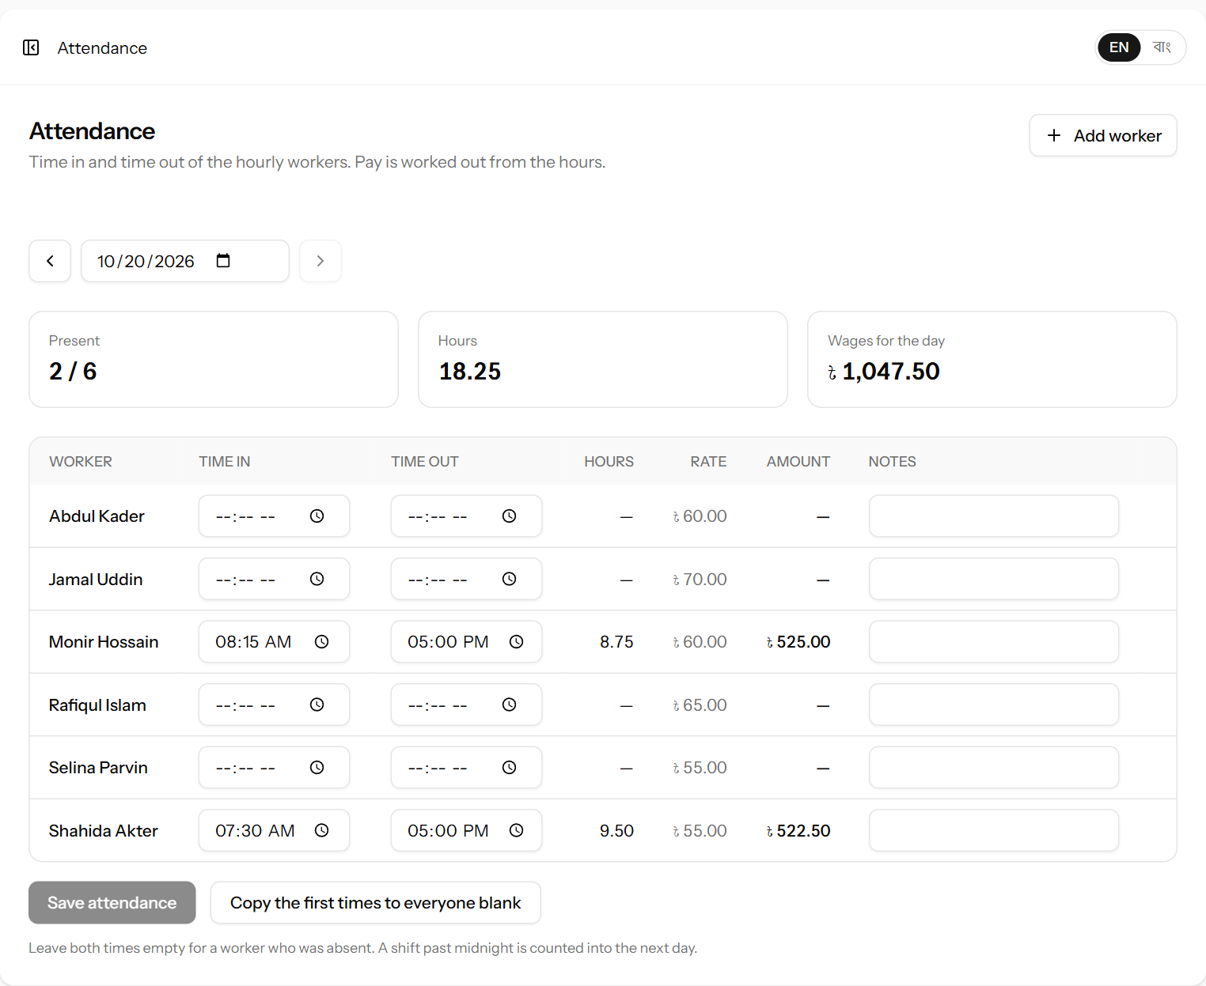
Figure 41. The attendance sheet in the middle of the day: two workers’ times are in so far.
- Check the date. Use ‹ › or the date box for another day.
- For each worker who came, enter Time in and Time out. The hours, rate and amount are worked out as you type, and the boxes at the top total the day.
- Leave both times empty for a worker who was absent.
- Click Save attendance.
- Copy the first times to everyone blank puts the first filled-in times into every empty line — useful when most workers keep the same hours. Then change the few that differ, and clear the absent ones.
- A night shift past midnight is counted correctly: 21:00 to 05:00 is 8 hours.
- To correct a day, change the times and save again. To remove a worker’s day, clear both times and save. Lines older than three days are locked (chapter 16).
Worked example: Monir Hossain, ৳60 an hour, in at 08:15 and out at 17:00: 8.75 hours × ৳60 = ৳525.00.
Jamal Uddin, ৳70 an hour, night shift 21:00 to 05:00: 8 hours × ৳70 = ৳560.00.

13.3 Contract work
Workforce → Contract work lists the piece work done on one day, with the day’s total at the bottom.
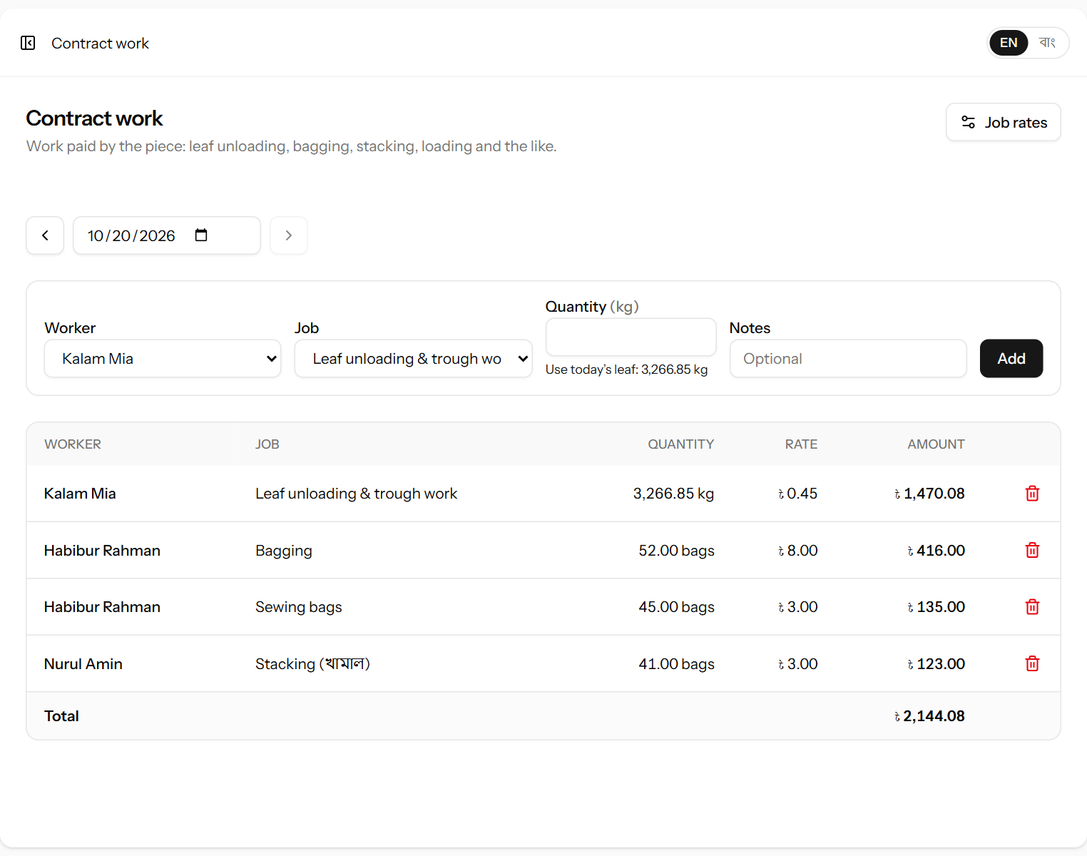
Figure 42. Recording contract work. For a job paid per kg, the day’s leaf can be filled in with one click.
- Choose the Worker (only contract workers are listed) and the Job. Each job shows its rate and unit.
- Enter the Quantity in the job’s unit (kg, bags, tons or jobs). For a job paid per kg, click Use today’s leaf to fill in the day’s net leaf.
- Click Add. The line appears in the list with its amount. The rate is copied from the job at this moment.
Delete a line entered by mistake with the red bin symbol (within three days), and add it again correctly.
Worked example: Leaf unloading at ৳0.45 per kg, 3,266.85 kg = ৳1,470.08. Bagging 52 bags at ৳8 = ৳416.00.

13.4 Job rates
Workforce → Job rates (manager and administrator only) holds the contract jobs and what each pays.
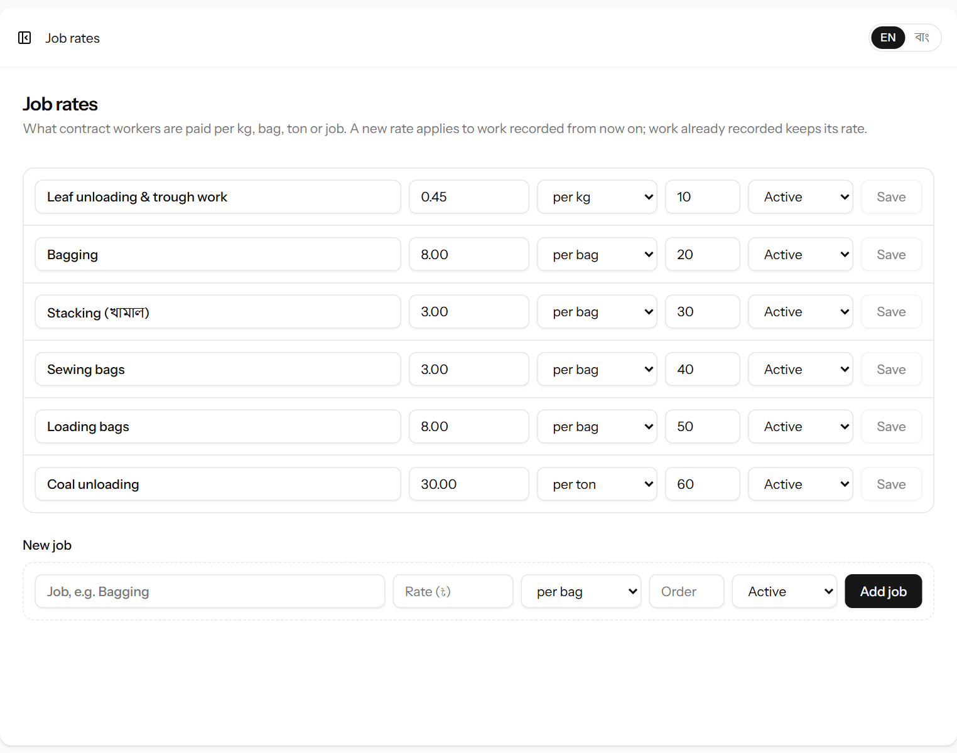
Figure 43. The contract jobs and their rates.
Change a job’s rate or unit (per kg, per bag, per ton or per job) on its line and click Save; add a job on the New job line. A new rate applies to work recorded from then on — work already recorded keeps the rate it was recorded at. A job no longer done can be set to Inactive.

13.5 Wages: the pay sheet
Workers are paid twice a week: on Sunday for Thursday to Saturday, and on Thursday for Sunday to Wednesday. Open Workforce → Wages; it opens on the last Sunday pay period.
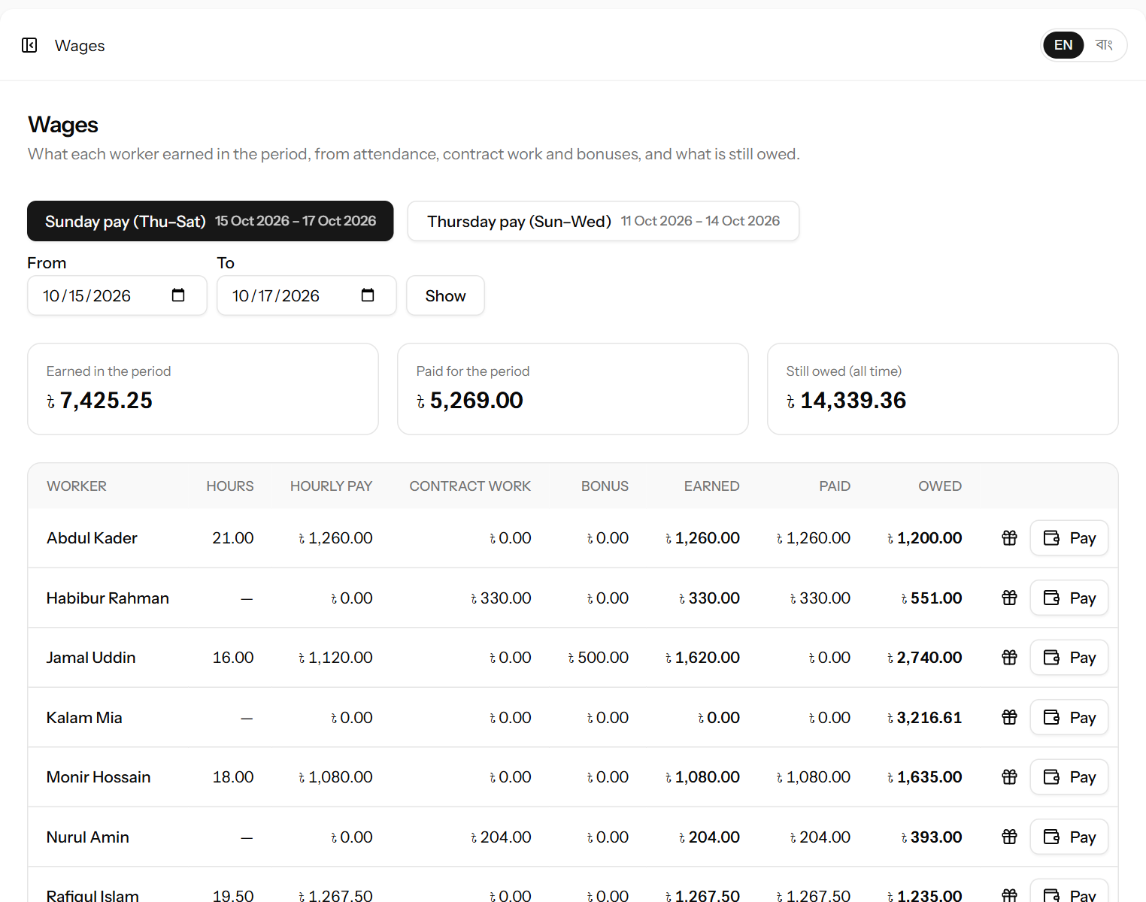
Figure 44. The pay sheet for the Sunday pay period. Below it (not shown) are the payments made and the bonuses given.
Part | Meaning
Sunday pay / Thursday pay | Show the last finished pay period of each kind. From, To and Show choose any other dates.
Hours, Hourly pay | Hours on the attendance sheet in the period, and what they earned.
Contract work | What contract work earned in the period.
Bonus | Bonuses given in the period.
Earned | Hourly pay + contract work + bonus for the period.
Paid | Payments recorded for this period, whenever they were handed over.
Owed | Everything the worker has ever earned, less everything paid — so it also includes days after the period, such as today.
Lists at the bottom | The payments made since the start of the period, and the bonuses given in it.

Paying a worker
- Choose the period with Sunday pay or Thursday pay.
- Click Pay on the worker’s line. The amount starts as what the worker is owed.
- Change the amount if paying less, check the date and how it was paid, and click Record payment.
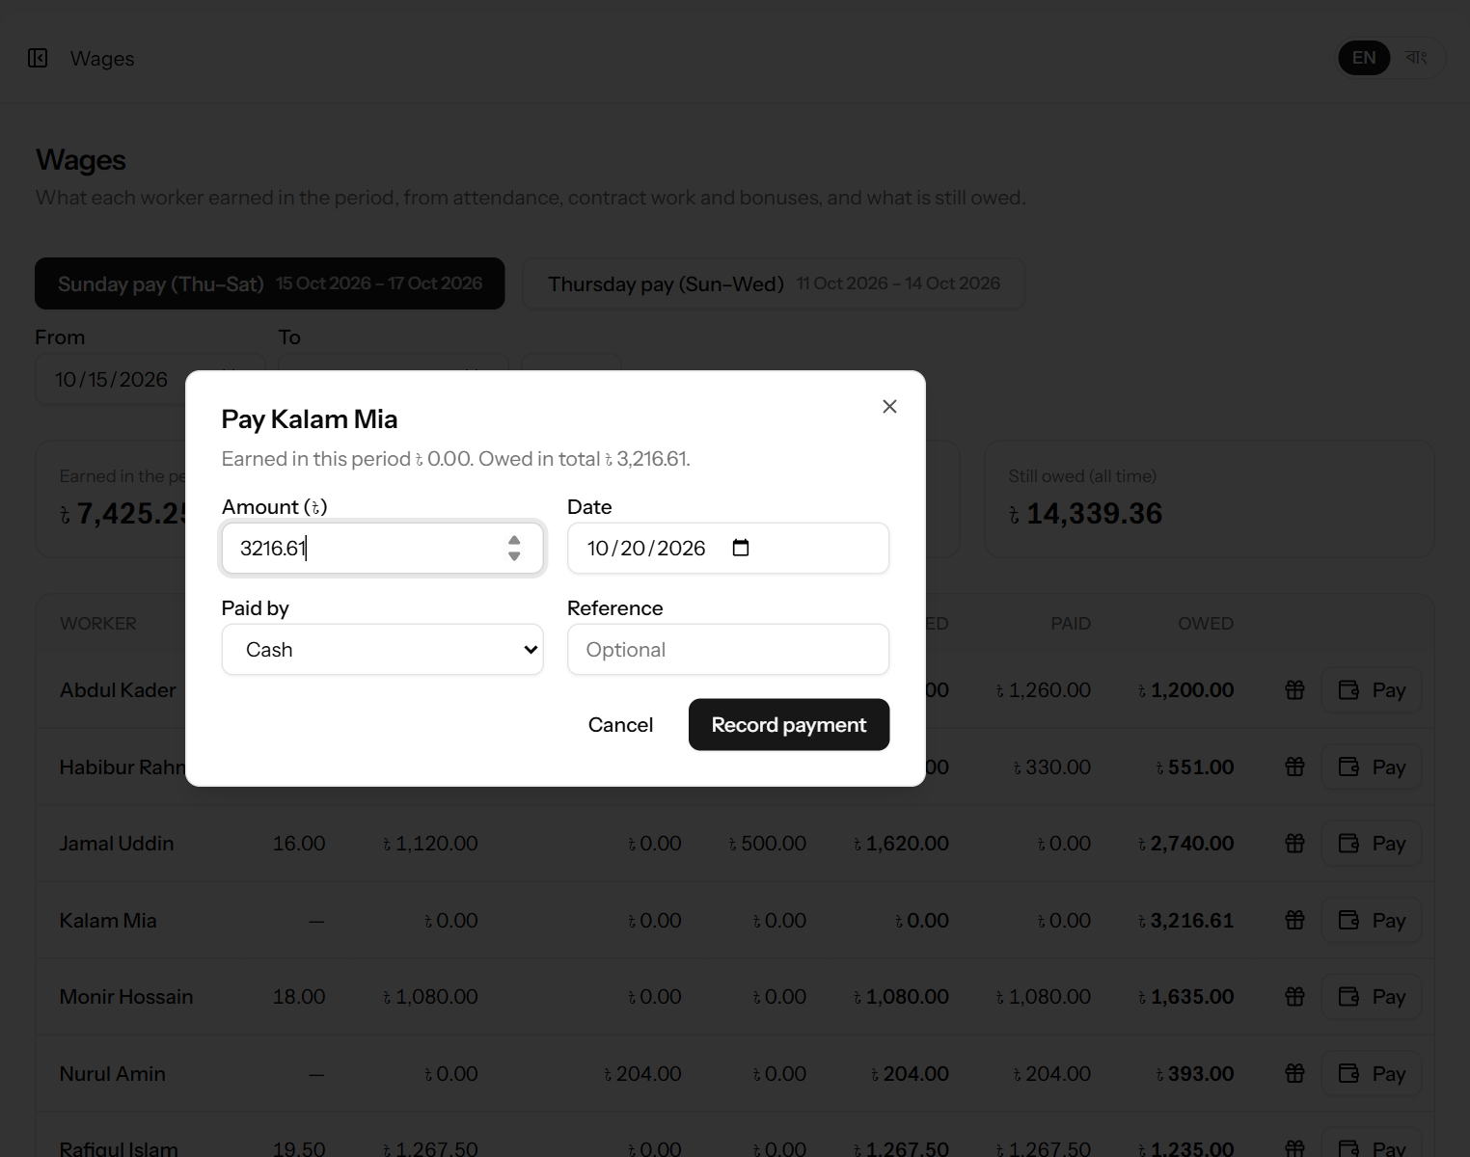
Figure 45. Paying a contract worker.

Giving a bonus
Click the gift symbol on the worker’s line, enter the amount and the reason (for example “Eid bonus”), and click Add bonus. The bonus is added to what the worker has earned and is paid with the wages.
Note: Wage payments appear in the cash book as money out (chapter 14). All wages — hours, contract work and bonuses — are counted as a cost in the reports on the day the work was done (chapter 15).

14. The cash book
The cash book lists every taka that came in or went out of the factory in a period, and splits it by how it was paid. Open Accounts → Cash book.
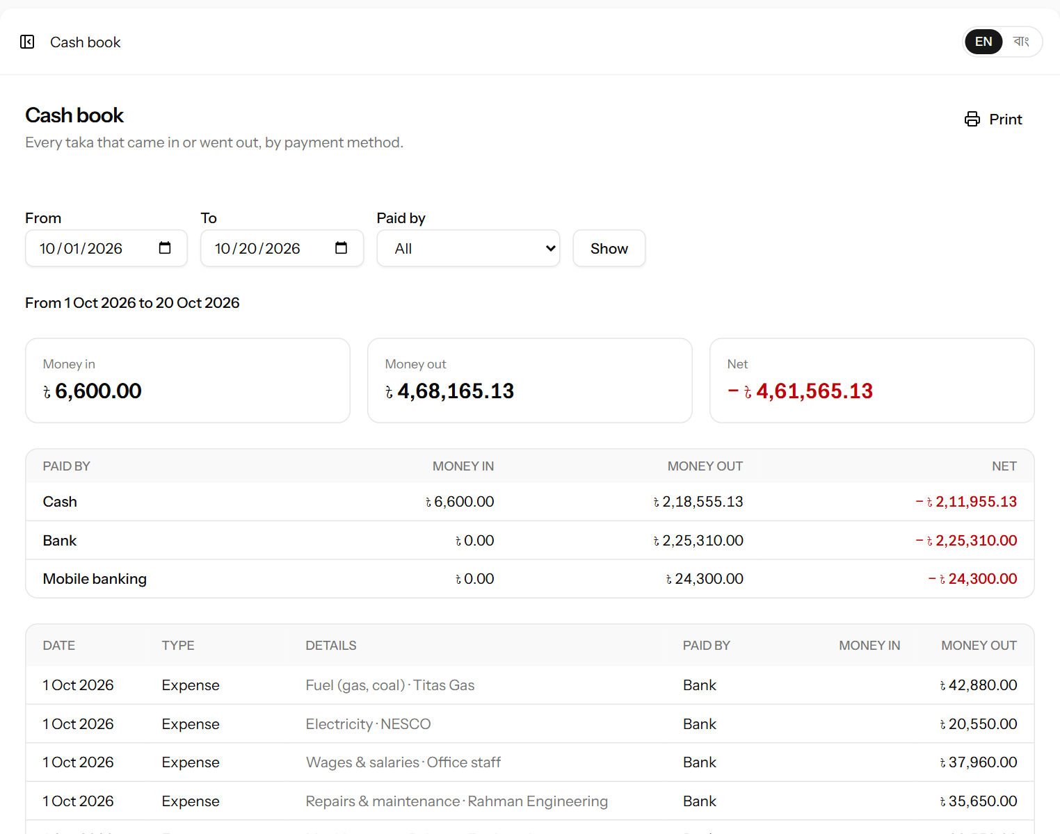
Figure 46. The cash book for the month, split by cash, bank and mobile banking (top of the page).
Money in | Money out
Payments received from retail customers (at the sale or later) | Payments and advances to leaf suppliers
Auction proceeds paid by the broker (always counted as bank) | Expenses (factory and vehicle)
 | Wages paid to workers

- Choose the period with From and To, and optionally one payment method with Paid by, then click Show.
- Money in, Money out and Net total the period. A negative net (in red) means more went out than came in.
- The middle table shows the same per method. Use the cash line to check the cash box and the bank line to check the bank statement.
- The list below shows every entry, in date order.
- Click Print to print the cash book.
Note: The cash book shows money movements only. It does not include sales still unpaid or tea still in stock — see the reports (chapter 15) for the business result.

15. Reports
The reports page shows the whole factory year month by month. It is meant above all for the owner. Open Accounts → Reports and choose the year at the top right.
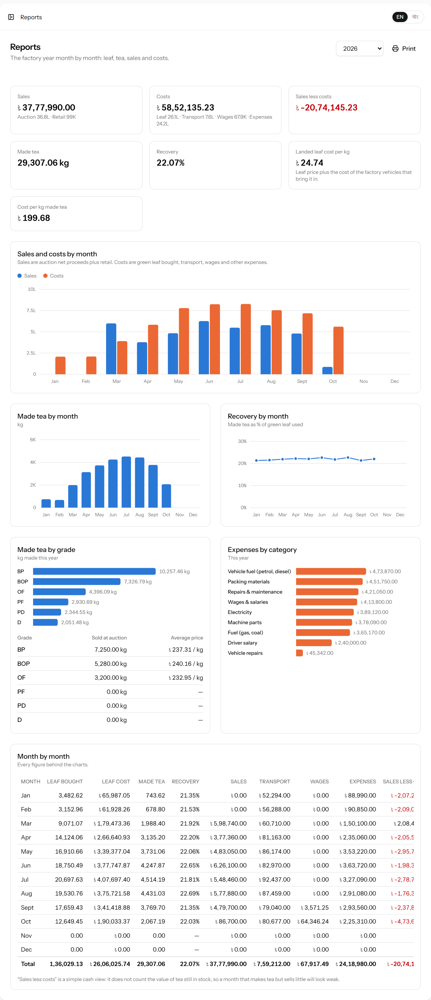
Figure 47. The yearly report: summary, charts and the month-by-month table.

15.1 The summary boxes
Box | How it is worked out
Sales | Auction net proceeds (by the auction date) + retail sales (by the memo date). Underneath, the two parts are shown separately.
Costs | Value of green leaf bought + transport (the expenses of the factory’s vehicles) + wages (hours, contract work and bonuses, by the day the work was done) + other expenses. Underneath, the four parts are shown separately.
Sales less costs | Sales − costs. Green when positive, red when negative.
Made tea | All made tea from production batches in the year.
Recovery | Made tea ÷ green leaf used × 100 for the year.
Landed leaf cost per kg | (Value of green leaf + transport cost) ÷ kg of leaf bought. What one kg of leaf really cost by the time it reached the factory, including collecting it with the factory’s own vehicles.
Cost per kg made tea | Costs ÷ made tea. What one kg of tea cost to buy and make.

Worked example: In a month the factory bought 40,000 kg of leaf for ৳800,000 and spent ৳40,000 running its pickups. Landed leaf cost = (800,000 + 40,000) ÷ 40,000 = ৳21.00 per kg, against an average price paid of ৳20.00.

15.2 The charts
- Sales and costs by month — blue columns for sales, orange for costs. Point at (or tap) a month to see the exact amounts.
- Made tea by month — the kg of tea made each month. The shape follows the plucking season.
- Recovery by month — the recovery % each month. A sudden fall is worth looking into (leaf quality, moisture, machinery).
- Made tea by grade — how the year’s tea divided between grades, with a table of kg sold at auction and the average auction price of each grade.
- Expenses by category — where the running costs went.

15.3 The month-by-month table
At the bottom is every figure behind the charts: for each month the leaf bought and its cost, made tea, recovery, sales, transport, wages, other expenses, sales less costs and cost per kg, with a total line. Click Print to print the whole report.
Important: “Sales less costs” is a simple cash view. It does not count the value of tea still in stock. In a month when a lot of tea is made but little is sold (for example at the start of the season), the figure will look weak even though the tea in stock has value. Read it together with the stock page.

16. Locked entries and the “edited” mark
To keep the records trustworthy, an entry can be changed freely only while it is fresh. After that, a change needs the administrator’s approval, and every change leaves a visible mark.

16.1 The three-day rule
Every entry — a delivery, a day’s leaf rates, a supplier payment, a production batch, the packing of an auction invoice, a retail sale, a customer payment, an expense, an attendance line or a piece of contract work — can be corrected or deleted by the manager for three days after it was recorded. After that it is locked: instead of the pencil and bin, its line shows Locked with a padlock.
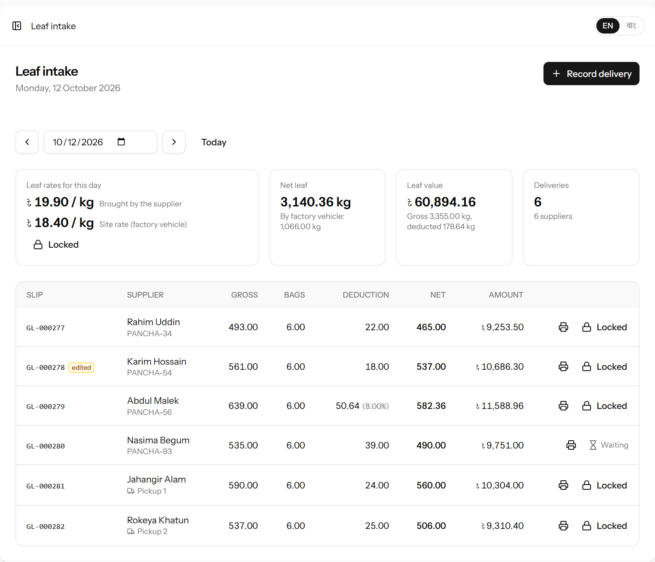
Figure 48. A day more than three days ago: the rates and every delivery are locked. One delivery was corrected earlier (edited), and for one an unlock is waiting for the administrator.
- The three days count from when the entry was recorded in the system, not from the date written on it.
- Locked entries count exactly as before in balances, statements, stock, the dashboard and the reports. Locking only stops changes.
- On an auction invoice only the packing is locked; the dispatch, result and payment can always be filled in (10.4).
- The administrator is never locked out. The owner never changes entries in any case.

16.2 Asking for an entry to be unlocked
- Click Locked on the entry’s line.
- In the window that opens, write what needs correcting — for example “Bags weight entered as 16 kg, it was 6 kg”.
- Click Send request. The line now shows Waiting with an hourglass, and the administrator sees the request (17.3).
- When the administrator approves, the entry opens again for 24 hours. Make the correction within that time; afterwards it locks again. If the request is rejected, the line shows Locked again.
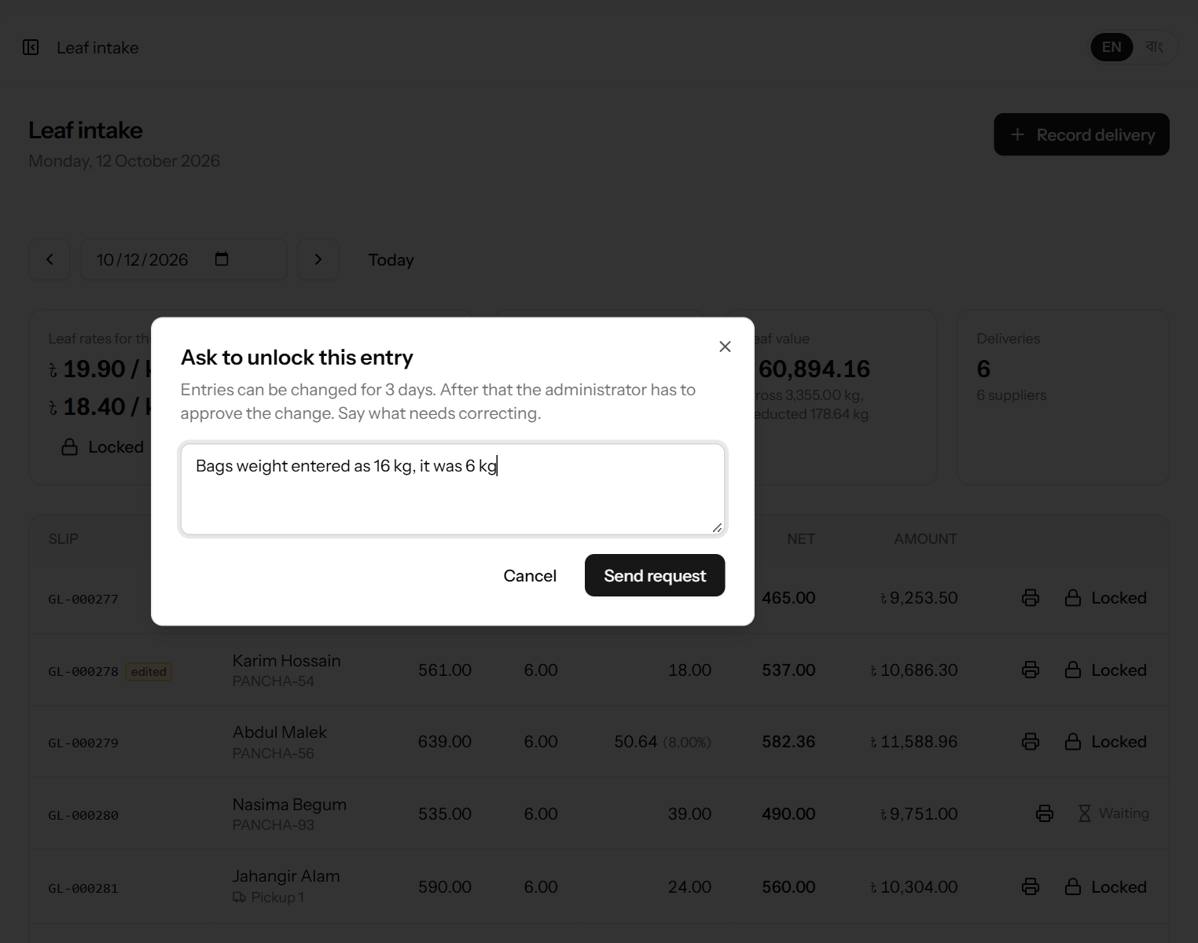
Figure 49. Asking the administrator to unlock a delivery.
Tip: Look over each day’s entries the next morning. A mistake found within three days can be corrected straight away, without a request.

16.3 The “edited” mark
When an entry is changed after it was first saved, a small orange edited mark appears next to it — like an edited message in WhatsApp. Point at the mark (or tap it on a phone) to see the date and time of the change. The activity log (17.2) shows exactly what was changed and by whom.
Changes the system makes by itself do not count: when a day’s rate is set and its deliveries are priced, they are not marked as edited. On an auction invoice only changes to the packing count; filling in the dispatch, result and payment does not.

17. Administration (administrator only)
These pages are only visible to the administrator, under Administration in the menu.

17.1 Users
Open Administration → Users to see everyone who can sign in, with their role, language and whether the account is active.
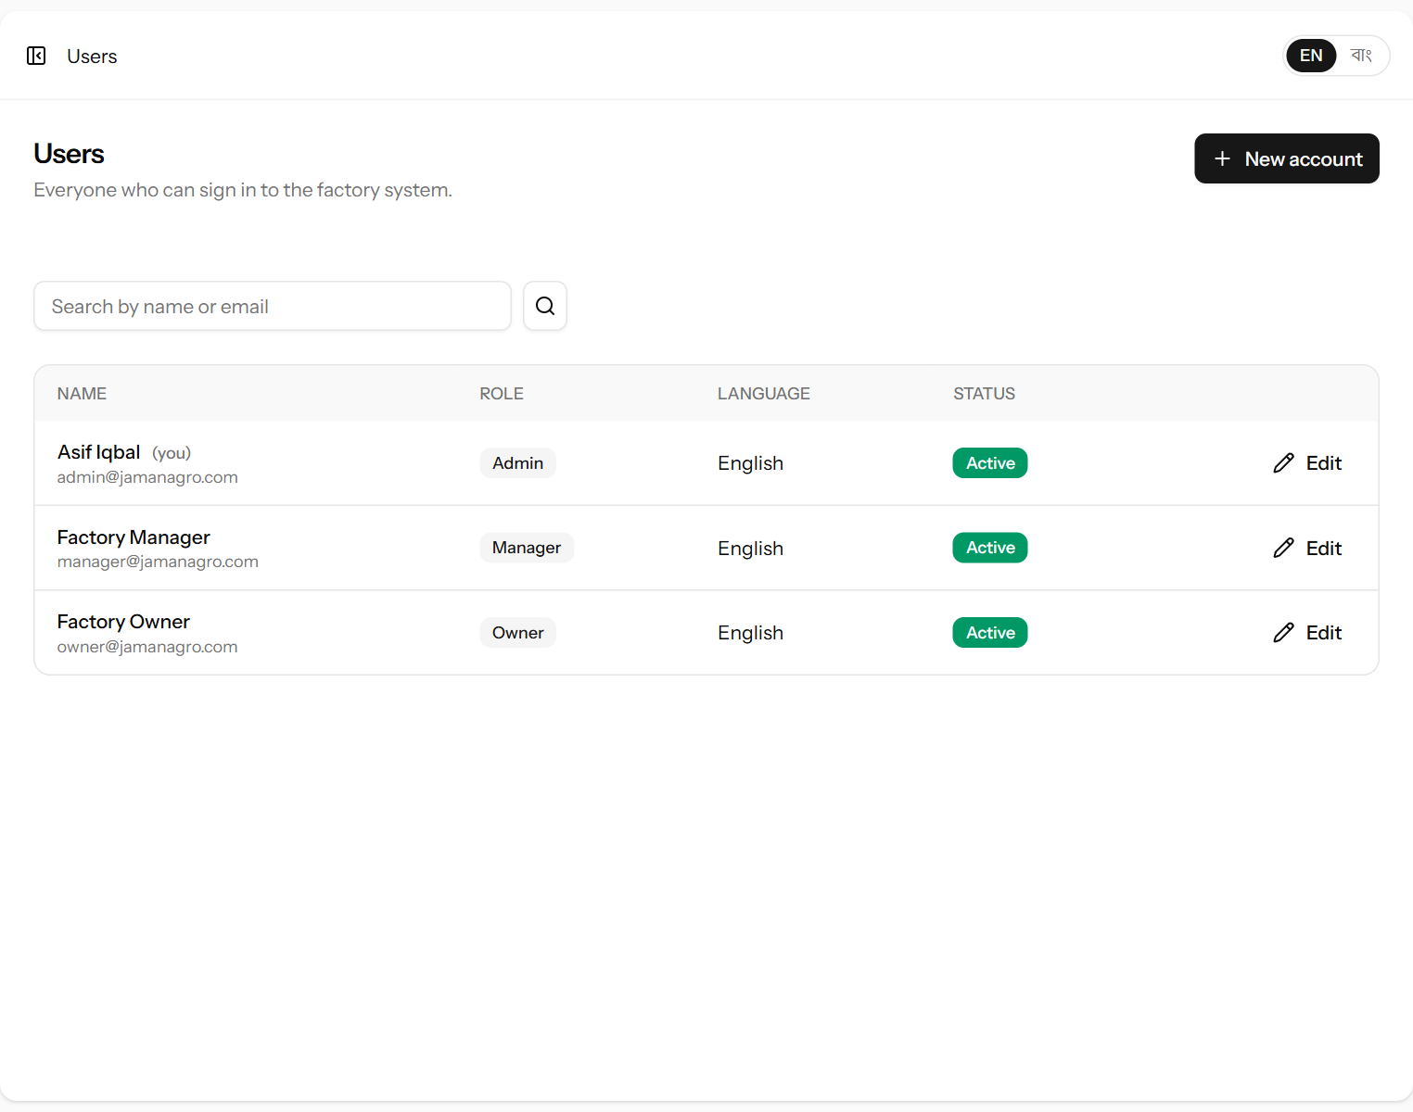
Figure 50. The list of user accounts.

Creating an account
- Click New account.
- Fill in the form and click Create account.
- Give the person their email address and password, and ask them to change the password after their first sign-in (chapter 18.2).
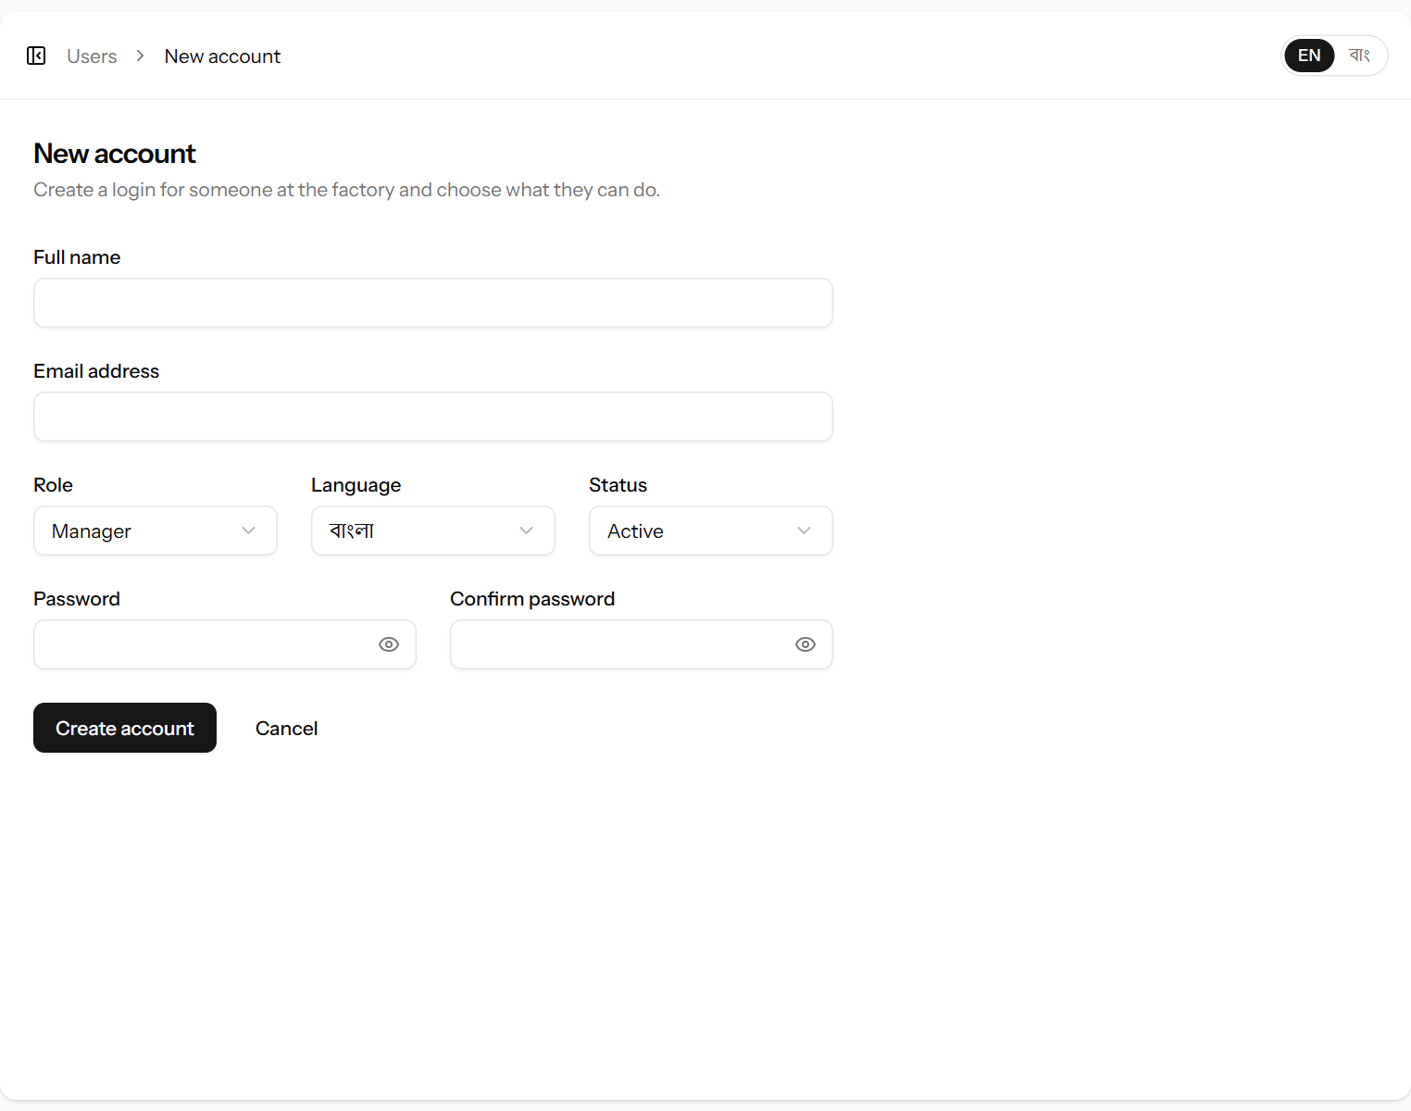
Figure 51. Creating an account.
Field | What it means | Required?
Full name | The person’s name, shown in the menu and on slips (“Recorded by”). | Yes
Email address | What they sign in with. Must be unique. | Yes
Role | Admin, Manager or Owner — see 1.2 and Appendix A. | Yes
Language | The language the system opens in for this person. They can change it themselves. | Yes
Status | Active can sign in; Inactive cannot. | Yes
Password / Confirm password | Their first password, typed twice. | Yes (new)

Changing an account, resetting a password, switching an account off
- Click Edit on the person’s line, make the change and click Save changes.
- To reset a forgotten password, type a new one in New password and Confirm password. Leave both empty to keep the current password.
- To stop someone using the system (for example when they leave), set Status to Inactive. They are signed out at once and cannot sign in again; everything they recorded stays.
- Accounts are never deleted, so the history of who did what is never lost.
Important: You cannot change your own role or switch off your own account. This stops the administrator from locking themselves out by mistake.

17.2 The activity log
Open Administration → Activity log to see every sign-in, sign-out and every change made in the system, newest first.
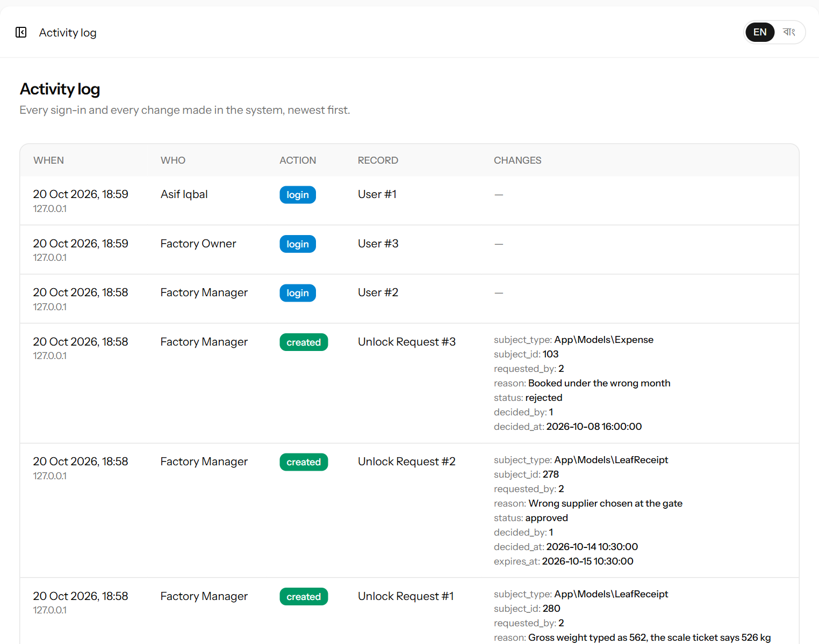
Figure 52. The activity log: who did what and when, with the values.
Column | Meaning
When | Date and time, and the internet address of the computer used.
Who | The person who made the change.
Action | created, updated, deleted, login or logout.
Record | What was changed, for example “Leaf Receipt #289” or “Supplier Payment #55”.
Changes | The values. For an update, the old value is crossed out and followed by the new one. Passwords are never shown.

17.3 Unlock requests
When the manager asks for a locked entry to be unlocked (16.2), the request appears under Administration → Unlock requests. The number of requests waiting is shown in an orange badge next to the menu item.
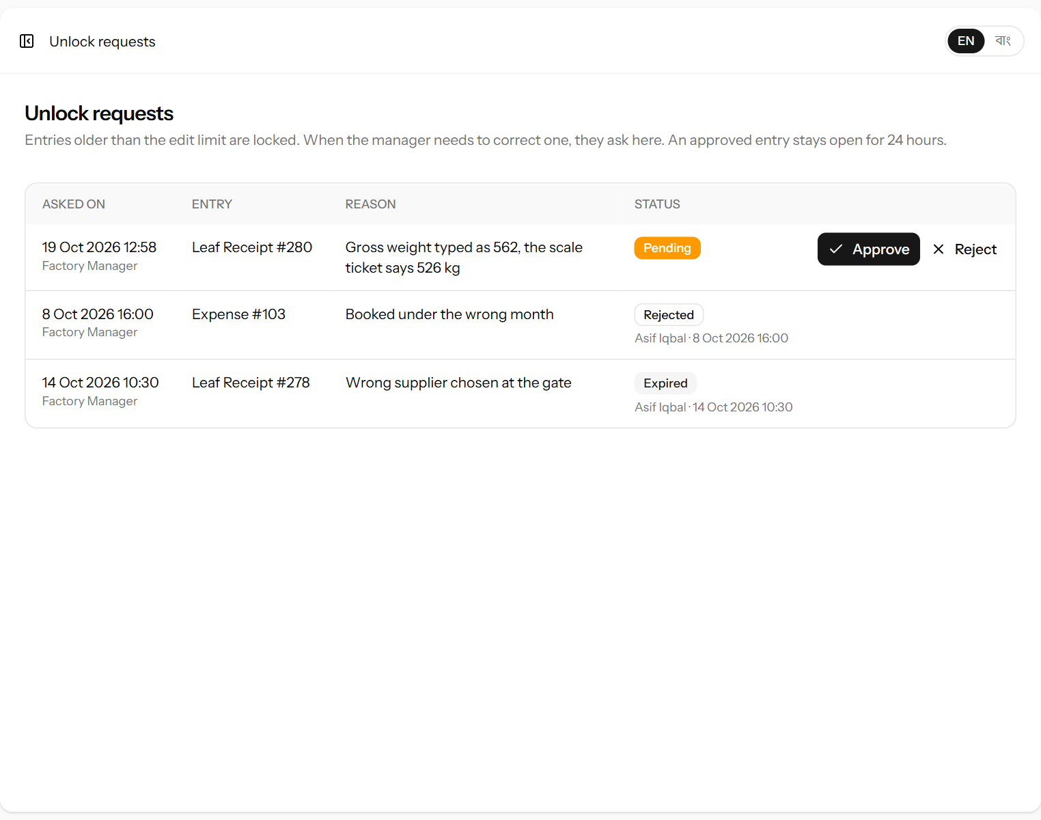
Figure 53. Unlock requests: one waiting, one approved and since expired, one rejected.
Column | Meaning
Asked on | When the request was made, and by whom.
Entry | What is to be unlocked, for example “Leaf Receipt #280”.
Reason | What the manager wants to correct.
Status | Pending — waiting for you. Unlocked — approved and still open. Expired — approved, but the 24 hours are over. Rejected — refused. Under it: who decided, and when.

- Click Approve to open the entry for 24 hours, or Reject to keep it locked. The manager sees the result on the entry’s line.
- Before approving, check the reason against the paper record — the weighing ticket, bill or voucher.
- Every change made while the entry is open is written to the activity log, and the entry gets the edited mark.
Note: As administrator you are never locked out. You can correct an old entry yourself without a request; the change is logged as usual.

18. Your own settings
Every user can change their own name, email address, password and the look of the screen. Click your name at the bottom of the menu and choose Settings.

18.1 Profile
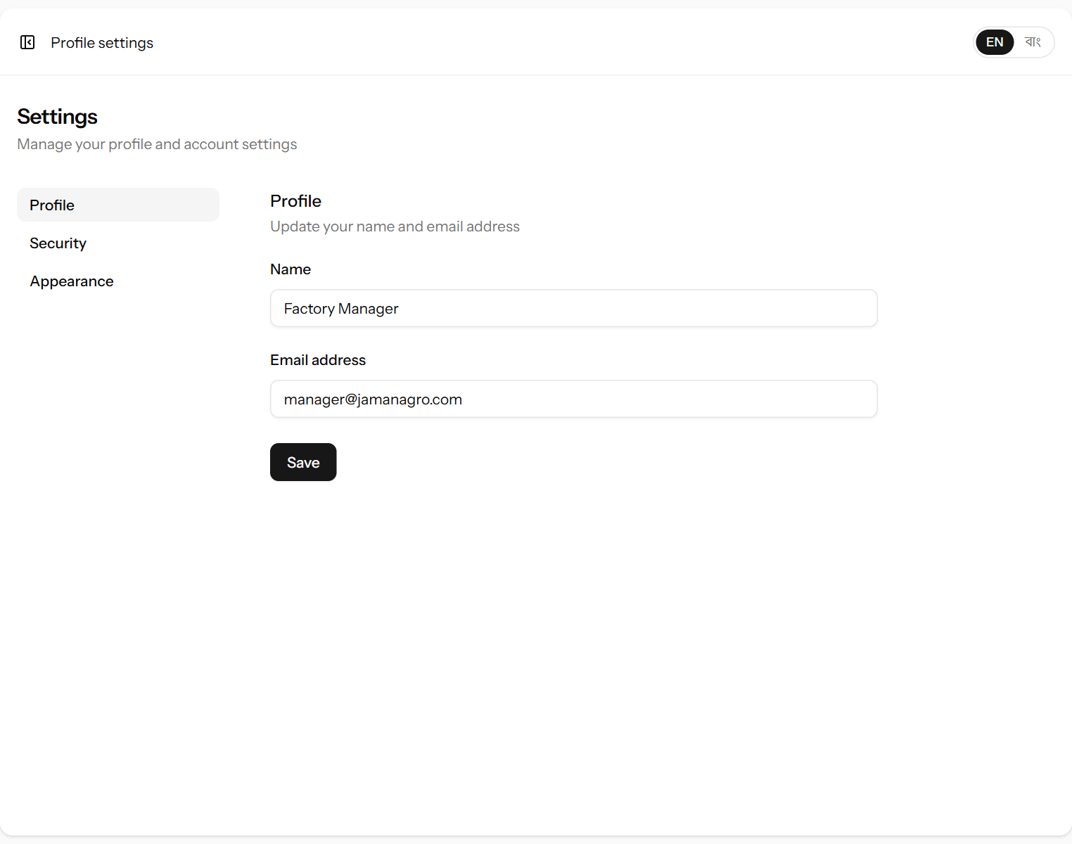
Figure 54. Changing your name and email address.
Change your Name or Email address and click Save. If you change your email, use the new one to sign in next time.

18.2 Security: changing your password
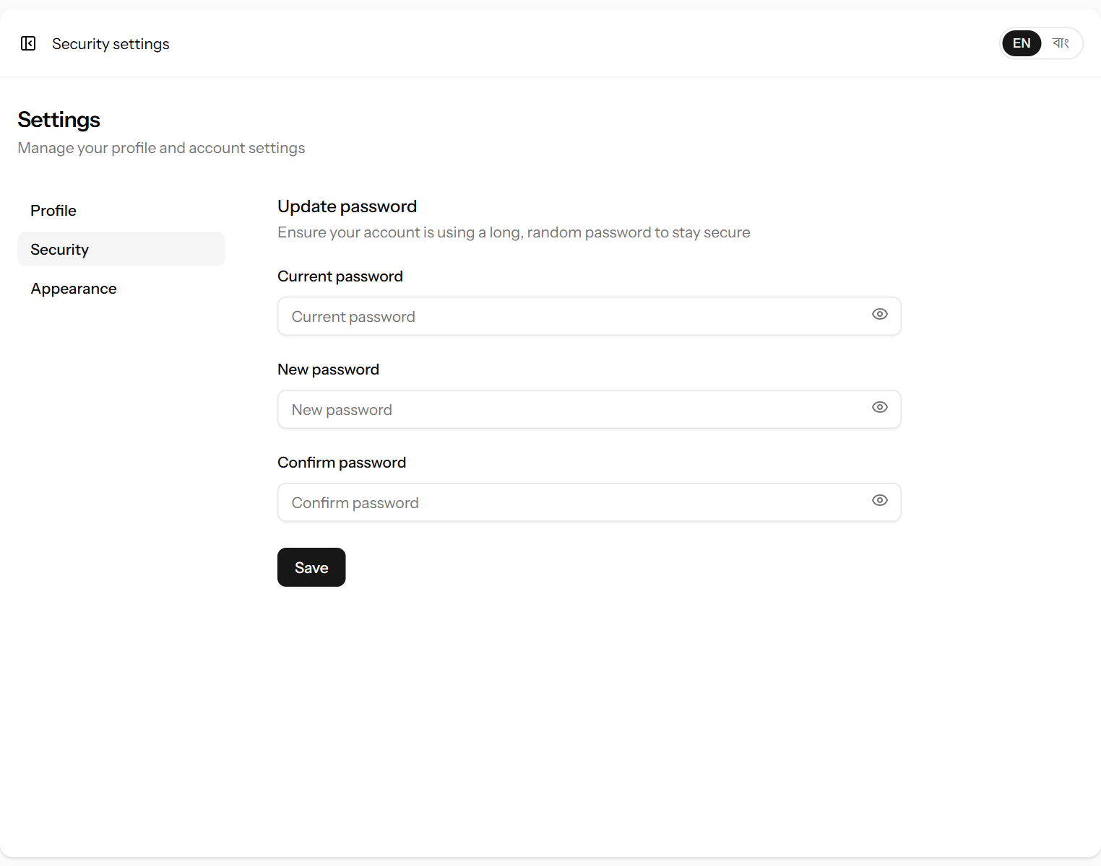
Figure 55. Changing your password.
- Click Security.
- Type your Current password.
- Type the new password in New password and again in Confirm password.
- Click Save.
Tip: Use a long password that others cannot guess, and do not share it. Every change in the system is recorded under the name of the person signed in.

18.3 Appearance
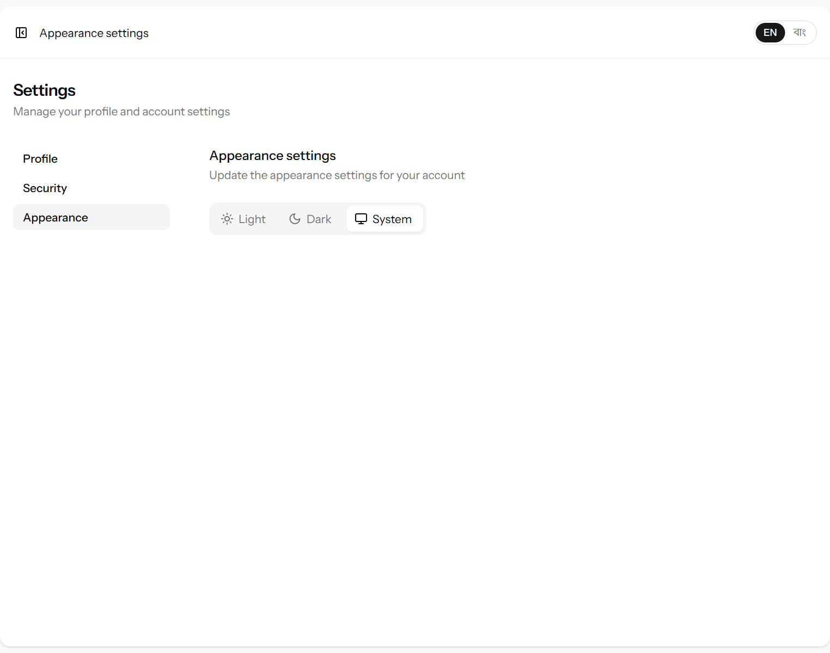
Figure 56. Choosing light, dark or system appearance.
Choose Light, Dark, or System (follow the computer’s or phone’s own setting). Dark mode is easier on the eyes at night.

19. Rules the system enforces, and messages you may see
The system checks every entry before saving it. When something is not allowed, it shows a message — usually in red under the field concerned — and saves nothing. This table lists the main rules and what to do.
Message or situation | Why | What to do
“This would leave less than zero kg in stock for PF.” | An invoice, sale, adjustment or batch change would take more tea of that grade than is in stock. | Check the stock page. Correct the quantity, or record the missing production first.
“A sale without a customer must be paid in full.” | Walk-in sales cannot be on credit. | Choose the customer, or enter the full amount as received.
“Record the auction price before the payment.” | A payment date was entered on an invoice with no auction price. | Fill in Sold on and Price per kg first.
“A sold invoice cannot be deleted.” | Sold invoices are part of the accounts. | Correct the invoice instead of deleting it.
“This payment belongs to a sale. Cancel the sale instead.” | Money taken with a retail sale is tied to the memo. | Cancel the sale (11.4) and write it again.
“…has already been taken.” | A supplier code, invoice number, grade code, email or category name is already used. | Use a different code or number.
A date “must be a date before or equal to today” | Things that have not happened cannot be recorded. | Check the date.
Bags weight must be less than gross | The bags cannot weigh more than the whole delivery. | Check the weights.
“Enter the made tea of at least one grade.” | A batch with no tea. | Enter the kg for the grades made.
“The same grade … has a duplicate value” | A grade appears twice on one memo. | Put the whole quantity on one line.
Deliveries show “Rate pending” | The day’s rate — or, for factory-collected leaf, the site rate — has not been set. | Set the rate or site rate (6.2).
“This entry is older than 3 days and is locked…” | The entry was recorded more than three days ago. | Ask the administrator to unlock it (16.2).
“The deduction must be less than the leaf weight…” | A kg deduction as large as the whole delivery. | Check the kg, or click % if you meant a percentage.
“A percentage cannot be more than 100.” | A % deduction above 100. | Check the figure, or click kg if you meant kilograms.
A vehicle field “is required” | Factory-collected leaf, or a vehicle expense, without the vehicle. | Choose the vehicle. Add it under Vehicles first if it is new (6.6).
The site rate “must be less than or equal to” the rate | The site rate was typed higher than the supplier rate. | Check both rates.
“Check the times: both time in and time out are needed.” | Only one of the two times was filled on the attendance sheet. | Fill in both, or clear both for an absent worker.
Recovery shown in orange | Below 15% or above 30%. | Re-check the leaf and made tea figures.
“No active account matches…” at sign-in | Wrong email or password, or the account is switched off. | Check the spelling; otherwise ask the administrator.
A page says 403 / “Forbidden” | Your role is not allowed on that page (for example the owner on an entry form). | Ask the manager or administrator to make the entry.

20. Frequently asked questions
We found a mistake in last week’s delivery.
It is locked. Click Locked on its line, explain the mistake and send the request (16.2). Once the administrator approves, correct it within 24 hours.
Which rate does a delivery get?
Leaf the supplier brought gets the day’s rate; leaf collected by a factory vehicle gets the day’s site rate. If the wrong one was chosen, edit the delivery and change How did the leaf arrive? — it is re-priced at once.
Do we have to deduct moisture in kg?
No. kg is the default because that is how the factory usually works, but click % beside the box to enter a percentage for any delivery.
A worker wants part of their wages before pay day.
Click Pay on the Wages page and record the amount given. It is taken off what the worker is owed; on pay day pay the rest.
Should we still use the “Wages & salaries” expense category?
Only for salaried staff who are not paid through the Wages page. Daily and contract workers’ pay is already counted from attendance and contract work (12.3).
A contract job rate went up.
Change it in Job rates (13.4). Work already recorded keeps the old rate; new work gets the new one.
A supplier says the amount on their slip is wrong. What happened?
If the slip was printed before the day’s rate was set, it shows “Rate pending”. If the rate was changed after printing, the amount on the old slip is out of date. Open the delivery, check the weights, and print the slip again.
We weighed a delivery under the wrong supplier.
Open the delivery from Leaf intake (pencil symbol), choose the right supplier and save. Both suppliers’ balances update at once. If the delivery is already locked, ask for it to be unlocked first (16.2).
Can we pay a supplier before the rate is set?
Yes. Record the payment as usual. The supplier’s balance will look like an advance until the rate is set and the leaf is priced.
How do we record a fertiliser loan to a garden?
As a supplier payment of type Advance, with a note. It is recovered automatically as the supplier’s leaf is priced.
The stock in the system is different from the store.
First check that all production, invoices and sales are entered. Then correct the remaining difference with Adjust stock, giving the reason (9.2).
An auction lot did not sell. What do we do?
Leave the invoice as Dispatched. When it is sold in a later auction, update the sale and lot numbers and enter the result then.
A retail customer returns some tea.
Cancel the memo and write a new one with the correct quantity. If the money was already received separately, the customer’s balance will show it as an advance.
Why does the report show a loss in March when we made a lot of tea?
“Sales less costs” counts tea only when it is sold. Tea made in March and sold in May shows as a cost in March and a sale in May. See 15.3.
Can the owner change anything?
No. The owner can see and print everything but cannot enter or change data. This keeps the records in the manager’s hands and the owner’s view independent.
Someone left the factory. What about their account?
The administrator sets it to Inactive (17.1). Their past entries stay, and the activity log still shows their name.
Can we use the system without internet?
No. The system runs on a server and needs a connection. On a phone, mobile data is enough.
How do we make a PDF of a statement to send by WhatsApp or email?
Click Print on the statement, and in the print window choose “Save as PDF” as the printer.

Appendix A. Who can use which screen
Screen | Admin | Manager | Owner
Dashboard | See | See | See
Go-live checklist | See | See | —
Leaf intake, set rates, slips | See & change | See & change | See & print
Vehicles | Change | Change | —
Suppliers and statements | See & change | See & change | See & print
Supplier payments | See & change | See & change | See
Production | See & change | See & change | See
Made tea stock | See & adjust | See & adjust | See
Tea grades | Change | Change | —
Auction invoices | See & change | See & change | See
Brokers, warehouses | Change | Change | —
Retail sales and memos | See & change | See & change | See & print
Customers, statements, payments | See & change | See & change | See & print
Workers | See & change | See & change | See
Attendance, contract work | See & change | See & change | See
Wages (pay sheet, pay, bonus) | See & change | See & change | See
Job rates | Change | Change | —
Expenses | See & change | See & change | See
Expense categories | Change | Change | —
Cash book | See | See | See & print
Reports | See | See | See & print
Users | Change | — | —
Activity log | See | — | —
Unlock requests | Approve or reject | Ask, from the entry | —
Own settings (profile, password, appearance, language) | Change | Change | Change

For the manager, “change” means for three days after an entry is recorded; older entries need the administrator’s approval (chapter 16).

Appendix B. Menu names in English and Bangla
English | বাংলা | Chapter
Factory → Dashboard | কারখানা → ড্যাশবোর্ড | 3
Factory → Go-live checklist | কারখানা → চালু করার চেকলিস্ট | 4.1
Green leaf → Leaf intake | কাঁচা পাতা → কাঁচা পাতা গ্রহণ | 6
Green leaf → Suppliers | কাঁচা পাতা → সরবরাহকারী | 5
Green leaf → Supplier payments | কাঁচা পাতা → সরবরাহকারীকে পরিশোধ | 7
Green leaf → Vehicles | কাঁচা পাতা → গাড়ি | 6.6
Manufacturing → Production | উৎপাদন বিভাগ → উৎপাদন | 8
Manufacturing → Made tea stock | উৎপাদন বিভাগ → তৈরি চায়ের মজুদ | 9
Manufacturing → Tea grades | উৎপাদন বিভাগ → চায়ের গ্রেড | 9.3
Sales → Auction invoices | বিক্রয় → নিলাম ইনভয়েস | 10
Sales → Retail sales | বিক্রয় → খুচরা বিক্রয় | 11
Sales → Customers | বিক্রয় → ক্রেতা | 11
Sales → Warehouses | বিক্রয় → ওয়্যারহাউস | 10.7
Sales → Brokers | বিক্রয় → ব্রোকার | 10.6
Workforce → Workers | শ্রমিক ও মজুরি → শ্রমিক | 13.1
Workforce → Attendance | শ্রমিক ও মজুরি → হাজিরা | 13.2
Workforce → Contract work | শ্রমিক ও মজুরি → চুক্তির কাজ | 13.3
Workforce → Wages | শ্রমিক ও মজুরি → মজুরি | 13.5
Workforce → Job rates | শ্রমিক ও মজুরি → কাজের রেট | 13.4
Accounts → Reports | হিসাব → প্রতিবেদন | 15
Accounts → Expenses | হিসাব → খরচ | 12
Accounts → Cash book | হিসাব → নগদান বই | 14
Accounts → Expense categories | হিসাব → খরচের খাত | 12.3
Administration → Users | প্রশাসন → ব্যবহারকারী | 17.1
Administration → Activity log | প্রশাসন → কার্যক্রম লগ | 17.2
Administration → Unlock requests | প্রশাসন → আনলকের অনুরোধ | 17.3
Settings | সেটিংস | 18
Log out | লগ আউট | 2.2

Common buttons
English | বাংলা
Record delivery | পাতা গ্রহণ লিখুন
Set rate | দর ঠিক করুন
Record payment | পরিশোধ লিখুন
Record production | উৎপাদন লিখুন
Adjust stock | মজুদ সমন্বয়
Pack invoice | ইনভয়েস প্যাক করুন
New sale | নতুন বিক্রয়
Receive payment | টাকা গ্রহণ
Record expense | খরচ লিখুন
Save attendance | হাজিরা সংরক্ষণ
Pay | মজুরি দিন
Add bonus | বোনাস যোগ করুন
Locked | লক
Send request | অনুরোধ পাঠান
Save changes | পরিবর্তন সংরক্ষণ করুন
Cancel | বাতিল
Print | প্রিন্ট

Appendix C. Glossary
Term | বাংলা | Meaning
Advance | অগ্রিম | Money paid to a supplier before their leaf, recovered from future leaf.
Auction centre | নিলাম কেন্দ্র | Where the tea auction is held.
Balance | জের | What is owed on an account at a point in time.
Broker | ব্রোকার | The company that catalogues and sells tea at auction for the factory.
Broker deductions | ব্রোকারের কর্তন | Brokerage, warehouse charges and taxes taken from auction proceeds.
Cash book | নগদান বই | The list of all money in and out.
Contract work | চুক্তির কাজ | Work paid by the piece — per kg, bag, ton or job — at the job rates.
CTC | সিটিসি | Crush–tear–curl: the method the factory makes tea by.
Factory vehicle | কারখানার গাড়ি | One of the factory’s own vehicles that collect leaf from the gardens.
Gross weight | মোট ওজন | Scale weight including bags.
Hourly worker | ঘণ্টাভিত্তিক শ্রমিক | A worker paid for the hours between time in and time out.
Invoice (auction) | নিলাম ইনভয়েস | Packages of one grade sent to auction.
Landed leaf cost | পাতার মোট খরচ (পরিবহনসহ) | Price of leaf plus the cost of bringing it in, per kg.
Leaf rate | পাতার দর | Price per kg of green leaf for one day, for leaf the supplier brings.
Locked entry | লক করা এন্ট্রি | An entry more than three days old; changing it needs the administrator’s approval.
Lot / Sale no. | লট / সেল নম্বর | Numbers from the broker’s auction catalogue.
Made tea | তৈরি চা | Finished, sorted tea.
Memo | মেমো | Retail sale document.
Moisture deduction | আর্দ্রতা কর্তন | Weight taken off for excess water.
Net proceeds | নিট প্রাপ্তি | Auction sale value less broker deductions.
Net weight | নিট ওজন | Weight the supplier is paid for.
Opening balance | প্রারম্ভিক জের | The balance at the start of a period or when an account was added.
Pay period | মজুরির সময়কাল | Thursday–Saturday (paid on Sunday) or Sunday–Wednesday (paid on Thursday).
Recovery | রিকভারি | Made tea ÷ green leaf used × 100.
Site rate | সাইট রেট | Price per kg for leaf the factory collects with its own vehicle.
Stock adjustment | মজুদ সমন্বয় | A manual correction of stock, with a reason.
Walk-in customer | সাধারণ ক্রেতা | A buyer with no account; must pay in full.
Warehouse | ওয়্যারহাউস | The auction warehouse an invoice is sent to before the sale.

Appendix D. Quick reference card
Print this page and keep it near the computer at the gate and in the office.
I want to… | Go to | Click
Record leaf at the gate | Green leaf → Leaf intake | Record delivery → Save & print slip
Set today’s leaf rates | Green leaf → Leaf intake | Type the rate and site rate → Set rate
Reprint a weighing slip | Green leaf → Leaf intake | Printer symbol on the line
Pay a supplier or give an advance | Suppliers → the supplier | Record payment
Print a supplier’s bill | Suppliers → the supplier | Choose dates → Show → Print
Record the day’s manufacture | Manufacturing → Production | Record production
Correct the stock after a count | Manufacturing → Made tea stock | Adjust stock
Pack tea for auction | Sales → Auction invoices | Pack invoice
Enter an auction result | Sales → Auction invoices | Invoice number → fill result → Save changes
Sell tea to a shop | Sales → Retail sales | New sale → Save & print memo
Take money from a customer | Sales → Customers → the customer | Receive payment
Fill in the attendance | Workforce → Attendance | Type the times → Save attendance
Record contract work | Workforce → Contract work | Worker, job, quantity → Add
Pay the workers (Sun / Thu) | Workforce → Wages | Period button → Pay on each line
Correct an entry older than 3 days | The entry’s line | Locked → reason → Send request
Record an expense | Accounts → Expenses | Record expense
See money in and out | Accounts → Cash book | Choose dates → Show
See the year’s results | Accounts → Reports | Choose the year
Switch to Bangla | Any page | বাং at the top right

