Problem Statement
In the context of increasing digital engagement and sustainability awareness, it remains uncertain how users' psychological perceptions, usability experiences, and demographic characteristics interact to shape their satisfaction, attitudes toward sustainability, and willingness to continue using a system. Despite theoretical assumptions about the roles of performance expectancy, hedonic motivation, and demographic factors such as age and education, their actual influence and interplay are still not well understood.
To address this gap, a structural equation modeling approach is proposed to empirically assess the direct and moderating effects of these constructs on users’ attitudes and behavioral intentions, offering insights into the relative importance of these factors in sustaining user engagement and promoting pro-sustainability behavior.

Confirmatory path analysis including moderation and mediation analysis
Table 1: Goodness of Fit of Model
Fit Index | Saturated Model | Estimated Model | Comments
SRMR (Standardized Root Mean Square Residual) | 0.054 | 0.067 | Acceptable Fit: SRMR < 0.08 is generally considered a good fit.
d_ULS (Squared Euclidean Distance) | 1.030 | 1.561 | Acceptable, but slightly higher.
d_G (Geodesic Distance) | 0.373 | 0.413 | Good Fit: Small values indicate a better model fit.
Chi-square | 398.369 | 443.477 | Though slightly higher than accepted, in PLS-SEM, Chi-square is less emphasized compared to other fit indices.
NFI (Normed Fit Index) | 0.808 | 0.787 | Acceptable but slightly below optimal: An NFI > 0.90 is preferred. The estimated model is slightly lower than the saturated.

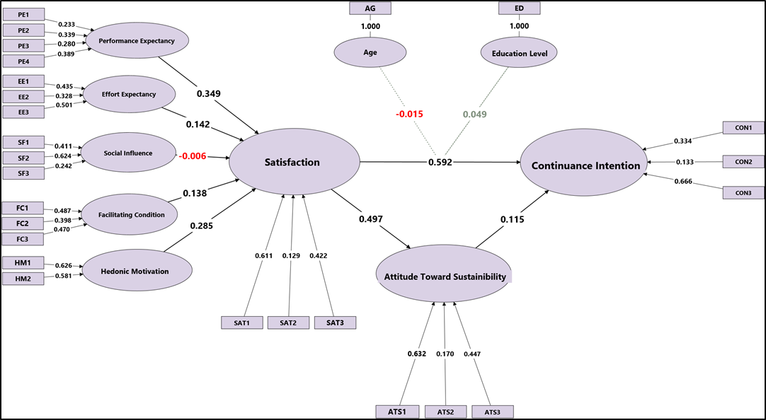
Figure 1: Confirmatory PLS_SEM of Proposed Hypothesis

Table2: Path-Coefficient Matrix
 | Age | Attitude Toward Sustainibility | Continuance Intention | Education Level | Effort Expectancy | Facilitating Condition | Hedonic Motivation | Performance Expectancy | Satisfaction | Social Influence | Age x Satisfaction | Education Level x Satisfaction
Age |  |  | -0.082
Attitude Toward Sustainibility |  |  | 0.115
Continuance Intention
Education Level |  |  | -0.010
Effort Expectancy |  |  |  |  |  |  |  |  | 0.142
Facilitating Condition |  |  |  |  |  |  |  |  | 0.138
Hedonic Motivation |  |  |  |  |  |  |  |  | 0.285
Performance Expectancy |  |  |  |  |  |  |  |  | 0.349
Satisfaction |  | 0.497 | 0.592
Social Influence |  |  |  |  |  |  |  |  | -0.006
Age x Satisfaction |  |  | -0.015
Education Level x Satisfaction |  |  | 0.049

Table3: R-Squared Overview
Construct | R-Squared | R-Squared Adjusted | Comments
Attitude Toward Sustainability (ATS) | 0.247 | 0.244 | Moderate Predictive Power: About 24.7% of the variance in ATS is explained by the predictor variables suggests other external factors may influence ATS.
Continuance Intention (CON) | 0.427 | 0.411 | Moderate to Strong Predictive Power: The model explains 42.7% of the variance in CON. This explains that predictors have a meaningful influence on users' continuance intention.
Satisfaction (SAT) | 0.427 | 0.414 | Moderate to Strong Predictive Power: The model accounts for 42.7% of the variance in satisfaction, which explains a significant influence by the independent variables.

Table4: F1-Squared Overview
 | Age | Attitude Toward Sustainibility | Continuance Intention | Education Level | Effort Expectancy | Facilitating Condition | Hedonic Motivation | Performance Expectancy | Satisfaction | Social Influence | Age x Satisfaction | Education Level x Satisfaction
Age |  |  | 0.011
Attitude Toward Sustainibility |  |  | 0.016
Continuance Intention
Education Level |  |  | 0.000
Effort Expectancy |  |  |  |  |  |  |  |  | 0.024
Facilitating Condition |  |  |  |  |  |  |  |  | 0.024
Hedonic Motivation |  |  |  |  |  |  |  |  | 0.118
Performance Expectancy |  |  |  |  |  |  |  |  | 0.149
Satisfaction |  | 0.329 | 0.432
Social Influence |  |  |  |  |  |  |  |  | 0.000
Age x Satisfaction |  |  | 0.000
Education Level x Satisfaction |  |  | 0.005

Table5: Interpreting f² (Effect Size) in PLS-SEM
Effect Size Category | Relationship | f² Value | Interpretation
Large Effect (f² ≥ 0.35) | Satisfaction → Continuance Intention | 0.432 | Strongest effect
Large Effect (f² ≥ 0.35) | Satisfaction → Attitude Toward Sustainability | 0.329 | Strong effect
Medium Effect (0.15 ≤ f² < 0.35) | Performance Expectancy → Satisfaction | 0.149 | Moderate effect
Medium Effect (0.15 ≤ f² < 0.35) | Hedonic Motivation → Satisfaction | 0.118 | Moderate effect
Small Effect (0.02 ≤ f² < 0.15) | Effort Expectancy → Satisfaction | 0.024 | Small effect
Small Effect (0.02 ≤ f² < 0.15) | Facilitating Condition → Satisfaction | 0.024 | Small effect
Small Effect (0.02 ≤ f² < 0.15) | Attitude Toward Sustainability → Continuance Intention | 0.016 | Minimal effect
Small Effect (0.02 ≤ f² < 0.15) | Age → Attitude Toward Sustainability | 0.011 | Minimal effect
Small Effect (0.02 ≤ f² < 0.15) | Education Level x Satisfaction → Attitude Toward Sustainability | 0.005 | Minimal effect
Negligible/No Effect (f² < 0.01) | Age x Satisfaction → Attitude Toward Sustainability | 0.000 | No effect
Negligible/No Effect (f² < 0.01) | Social Influence → Satisfaction | 0.000 | No effect
Negligible/No Effect (f² < 0.01) | Education Level → Attitude Toward Sustainability | 0.000 | No effect

